**Task 9(a): Develop an applet that displays a simple message**.

import java.applet.*;

import java.awt.*;

/*<applet code="task9a.class" height=300 width=300>

</applet>*/

public class task9a extends Applet

{

public void paint(Graphics g)

{

g.drawString("hello world",30,50);

}

}

**OUTPUT:**

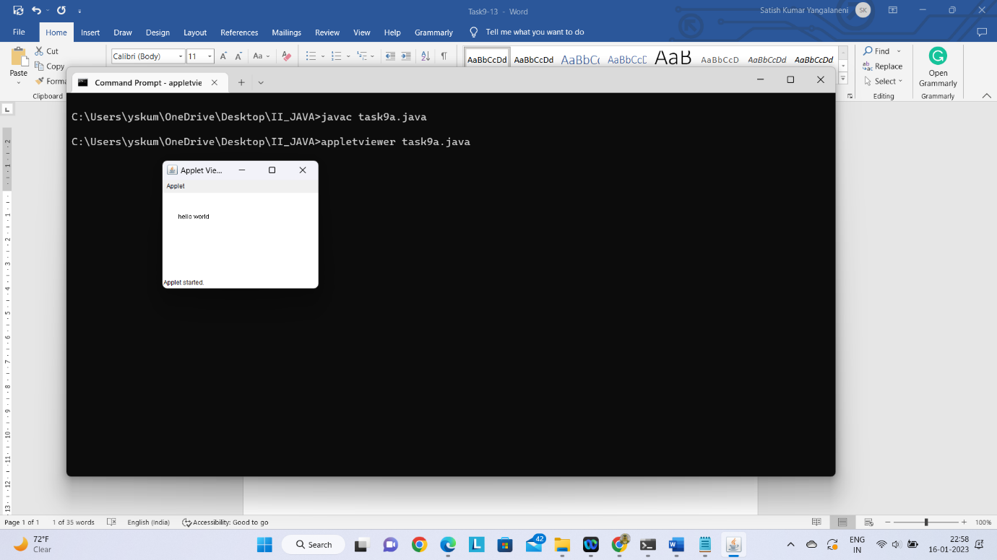

**Task 9(b): Develop an applet that receives an integer in one text field and compute its factorial value and return it in another text field, when the button named “Compute” is clicked.**

import java.awt.*;

import java.applet.*;

import java.awt.event.*;

/*<applet code="Task9b" width=500 height=250>

</applet>*/

public class Task9b extends Applet implements ActionListener {

Label L1,L2;

TextField T1,T2;

Button B1;

public void init() {

L1=new Label("Enter any Number : ");

add(L1);

T1=new TextField(10);

add(T1);

L2=new Label("Factorial of Num : ");

add(L2);

T2=new TextField(10);

add(T2);

B1=new Button("Compute");

add(B1);

B1.addActionListener(this);

}

public void actionPerformed(ActionEvent e) {

if(e.getSource()==B1)

{

int value=Integer.parseInt(T1.getText());

int fact=factorial(value);

T2.setText(String.valueOf(fact));

}

}

int factorial(int n) {

if(n==0)

return 1;

else

return n*factorial(n-1);

}

}

**OUTPUT:**

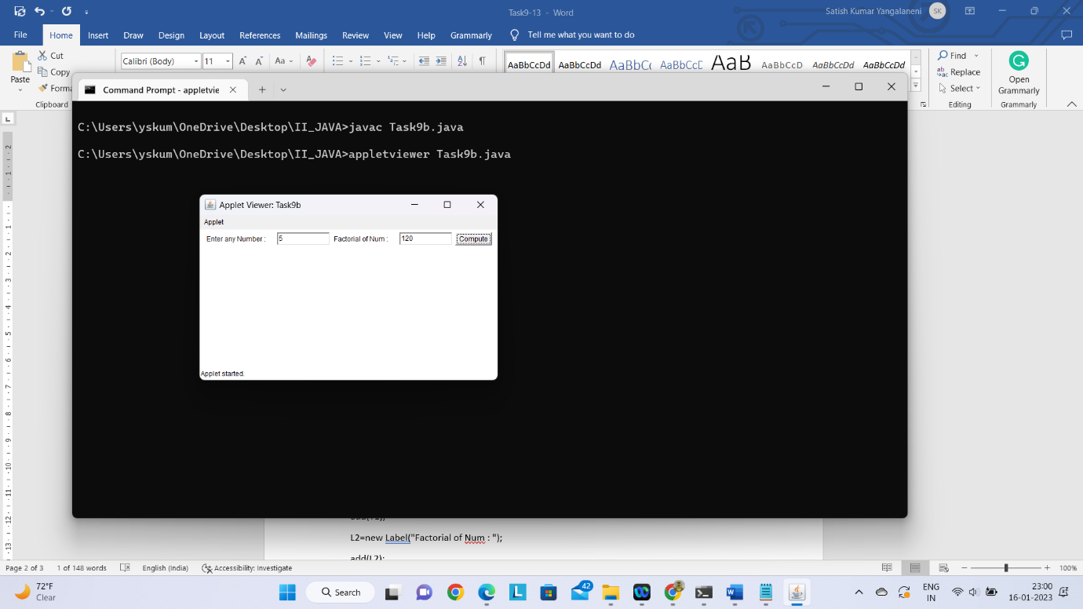

**Task 9(c): Write a Java program that works as a simple calculator. Use a gridlayout to arrange buttons for the digits and for the +, -, *, % operations. Add a text field todisplay the result.**

import java.awt.*;

import java.awt.event.*;

import java.applet.*;

import javax.swing.*;

/*

<applet code="Task9c" width=300 height=300>

</applet>

*/

public class Task9c extends Applet implements ActionListener {

int num1,num2,result;

TextField T1;

Button NumButtons[]=new Button[10];

Button Add,Sub,Mul,Div,clear,EQ;

char Operation;

Panel nPanel,CPanel,SPanel;

public void init() {

nPanel=new Panel();

T1=new TextField(30);

nPanel.setLayout(new FlowLayout(FlowLayout.CENTER));

nPanel.add(T1);

CPanel=new Panel();

CPanel.setBackground(Color.white);

CPanel.setLayout(new GridLayout(5,5,3,3));

for(int i=0;i<10;i++) {

NumButtons[i]=new Button(""+i);

}

Add=new Button("+");

Sub=new Button("-");

Mul=new Button("*");

Div=new Button("/");

clear=new Button("clear");

EQ=new Button("=");

T1.addActionListener(this);

for(int i=0;i<10;i++) {

CPanel.add(NumButtons[i]);

}

CPanel.add(Add);

CPanel.add(Sub);

CPanel.add(Mul);

CPanel.add(Div);

CPanel.add(EQ);

SPanel=new Panel();

SPanel.setLayout(new FlowLayout(FlowLayout.CENTER));

SPanel.setBackground(Color.yellow);

SPanel.add(clear);

for(int i=0;i<10;i++) {

NumButtons[i].addActionListener(this);

}

Add.addActionListener(this);

Sub.addActionListener(this);

Mul.addActionListener(this);

Div.addActionListener(this);

clear.addActionListener(this);

EQ.addActionListener(this);

this.setLayout(new BorderLayout());

add(nPanel,BorderLayout.NORTH);

add(CPanel,BorderLayout.CENTER);

add(SPanel,BorderLayout.SOUTH);

}

public void actionPerformed(ActionEvent ae) {

String str=ae.getActionCommand ();

char ch=str.charAt(0);

if(Character.isDigit(ch))

T1.setText(T1.getText()+str);

else

if(str.equals("+")){

num1=Integer.parseInt (T1.getText());

Operation='+';

T1.setText ("");

}

if(str.equals("-")){

num1=Integer.parseInt(T1.getText());

Operation='-';

T1.setText("");

}

if(str.equals("*")){

num1=Integer.parseInt(T1.getText());

Operation='*';

T1.setText("");

}

if(str.equals("/")){

num1=Integer.parseInt(T1.getText());

Operation='/';

T1.setText("");

}

if(str.equals("%")){

num1=Integer.parseInt(T1.getText());

Operation='%';

T1.setText("");

}

if(str.equals("=")) {

num2=Integer.parseInt(T1.getText());

switch(Operation)

{

case '+':result=num1+num2;

break;

case '-':result=num1-num2;

break;

case '*':result=num1*num2;

break;

case '/':try {

result=num1/num2;

}

catch(ArithmeticException e) {

result=num2;

JOptionPane.showMessageDialog(this,"Divided by zero");

}

break;

}

T1.setText(""+result);

}

if(str.equals("clear")) {

T1.setText("");

}

}

}

**OUTPUT:**

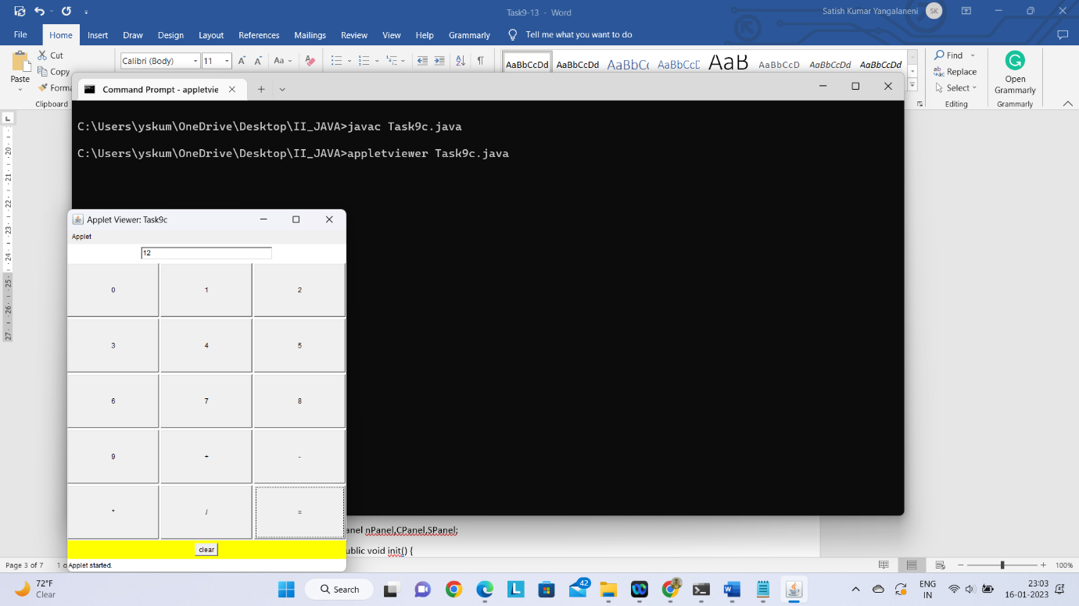

Task 10(a): Write a java program for handling mouse events.

import java.awt.*;

import java.awt.event.*;

class MouseListenerImpl implements MouseListener

{

public void mouseClicked(MouseEvent me)

{

System.out.println("Mouse Clicked:["+me.getX()+" ," +me.getY()+"]");

}

public void mousePressed(MouseEvent me)

{

System.out.println("Mouse Pressed:["+me.getX()+" ," +me.getY()+"]");

}

public void mouseReleased(MouseEvent me)

{

System.out.println("Mouse Released:["+me.getX()+" ," +me.getY()+"]");

}

public void mouseEntered(MouseEvent me)

{

System.out.println("Mouse Entered:["+me.getX()+" ," +me.getY()+"]");

}

public void mouseExited(MouseEvent me)

{

System.out.println("Mouse Exited:["+me.getX()+" ," +me.getY()+"]");

}

}

class MyFrame extends Frame

{

MyFrame()

{

this.setVisible(true);

this.setTitle("Mouse Events");

this.setSize(500,500);

this.setBackground(Color.yellow);

this.addMouseListener(new MouseListenerImpl());

}

}

class Task10a

{

public static void main(String[] args)

{

MyFrame frame=new MyFrame();

}

}

**OUTPUT:**

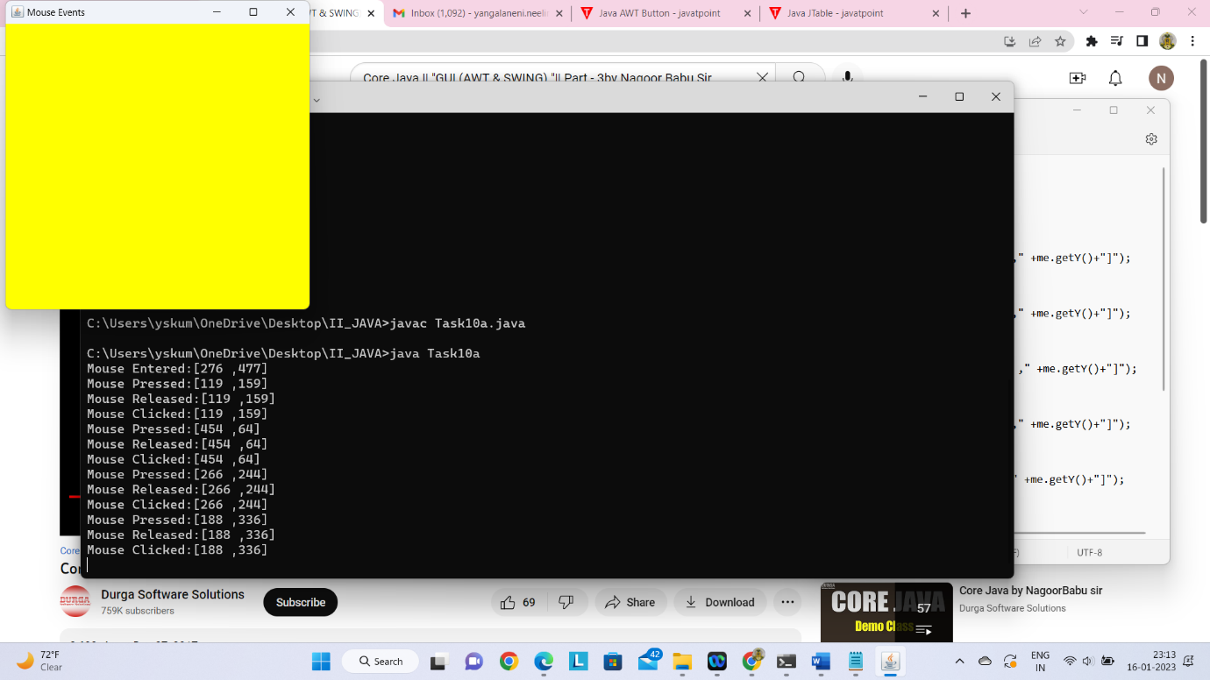

**Task 10(b): Write a java program for handling key events**

import java.awt.*;

import java.awt.event.*;

class KeyListenerImpl implements KeyListener

{

public void keyPressed(KeyEvent ke)

{

System.out.println("Key Pressed:"+ke.getKeyChar());

}

public void keyReleased(KeyEvent ke)

{

System.out.println("Key Released:"+ke.getKeyChar());

}

public void keyTyped(KeyEvent ke)

{

System.out.println("Key Typed:"+ke.getKeyChar());

}

}

class MyFrame extends Frame

{

MyFrame()

{

this.setVisible(true);

this.setTitle("Key Events");

this.setSize(500,500);

this.setBackground(Color.yellow);

this.addKeyListener(new KeyListenerImpl());

}

}

class Task10b

{

public static void main(String[] args)

{

MyFrame frame=new MyFrame();

}

}

**OUTPUT:**

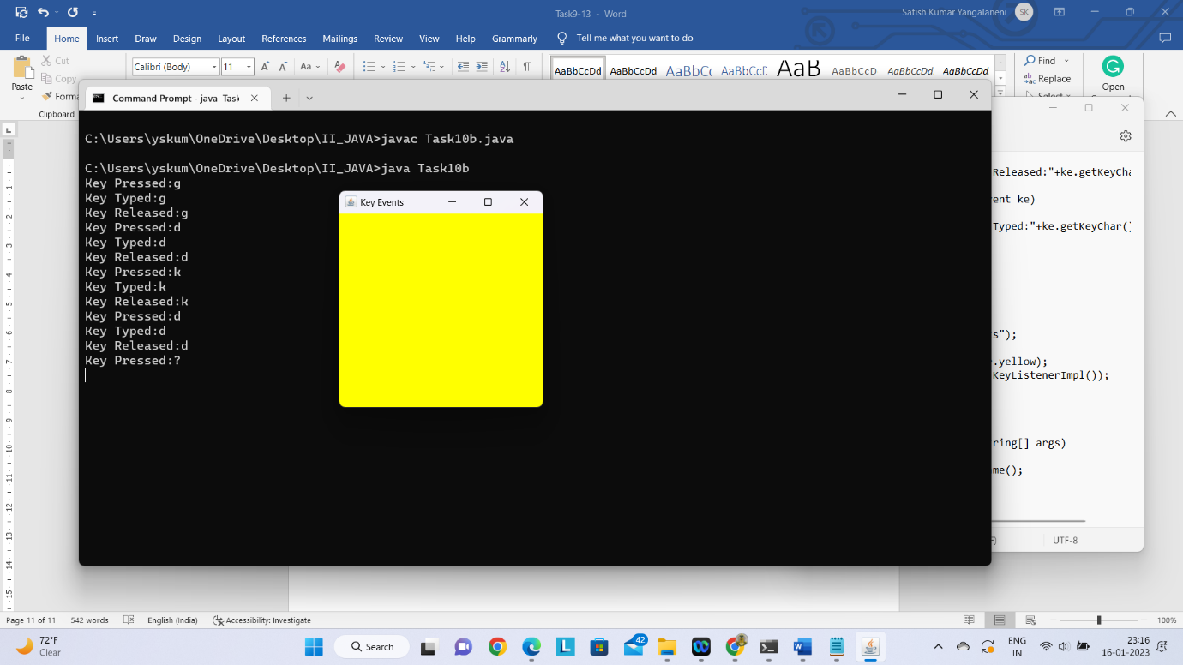

**Task 11: Write a program that creates a user interface to perform integer divisions. The user enters two numbers in the textfields, Num1 and Num2. The division of Num1 and Num2 isdisplayed in the Result field when the Divide button is clicked. If Num1 or Num2 were not an integer,the program would throw a NumberFormatException. If Num2 were Zero, the programwould throw an ArithmeticException. Display the exception in a message dialog box.**

import java.awt.*;

import javax.swing.*;

import java.applet.Applet;

import java.awt.event.*;

/*<applet code="Task11.class" width=400 height=350></Applet>*/

public class Task11 extends Applet implements ActionListener{

TextField t1,t2,t3;

Button b;

Label L1,L2,L3,L4;

String s;

Task11 e;

public void init()

{

e=this;

t1=new TextField(10);

t2=new TextField(10);

t3=new TextField(10);

L1=new Label("enter num1");

L2=new Label("enter num2");

L3=new Label("Result is");

L4=new Label("Division of 2 numbers");

b=new Button("Divide");

add(L4);

add(L1);

add(t1);

add(L2);

add(t2);

add(L3);

add(t3);

add(b);

b.addActionListener(this);

}

public void paint(Graphics g)

{

setBackground(Color.red);

setForeground(Color.black);

L1.setBackground(Color.blue);

L2.setBackground(Color.blue);

L3.setBackground(Color.blue);

L4.setBackground(Color.green);

b.setBackground(Color.cyan);

}

public void actionPerformed(ActionEvent ae)

{

try

{

int num1=Integer.parseInt(t1.getText());

int num2=Integer.parseInt(t2.getText());

s=""+(num1/num2);

t3.setText(s);

}

catch(ArithmeticException a)

{

JOptionPane.showMessageDialog(null,"Divide by zero");

}

catch(NumberFormatException b)

{

JOptionPane.showMessageDialog(null,"NumberFormateException");

}

}

}

**OUTPUT:**

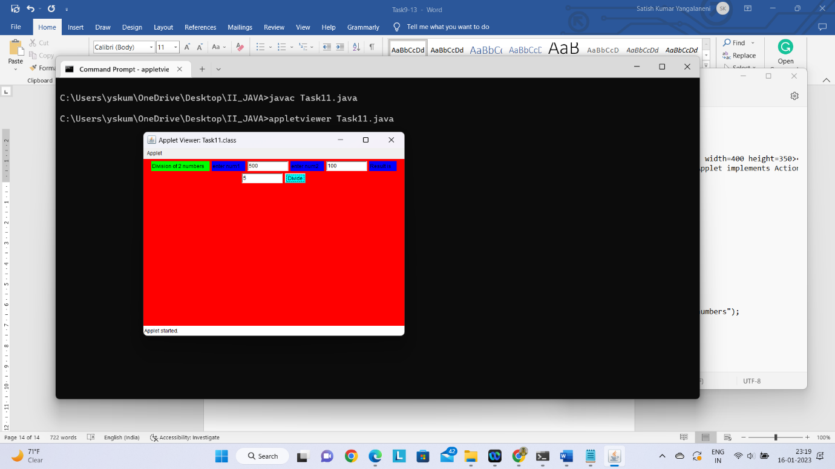

**Task 12(a): Write a java program that simulates a traffic light. The program lets the user select one of three lights: red, yellow, or green. When a radio button is selected, the light is turned on, and only one light can be on at a time. No light is on when the program starts.**

import java.awt.*;

import java.applet.*;

import java.awt.event.*; /*

<applet code="Task12a.class" width=500 height=500> </applet>

*/

public class Task12a extends Applet implements ActionListener

{

int i=0;

Button R,O,G;

public void init()

{

setBackground(Color.white);

setForeground(Color.black);

R=new Button("red");

O=new Button("orange");

G=new Button("green");

add(R);

add(O);

add(G);

R.addActionListener(this);

O.addActionListener(this);

G.addActionListener(this);

}

public void actionPerformed(ActionEvent ae)

{

String s=ae.getActionCommand();

if(s.equals("red"))

i=1;

if(s.equals("orange"))

i=2;

if(s.equals("green"))

i=3;

repaint();

}

public void paint(Graphics g)

{

g.setColor(Color.yellow);

g.drawRect(50,50,100,200);

g.fillRect(50,50,100,200);

g.setColor(Color.black);

g.drawOval(80,70,30,30);

g.drawOval(80,130,30,30);

g.drawOval(80,190,30,30);

g.setColor(Color.yellow);

g.drawLine(100,250,100,900);

if(i==1)

{

g.setColor(Color.red);

g.fillOval(80,70,30,30);

}

if(i==2)

{

g.setColor(Color.orange);

g.fillOval(80,130,30,30);

}

if(i==3)

{

g.setColor(Color.green);

g.fillOval(80,190,30,30);

}

}

}

**OUTPUT:**

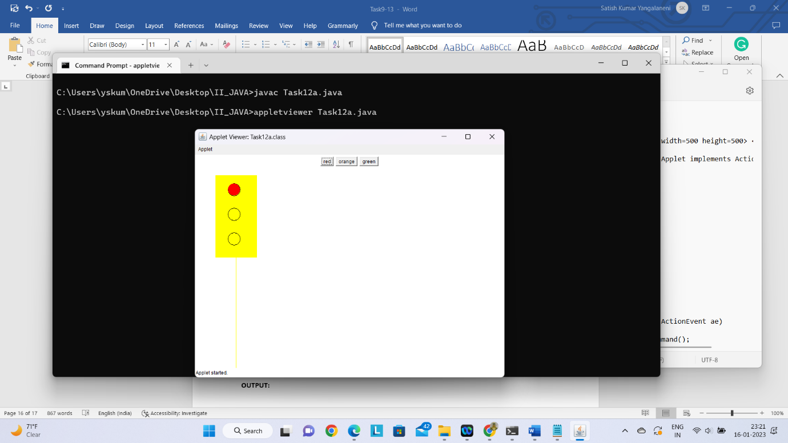

**Task 12(b): Write a Java program that allows the user to draw lines,rectangles and ovals.**

import java.applet.*;

import java.awt.event.*;

import java.awt.*;

/*<applet code="Task12b.class" height=310 width=400> </applet>*/

public class Task12b extends Applet implements ActionListener

{

Button b[]=new Button[10];

int in;

public void init()

{

b[0]=new Button("Line");

b[1]=new Button("Rectangle");

b[2]=new Button("FilledRectangle");

b[3]=new Button("RoundedRectangle");

b[4]=new Button("FilledRoundedRectangle");

b[5]=new Button("Oval");

b[6]=new Button("FilledOval");

b[7]=new Button("Arc");

b[8]=new Button("FilledArc");

b[9]=new Button("Polygon");

for(int i=0;i<10;i++)

{

add(b[i]);

b[i].addActionListener(this);

}

}

public void actionPerformed(ActionEvent ae)

{

for(int j=0;j<10;j++)

{

if(ae.getSource()==b[j])

{

in=j+1;

break;

}

}

repaint();

}

public void paint(Graphics g)

{

if(in==1)

g.drawLine(150, 150, 250,300);

if(in==2)

g.drawRect(150, 150, 60,50);

if(in==3)

g.fillRect(150,150, 60,50);

if(in==4)

g.drawRoundRect(150, 150, 60, 50, 15, 15);

if(in==5)

g.fillRoundRect(150, 150, 60, 50, 15, 15);

if(in==6)

g.drawOval(150, 150, 60, 50);

if(in==7)

g.fillOval(150, 150, 60,50);

if(in==8)

g.drawArc(150, 150, 60, 50, 0, 75);

if(in==9)

g.fillArc(150, 150, 60, 50, 0,75);

if(in==10)

{

int xpoints[] = {50, 200,250, 250,200};

int ypoints[] = {250, 200,250,300,300};

int num = 5;

g.drawPolygon(xpoints, ypoints, num);

}

}

}

**OUTPUT:**

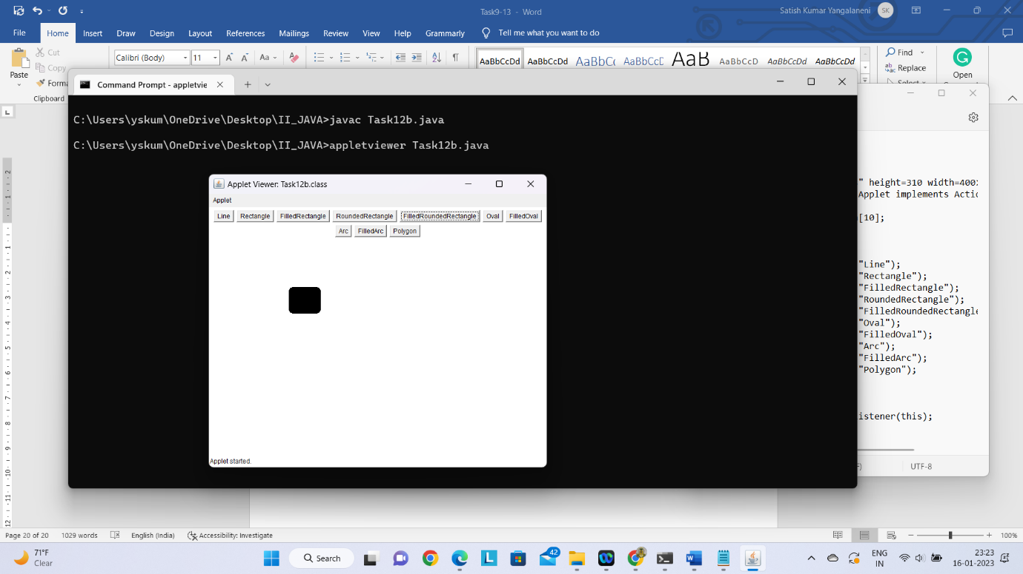

**Task 13: Create a table in Table.txt file such that the first line in the file is the headerand the remaining lines corresponds to rows in the table. The elements are separatedby commas. Write a java program to display the table using JTable component.**

import javax.swing.*;

public class Task13

{

JFrame f;

Task13()

{

f=new JFrame();

String data[][]={ {"101","Minnie","670000"},

{"102","Vaishu","780000"},

{"101","Lucky","700000"}};

String column[]={"ID","NAME","SALARY"};

JTable jt=new JTable(data,column);

jt.setBounds(30,40,200,300);

JScrollPane sp=new JScrollPane(jt);

f.add(sp);

f.setSize(300,400);

f.setVisible(true);

}

public static void main(String[] args)

{

new Task13();

}

}

**OUTPUT:**