HTML & CSS 레퍼런스

<https://www.w3schools.com/html/html_elements.asp>

<https://developer.mozilla.org/en-US/docs/Web/HTML/Element>

Google Fonts

coolors.co

색 조합 알려주는

<https://coolors.co/>

Bootstrap 공식 – install, docs

<https://getbootstrap.com/docs/3.3/getting-started/>

Javascript docs

<https://developer.mozilla.org/ko/docs/Web/JavaScript/Reference/Global_Objects/Array>

- for(임시변수 of array이름)

- array이름.forEach(함수이름-()안씀!) -> 이벤트 반복

- Object 멤버를 key로 접근할 때 “”(or ‘’)써줘야 함. 예) mycar{“name”}

- for(임시변수(key) in Object이름) : key순차적 접근. 값 접근하려면 Object이름[key]

* console.dir(document)
* document.URL, document.body, document.head, document.links
* document.getElementById(), document.getElementByClassName(),

document.getElementsByTagName(), document.querySelector(),

document.querySelectorAll()

* myvariable.textContent, myvariable.innerHTML,

myvariable.getAttribute(attr이름), myvariable.setAttribute(attr이름,값)

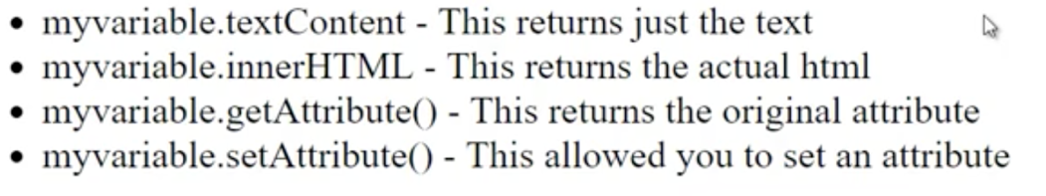

* myvariable.addEventListener(event,func)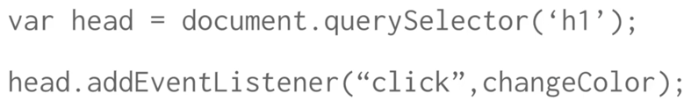

Event 관련 docs

<https://www.w3schools.com/jsref/dom_obj_event.asp>

jQuery

<https://code.jquery.com/>

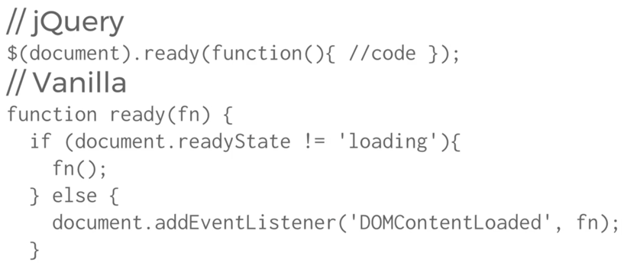

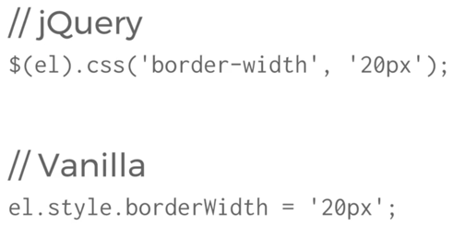

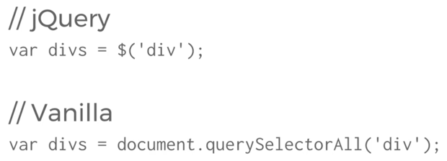

jQuery 이벤트 docs

<https://api.jquery.com/category/events/>