# Introduction of my Shell

## Hang Shi

My shell is an individual work. She realizes all the minimum requirements and 3 optional features, along with one extension: history.

The 3 optional my shell realized are, cd, process finishing print in when in background & change the environment variables.

For environment variable modification, I wrote a program called env.c. It creates 3 environment called VAR, UBAL and OS, and print them all. You can compile and run it like following:

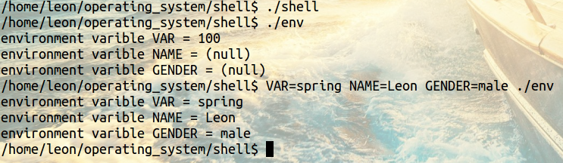

Cd and Print-finishing are performed as the real shell.

I haven’t complete the key action *up and down*. I stored all the shell history and you can watch them by taping the shell: history. As following:

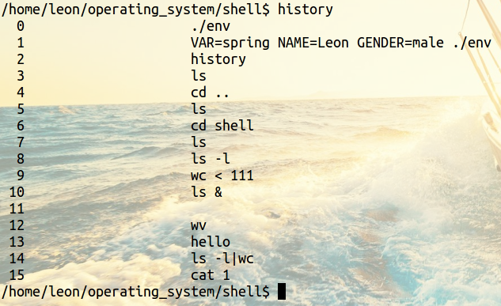

That’s all. Thank you!