First off I want to stress that I am by no means an expert on this but I thought I would try to share my experiences with others (specifically Windows users contributing to the Fanboy adblock list project).

Tools needed:
TortoiseHg

“TortoiseHg is a Windows shell extension and a series of applications for the Mercurial distributed revision control system.”

Note: If you are reading this I’m assuming that you are already able to commit changes to the repository.

After pushing changes made to one or more files in your local repository you should see a message that looks something like the following screenshot.
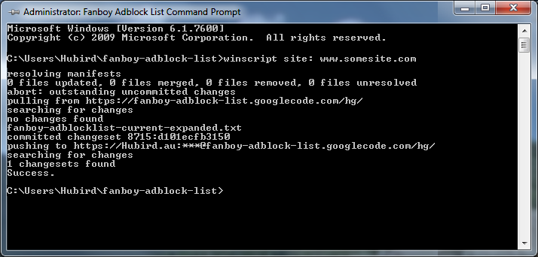
The above is an example of the message you will get if no merging was required.

In this next screen shot you will notice that a different message is displayed. If you see this message it means you will have to merge your changes (changes have been added as an additional head to our repository). If you do not merge your changes things will start to get confusing & messy real quick.
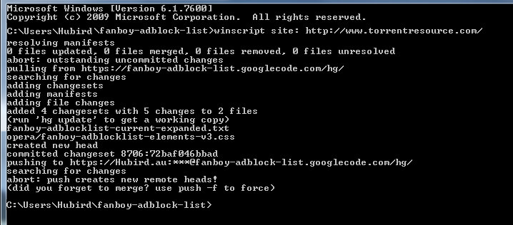
Merging:
At the command prompt (make sure you are in the correct directory) type:
hg merge
Upon pressing enter you will be presented with a screen that looks something like this:
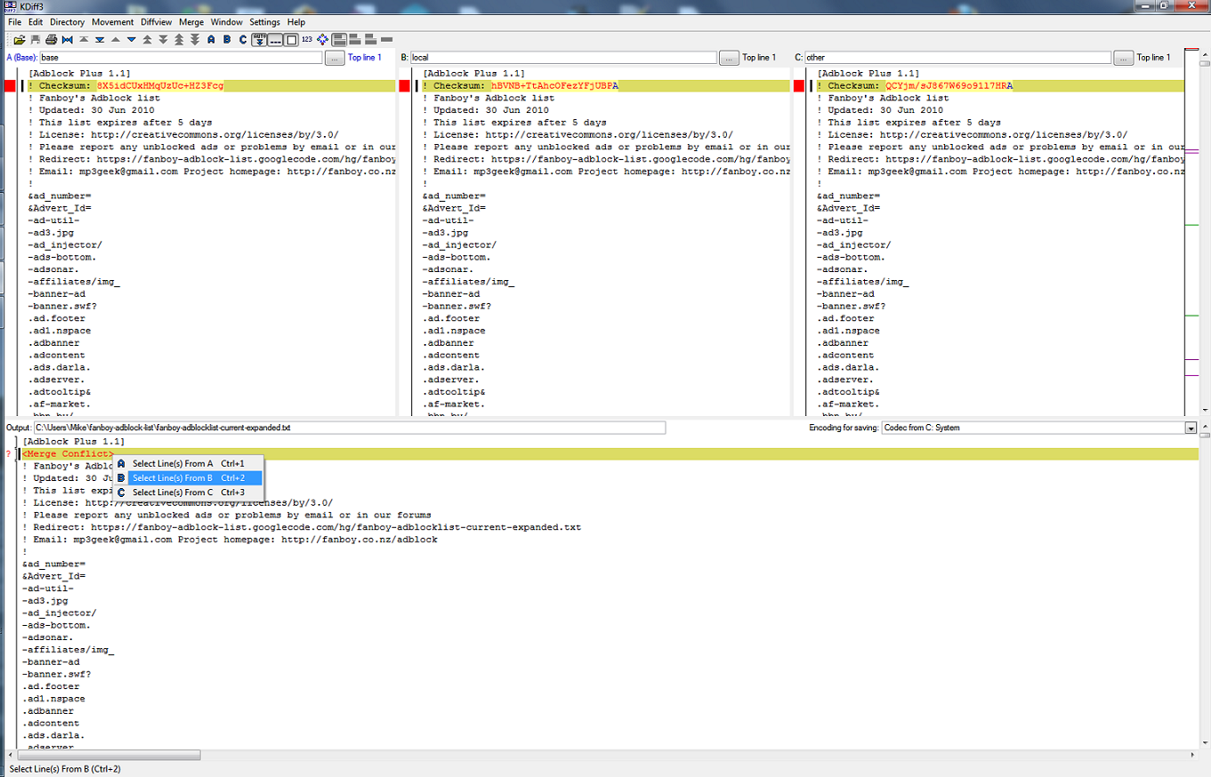
You will notice you have 3 columns up the top labelled “A, B & C” and one down the bottom called “Output”. The 3 columns up the top cannot be modified and are for your reference only. Changes between the different file versions are highlighted in red in columns “A,B & C”. In the output area you need to right click on the highlighted entry and select which change you would like (either A,B or C).
Kdiff3 tries it’s best to automatically choose sensible selections for you (from memory they are always spot on) but for more complicated merging operations user input will be required.

Note: When it comes to merging the checksum you can choose any entry as a new one will be generated from the final version of the file.

Here is another screenshot for your reference:
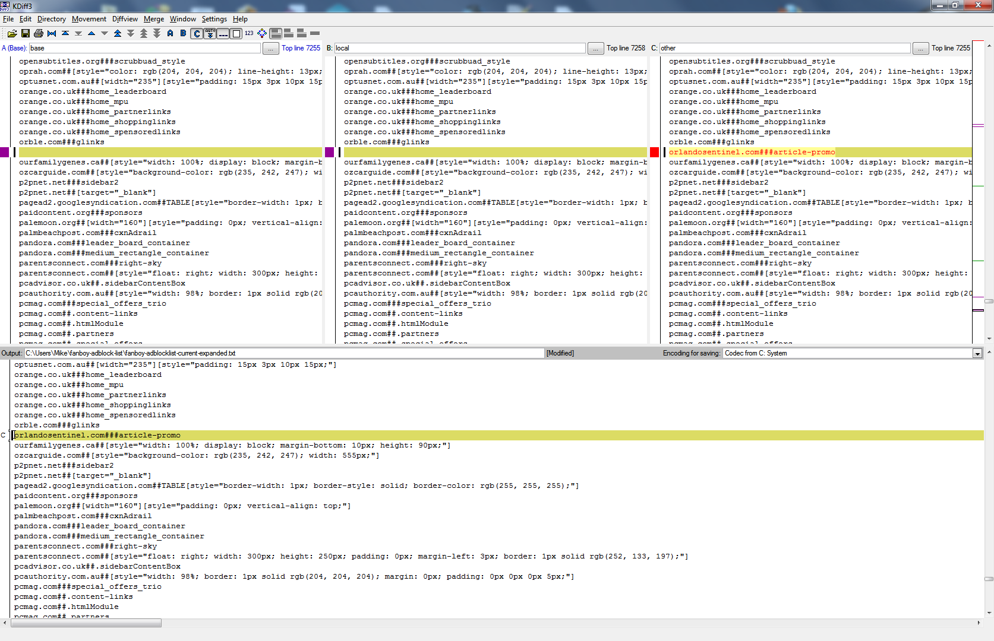
Pressing the up and down arrows on the Kdiff3 toolbar will jump you to the next items that requires your attention.
After all conflicts have been resolved simply save your changes (if you close the window it will prompt you to save), exit out of Kdiff3 (back to the command prompt) and use winscript to push your changes.
I usually go with something like winscript merge but it’s entirely up to you.

If you want to be sure that you have correctly merged all the heads you can use the hg heads command.

If it comes up with multiple entries (like in the screen shot below you know you have changes that need to be merged.
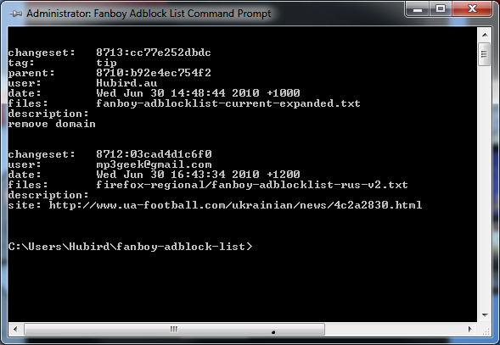

If it looks like the following screen shot everything is ok
