Easy onboarder

1. What is the purpose of the application? (who uses it & what for)

Easy onboarder application is meant to be used by any new employee in order to easily gain useful information about the department or project that he/she is part of. It also provides a means to enroll to courses (specific to the team’s/department’s need.)

1. What are technologies used for creating the application? (front-end & back-end)

2.1 Back-end:

* Spring Boot – embedded Tomcat server
* MapStruct: framework used to provide mappers for entity classes
* JPA: used in persistence layer

2.2 Front-end:

* Angular
* Material Design for Angular

2.3 Database: Oracle 11g

2.3 Docker integration for client side and server side application

1. What are the main features?

* User register/ user login
* Display courses (name, overview, keywords of each course)
* Search by overview (find courses which contain the searched words in overview)

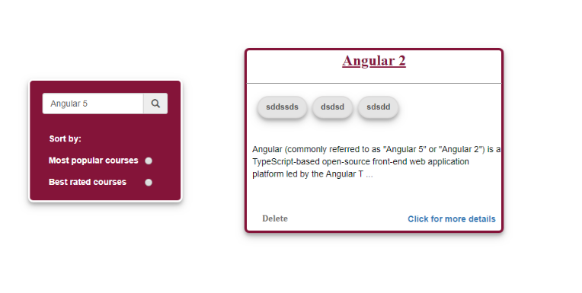

* Filter by keyword (maximum 4 keywords/course. Click on one keyword and get all courses containing that keyword)
* Display details of any course (on click, show more informations)
* Display course chapters (when click on syllabus on details)
* Enroll/ unenroll to course
* Edit course
* Add course

Step 1:

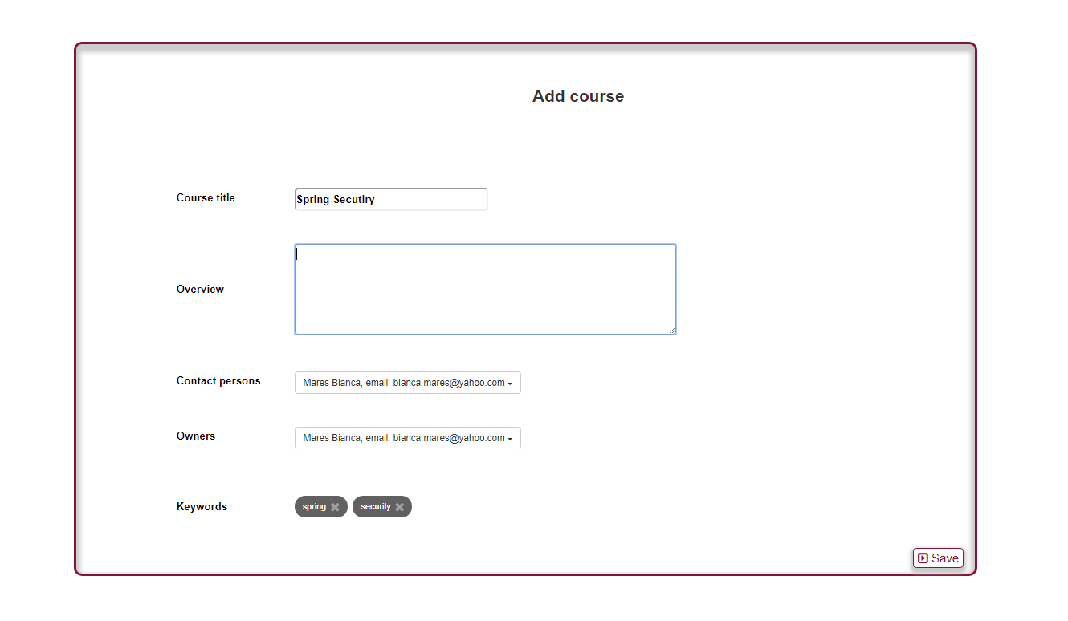

Step 2:

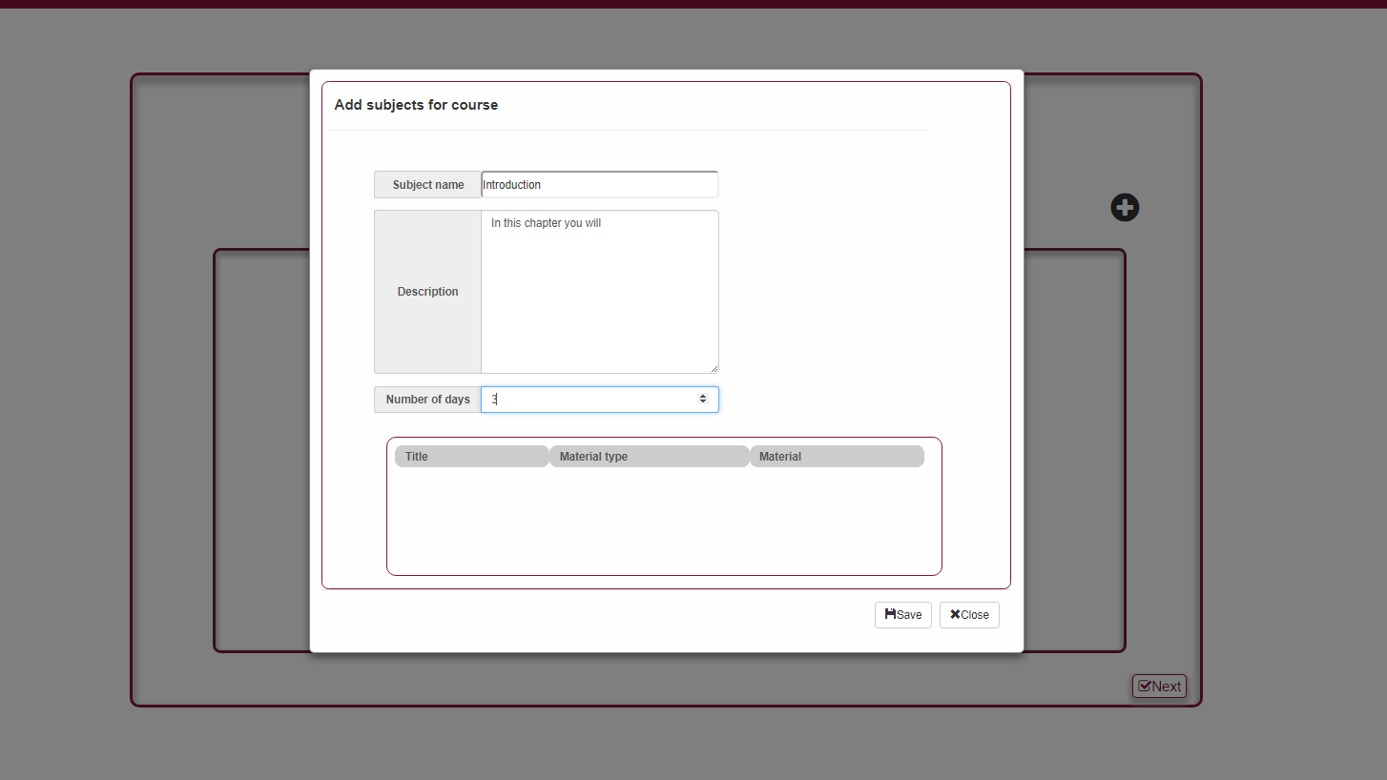

Step 3:

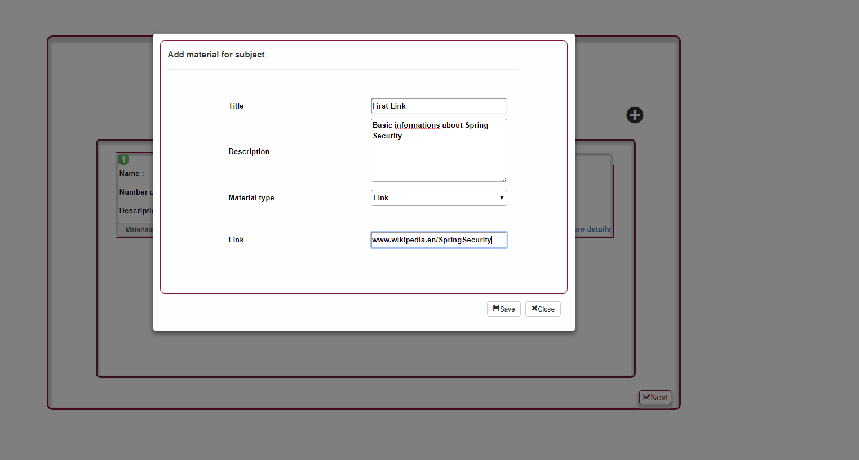

* Edit profile
* Display courses that user is enrolled to

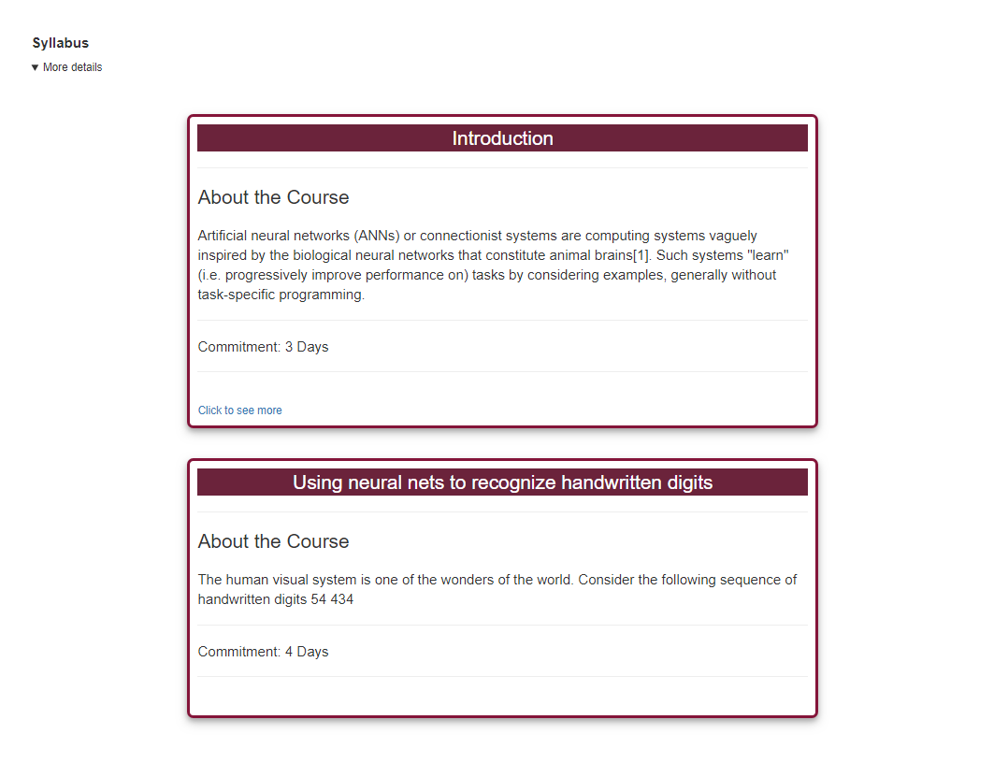

* Display user’s progress on course
* Add review to course
* Display general rating for each course
* Logout

1. What are the main use-cases?

4.1 Login/Register

* Register - User does not have an account. Create one.
* Login – user is already registered

4.2 Enroll to course

* + User logs in
  + Search course
  + View course details
  + Click on enroll button
  + Open Syllabus section
  + Click on first subject (chapter)
  + After the user marks current subject as finished the next subject will be available

4.3 Add Course

* To add a course a user should fill in the first form which requires course title, overview, contact persons, owners and keywords. By default the user is added to contact persons and owners but this information can be modified.
* To add a subject, the user first has to click on “Save” button.
* Next, the user should add a least one subject to course
* After the subject is added the user can add materials to this subject (link and PDF files)
  1. Search course by overview
* When a user is interested in one particular course, it can be search by overview (words found in the overview section)
  1. Filter courses by keyword
  2. View courses that user is enrolled to
* User logs in
* Select view courses option
* A list with all the courses to which the user is enrolled will appear and a progress indicator for each course
  1. Edit profile
  2. Edit course

1. Further development. New proposed features.

5.1 Search by keywords. Use more than only 4 keywords/course.

* 1. User login/register security enhancement.
  2. Display course’s reviews
  3. Material Design Angular. (used for interface generation. Avoid html code. Easier to use and maintain)
  4. Create roles for the application. Make courses available according to user’s role.