

CS 320 Course Project Final Report

for

Hot Logbook

Prepared by

Group Name: *Sasswords Puck*

|  |  |  |
| --- | --- | --- |
| Jesse Griffin | 11641870 | [jesse.w.griffin@wsu.edu](mailto:jesse.w.griffin@wsu.edu) |
| Patrick Kent | 11019238 | [patrick.kent@wsu.edu](mailto:patrick.kent@wsu.edu) |
| Pierson Cavulli | 11608370 | [pierson.carulli@wsu.edu](mailto:pierson.carulli@wsu.edu) |

|  |  |
| --- | --- |
|  |  |
| Date: | 13 December 2018 |
|  |  |
|  |  |
|  |  |

Contents

Contents ii

1 Introduction 1

1.1 Project Overview 1

1.2 Definitions, Acronyms and Abbreviations 1

1.3 References and Acknowledgments 1

2 Design 2

2.1 System Modeling 2

2.2 Interface Design 2

3 Implementation 3

3.1 Development Environment 3

3.2 Task Distribution 3

3.3 Challenges 3

4 Testing 4

4.1 Testing Plan 4

4.2 Tests for Functional Requirements 4

4.3 Tests for Non-functional Requirements 4

4.4 Hardware and Software Requirements 4

5 Analysis 5

6 Conclusion 6

Appendix A - Group Log 7

# 

# Introduction

*<TO DO: Please provide a brief introduction to your project.>*

## Project Overview

The HotLogBook is an passoword manager that allows users to store their account information privately. The user will be able to keep track of their accounts, edit accounts, and remove accounts through our interface.

When the user wants to add an account, they will be given the option to use a randomly genearated password. This is a secure password that would be extremly hard to hack. The user will also be able to edit previously added accounts for cases where changing a password or user name is needed.

## Definitions, Acronyms and Abbreviations

<Define all the terms necessary to properly interpret the report, including acronyms and abbreviations.

TO DO: Please provide a list of all abbreviations and acronyms used in this document sorted in alphabetical order.>

## References and Acknowledgments

Our site would not be possible without the aid of Meteor and Semantic UI.

# Design

## System Modeling

## Interface Design

**Home/About Page**

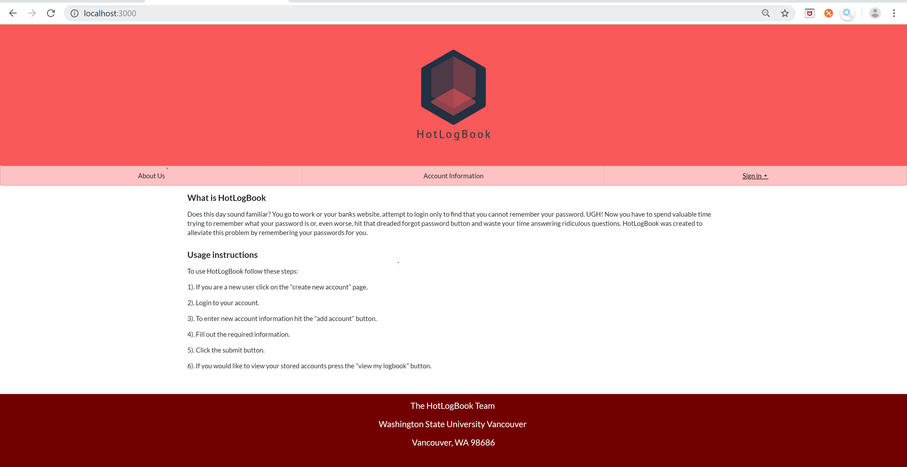

**Account Page**

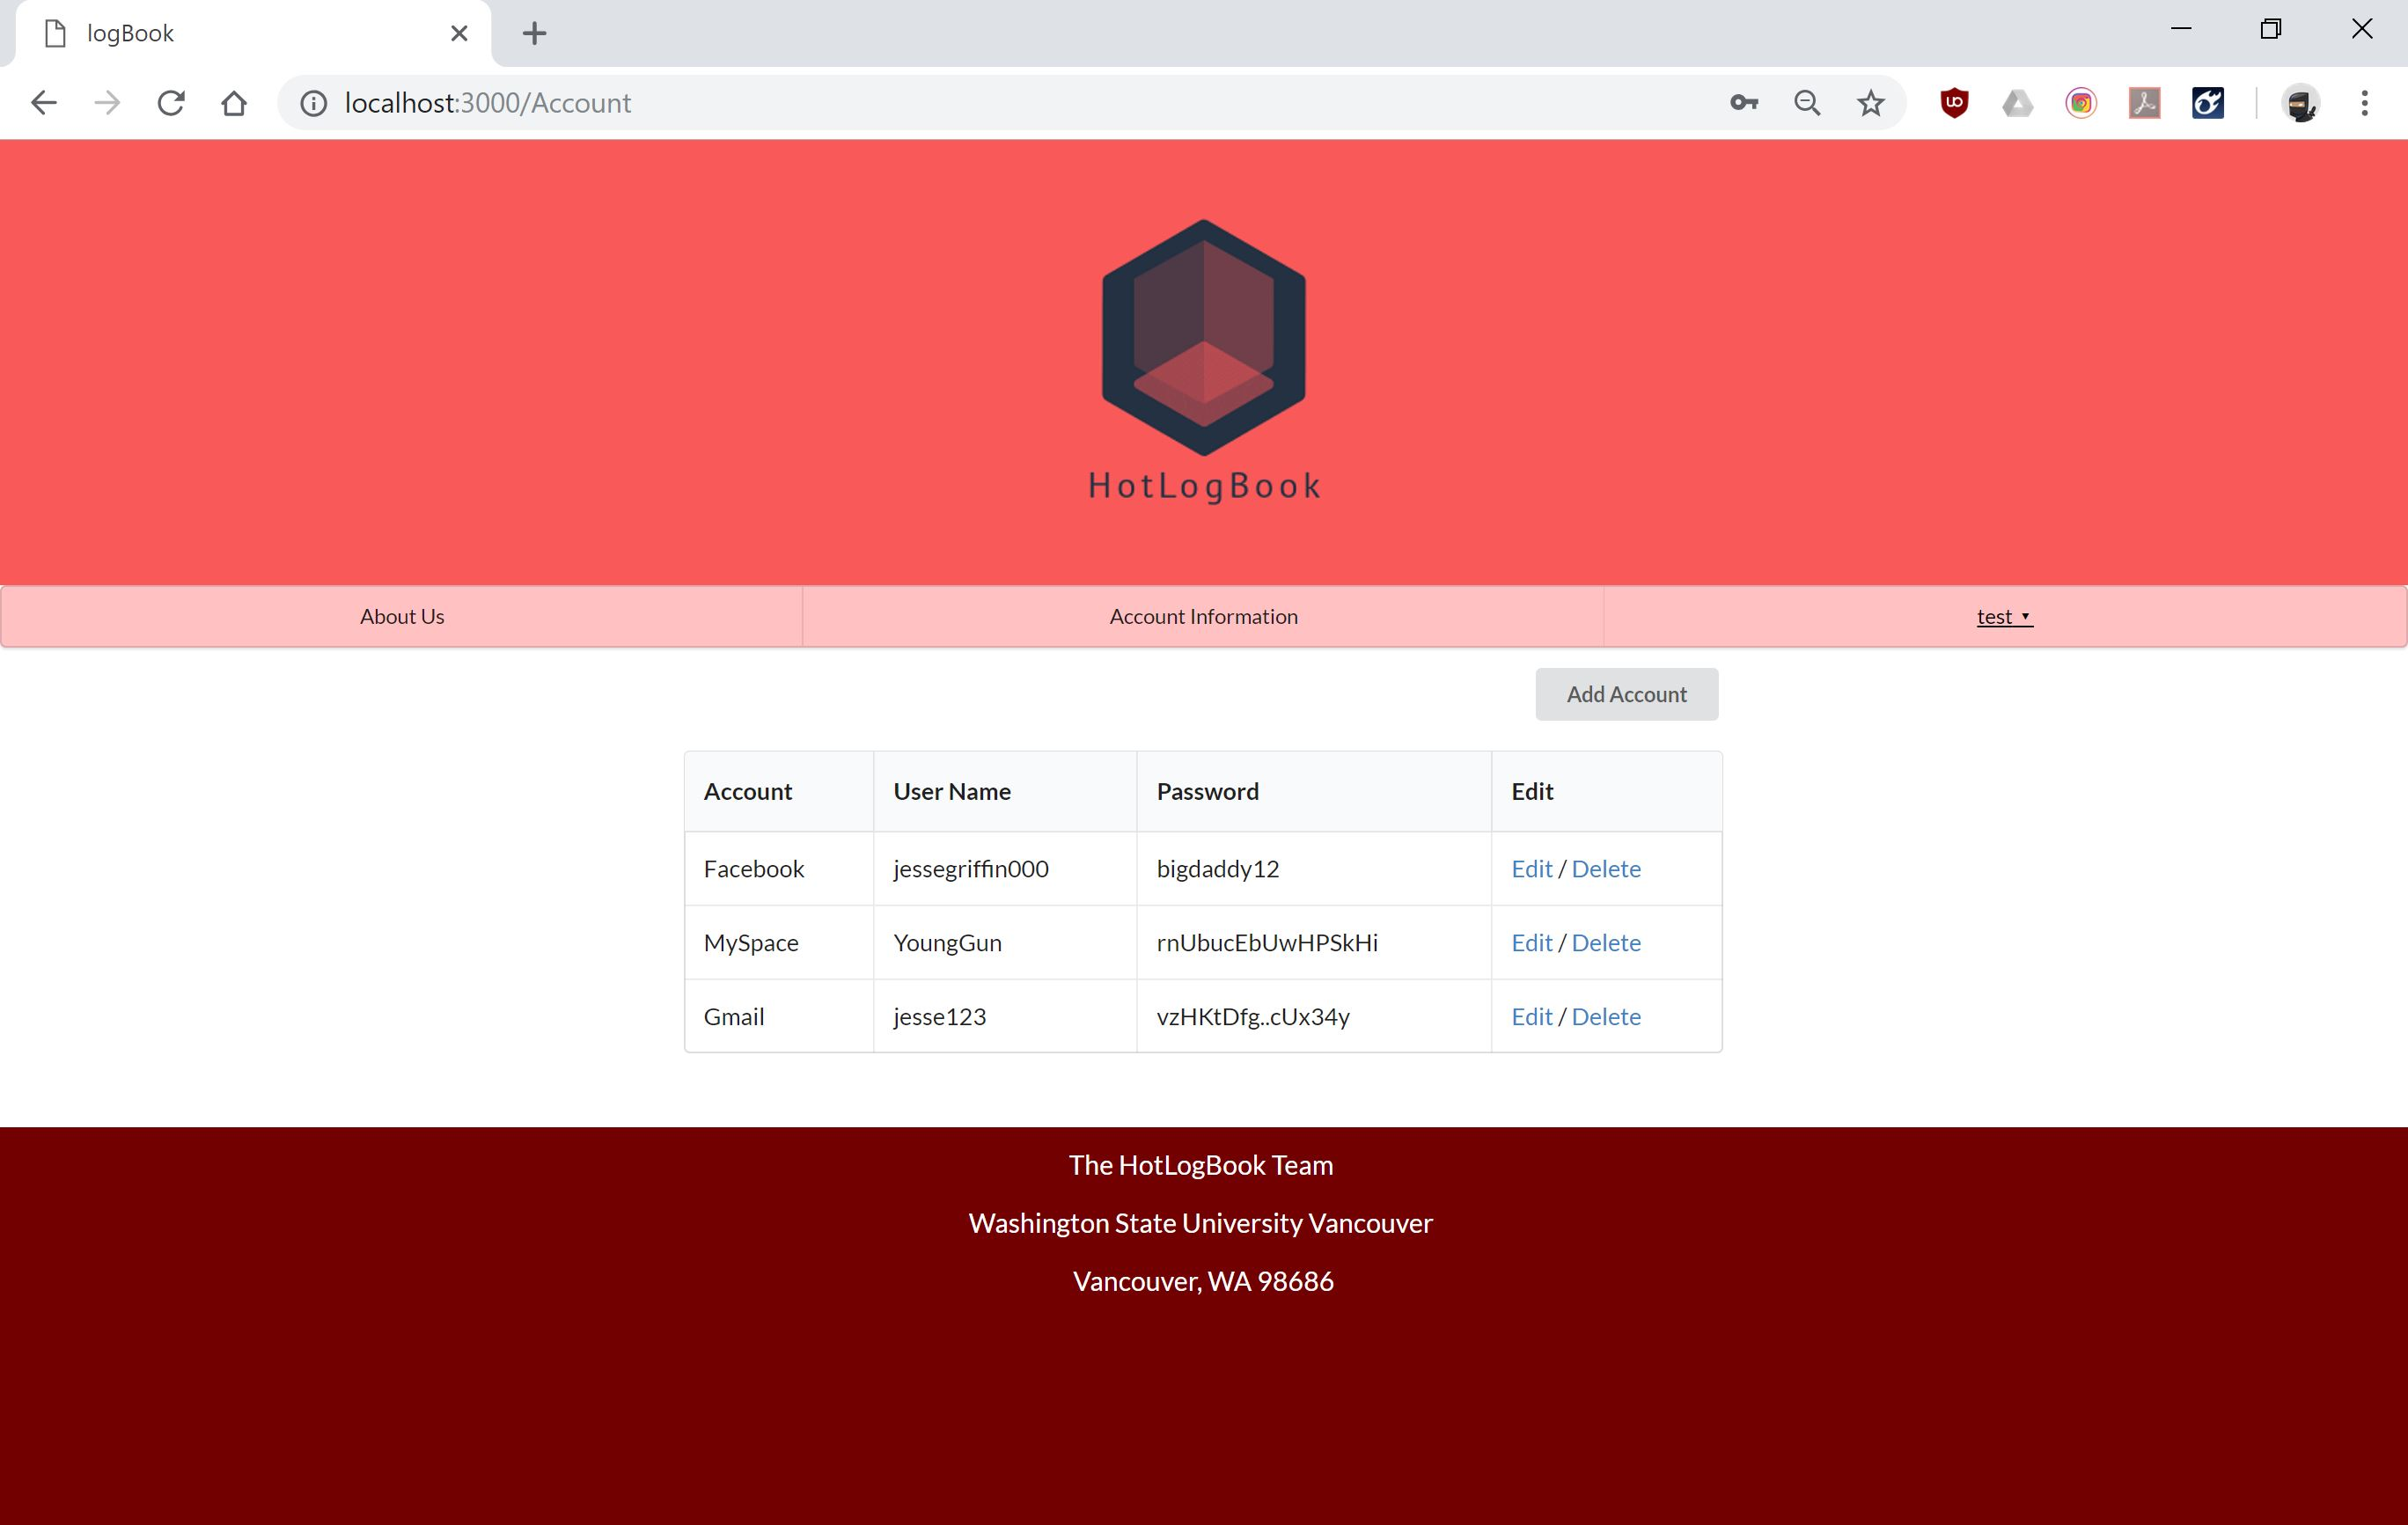

**Add Account Page**

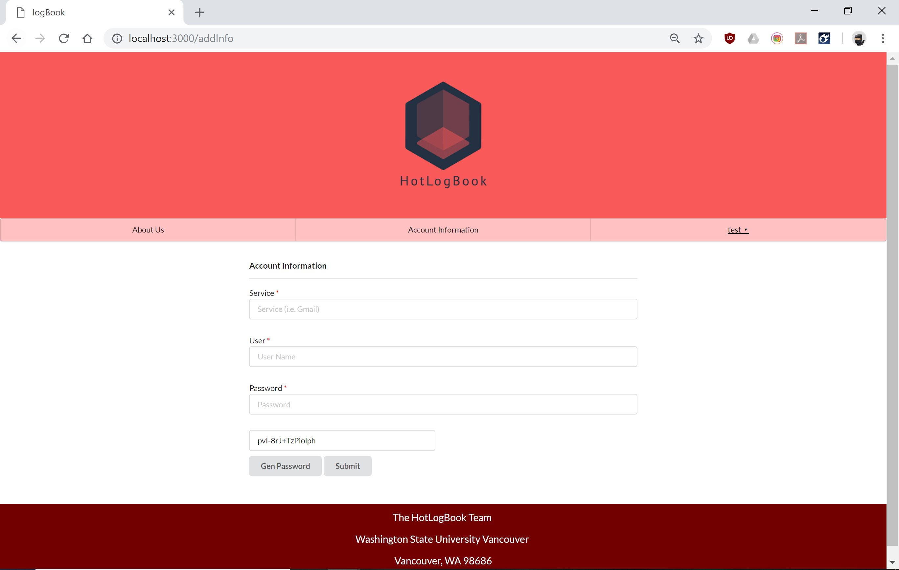

**Edit Account**

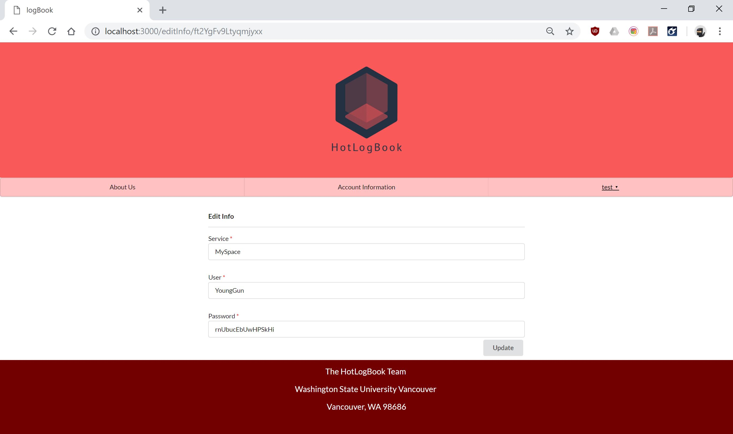

# Implementation

## Development Environment

Tools and Languages used to develop the HotLogBook:

* JavaScript
* HTML/CSS
* Meteor
* IntelliJ
* SemanticUI
* Mongo Database

## Task Distribution

Jesse Griffin: Created logo design for project. Also implemented sign in, add page, edit page, and schema inspired from Assignment 7.

Patrick Kent: Implementation of individual users and user accounts. Also memebr who turns in course work.

Pierson Cavulli: Started project and created file structure for project, edited the add account form (originally created by Jesse) to allow the results to be saved to Mongo, created/managed routes.js. Also created home page and many CSS contributions.

## Challenges

The challenges our group experienced were implementing individual user accounts and adding the delete feature for our app. The way we solved this problem was completing meteor tutorials and learning how schemas and user id’s are stored.

Other problems we ran into were GitHub related. We spent a whole team session on learning how to work together with git without creating merge conflicts. While GitHub was a hinderance in the beginning of our project, it ended up being helpful towards the end by allowing us to implement effective version control.

# Testing

## <*This section is a summary of your testing report>*

## Testing Plan

<Describe your testing plan for the project.

TODO: Give a list of items or functions you want to test, and also a schedule for performing the testing. >

* The genertate password function
* The links in the project
* Browser support (test which browsers work best with our application)

We plan to have all testing done by 12/13/2018

## Tests for Functional Requirements

<Describe your test results for the functional requirements.

TODO: Provide a list of use cases or functions you have tested, as well as the testing results (whether or not the system passed the tests).>

We implemented the black box testing method. Consequently, our program was tested both by the Sasswords Puck team and random end users. The main funstionalities of the website were heavily tested both by the team and the end users who used our software. Any bugs reported have since been fixed. The HotLogBook passed the last test, which was performed on 12/9/2018. Here is a short list of the functionalites that have been tested:

* The generate password function was tested to ensure that a random password was generated on each click.
* To make sure the routes.js file was correclty routing the users requests all the links on our site were tested.

## Tests for Non-functional Requirements

<Similar to the Section 4.2, but this section is for the non-functional requirements. >

The HotLogBook application works well in Chrome, and Firefox; unfortunatly, the font-fire effect does not work in Internet Explorer or Microsoft Edge. While the font-fire does not function in Microsoft Edge the functionality of the HotLogBook is unaltered. The Sasswords Puck team would recommend not using Internet Explorer because the edit account option does not work. A list of other non-functional tests that were performed include:

* Speed test: does the application hang for long periods of time
* CSS test: does each page render properly

## Hardware and Software Requirements

<Describe the hardware and software requirements for performing the tests. >

# Analysis

<In this Section you need to analyze the effort that has been put on this project.

TODO: Describe how many hours (approximately) each team member spent on the project, for each milestone, which milestone takes the most effort and why. >

**Jesse Griffin**

Milestone 1: 6 hours

Milestone 2: 4 hours

Milestone 3: 16-20 hours

**Patrick Kent:**

Milestone 1:

Milestone 2:

Milestone 3:

**Pierson Carulli:**

Milestone 1: 4 hours

Milestone 2: 3 hours

Milestone 3: 25-30 hours

The first milestone took a while because we were dividing out the work and talking about how we can work together. It was also where we developed the idea of our project.

The last milestone took the longest as we implemented our idea into software. All of the bugs and new structures we had to learn is what made this part take the most hours.

# Conclusion

<Conclude the document with what you have learned through working on the project.>

Appendix A - Group Log

< Describe how frequently the group meembers meet during the semester, and how effective the communication is. This is optional for one-person projects.>