
Rolfe H. Green
Student
Computer Science, BA

CS 255 Business Requirements Document
System Components and Design
Purpose
What is the purpose of this project? Who is the client and what do they want their system to be able to do?
- Our consulting company will document DriverPass’s needs so the system we design matches the interview with Liam (owner) and Ian (IT officer).
- DriverPass wants one system for online classes, practice tests, and on-the-road driving lessons.
- The problem they want to fix is that many students fail the DMV test and there are few tools that train them well.
- Their solution is online study plus optional two-hour behind-the-wheel lessons that can be booked online or through the secretary.
- Liam also needs online access to data from a computer or phone and the ability to download reports for Excel.
System Background
What does DriverPass want the system to do? What is the problem they want to fix? What are the different components needed for this system?
- Users: Liam (owner), Ian (IT/admin), secretary, customers/students, and drivers/instructors.
- Components: user accounts and roles; package selection; online class/practice tests; reservation scheduling; driver/car/time matching; activity tracking; student profile pages; web/cloud hosting.
- Three current packages: 6 hours in-car; 8 hours plus an in-person DMV lesson; 12 hours plus the in-person lesson and online class/practice tests. Each driving session is two hours. Liam must be able to disable a package.
- Reservations must record who created, changed, or canceled them. Ian must reset passwords and block accounts. Registration collects name, address, phone, state, payment data, and pickup/drop-off (same location).
Objectives and Goals
What should this system be able to do when it is completed? What measurable tasks need to be included in the system design to achieve this?
- A customer can open online class material and practice tests (required for Package Three; status can be not taken, in progress, failed, or passed).
- A customer or the secretary can book, change, or cancel a two-hour driving lesson.
- Each lesson is matched to one driver, one car, and one time slot.
- Liam can disable a package so new customers cannot register for it.
- Ian can reset a password and block an account.
- An activity report can show who made, changed, or canceled a reservation.
- The student screen shows test progress (name, time, score, status) and driver notes (start, end, comments).
- The system runs on the web/cloud so DriverPass does not handle backup and security itself.
- The team can tell these goals are met if each role, package, reservation action, and screen above is present in the design.
Requirements
Nonfunctional Requirements
Performance Requirements
What environments (web-based, application, etc.) does this system need to run in? How fast should the system run? How often should the system be updated?
- The system needs to run as a web application in the cloud, not as a program installed only on one office computer.
- Customers and staff should be able to use it from a computer or a phone browser.
- Scheduling, login, and student pages should stay usable during normal work with 10 cars and 10 drivers.
- Liam should be able to download reports without waiting on a technician.
- Content updates (especially DMV rule or sample-question changes) should be applied in the hosted system so DriverPass is not patching servers itself.
Platform Constraints
What platforms (Windows, Unix, etc.) should the system run on? Does the back end require any tools, such as a database, to support this application?
- The system should run in a web browser. It should not be limited to one desktop operating system.
- A central database is required to store students, packages, reservations, cars, drivers, tests, and activity logs.
- There should not be a separate offline copy that people can edit. Sam already warned that offline edits would create duplicate data.
- Report downloads should open in Excel, which is what Liam asked for.
- Cloud hosting should handle backup so Ian and Liam can focus on the business.
Accuracy and Precision
How will you distinguish between different users? Is the input case-sensitive? When should the system inform the admin of a problem?
- The system must tell users apart by role: owner (Liam), IT officer (Ian), secretary, customer/student, and driver.
- Packages must stay distinct: Package One is 6 hours (3 sessions), Package Two is 8 hours plus an in-person DMV lesson, Package Three is 12 hours plus the in-person lesson plus online class and practice tests.
- Each driving session is exactly two hours and must be matched to one student, one driver, one car, and one time.
- Pickup and drop-off should start as the same location.
- Test status should only be: not taken, in progress, failed, or passed.
- The activity report should show who created, changed, or canceled a reservation so Liam can see who is responsible if something goes wrong.
Adaptability
Can you make changes to the user (add/remove/modify) without changing code? How will the system adapt to platform updates? What type of access does the IT admin need?
- Liam should be able to disable a package so new customers cannot sign up for it, without a full rewrite.
- Adding or removing whole package modules is not part of this build. Sam said that still needs a developer later.
- Ian needs full account access so he can add, reset, or block users when staff or customers change.
- Practice tests and class content should be updateable when the DMV sends new rules, policies, or sample questions.
- Cloud/platform updates should be handled by the host so DriverPass is not doing that work in-house.
Security
What is required for the user to log in? How can you secure the connection or the data exchange between the client and the server? What should happen to the account if there is a “brute force” hacking attempt? What happens if the user forgets their password?
- Users need a unique login to enter the system.
- Customers should be able to reset a forgotten password themselves. Ian should also be able to reset a password.
- Ian should be able to block an account if someone leaves the company or should no longer have access.
- Different roles should see and change only what they are allowed to see and change.
- Registration collects credit card number, expiration date, and security code, so that payment data has to travel and be stored through the secure cloud connection.
- Reservation create, change, and cancel actions should be logged.
- If someone tries many wrong passwords in a row, the account should be locked or blocked until Ian resets it. The interview did not give an exact number of tries, but a lockout is needed to stop a brute-force attempt.
Functional Requirements
Using the information from the scenario, think about the different functions the system needs to provide. Each of your bullets should start with “The system shall . . .”
- The system shall validate user credentials when logging in.
- The system shall show each user only the actions allowed for that user’s role.
- The system shall allow a customer or the secretary to enter student information, including first name, last name, address, phone number, state, credit card number, expiration date, security code, pickup location, and drop-off location.
- The system shall allow a customer to choose Package One, Package Two, or Package Three unless that package has been disabled.
- The system shall allow a customer or the secretary to schedule a two-hour driving lesson for a chosen day and time.
- The system shall allow a customer or the secretary to modify or cancel a reservation.
- The system shall assign and display the driver and car for each lesson.
- The system shall provide online class material and practice tests for Package Three.
- The system shall record test name, time taken, score, and status.
- The system shall record driver comments and lesson start and end times.
- The system shall provide a page for contacting DriverPass and a way for staff to contact the student.
- The system shall allow the owner to disable a package.
- The system shall allow the owner to print an activity report of reservation changes.
- The system shall allow the owner to download reports and selected data for Excel.
- The system shall allow the IT officer to reset passwords and block accounts.
- The system shall notify DriverPass when the DMV updates rules, policies, or sample questions.
- The system shall allow a user to correct a scheduling or registration mistake without leaving a dead-end account or an unchangeable booking.
User Interface
What are the needs of the interface? Who are the different users for this interface? What will each user need to be able to do through the interface? How will the user interact with the interface (mobile, browser, etc.)?
- Users of the interface: Liam (owner), Ian (IT), the secretary, customers/students, and drivers.
- People will use a web browser on a computer or phone. Ian said the system should run on the web, preferably in the cloud.
- Customer/secretary needs: registration form, package choice, schedule/change/cancel screens, password reset, and a contact page.
- Customer also needs online test pages and a progress view.
- Liam’s sketch of a student page includes a logo, online test progress, student information (name, address, city, state, zip, phone, email), driver notes, special needs, driver photo, and student photo.
- Online test progress should list test name, time taken, score, and status.
- Driver notes should use a table with Lesson Time, Start Hour, End Hour, and Driver Comments.
- Owner also needs controls to disable a package, view the activity report, and download files.
- Ian needs screens to reset passwords and block accounts.
- Drivers need a way to leave comments on a lesson.
Assumptions
What things were not specifically addressed in your design above? What assumptions are you making in your design about the users or the technology they have?
- Students and staff have internet access and a current web browser.
- A secretary is available for phone and in-person registration and scheduling.
- DriverPass has 10 cars and a driver for each car, as Liam said.
- Pickup and drop-off begin as the same place.
- Payment information collected at registration can be processed through the cloud system.
- The DMV can send, or DriverPass can receive, updates to rules and sample questions.
- Electricity and cloud service stay available so the site can run.
- Users have a valid email so password reset can work.
Limitations
Any system you build will naturally have limitations. What limitations do you see in your system design? What limitations do you have as far as resources, time, budget, or technology?
- This release will not let Liam add or delete whole packages himself. He can only disable a package. New modules need a later release and a developer.
- Users cannot edit live records while offline. They can only download data, such as Excel reports.
- The product is a website, not a native phone app and not voice-controlled.
- Building custom packages is future work. Liam said to focus on the current three packages first.
- The DMV connection in this version is notification plus the ability to update tests and content. A full two-way DMV system may not be available.
- Schedule and staffing are based on 10 cars and 10 drivers.
- Time for this project follows the Jan–May plan in the interview. Large extra features would not fit that window.
Gantt Chart
Please include a screenshot of the GANTT chart that you created with Lucidchart. Be sure to check that it meets the plan described by the characters in the interview.

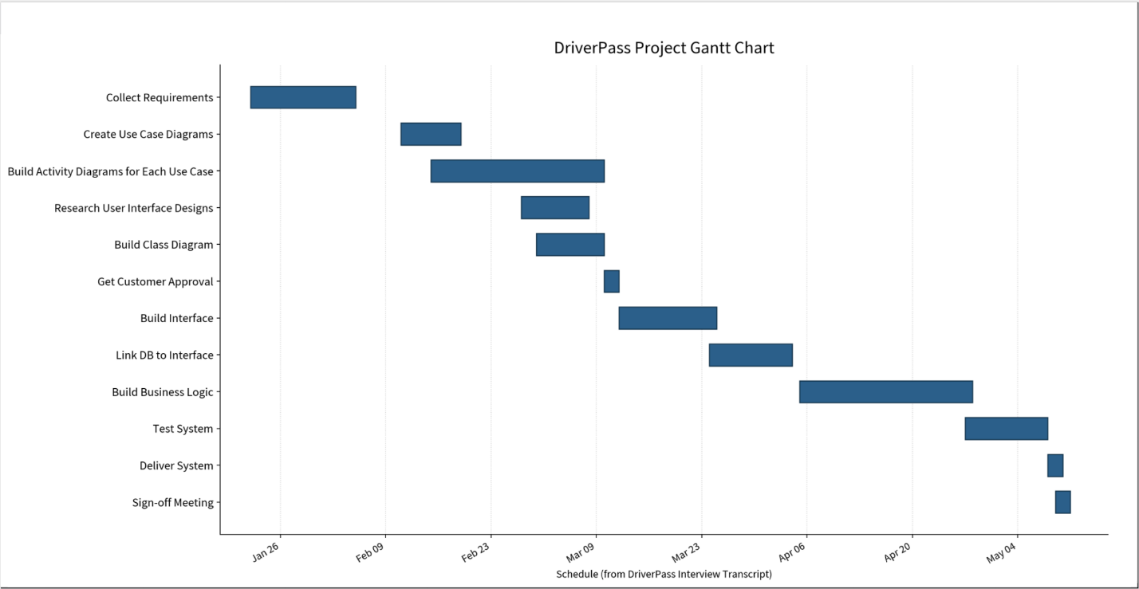
- Schedule source: Sam and Jennifer interview table.
- Build Interface ends 24 Mar; Link DB starts 24 Mar (same-day handoff).
- Test starts when business logic ends on 27 Apr.
I used an AI assistant to organize my notes from the DriverPass interview transcript into this template. I reviewed the transcript, edited the wording, and imported the chart so it reflects the client’s stated needs.

