DriverPass — System Design Document
SNHU CS 255 | Project Two | Lucidchart-export publication edition
Prepared by Rolfe H. Green • 17 October 2026

Design Overview
DriverPass is a browser-based system for administering driving instruction and DMV test preparation. The model covers student enrollment and packages, two-hour driving lessons, staff scheduling, practice tests and progress, user administration, and operational reporting. This review edition consolidates the five coordinated UML diagrams.

Functional Requirements
- Students register, manage profiles, select a training package, and view training progress.
- Students or the secretary request, change, or cancel driving lessons, subject to driver and vehicle availability.
- Drivers record lesson observations and outcomes; staff can access information appropriate to their role.
- Eligible students take online practice tests and review results.
- The IT officer administers accounts and access; the owner reviews reports and audit information.
- DMV rules or test updates are represented as an external information requirement; an automated DMV interface is not assumed without confirmation.

Nonfunctional and Technical Requirements
- Browser-accessible interface for computers, tablets, and smartphones with an internet connection.
- Authentication, role-based access, protected transmission, secure password handling, and audit logging.
- Transactional scheduling to prevent double-booking of drivers and vehicles.
- Persistent database, regular backups, recovery procedures, and appropriate availability monitoring.
- Accessible interface and readable notifications; validation and error handling for enrollment, appointments, and test submissions.
- If payment processing is implemented, use a specialized compliant payment service rather than storing card numbers in DriverPass.

Five UML Diagrams

1. Use Case Diagram
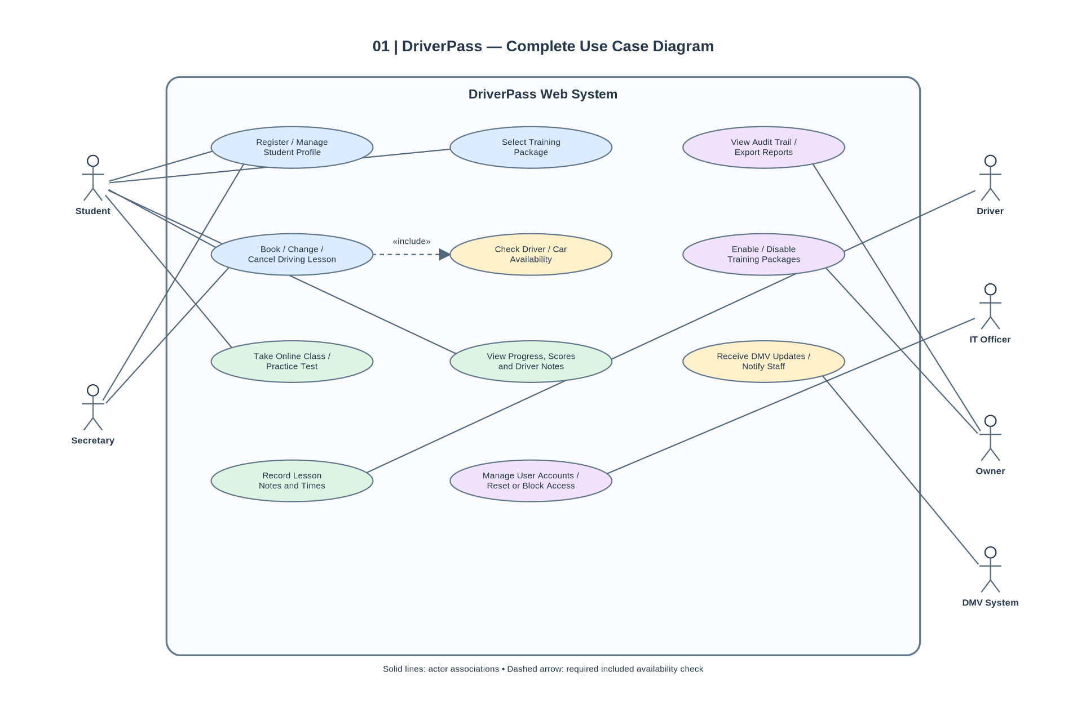
The use case diagram presents the roles and interactions described in the DriverPass interview. Students manage enrollment, packages, lessons, and progress; office staff help schedule; drivers record training outcomes; IT manages accounts; and the owner reviews reports. DMV updates are modeled as an external information interaction, subject to integration confirmation.

2. Activity Diagram — Schedule Driving Lesson
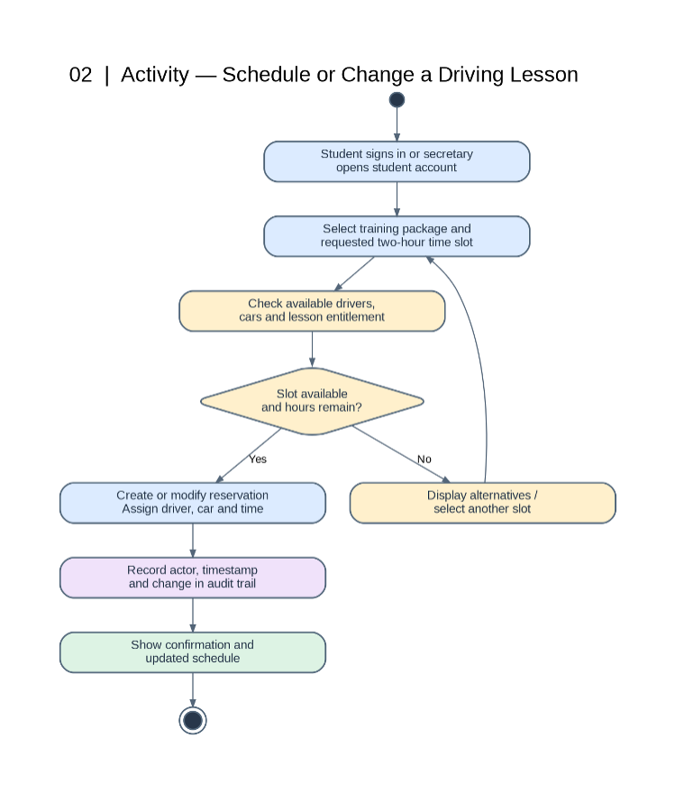
The scheduling activity diagram shows a request to book or change a two-hour lesson. The system checks driver and vehicle availability, handles conflicts by offering alternatives, and confirms a valid appointment. Staff-initiated actions should be recorded for auditability.

3. Activity Diagram — Take Practice Test / View Progress
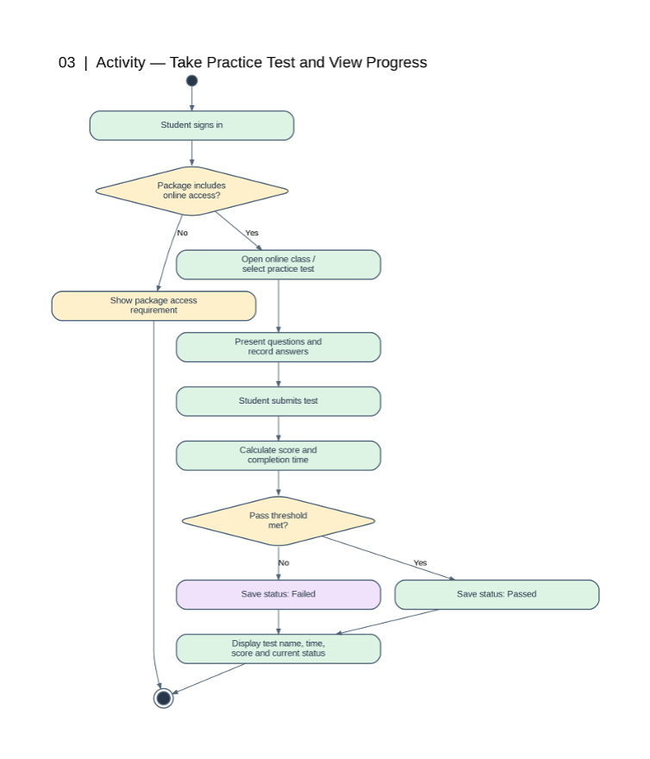
The practice-test activity diagram shows package eligibility, delivery of practice questions, submission and scoring, and student progress visibility. The client indicated that online tests belong to the appropriate training package.

4. Sequence Diagram — Schedule Driving Lesson
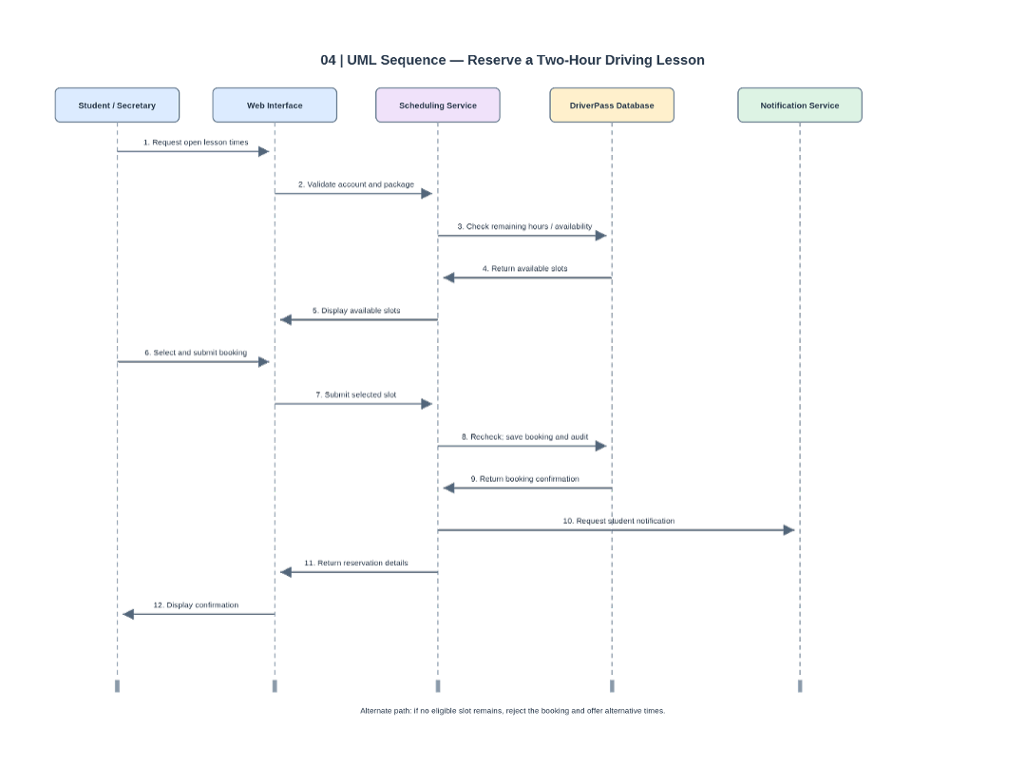
The sequence diagram shows the order of requests and responses during scheduling: a student or secretary requests a time, the application checks availability, records a valid booking, and communicates confirmation or alternatives.

5. Class Diagram — DriverPass Data Model
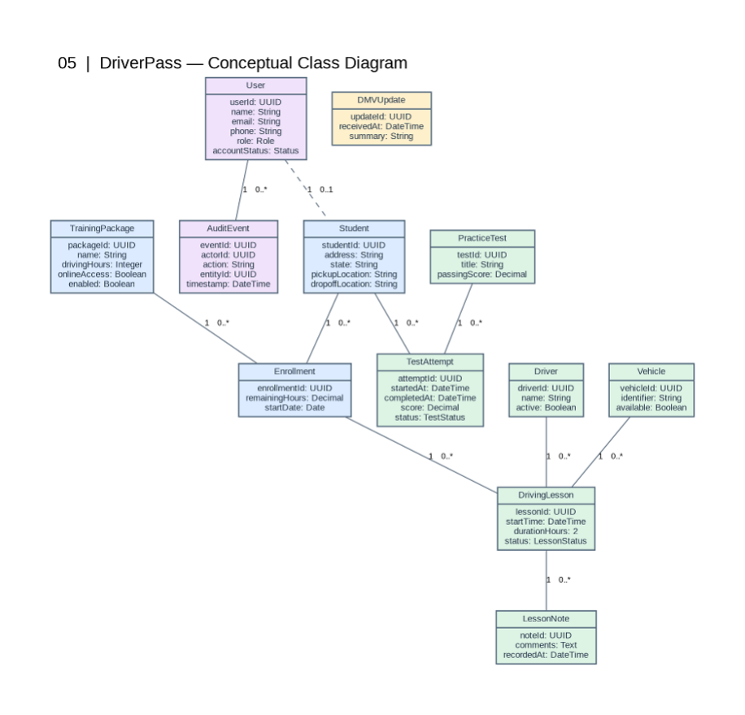
The class diagram identifies the domain entities needed to store students, training packages, enrollments, appointments, drivers, vehicles, test results, and operational records. Associations and multiplicities should be checked against the final implementation requirements.

Design Traceability and Validation
The scheduling use case maps to the scheduling activity and sequence diagrams, and to the appointment, driver, vehicle, and enrollment entities in the class model. The practice-test use case maps to the practice-test activity and test-result entities. Account, report, and audit use cases map to role permissions and stored operational records.
Design verification: Five UML diagrams are included. Class operations are optional under the Project Two directions. The diagrams were developed through manual prototyping, AI-assisted drafting, and Lucidchart import/export.

AI Assistance Acknowledgment
Generative AI (ChatGPT) was used to assist with UML diagram drafting, document organization, editing, and presentation preparation. I reviewed the designs, prototyped UML elements in Lucidchart, imported and exported the diagrams using Lucidchart, and remain responsible for the final submission and its accuracy.

