Quick Guide to Generating a KiCAD Model from 3D STEP Data
Using “kicadStepUpMod” for FreeCAD
2018-04-22-Rev.02
Written by Mark Jones
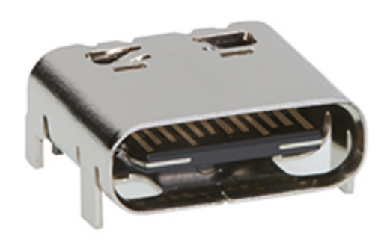
Things you will need:
- KiCAD 4.0.7 or KiCAD 5.0
http://downloads.kicad.org – Windows, Linux, OSX
- FreeCAD v0.17 (stable) or v0.18 daily builds
https://www.freecadweb.org/wiki/Download – Windows, Linux, OSX
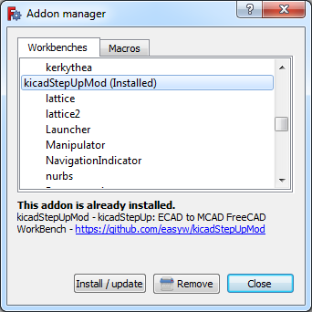
- A 3D .STP model… if you do not already have one, get the Molex USB-C PCB-mount Receptacle 105450-0101
http://www.molex.com/pdm_docs/stp/105450-0101_stp.zip

First things’ first:
- Start FreeCAD and open the Tools → Addon Manager, scroll through the list, pick the “kicadStepUpMod” and “Manipulator” work benches, then click install. A restart of FreeCAD may be needed. If you do not have the Addon manager (FreeCAD 0.16, etc) then see: https://www.freecadweb.org/wiki/
How_to_install_additional_workbenches The kicadStepUpMod is updated regularly; follow changes at https://forum.kicad.info

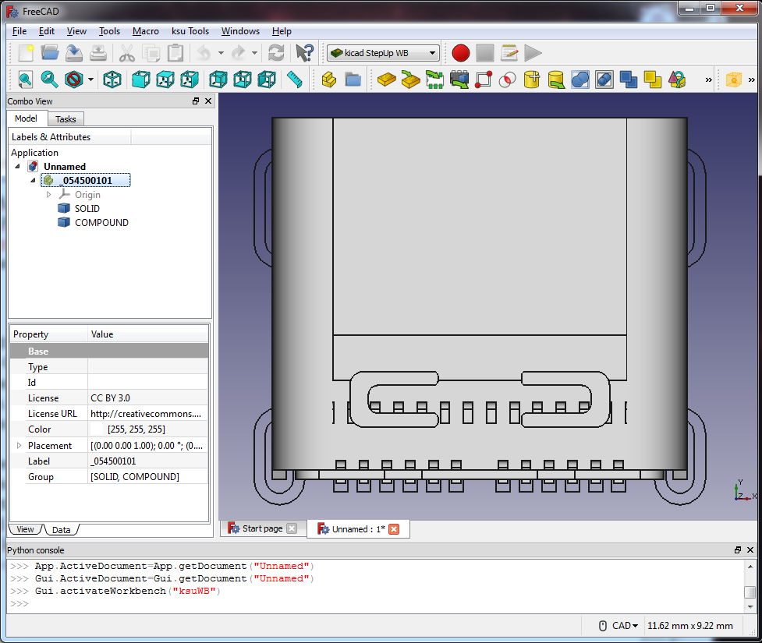


1. Now Open the 10545001001.stp file in FreeCAD.
(check the import option is using the simplified mode )
Notice on the left that SOLID and COMPOUND are listed. These are the PCB footprint and 3D model for this particular component, respectively. Click on each and they will highlight in green so it is easy to tell which is which.

To edit these without fear of changing the original file, we will create copies. To do this, the “kicad StepUp Workbench” must be active. This is the toolbar provided by the kicadStepUpMod add-on. Activate this
by going to View → Workbench → “kicad StepUp WB.” Then you will see the same toolbars as shown here.

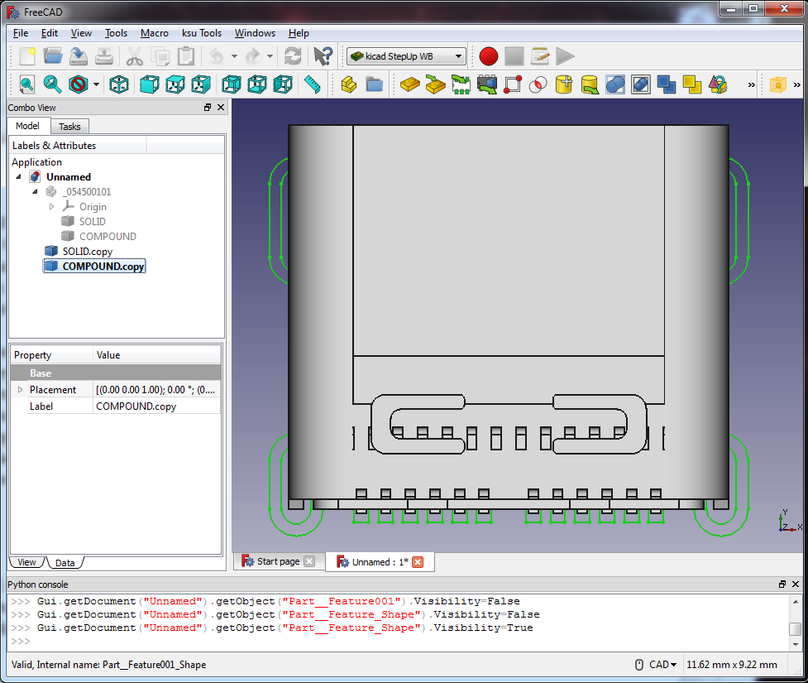

2. With the entire model selected (_054500101, highlighted in blue above) copy the footprint and 3D outline by clicking the yellow “Part DN Copy Object” button. Now these copies are what we will be working with, shown highlighted in blue.


To hide the original objects (greyed out), click them and press the spacebar. We only want to work with copies.
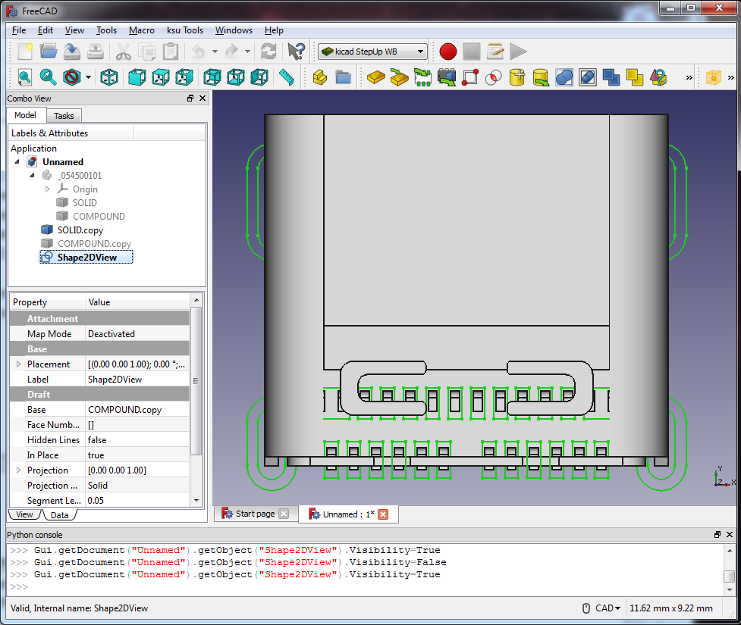
1. Lets first work on the footprint and silk. To convert the COMPOUND.copy (which is really a 3D object) to
a 2D sketch, first make sure the COMPOUND.copy is selected, then press the yellow “3D Object to 2D Projection” button. You should end up with a “Shape2DView” which appears identical.


Also, make sure you are in the top view when doing this (number pad 2) else the projection will be off. A projection isn’t a sketch, but it will be in the next step.

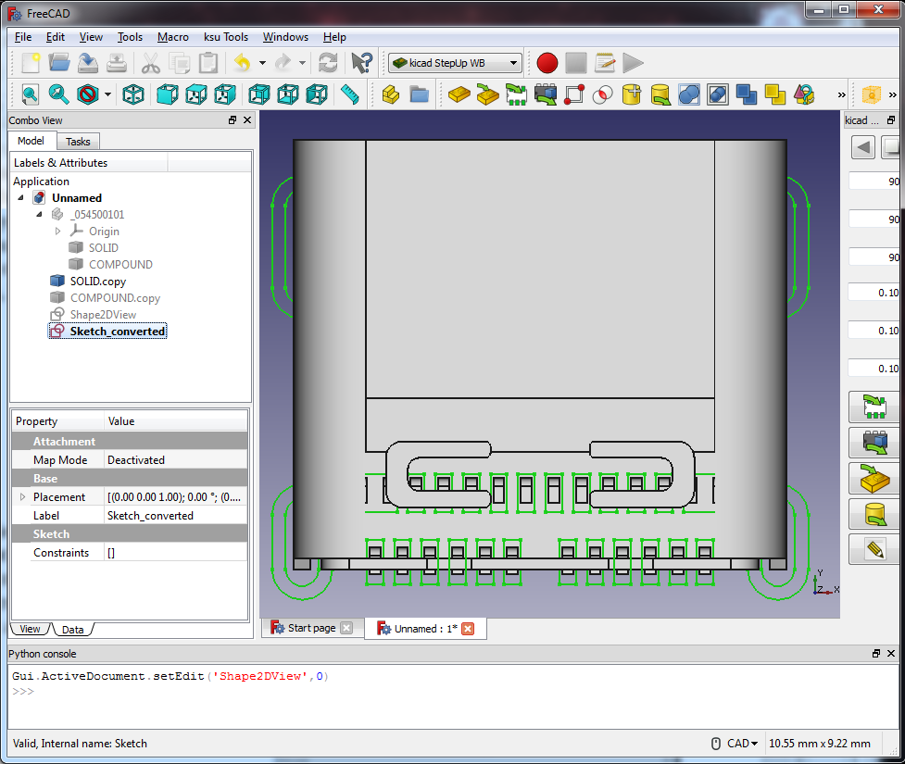
2. With the “Shape2DView” selected, press the grey and red “2D Object to Sketch” button. The very first time this button is pressed, a message may pop up stating a ksu-config.ini file was created. You should open that file and take a look in it as modifications may be needed.

You’ll now have a “Sketch_Converted” entity.

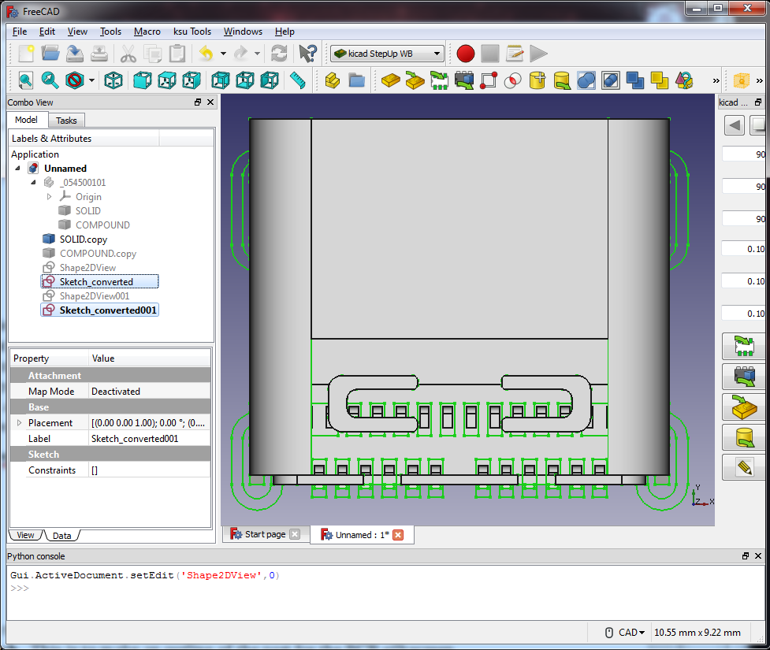
3. Perform the previous two steps on the SOLID.copy – pick it, convert 3D Object to 2D Projection, then 2D Object to Sketch. This is to make an outline of the part for the PCB silkscreen.

You should now have the two sketches highlighted: Sketch_converted (which is the pads) and Sketch_ converted001 (the silk.)

Since these names are rather confusing (and not at all what KiCAD is expecting), next we will use the names from a template as a guide to rename them.

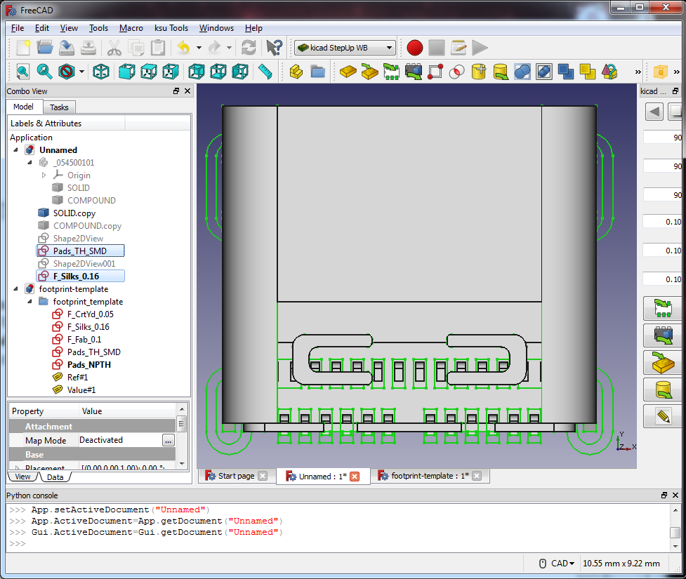
4. From the ksu Tools menu, go to Demo, and click footprint-template.FCStd. This opens another group. Use the names from the template (copy and paste is easiest) to rename our Sketch_converted to Pads_TH_SMD, and Sketch_converted001 to F_Silks_0.16. Of course this may change with a different component.

Use the tabs at the bottom of the 3D view to switch between the active groups.

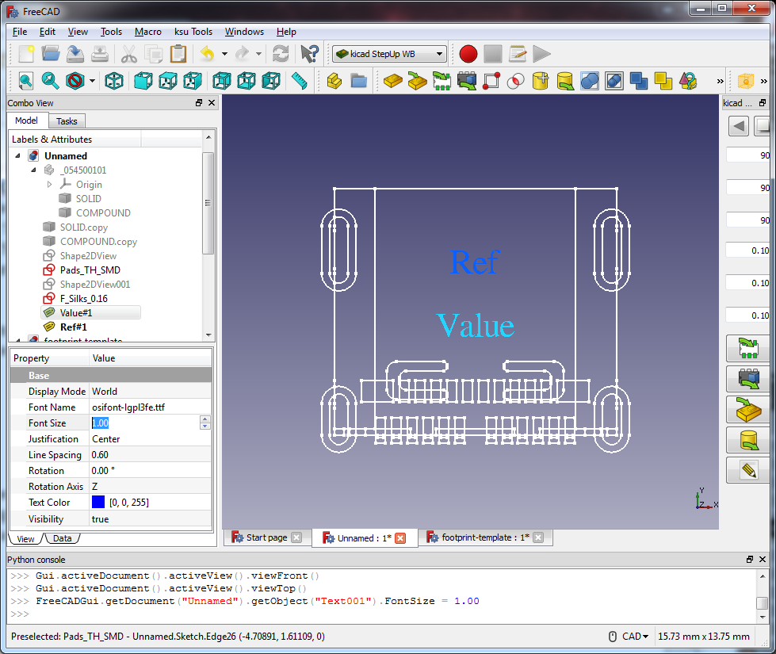
5. KiCAD footprints need a Ref and Value. Copy and paste Ref#1 and Value#1 from the footprint-template into our group.

Now if you zoom out (scrollwheel) in the 3D view, you’ll see the text added. Use the View and Data tabs to change the text size to 1.0 and position as desired.

Here the SOLID.copy was hidden to make the text
more visible.

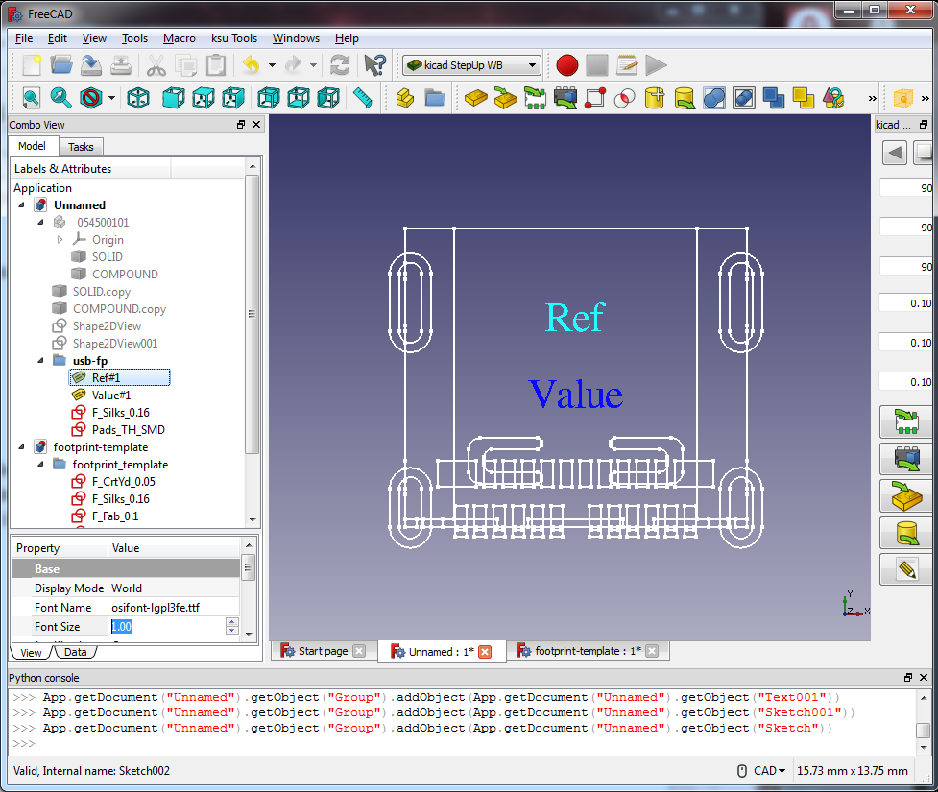

6. Lets organize things better and get the items we want to be part of the footprint in one group. Click the blue folder icon, Create a new Group for Ordering Objects. This will create an empty blue folder in our object tree named Group. Rename this to usb-fp. Now select and drag our four working files into this folder.

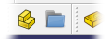

When we export to KiCAD footprint in the next step,
a group is expected, which contains silk, pads, ref, and val.

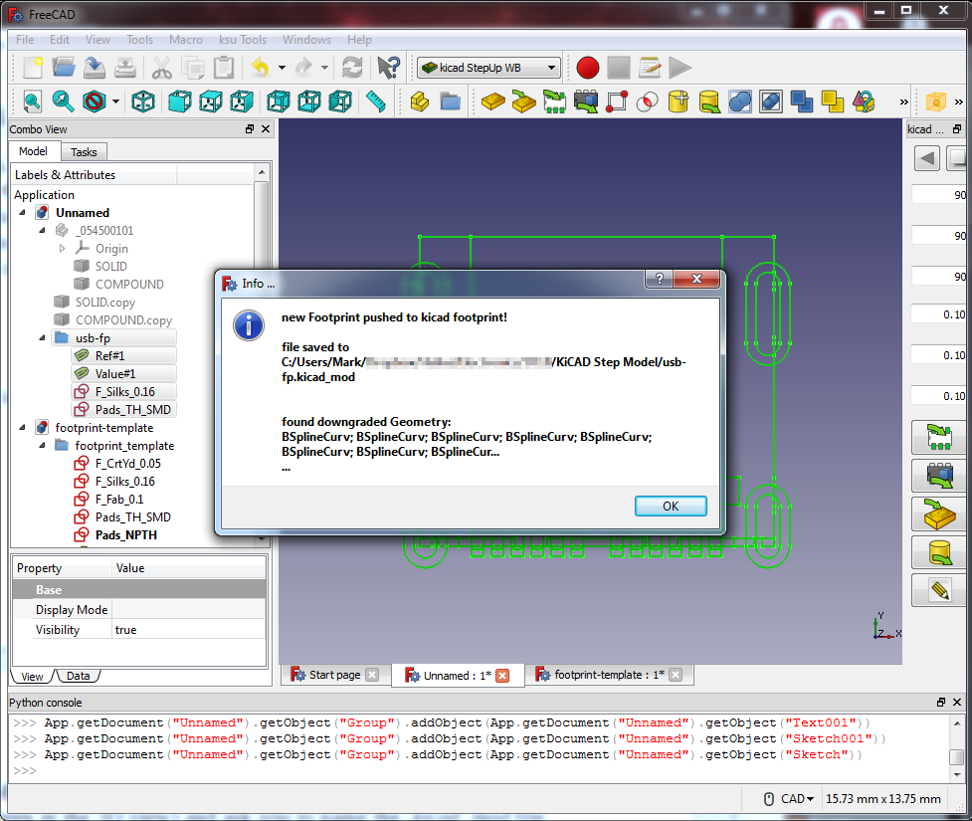
7. With the group name selected (usb-fp), click the Footprint Editor and Export button. It will select
each object in the group (they all turn green in the 3D view) and ask you to name the .kicad_mod file being created. In a split second it should report that the file was saved and a ton of b-splines were converted.

Congratulations, you now have a footprint that can be opened in FreeCAD and the KiCAD Footprint Editor.
You might be tempted to close some of these open objects and templates, but resist that urge! Onto the 3D model.

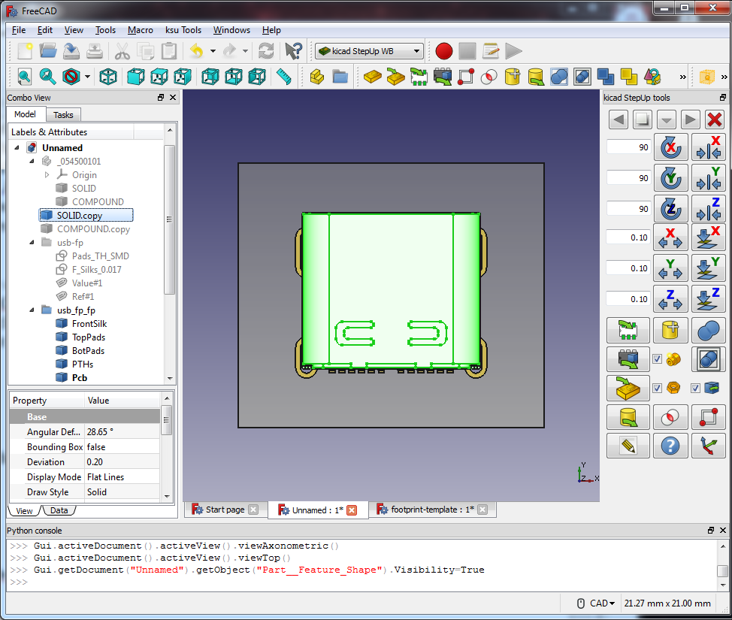
1. The 3D model now – click the Load KiCAD PCB Footprint button and select the footprint file just created.



It will create another group called usb-fp-fp… now hide everything except usb-fp and SOLID.copy. SOLID.copy will be our 3D model. But, there may be some artifacts to clean up first. Generally, when the silk and pads are projected to 2D and a PCB is modeled, there might be a slight Z- alignment issue. We will fix this next. But first, click the Switch Between Workbenches pull-down and select Manipulator-WB. We will use that tool to easily align the items.

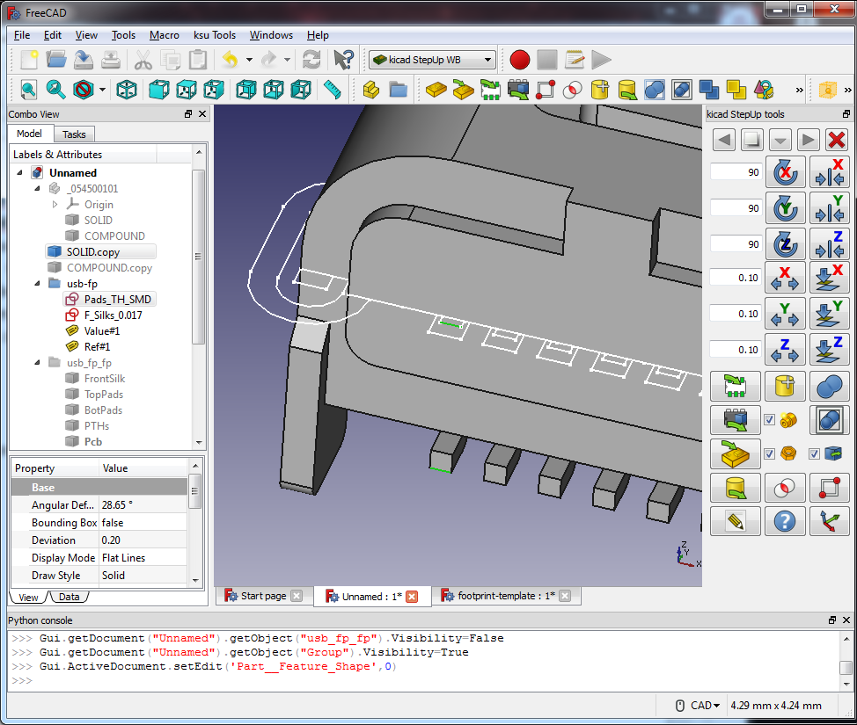

2. Rotate the view (middle-mouse and either button) so that the Z-axis alignment issue is visible. On this particular component, you can see where the bottom of the pin should be touching the pad. Click to select one mating line from the sketch first (the reference), hold CTRL, and click the second from the Model to make two selected lines. The order is important here, as the second item will be made to align with the first item. These are the positions we want to match (in the Z axis) for the part to be properly placed in 3D.

Before you do this would be an excellent time to save your work (as a temporary .FCStd file) because the Aligner tool may not have an un-do feature!
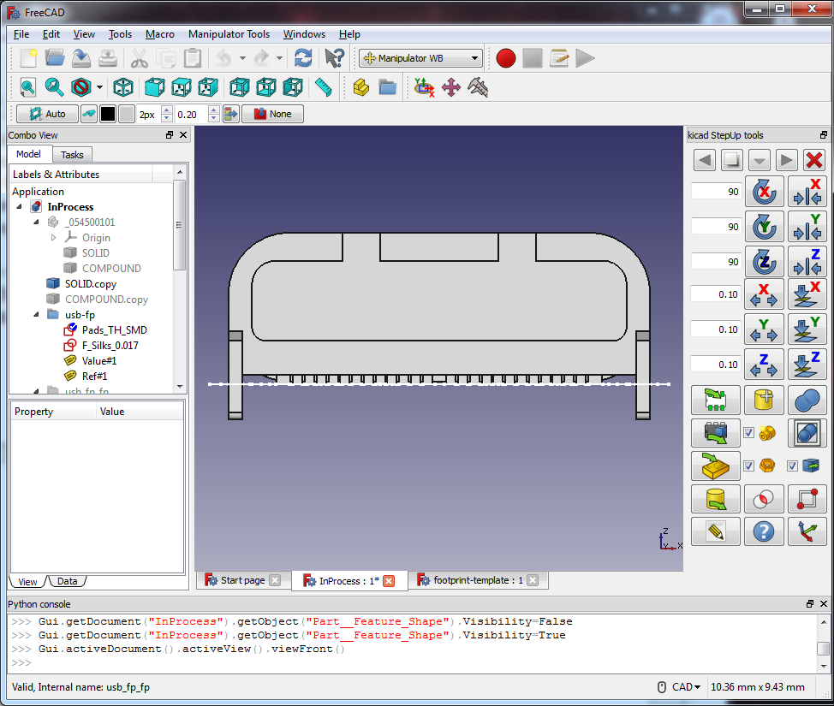
3. If something messes up, re-load your saved version. With a little luck, you should have the sketches (dashed white line) perfectly as the bottom of your pins.

Only two things left to do – rename your SOLID.copy to usb-3D, switch back to the kicad-StepUp WB, and then, with usb-3D selected, press the Export 3D Model to Kicad button. Several choices then appear.

For Mesh Deviation, 0.03 is good for most models. Make this smaller for more detail and larger file size.

Crease Deviation is how abrupt an angle is before it is considered a crease (and not smoothed.)

Material Properties lets you define how this object will render. Since it is mostly metal (we are not modeling the black insert) just pick Metal Grey Pins. This will produce a nice and shiny silver metallic look. Presto, a .wrl file is created! If you aligned things properly, then the KiCAD model scale should be 1,1,1, and the offsets all zeroes. Start the KiCAD footprint editor, import the usb-fp, go to it’s footprint properties, then the 3D settings tab, and add the 3D model.

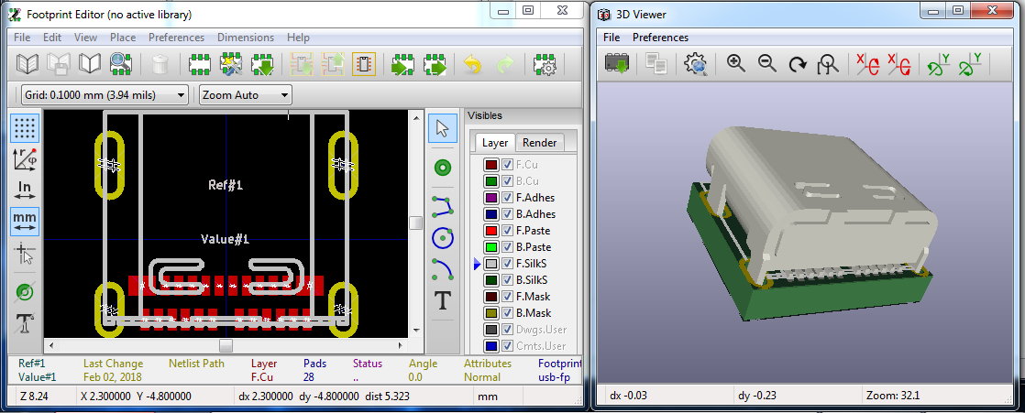

Have fun and happy experimenting!

Notes:
if the manufacturer will not offer footprint outline as STEP model, a DXF or a pdf should be available... then the route is a bit more complex, but similar.

