**Final Project Report: Office of Undergraduate Research (OUR) Summer Undergraduate Research Fellowship (SURF) - Summer 2018**

Fellowship Recipient: Beau Horenberger, Mathematics, University of Idaho

Faculty Mentor: Dr. Jennifer Johnson-Leung, Department of Mathematics, University of Idaho

Project Title: Calculating Siegel Modular Forms

**Abstract:** The aim of this research project was to build a code base for calculating Siegel modular forms of paramodular level N. Siegel modular forms have Fourier expansions in- dexed by binary quadratic forms. Thus, the first step in representing Siegel modular forms is to identify and calculate good representatives for appropriate equivalence classes of these binary quadratic forms. This is the essential problem that was solved in the course of this research. This code base will have practical use for further research in Number Theory, specifically in verifying examples of the paramodular conjecture. The resultant objects also have applications to hyperelliptic curve cryptography. The project will be mentored by Jennifer Johnson-Leung, who will use this computational procedure for further research.

**Project Accomplishments**

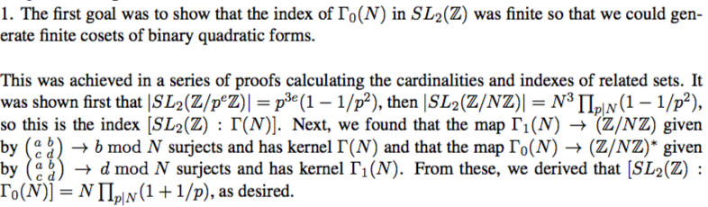

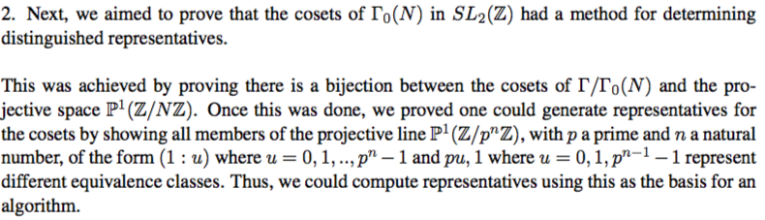

3. The next goal was to implement these proofs in a program which could calculate representatives for binary quadratic forms.

The program was written in C++ to efficiently calculate these representative binary quadratic forms in their matrix form. Additional functions and classes were written to handle math- ematical operations involving matrices, primes, and moduli.

4. Finally, we intend to use this program to calculate the Fourier coefficients for twists of Siegel paramodular forms.

Work has begun on this end, and the program is still under development. Although more work remains to generate and twist coefficients, the analysis of the coefficients already has a code base from the previous goal, making the remaining work minimal. This work will be continued to completion in approximately the next month.

**Summary of Budget Expenditures:**

1. Stipend: $4000

2. Cost for UI Undergraduate Research Symposium Presentation: $75

3. Travel expenses for presenting research at AMS National Meeting in Batimore, MD:

(a) Flight to Baltimore, round trip: $450 (b) Hotel for 3 nights: $225

Total expenses (sans stipend): $750

Both research presentations are in the future, thus the funds have not yet been spent.

**Acknowledgement:**

I would like to sincerely thank the State Board of Education for the wonderful oppor- tunity I was provided through the Summer Undergraduate Research Fellowship. Their contribution absolutely made this eye-opening experience possible for me.