[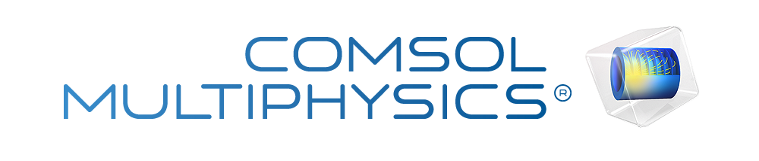](https://www.comsol.com/)

Design

Report date

Sep 12, 2022, 11:38:42 PM

Prepared By: MD. Ether Deowan

[Mdeather0056@gmail.com](mailto:Mdeather0056@gmail.com)

Contents

1. Global Definitions

1.1. Parameters

2. Component 1

2.1. Definitions

2.2. Geometry 1

2.3. Materials

2.4. Solid Mechanics

2.5. Electrostatics

2.6. Electrical Circuit

2.7. Multiphysics

2.8. Mesh 1

3. Frequency Response

3.1. Frequency Domain

4. Load dependence(Resistor)

4.1. Frequency Domain

5. Load dependence(Capacitor)

5.1. Frequency Domain

6. Acceleration dependence

6.1. Frequency Domain

7. Study 6

7.1. Frequency Domain

8. Results

8.1. Datasets

8.2. Tables

8.3. Plot Groups

8.4. Applied Loads (solid)

8.5. Plot Groups

8.6. Applied Loads (solid) 1

8.7. Plot Groups

8.8. Applied Loads (solid) 2

8.9. Plot Groups

1. Global Definitions

|  |  |
| --- | --- |
| Date | Sep 7, 2022, 12:26:43 AM |

Global settings

|  |  |
| --- | --- |
| Name | Design.mph |
| Path | D:\Consaltation\COMSOL Project\File\Design.mph |
| Version | COMSOL Multiphysics 6.0 (Build: 318) |

Used products

|  |
| --- |
| MEMS Module |
| COMSOL Multiphysics |
| CAD Import Module |

Computer information

|  |  |
| --- | --- |
| CPU | Intel64 Family 6 Model 142 Stepping 12, 4 cores |
| Operating system | Windows 10 |

* 1. Parameters

Parameters 1

| **Name** | **Expression** | **Value** | **Description** |
| --- | --- | --- | --- |
| Acceleration | 1[m/(s^2)] | 1 m/s² | Acceleration (g) |
| R_load | 12[kohm] | 12000 Ω | Load resistance |
| w_plate | 14[mm] | 0.014 m | Out of plane dimension |
| Capacitor | 100[uF] | 1E−4 F |  |

1. Component 1
   1. Definitions
      1. Nonlocal Couplings

#### Integration 1

|  |  |
| --- | --- |
| Coupling type | Integration |
| Operator name | intop1 |

Selection

|  |  |
| --- | --- |
| Geometric entity level | Domain |
| Selection | Geometry geom1: Dimension 3: All domains |

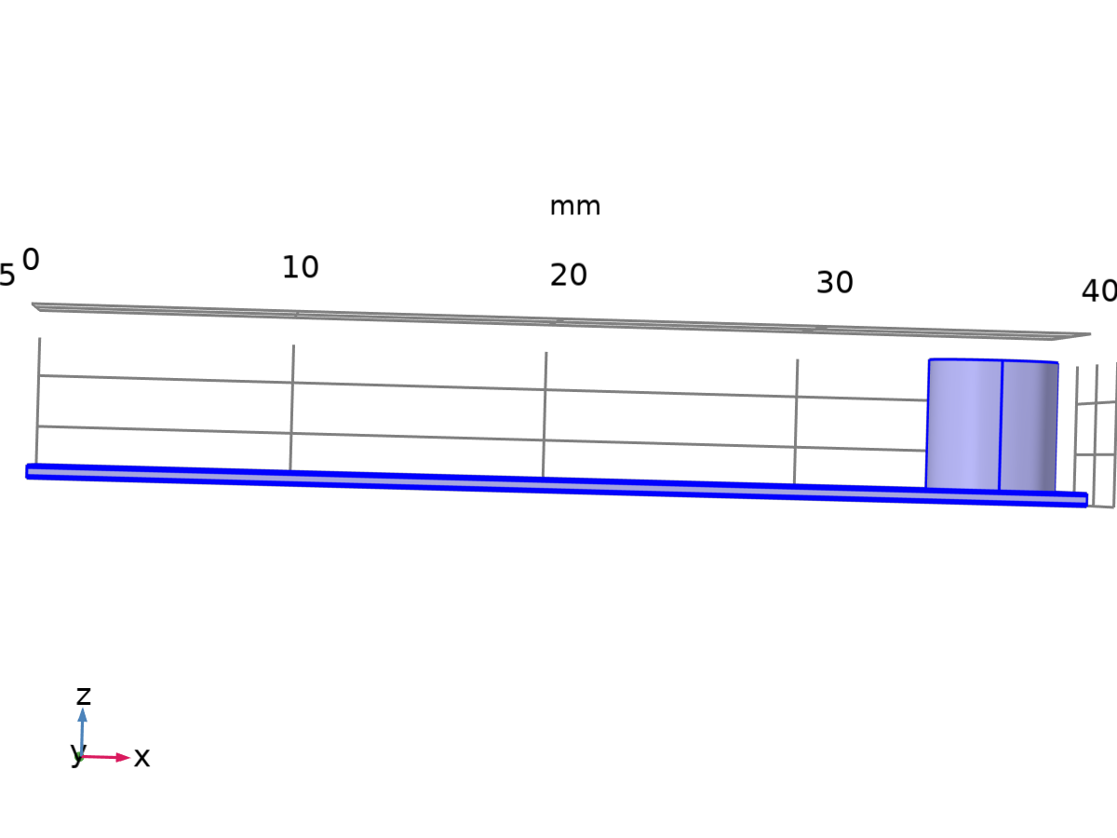

Selection

* + 1. Coordinate Systems

#### Boundary System 1

|  |  |
| --- | --- |
| Coordinate system type | Boundary system |
| Tag | sys1 |

Coordinate names

| **First** | **Second** | **Third** |
| --- | --- | --- |
| t1 | t2 | n |

* 1. Geometry 1

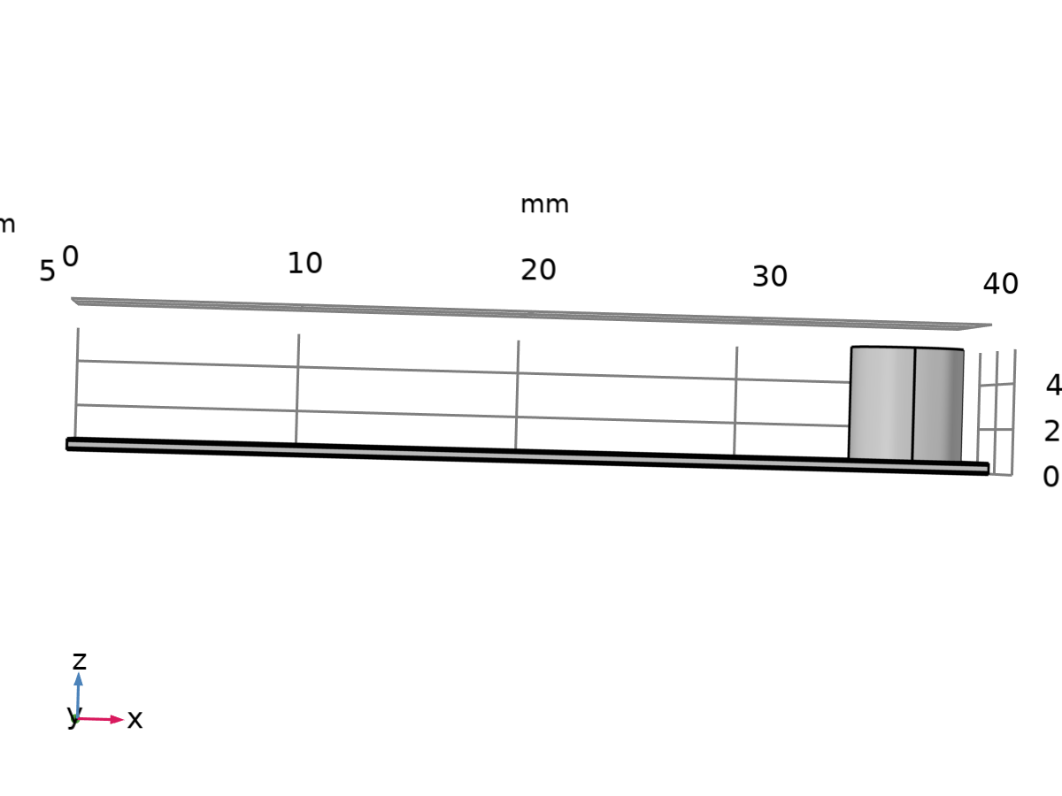

Geometry 1

Units

|  |  |
| --- | --- |
| Length unit | mm |
| Angular unit | deg |

* 1. Materials
     1. Lead Zirconate Titanate (PZT-5H)

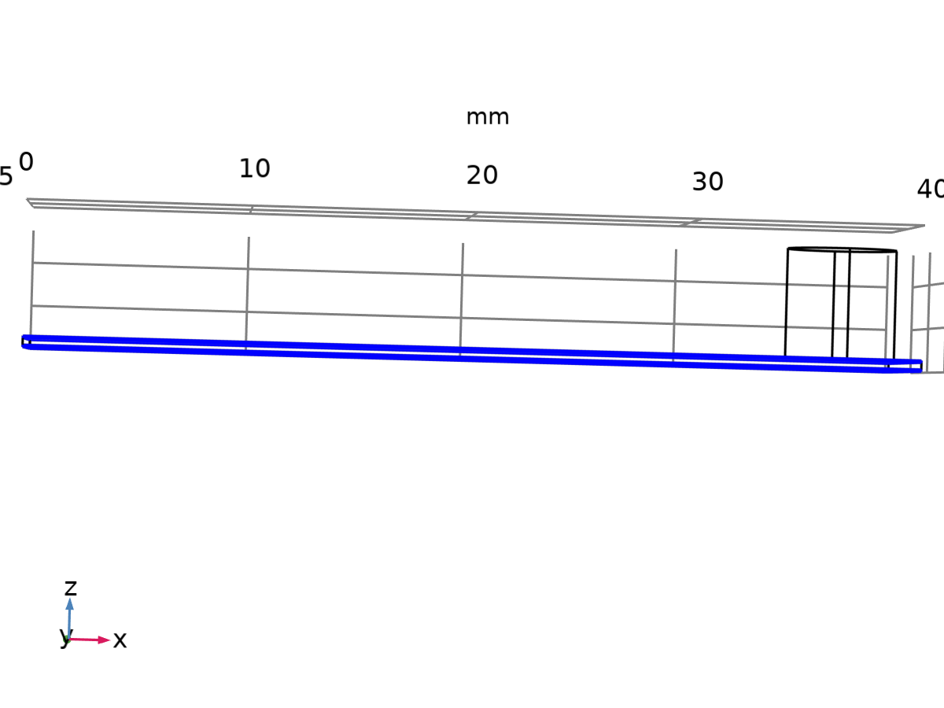

Lead Zirconate Titanate (PZT-5H)

Selection

|  |  |
| --- | --- |
| Geometric entity level | Domain |
| Selection | Geometry geom1: Dimension 3: Domains 1, 3 |

* + 1. Copper [solid,120 nm thin film]

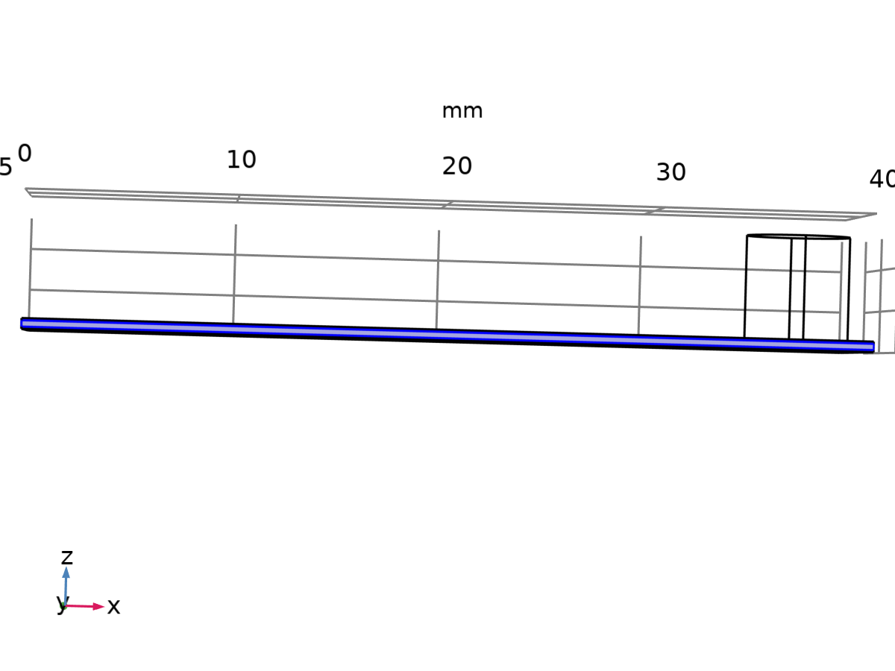

Copper [solid,120 nm thin film]

Selection

|  |  |
| --- | --- |
| Geometric entity level | Domain |
| Selection | Geometry geom1: Dimension 3: Domain 2 |

* + 1. Magnet

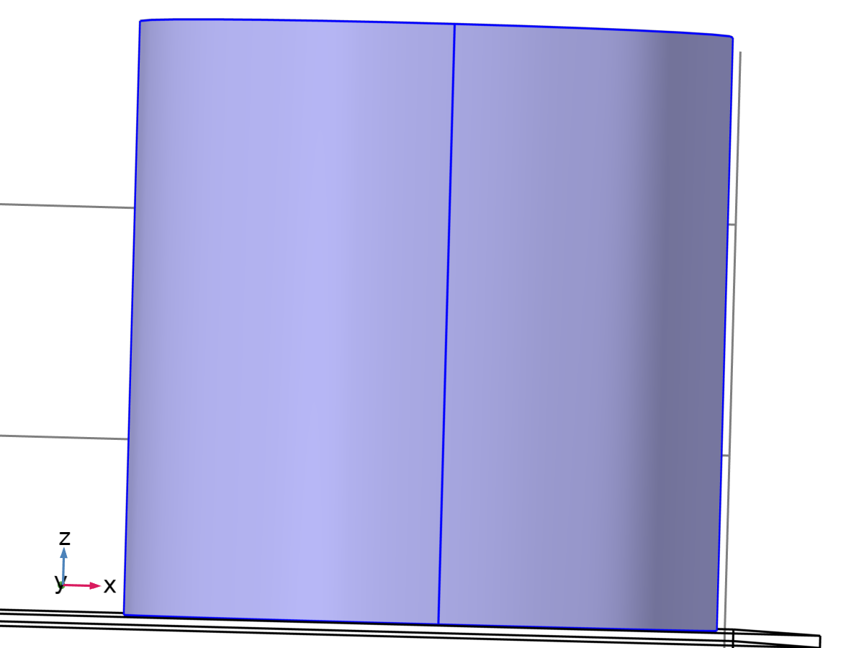

Magnet

Selection

|  |  |
| --- | --- |
| Geometric entity level | Domain |
| Selection | Geometry geom1: Dimension 3: Domain 4 |

* 1. Solid Mechanics



Solid Mechanics

Equations



Features

| **Name** | **Level** |
| --- | --- |
| Linear Elastic Material 1 | Domain |
| Free 1 | Boundary |
| Initial Values 1 | Domain |
| Piezoelectric Material 1 | Domain |
| Fixed Constraint 1 | Boundary |
| Body Load 1 | Domain |

* 1. Electrostatics



Electrostatics

Equations





Features

| **Name** | **Level** |
| --- | --- |
| Charge Conservation 1 | Domain |
| Zero Charge 1 | Boundary |
| Initial Values 1 | Domain |
| Charge Conservation, Piezoelectric 1 | Domain |
| Ground 1 | Boundary |
| Terminal 1 | Boundary |

* 1. Electrical Circuit

Features

|  |
| --- |
| Ground Node 1 |
| Resistor 1 |
| Capacitor 1 |
| External I-terminal 1 |

* 1. Multiphysics
     1. Piezoelectric Effect 1



Piezoelectric Effect 1

* 1. Mesh 1

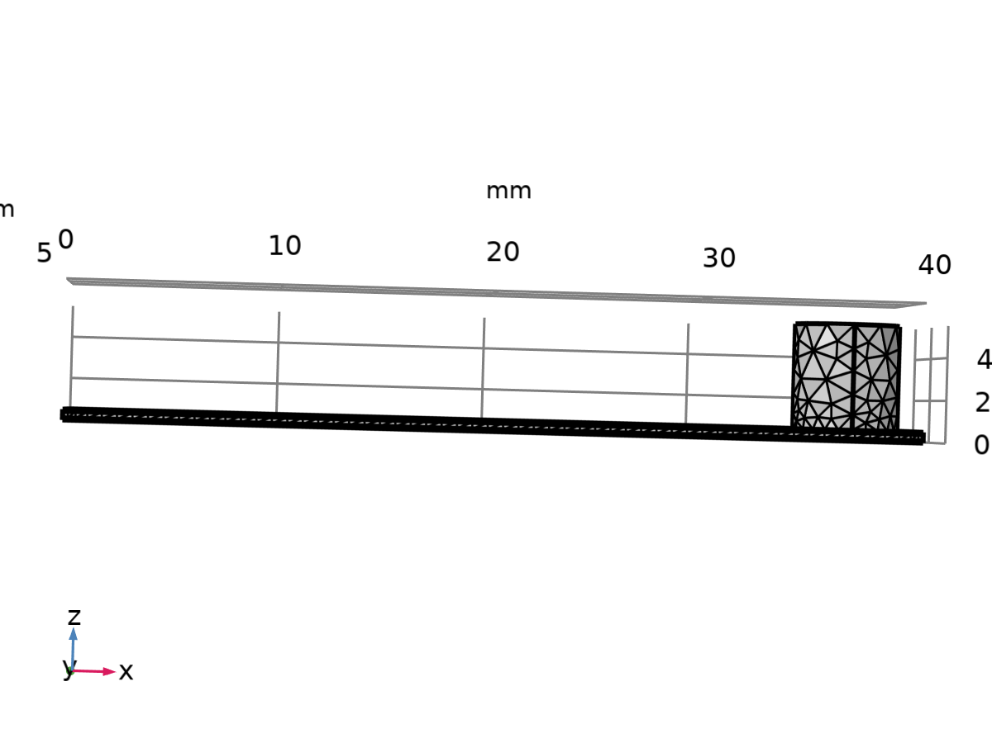

Mesh 1

1. Frequency Response

Computation information

|  |  |
| --- | --- |
| Computation time | 1 min 4 s |

* 1. Frequency Domain

| **Frequencies (Hz)** |
| --- |
| 1,2,3 |

Study settings

| **Description** | **Value** |
| --- | --- |
| Include geometric nonlinearity | Off |

Settings

| **Description** | **Value** |
| --- | --- |
| Frequencies | {1, 2, 3} |

Physics and variables selection

| **Physics interface** | **Discretization** |
| --- | --- |
| Solid Mechanics (solid) | physics |
| Electrostatics (es) | physics |
| Electrical Circuit (cir) | physics |

Mesh selection

| **Geometry** | **Mesh** |
| --- | --- |
| Geometry 1 (geom1) | mesh1 |

1. Load dependence(Resistor)

Computation information

|  |  |
| --- | --- |
| Computation time | 30 s |

* 1. Frequency Domain

| **Frequencies (Hz)** |
| --- |
| 3 |

Study settings

| **Description** | **Value** |
| --- | --- |
| Include geometric nonlinearity | Off |

Settings

| **Description** | **Value** |
| --- | --- |
| Frequencies | 3 |

Study extensions

| **Description** | **Value** |
| --- | --- |
| Auxiliary sweep | On |
| Sweep type | Specified combinations |

Parameters

| **Parameter name** | **Parameter value list** | **Parameter unit** |
| --- | --- | --- |
| R_load (Load resistance) | 1,10,range(100,100,1000) | Ω |

Physics and variables selection

| **Physics interface** | **Discretization** |
| --- | --- |
| Solid Mechanics (solid) | physics |
| Electrostatics (es) | physics |
| Electrical Circuit (cir) | physics |

Mesh selection

| **Geometry** | **Mesh** |
| --- | --- |
| Geometry 1 (geom1) | mesh1 |

* + 1. Study extensions

Study extensions

| **Description** | **Value** |
| --- | --- |
| Auxiliary sweep | On |
| Sweep type | Specified combinations |

Parameters

| **Parameter name** | **Parameter value list** | **Parameter unit** |
| --- | --- | --- |
| R_load (Load resistance) | 1,10,range(100,100,1000) | Ω |

1. Load dependence(Capacitor)

Computation information

|  |  |
| --- | --- |
| Computation time | 21 s |

* 1. Frequency Domain

| **Frequencies (Hz)** |
| --- |
| 3 |

Study settings

| **Description** | **Value** |
| --- | --- |
| Include geometric nonlinearity | Off |

Settings

| **Description** | **Value** |
| --- | --- |
| Frequencies | 3 |

Study extensions

| **Description** | **Value** |
| --- | --- |
| Auxiliary sweep | On |
| Sweep type | Specified combinations |

Parameters

| **Parameter name** | **Parameter value list** | **Parameter unit** |
| --- | --- | --- |
| Capacitor | 47,100,680,1000,2000,4700 | uF |

Physics and variables selection

| **Physics interface** | **Discretization** |
| --- | --- |
| Solid Mechanics (solid) | physics |
| Electrostatics (es) | physics |
| Electrical Circuit (cir) | physics |

Mesh selection

| **Geometry** | **Mesh** |
| --- | --- |
| Geometry 1 (geom1) | mesh1 |

* + 1. Study extensions

Study extensions

| **Description** | **Value** |
| --- | --- |
| Auxiliary sweep | On |
| Sweep type | Specified combinations |

Parameters

| **Parameter name** | **Parameter value list** | **Parameter unit** |
| --- | --- | --- |
| Capacitor | 47,100,680,1000,2000,4700 | uF |

1. Acceleration dependence

Computation information

|  |  |
| --- | --- |
| Computation time | 21 s |

* 1. Frequency Domain

| **Frequencies (Hz)** |
| --- |
| 3 |

Study settings

| **Description** | **Value** |
| --- | --- |
| Include geometric nonlinearity | Off |

Settings

| **Description** | **Value** |
| --- | --- |
| Frequencies | 3 |

Study extensions

| **Description** | **Value** |
| --- | --- |
| Auxiliary sweep | On |
| Sweep type | Specified combinations |

Parameters

| **Parameter name** | **Parameter value list** | **Parameter unit** |
| --- | --- | --- |
| Acceleration (Acceleration (g)) | range(0.25,0.25,2) | m/s^2 |

Physics and variables selection

| **Physics interface** | **Discretization** |
| --- | --- |
| Solid Mechanics (solid) | physics |
| Electrostatics (es) | physics |
| Electrical Circuit (cir) | physics |

Mesh selection

| **Geometry** | **Mesh** |
| --- | --- |
| Geometry 1 (geom1) | mesh1 |

* + 1. Study extensions

Study extensions

| **Description** | **Value** |
| --- | --- |
| Auxiliary sweep | On |
| Sweep type | Specified combinations |

Parameters

| **Parameter name** | **Parameter value list** | **Parameter unit** |
| --- | --- | --- |
| Acceleration (Acceleration (g)) | range(0.25,0.25,2) | m/s^2 |

1. Study 6

Computation information

|  |  |
| --- | --- |
| Computation time | 1 min 4 s |

* 1. Frequency Domain

| **Frequencies (Hz)** |
| --- |
| 1,2,3 |

Study settings

| **Description** | **Value** |
| --- | --- |
| Include geometric nonlinearity | Off |

Settings

| **Description** | **Value** |
| --- | --- |
| Frequencies | {1, 2, 3} |

Physics and variables selection

| **Physics interface** | **Discretization** |
| --- | --- |
| Solid Mechanics (solid) | physics |
| Electrostatics (es) | physics |
| Electrical Circuit (cir) | physics |

Mesh selection

| **Geometry** | **Mesh** |
| --- | --- |
| Geometry 1 (geom1) | mesh1 |

1. Results
   1. Datasets
      1. Frequency Response/Solution 1

Solution

| **Description** | **Value** |
| --- | --- |
| Solution | Solution 1 |
| Component | Component 1 (comp1) |

Dataset: Frequency Response/Solution 1

* + 1. Load dependence(Resistor)/Solution 2

Solution

| **Description** | **Value** |
| --- | --- |
| Solution | Solution 2 |
| Component | Component 1 (comp1) |

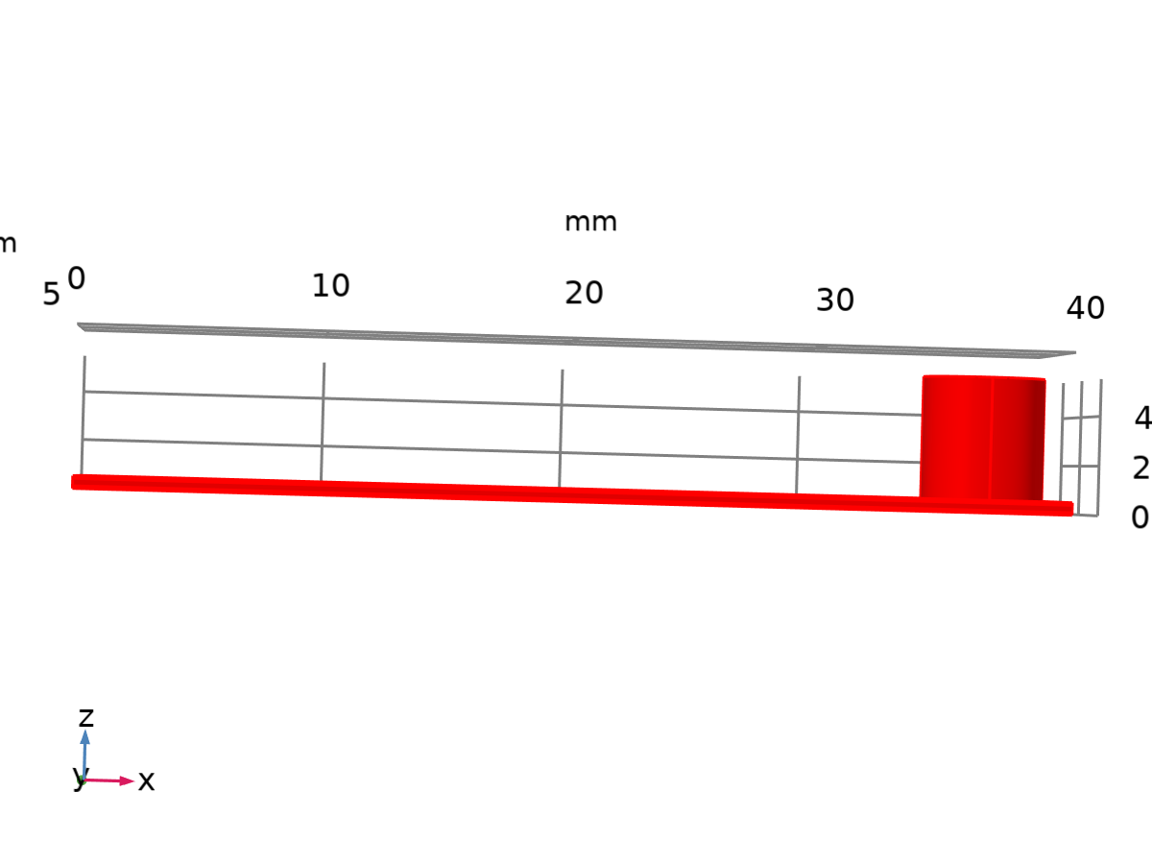

Dataset: Load dependence(Resistor)/Solution 2

* + 1. Load dependence(Capacitor)/Solution 3

Solution

| **Description** | **Value** |
| --- | --- |
| Solution | Solution 3 |
| Component | Component 1 (comp1) |



Dataset: Load dependence(Capacitor)/Solution 3

* + 1. Acceleration dependence/Solution 4

Solution

| **Description** | **Value** |
| --- | --- |
| Solution | Solution 4 |
| Component | Component 1 (comp1) |



Dataset: Acceleration dependence/Solution 4

* + 1. Frequency Response/Solution 1

Solution

| **Description** | **Value** |
| --- | --- |
| Solution | Solution 1 |
| Component | Component 1 (comp1) |

Dataset: Frequency Response/Solution 1

* + 1. Frequency Response/Solution 1

Solution

| **Description** | **Value** |
| --- | --- |
| Solution | Solution 1 |
| Component | Component 1 (comp1) |



Dataset: Frequency Response/Solution 1

* 1. Tables
     1. Evaluation 3D

Interactive 3D values

| **x** | **y** | **z** | **Value** |
| --- | --- | --- | --- |
| 12.235 | 5.0000 | 0.35146 | 0.0000 |
| 33.323 | 3.5190 | 4.9604 | 1.9753E5 |
| 20.515 | 4.0365 | -0.17598 | 1.5891E5 |
| 38.205 | 7.1771 | 4.5218 | 1.0000 |
| 39.345 | 5.8372 | 3.5204 | 1.0000 |

* + 1. Table 1

| **x** | **Voltage** |
| --- | --- |
| 100.00 | 1.3110 |
| 680.00 | 1.3110 |
| 1000.0 | 1.3110 |
| 2000.0 | 1.3110 |
| 4700.0 | 1.3110 |

* + 1. Table 2

| **x** | **Power** |
| --- | --- |
| 100.00 | 0.23235 |
| 680.00 | 0.23235 |
| 2000.0 | 0.23235 |
| 4700.0 | 0.23235 |

* 1. Plot Groups
     1. Stress (solid)

Volume: Von Mises stress, peak (N/m2)

* + 1. Electric Potential (es)

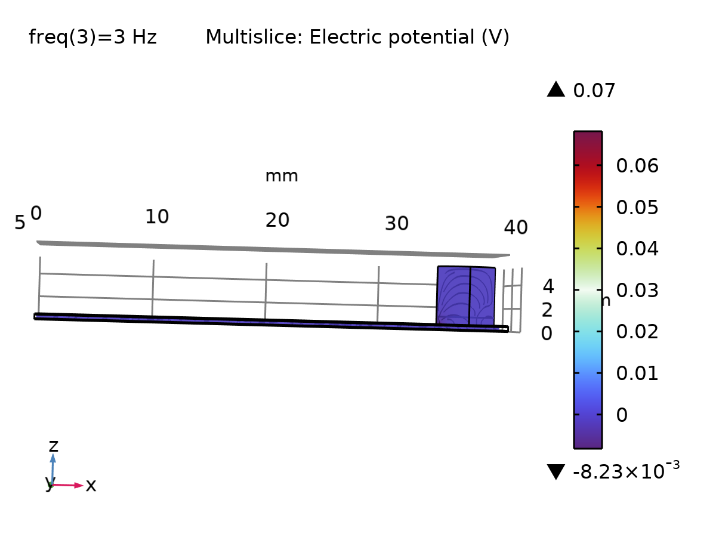

Multislice: Electric potential (V)

* + 1. Electric Field Norm (es)

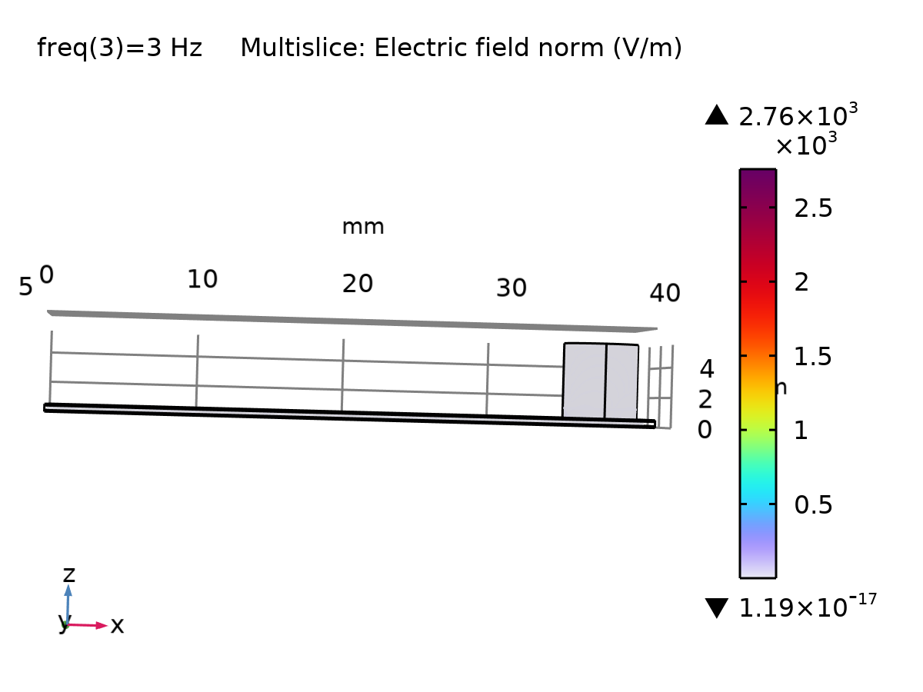

Multislice: Electric field norm (V/m)

* + 1. Voltage Frequency

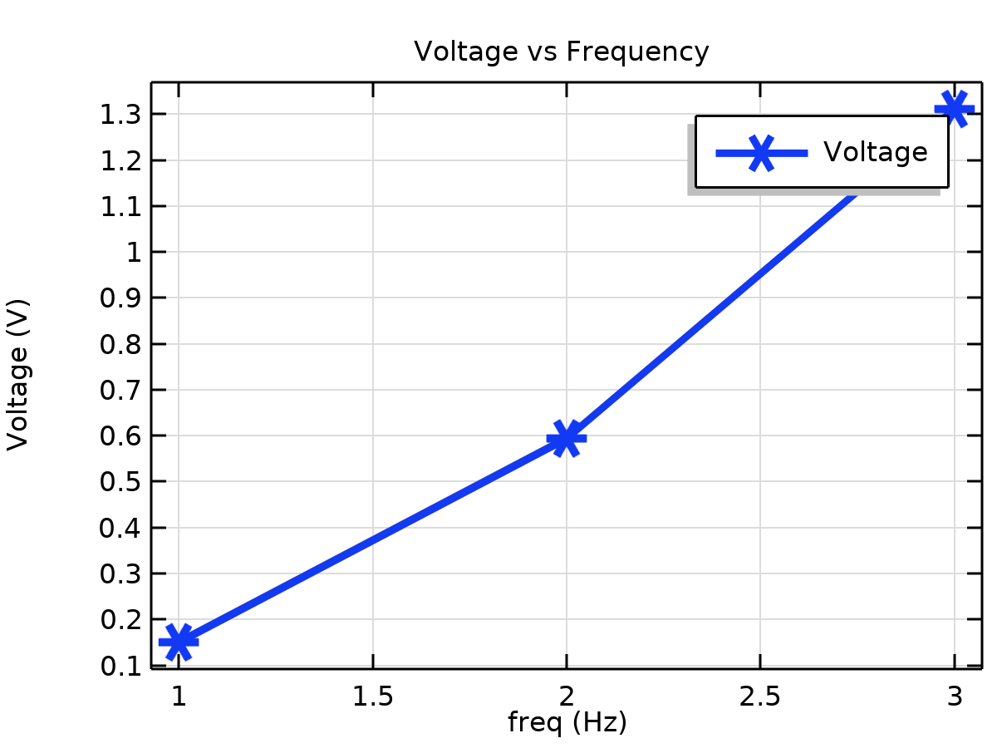

Voltage vs Frequency

* + 1. Load vs Voltage

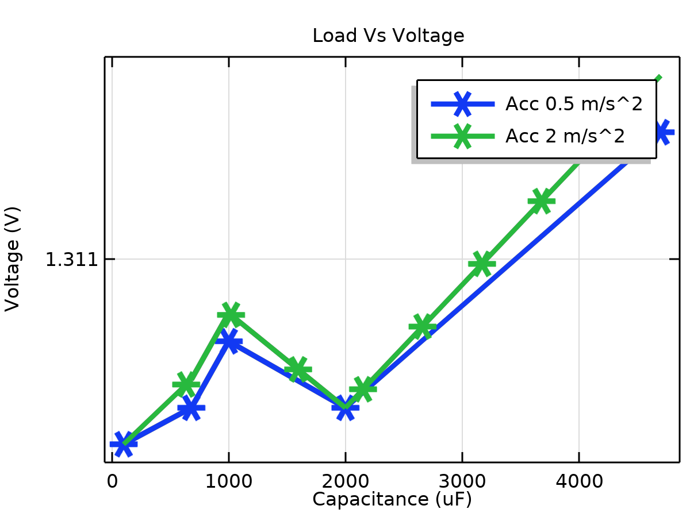

Load Vs Voltage

* + 1. Load vs Power

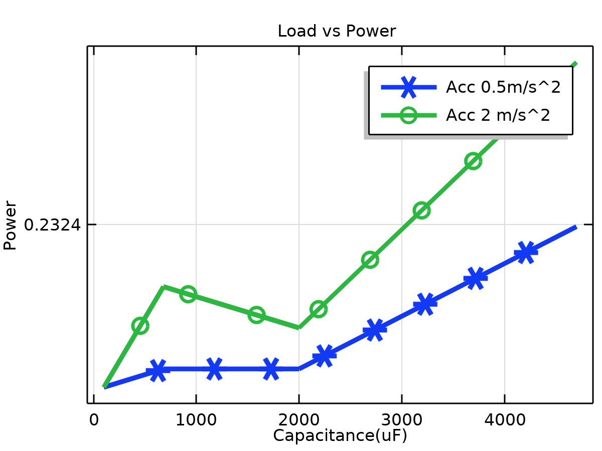

Load vs Power

* + 1. Acceleration vs frequency

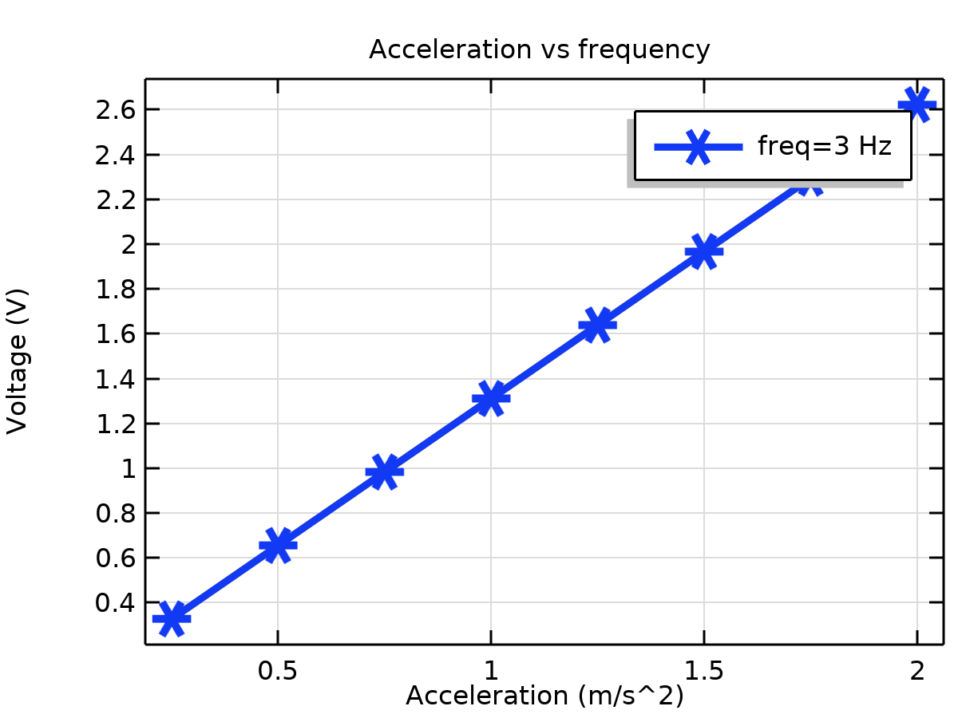

Acceleration vs frequency

* + 1. Stress (solid) 1

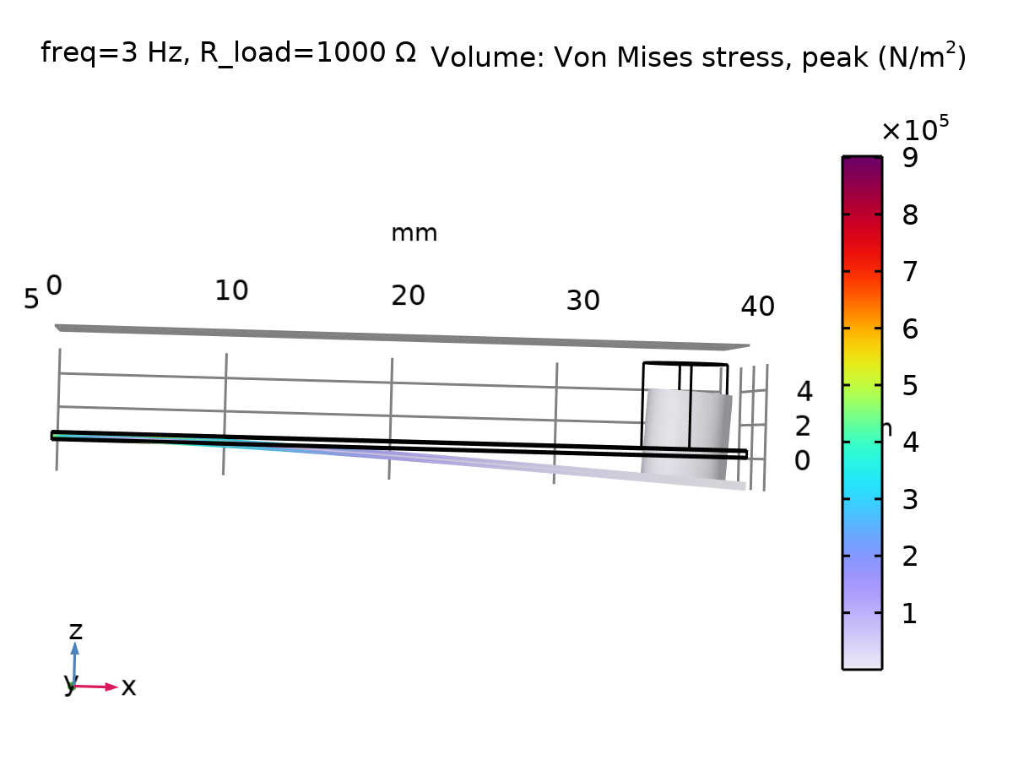

Volume: Von Mises stress, peak (N/m2)

* 1. Applied Loads (solid)
     1. Stress (solid)

Volume: Von Mises stress, peak (N/m2)

* 1. Plot Groups
     1. Electric Potential (es) 1

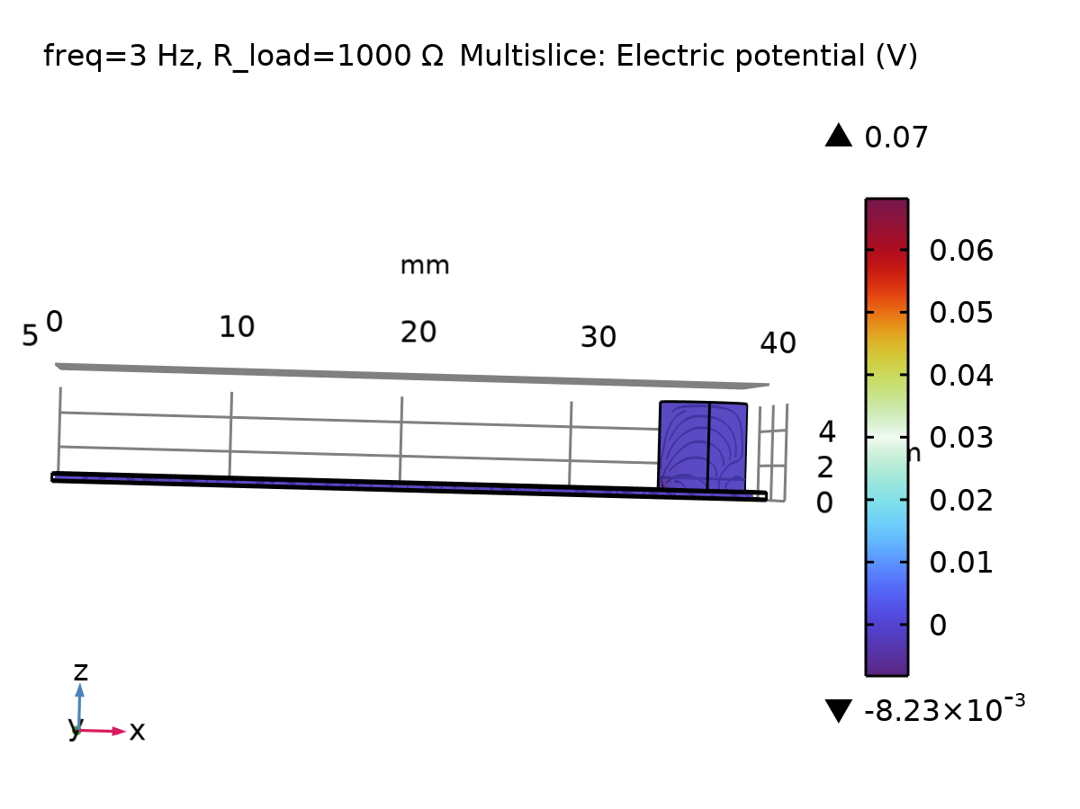

Multislice: Electric potential (V)

* + 1. Electric Field Norm (es) 1

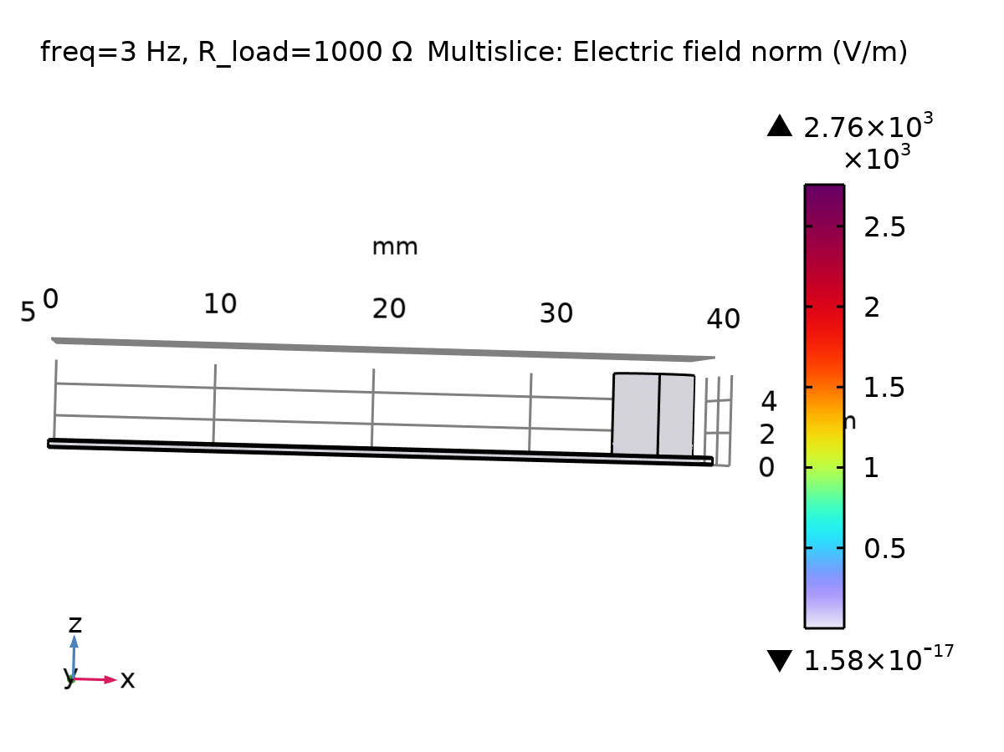

Multislice: Electric field norm (V/m)

* + 1. Stress (solid) 2

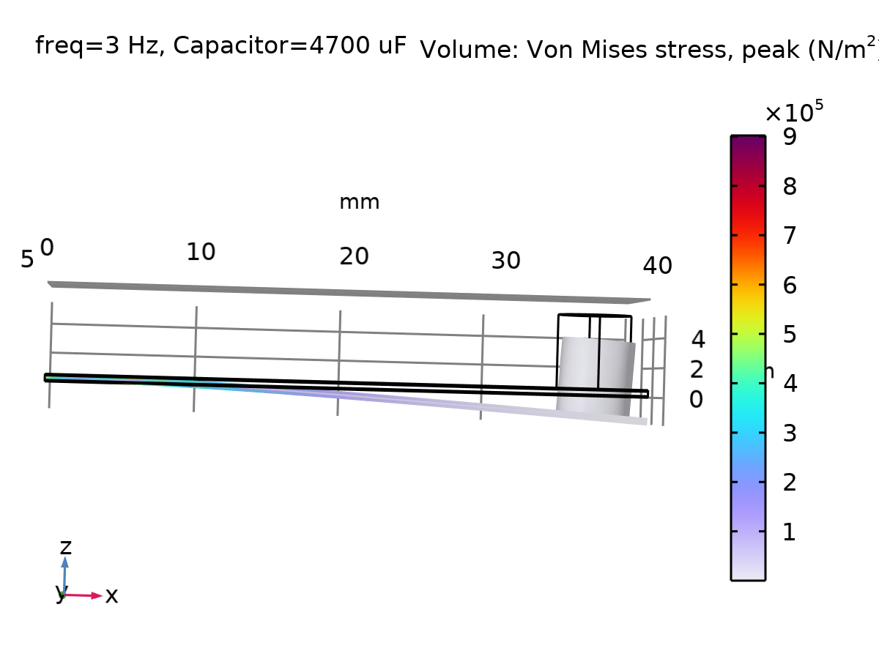

Volume: Von Mises stress, peak (N/m2)

* 1. Applied Loads (solid) 1
     1. Stress (solid)

Volume: Von Mises stress, peak (N/m2)

* 1. Plot Groups
     1. Electric Potential (es) 2

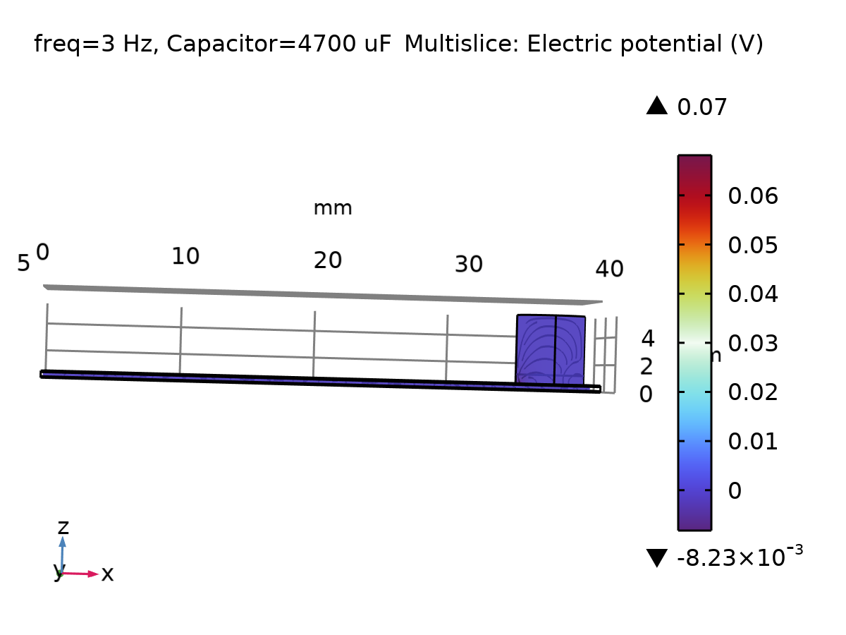

Multislice: Electric potential (V)

* + 1. Electric Field Norm (es) 2

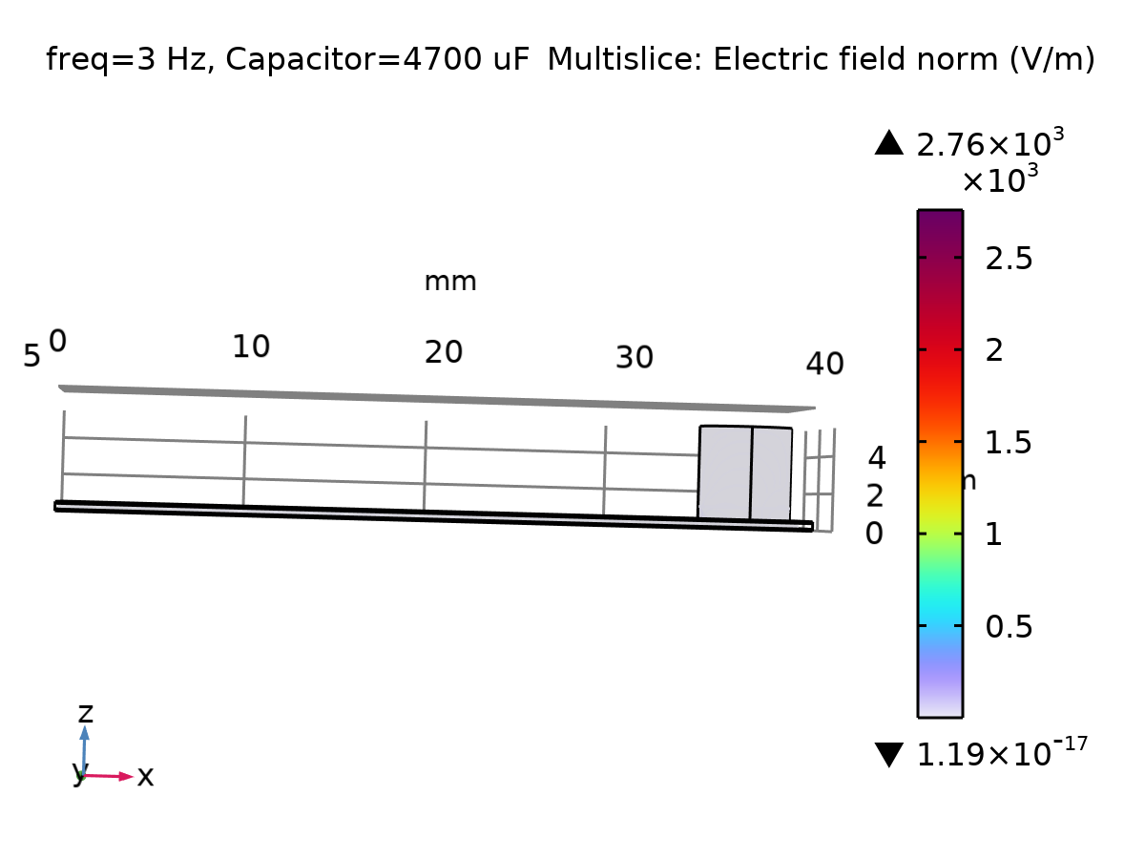

Multislice: Electric field norm (V/m)

* + 1. Stress (solid) 3

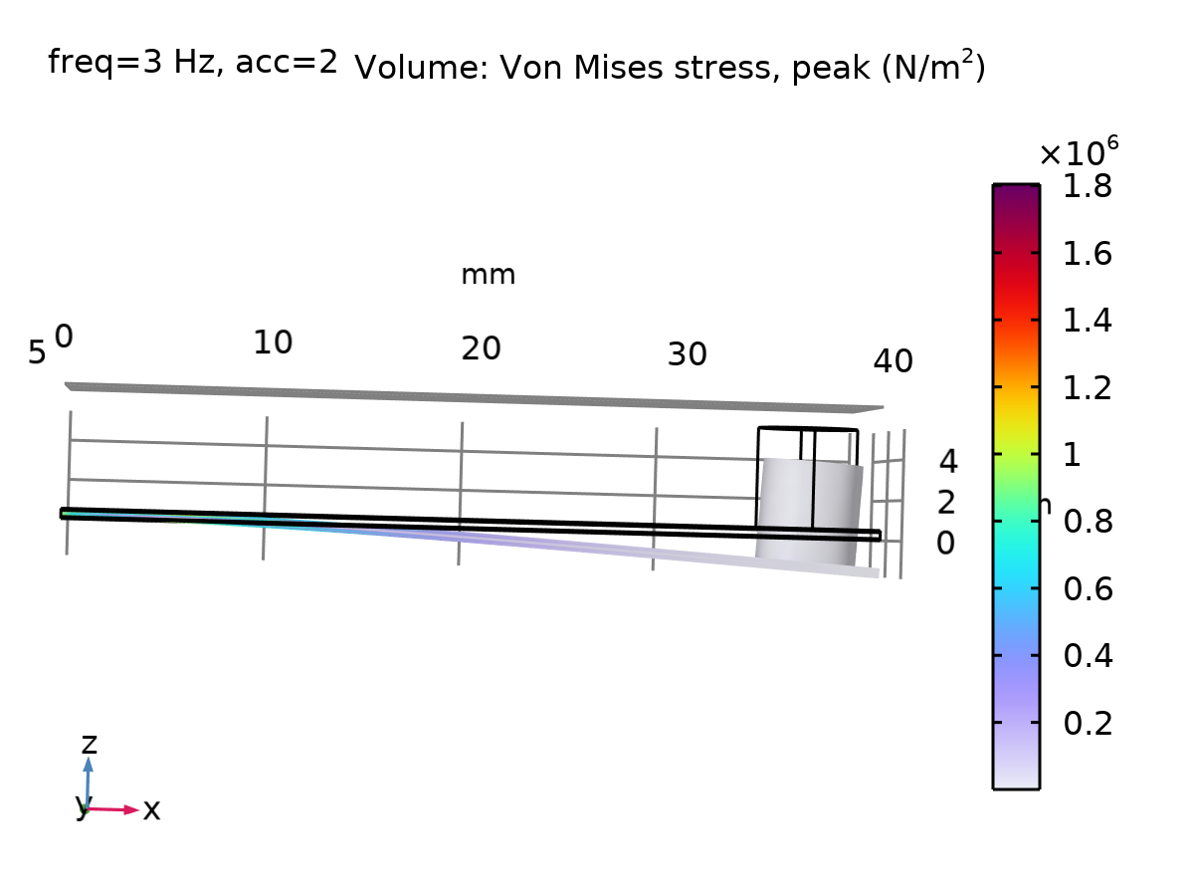

Volume: Von Mises stress, peak (N/m2)

* 1. Applied Loads (solid) 2
     1. Stress (solid)

Volume: Von Mises stress, peak (N/m2)

* 1. Plot Groups
     1. Electric Potential (es) 3

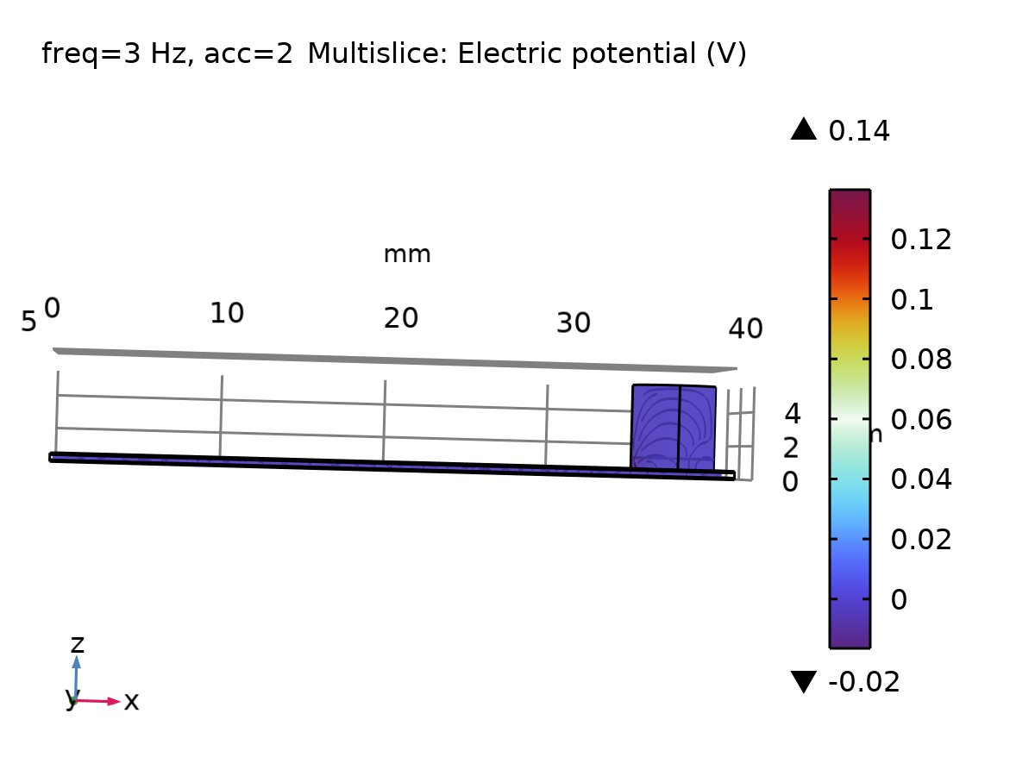

Multislice: Electric potential (V)

* + 1. Electric Field Norm (es) 3

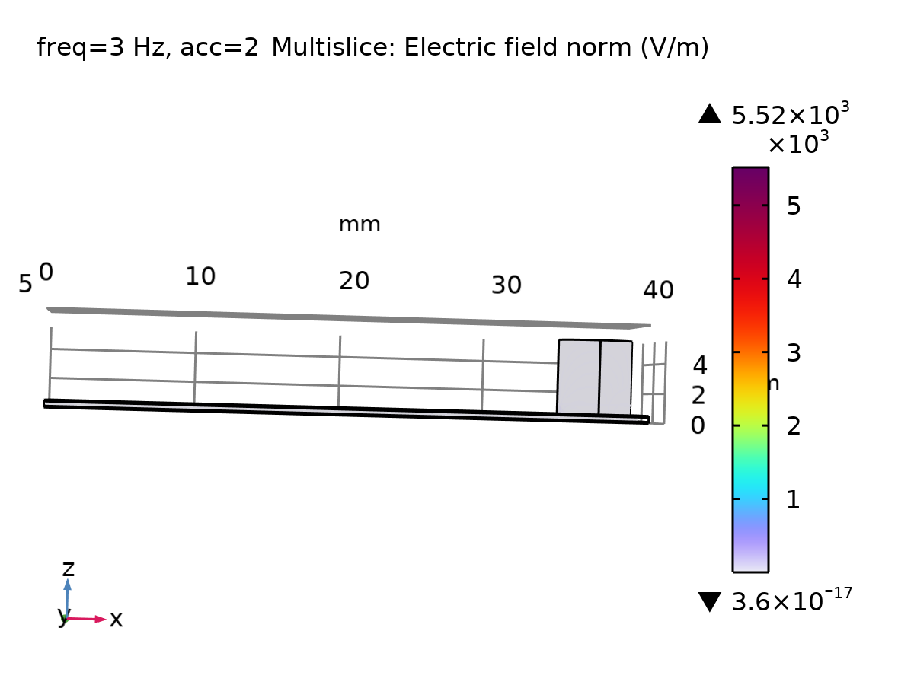

Multislice: Electric field norm (V/m)

* + 1. Stress (solid)

Volume: Von Mises stress, peak (N/m2)

* + 1. Stress (solid)

Volume: Von Mises stress, peak (N/m2)

* + 1. Stress (solid)

Volume: Von Mises stress, peak (N/m2)

* + 1. Stress (solid)

Volume: Von Mises stress, peak (N/m2)

* + 1. Stress (solid)

Volume: Von Mises stress, peak (N/m2)

* + 1. Stress (solid)

Volume: Von Mises stress, peak (N/m2)

* + 1. Stress (solid)

Volume: Von Mises stress, peak (N/m2)

* + 1. Stress (solid)

Volume: Von Mises stress, peak (N/m2)

* + 1. Stress (solid)

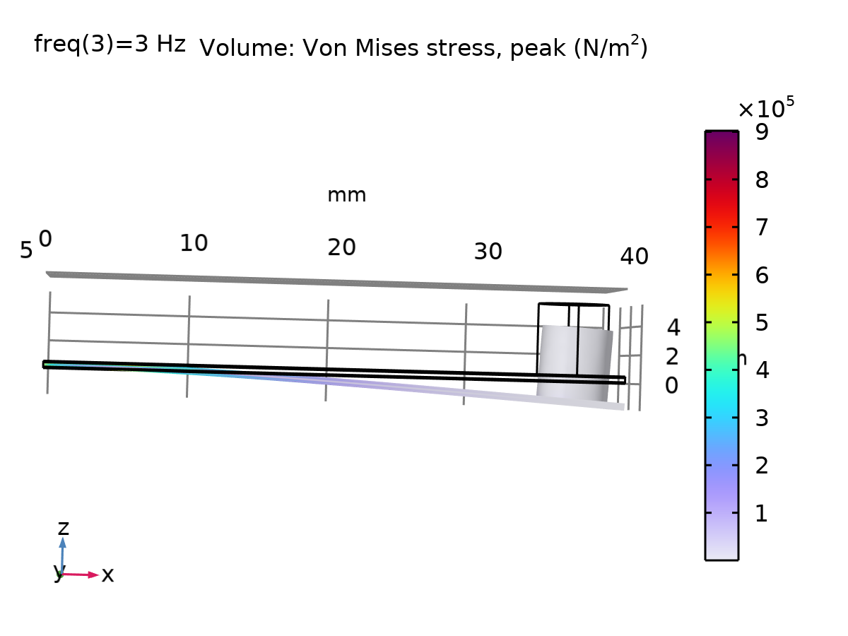

Volume: Von Mises stress, peak (N/m2)