#1-a

> standardized<-function(numbers){

+ numbers<-(numbers- mean(numbers))/sd(numbers)

+ return (numbers)

+ }

> rnorm<-rnorm(n=1000,mean=940,sd=190)

> rnorm_std<-standardized(rnorm)

> plot(density(rnorm_std),col="blue",lwd=2)

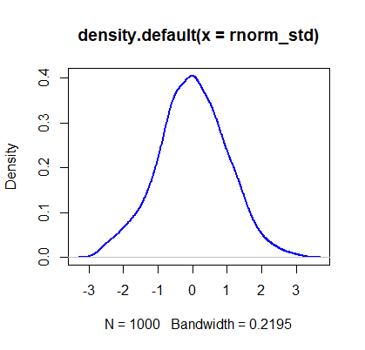

> #1-b

> minday_std<-standardized(minday)

> plot(density(minday_std), col="green", lwd=2)

> mean(minday_std)

[1] -4.25589e-17

> sd(minday_std)

[1] 1

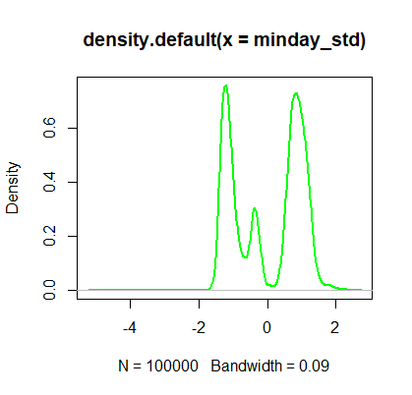

> visualize_sample_ci <- function(num_samples, sample_size, pop_size,mean,sd) {

+ # Simulate a large population

+ population_data <- rnorm(n=pop_size, mean=mean,sd=sd)

+ pop_mean <- mean(population_data)

+ pop_sd <- sd(population_data)

+

+ # Simulate samples

+ samples <- replicate(num_samples,

+ sample(population_data, sample_size, replace=FALSE))

+

+ # Calculate descriptives of samples

+ sample_means = apply(samples, 2, FUN=mean)

+ sample_stdevs = apply(samples, 2, FUN=sd)

+ sample_stderrs <- sample_stdevs/sqrt(sample_size)

+ ci95_low <- sample_means - sample_stderrs*1.96

+ ci95_high <- sample_means + sample_stderrs*1.96

+ ci99_low <- sample_means - sample_stderrs*2.58

+ ci99_high <- sample_means + sample_stderrs*2.58

+

+ # Visualize confidence intervals of all samples

+ plot(NULL, xlim=c(pop_mean-(pop_sd/2), pop_mean+(pop_sd/2)),

+ ylim=c(1,num_samples), ylab="Samples", xlab="Confidence Intervals")

+ add_ci_segment(ci95_low, ci95_high, ci99_low, ci99_high,

+ sample_means, 1:num_samples, good=TRUE)

+

+ # Visualize samples with CIs that don't include population mean

+ bad = which(((ci95_low > pop_mean) | (ci95_high < pop_mean)) |

+ ((ci99_low > pop_mean) | (ci99_high < pop_mean)))

+ add_ci_segment(ci95_low[bad], ci95_high[bad], ci99_low[bad], ci99_high[bad],

+ sample_means[bad], bad, good=FALSE)

+

+ # Draw true population mean

+ abline(v=mean(population_data))

+ }

> add_ci_segment <- function(ci95_low, ci95_high, ci99_low, ci99_high,

+ sample_means, indices, good=TRUE) {

+ segment_colors <- list(c("lightcoral", "coral3", "coral4"),

+ c("lightskyblue", "skyblue3", "skyblue4"))

+ color <- segment_colors[[as.integer(good)+1]]

+

+ segments(ci99_low, indices, ci99_high, indices, lwd=3, col=color[1])

+ segments(ci95_low, indices, ci95_high, indices, lwd=3, col=color[2])

+ points(sample_means, indices, pch=18, cex=0.6, col=color[3])

+ }

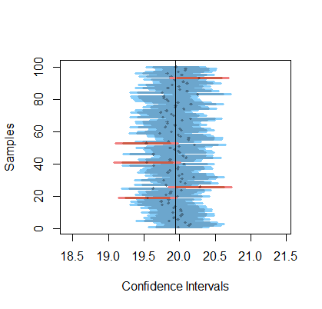

> #2-a

> visualize_sample_ci(num_samples = 100, sample_size = 100, pop_size=10000, distr_func = rnorm)

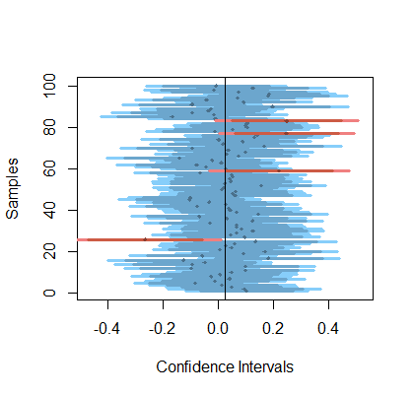

> #2-a-i

We expect 5% of sample not include in the population mean in its 95% CI, that is 5 of 100 will not be included in 95% CI.

> #2-a-ii

We expect 1% of sample not include in the population mean in its 99% CI, that is 1 of 100 will not be included in 95% CI.

> #2-b

> visualize_sample_ci(num_samples = 100, sample_size = 300, pop_size=10000,distr_func = rnorm)

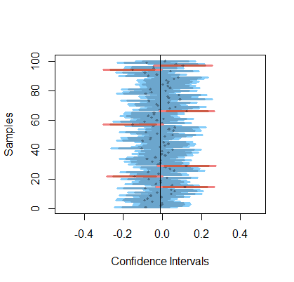

> #2-b-i

Since 95% (99%) CI equal to (sample mean-1.96(2.58) * sample deviation / sqrt(sample size) , sample mean+1.96(2.58) * sample deviation / sqrt(sample size)) .From above, we can see that the width of CI is inversely proportional to sample size.

> #2-b-ii

We expect 5% of sample not include in the population mean in its 95% CI, that is 5 of 100 will not be included in 95% CI.

>#3-a-i

> bookings <- read.table("first_bookings_datetime_sample.txt", header=TRUE)

> bookings$datetime[1:9]

[1] "4/16/2014 17:30" "1/11/2014 20:00" "3/24/2013 12:00"

[4] "8/8/2013 12:00" "2/16/2013 18:00" "5/25/2014 15:00"

[7] "12/18/2013 19:00" "12/23/2012 12:00" "10/18/2013 20:00"

> hours <- as.POSIXlt(bookings$datetime, format="%m/%d/%Y %H:%M")$hour

> mins <- as.POSIXlt(bookings$datetime, format="%m/%d/%Y %H:%M")$min

> minday <- hours*60 + mins

> plot(density(minday), main="Minute (of the day) of first ever booking", col="blue", lwd=2)

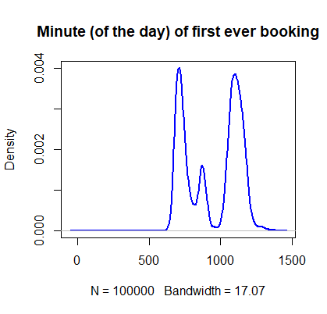

> mean(minday)

[1] 942.4964

> sd(minday)

[1] 189.6631

> interval<-mean(minday)+c(-1.96,1.96)*sd(minday)/sqrt(length(minday))

> interval

[1] 941.3208 943.6719

> #3-a-ii

> minday_size=300

> minday2=sample(minday,minday_size)

> minday_mean=mean(minday)

> resamples<-replicate(2000,sample(minday2 ,length(minday2), replace=TRUE))

> resamples

[,1] [,2] [,3] [,4] [,5] [,6] [,7] [,8] [,9] [,10] [,11] [,12]

[,13] [,14] [,15] [,16] [,17] [,18] [,19] [,20] [,21] [,22]

[,23] [,24] [,25] [,26] [,27] [,28] [,29] [,30] [,31] [,32]

[,33] [,34] [,35] [,36] [,37] [,38] [,39] [,40] [,41] [,42]

[,43] [,44] [,45] [,46] [,47] [,48] [,49] [,50] [,51] [,52]

[,53] [,54] [,55] [,56] [,57] [,58] [,59] [,60] [,61] [,62]

[,63] [,64] [,65] [,66] [,67] [,68] [,69] [,70] [,71] [,72]

[,73] [,74] [,75] [,76] [,77] [,78] [,79] [,80] [,81] [,82]

[,83] [,84] [,85] [,86] [,87] [,88] [,89] [,90] [,91] [,92]

[,93] [,94] [,95] [,96] [,97] [,98] [,99] [,100] [,101] [,102]

[,103] [,104] [,105] [,106] [,107] [,108] [,109] [,110] [,111]

[,112] [,113] [,114] [,115] [,116] [,117] [,118] [,119] [,120]

[,121] [,122] [,123] [,124] [,125] [,126] [,127] [,128] [,129]

[,130] [,131] [,132] [,133] [,134] [,135] [,136] [,137] [,138]

[,139] [,140] [,141] [,142] [,143] [,144] [,145] [,146] [,147]

[,148] [,149] [,150] [,151] [,152] [,153] [,154] [,155] [,156]

[,157] [,158] [,159] [,160] [,161] [,162] [,163] [,164] [,165]

[,166] [,167] [,168] [,169] [,170] [,171] [,172] [,173] [,174]

[,175] [,176] [,177] [,178] [,179] [,180] [,181] [,182] [,183]

[,184] [,185] [,186] [,187] [,188] [,189] [,190] [,191] [,192]

[,193] [,194] [,195] [,196] [,197] [,198] [,199] [,200] [,201]

[,202] [,203] [,204] [,205] [,206] [,207] [,208] [,209] [,210]

[,211] [,212] [,213] [,214] [,215] [,216] [,217] [,218] [,219]

[,220] [,221] [,222] [,223] [,224] [,225] [,226] [,227] [,228]

[,229] [,230] [,231] [,232] [,233] [,234] [,235] [,236] [,237]

[,238] [,239] [,240] [,241] [,242] [,243] [,244] [,245] [,246]

[,247] [,248] [,249] [,250] [,251] [,252] [,253] [,254] [,255]

[,256] [,257] [,258] [,259] [,260] [,261] [,262] [,263] [,264]

[,265] [,266] [,267] [,268] [,269] [,270] [,271] [,272] [,273]

[,274] [,275] [,276] [,277] [,278] [,279] [,280] [,281] [,282]

[,283] [,284] [,285] [,286] [,287] [,288] [,289] [,290] [,291]

[,292] [,293] [,294] [,295] [,296] [,297] [,298] [,299] [,300]

[,301] [,302] [,303] [,304] [,305] [,306] [,307] [,308] [,309]

[,310] [,311] [,312] [,313] [,314] [,315] [,316] [,317] [,318]

[,319] [,320] [,321] [,322] [,323] [,324] [,325] [,326] [,327]

[,328] [,329] [,330] [,331] [,332] [,333] [,334] [,335] [,336]

[,337] [,338] [,339] [,340] [,341] [,342] [,343] [,344] [,345]

[,346] [,347] [,348] [,349] [,350] [,351] [,352] [,353] [,354]

[,355] [,356] [,357] [,358] [,359] [,360] [,361] [,362] [,363]

[,364] [,365] [,366] [,367] [,368] [,369] [,370] [,371] [,372]

[,373] [,374] [,375] [,376] [,377] [,378] [,379] [,380] [,381]

[,382] [,383] [,384] [,385] [,386] [,387] [,388] [,389] [,390]

[,391] [,392] [,393] [,394] [,395] [,396] [,397] [,398] [,399]

[,400] [,401] [,402] [,403] [,404] [,405] [,406] [,407] [,408]

[,409] [,410] [,411] [,412] [,413] [,414] [,415] [,416] [,417]

[,418] [,419] [,420] [,421] [,422] [,423] [,424] [,425] [,426]

[,427] [,428] [,429] [,430] [,431] [,432] [,433] [,434] [,435]

[,436] [,437] [,438] [,439] [,440] [,441] [,442] [,443] [,444]

[,445] [,446] [,447] [,448] [,449] [,450] [,451] [,452] [,453]

[,454] [,455] [,456] [,457] [,458] [,459] [,460] [,461] [,462]

[,463] [,464] [,465] [,466] [,467] [,468] [,469] [,470] [,471]

[,472] [,473] [,474] [,475] [,476] [,477] [,478] [,479] [,480]

[,481] [,482] [,483] [,484] [,485] [,486] [,487] [,488] [,489]

[,490] [,491] [,492] [,493] [,494] [,495] [,496] [,497] [,498]

[,499] [,500] [,501] [,502] [,503] [,504] [,505] [,506] [,507]

[,508] [,509] [,510] [,511] [,512] [,513] [,514] [,515] [,516]

[,517] [,518] [,519] [,520] [,521] [,522] [,523] [,524] [,525]

[,526] [,527] [,528] [,529] [,530] [,531] [,532] [,533] [,534]

[,535] [,536] [,537] [,538] [,539] [,540] [,541] [,542] [,543]

[,544] [,545] [,546] [,547] [,548] [,549] [,550] [,551] [,552]

[,553] [,554] [,555] [,556] [,557] [,558] [,559] [,560] [,561]

[,562] [,563] [,564] [,565] [,566] [,567] [,568] [,569] [,570]

[,571] [,572] [,573] [,574] [,575] [,576] [,577] [,578] [,579]

[,580] [,581] [,582] [,583] [,584] [,585] [,586] [,587] [,588]

[,589] [,590] [,591] [,592] [,593] [,594] [,595] [,596] [,597]

[,598] [,599] [,600] [,601] [,602] [,603] [,604] [,605] [,606]

[,607] [,608] [,609] [,610] [,611] [,612] [,613] [,614] [,615]

[,616] [,617] [,618] [,619] [,620] [,621] [,622] [,623] [,624]

[,625] [,626] [,627] [,628] [,629] [,630] [,631] [,632] [,633]

[,634] [,635] [,636] [,637] [,638] [,639] [,640] [,641] [,642]

[,643] [,644] [,645] [,646] [,647] [,648] [,649] [,650] [,651]

[,652] [,653] [,654] [,655] [,656] [,657] [,658] [,659] [,660]

[,661] [,662] [,663] [,664] [,665] [,666] [,667] [,668] [,669]

[,670] [,671] [,672] [,673] [,674] [,675] [,676] [,677] [,678]

[,679] [,680] [,681] [,682] [,683] [,684] [,685] [,686] [,687]

[,688] [,689] [,690] [,691] [,692] [,693] [,694] [,695] [,696]

[,697] [,698] [,699] [,700] [,701] [,702] [,703] [,704] [,705]

[,706] [,707] [,708] [,709] [,710] [,711] [,712] [,713] [,714]

[,715] [,716] [,717] [,718] [,719] [,720] [,721] [,722] [,723]

[,724] [,725] [,726] [,727] [,728] [,729] [,730] [,731] [,732]

[,733] [,734] [,735] [,736] [,737] [,738] [,739] [,740] [,741]

[,742] [,743] [,744] [,745] [,746] [,747] [,748] [,749] [,750]

[,751] [,752] [,753] [,754] [,755] [,756] [,757] [,758] [,759]

[,760] [,761] [,762] [,763] [,764] [,765] [,766] [,767] [,768]

[,769] [,770] [,771] [,772] [,773] [,774] [,775] [,776] [,777]

[,778] [,779] [,780] [,781] [,782] [,783] [,784] [,785] [,786]

[,787] [,788] [,789] [,790] [,791] [,792] [,793] [,794] [,795]

[,796] [,797] [,798] [,799] [,800] [,801] [,802] [,803] [,804]

[,805] [,806] [,807] [,808] [,809] [,810] [,811] [,812] [,813]

[,814] [,815] [,816] [,817] [,818] [,819] [,820] [,821] [,822]

[,823] [,824] [,825] [,826] [,827] [,828] [,829] [,830] [,831]

[,832] [,833] [,834] [,835] [,836] [,837] [,838] [,839] [,840]

[,841] [,842] [,843] [,844] [,845] [,846] [,847] [,848] [,849]

[,850] [,851] [,852] [,853] [,854] [,855] [,856] [,857] [,858]

[,859] [,860] [,861] [,862] [,863] [,864] [,865] [,866] [,867]

[,868] [,869] [,870] [,871] [,872] [,873] [,874] [,875] [,876]

[,877] [,878] [,879] [,880] [,881] [,882] [,883] [,884] [,885]

[,886] [,887] [,888] [,889] [,890] [,891] [,892] [,893] [,894]

[,895] [,896] [,897] [,898] [,899] [,900] [,901] [,902] [,903]

[,904] [,905] [,906] [,907] [,908] [,909] [,910] [,911] [,912]

[,913] [,914] [,915] [,916] [,917] [,918] [,919] [,920] [,921]

[,922] [,923] [,924] [,925] [,926] [,927] [,928] [,929] [,930]

[,931] [,932] [,933] [,934] [,935] [,936] [,937] [,938] [,939]

[,940] [,941] [,942] [,943] [,944] [,945] [,946] [,947] [,948]

[,949] [,950] [,951] [,952] [,953] [,954] [,955] [,956] [,957]

[,958] [,959] [,960] [,961] [,962] [,963] [,964] [,965] [,966]

[,967] [,968] [,969] [,970] [,971] [,972] [,973] [,974] [,975]

[,976] [,977] [,978] [,979] [,980] [,981] [,982] [,983] [,984]

[,985] [,986] [,987] [,988] [,989] [,990] [,991] [,992] [,993]

[,994] [,995] [,996] [,997] [,998] [,999] [,1000] [,1001]

[,1002] [,1003] [,1004] [,1005] [,1006] [,1007] [,1008] [,1009]

[,1010] [,1011] [,1012] [,1013] [,1014] [,1015] [,1016] [,1017]

[,1018] [,1019] [,1020] [,1021] [,1022] [,1023] [,1024] [,1025]

[,1026] [,1027] [,1028] [,1029] [,1030] [,1031] [,1032] [,1033]

[,1034] [,1035] [,1036] [,1037] [,1038] [,1039] [,1040] [,1041]

[,1042] [,1043] [,1044] [,1045] [,1046] [,1047] [,1048] [,1049]

[,1050] [,1051] [,1052] [,1053] [,1054] [,1055] [,1056] [,1057]

[,1058] [,1059] [,1060] [,1061] [,1062] [,1063] [,1064] [,1065]

[,1066] [,1067] [,1068] [,1069] [,1070] [,1071] [,1072] [,1073]

[,1074] [,1075] [,1076] [,1077] [,1078] [,1079] [,1080] [,1081]

[,1082] [,1083] [,1084] [,1085] [,1086] [,1087] [,1088] [,1089]

[,1090] [,1091] [,1092] [,1093] [,1094] [,1095] [,1096] [,1097]

[,1098] [,1099] [,1100] [,1101] [,1102] [,1103] [,1104] [,1105]

[,1106] [,1107] [,1108] [,1109] [,1110] [,1111] [,1112] [,1113]

[,1114] [,1115] [,1116] [,1117] [,1118] [,1119] [,1120] [,1121]

[,1122] [,1123] [,1124] [,1125] [,1126] [,1127] [,1128] [,1129]

[,1130] [,1131] [,1132] [,1133] [,1134] [,1135] [,1136] [,1137]

[,1138] [,1139] [,1140] [,1141] [,1142] [,1143] [,1144] [,1145]

[,1146] [,1147] [,1148] [,1149] [,1150] [,1151] [,1152] [,1153]

[,1154] [,1155] [,1156] [,1157] [,1158] [,1159] [,1160] [,1161]

[,1162] [,1163] [,1164] [,1165] [,1166] [,1167] [,1168] [,1169]

[,1170] [,1171] [,1172] [,1173] [,1174] [,1175] [,1176] [,1177]

[,1178] [,1179] [,1180] [,1181] [,1182] [,1183] [,1184] [,1185]

[,1186] [,1187] [,1188] [,1189] [,1190] [,1191] [,1192] [,1193]

[,1194] [,1195] [,1196] [,1197] [,1198] [,1199] [,1200] [,1201]

[,1202] [,1203] [,1204] [,1205] [,1206] [,1207] [,1208] [,1209]

[,1210] [,1211] [,1212] [,1213] [,1214] [,1215] [,1216] [,1217]

[,1218] [,1219] [,1220] [,1221] [,1222] [,1223] [,1224] [,1225]

[,1226] [,1227] [,1228] [,1229] [,1230] [,1231] [,1232] [,1233]

[,1234] [,1235] [,1236] [,1237] [,1238] [,1239] [,1240] [,1241]

[,1242] [,1243] [,1244] [,1245] [,1246] [,1247] [,1248] [,1249]

[,1250] [,1251] [,1252] [,1253] [,1254] [,1255] [,1256] [,1257]

[,1258] [,1259] [,1260] [,1261] [,1262] [,1263] [,1264] [,1265]

[,1266] [,1267] [,1268] [,1269] [,1270] [,1271] [,1272] [,1273]

[,1274] [,1275] [,1276] [,1277] [,1278] [,1279] [,1280] [,1281]

[,1282] [,1283] [,1284] [,1285] [,1286] [,1287] [,1288] [,1289]

[,1290] [,1291] [,1292] [,1293] [,1294] [,1295] [,1296] [,1297]

[,1298] [,1299] [,1300] [,1301] [,1302] [,1303] [,1304] [,1305]

[,1306] [,1307] [,1308] [,1309] [,1310] [,1311] [,1312] [,1313]

[,1314] [,1315] [,1316] [,1317] [,1318] [,1319] [,1320] [,1321]

[,1322] [,1323] [,1324] [,1325] [,1326] [,1327] [,1328] [,1329]

[,1330] [,1331] [,1332] [,1333] [,1334] [,1335] [,1336] [,1337]

[,1338] [,1339] [,1340] [,1341] [,1342] [,1343] [,1344] [,1345]

[,1346] [,1347] [,1348] [,1349] [,1350] [,1351] [,1352] [,1353]

[,1354] [,1355] [,1356] [,1357] [,1358] [,1359] [,1360] [,1361]

[,1362] [,1363] [,1364] [,1365] [,1366] [,1367] [,1368] [,1369]

[,1370] [,1371] [,1372] [,1373] [,1374] [,1375] [,1376] [,1377]

[,1378] [,1379] [,1380] [,1381] [,1382] [,1383] [,1384] [,1385]

[,1386] [,1387] [,1388] [,1389] [,1390] [,1391] [,1392] [,1393]

[,1394] [,1395] [,1396] [,1397] [,1398] [,1399] [,1400] [,1401]

[,1402] [,1403] [,1404] [,1405] [,1406] [,1407] [,1408] [,1409]

[,1410] [,1411] [,1412] [,1413] [,1414] [,1415] [,1416] [,1417]

[,1418] [,1419] [,1420] [,1421] [,1422] [,1423] [,1424] [,1425]

[,1426] [,1427] [,1428] [,1429] [,1430] [,1431] [,1432] [,1433]

[,1434] [,1435] [,1436] [,1437] [,1438] [,1439] [,1440] [,1441]

[,1442] [,1443] [,1444] [,1445] [,1446] [,1447] [,1448] [,1449]

[,1450] [,1451] [,1452] [,1453] [,1454] [,1455] [,1456] [,1457]

[,1458] [,1459] [,1460] [,1461] [,1462] [,1463] [,1464] [,1465]

[,1466] [,1467] [,1468] [,1469] [,1470] [,1471] [,1472] [,1473]

[,1474] [,1475] [,1476] [,1477] [,1478] [,1479] [,1480] [,1481]

[,1482] [,1483] [,1484] [,1485] [,1486] [,1487] [,1488] [,1489]

[,1490] [,1491] [,1492] [,1493] [,1494] [,1495] [,1496] [,1497]

[,1498] [,1499] [,1500] [,1501] [,1502] [,1503] [,1504] [,1505]

[,1506] [,1507] [,1508] [,1509] [,1510] [,1511] [,1512] [,1513]

[,1514] [,1515] [,1516] [,1517] [,1518] [,1519] [,1520] [,1521]

[,1522] [,1523] [,1524] [,1525] [,1526] [,1527] [,1528] [,1529]

[,1530] [,1531] [,1532] [,1533] [,1534] [,1535] [,1536] [,1537]

[,1538] [,1539] [,1540] [,1541] [,1542] [,1543] [,1544] [,1545]

[,1546] [,1547] [,1548] [,1549] [,1550] [,1551] [,1552] [,1553]

[,1554] [,1555] [,1556] [,1557] [,1558] [,1559] [,1560] [,1561]

[,1562] [,1563] [,1564] [,1565] [,1566] [,1567] [,1568] [,1569]

[,1570] [,1571] [,1572] [,1573] [,1574] [,1575] [,1576] [,1577]

[,1578] [,1579] [,1580] [,1581] [,1582] [,1583] [,1584] [,1585]

[,1586] [,1587] [,1588] [,1589] [,1590] [,1591] [,1592] [,1593]

[,1594] [,1595] [,1596] [,1597] [,1598] [,1599] [,1600] [,1601]

[,1602] [,1603] [,1604] [,1605] [,1606] [,1607] [,1608] [,1609]

[,1610] [,1611] [,1612] [,1613] [,1614] [,1615] [,1616] [,1617]

[,1618] [,1619] [,1620] [,1621] [,1622] [,1623] [,1624] [,1625]

[,1626] [,1627] [,1628] [,1629] [,1630] [,1631] [,1632] [,1633]

[,1634] [,1635] [,1636] [,1637] [,1638] [,1639] [,1640] [,1641]

[,1642] [,1643] [,1644] [,1645] [,1646] [,1647] [,1648] [,1649]

[,1650] [,1651] [,1652] [,1653] [,1654] [,1655] [,1656] [,1657]

[,1658] [,1659] [,1660] [,1661] [,1662] [,1663] [,1664] [,1665]

[,1666] [,1667] [,1668] [,1669] [,1670] [,1671] [,1672] [,1673]

[,1674] [,1675] [,1676] [,1677] [,1678] [,1679] [,1680] [,1681]

[,1682] [,1683] [,1684] [,1685] [,1686] [,1687] [,1688] [,1689]

[,1690] [,1691] [,1692] [,1693] [,1694] [,1695] [,1696] [,1697]

[,1698] [,1699] [,1700] [,1701] [,1702] [,1703] [,1704] [,1705]

[,1706] [,1707] [,1708] [,1709] [,1710] [,1711] [,1712] [,1713]

[,1714] [,1715] [,1716] [,1717] [,1718] [,1719] [,1720] [,1721]

[,1722] [,1723] [,1724] [,1725] [,1726] [,1727] [,1728] [,1729]

[,1730] [,1731] [,1732] [,1733] [,1734] [,1735] [,1736] [,1737]

[,1738] [,1739] [,1740] [,1741] [,1742] [,1743] [,1744] [,1745]

[,1746] [,1747] [,1748] [,1749] [,1750] [,1751] [,1752] [,1753]

[,1754] [,1755] [,1756] [,1757] [,1758] [,1759] [,1760] [,1761]

[,1762] [,1763] [,1764] [,1765] [,1766] [,1767] [,1768] [,1769]

[,1770] [,1771] [,1772] [,1773] [,1774] [,1775] [,1776] [,1777]

[,1778] [,1779] [,1780] [,1781] [,1782] [,1783] [,1784] [,1785]

[,1786] [,1787] [,1788] [,1789] [,1790] [,1791] [,1792] [,1793]

[,1794] [,1795] [,1796] [,1797] [,1798] [,1799] [,1800] [,1801]

[,1802] [,1803] [,1804] [,1805] [,1806] [,1807] [,1808] [,1809]

[,1810] [,1811] [,1812] [,1813] [,1814] [,1815] [,1816] [,1817]

[,1818] [,1819] [,1820] [,1821] [,1822] [,1823] [,1824] [,1825]

[,1826] [,1827] [,1828] [,1829] [,1830] [,1831] [,1832] [,1833]

[,1834] [,1835] [,1836] [,1837] [,1838] [,1839] [,1840] [,1841]

[,1842] [,1843] [,1844] [,1845] [,1846] [,1847] [,1848] [,1849]

[,1850] [,1851] [,1852] [,1853] [,1854] [,1855] [,1856] [,1857]

[,1858] [,1859] [,1860] [,1861] [,1862] [,1863] [,1864] [,1865]

[,1866] [,1867] [,1868] [,1869] [,1870] [,1871] [,1872] [,1873]

[,1874] [,1875] [,1876] [,1877] [,1878] [,1879] [,1880] [,1881]

[,1882] [,1883] [,1884] [,1885] [,1886] [,1887] [,1888] [,1889]

[,1890] [,1891] [,1892] [,1893] [,1894] [,1895] [,1896] [,1897]

[,1898] [,1899] [,1900] [,1901] [,1902] [,1903] [,1904] [,1905]

[,1906] [,1907] [,1908] [,1909] [,1910] [,1911] [,1912] [,1913]

[,1914] [,1915] [,1916] [,1917] [,1918] [,1919] [,1920] [,1921]

[,1922] [,1923] [,1924] [,1925] [,1926] [,1927] [,1928] [,1929]

[,1930] [,1931] [,1932] [,1933] [,1934] [,1935] [,1936] [,1937]

[,1938] [,1939] [,1940] [,1941] [,1942] [,1943] [,1944] [,1945]

[,1946] [,1947] [,1948] [,1949] [,1950] [,1951] [,1952] [,1953]

[,1954] [,1955] [,1956] [,1957] [,1958] [,1959] [,1960] [,1961]

[,1962] [,1963] [,1964] [,1965] [,1966] [,1967] [,1968] [,1969]

[,1970] [,1971] [,1972] [,1973] [,1974] [,1975] [,1976] [,1977]

[,1978] [,1979] [,1980] [,1981] [,1982] [,1983] [,1984] [,1985]

[,1986] [,1987] [,1988] [,1989] [,1990] [,1991] [,1992] [,1993]

[,1994] [,1995] [,1996] [,1997] [,1998] [,1999] [,2000]

[ reached getOption("max.print") -- omitted 300 rows

> #3-a-iii

> plot(density(minday),lwd=0,ylim=c(0, 0.009), main="population vs. bootstrapped samples")

> plot_resample_density<-function(sample_i) {

+ lines(density(sample_i), col=rgb(0.0, 0.4, 0.0, 0.01))

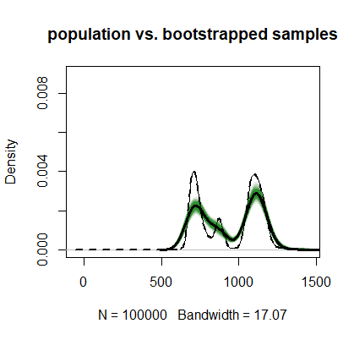+ return(mean(sample_i))

+ }

> sample_means<-apply(resamples, 2, FUN=plot_resample_density)

> lines(density(minday2),lwd=3)

> lines(density(minday),lwd=2,lty="dashed")

> #3-a-iv

> interval<-function(data){

+ return (c(mean(data)-1.96*sd(data),mean(data)+1.96*sd(data)))

+ }

> bootstrap_interval<-sapply(resamples,interval)