**BACS HW - Week 9**

108070023

**Question 1)** Let’s make an automated recommendation system for the PicCollage mobile app.

1. Let’s explore to see if any sticker bundles seem intuitively similar:
   1. ***(recommended)*** Download PicCollage onto your mobile from the App Store and take a look at the style and content of various bundles in their Sticker Store: how many recommendations does each bundle have?

Ans: There are 6 recommendations for each bundle.

* 1. Find a single sticker bundle that is both in our limited data set and also in the app’s Sticker Store   
     Ans: I’ll choose X’mas Sketches(col: xmassketches),and recommend these 5 bundles: xmasquotes, Xmas2012StickerPack, christmassnow, newyearsparty, snowflakeee since these 5 bundles are all related to same theme(Christmas).

1. Let’s find similar bundles using geometric models of similarity:
2. Let’s create *cosine similarity* based recommendations for all bundles:

> #1

> #Import data

> #install.packages("data.table")

> library(data.table)

> ac_bundles_dt<-fread("piccollage_accounts_bundles.csv")

> ac_bundles_matrix<-as.matrix(ac_bundles_dt[,-1,with=FALSE])

> #1-b-i

> #create a matrix for top 5 recommendations for all bundles

> recom<-matrix(0,nrow=5,ncol =length(ac_bundles_matrix[1,]) ,dimnames = list(c("rec1","rec2","rec3","rec4","rec5"),colnames(ac_bundles_matrix)))

> recom[,1:5]

Maroon5V between pellington StickerLite saintvalentine

rec1 0 0 0 0 0

rec2 0 0 0 0 0

rec3 0 0 0 0 0

rec4 0 0 0 0 0

rec5 0 0 0 0 0

> #Write a function to calculate cosine similarity

> cossim<-function(matrix){

+ return<-matrix(0,nrow=6,ncol =length(ac_bundles_matrix[1,]) ,dimnames = list(c("rec1","rec2","rec3","rec4","rec5","rec6"),colnames(ac_bundles_matrix)))

+ for (i in 1:length(ac_bundles_matrix[1,])){

+ a<-matrix[,i]

+ cos<-c()#create cosine similarity matrix

+ for(j in 1:length(ac_bundles_matrix[1,])){

+ b<-matrix[,j]

+ cos<-c(cos,sum(a*b)/(sqrt(sum(a^2))*sqrt(sum(b^2))))#compute cosine similarity

+ }

+ return[,i]=colnames(ac_bundles_matrix)[order(cos,decreasing=TRUE)[1:6]] #put the top 1-6 bundles into recommendation matrix

+ }

+ return[] #return recommendation matrix

+ }

> top6<-cossim(ac_bundles_matrix)

> top6[,'xmassketches']

rec1 rec2 rec3

"pacmanholiday" "vintagexmas" "yummyfood"

rec4 rec5 rec6

"watercolorywinter" "wordstoliveby" "helloautumn"

> recom<-top6[1:5,] #"xmassketches" itself doesn't appear in top 6

> recom[,"xmassketches"]

rec1 rec2 rec3

"pacmanholiday" "vintagexmas" "yummyfood"

rec4 rec5

"watercolorywinter" "wordstoliveby"

Ans: According to cosine similarity, the top 5 recommendations for 'xmassketches' is:"pacmanholiday", "vintagexmas", "yummyfood", "watercolorywinter", "wordstoliveby".

1. Let’s create *correlation* based recommendations.

> #1-b-ii

> #create a matrix for top 5 recommendations for all bundles

> recom<-matrix(0,nrow=5,ncol =length(ac_bundles_matrix[1,]) ,dimnames = list(c("rec1","rec2","rec3","rec4","rec5"),colnames(ac_bundles_matrix)))

> #Some adujstment on correlation

> col_means <- apply(ac_bundles_matrix, 2, mean)

> col_means_matrix <- t(replicate(nrow(ac_bundles_matrix),col_means))

> ac_bundles_matrix_cor <- ac_bundles_matrix - col_means_matrix

> top6 <- cossim(ac_bundles_matrix_cor)

> top6[,'xmassketches']

rec1 rec2 rec3

"pacmanholiday" "vintagexmas" "yummyfood"

rec4 rec5 rec6

"watercolorywinter" "wordstoliveby" "helloautumn"

> recom<-top6[1:5,]#"xmassketches" itself doesn't appear in top 6

> recom[,"xmassketches"]

rec1 rec2 rec3

"pacmanholiday" "vintagexmas" "yummyfood"

rec4 rec5

"watercolorywinter" "wordstoliveby"

Ans: According to correlation similarity, the top 5 recommendations for 'xmassketches'is:"pacmanholiday","vintagexmas","yummyfood","watercolorywinter", "wordstoliveby". And the result is same as cosine similarity .

1. Let’s create *adjusted-cosine* based recommendations.

#1-b-iii

> #create a matrix for top 5 recommendations for all bundles

> recom<-matrix(0,nrow=5,ncol =length(ac_bundles_matrix[1,]) ,dimnames = list(c("rec1","rec2","rec3","rec4","rec5"),colnames(ac_bundles_matrix)))

> #Some adujstment for adjusted-cosine similarity

> account_means <- apply(ac_bundles_matrix, 1, mean)

> account_means_matrix <- replicate(ncol(ac_bundles_matrix),account_means)

> ac_bundles_matrix_adjcos <- ac_bundles_matrix - account_means_matrix

> top6 <- cossim(ac_bundles_matrix_adjcos)

> top6[,'xmassketches']

rec1 rec2 rec3

"dayofdead" "xmassketches"  "summergetaway"

rec4 rec5 rec6

"watercolorywinter" "pacmanholiday" "helloautumn"

> recom[1,]<-top6[1,]#"xmassketches" itself appears in top 6

> recom[2:5,]<-top6[3:6,] #remove itself

> recom[,"xmassketches"]

rec1 rec2 rec3

"dayofdead" "summergetaway" "watercolorywinter"

rec4 rec5

"pacmanholiday" "helloautumn"

Ans: According to adjusted-cosine similarity, the top 5 recommendations for 'xmassketches' is: "dayofdead","summergetaway","watercolorywinter",

"pacmanholiday", "helloautumn" , which is different from the above two results.

1. *(not graded)* Are the three sets of geometric recommendations similar in nature (theme/keywords) to the recommendations you picked earlier using your *intuition* alone? What reasons might explain why your computational geometric recommendation models produce different results from your intuition?

Ans: No, they are totally different from the five bundles I pick by intuition, while looking at the results produced by computer, I’ll still consider it reasonable, since bundles like "summergetaway","watercolorywinter","vintagexmas","yummyfood" still relate to the events that happen in Christmas or the feature of Christmas itself.And I think the difference between computation model and my intuition may probably be the aspect of my consideration.

1. *(not graded)* What do you think is the conceptual difference in cosine similarity, correlation, and adjusted-cosine?

Ans: Cosine similarity doesn’t take center(mean) into consideration, while correlation and adjusted-cosine do and the centers they take are different.

**Question 2)** Correlation is at the heart of many data analytic methods so let’s explore it further.

1. Create a horizontal set of random points, with a relatively narrow but flat distribution.
   1. What *raw slope* of x and y would you *generally* expect?

Ans: We’ll expect the slope nearly close to 0, since it is horizontal.

* 1. What is the correlation of x and y that you would *generally* expect?

Ans: Similarly, we’ll also expect the correlation is nearly close to 0, since horizonal set indicates that the movement of x is totally unrelated to y.

1. Create a completely random set of points to fill the entire plotting area, along both x-axis and y-axis
2. What *raw slope* of the x and y would you *generally* expect?

Ans: I’ll expect the slope to be nearly 0, since the set of points fill the entire plotting area, we can’t observe any trend in it.

ii.What is the correlation of x and y that you would *generally* expect?

Ans: Also, the correlation of x and y will be expected to be 0. For a fixed x-axis (ex.look at x=5), there will appear many points with different y and we can see that the relationship between x and y must not be 1-1 related.

1. Create a diagonal set of random points trending upwards at 45 degrees

i.What *raw slope* of the x and y would you *generally* expect? (note that x, y have the same scale)

Ans: We’ll expect the slope of the regression line to be around 1 since the set of points is diagonal(slope=1) but they don’t completely lie on the same line and upward(positive).

ii.What is the correlation of x and y that you would *generally* expect?

Ans: I’ll expect the correlation of x and y to be >0 and <1. The set of points exhibits a positive diagonal trend, which indicates certain positive relationship between x and y, while these points don’t completely lie on the same line, so correlation will be smaller than 1 and bigger than 0.

1. Create a diagonal set of random trending downwards at 45 degrees

i.What *raw slope* of the x and y would you *generally* expect? (note that x, y have the same scale)

Ans: I’ll expect the slope of the regression line to be around -1 since the set of points is diagonal(slope=-1) but they don’t completely lie on the same line.

ii.What is the correlation of x and y that you would *generally* expect?

Ans: I’ll expect the correlation of x and y to be >-1 and <0. The set of points exhibits a negative diagonal trend, which indicates certain negative relationship between x and y, while these points don’t completely lie on the same line, so correlation will be smaller than 0 and bigger than -1.

|  |  |  |  |
| --- | --- | --- | --- |
| *Scenario A* | *Scenario B* | *Scenario C* | *Scenario D* |
| https://lh6.googleusercontent.com/bsGW7PEA7Tjdos6LFeI8Sw5NTWvhx8EFbQWViSgXKO1lXXvmKAASQDEADMvJLuYziCR6C4CGhwDzMGe7sEm5eJ1FquvGeBTypZuXbi7jJE15Lt7ExoMZpR8S3DLAGVMf9Rt21ON_ | https://lh6.googleusercontent.com/v__7b7FfAliS-HoWGNehfXRGBty6s3xDIL5kW7xnSs5kDY4_iLezvY55tSj6r5VxxNJGFWfFKGNWN5M1zlic0osjRNb-xShxHVAZBqrgvQUe7YbRJPwwDBjkpJclnTn26MrDR_T6 | https://lh6.googleusercontent.com/Shne9yXjEdHa_sxoesSJafCrjfAcymkDyUHXjBVSljZ8k0kHJQDAJr06NKwtZURLqvh-fZzJ1N5biDKO7MdJeD7_7PLuyzU7lRXK7rnRJ9Ce7vEu-GQntxj3j9ki5S8as7AKuUtn | https://lh5.googleusercontent.com/lF_z2zGz4VXXSqiZy3Vd1Lbs3w9phTiDPITtGKdQ5R78vqZaGaG686cq3uOrtzj-QP9EE20ZSiGYg6XW2eXghikFt5xnuli91ChXwtzWGUMj--Cm1JZZ4-4brdttcZ2mQU03uzVo |

1. Apart from any of the above scenarios, find another pattern of data points with no correlation (r ≈ 0).  
   *(can create a pattern that visually suggests a strong relationship but produces* r ≈ 0*?)*

Ans: Create a pattern of points with distribution visually similar to a circle, and we can observe this relationship by eyes while its correlation of x and y is nearly 0.

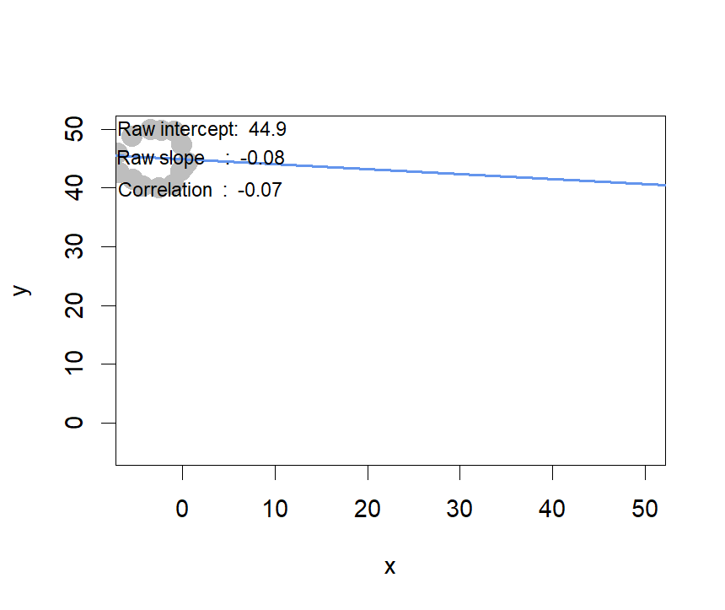

1. Apart from any of the above scenarios, find another pattern of data points with perfect correlation (r ≈ 1).  
   *(can you find a scenario where the pattern visually suggests a different relationship?)*

Ans: As long as we create a set of data points that lies on the same line and the slope of line isn’t 0, the correlation between x and y must be 1.

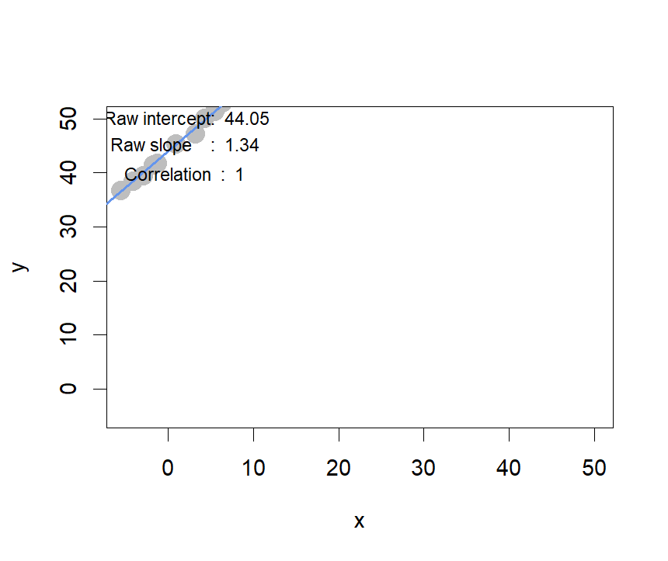

1. Let’s see how correlation relates to simple regression, by simulating any *linear relationship* you wish:
   1. Run the simulation and record the points you create: pts <- interactive_regression()   
      (simulate either a positive or negative relationship)

> pts<-interactive_regression()

* 1. Use the lm() function to estimate the *regression intercept and slope* of pts to ensure they are the same as the values reported in the simulation plot: summary( lm( pts$y ~ pts$x ))

> #original regression line

> summary( lm( pts$y ~ pts$x ))

Call:

lm(formula = pts$y ~ pts$x)

Residuals:

Min 1Q Median 3Q Max

-5.0264 -3.9951 0.4059 2.9360 7.2758

Coefficients:

Estimate Std. Error t value Pr(>|t|)

(Intercept) 44.7211 1.1862 37.701 7.8e-14 ***

pts$x 0.9103 0.2752 3.308 0.00625 **

---

Signif. codes: 0 ‘***’ 0.001 ‘**’ 0.01 ‘*’ 0.05 ‘.’ 0.1 ‘ ’ 1

Residual standard error: 4.054 on 12 degrees of freedom

Multiple R-squared: 0.4769, Adjusted R-squared: 0.4333

F-statistic: 10.94 on 1 and 12 DF, p-value: 0.006251

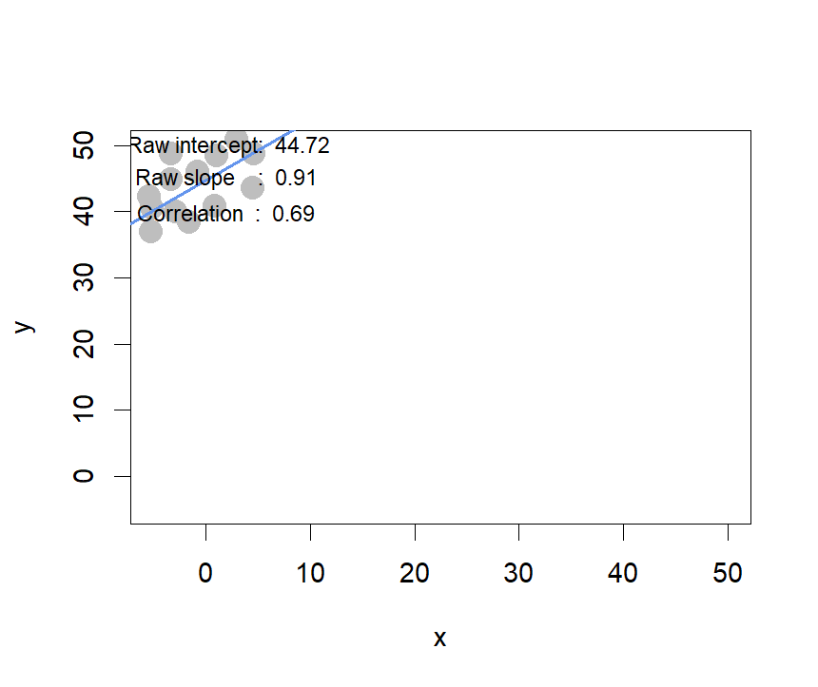

Ans: The regression intercept and slope of pts are same as the values reported in the simulation plot.

* 1. Estimate the correlation of x and y to see it is the same as reported in the plot: cor(pts)

> cor(pts)

x y

x 1.000000 0.690592

y 0.690592 1.000000

Ans: Yes, the correlation of x and y is the same as reported in the plot

* 1. Now, *standardize* the values of *both* x and y from pts and re-estimate the regression slope

What is the relationship between *correlation* and the *standardized simple-regression estimates*?

#standardized

> pts$x<-scale(pts$x)

> pts$y<-scale(pts$y)

> #standardized regression line

> summary( lm( pts$y ~ pts$x ))

Call:

lm(formula = pts$y ~ pts$x)

Residuals:

Min 1Q Median 3Q Max

-0.93335 -0.74186 0.07537 0.54519 1.35103

Coefficients:

Estimate Std. Error t value Pr(>|t|)

(Intercept) 3.672e-17 2.012e-01 0.000 1.00000

pts$x 6.906e-01 2.088e-01 3.308 0.00625 **

---

Signif. codes: 0 ‘***’ 0.001 ‘**’ 0.01 ‘*’ 0.05 ‘.’ 0.1 ‘ ’ 1

Residual standard error: 0.7528 on 12 degrees of freedom

Multiple R-squared: 0.4769, Adjusted R-squared: 0.4333

F-statistic: 10.94 on 1 and 12 DF, p-value: 0.006251

> cor(pts)

x y

x 1.000000 0.690592

y 0.690592 1.000000

Ans: Even the values have been standardized, the correlation of x and y still doesn’t change, and the standardized regression coefficient is the correlation and the intercept is 0.