**108070023 HW2**

**Q1**

**(a)**

> # Three normally distributed data sets

> d1 <- rnorm(n=600, mean=60, sd=8)

> d2 <- rnorm(n=150, mean=40, sd=8)

> d3 <- rnorm(n=50, mean=10, sd=8)

> D2 <- c(d1, d2, d3)

> plot(density(D2), col="blue", lwd=2, main = "Distribution 2")

> abline(v=mean(D2))

> abline(v=median(D2), lty="dashed")

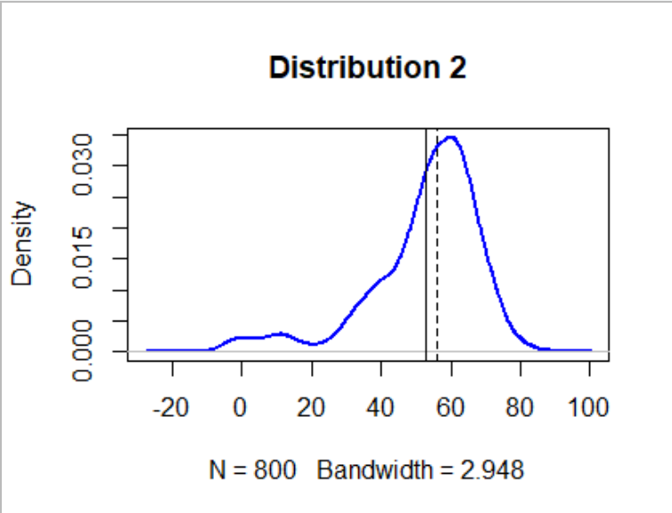

**(b)**

> D3<-rnorm(800,30,8)

> plot(density(D3), col="blue", lwd=2, main = "Distribution 3")

> abline(v=mean(D3))

> abline(v=median(D3), lty="dashed")

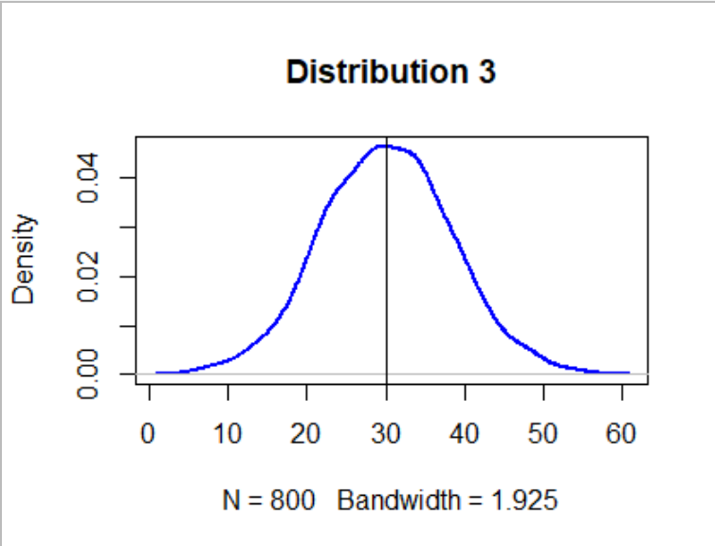>

**(c)**

Mean is more sensitive than median,since it take the outliers into account.

**Q2**

**(a)**

> a<-rnorm(2000,mean=0,sd=1)

> fig1<-density(a)

> plot(fig1)

> abline(v=mean(a))

> abline(v=mean(a)+sd(a), lty="dashed")

> abline(v=mean(a)+2*sd(a), lty="dashed")

> abline(v=mean(a)+3*sd(a), lty="dashed")

> abline(v=mean(a)-sd(a), lty="dashed")

> abline(v=mean(a)-2*sd(a), lty="dashed")

> abline(v=mean(a)-3*sd(a), lty="dashed")

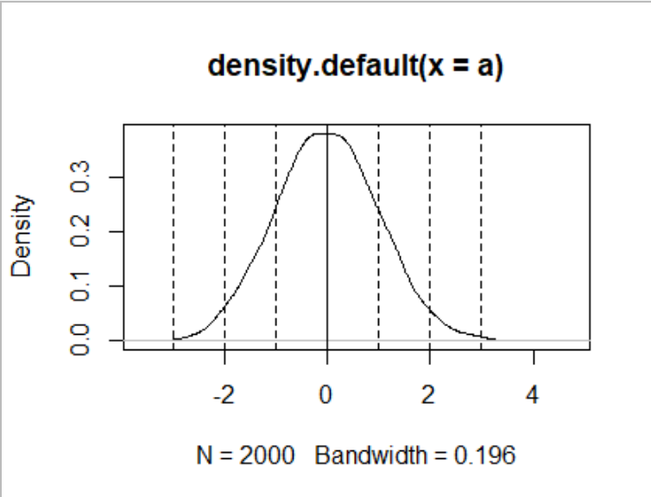

**(b)**

> st1<-quantile(a,1/4)

> st2<-quantile(a,1/2)

> st3<-quantile(a,3/4)

> sd<-sd(a)

> ans<-c(st1,st2,st3)/sd

> ans

25% 50% 75%

-0.69212714 -0.02438176 0.66336760

**(c)**

> c<-rnorm(2000,mean=35,sd=3.5)

> st1c<-quantile(a,1/4)

> st3c<-quantile(a,3/4)

> sdc<-sd(c)

> ansc<-c(st1c,st3c)/sdc

> ans

25% 50% 75%

-0.69212714 -0.02438176 0.66336760

> ansc

25% 75%

-0.1969997 0.1888139

Standard deviations away from the mean of (c) is smaller than (b)

**(d)**

>st1d<-quantile(d123,1/4)

>st3d<-quantile(d123,3/4)

>sdd<-sd(d123)

> ans

25% 50% 75%

-0.69212714 -0.02438176 0.66336760

>c(st1,st3)/sdd

25% 75%

-0.05831244 0.05588942

Standard deviations away from the mean of (d) is smaller than (b)

**Q3**

**(a)**

Freedman-Diaconis rule is very robust and works well in practice.

**(b)**

>rand_data <- rnorm(800, mean=20, sd = 5)

> #(b)-1

> n1<-ceiling(log(800,2)+1) #num of bins

> h1<-(max(rand_data) - min(rand_data)) / n

> #(b)-2

> h2<-3.49*sd(rand_data)/(800^(1/3)) #width of bins

> n2<-ceiling((max(rand_data) - min(rand_data))/h2)

> #(b)-3

> IQR<-IQR(rand_data)

> h3=2*IQR*(800^(-1/3))#width of bins

> n3<-ceiling((max(rand_data) - min(rand_data))/h3)

> c(n1,h1)

[1] 11.00000 1.95738

> c(n2,h2)

[1] 18.000000 1.900545

> c(n3,h3)

[1] 25.000000 1.357844

**(c)**

> out_data <- c(rand_data, runif(10, min=40, max=60))

> #(c)-1

> out_n1<-ceiling(log(800,2)+1) #number of bins

> out_h1<-(max(out_data) - min(out_data)) / n #width of bin

> #(c)-2

> out_h2<-3.49*sd(out_data)/(800^(1/3)) #width of bins

> out_n2<-ceiling((max(out_data) - min(out_data))/h) #number of bins

> #(c)-3

> IQR<-IQR(out_data)

> out_h3=2*IQR*(800^(-1/3))#width of bins

> out_n3<-ceiling((max(out_data) - min(out_data))/h) #number of bins

> c(out_n1,out_h1)

[1] 11.000000 3.380175

> c(out_n2,out_h2)

[1] 31.00000 2.27167

> c(out_n3,out_h3)

[1] 31.000000 1.373485

> diff<-c(out_h1-h1,out_h2-h2,out_h3-h3) #calculate the difference between (b) and (c)

> diff

[1] 1.42279476 0.37112488 0.01564072

Freedman-Diaconis’ choice changes the least when outliers are added since it uses IQR to decide the width of bins. Therefore, the number of bins and width of bins won’t be affected by outliers significantly.