Title: A Laboratory Apparatus for Continuous Macromolecular and Biological Evolution

References:

Selection and Evolution of Bacteriophages in Cellstat, Yuruzu Husimi, Advances in Biophysics, Vol. 25, pp.1-43 (1989).

A system for the continuous directed evolution of biomolecules,Esvelt KM, Carlson JC, Liu DR, Nature. 2011 Apr 28;472(7344):499-503. doi: 10.1038/nature09929. Epub 2011 Apr 10.

pH Indicator, Wikipedia, http://en.wikipedia.org/wiki/PH_indicator

Background of the invention:
Macromolecular engineering can employ the mechanisms of evolution – mutation and selection – to discover novel genetic sequences with desired properties. Earlier means consisted of separate steps for mutation, selection, and cloning, with one or more manual steps, limiting the number of complete cycles to a few per day. Recent advances use continuous cell cultivation techniques, such as a cellstat, to create an environment for continuous evolution. One such method, Phage Assisted Continuous Evolution (PACE), employs the evolution of a bacterial virus with a generation time on the order of a few minutes. In the span of this cycle, all three steps of the evolutionary process – mutation, selection, and reproduction – are carried out without the need to manually isolate or remove any of the reactants. A requirement for this process is the relatively long-term maintenance of the environmental conditions required by the organisms or macromolecules involved.
Just as a device to control heating or cooling from the feedback provided by a temperature sensor is called a thermostat, devices for controlling chemical concentrations, cell concentrations, and active bacterial virus populations are given the names chemostat, turbidostat or cellstat, and phagestat. In each case, particular measurements correlated with the condition being maintained must be sensed to provide feedback for the control of temperature, nutrient concentration, cell density, flow rate, pH, or other conditions.
Sensors for properties such as temperature, pH, and reagent concentration can often require contact with the materials involved. In the case of biological systems, this requires the sensors to withstand: autoclaving at elevated temperature and pressure, corrosive chemistry similar to ocean water, and the build-up of bio-film on surfaces. For these reasons, we would prefer to use non-contact means (e.g. optical) to measure environmental conditions.
A turbidostat controls cell density of a culture by monitoring the optical density (OD) and controlling the inflow of a clear nutrient solution and outflow of cells in solution. For example, the complexity of a phagestat precludes the simplicity of a thermostat, where a single measured quantity controls one parameter. Measured quantities and parameters can interact, as when aeration, necessary to achieve optimal growth rate of the host cell culture, will increase acidity by the addition of dissolved carbon dioxide.
Multiple light sources can be used with a single camera to detect the reflected color, degree of light scattering, and light absorption at various wavelengths. Even precise pH measurements can be obtained optically by adding non-toxic indicators and measuring absorbance at two or more wavelengths. A Passive Infra-Red (PIR) sensor can provide accurate non-contact means to measure temperature.

Summary of the invention:
A system of non-contact sensing means and computer activated controls to maintain multiple environmental conditions including, but not limited to, temperature, turbidity as a proxy for cell density, liquid levels to manage the rate of liquid flow through the system, reflected or transmitted spectra as proxies for chemical concentrations and pH, and bio-luminescence as a proxy for phage population and macromolecular concentrations.
Although mutation rates can be elevated and the selection process accelerated to the life-cycle of bacterial phage of only a few minutes, evolution experiments may require days, weeks, or longer to achieve the desired results. The present invention is intended to increase reliability of such a system through the reduction of moving or wearing parts, eliminate contact of sensors with biological materials, and reduce the amount of oversight required during the experiment.
Precise pH measurements are achieved by adding one or more non-toxic pH indicators to the nutrient stock, giving suitable color transitions around the desired pH. A combination of reflected and absorbed spectral information will be used to gain precision.
A system necessary to maintain a stable population of bacterial phage (the evolving species), requires precise control of the flow rate from a source of uninfected host cells, which in turn requires turbidostatic and thermostatic controls.

Description of the drawings:

Drawing 1: Hierarchy of parameter-controlled subunits from thermostat, turbidostat, and cellstat, to phagestat.

Drawing 2: Elevation View of the Phagestat

- Nutrient supply line
- Nutrient supply pump
- Nutrient supply valve
- Host cell supply line
- Host cell supply pump
- Host cell supply valve
- One-to-four line splitter for host cell supply
- Host cell supply line for lagoon 1 (one of four)
- Compression rod valve for Host cell supply for lagoon 1
- Host cell supply cannula for lagoon 1
- Inducer supply line
- Inducer supply pump
- Inducer supply valve
- One-to-four line splitter for inducer
- Inducer supply line for lagoon 1 (one of four)
- Compression rod valve for inducer supply for lagoon 1
- Inducer supply cannula for lagoon 1
- Outflow cannula for lagoon 1 (one of four)
- Compression rod valve for lagoon 1 outflow
- Four-to-one line combiner
- Outflow valve
- Outflow pump

Drawing 3: Lighting and image capture

- Meniscus highlight LED for host cell incubator
- Meniscus highlight LED for lagoon 1 (one of four)
- LED Laser
- Full spectrum (white) LED
- Multiple monochromatic LEDs
- Camera

Description of the invention:
A transparent container to hold a host cell culture.
A source of liquid nutrient sufficient to maintain the maximum flow rate through the system, a multiplicity of supplementary liquid reagents (inducers) which may be added to the containers.
A pump and valve complex, the primer, which can prime (valve closed, pump on) and then maintain (valve open, pump off) sufficient flow to sustain the maximum flow rate required by the system.
A flow control apparatus consisting of a multiplicity of valves controlling the flow of liquid between the outflow and inflow of the host cell container and each of the lagoons.
A host cell container which is elevated with respect to the phagestat containers (lagoons).
A multiplicity of secondary containers (lagoons) containing a population of bacteria and bacterial phage, each of said lagoons having one or more inputs from and one or more outputs to the flow-control apparatus.
A non-contact (IR) temperature sensor, camera, computer, and image processing software to provide real-time information about the temperature, levels, turbidity, reflected and absorbed spectra, and luminescence of the liquid in a multiplicity of transparent containers.
A heating unit in contact with the primary host cell container. Said heating unit being controlled by the computer control system.
An aeration unit producing pressurized air to be conveyed to the bottom of the host cell container and released into the cell culture.
Immersion or magnetic mixing means for each of the transparent containers.
Means to control lighting in the form of yellow light projected up from beneath the transparent containers to illuminate the meniscus of the liquid in the container, a laser projecting into the transparent host cell container from the side, multiple monochromatic sources directed at the camera from the far side of the transparent containers, and a full spectrum light from the camera's direction to provide visual monitoring of the apparatus.
A liquid sensing device in the bottom of the apparatus to detect leaks and a means to react to said leaks by shutting off the flow of liquid and means for reporting the condition of the apparatus.

Claims:
Claim 1: Simultaneous liquid level detection for multiple transparent containers consisting of an edge detection algorithm from the set {Marr-Hidreth, Roberts cross, Sobel, Compass, Canny} followed by a line detection algorithm from the set {Hough, Convolution, Radon , Cauchy-Crofton , Fourier} to detect the illuminated meniscus of the liquid in said transparent containers.
Claim 2: Claim 1 where the transparent containers are illuminated from below.
Claim 3: Flow modulation consisting of multiple valves controlling a multiplicity of inputs and a single output for a multiplicity of containers where the amount of time allotted to opening each valve is varied to modulate the rate of flow through each valve.
Claim 4: The apparatus of claim 3 where the flow modulation for each container is a function of the instantaneous, time-derivative, and/or time-integral of the said container's liquid level.
Claim 5: The apparatus of claim 4 where the flow control parameters are computed by a calibration process consisting of:
- An output leakage measurement taken by closing all input flow channels and measuring the rate of output flow with all output valves closed.
- A nominal output flow measurement taken by closing all input flow channels and measuring the rate of output flow with each output valve opened for a specific interval.
- An input leakage measurement consisting of closing of all output flow channels and measuring the rate of input flow with input valves closed.
- A nominal input flow measurement taken by closing all output flow channels and measuring the rate of input flow with each input valve opened for a specific interval.
Claim 6: The apparatus of claim 5 where the individual liquid containers are transparent and the rate of flow is measured by the image processing means of line detection.
Claim 7: The apparatus of claim 5 where the rate of flow is measured by detecting any or all of the instantaneous, time-derivative, and/or time-derivative liquid levels of the containers.
Claim 8: The apparatus of claim 5 where one or more pH indicators are added to the containers and a pH value is computed from the reflected and/or absorbed spectra.

Abstract of the Disclosure:

A device to maintain an environment for continuous evolution of micro-organisms or macro-molecules using non-contact sensing means to reduce cost and increase reliability. Precise integrated control over numerous parameters is provided by computer control to allow the range of control necessary to support research environments.

Illustrations:
- Controlled Parameters
- EvoStat System Structure
- Elevation View of the Main Chamber
- Low-pressure pinch valve
- Autosampler Assembly
- Visual Liquid Level Detection
- Glassware modification for Gravity Flow Control

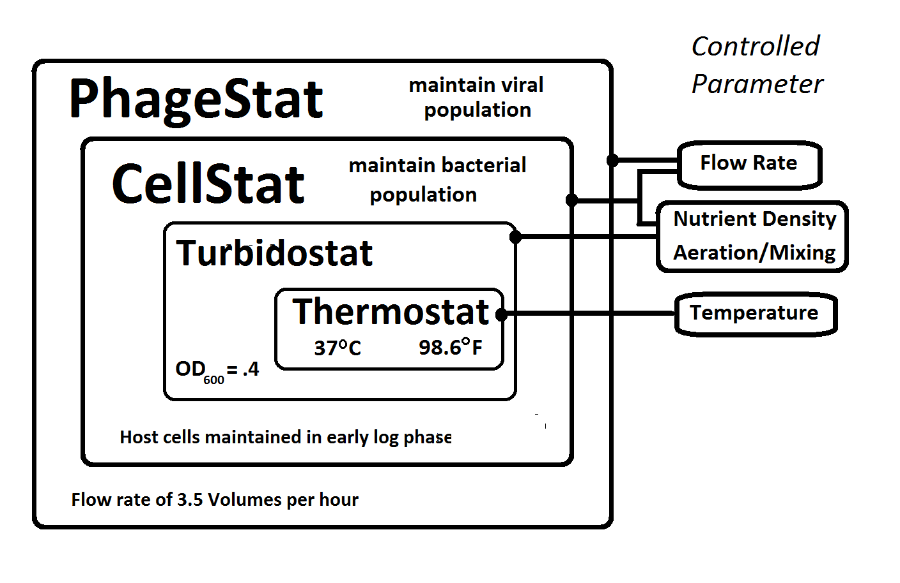Illustration 1: Controlled Parameters

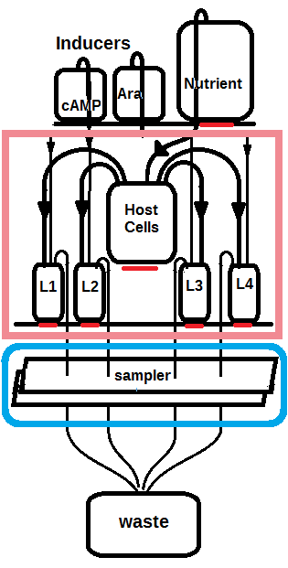
Drawing 1: EvoStat System Structure

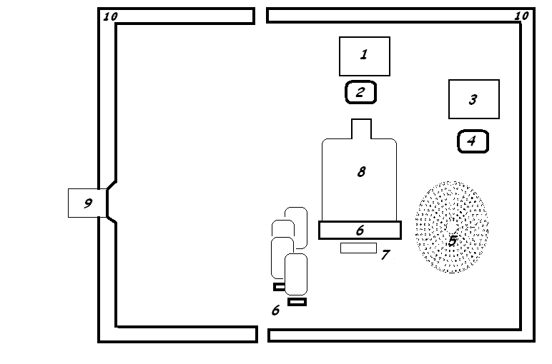Illustration 2: Elevation View of the Main Chamber
A micro-controller with 10 digital outputs controlling current sources for LED light sources, pumps, and valves; one pulse-width modulated output controlling a current source; one two-wire (SDA/SCL) interface for a PIR temperature sensor, one analog input for rotary valve position sensing.

10 Digital Outputs:
- Heater
- Laser
- Yellow LED light
- White LED light
- Nutrient pump
- Host cell pump and valve
- Inducer pump and valve
- Lagoon outflow pump and valve

1 PWM output: Rotary valve motor

1 Analog input: Rotary valve position sensor

A system for controlling multiple turbidostats and cellstats with minimal medium contact consisting of a dark environmental chamber with an infra-red temperature sensor, a heat source, a multiplicity of light sources under computer control, a digital camera connected to said computer, a multiplicity of liquid pumps, each with a valve whose input and output are in parallel with the pump input and output, an air pump, and stirring means in each of the transparent containers.

A multiplicity of valves each consisting of a stiff rod compressing a soft tube in which the nutrient, cell culture, inducer, or other liquid would otherwise flow freely. A central pointer with adjustable torque which contacts said rods sequentially and flexes them sufficiently to relieve the compression on said tubes allowing liquid to flow freely for a specific time duration. At the end of said duration, the torque being increased to cause the pointer to push past the flexible rod, releasing it to allow it to re-compress said tube, shutting off the liquid flow, whereupon the torque applied to the pointer is immediately reduced to allow the pointer to come into light contact with the rod of the next valve. Said light contact being sufficient for the voltage present on said rod being conveyed to the pointer and then to the analog to digital converter of the computer, allowing the computer to detect the voltage and thereby identify the corresponding valve position of the central pointer.

Image event processing
Image event processing eliminates the need to synchronize lighting changes with image processing or to make special arrangements for technicians to access the apparatus while in use. The controlling computer asynchronously captures images from the apparatus and performs a rapid analysis of the image to determine the lighting conditions. Measurements are made from the image depending upon the lighting conditions as follows:
- Yellow LEDs lighting the containers from below indicates a level detection event
- Red laser light projecting a horizontal beam through the host cell container for turbidity measurement
- Full-spectrum light for images to display on the web page
- Extremely low light (dark) images indicate integration measurement, summing of pixel values over multiple frames, to detect fluorescence or bioluminescence.
- Other phage population density indicators may be used and may be detected from the white light image or integrated from multiple full spectrum or monochromatic images.

The image processing loop calculates levels, turbidity, bioluminescence, and visible light color analysis depending upon the lighting detected in the image stream. The lighting control can be implemented by a simple asynchronous mechanism which gives sufficient times to each of the required lighting conditions. During different phases of the experiment, more frequent turbidity or level measurements may be needed and this can be accomplished by changing the lighting schedule.
An important consequence of image event processing is that incorrect readings will not result from a change in light conditions when a researcher opens the capsule during operation. Images acquired from an open device will be interpreted as full spectrum images and used only to update the user monitoring (e.g. Web) image. Previous turbidity or liquid levels will be considered valid until an appropriate image with the correct lighting is acquired.

Images can be captured from any of a number of devices at various times and will be processed to update the monitored parameters according to the following image identification:

- Fully illuminated image with full color spectrum and normal brightness: Update the human viewable “Web Image.”
- Moderately illuminated image with predominantly yellow coloration: Identify liquid levels.
- Low illumination image with predominantly red (laser) coloration: Use high contrast blob detection to evaluate turbidity.
- Multiple point light source of different wavelengths behind the primary reactor vessel: Update absorbance data for wavelengths of each point source.
- No detectable illumination: Add image information to integrated image for bioluminescence detection. For example, we add the value (+green – red/2 – blue/2) for each of 80 images to detect green bioluminescence.

AutoSampler
Inexpensive sequencing allows us to monitor the evolutionary trajectory by frequently sampling the populations of the lagoons at regular intervals. Our initial configuration takes one sample from each of four lagoons every hour. The autosampler described here will take 24x4 samples without human intervention (e.g. four simultaneous samples every hour for 24 hours). Sample times can be more or less frequent and organized in groups (e.g. 12 samples one day and then 12 samples two days later) for longer unattended sampling periods.

The auto-sampler uses a one-dimensional positioning platform (from a flat-bed document scanner) and a custom part (shown below) produced on a 3D printer. Eccentric rotating cylinder provides simultaneous pinch control of all four sample tubes. Pinch-off pressure requirement is lessened by a relief cylinder behind the silicon tubing.

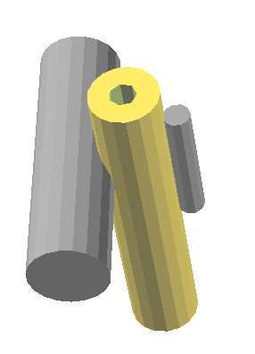Illustration 3: Compression relief cylinder reduces pinch-off pressure

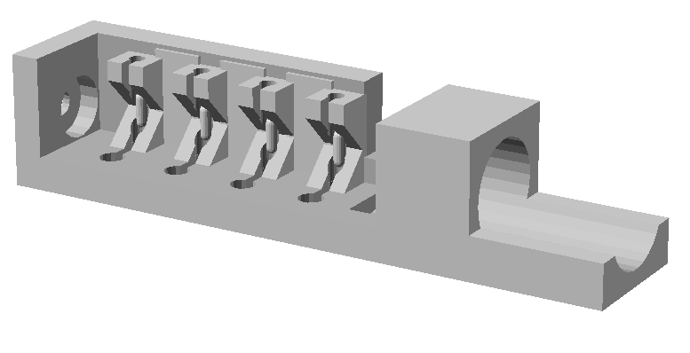Illustration 4: Autosampler assembly (ABS plastic)

Communication Architecture:

1 Cellstat with Bluetooth or Wifi communications module
N Lagoons with Bluetooth or Wifi communications module
1 Auto-sampler with Bluetooth or Wifi communications
1 IP Camera (Ethernet or Wifi)

Controlling computer can be any computer with network and/or Bluetooth capability.
There is no wiring between the controlling computer and the Evostat, enabling any computer to temporarily become the controlling computer and 'run' the experiment. Inthe preferred embodiment, there is a dedicated computer which controls the experiment by default. This computer will accept a request from another computer to become the controlling computer and it will acknowledge a valid request by severing its established communication links to the various sub-systems of the Evostat, allowing the requesting computer to establish it's own communication links with the equipment. After a short interval, the original controlling computer will monitor the communication status of the subsystems and be prepared to control the apparatus when the requesting computer has reliquished control.

Using an external reference for calibration of cell density measurement:

As the host cell culture is becoming established at the beginning of an experiment, we use an external resource to accurately measure cell density (OD₆₀₀ ) and report these values to the Evostat. This procedure is completed when the value reaches the target, early log-phase density to be maintained ( e.g. OD₆₀₀ 0.4). The simple Evostat turbidity monitor maintains this turbidity level without the need to be calibrated for absolute turbidity. Throughout the experiment, additional measurements of cell density can be taken and reported to the Evostat to compensate for errors due to biofilm build up, temperature sensitivity of the laser or phototransistor, or any other effect which changes over the course of the experiment. A single high-accuracy cell density measurement system can thus be shared over any number of Evostats and still be available for general use within the laboratory.

User Guide:
Software Requirements

Although the exemplary system will have a small dedicated computer, such as a Raspberry Pi to run the apparatus, we provide the capability to take control and run the experiment from any Windows or Debian/Ubuntu system. Such a system will require the following open source software in order to run the apparatus.

SWI-Prolog, Python 2.7x, Bluetooth stack (including bluez and pybluez), OpenCV including opencv/Python and V4L (video for Linux) support.

It is interesting to note that these requirements are fulfilled by current smart phones containing Linux systems with integrated cameras and Bluetooth(TM) (Android, Iphone) with tools for software development (e.g. Android Studio, Eclipse, XCode).

Theory of Operation:

When the evostat program is run, it reads the configuration in <hostname>.pl and creates a new file named <hostname>.settings. Multiple Evostats can be set up by giving each one a configuration file ( e.g. darwin.pl, huxley.pl, etc. ) and calling the evostat program with the Evostat name. The default, using <hostname>.pl is a convenience for the common situation where we have a dedicated computer controlling a single Evostat. The <name>.settings file is a Python dictionary used by the OpenCV/Python programs for level and luminescence detection. Although this <name>.settings file can be edited to try different parameters for testing and debugging of the Python programs, remember that it will be overwritten from the values in <name>.pl whenever the main evostat program is run.

The user will need to modify parameters in this file during the EvoStat setup. Specific information about the camera IP and/or MAC address, or whether a USB camera is installed (use appropriate integer in place of the MAC address (0 for the first USB camera, 1 for the second, etc.). Also, the commands (URLs) to set brightness and contrast on the camera and to retrieve an image (IP cameras only, these parameters are not used by USB cameras).

A timer inside the EvoStat program periodically runs the Python program (ipcam.py) to read liquid levels and luminosity. Whenever the internal meniscus lighting is turned on, ipcam recognizes the light level and performs the level detection algorithm. If the light-level is below a certain threshold, it is assumed that the internal EvoStat illumination has been turned off, and the multi-frame luminosity algorithm is run. This light threshold and the number of frames to be integrated are user-defined parameters in the <hostname>.pl configuration file.

An EvoStat is comprised of: one cellstat, one or more lagoons, and one auto-sampler. A functioning EvoStat results when the controlling computer has established Bluetooth® serial communication links with these sub-systems as designated in the <hostname>.pl configuration file.

Illustration 5: Image for Liquid Level Detection

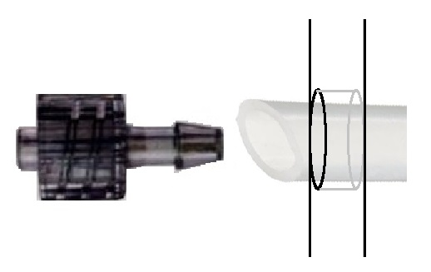Illustration 6: Glassware modification: gravity flow

Inventor: Peter Brandon Reintjes
Applicant: Inventor (Peter Brandon Reintjes)
Oath or Declaration:
The above-identified application was made or authorized to be made by me.
I believe that I am the original inventor or an original joint inventor of a claimed invention in the application.
I hereby acknowledge that any willful false statement made in this declaration is punishable under 18 U.S.C. 1001 by fine or imprisonment of not more than five (5) years, or both.

Appendix 1: Part Lists

CellStat

Arduino Pro Mini
12-volt Solenoid Valve (Nutrient supply)
nMOS Transistor 2A (Heater resistor supply)
6” stove top coil
MLX90614 Temperature sensor
3v 20mA red laser module
SFH 3310 570nM phototransitor (turbidity sensor DigitKey #475-3022-ND)
32-48 volt supply (for heating coil)
2XULN2003 Darlington Array (Motor, LED, and valve drivers)
2X RJ-45 Jack

Lagoon

Arduino Pro Mini
5v 180-degree servo (Airtronics or equivalent)
SIPMOS P-channel Transistor 10A (Servo power supply)
nMOS Transistor 2A (Heater resistor supply)
3X25 ohm
LM35DZ Temperature sensor
0.1uF ceramic capacitor (Analog input filter)
ULN2003 Darlington Array (Motor and LED drivers)
RJ-45 Jack

Auto-Sampler

Arduino Pro Mini
Maxon 12 gear motor with encoder
AutoSampler fixture (see 3D print image in AutoSampler section)
4” x 0.25” stainless steel tube
nMOS Transistor 2A (motor control)
5X 12-volt Solenoid Valve
Dino-Lite USB microscope (modified)
5X 1mL 5mm glass pipets
ULN2003 Darlington Array (Valve driver)
RJ-45 Jack

Appendix 2: Wiring list for subsystems

BLACK (Lagoon)

OW + 12
Or Mixer
GW
Bl +5V
BW LED
G Ground
BrW A0 (Temp)
Br Heater

WHITE ( Lagoon Valves)
OW +12
Org OUTFLOW
GW HOSTCELLS
BLUE IND1
BW IND2
G INH1
BrW ?
Br NC

AutoSampler

PhotoInterruptor:
Red: +5v
Black: Gnd
Yellow: Interruptor Out

DC Motor + Encoder:
- Motor + (red stripe on cable)
- NC
- Encoder B output
- +5v (encoder)
- Encoder A output
- Gnd (encoder)
- NC
- Motor -

NB: Autosampler designed for CCW rotation of motor so pin 8 (Motor –) will be connected to 12VDC

