An Automated Phagestat for Continuous Evolution Research

Table of Contents
Abstract 1
Technical Proposal Narrative 2
Problem 2
Current Status of Research 3
Technical Goals 6
Project Plan 7
Evaluation 9
Challenges 9
Commercial Proposal Narrative 10
Problem 10
Commercial Goals 11
Market 11
Intellectual Property 12
Project Plan 13
Evaluation 13
Roles and Responsibilities 13
Project Time Line 14
Budget Justification 14
Bibliography 15
Previous, Current, and Pending Grants 16

Abstract
Affinity selection is at the core of the biotechnology industry. Continuous evolution systems (PACE, PATHE) provide a powerful approach to protein engineering to increase Protein-DNA and Protein-Protein binding affinities and selectivity through directed evolution. Ad hoc systems built from commercially available equipment have material costs on the order of $30,000 and high labor operational cost because they require continuous monitoring. Alternatively, by using inexpensive computational systems, commodity electronics and plumbing, and a few custom 3D-printed components, a bio-reactor can be built for approximately $1000 which also reduces oversight requirements through non-contact sensing, image processing, and computer-controlled feedback. This inexpensive and easy-to-use apparatus will provide a scalable platform for using directed evolution for protein engineering.
The EvoStat will accelerate those procedures and free researchers from having to create a reliable phagestat from a collection of disjoint components.

Technical Proposal Narrative

Problem
Affinity selection is the central technology used to find new protein-based therapeutics. There are 100-200 therapeutic proteins on the 93 billion dollar market. Phage display, the current state of the art for affinity selection, has probably been used to find or fine tune at least half of these proteins. Phage display while effective is a cumbersome manual technology allowing at best one or two generations of mutagenesis and selection per day. Inspired by a system for continuous evolution [Husimi] and enabled by a recent advance in protein design by evolution called Phage Assisted Continuous Evolution [PACE] Innatrix has designed and is testing a novel system, which addresses the features missing in phage display. What Innatrix and the scientific community needs is an inexpensive automated apparatus to implement continuous evolution.
Protein engineering consists principally of finding DNA sequence modifications that result in a desired protein structure and function. The difficulty of predicting changes in three-dimensional shape and charge distribution from a given mutation can mean it is impractical to infer the required sequence modification from 3D models and analysis of structure-activity response. Furthermore, small differences between in-vivo conformations and the models from crystallographic and NMR data can make such direct fine-tuning of affinity impractical.
However, evolutionary competition can search for and retain protein mutations with stronger and more selective binding to a particular target. Directed evolution is a method whereby in vivo interaction between a target protein and mutable protein can be used as a selection mechanism to discover novel sequences with desired properties. Given a target and an initial protein which have some binding affinity, directed evolution is a method of finding sequence changes which increase binding and selectivity [PACE].
We give the name “phagestat” to an apparatus which maintains a population of bacterial virus undergoing directed evolution through interaction with a bacterial host that has been programmed to mutate, select, and propagate that virus based on its binding affinity for the target [Husimi].[Cellstat].
An inexpensive, reliable, and highly automated phagestat will allow many more directed evolution experiments to be performed. Even more importantly the automated system will foster the exploration of a larger realm of structural space than phage display. The inexpensive phagestat opens the possibility of performing more parallel experiments with different starting sequences and sequentially running series of directed evolution procedures involving positive and negative selection for different properties. In particular, the negative selection demonstrated by members of the original PACE team suggests an approach to evolve therapeutics away from unwanted side-effects of identified off-target substrates[NEGATIVE].

Current Status of Research

We are in the final stages of construction of the EvoStat prototype, an automated phagestat for continuous evolution experiments. Illustration 1 shows the tower construction design to facilitate gravity fed fluid flow from nutrient and inducer sources to the host cell incubator (cellstat), multiple viral colony lagoons(L1-L4), auto-sampler, cryogenic bio-luminescence detector, and waste receptacle.
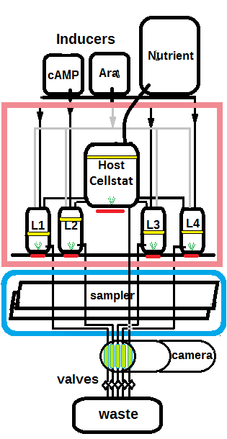Illustration 1: Evostat
Each of the five vessels containing bacterial and phage cultures are supported by self-contained environmental control systems comprised of:
- A micro-controller with wireless communication capability
- Resistive heater
- Temperature sensor
- Magnetic mixer
- Light source
- Multiple inlet solenoid valves
- Aeration control (cellstat only)
- Cell density sensor (cellstat only)
The host cell incubator additionally has controls for an aeration source (bubbler) and cell density sensor (turbidometer) not needed in the lagoons.
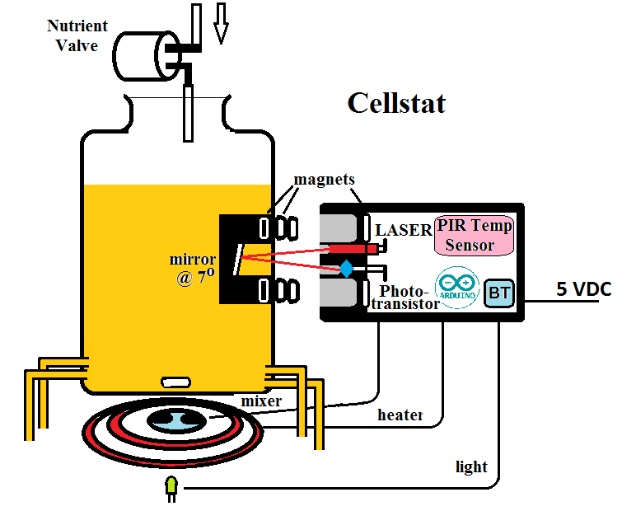Illustration 2: Cellstat Detail
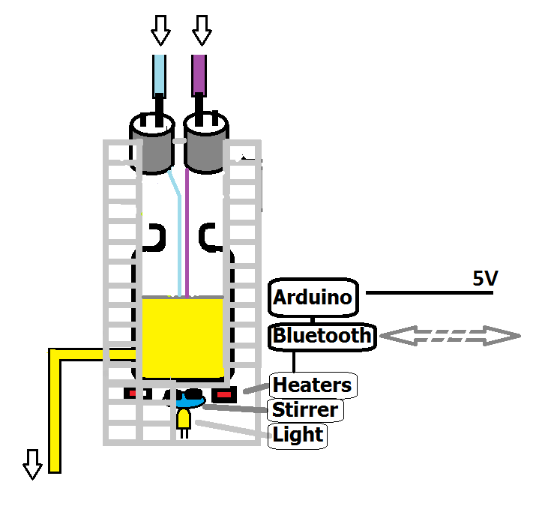Illustration 3: Lagoon Detail

All of these functions are under the direct control of the micro-controller and also indirectly controllable from the main system software via the wireless communication link. In the absence of communication over this link, the micro-controllers maintain the environmental conditions and valve control schedules last specified. This autonomy is given to the reaction vessels to accomodate the temporary absence of main computer control.
The system incorporates two cameras. The main camera is inside the thermally and optically (dark) isolated chamber containing the host cell incubator and four phage-containing vessels called lagoons. This camera provides an elevation view of the vessels which serves several purposes:
- The internal configuration can be viewed remotely by researchers without the necessity of opening the main chamber.
- The liquid level in each vessel can be measured by an image processing system.
- Communications and control of the individual vessels is verified by the image processing system by selectively illuminating each vessel and determining its location.
The illumination system consists of a light source projected into each vessel from below. Using this light, referred to hereafter as the meniscus light, the camera is able to capture an image with a sharp delineation of the liquid level in each vessel. When these lights are off, we have an effectively dark chamber from which we integrate a series of images to detect bio-luminescence. For more precise luminosity measurements, an actively cooled (cryogenic) second camera, located in the auto-sampler is directed at five parallel glass tubes carrying the outflows from the four lagoons and the cellstat. This allows the direct comparison between active lagoon bio-luminescence and the background luminosity from uninfected host cells.
Because of the long run times of directed evolution procedures, the system is designed to be remotely accessed by researchers during operation. A range of data from the operating EvoStat will be available, including images from inside the environmental chamber, logs of controlled parameters including temperature, cell density, flow rates and bio-luminescence. Researchers will have the ability to remotely change parameters to modify an ongoing experiment.
Prototypes of all individual components, including the turbidostat, host cell incubator (cellstat), computer vision level monitoring, lagoons, leakage alarm, and automatic sampling system have been built and tested. Reliability testing over several weeks has been performed on various subsystems including the heating/mixing/aeration cell culture system, phage lagoon mixing, heating, and lighting systems as well as communications between the main computer, cellstat and lagoons. Platform independent control software, written in Python and Prolog, and using OpenCV for image processing has been tested on Microsoft Windows (XP, 7) and Linux (Debian8, Ubuntu, and Raspian).
We know of no similar work to reduce the cost of constructing and operating phage-based continuous evolution environments. Affinity selection, the end goal of this project is currently done using a system called phage display. That system is labor intensive and only two or three cycles of evolution and selection can be carried out per day. This process requires manual operations for each cycle of mutation and selection In contrast, the apparatus we are building is fully automated and can accomplish 20-30 cycles of mutation and selection per day for weeks on end. This system explores a larger range of evolutionary space than phage display by evaluating 10¹¹ different protein configurations along a competitive evolutionary trajectory, randomizing from the 'best so far' in each generation, as compared to a few cycles of selection from an initial randomized library of 10¹¹ candidates.
Building the EvoStat requires expertise in areas outside of molecular biology, and its goal is to lower the cost of entry into this area of research rather than to achieve any particular protein engineering task. That said, the design is being verified by ongoing work by Drs. Edgell, Charles, and Collier to develop an attack on drug-resistant bacterial pathogens by creating protein-based inhibitors of bacterial extra-cellular virulence factors.
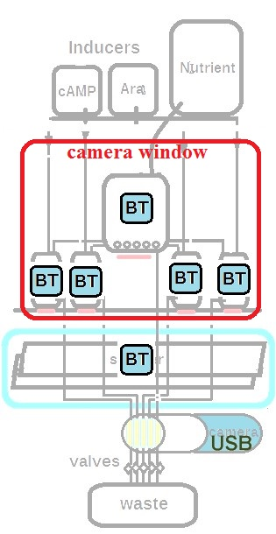
Illustration 2 shows the system's communications architecture configuration simplification possible by including a standard wireless communication protocol for each of the sub-systems. Each of the major subsystems appears to the main computer as a Bluetooth® device.
The illustration shows the main camera view of the main chamber. After establishing communications with the individual modules, the main computer uses this view of the cellstat and lagoons to identify each subsystem by selectively turning each meniscus light in turn and verifying the location and identity of each device.
The two cameras can either be USB cameras, connected directly to the main computer or IP cameras on the local network. We have tested the system with both configurations.
An important design criterion is that there should be no high voltage in a liquid handling system. For this reason, the highest voltage (supplied to the cellstat heating element) is between 24 and 32 volts. All other subsystems operate from a common power supply supplying 5 and 12 volts. This DC power distribution is the only system-wide wiring required as all control functions are handled by wireless communication and the two USB cameras connections.

Technical Goals

- Reduce the cost of continuous evolution experiments by an order of magnitude
- Build three phagestats with a materials cost of approximately $1000 each
- Perform affinity selection evolution procedures using the automated phagestat
- Provide remote access for setup, monitoring, and data retrieval from phagestats

Project Plan
Three complete EvoStat systems will be built: An initial prototype is nearing completion as of this writing, to support the work of Dr. Edgell et al. (Innatrix) at the Genome Sciences building on the campus of UNC-Chapel Hill. A second will be constructed at the local maker space in Durham, NC (Splatspace) where we have access to 3D printers, an electronic workbench, woodworking, and machine shop, and a third system at the Museum of Life and Science, where principal construction of components for all three systems will occur.
Each EvoStat will consist of a tower frame, main computer, one cellstat, four lagoons, and one auto-sampler. An additional cellstat and an auto-sampler along with a few additional lagoons may be constructed as backup units. We have no plans to run active cultures at the Museum of Life and Science or the makerspace. When the design stabilizes and the second and third EvoStat have demonstrated reliability, they will be moved to UNC-CH or another laboratory to be used for evolution experiments.
We will review the intellectual property landscape around this technology and identify details which may be candidates for patent protection. There is potential IP in the external turbidometer, image-based level detection, the design of the auto-sampling valve, cryogenic multi-channel luminometer, as well as the communications architecture and flow-control system. The overall combination of the technologies in the device will constitute a valid IP claim.
Support will provide funding for two days per week for the PI for the first six months: one day per week at the Museum of Life and Science for primary construction and software development of three complete EvoStats and one day per week on-site at the Genome Sciences building (biology department) at UNC-Chapel Hill integrating and maintaining the EvoStat for use by Innatrix researchers.

Completed design and construction of major sub-systems:
- EvoStat Frame
  - Three-level PVC support platform
  - Insulated dark environmental chamber
  - Camera
  - Power supplies: 5-, 12-, and 32-volt
- Host cell incubator (cellstat)
  - Turbidostat
  - Digital thermometer
  - Heating element
  - Meniscus light
  - Magnetic mixer/Aeration
  - Micro-controller + software
  - Bluetooth communication module
- Viral colony vessel (lagoon)
  - Thermometer
  - Heating elements
  - Meniscus light
  - Magnetic mixer
  - Five-position pinch valve
  - Microcontroller + software
  - Bluetooth communication module
- Auto-sampler
  - Parallel four-channel pinch valve
  - Sample plate positioning platform
  - Micro-controller, stepper, motor and sample-timing software
  - Bluetooth Communication module
- Luminometer to monitor phage yield which represents the affinty attained
  - USB microscopic camera
  - Dark enclosure for camera
  - Cooling unit for camera

Deliverables:

- Manifest of all parts including pricing and alternative sources
- Schematics and PCB layout for Cellstat, Lagoon, and Auto-sampler controls
- Micro-controllers and user interface software
- Instructions for construction, setup, and maintenance of the system
Test operation over many hours of unattended operation. Goals include reliable operation for at least 100 hours (four days) and rapid detection and communication of error conditions. Error conditions will include include leak detection and any of the controlled parameters being out of user specified bounds. The controlled parameters include host cellstat volume, temperature and turbidity, lagoon volume, temperature, and flow rate, auto-sampler positioning and sampling schedule, bio-luminescence readings and cryogenic camera operating temperature. Error conditions as well as regular nominal reading updates will be logged and communicated via email and text messaging..
Network connectivity is of primary importance to support unattended operation and researchers will be able able to access the system from remote locations to monitor and change operational parameters. The system will also use this connectivity to initiate communication with researchers to report errors and other important events, such as a rapid increase in bio-luminescence.
The system will also provide Internet accessible viewing of data logs and live images from both the main camera and microscopic/bio-luminescence camera as well as access to the user-settable parameters: the flow rate of each individual lagoon, selection pressure modulation (inducer schedule), and temperature settings for the E. coli cellstat, the individual viral colonies, and the cryogenic camera.
Because of the long running time (~ 1 week) of the continuous evolution process, we will also develop procedures to replace any of the major subsystems without interrupting the long-term experiment.

In the final stages of the project, we will identify other researchers that may be interested in using the EvoStat for continuous evolution experiments. We plan to offer the device to researchers (such as Esvelt and Liu's group at Harvard) in exchange for their help evaluating the design.
The operational metrics from running multiple instances of the EvoStat will give us confidence that this design can be replicated, will reliably perform the intended operations, and will result in significant reductions in operational costs when compared to current manual phage-display procedures or ad-hoc configurations for performing continuous evolution.
All three EvoStat instances must be capable of maintaining the environmental conditions required for early exponential host cell growth, bacteriophage replication, accurate sampling, and bio-luminescence detection continuously for four days. We will automatically log and evaluate any instance of a controlled parameter falling outside of its target range.
Perform long term evolution experiments with the claimed reduction in maintenance and oversight.
Achieving sufficient image sensitivity for a range of bio-luminescence (to be determined) through the active cooling of commodity USB microscopic camera (Dino-Lite® or equivalent).
In addition to complete logging of the listed parameters at 10-minute intervals throughout the run, we will record any instantaneous occurrences of out-of-range parameters.
Perform the proof-of-principle experiment on evolving phage yielding a protein that binds to the target at the end of a run significantly better than at the beginning.

Evaluation
Demonstration that the device can maintain the following operational conditions for greater than 100 hours: Temperature of host cell culture at 37ºC ± 1ºC, maintain host cell growth in early log phase with a cell density of OD600 of 0.4 ± 0.03, maintain temperature of viral population at a selected range of temperatures between 31ºC and 37ºC ±2ºC, and maintain flow rates of 1.5, 2.5, and 3.5 volumes per hour ± 10% in viral lagoons. Logging of all these parameters is automatic in this device but will be verified with random external measurements including temperature, cell density measurements via Nanodrop® spectrophotometer, and flow rates by measuring the volume of waste fluid.

Evaluate person-hours required to support long term (~ 1-week) evolution experiments for comparison with with previous efforts monitoring these experiments.

Verify that bio-luminescence detection is sufficiently precise (minimally 0.001 lux, but actual requirements to be determined) using the USB microscopic camera with active cooling.

Challenges
Image processing must be adaptable to constantly changing hardware availability as well as different laboratory conditions. Configuration and calibration procedures will need to be developed.
There are two open questions about the use of active cooling with commodity USB cameras to avoid the expense of high-end cryogenic cameras (e.g. $25,000 from Hammumatsu). Functional prototypes have demonstrated the principal, but there are questions about the limits of detection and the cost benefits of a custom approach.
The device itself is a tool for sequence discovery and does not produce therapeutic proteins or chemicals so it should not be subject to medical equipment or FDA requirements other than those regarding laboratory equipment designed to contain live bacterial cell culture.

Commercial Proposal Narrative
Affinity selection is the central technology used to find new protein-based therapeutics. There are 100-200 therapeutic proteins on the $93 billion market. Phage display, the current state of the art for affinity selection, has probably been used to find or fine tune at least half of these proteins. Phage display while effective is a cumbersome manual technology allowing at best one or two generations of mutagenesis and selection per day. A Google search on phage display finds 1,330,000 results; it is a widely used technology. We expect the affinity selection technology to be implemented by the phagestat to replace phage display. We expect to sell the apparatus to implement this new affinity selection technology. Innatrix intends to use the new affinity selection technology to make inhibitors against the major drug resistant bacterial pathogens that threaten modern medicine. We will sell these to pharmaceutical companies; we do not in tend to become a pharmaceutical company ourselves.
From Peptide therapeutics: current status and future directions:
Currently, there are more than 60 US Food and Drug Administration (FDA)-approved peptide medicines on the market and this is expected to grow significantly, with approximately 140 peptide drugs currently in clinical trials and more than 500 therapeutic peptides in preclinical development. An overview was presented in a recent review by Kaspar and Reichert [5]. In terms of value, the global peptide drug market has been predicted to increase from US$14.1 billion in 2011 to an estimated US$25.4 billion in 2018, with an underlying increase in novel innovative peptide drugs from US$8.6 billion in 2011 (60%) to US$17.0 billion (66%) in 2018 [6]. The most recent example of a novel peptide drug class is the group of glucagon-like peptide-1 (GLP-1) agonists for the treatment of type 2 diabetes mellitus (T2DM), which reached total sales of over US$2.6 billion in 2013, with VictozaTM, the most prominent member of the class, reaching blockbuster status.

It is important to remember that this is a device for sequence discovery and does not produce or interact in any way with therapeutic products. In this way, it is much like the computational tools used in drug discovery. The output of this device is data: novel DNA sequences of engineered proteins.

Problem

Phage-based continuous evolution is a new technology with few practitioners. As continuous evolution techniques mature as a replacement for phage display, this technique will undoubtedly become more widespread subject to freedom to operate under the Harvard patent (US patent 9,023,594).
While compliance with standards for laboratory equipment will be the responsibility of potential manufacturers of a commercial version of this device, we nevertheless need to consider the impact of standards such as US Federal code under Title 21, Chapter 1, Subchapter H, part 820, Quality System Regulation.

Commercial Goals

As an educational institution, we want to encourage researchers with limited budgets to use these design ideas to perform research, possibly by initially requiring no licensing fee. This approach could result in the sharing of improvements to the design from an open community. We would require licensing only for commercial exploitation of sequences resulting from the use of this device.
As evolution-based protein modification matures into a standard technique for pharmaceutical and materials development, we intend to license this design to laboratory equipment manufacturers.
There is a business model for an organization employing a number of these machines and a staff with expertise in selection-plasmid design to provide contract protein optimization. Such a service would allow a drug development company with an existing protein therapeutic to contract out the task of affinity or selectivity optimization without the need to build and maintain phagestats or develop in-house expertise in directed evolution.
There is a consultation business opportunity for introducing continuous evolution technology to companies in the pharmaceutical sector.

Market
The Evostat shares many of the operational details of bio-reactors and its use could mirror some of the aspects of that broad and rapidly growing market. It is also clear that protein modification will have a fundamental role in improving bio-reactor performance.
The principal market for automated phage-based continuous evolution consists of those entities currently using phage-display and other manual laboratory procedures for modifying and selecting proteins. To this we can add those who are not using phage display because of its limited number of evolution cycles or the difficulty of setting up and performing those operations. The availability of an automated system will lower the barrier of entry into the field of sequence optimization.
Although protein affinity selection is now regarded as a research activity, the number of applications and potential protein products could soon see this process take on a scale approaching that of a manufacturing process. Scaling of this process is enhanced by the fact that this project shares technical features with single-use bio-reactors as well as an overlapping customer base.
Manufacturers of liquid handling laboratory equipment such as Tecan, Aventics, Humphrey, and Nordson EFD are potential manufacturers of the EvoStat. Others include Becton Dickinson, Topac, Intellitech, and Pope Scientific.
Key players in the single-use bioreactor market include Thermo Fischer Scientific, Inc., GE Healthcare and Pall Corporation in the US and Germany's Sartorius AG and Merck KGaA.
From [Processing Magazine] February 2, 2015
Single use bioreactors (SUBs) are used in research and development (R&D) carried out by biopharmaceutical manufacturers, research institutes and contract research organizations (CROs), as well as in biopharmaceutical manufacturing.
It's a growing market, driven by the low capital investment required to set up a facility, reduced complexity of automation, and energy efficiency. A new report by Research and Markets predicts that the global SUB market will expand at a compound annual growth rate (CAGR) of 18.4 percent over the coming years, reaching a value of $470.9 million by 2019 compared with $202.5 million in 2014.
Potential customers include:
- Pharmaceutical research organizations engaged in protein engineering.
- Developers of enzymes for bio-fuel and other bio-reactors.
- Non-pharmaceutical protein engineering in materials science.
- Protein optimization services for organizations that do not want to develop in-house phage/evolution capabilities. A protein optimization service would accept sequences for binding target and initial candidate proteins, design selection-plasmids and hybrid proteins, and perform the evolution process.

Intellectual Property

The design of the EvoStat, including the non-contact sensing techniques, semi-autonomous reaction vessels, and novel use of wireless communication should have wide applicability in laboratory automation. Its suitability to support PACE should not restrict our freedom to operate to licensing under the PACE patent. We can contrast this with thermocyclers which include features for PCR and few other uses, and have therefore required licensing under PCR patents.
The intellectual property in the Harvard patent relates directly to the molecular biology, phage selection, the use of evolving protein as a proxy for phage fusion protein, and other matters relating to the molecular biology of mutation and selection. This IP does not appear to impact phagestat design and our improvements are based on well-known and largely open technologies. A description of the prior art can be found in Husimi [Husimi] and Subramanian [Cellstat].
As far as we know, none of the details of operation of this design are subject to IP constraints. The EvoStat system can be positioned as a re-configurable laboratory system for a variety of cellstat and continuous flow procedures.

Project Plan
Evaluate prior art for other developments in continuous culture systems, feedback control systems based on image processing, and non-contact turbidity measurement (there is at least one example in marine science).
Work with an IP evaluation consultant to evaluate the patent landscape. We are considering the Kenan Institute's Technology Commercialization Center to perform this function and have initiated contact.
Identify researchers in industry and academia who are currently engaged in affinity selection and investigate partnering with them to

Evaluation
Evaluate potential markets, intellectual property, and freedom to operate for a Go/No-go decision about patent filing.

Roles and Responsibilities

The PI will be responsible for the design, construction, and testing of the three Evostat prototypes.

The commercialization adviser will be responsible for investigation of the Intellectual property landscape and market analysis.

Project Time Line
 | Month 1-3 | Month 4-6 | Month 8-9 | Month 10-12
Testing | Liquid flow and thermal integrity of 1st EvoStat with live culture | Determine limit of detection for bio-luminescence | Begin long-term testing of Units 2 & 3 | Logging  Remote Access  Sampling
Mechanical and Electrical Design | Final Cellstat and Lagoon mechanical | Final Auto-sampler mechanical | Electrical packaging Cellstat and Lagoon | Electrical packaging for auto-sampler
Software Development | Micro-controller for Cellstat and Lagoon Running prototype of User interface | Micro-controller code for Auto-sampler  Logging, alerts and remote access in user interface | Final design of User Interface including  Logging Remote Access and Sampling
Fabrication | Cryogenic Camera 1 | Lagoons 3,4 mechanical  1st Printed Circuit (PCB) Fabrication | 2nd PCB Fabrication  2nd and 3rd Cryogenic camera.
Assembly | Unit 1 mechanical assembly complete with breadboard electronics.  Physical and Electronics for Lagoons 1,2 | Frames for Units 2&3  Breadboard Cellstat 2,3 Lagoons 3,4 | Final Assembly Cellstat 3 and Lagoons 5-12
Table 1

Budget Justification
The salary of the PI will be responsible for all design and construction operations and this time is reflected in the manpower request.

We require basic construction materials for three complete systems, including PVC structures, stainless steel hardware, insulation, glassware, tubing, fittings, microcontrollers, basic electronic components to include photo-transistors, laser modules, power supplies, wiring, cases, and outsourcing of printed circuit board fabrication.

The main computer for the final configuration will be an inexpensive single-board computer (Raspberry Pi). We require multiple instances for additional prototyping and testing.
The project depends upon rapid prototyping of custom parts with a 3D printer. While we have had limited access to small scale 3D printing from SplatSpace and facilities at UNC-Chapel Hill, we need the ability to iterate and produce multiple instances of new parts on demand and at one of our parts (auto-sampler) requires a large print area. We have identified the Luzlbot Taz 5 as a suitable low-cost 3D printer for this work.

Bibliography

[Husimi] Selection and Evolution of Bacteriophages in Cellstat, Yuruzu Husimi, Advances in Biophysics, Vol. 25, pp.1-43 (1989).
[Cellstat] Continuous Processing in Pharmaceutical Manufacturing, Ganapathy Subramanian, Wiley, February 2015.
[PACE] A system for the continuous directed evolution of biomolecules,Esvelt KM, Carlson JC, Liu DR, Nature. 2011 Apr 28;472(7344):499-503. doi: 10.1038/nature09929. Epub 2011 Apr 10.
[PATHE] Dr. Marshall Hall Edgell, unpublished private communication.
[Negative] Negative selection and stringency modulation in phage-assisted continuous evolution, Carlson, Badran, Guggiana-Nilo, and Liu. (2014)
[MarketsAndMarkets] URL: http://www.marketsandmarkets.com/Market-Reports/single-use-bioreactor-market-49113750.html
[Peptide] Peptide therapeutics: current status and future directions, Keld Fosgerau and Torsten Hoffmann, Drug Discovery Today, Volume 20, Number 1, January 2015

- [Peptide] also refers to:
Padhi, A. et al. (2014) Antimicrobial peptides and proteins in mycobacterial therapy: current status and future prospects. Tuberculosis 94, 363–373

Kaspar, A.A. and Reichert, J.M. (2013) Future directions for peptide therapeutics development. Drug Discovery. Today 18, 807–817

Transparency Market Research (2012) Peptide Therapeutics Market: Global Industry Analysis, Size, Share, Growth, Trends and Forecast 2012–2018. Transparency Market Research

Previous, Current, and Pending Grants
There are no previous, current or pending grants associated with this project.

