The EvoStat
Evolution: on your schedule

This document describes the construction of an automated phagestat to maintain an evolving population of bacterial virus. The current device was designed to maintain a population of M13 phage using a supply of E. coli host cells but could be used for directed evolution of other organisms as it manages temperature, turbidity, reagent concentrations, and precise flow control.
Software for EvoStat

MAIN PROGRAM: INITIALIZE, RUN

INITIALIZE:
Arduino discovery and initialization
Light testing (verify closed chamber)
Level detection, Prime Sequence if necessary

RUN
for(i=0;i<normalcycles;i++)
if (temperature[t] < set_temp[t])
heater(t,ON);
else heater(t,OFF);
if (!check level) re-calibrate flow rate
if (turbidity > setpoint) open nutrient valve
if (bioluminescence) report activity

check temperature:
check nutrient temperature
check host cell temperature
check lagoon temperatures

Arduino Command Reference

d – dump parameter values
s – save current values in EEPROM
r – restore parameter values from EEPROM
l1 – level detection (meniscus) lights on
l0 – level detection (meniscus) lights off
d
pN1 – pump N on
pN0 – pump N off
vN1 – valve N on
vN0 – valve N off
hN1 – heater N on (auto temperature control)
hN0 – heater N off (no temperature control)
Heaters 1-4=Lagoons, 5=Host Cells, 6=Nutrient Preheater
Pumps 1=Nutrient,2=Host Output,3=Inducer1,4=Inducer2,5=Waste
Valves 1=Nutrient,2=Host Output,3=Inducer1,4=Inducer2,5=Waste

Arduino Acquisition and Initialization
Logging

Calibrate Flow-Rate
V30,V40,V50 -Host Cells into lagoons, no lagoon outflow
monitor level increase rate and adjust timings 1-4
V30,V40,V20,V51 – Lagoon outflow only
monitor level decrease and adjust timings 13-16
V31, V40, V20,V50 – Inducer1 inflow only
monitor level increase and adjust timings 5-8
V30,V41,V20,V50 – Inducer 2 inflow only
monitor level increase and adjust timings 9-12

EvoStat part list with ordering information

Qnty | Description | URL | Price
10 | 3A rectifier diodes | Jameco diode | 100 @ $10.00
2 | 71 RPM 12VDC gearhead motor | Jameco #155855 | 1 @ $21.95
16 | Compression Valve Fitting (ABS) | 3D Printer | -
1 | Compression Valve Pointer (ABS) | 3D Printer | -
16 | ³/₃₂ Stainless Steel Welding Rod 4” |  | -
1 | Chicago Metal 14” pizza crisper pan
5 | 12V DC Peristaltic pump
5 | 12V DC N/C valve
32 | 1K 1% metal film resistors | DigiKey resistors | 5000 @ 42.75
2 | 10ft ¾” PVC pipe | Lowes / Home Depot
1 | 10ft 3” PVC pipe | “
4 | ¾ X ¾ X 1 PVC elbow | “
4 | Sample valve fitting | 3D Printer
4 | ¼-20 anodized speed nut
1 | 12” 4.75mm (.1875”) stainless steel rod | Online Metals | 0.80
1 | Surplus image scanner + stepper motor | Triangle E-cycling? | -
 | RJ-45 inline couplers | Amazon | 12 @ 12.00
 | Ethernet cables w/ RJ-45 plugs
1 | Ardweeny (auto sampler controller) | Solarbotics | 9.95
1 | Arduino Mega 2650 (main controller) | Amazon Mega 2650 | 14.99
 | FOR WIRELESS LAGOONS:
4 | Arduino Mini Pro (5V 16Mhz 368) | MinInTheBox | $3.95
4 | Bluefruit EZ-link (Bluetooth FTDI) | AdaFruit | $22.50
4 | HC-06 (alternative Bluetooth/slave only) | MiniInTheBox | $4.79
4 | ULN2003 | JameCo | 0.35
1 | 7X9cm pre-drilled PC board 276-168 | Radio Shack | $3.49
1 | Connectors | MiniInTheBox | $1.99
1 | Melexis 90614 PIR Temp sensor | DigiKey | $27.22
1 | Heating wrap for Nutrient | Carboy Heater
1 | Foscam 1.3M Wireless Outdoor Camera  alt/ Microsoft LifeCam VX-5000 | Foscam | $259.99
8 | Multi-color RJ-45 jacks | Amazon | 4.99 each
8 | Multi-color cables | Cable Matters | 11.99
2 | 1 ¼” stainless steel hose clamp
100 | ½” #6 flat phillips sheet metal screws

Assemblies

- Rotary Valve Assembly (1)
- Priming pumps with valves (4)
- Host Cell Stand – magnetic mixer + LED light + heater (1)
- Lagoon Stands - magnetic mixer + LED light + heater (4)
- Optical assembly (LED's, laser, PIR temperature sensor) (1)
- Camera Mount
- Stainless steel containment pan with leak sensors
- Four-channel Auto sampler
- Arduino Mega 2650 system controller

Connections

Four RJ-45 sockets on the main controller board connect to the four sub-systems.

Temp includes the main Host Cell container heating element (1 output) and the PIR temperature sensor (+5V, SCL, SDA, Gnd) and position feedback for Rotary Valve (Rotary In)

Flow connects to the first three priming pumps and valves (6 outputs Host, Inducer, Waste) and Rotary Valve motor (1 output plus 12VDC)

Mixers connects to the magnetic mixers for the host cell container and four lagoons (5 outputs), the host cell nutrient valve (1 output) and aeration (1 output), plus 12VDC mixer supply.

Lights connects to seven outputs: yellow meniscus lighting, white camera light, white, blue, green, and red backlight LEDs, laser, and 12VDC source.

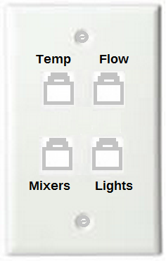

Ethernet cable connections: Lights

Orange | + 12V
Orange-white | Yellow LED
Green | Green LED
Green-white | White LED
Blue | Blue LED
Blue-white
Brown | Laser
Brown-white | Red

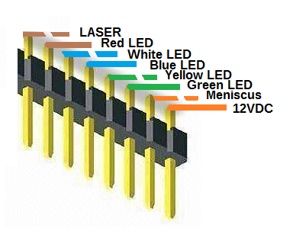

Ethernet cable connections: Mixers

Orange | + 12V
Orange-white
Green | Host Cell container
Green-white
Blue | Lagoon 1
Blue-white | Lagoon 2
Brown | Lagoon 3
Brown-white | Lagoon 4

Ethernet cable connections: Flow (Pumps and Valves)

Orange | + 12V
Orange-white | Rotary Valve Motor
Host Cell supply
Green | Pump 1
Green-white | Valve 1
Mutagenesis Inducer supply
Blue | Pump 2
Blue-white | Valve 2
Lagoon Outflow (waste)
Brown | Pump 3
Brown-white | Valve 3

Ethernet cable connections: Temperature Sensor/Heat control

Orange | + 5V
Orange-white | SCL
Green | Ground
Green-white | SDA
Blue | Lagoon Heaters
Blue-white | Chamber Heat
Brown | Nutrient Heat
Brown-white | Host Cell heat

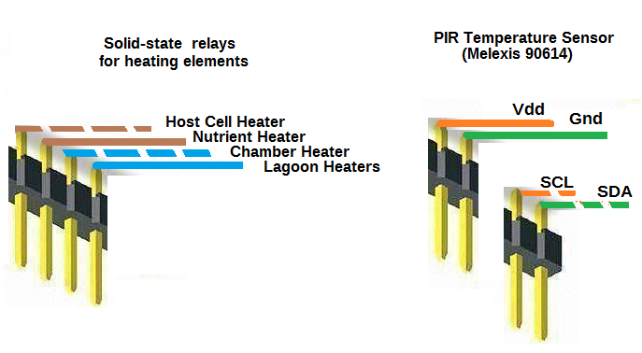

Length | type | diameter
1” | ring | 2”
1” | split | 2”
1” | split | 1.5”
1” | 2 spacers | 1.5”
1.5” | Double split | 3/4”

System Diagram

Cellstat
System Controller
Raspberry Pi
Phagestat
Lagoon Controller
Arduino
Phagestat
Lagoon Controller
Arduino
Phagestat
Lagoon Controller
Arduino
Phagestat
Lagoon Controller
Arduino
Bluetooth
RF Link

Bluetooth Serial
Arduino
Mini Pro
mixer
light
heater
T sensor
valve
valve
valve
valve
Phagestat
1 of 4
Raspberry Pi
Debian Linux
Remote Desktop
OpenCV
Python
Bluetooth Serial
Nutrient
pump + valve
Host Cell
pump + valve
Waste/Samplepump + valve
camera
magnetic mixer
aeration
Cellstat
Nutrient heater Host cell heater
PIR Temp Sensor
lights
Bluetooth
Communication
Software Architecture

Raspberry Pi:
- Level detection (levelapp.py, observe.py)
- Turbidity measurement (turbid.py)
- Bioluminescence detection (fluor.py)
- Temperature controls (Nutrient, Inducers, Host culture)
- Light control
- Logging
- Sampling? (currently stand-alone auto-sampler)

Arduino:
- lagoon.ino (main controller routine)
Controls magnetic mixer and meniscus light via commands from the system controller, regulates lagoon temperature using local temperature sensor
- valves.h (multiple valve controller object)
Autonomously opens valves on a regular schedule which is then adjusted via communication with the System controller, which has eyes on the liquid levels
- pid.h (PID controller object)
Proportional/Integral/Differential temperature/heater control

