Title: A Laboratory Apparatus for Continuous Macromolecular and Biological Evolution

References:

Selection and Evolution of Bacteriophages in Cellstat, Yuruzu Husimi, Advances in Biophysics, Vol. 25, pp.1-43 (1989).

A system for the continuous directed evolution of biomolecules,Esvelt KM, Carlson JC, Liu DR, Nature. 2011 Apr 28;472(7344):499-503. doi: 10.1038/nature09929. Epub 2011 Apr 10.

pH Indicator, Wikipedia, http://en.wikipedia.org/wiki/PH_indicator

Background of the invention:
Macromolecular engineering can employ the mechanisms of evolution – mutation and selection – to discover novel genetic sequences with desired properties. Earlier means consisted of separate steps for mutation, selection, and cloning, with one or more manual steps, limiting the number of complete cycles to a few per day. Recent advances use continuous cell cultivation techniques, such as a cellstat, to create an environment for continuous evolution. One such method, Phage Assisted Continuous Evolution (PACE), employs the evolution of a bacterial virus with a generation time on the order of a few minutes. In the span of this cycle, all three steps of the evolutionary process – mutation, selection, and reproduction – are carried out without the need to manually isolate or remove any of the reactants. A requirement for this process is the relatively long-term maintenance of the environmental conditions required by the organisms or macromolecules involved.
Just as the simplest device to control a heating or cooling device from the feedback provided by a temperature sensor is called a thermostat, devices for controlling chemical concentrations, cell concentrations, and active bacterial virus populations are given the names chemostat, turbidostat or cellstat, and phagestat. In each case, particular measurements correlated with the condition being maintained must be sensed to provide feedback for the control of temperature, nutrient concentration, flow rate, pH, or other condition.
Sensors for properties such as temperature, pH, and reagent concentration often require contact with the materials involved. In the case of biological systems, this can require the sensors to withstand: autoclaving at elevated temperature and pressure, a corrosive environment with chemistry similar to ocean water, and the build-up of bio-film on sensor surfaces. For these reasons, we would prefer to use non-contact means (e.g. optical) to measure environmental conditions.
A turbidostat controls cell density of a cell culture by monitoring the optical density and controlling the inflow of a clear nutrient solution and outflow of cells in solution. For example, the complexity of a phagestat precludes the simplicity of a thermostat, where a single measured quantity controls one parameter. Measured quantities and parameters can interact, as when aeration, necessary to achieve optimal growth rate of the host cell culture, increases acidity by the addition of dissolved carbon dioxide.
Multiple light sources can be used with a single camera to detect the reflected color, degree of light scattering, and light absorption at various wavelengths. Even precise pH measurements can be obtained optically by adding non-toxic indicators and measuring absorbance at two or more wavelengths. PIR (Passive InfraRed) sensors can provide accurate non-contact means to measure temperature.

Summary of the invention:
A system of non-contact sensing means and computer activated controls to maintain multiple environmental conditions including, but not limited to, temperature, turbidity as a proxy for cell density, liquid levels, reflected or transmitted spectra as proxies for chemical concentrations and pH, bioluminescence as a proxy for phage population and macromolecular concentrations.
Although mutation rates can be elevated and the selection process accelerated to the life-cycle of bacterial phage of only a few minutes, evolution experiments require days, weeks, or longer to achieve the desired results. The present invention is intended to increase reliability of such a system through the reduction of moving or wearing parts and eliminating contact with biological materials.
Precise pH measurement is possible by adding to the nutrient stock one or more non-toxic pH indicators which give a suitable color transition at the desired pH setting. A combination of reflected and absorbed spectral information will be used to gain precision.
A system necessary to maintain a stable population of bacterial phage (the evolving species), requires a cellstat subsystem to maintain the uninfected host cell production, which in turn requires turbidostat and thermostatic controls.

Description of the drawings:

Drawing 1: Hierarchy of parameter-controlled subunits from thermostat, turbidostat, and cellstat, to phagestat.

Drawing 2: Elevation View of the Phagestat

- Nutrient supply line
- Nutrient supply pump
- Nutrient supply valve
- Host cell supply line
- Host cell supply pump
- Host cell supply valve
- One-to-four line splitter for host cell supply
- Host cell supply line for lagoon 1 (one of four)
- Compression rod valve for Host cell supply for lagoon 1
- Host cell supply cannula for lagoon 1
- Inducer supply line
- Inducer supply pump
- Inducer supply valve
- One-to-four line splitter for inducer
- Inducer supply line for lagoon 1 (one of four)
- Compression rod valve for inducer supply for lagoon 1
- Inducer supply cannula for lagoon 1
- Outflow cannula for lagoon 1 (one of four)
- Compression rod valve for lagoon 1 outflow
- Four-to-one line combiner
- Outflow valve
- Outflow pump

Drawing 3: Lighting and image capture

- Meniscus highlight LED for host cell incubator
- Meniscus highlight LED for lagoon 1 (one of four)
- LED Laser
- Full spectrum (white) LED
- Multiple monochromatic LEDs
- Camera

Description of the invention:
A transparent container to hold a host cell culture.
A source of liquid nutrient sufficient to maintain the maximum flow rate through the system, a multiplicity of supplementary liquid reagents (inducers) which may be added to the containers.
A pump and valve complex, the primer, which can prime (valve closed, pump on) and then maintain (valve open, pump off) sufficient flow to sustain the maximum flow rate required by the system.
A flow control apparatus consisting of a multiplicity of valves controlling the flow of liquid between the outflow and inflow of the host cell container and each of the lagoons.
A host cell container which is elevated with respect to the phagestat containers (lagoons).
A multiplicity of secondary containers (lagoons) containing a population of bacteria and bacterial phage, each of said lagoons having one or more inputs from and one or more outputs to the flow-control apparatus.
A non-contact (IR) temperature sensor, camera, computer, and image processing software to provide real-time information about the temperature, levels, turbidity, reflected and absorbed spectra, and luminescence of the liquid in a multiplicity of transparent containers.
A heating unit in contact with the primary host cell container. Said heating unit being controlled by the computer control system.
An aeration unit producing pressurized air to be conveyed to the bottom of the host cell container and released into the cell culture.
Immersion or magnetic mixing means for each of the transparent containers.
Means to control lighting in the form of yellow light projected up from beneath the transparent containers to illuminate the meniscus of the liquid in the container, a laser projecting into the transparent host cell container from the side, multiple monochromatic sources directed at the camera from the far side of the transparent containers, and a full spectrum light from the camera's direction to provide visual monitoring of the apparatus.
A liquid sensing device in the bottom of the apparatus to detect leaks and a means to react to said leaks by shutting off the flow of liquid and means for reporting the condition of the apparatus.

Claims:
Claim 1: Simultaneous liquid level detection for multiple transparent containers consisting of an edge detection algorithm from the set {Marr-Hidreth, Roberts cross, Sobel, Compass, Canny} followed by a line detection algorithm from the set {Hough, Convolution, Radon , Cauchy-Crofton , Fourier} to detect the illuminated meniscus of the liquid in said transparent containers.
Claim 2: Claim 1 where the transparent containers are illuminated from below.
Claim 3: Flow modulation consisting of multiple valves controlling a multiplicity of inputs and a single output for a multiplicity of containers where the amount of time allotted to opening each valve is varied to modulate the rate of flow through each valve.
Claim 4: The apparatus of claim 3 where the flow modulation for each container is a function of the instantaneous, time-derivative, and/or time-integral of the said container's liquid level.
Claim 5: The apparatus of claim 4 where the flow control parameters are computed by a calibration process consisting of:
- An output leakage measurement taken by closing all input flow channels and measuring the rate of output flow with all output valves closed.
- A nominal output flow measurement taken by closing all input flow channels and measuring the rate of output flow with each output valve opened for a specific interval.
- An input leakage measurement consisting of closing of all output flow channels and measuring the rate of input flow with input valves closed.
- A nominal input flow measurement taken by closing all output flow channels and measuring the rate of input flow with each input valve opened for a specific interval.
Claim 6: The apparatus of claim 5 where the individual liquid containers are transparent and the rate of flow is measured by the image processing means of line detection.
Claim 7: The apparatus of claim 5 where the rate of flow is measured by detecting any or all of the instantaneous, time-derivative, and/or time-derivative liquid levels of the containers.
Claim 8: The apparatus of claim 5 where one or more pH indicators are added to the containers and a pH value is computed from the reflected and/or absorbed spectra.

Abstract of the Disclosure:

A device to maintain an environment for continuous evolution of micro-organisms or macro-molecules using non-contact sensing means to reduce cost and increase reliability. Precise integrated control over numerous parameters is provided by computer control to allow the range of control necessary to support research environments.

Drawings:
Drawing #1
Thermostat → Turbidostat  Cellstat  Phagestat Hierarchy

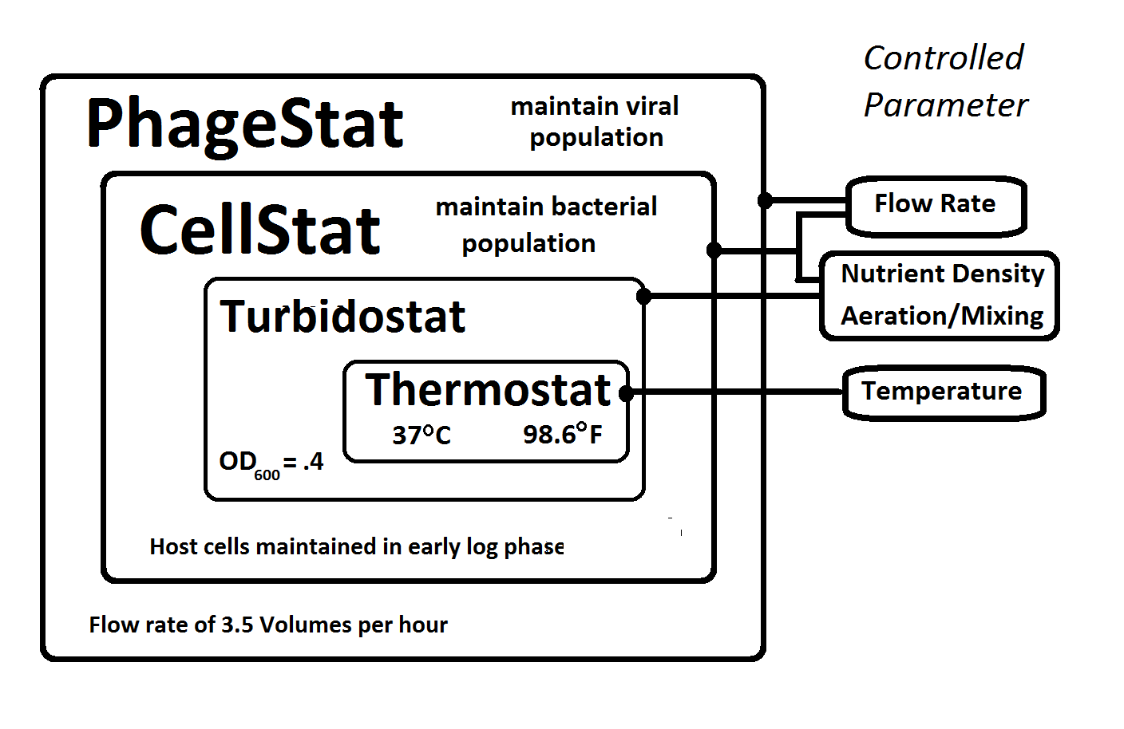
Drawing #2
Elevation View :
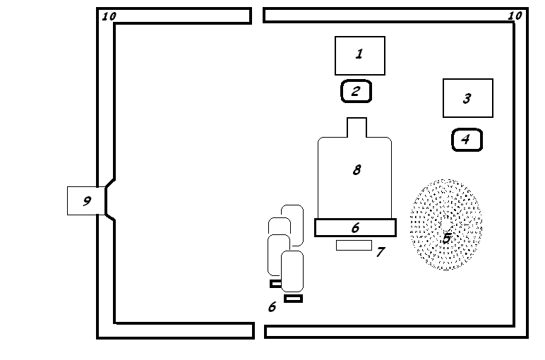

Keywords: image processing, line detection, controlled illumination, turbidity.

Multi-valve control for liquid flow control of multiple
A Laboratory Apparatus for Macromolecular and Biological Evolution

A micro-controller with 10 digital outputs controlling current sources for LED light sources, pumps, and valves; one pulse-width modulated output controlling a current source; one two-wire (SDA/SCL) interface for a PIR temperature sensor, one analog input for rotary valve position sensing.

10 Digital Outputs:
- Heater
- Laser
- Yellow LED light
- White LED light
- Nutrient pump
- Host cell pump and valve
- Inducer pump and valve
- Lagoon outflow pump and valve

1 PWM output: Rotary valve motor

1 Analog input: Rotary valve position sensor

A system for controlling multiple turbidostats and cellstats with minimal medium contact consisting of a dark environmental chamber with an infra-red temperature sensor, a heat source, a multiplicity of light sources under computer control, a digital camera connected to said computer, a multiplicity of liquid pumps, each with a valve whose input and output are in parallel with the pump input and output, an air pump, and stirring means in each of the transparent containers.

A multiplicity of valves each consisting of a stiff rod compressing a soft tube in which the nutrient, cell culture, inducer, or other liquid would otherwise flow freely. A central pointer with adjustable torque which contacts said rods sequentially and flexes them sufficiently to relieve the compression on said tubes allowing liquid to flow freely for a specific time duration. At the end of said duration, the torque being increased to cause the pointer to push past the flexible rod, releasing it to allow it to re-compress said tube, shutting off the liquid flow, whereupon the torque applied to the pointer is immediately reduced to allow the pointer to come into light contact with the rod of the next valve. Said light contact being sufficient for the voltage present on said rod being conveyed to the pointer and then to the analog to digital converter of the computer, allowing the computer to detect the voltage and thereby identify the corresponding valve position of the central pointer.

Image event processing
Image event processing eliminates the need to synchronize lighting changes with image processing or to make special arrangements for technicians to access the apparatus while in use. The controlling computer asynchronously captures images from the apparatus and performs a rapid analysis of the image to determine the lighting conditions. Measurements are made from the image depending upon the lighting conditions as follows:
- Yellow LEDs lighting the containers from below indicates a level detection event
- Red laser light projecting a horizontal beam through the host cell container for turbidity measurement
- Full-spectrum light for images to display on the web page
- Extremely low light (dark) images indicate integration measurement, summing of pixel values over multiple frames, to detect fluorescence or bioluminescence.
- Other phage population density indicators may be used and may be detected from the white light image or integrated from multiple full spectrum or monochromatic images.

The image processing loop calculates levels, turbidity, bioluminescence, and visible light color analysis depending upon the lighting detected in the image stream. The lighting control can be implemented by a simple asynchronous mechanism which gives sufficient times to each of the required lighting conditions. During different phases of the experiment, more frequent turbidity or level measurements may be needed and this can be accomplished by changing the lighting schedule.
An important consequence of image event processing is that incorrect readings will not result from a change in light conditions when a researcher opens the capsule during operation. Images acquired from an open device will be interpreted as full spectrum images and used only to update the user monitoring (e.g. Web) image. Previous turbidity or liquid levels will be considered valid until an appropriate image with the correct lighting is acquired.

A single main processor can support multiple phagestat devices as images are captured from each device at various times and are processed to update the monitored parameters according to the following image identification:

- Fully illuminated image with full color spectrum and normal brightness: Update the human viewable “Web Image.”
- Moderately illuminated image with predominantly yellow coloration: Identify liquid levels.
- Low illumination image with predominantly red (laser) coloration: Use intensity measurement and high contrast blob detection to evaluate turbidity.
- Multiple light sources of different wavelengths, such as red, green, and blue LEDs, behind the primary reactor vessel: Update absorbance data for wavelengths of each point source.
- No detectable illumination: Add image information to integrated image for bioluminescence detection. For example, we add the value (+green – red/2 – blue/2) for each of 80 images to detect green bioluminescence.

Oath or Declaration:
(required for patent application)
Applicant: Inventor (Peter Brandon Reintjes)
The above-identified application was made or authorized to be made by me.
I believe that I am the original inventor or an original joint inventor of a claimed invention in the application.
I hereby acknowledge that any willful false statement made in this declaration is punishable under 18 U.S.C. 1001 by fine or imprisonment of not more than five (5) years, or both.

