Some ideas for
Engineering the Virion

"The Power of Negative Thinking"
Peter Reintjes 5/24/2016

PACE 2.0 introduced Negative Selection to deal with the issue that better binding might simply broaden the range of targets and not make a protein more specific for a particular target. Negative selection against similar targets is a way to gain specificity as well as binding.
Ref: Negative selection and stringency modulation in phage-assisted continuous evolution. Carlson, et al.. Nature, Chemical biology Feb 2014
A smaller genome is highly advantageous to phage (shorter life cycle, lower energy budget, more virions). This deletion of unneeded genes has been a major problem! Genes for anything consistently produced by E. coli will be eliminated from the viral genome. Seems like a problem we can turn into a tool. Here's a possibility:
1) Use only negative selection mechanism (take pIII out of the host Bait plasmid).
2) Put pIII back into phage along with hybrid(Predator), the target binding now being necessary to make the conditions right for a functional pIII.
3) Our new positive selection mechanism is one that generates pIII inhibitor by default and is shut down by desired Predator/Bait binding. This binding turns-off default 'pIII poisoning' (or other anti-viral/negative-selection mechanism).
'By default' can be improved to 'by default, after infection' using the phage shock promoter.
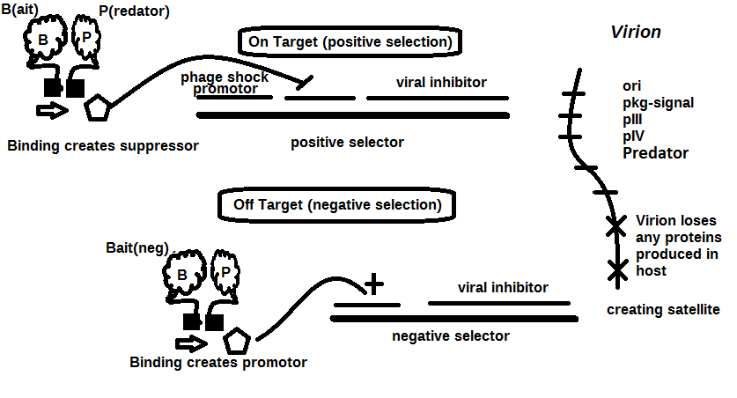
This could not only work, but I think it gets better:
4) Program E. coli (plasmid, genome pro-phage, or pre-infect with “helper-phage” [but no pIII - so no infection response and no pIV which triggers phage shock protein]) to produce most viral proteins by default -- not strictly necessary for the idea above, but may help on the front of keeping the phage from discarding the genes we want by having a near-minimal viral genome (at some point, we will stop calling this construct a phage. It will be more like a satellite).
Having a larger code space in the phage at our disposal will allow us to play with larger proteins – I’m not certain, but I think the physical size of filamentous phage is a kind of thermodynamic restriction, some trade off with the adhesion of the coat protein, possibly. But turning our phage into a minimal satellite (~3 genes + signaling DNA) might allow us to work with larger proteins than anyone else.
We will of course have all the power of multiple negative selection targets to also turn on production of inhibitor, and with the new approach, we can concentrate on the more general purpose negative-selection cassette design, with the idea that a given experiment will use one of these negative selection targets in 'default on' mode, to provide the positive selection.
Working with a large protein, there’s nothing to keep the phage from discarding the sequence for domains that aren’t involved with target binding, unfortunately, this is fundamental to PACE, you may just end up with a few domains of your original protein plus the important hybrid section. The absence of these domains would mean there is nothing to bind with the negative-selection bait and therefore no inhibitor will be created – so the absence of a domain of interest will be indistinguishable from a mutated domain evolved away from binding with the negative selection mechanism (the latter being the thing we wanted). If we truly want to evolve away from some activity – like eliminating a side-effect in a therapeutic, the active site must be the same as the one participating directly in the positive selection binding – The positive selection working to keep it in the phage genome and the negative selection keeping it from binding with a particular (unwanted) target.
Since the positive selector is really a ‘default on’ inhibitor, we can have more than one positive selector and when all of them are activated we get minimal inhibitor production. This could preserve important parts of a large protein in an environment that is trying to strip everything down (I’m not going to pretend that the mechanics of this is easy, finding multiple targets for different parts of a large protein, or how different binding sites of a large protein will still bring the other half of the hybrid into the right position, just saying it might be possible). I’m not even trying to make this fit a specific mechanism like bringing two pieces of acyclase together as the ‘binding signal’.
Can we create multiple (somewhat independent) positive selection mechanisms which can each maintain part of a complex protein in the viral genome? The presence of all of them being necessary to maintain the entire sequence, but allowing for (at least one) of them to improve fitness through improved binding.
This suggests two different kinds of positive selector:
- Modulated response to improve the binding of the particular domain of interest – this is the original positive selection. By controlling the amount of functional pIII, or slowing down any of the processes leading up to phage release. Slowing down phage release could be particularly effective as this is a continuous flow system and hosts are continually washing out.
- Go-noGo which requires the presence of the domain to be maintained. A phage missing a required domain is eliminated – we can interfere with release or poison a coat protein. How can we guarantee the presence of a particular sequence/protein?
One result of multiple positive/negative selectors could be many 'neutral' mutations which slightly improve one while equally diminishing another. This might motivate adjusting the mutation rate down – though probably not down to the limit of one mutation/phage.
For evolution we need a modulated response from the negative selection. The 2014 paper on PACE+negative selection emphasizes this modulated characteristic of ‘pIII poisoning’, so this will be desired of any alternative inhibitor, though we may find a use for a crude 'instant-death' inhibitor as in the Go-NoGo positive selector used to maintain the phage genome.
The most pressing example of this need for a modulated response (since we are now perversely using a negative selection mechanism for positive selection) is the case of late infection, where some of the pIII inhibitor may have been created in the host before the virus gets there. This could be mitigated if the so-called 'default' production of pIII inhibitor is triggered by infection (PS) instead of building up the anti-pIII while waiting for the virus. Now that the virus once again contains its pIII gene, triggering on infection is a nice large signal input without even the possibility of leakage.
I realize it must sound completely crazy to put the pIII back into the phage: and I'm not suggesting it just to get around the Harvard patent (which it may or may not even do, but is something to be considered -- we'll have to see when a patent around the negative selection idea appears), but this seems like a much bigger playground than the idea of having pIII in the host.
Two positives are that it seems easier to modulate inhibitors than pIII production, and these inhibitors won't affect infectability (at least the early stages of infection), or can be made to be dormant prior to infection.
When M13 was mutated to reduce its number of DNA bases (from 6.4 knt to 221 nt), then the number of p8 copies was decreased to fewer than 100, causing the p8 coat to shrink in order to fit the reduced genome. The phage appear to be limited at approximately twice the natural DNA content. However, deletion of a phage protein (p3) prevents full escape from the host E. coli, and phage that are 10-20X the normal length with several copies of the phage genome can be seen shedding from the E. coli host.
Reference for the idea of minimal size for DNA bacteriophage:
1) Specthrie, L; Bullitt, E; Horiuchi, K; Model, P; Russel, M; Makowski, L (1992). "Construction of a microphage variant of filamentous bacteriophage.". Journal of Molecular Biology 228 (3): 720–4. doi:10.1016/0022-2836(92)90858-h. PMID 1469710.
Anti-viral modulators

Today, "anti-viral" technology is really about human/animal viruses, so maybe this is more of an analogy than literal. But since we clearly aren't trying to prevent infection, the early-stage viral intervention ideas are of no use, only the later ones.

We will not be restricted to "pIII poisoning" as the only inhibitor, here is a list of anti-viral intervention points as a starting point to discuss inhibitor design. Viral inhibition points that are too early (e.g. prevent infection) are crossed out.

Slowing metabolism of the host is the ultimate anti-viral

Anything that slows down the host can be considered anti-viral for our purposes. After all, we're not trying to 'cure' the E. coli of it's infection, just reduce the number and/or unfectiousness of virions released into the lagoon. This really broadens the idea of an inhibitor and might be easier than other anti-viral approaches, since we can even kill the patient, if needed. It may be hard to keep this in mind; The needed inhibitors are just anti-viral-propagation, and not necessarily pro-host.

To use a system where a significant amount of the inhibitor may be present in the early stages, we will probably want to ramp up the flow rate, starting from a near stagnant lagoon (where slow growing things can fester) to a PACE-like flow rate that washes out the slowest-growing, inhibited E. coli, maybe even before they release any phage. Linking total inhibitor concentration to bio-luminescence would be useful for us to control the flow rate and it should be dead easy – simply producing LuxA/B (after phage shock) will cause luminescence to correlate with metabolic rate – the very thing affected by our inhibitors.

This has been leading me to think about the bacteria+temperate-phage as an organism that receives an infectious satellite from a previous generation, tests it for a particular property while creating modified versions and then releases the new satellites in proportion to how well the tested property led to the reduction of an inhibitor. Anything which slows release of the new infectious particles is a potential inhibitor. An agent which increased the rate of production of the viral particles would be a positive selector. If the inhibition is acting on the bacterial metabolism, the phage/satellite cannot easily mutate to get around it – it can only mutate something that will shut off the inhibitor – and of course, that is the easy path we've given it for its evolution. It may come up with a novel way of shutting off the inhibitor. But that kind of novelty is reserved for Evolution (with a big E), instead of the tinkering that we are doing (is that a valid distinction?).

What I’m really trying to do is broaden the potential mechanisms to anything that reduces the
number of released phage particles, (yes they are phage inhibitors, but really we can do any number of things to the E. coli to get less phage production, no?) Think of all the things that might do this, affecting any mechanisms in the E. coli that would slow it down – or rather slow anything that leads to particle release. Attacking the transcription/expression mechanisms (we don’t care about future generations of this particular E. coli). There are many things that have nothing to do with the genes left in the phage/satellite, and so reduce the chances of an alternative evolutionary ‘escape’.

Steve: I think that sculpting expression of an inhibitor such that phage production runs from just above wash out to full production based on the two hybrid strength will be tricky and time consuming.

To help with this, I suggest ramping the flow rate from near zero to full flow rate based upon
Lux feedback. Where lux is a measure of the metabolic performance of infected E. coli, as a proxy for phage release.
1) Un-infected E. coli produce low lux levels,
2) E. coli infected with a phage that doesn’t have a good binding produces lux slowly. E. coli is crippled by Phage Shock triggered inhibitor that isn’t suppressed by good Preditor/Bait binding.
3) E. coli infected by phage that successfully suppresses inhibitor produces lux according to
its ‘health’.

Your thesis presumes that it would be facile to create phage inhibitors. Of the possible mechanisms you list near the end, I think antisense, and possibly the expression of negative interfering versions of the capsid protein might qualify to be facile enough.

In the case of antisense, if it's a large antisense transcript, it might be hard for the virus to evolve around it. So maybe that could be done in a straight forward way. If it was a short antisense transcript, the virus could evolve around it. It would be possible, as you suggest, to offload the target transcript into some plasmid or other form for host expression. Then the target of the inhibition would be replenished with the host, preventing mutagenesis of the target from becoming a factor.

Off loading phage proteins onto plasmids may be tougher than you're imagining. The problem is that that the complementing plasmid will be unstable. Using phage shock promoters to try to keep expression off till needed seems like a good solution to that.

Steve Hardies: I think trying to offload very large numbers of phage proteins to host expression would be almost impossible. You'd be tied up forever trying to replace all the promoters with phage shock promoters and getting the relative expression right. People always use M13 helpers for that sort of
purpose, because growth of the helper as an M13 provides selection to keep the genes. But you'd have to make it a gpIII- helper, and either make it immune to the hybrid modulated inhibition, or provide some complicated system to constantly feed helper into the lagoon. Seems complicated.

Before cell entry
Entry inhibitor
Uncoating inhibitor
During viral synthesis
Reverse transcription
Integrase
Transcription
Translation/antisense ??
Translation/ribozymes ??
Protein processing and targeting
Protease inhibitors
Assembly
Release phase
