single-use bioreactor Take advantage of single use bioreactor technologies by including
internal sensors enable single-use bioreactor vessels with

The advantages of single-use products include lower cleaning and sterilization costs, less cross-contamination, increased operational flexibility leading to lead times.
The disposable bioreactor market is exploring many alternatives to stainless steel and glass reaction vessels. Our exit flow fluorometer allows the main (lagoon) reaction vessels to be made of any plastic with sufficient translucency for the level detection.
Previous designs required high-quality glass to allow for bioluminescence detection.
Single-use technologies today make up an already large and growing percentage of small- and mid-scale biopharmaceutical manufacturing, clinical testing, and research.

References
- www.marketsandmarkets.com/Market-Reports/single-usebioreactor-market-49113750.html
- www.thatsnice.com/article/magazine/156

January/February 2016

http://www.marketsandmarkets.com/Market-Reports/single-use-bioreactor-market-49113750.html

The single use bioreactors (SUBs) market is expected to grow at a double digit CAGR of 18.4% to reach $470.9 million by 2019 from $202.5 million in 2014. Major factors fueling the growth of this market are low requirements of capital investment for setting up the facility, reduced complexity of automation, and energy efficiency. However, regulatory concerns regarding the mixing process, contamination by leachables and extractable, and difficulties in meeting good manufacturing practices (GMP) standards are restricting the growth of the SUBs market.

Single Use Bioreactor Market by Product Type (Recombinant Proteins, Monoclonal Antibodies), Cell Type (Bacteria, Yeast), Technology (Stirred SUB, Single Use Bubble Column Bioreactor), End User(Bio pharmaceutical Manufacturers) - Global Forecast to 2019

The single use bioreactors (SUBs) market is expected to grow at a double digit CAGR of 18.4% to reach $470.9 million by 2019 from $202.5 million in 2014. Major factors fueling the growth of this market are low requirements of capital investment for setting up the facility, reduced complexity of automation, and energy efficiency. However, regulatory concerns regarding the mixing process, contamination by leachables and extractable, and difficulties in meeting good manufacturing practices (GMP) standards are restricting the growth of the SUBs market.

Double-Digit Growth Predicted In Single-Use Bioreactor Market
http://www.processingmagazine.com/processing-e-news/pharmaceutical/double-digit-growth-predicted-in-single-use-bioreactor-market/

Turbidostat detail
Passive internal mirror which enables a single-use bioreactor to take advantage of the external turbidometer.

Communications architecture:
Bluetooth communication is particularly convenient as it allows the controlling computer to poll the local environment for active devices. Activating the meniscus lights on each of these devices sequentially to identify and locate the devices in the visual field.

Autosamper detail

Low-pressure parallel pinch valve for autosampling

Luminometer detail

Five channel luminometer consisting of an opaque chamber to hold five parallel 1mL glass pipets within the visual frame of a USB microscoping camera.

------------

Evolution in Action: Educational Programs

Demostrations of Evolution as an industrial process and workshops on building phagestats, possibly in collaboration with a local makerspace with a DIY-Bio group.

Evolution as a Service.

Enable a large scale with expertise in two-hybrid, three-hybrid protein construction, plasmid design for induction of mutation, affinity selection, and negative selection. This business model is one proposed for Innatrix, whereby a client with a target protein

The service organization can offer a two-phase payment system whereby the client makes a non-refundable initial payment for the evolutionary process to be applied to search for an enhanced sequence which meets certain requirements of affinity and selectivity. After this phase, and evaluation of the properties of the initial sequence, the client has the option of making a second payment for all rights to the novel sequence. If the sequence discovered

The service organization can accept contracts with an

Modular bio-reactor construction:

The phagestat is an exemplary example of a modular bio-reactor consisting of a single cellstat, multiple phagestat lagoons, an autosampler/bioluminescene detector controlled by a main computer with a camera.

With the use of Bluetooth/Wifi to eliminate control wiring between subsystems, it is possible to reconfigure these systems by removing or installing devices and allowing the main computer to detect the new configuration. Fluid connections can be discovered or verified by interrogating and controlling the new devices and verify via visual feedback.

The cost of this reconfigurable bio-reactor will approaches the target costs of
More importantly, flexible arrangements of such components will reduce operating costs.

-------------------
Single Use Bioreactors

Single Use Bioreactor Market worth $470.9 Million by 2019

The Single Use Bioreactor Market by Product Type - Global Forecast to 2019´ provides a detailed overview of major drivers, restraints, challenges, opportunities, current market trends and strategies impacting the global market along with estimates and forecast of revenue.

The global single use bioreactor (SUBs) market is poised to reach $470.9 million by 2019 from $202.5 million in 2014, at a CAGR of 18.4% from 2014 to 2019 [MarketsAndMarkets].

Factors such as low operational costs, lesser requirement of monitoring and maintenance than traditional bioreactors, ease in culturing of marine microorganism such as algae, and low energy consumption are the factors driving the growth of the SUB market. In addition, the tremendous growth potential of the biologics market is offering robust growth opportunities to market players. However, low volume capacity and lack of availability of sterilized sensors are hindering the growth of this market.

The market is segmented on the basis of molecule type, type of cell, technology, end user, and region. Based on molecule type, the market is segmented into monoclonal antibodies (MAbs), vaccines, gene therapy, recombinant proteins, stem cells, and others (growth factors, interferons, antisense, RNA interference). MAbs accounted for the majority of the global market in 2014.

On the basis of type of cell, the market is broadly classified into mammalian cells, bacterial cells, yeast cells and others (insect cells and plant cells). Mammalian cells are the largest and fastest-growing segment of the market. The large share of this market can be attributed to the higher efficacy of biomolecules expressed by mammalian cells.

The technology segment is categorized into the wave-induced motion SUBs, stirred SUBs, single-use bubble column bioreactors, and others (single-use reactors with vertically perforated discs and single-use hybrid reactors). The wave-induced motion SUB segment accounted for the largest share and is estimated to grow at the fastest rate in the forecast period.

Based on end users, the market is segmented into R&D department (CROs, biopharmaceutical manufacturers, and research institutes) and biopharmaceutical manufacturers. The R&D end-user segment accounted for the major market share in 2014. The biopharmaceutical manufacturers segment, on the other hand will witness the highest growth rate.

On the basis of region, the market is segmented into North America, Europe, Asia-Pacific, and Rest of the World (RoW). In 2014, Europe is expected to account for the largest share of the market, followed by North America. Both markets are estimated to register double-digit growth rates over the next five years. However, Asia-Pacific is expected to register a higher growth rate during the forecast period, owing to huge investment opportunities available to biologics manufacturers in this region. Growth of the SUB market in the Asia-Pacific region will revolve around China, India, Australia, South Korea, Taiwan and countries in the Middle East.

Major players operating in the SUB market are Thermo Fischer Scientific, Inc. (U.S.), Sartorius AG (Germany), Merck KGaA (Germany), GE Healthcare (U.S.), and Pall Corporation (U.S.).

[Source: Markets and Markets, Inc.
----------
[Processing Magazine]FEBRUARY 2, 2015

Single use bioreactors (SUBs) are used in research and development (R&D) carried out by biopharmaceutical manufacturers, research institutes and contract research organizations (CROs), as well as in biopharmaceutical manufacturing.

It's a growing market, driven by the low capital investment required to set up a facility, reduced complexity of automation, and energy efficiency. A new report by Research and Markets predicts that the global SUB market will expand at a compound annual growth rate (CAGR) of 18.4 percent over the coming years, reaching a value of $470.9 million by 2019 compared with $202.5 million in 2014.

Holding back the market to some extent will be regulatory concerns regarding the mixing process, contamination by leachables and extractables, and difficulties in meeting standards on good manufacturing practices (GMP).

Monoclonal antibodies (MAbs) represent the biggest segment of the single use bioreactor market by molecule type. The research firm attributes the high growth rate of this segment to rising demand for SUBs in small-scale manufacturing of MAbs as a result of low investment costs, low requirement of manpower and reduction in time-consuming changeover procedures.

In terms of cell type, the mammalian cells segment of the market is the largest and fastest-growing segment due to the successful employment of SUBs for mammalian cell cultures for clinical and commercial drug manufacturing.

The report looks at the SUB market on the basis of molecule type (monoclonal antibodies [MAbs], vaccines, gene therapy, recombinant proteins, stem cells and others [growth factors, interferons, antisense, RNA interference]), type of cell (mammalian cell, bacterial cell, yeast cell and others [insect cell and plant cell]), technology (wave-induced motion SUBs, stirred SUBs, single-use bubble column bioreactors and others [single-use reactors with vertically perforated discs and single-use hybrid reactors]), end users (R&D [CROs, biopharmaceutical manufacturers and research institutes] and biopharmaceutical manufacturers) and region (North America, Europe, Asia-Pacific, rest of the world).

Europe dominates the SUB market, followed by North America. But growth will be strongest in the Asia-Pacific region over the next few years.

Key market players are US companies Thermo Fischer Scientific, Inc., GE Healthcare and Pall Corporation and Germany's Sartorius AG and Merck KGaA.

-----------
Advantage of Single-Use Products

The advantages of single-use products in these situations are as obvious, as they are wide-ranging. They include lower cleaning and sterilization costs due to shorter downtimes. Other advantages include a lessened cross-contamination risk, as well as the capability for lower volumes per batch. Overall, the increased operational flexibility and shorter lead times can lower capital expenditure costs.

The disposable-bioreactor market has become quite dynamic, with new entrants and variants continually being tested as alternatives to stainless steel for commercial applications. Single-use technologies today comprise a large percentage of small- and mid-scale biopharmaceutical manufacturing, particularly in clinical testing and research and development (R&D), but that is expected to grow as more manufacturers are seeing it as a competitive edge.

International suppliers of integrated solutions for the biopharmaceutical industry have to deal with fermentation, cell cultivation, filtration, and purification. The growing demand for single-use bioreactors have led biotech companies to develop a bag that meets all the design criteria offered by conventional stainless steel reactors, giving birth to the first completely disposable and scalable solution on the bioreactor market. In essence, a chamber optimized for cell cultivation using stirred motion mixing technology, as in reusable bioreactors, and suitable for a large variety of cell types, such as mammalian and insect cells.

A Question of Scale

While such disposable bags are often found on the lab bench holding as little as ten liters of liquid, bioreactor bags have now been scaled up to hold a total volume exceeding 2,000 liters. This naturally incurs some technical challenges.

For example, the aim to retain the adequate geometry and impeller design as well as the tip speed and power input per volume. However, on a scale-up of this size, a huge amount of torque is applied to the stirrer inside the reactor and a new drive assembly for the mixing technology inside the bag is needed.

Particular attention has to be paid to specifically targeting the assembly requirements without jeopardizing quality and compliance. A conventional planar coupling is not sufficient, but a radial magnetic coupling with an assembly incorporating a special bearing provides an excellent solution. The complete assembly·consisting of the radial magnetic coupling and a polyethylene port, which is welded onto the bag·ensures a hermetical sealing between the bag and the external environment. This eliminates the risk of contamination.

The Future of Single-Use Technologies

As single-use technologies such as disposable bioreactor bags, mixers, and other disposable vessels, start to proliferate the market, expect to see more manufacturers look at methods and technologies to differentiate. There will be enhanced supply chain security, cleanliness, integrity testing (to avoid leaks), visibility (have it be crystal clear), and delivery programs for on-time delivery.

In the future, single-use technologies will be seen as an enabler that will support the expansion of drug development and manufacturing applications on a global scale for varied disease treatments. As developing economies strengthen, their population will influence the need for accessing medications that were not available to them previously. This will help drive the growth of single-use technologies. Companies can benefit from single-use bioreactor bags because it enables more manageable processes·allowing them to be flexible and adapt to changing product needs.

References

www.marketsandmarkets.com/Market-Reports/single-usebioreactor-market-49113750.html
www.thatsnice.com/article/magazine/156
About Luis Tissone
This article can also be found in the January/February 2016 edition.

http://www.reportsnreports.com/reports/431771-global-bioreactors-industry-2015-market-research-report.html
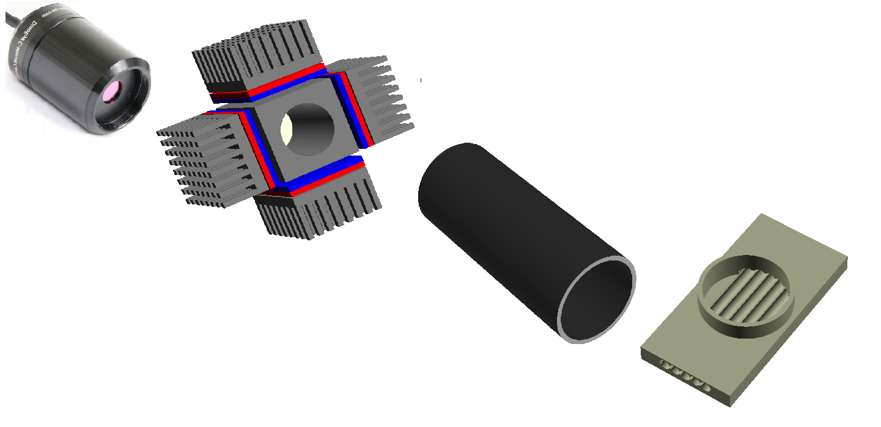Illustration 1: Camera, cooling unit with peltier junctions, blackout tube, 5-channel optical chamber

