Biology Electronics Software Music

Yeast → Laser → Sensor → Raspberry Pi → SuperCollider → Music

Although something similar might be achieved by a guitarist having a few beers, a fully automated system has the advantage that when we project this idea into the future, we can't imagine that the same computer operating the Fermentophone would also be driving a car.

The main controller is a Raspberry Pi ($35) with a bluetooth dongle ($4.95). On start-up it makes contact with the bluetooth controller ($3.00) on the Sensor which is monitoring temperature, turbidity, and gas production.

The use of current open-source computer systems (Raspberry Pi, Arduino), plus the latest in open-source sharing (Git) means that anyone interested in this exhibit can download the source and see exactly how it is working. With the Git program they can use the command:
“git clone https://github.com/eatoin5hrdlu/Brewhaha.git“

to get a copy of the source code and this document.

In addition to the software and schematics the CAD model and 3D printer files for the non-contact sensor are also included here.

Sensor Package
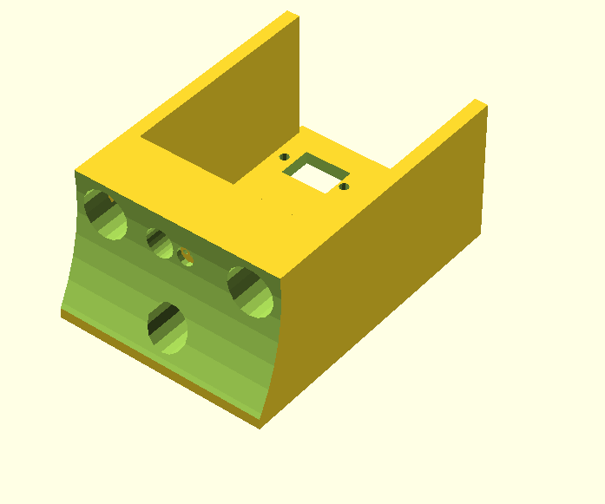Illustration 1: Turbidity/Temperature Sensor Package

Mirror Assembly

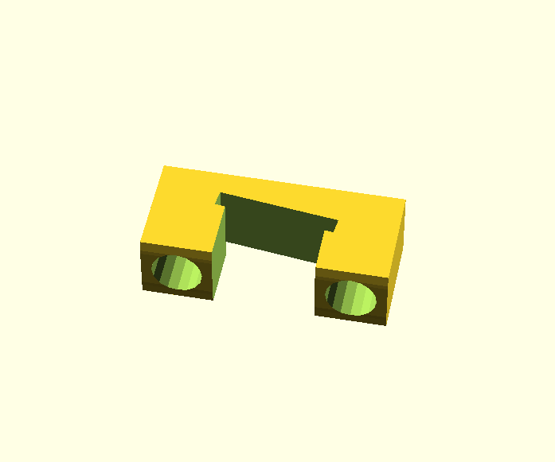Illustration 2: Internal Mirror Assembly for Turbidometer

Sensor Synthesizer

Bluetooth

To set up a Raspberry Pi as a Bluetooth host:

apt-get install bluez-utils bluez-tools blueman libbluetooth-dev

Then:

hciconfig

will give you the hci device number (say hci0) and

hcitool scan

will show you available bluetooth devices

If hcitool scan produces : 98:D3:31:30:2A:D1

then:

bluez-simple-agent hci0 98:D3:31:30:2A:D1

will allow you to pair with that device.

Using the command line instead of blueman-manager(GUI) allows you to set this up on an IPE (blackout proof) version of raspian.
Once your software is installed and tested, you type:

ipe-ro

And the root file system becomes read-only, protecting your SD file system from power outages.

Time Compression vs. Instantaneous Measurement

As the fementation progresses, the gas production (rhythm) will increase and decrease slowly, as does the temperature. Turbidity will probably only increase, although there are clarifying agents we can introduce to settle out particles (or it may happen spontaneously). The time scale of these changes is many hours (days?) so the Fermentophone will have two modes of operation.

Real time: Sounds will be produced to represent the current values of temperature, turbidity, and gas production.

Cumulative: A time-compressed playback of the parameters measured over a longer period of time (15 minutes, 1 hour, four hours, etc.). For example, a 30-second playback of the cumulative data could occur every few minutes with the real time data providing a background.

SuperCollider on the Raspberry Pi
These helpful instructions were derived from Sam Aaron's Website

Initial Setup
First, let’s get some base dependencies installed:
- Get a terminal connection to your Pi (either by sshing into the Pi itself or by opening up the Terminal app).
- Update your packages: sudo apt-get update
- Install Jack 2: sudo apt-get install jackd2
- Install supercollider: sudo apt-get install supercollider

Install Jack2 v1.9.8
Under Linux, the latest versions of SuperCollider requires Jack to make sound. Unfortunately, the version of jackd2 that apt-get just installed is currently broken. If you try running it, you get a remarkably unhelpful Bus Error message as it dies due to struct alignment errors.
The solution: either wait until Jack or the compiler (whichever turns out to be the culprit) is fixed, or compile and install an older version which doesn’t suffer from the errors. It just so happens that version 1.9.8 works perfectly well. So, either download the source and compile it yourself, or follow these steps to set up a pre-compiled jackd2 binary available here.
- Move into your home directory: cd ~
- Fetch the Jack binary: wget http://sam.aaron.name/files/jack_for_pi_v1.9.8.tar.gz
- Unpack the binary: tar xf jack_for_pi_v1.9.8.tar.gz
- Update your PATH: export PATH=/home/pi/local/bin:${PATH}
- Ensure the library is visible: export LD_LIBRARY_PATH=/home/pi/local/lib
- Test that jackd points to the newly downloaded version: which jackd should point to /home/pi/local/bin/jackd

Start Jack and SuperCollider
Next we need to do a bunch of things:
- Start Jack in dummy mode - i.e. it doesn’t talk directly to any sound card but can be connected to from external apps.
- Start alsa_out which does talk directly to the sound card, and can be connected to Jack to receive audio. (This is necessary because the Pi’s soundcard doesn’t currently support mmap which is required for direct Jack -> sound card connectivity).
- Start scsynth, the SuperCollider server.
- Connect both left and right channels within SuperCollider to alsa_out.
This can all be achieved by copying the following to a file such as ~/bin/start-sc:
#!/bin/bash

jackd -m -p 32 -d dummy &
sleep 1
alsa_out -q1 2>&1 > /dev/null &
sleep 1
scsynth -u 4555 &
sleep 1
jack_connect SuperCollider:out_1 alsa_out:playback_1 &
jack_connect SuperCollider:out_2 alsa_out:playback_2 &
Now, give your file an execute bit: chmod u+x ~/bin/start-sc and start it up:
~/bin/start-sc
If you see the following, SuperCollider’s server, scsynth, should be running and listening for UDP packets on port 4555 (don’t worry about the Zeroconf warning):
jackdmp 1.9.8
Copyright 2001-2005 Paul Davis and others.
Copyright 2004-2011 Grame.
jackdmp comes with ABSOLUTELY NO WARRANTY
This is free software, and you are welcome to redistribute it
under certain conditions; see the file COPYING for details
JACK server starting in realtime mode with priority 10
JackDriver: client name is 'SuperCollider'
SC_AudioDriver: sample rate = 48000.000000, driver's block size = 1024
SuperCollider 3 server ready..
Zeroconf: failed to create client: Daemon not running

