Spectrum Analysis:

Cellular Traffic near Sox Stadium

Efthimios Atsaloglou

Computer Science Department

Illinois Institute of Technology, Chicago, Illinois

eatsalog@hawk.iit.edu

Richard Shepherd

Computer Science Department

Illinois Institute of Technology, Chicago, Illinois

rshepher@hawk.iit.edu

***Abstract* – Between the dates of August 3rd–16th of 2015, the WiNCom research lab at The Tower on IIT’s campus analyzed the wireless network spectrum, more specifically how the power at discrete frequency ranges fluctuated over time. The goal of the project was to analyze certain frequencies, more specifically the PCS band (1930–1990 MHz) and AWS band (2110–2155 MHz), and conclude as to whether or not the network fluctuated during times that games were held. For the time periods selected, four-hour windows of time were selected such that half of the times included the start of the game, and the other half included times that games were not occurring. The selected times for when games were not occurring were the same time of the day as to help understand the typical network frequency allocation.**

*Index Terms* – 3G, 4G, cellular traffic, cellular data, GSM, PCS band, AWS band, White Sox, spectrum analysis, denoising, moving average filter, time series, heatmap.

**Goals & Objectives**

The purpose of the project was to examine the power across multiple cellular frequencies during specific time periods, and to conclude as to whether or not Sox Games impact the volume of cellular traffic in the surrounding region. This was accomplished through contrasting time periods when games occurred versus when none were occurring, and to conclude if there is typically a peak in cellular traffic before or during a game. Spectrum analysis data was continually collected by the WiNCom research facility at the IIT Tower, of whom we were mainly in communication with Dr. Roger Bacchus and our Professor, Dennis Roberson.

The following are the primary goals of the project: becoming familiar with the pertinent software; using a heatmap to plot power across the spectrum in order to isolate pertinent frequencies; using a time series to plot the entire power of a frequency band over time; and making a conclusion as to whether or not Sox games impact cellular traffic on these frequency bands. The first involved learning how to use HDF Compass to visualize the data, and downloading Anaconda Python in order to have access to libraries to interact with the data file. For heat maps, displaying data with interpolation can make it look a little more clear which makes it easier to locate exact start / end frequencies for a particular band, whereas the raw data is a better visualization of the cellular spectrum allocation.

**Hypothesis**

Our initial hypothesis is that, in the control time of 8:00am - 12:00pm from August 14th-16th, 2015, that there would be a gradual increase in traffic in the time series plots due to more people becoming awake and contributing to the local cellular network. This effect would be appear in both the PCS and the AWS band, as people producing calls and using data on the 3G and 4G networks should increase in this time frame.

The hypothesis for the game time is that there would be a peak in traffic when the game starts, and the peak will be compared to a change of 1 - 1.5 dBm from the norm for the PCS band experiment. Our alternative hypothesis for the game time is that if there is random peaks and troughs throughout the specified four-hour period, or no significant peak or trough, then we would consider the data to be inconclusive.

**Handling The Data**

For the project, we were given a 27 GB file which contained the powers at each frequency band from August 3rd-16th of 2015. To isolate a frequency at a particular commercial band, it involved figuring out which rows in the file corresponded to the start and end frequency of our bands, as well as which columns related to the Unix timestamp for the start and end of the polling period. To isolate these particular rows and columns, the frequencies were evenly separated by 19531.25 Hz, which made it easy to calculate:

***Eq. 1 – Calculation used to get row number***

...but there were many instances of dates that skipped more seconds than usual. The usual timestamp difference was 0.67391 between columns, so doing a similar calculation as for frequency got us close:

***Eq. 2 – Calculation used to get column number***

...but we needed to manually adjust it from there to get the start and end times.

The original graph’s x-axis was originally labelled with the index in the array, so we solved for the target frequencies for sub-bands using the x-axis values in the heatmap as well as the original index for the range:

***Eq. 3 – Calculation used to get row number of sub-bands***

We decided to contrast consistent four-hour periods for the control case (no game occurring) versus test cases, which were four-hour periods that included two hours before a game to help us notice any anomalies leading up to the start of each game. This method is further explained in the following section.

**The Process**

For this project, we had to deal with data such as power in dBm and time in timestamp. Initially we were planning of selecting big parts of the spectral data and then compare it with each other. Though we found more effective and significant to compare three consecutive games between the Chicago White Sox and the Chicago Cubs. Therefore we started out by selecting the different bands we would focus on. We decided to work on the PCS band which contains data on the GSM network (1,930 - 1,990 MHz), and the AWS band which contains data on the 3G and 4G networks (2,110 - 2,155 MHz).

Our next goal was to use a software to handle the data and generate graphs. Initially we used the HDF Compass software, since our data was in the software’s format. We looked at the data to understand how it is stored, such as time being in Unix timestamps and the power at a particular frequency in dBm. For the time series graphs, all powers needed to be converted from dBm (logarithmic) to Watts in order to be added linearly, and then back to dBm afterward. For instance, it takes ten instruments playing at the same intensity in order to double the perceived volume, so summing up the power linearly will not work properly (not to mention that many powers will be negative, which would subtract from the sum). On the x-axis of the time series, the timestamp was converted to a date so it could be viewed in military time for the local timezone (UTC-6:00), which makes it easier for laymen to comprehend the graph.

We used the software Anaconda Python, and more specifically the Pyplot library, to write the code and generate our heatmaps. The heatmaps focused on frequency and time, and were used to isolate specific frequency ranges (only part of the entire band) where there was a high rate of traffic. Finding the frequencies was critical as we were able to apply it in all our plots, generate smaller portions of the band, and look at how the power across the frequencies changed over time.

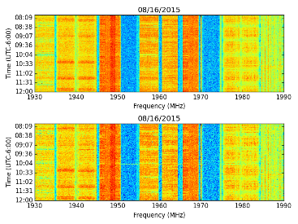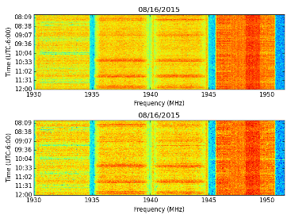

***Fig. 1a – Entire Band 08/16/2015, 08:00-12:00, 1930-1990 MHz***

***Fig. 1b – Sub-Band 08/16/2015, 08:00-12:00, 1930-1951 MHz***

Then our next objective was to remove the randomness and noise in the data. There are multiple ways to filter data, such as low / high pass filters, wavelet analysis, and moving averages. However we chose to only use moving average, primarily since it was easy enough to adjust. This was preferable since we were dealing a lot of data and it could be uniformly applied to every time series graph without the need for individual adjustment, which also kept the results consistent. For the filters themselves, we uniformly took the averages of groups of 150 elements as there were almost 9,000 elements in total.

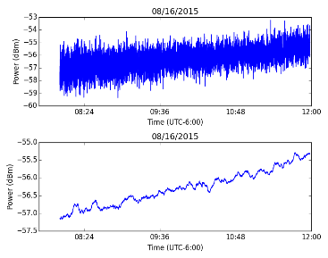

***Fig. 2 – Moving Average - 08/16/2015, 1930-1951 MHz***

Looking above, it is pretty easy to see the benefits of applying the moving average filter to the data. Initially, the data was incredibly noisy and it was nearly impossible to detect any trends. If anything, the data almost appeared flat and without any significant trend. After applying the filter, it became much easier to notice that the noise was less evident further in the graph, and the noise was actually masking a reasonable upward trend.

This particular trend, we’ve learned, is predominantly common across the bands (near-all in PCS, many in AWS) from 8:00am local time to noon. We postulate that this is the result of more people gradually becoming awake and contributing to the local cellular network. Noticing this anomaly, it is the benchmark we used to determine if a surge in traffic is actually an anomaly, which is to say a difference of about 1.5 dBm than the norm. More specifically, if we can detect a similar spike during the middle of the day where there is a significant reduction in people waking up / falling asleep, then it is incredibly likely for the surge in traffic to be due to the White Sox game.

Lastly to mention, as computer science majors we found a way to optimize the output of the graphs, as there are 48 each. Handling the labeling, date and frequency ranges, and naming of each file would have taken a while by hand, so we wrote a Python script that generates all of the output given a list of parameter values. The script is included in the attachments, and can conceivably be modified to generate other graphs for any date / frequency range on any of the files.

**PCS Band** – **1930-1990 MHz**

The AWS band generated expected and unexpected results in general. The heatmap for all the data was the same. It allowed us to know in which specific parts of the band with high traffic as observed below. Using (eq. 2), these are the indices for the frequencies for the 1930-1990 MHz band:

(1,930,000,000 - 1,700,000,000) / 19531.25 = 11776

(1,990,000,000 - 1,700,000,000) / 19531.25 = 14848

Plotting the heatmap with these frequencies over a four-hour period (08/14/2015 shown below), this is the output:

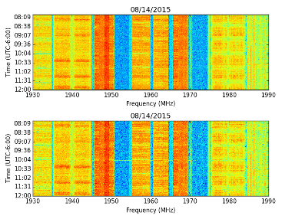

***Fig. 3a – HeatMap for 1930-1990 MHz***

Looking at the heatmap is how we decided to select the frequency ranges from 1930-1951.5 MHz, 1954.4-1969.1 MHz, and 1973-1990 MHz. More specifically, the original graph’s x-axis was originally labelled with the index in the array, so we solved for the target frequencies for sub-bands using the x-axis values. The calculated frequencies are below using (eq. 3), followed by the heatmaps for these new ranges:

= 1955.4 MHz

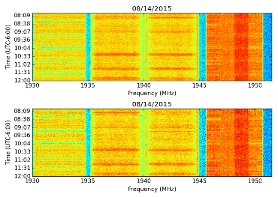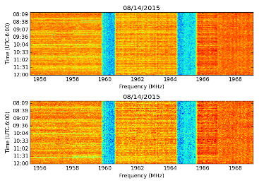

***Fig. 3b – HeatMap for 1930-1951.5 MHz***

***Fig. 3c – HeatMap for 1955.4-1969.1 MHz***

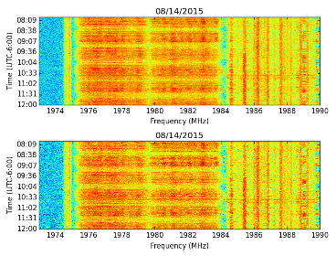

***Fig. 3d – HeatMap for 1973-1990 MHz***

**PCS Band** – **08:00**-**12:00**

This particular time was selected for two main reasons: there were no Sox games during that time period to discover the impact (control data); also, people waking up in the morning and increasing cellular traffic is an amazing benchmark to contrast the impact on the cellular network, as well as comparing the power of the band after it stabilizes at noon to any potential increase / decrease during the start of Sox games. As stated before, the difference in the PCS band averaged around 1-1.5 dBm (-55.5 to -54 dBm, -65.5 to -64 dBm, and -59.2 to -58.2 dBm for the sub-bands on 08/16/2015), which is the aforementioned benchmark for the sub-bands.

All three dates of the entire PCS Band performed pretty consistently during the time period (08:00-12:00 shown):

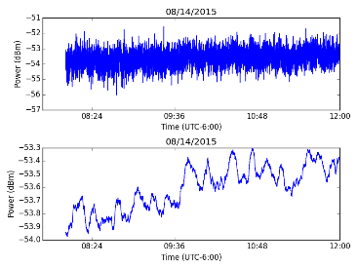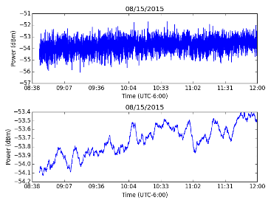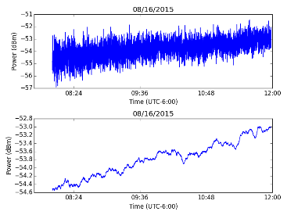

***Fig. 4 – Time Series for 1930-1990 MHz***

Those particular dates (August 14th-16th, 2015) were selected for two main reasons: there were three consecutive games scheduled, so we could track the cellular activity over that time period and also the Chicago rivalry, so we assume that there would be high traffic during the game period due it.

We have also observed that the individual sub-bands perform similar to the whole band, as they all typically exhibit a consistent, positive slope upward that stabilizes around noon.

**PCS Band** – **Game on 08/14/2015**

This first section shows the 1930-1951.5 MHz band, which only increases by a little more than 0.5 dBm over the time period during the control (-56.5 to -56 dBm), but increases from that point to its peak by over 2.5 dBm at the start of the game (-56 to -53.5 dBm).

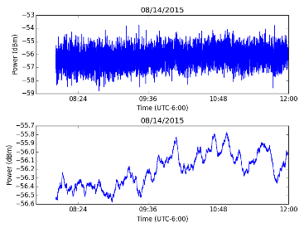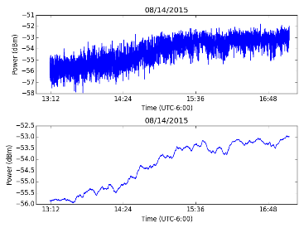

***Fig. 5a – Time Series for 1930-1951.5 MHz***

***(Control vs. Game Time)***

The second section shows the 1955.4-1969.1 MHz band, which only increases by more than 0.7 dBm over the time period during the control (-58.8 to -58.0 dBm), but increases from that point to its peak by over 1 dBm at the start of the game (-58.4 to -57.2 dBm).

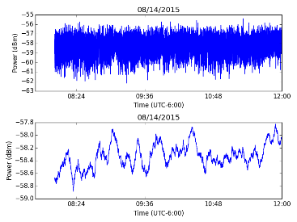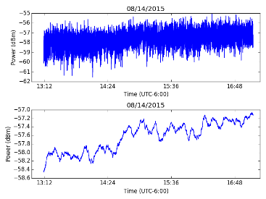

***Fig. 5b – Time Series for 1955.4-1969.1 MHz***

***(Control vs. Game Time)***

For the last section, the 1973-1990 MHz band, the power only increases by a little more than 1.5 dBm over the time period during the control (-65.6 to -64.0 dBm), but peaks at the start of the game by over 2 dBm (-64.0 to -61.8 dBm).

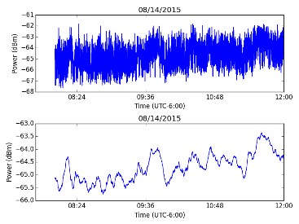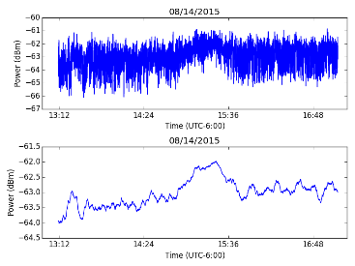

***Fig. 5c – Time Series for 1973-1990 MHz***

***(Control vs. Game Time)***

Across all three of these frequency ranges, the control is consistently on a positive slope with a relatively small increase over the period. Additionally, there appear to be peaks at the start of the game that are much stronger than the increases in the control, on the order of 1.5 to 2.5 dBm at that. These peaks appear to be sustained in the first two sub-bands, whereas the third plummets back to usual traffic.

**PCS Band** – **Game on 08/15/2015**

This first section shows the 1930-1951.5 MHz band, which only increases by a little more than 0.5 dBm over the time period during the control (-56.5 to -56 dBm), but increases from that point to its peak by over 2.5 dBm at the start of the game (-56 to -53.5 dBm).

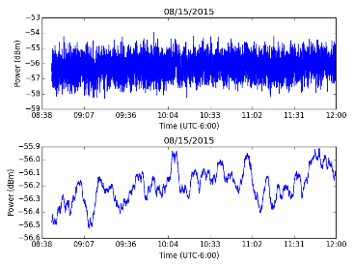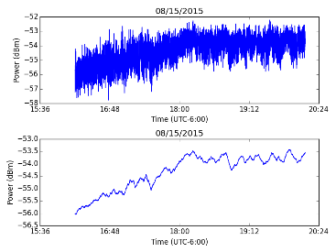

***Fig. 6a – Time Series for 1930-1951.5 MHz***

***(Control vs. Game Time)***

The second section shows the 1955.4-1969.1 MHz band, which only increases by nearly 1 dBm over the time period during the control (-59.2 to -58.2 dBm), but increases from that point to its peak by over 1 dBm at the start of the game (-58.4 to -57.2 dBm).

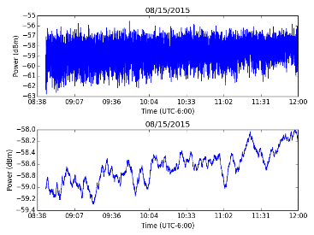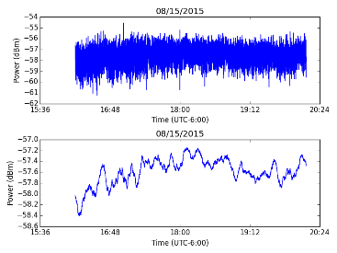

***Fig. 6b – Time Series for 1955.4-1969.1 MHz***

***(Control vs. Game Time)***

For the last section, the 1973-1990 MHz band, the power only increases by nearly 1.5 dBm over the time period during the control (-66 to -64.5 dBm), but peaks at the start of the game by well over 2.5 dBm (-64.0 to -63.5 to -61.7 dBm).

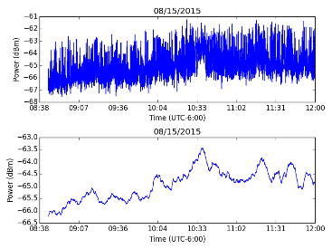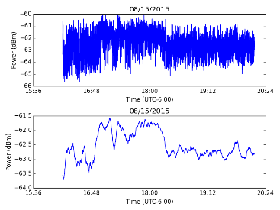

***Fig. 6c – Time Series for 1973-1990 MHz***

***(Control vs. Game Time)***

Across all three of these frequency ranges, the control is consistently on a positive slope with a relatively small increase over the period. Additionally, there appear to be peaks at the start of the game that are much stronger than the increases in the control, on the order of 2.5 dBm at that. These peaks appear to be sustained in the first two sub-bands, but the second definitely dips a bit after the start of the game (not as much as the third).

**PCS Band** – **Game on 08/16/2015**

This first section shows the 1930-1951.5 MHz band, which only increases by nearly 1.5 dBm over the time period during the control (-57 to -55.5 dBm), but increases from that point to its peak by nearly 2.5 dBm at the start of the game (-56 to -53.5 dBm).

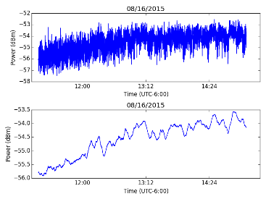

***Fig. 7a – Time Series for 1930-1951.5 MHz***

***(Control vs. Game Time)***

The second section shows the 1955.4-1969.1 MHz band, which only increases by a little more 0.7 dBm over the time period during the control (-59.4 to -58.6 dBm), but increases from that point to its peak by over 1 dBm at the start of the game (-58.8 to -57.6 dBm).

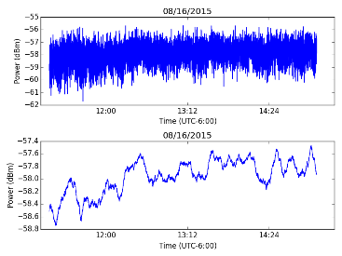

***Fig. 7b – Time Series for 1955.4-1969.1 MHz***

***(Control vs. Game Time)***

For the last section, the 1973-1990 MHz band, the power only increases by nearly 3 dBm over the time period during the control (-66.5 to -63.5 dBm), but peaks at the start of the game by a little over 2.5 dBm (-64.5 to -62.5 dBm).

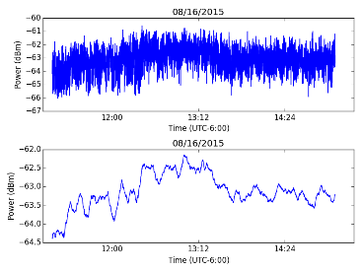

***Fig. 7c – Time Series for 1973-1990 MHz***

***(Control vs. Game Time)***

Across all three of these frequency ranges, the control is consistently on a positive slope, but the level of increase varied a bit more than usual. The bands ranged by 1.5, 0.7, and 3.0 dBm in the control, respectively, but this was still significantly less than the peak during the games on average (2.5, 1.0, and 2.5 dBm). Additionally, there appear to be peaks at the start of the game that are much stronger than the increases in the control, on the order of 2.5 dBm at that. These peaks appear to be sustained in the first two sub-bands, whereas the third plummets back to usual traffic.

**AWS Band** – **2110-2155 MHz**

The AWS band generated expected and unexpected results in general. The heatmap for all the data was the same. It allowed us to know in which specific parts of the band there was traffic as it can observed below. The respective heatmaps of those specific sub-bands are generated below. It can be observed in the heatmap of the entire band that there are a few areas which are dark and these correspond to high density or high traffic over time for a small portion of the band (look fig. 3c).There are also some really small areas (look fig. 3b) where the area is red, which correspond to peak at a specific point in time for a part of the band. Those dark areas would correspond to peaks in the time series plots and the lighter areas or blue areas would correspond to troughs in the time series plots. Using (eq. 2), these are the indices for the frequencies for the 2110-2155 MHz band:

Plotting the heatmap with these frequencies over a four-hour period (08/14/2015 shown below), this is the output:

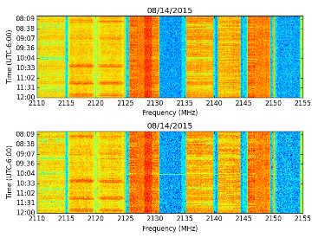

***Fig. 8a – HeatMap for 2110-2155 MHz***

Looking at the heatmap is how we decided to select the frequency ranges from 2110-2125 MHz, 2125.5-2131 MHz, and 1973-1990 MHz. More specifically, the original graph’s x-axis was originally labelled with the index in the array, so we solved for the target frequencies for sub-bands using the x-axis values. The calculated frequencies are below using (eq. 3), followed by the heatmaps for these new ranges:

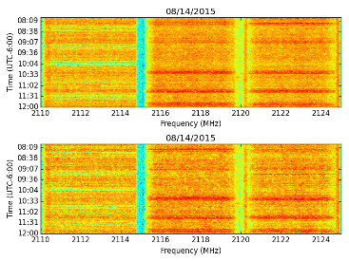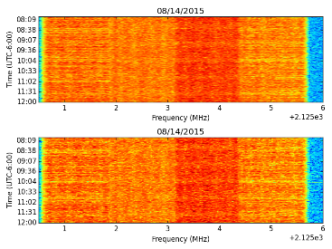

***Fig. 8b – HeatMap for 2110-2125 MHz***

***Fig. 8c – HeatMap for 2125.5-2131 MHz***

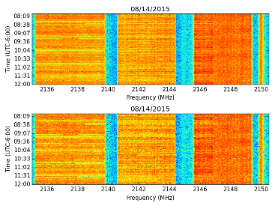

***Fig. 8d – HeatMap for 2135-2150.5 MHz***

**AWS Band** – **08:00**-**12:00**

This particular time was selected for two main reasons: there were no Sox games during that time period to discover the impact (control data); also, people waking up in the morning and increasing cellular traffic is an amazing benchmark to contrast the impact on the cellular network, as well as comparing the power of the band after it stabilizes at noon to any potential increase / decrease during the start of Sox games. As stated before, the difference in the AWS band averaged around 2-2.5 dBm (-67 to -64.5 dBm, -73 to -70.5 dBm, and -59 to -57 dBm), which is the aforementioned benchmark for the sub-bands.

Overall the time series plots behave as expected, meaning that there is an increase in traffic as time goes on, however the time series plot of the first and second sub-bands are not consistent with the entire band time series and the other sub-band.

There is a steady increase in traffic and change of 1.5 dBm, showing that people are slowly using the network.

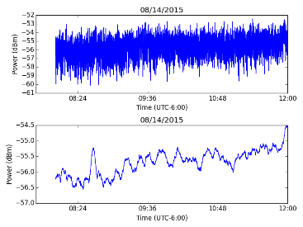

***Fig. 9a – Time Series for 2110-2155 MHz***

There is a stability in traffic and overall increase of 1.5 dBm, showing that people are on and off in using the network

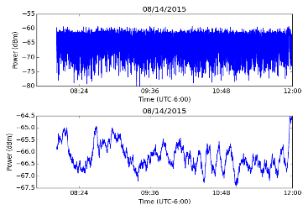

***Fig. 9b – Time Series for 2110-2125 MHz***

There is a stability in traffic and overall increase of 2-3 dBm and a few high points of usability of the network, showing that people are on and off in using the network

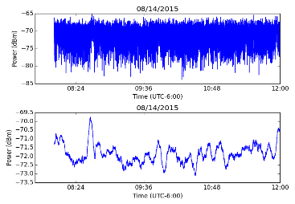

***Fig. 9c – Time Series for 2125.5-2131 MHz***

There is a steady increase in traffic and change of 1.5 dBm, showing that people are slowly using the network.

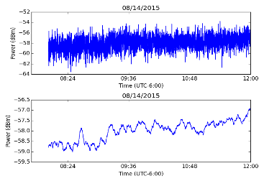

***Fig. 9d – Time Series for 2135-2150.5 MHz***

**AWS Band** – **Game Time**

Those particular dates were selected for two main reasons: there were three consecutive games scheduled, so we could track the cellular activity over that time period and also the Chicago rivalry, so we assume that there would be high traffic during the game period due it. We observed that the third sub-band is really consistent with the entire band and the first sub-band is relatively consistent with the second sub-band.

**AWS Band** – **Game on 08/14/2015**

It can be observed that the difference in the AWS band averaged around 0.8-1 dBm for the entire band and the third sub-band (-54.2 to 53.4 dBm and -56.8 to -56 dBm) meaning that the power is pretty stable over that four-hour period. Therefore showing that the game does not impact the cellular traffic. The first and second sub-band reported differences around 1.5-2 dBm (-65 to -63 dBm and -69 to -67.5 dBm), which is the aforementioned benchmark for the sub-bands. The difference of 1.5-2 dBm shows that there is significant, high traffic during game time, however because the data is unreliable and inconsistent we cannot be certain that the high activity in the bands is due to the game.

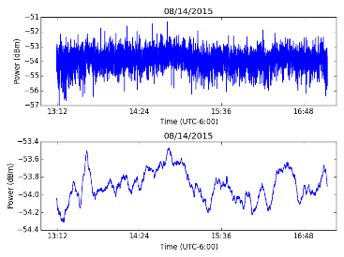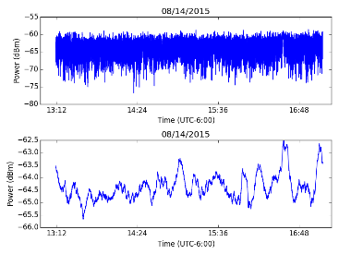

***Fig. 10a – Time Series for 2110-2155 MHz***

***Fig. 10b – Time Series for 2110-2125 MHz***

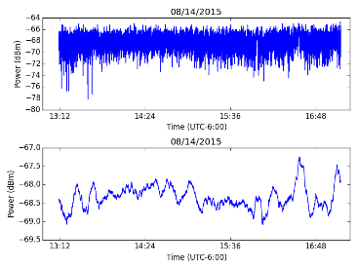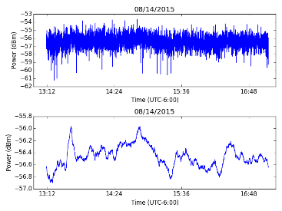

***Fig. 10c – Time Series for 2125.5-2131 MHz***

***Fig. 10d – Time Series for 2135-2150.5 MHz***

**AWS Band** – **Game on 08/15/2015**

It can be observed that the difference in the AWS band averaged around 0.8-1 dBm for the entire band and the third sub-band (-54.4 to 53.6 dBm and -57.2 to -56.2 dBm) meaning that the power is pretty stable over that four-hour period. Therefore showing that the game does not impact the cellular traffic. The first and second sub-band reported differences around 1.5-2 dBm (-65 to -62.5 dBm and -68.8 to -67.3 dBm), which is the aforementioned benchmark for the sub-bands. The difference of 1.5-2 dBm shows that there is significant, high traffic during game time, however because the data is unreliable and inconsistent we cannot be certain that the high activity in the bands is due to the game.

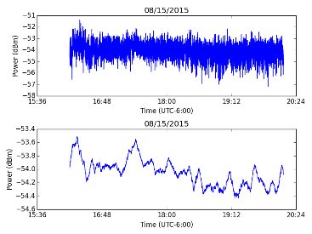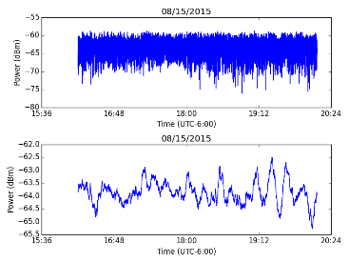

***Fig. 11a – Time Series for 2110-2155 MHz***

***Fig. 11b – Time Series for 2110-2125 MHz***

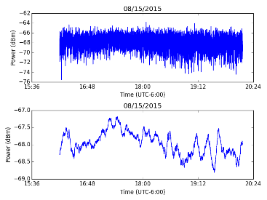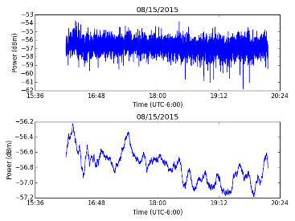

***Fig. 11c – Time Series for 2125.5-2131 MHz***

***Fig. 11d – Time Series for 2135-2150.5 MHz***

**AWS Band** – **Game on 08/16/2015**

It can be observed that the difference in the AWS band averaged around 0.8-1 dBm for the entire band and the third sub-band (-54.6 to 53.8 dBm and -57.4 to -56.6 dBm) meaning that the power is pretty stable over that four-hour period. Therefore showing that the game does not impact the cellular traffic. The first and second sub-band reported differences around 1.5-2.5 dBm (-65.5 to -63 dBm and -68.7 to -67.2 dBm), which is the aforementioned benchmark for the sub-bands. The difference of 1.5-2.5 dBm shows that there is significant, high traffic during game time, however because the data is unreliable and inconsistent we cannot be certain that the high activity in the bands is due to the game.

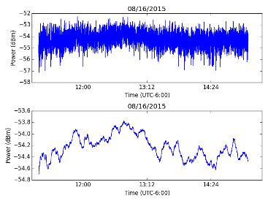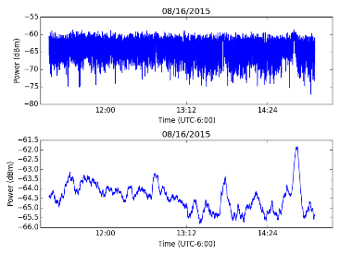

***Fig. 12a – Time Series for 2110-2155 MHz***

***Fig. 12b – Time Series for 2110-2125 MHz***

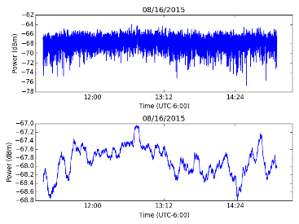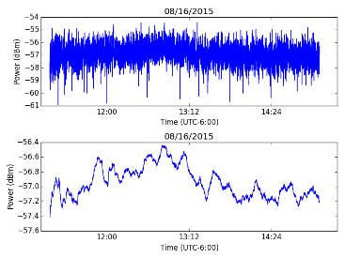

***Fig. 12c – Time Series for 2125.5-2131 MHz***

***Fig. 12d – Time Series for 2135-2150.5 MHz***

**Summary**

First and foremost, the project involved analyzing spectrum analysis data from the PCS and AWS bands, with an emphasis on trying to locate unusual activity near Sox Stadium around the time home games are occurring. The initial dates selected were those of the Sox and Cubs rivalry, as it would conceivably bring in a lot of fans from both teams around the Chicago. The control times are August 14th-16th, 2015 from 08:00-12:00 in local time (UTC-6:00), as there were no home games during the days and we could factor roughly the same amount of locals being awake for school and work at the same time each day.

Our initial hypothesis is that there would be a gradual increase in traffic near Sox Stadium due to more people becoming awake, and thus contributing to the local cellular network, on the control date-times we’ve selected. Our alternative hypothesis for the game time is that if there is random peaks and troughs throughout the specified four-hour period, or no significant peak or trough, then we would consider the data to be inconclusive.

Our goals include using a heatmap to plot power across the spectrum in order to isolate pertinent frequencies; using a time series to plot the entire power of a frequency band over time; and making a conclusion as to whether or not Sox games impact cellular traffic on these frequency bands. Solving for the row, relative to frequency, was calculated via (eq. 1); the column, relative to Unix timestamp, was calculated using (eq. 2); and the x-axis offset for the sub-bands was calculated using (eq. 3).

We used the HDF Compass software, since our data was in the software’s format and Anaconda Python, and more specifically the Pyplot library, to write the code and generate our heatmaps.

We used moving averages to remove the randomness and noise in the data, since it is easy enough to adjust and we are dealing with a lot of data. Predominantly, that entailed taking the averages of groups of 150 elements as there were nearly 9,000 date elements in each of the experiments.

While analyzing the data from the PCS band experiment, we examined the heatmap produced from plotting the power for each frequency band over time, and concluded using (eq. 3) that there were three sub-bands in the 1930-1990 MHz spectrum to analyze: 1930-1951.5 MHz, 1955.4-1969.1 MHz, and 1973-1990 MHz. Afterwards, the code (refer to “The Process” section) was modified to produce an output for each band in each time interval, in the form of a time series that plotted the total power of the band over time. The same process was then repeated on the AWS band to discover three sub-bands in the 2110-2155 MHz spectrum to analyze: 2110-2125 MHz, 2125.5-2131 MHz, and 2135-2150.5 MHz.

After collecting the graphs produced by our Python script, thereby having the opportunity to visually analyze the raw data with the de-noised data. Due to the randomness of distribution of frequency power in the AWS band, it was handled and analyzed in a different manner than the PCS band experiment.

**Conclusion**

We observed that there is a similarity in the heatmaps between the first sub-band of the PCS band and the first / second sub-band of AWS band, as well as the second sub-band of the PCS band and third sub-band of the AWS band.

**PCS Band experiment**: While analyzing the data from the PCS band experiment, we concluded that the control data behaved consistently in an upward slope on each of the dates, with an increase on the order of 0.7 to 1.5 dBm. Additionally, it was excellent to see a peak at the start of each Sox game, with an increase on the order of 1.5 to 2.5 dB. Half of the charts dipped back to normal traffic, with the other half sustaining the increase (mostly the first two sub-bands analyzed for this case). More specifically, these are the results of the experiment by contrasting the control data to the period where Sox games were occurring in order. Refer to the

**First PCS experiment (08/14/2015)**: across all three of the frequency ranges (1930-1951.5 MHz, 1955.4-1969.1 MHz, and 1973-1990 MHz), the control is consistently on a positive slope with a relatively small increase over the period. Additionally, there appear to be peaks at the start of the game that are much stronger than the increases in the control, on the order of 1.5 to 2.5 dBm at that. These peaks appear to be sustained in the first two sub-bands, whereas the third plummets back to usual traffic.

**Second PCS experiment (08/15/2015)**: across all three of the frequency ranges, the control is consistently on a positive slope with a relatively small increase over the period. Additionally, there appear to be peaks at the start of the game that are much stronger than the increases in the control, on the order of 2.5 dBm at that. These peaks appear to be sustained in the first two sub-bands, but the second definitely dips a bit after the start of the game (not as much as the third).

**Third PCS experiment (08/16/2015)**: across all three of the frequency ranges, the control is consistently on a positive slope, but the level of increase varied a bit more than usual. The bands ranged by 1.5, 0.7, and 3.0 dBm in the control, respectively, but this was still significantly less than the peak during the games on average (2.5, 1.0, and 2.5 dBm). Additionally, there appear to be peaks at the start of the game that are much stronger than the increases in the control, on the order of 2.5 dBm at that. These peaks appear to be sustained in the first two sub-bands, whereas the third plummets back to usual traffic.

**Conclusion on PCS experiment**: during each experiment, the control data was observed to have behaved consistently on each day, with a negligible increase in traffic on the third experiment, as the increase across four hours was still far less than the average increase during games (1.5 dBm vs. 2.5 dBm). Also, each game occurred at different times each day, the power of the total traffic started at the same point at the start of each time interval, and each graph has shown a peak in traffic that occurred around when the game was about to begin (sometimes the heavy traffic even persisted from then on). Due to the reliability of the results, and having exceeded the terms of the hypothesis in each of the PCS band experiments on each of the sub-bands between 1930-1990 MHz, we conclude that the Sox games - at least for the period during the Chicago rivalry - has impacted cellular traffic within the area.

**First AWS experiment (08/14/2015)**: the control has a consistent positive slope with gradual increase over the third sub-band and steady traffic across the first and second sub-band with a few increases of 1 dBm at different points in time. Moreover, there appear to be increases of 0.8-1 dBm for the third sub-band and 1.5-2 dBm for the first and second sub-band during game time. The less than 1 dBm increase in the third sub-band suggest that the power is stable over the four-hour period we are experimenting on. The increase of more than 1.5 dBm in the first and second sub-band suggest that there is high traffic in those bands, however because the data is inconsistent and unreliable we cannot be certain that the high activity is due to game.

**Second AWS experiment (08/15/2015)**: the control has a steady traffic across the different sub-bands with a few increases of 1-2 dBm at different points in time. Moreover, there appear to be increases of 0.8-1 dBm for the third sub-band and 1.5-2 dBm for the first and second sub-band during game time. The less than 1 dBm increase in the entire band and third sub-band suggest that the power is stable over the four-hour period we are experimenting on. The increase of more than 1.5 dBm in the first and second sub-band suggest that there is high traffic in those bands, however because the data is inconsistent and unreliable we cannot be certain that the high activity is due to game.

**Third AWS experiment (08/16/2015)**: there is a positive increase in the different sub-bands with a few increases of 1-1.5 dBm at different points in time. Moreover, there appear to be increases of 0.8-1 dBm for the entire band and the third sub-band and 1.5-2 dBm for the first and second sub-band during game time. The less than 1 dBm increase in the third sub-band suggest that the power is stable over the four-hour period we are experimenting on. The increase of more than 1.5 dBm in the first and second sub-band suggest that there is high traffic in those bands, however because the data is inconsistent and unreliable we cannot be certain that the high activity is due to game.

**Conclusion on AWS experiment**: there was stability with a few increases of 1-2 dBm in the control data in the first and second experiment and a steady increase with a few increase of 1-1.5 dBm in the control data in the third experiment. For each experiment there was an increase of less than 1 dBm in the entire band and third band, which declines the initial hypothesis, however because the data is inconsistent, it accepts the alternative hypothesis, concluding that the data in the third band is inconclusive. Moreover there was an increase of more than 1.5 dBm in the first and second band of each experiment, suggesting that there is high traffic during game time, however because of the random increases and troughs in the data, it declines the initial hypothesis and accepts the alternative hypothesis therefore supporting that the data for the first and second band is inconclusive.

**Attached Documents**

Python Code - PCS and AWS Bands

HeatMap Graphs - PCS and AWS Bands

Time Series Graphs - PCS and AWS Bands

**References**

Ancona, N. and Poggio, T., “Optical flow from 1D correlation: Application to a simple time-to-crash detector,” Fourth International Conference on Computer Vision, 1993, pp. 209-214.