The Next Generation e-Auction Management System: Enhancing Security, User Experience, and Data Analytics
by
Md Muktadir Rahman
Saima Shailin
Samir Asaf Smaran
MASTER OF SCIENCE IN INFORMATION AND COMMUNICATION TECHNOLOGY
Department of Information and Communication Technology
Faculty of Science and Technology
BANGLADESH UNIVERSITY OF PROFESSIONALS
November 2026

APPROVAL
The project titled “The Next Generation e-Auction Management System: Enhancing Security, User Experience, and Data Analytics” submitted by Md Muktadir Rahman (Roll No: 23549908004), Saima Shailin (Roll No: 23549908010), and Samir Asaf Smaran (Roll No: 23549908043), Session: 2022–2023, has been accepted as satisfactory for partial fulfillment of the requirement for the degree of Master of Science in Information and Communication Technology.

Lt Col Hussain Md Abu Nyeem, PhD, EME
Associate Professor
Department of Electrical, Electronic and Communication Engineering
Military Institute of Science and Technology (MIST)
Supervisor
Date: ____________________

DECLARATION
We hereby declare that this is our original work, and we have written it in its entirety. We have duly acknowledged all the sources of information that have been used in the thesis. This thesis (fully or partially) has not been submitted for any degree or diploma in any university or institute previously.

Md Muktadir Rahman
ID: 23549908004
Department of Information and Communication Technology
Faculty of Science and Technology
Bangladesh University of Professionals

Saima Shailin
ID: 23549908010
Department of Information and Communication Technology
Faculty of Science and Technology
Bangladesh University of Professionals

Samir Asaf Smaran
ID: 23549908043
Department of Information and Communication Technology
Faculty of Science and Technology
Bangladesh University of Professionals

ACKNOWLEDGEMENTS
First and foremost, we thank Almighty Allah for giving us the health and well-being needed to complete this project. We sincerely thank Lt Col Hussain Md Abu Nyeem, PhD, for his supervision, encouragement, patience, and guidance throughout the study and implementation of this work. We are grateful to the Department of Information and Communication Technology at Bangladesh University of Professionals for academic support. Finally, we thank our families and classmates for their continuous support and constructive feedback.

ABSTRACT
Online auction platforms are increasingly used for consumer and specialty goods trading, yet many deployments still struggle with listing trust, concurrent bidding integrity, payment settlement risk, and operational visibility for administrators. This project designs and implements Bid On, a next-generation web-based e-auction management system that combines moderated seller listings, real-time bidding, compliance gates for know-your-customer and bank verification, and an escrow-oriented payment workflow. The system follows a modular three-tier architecture: a Next.js progressive web frontend, an Express and Prisma application programming interface, and a PostgreSQL relational database hosted on Render. Socket.IO is used to propagate bid updates with low latency, while Stripe Checkout is integrated for winner payments with funds recorded in an escrow ledger prior to release or dispute resolution. The methodology covers requirements analysis mapped to an explicit functional and non-functional catalogue, logical and physical database design, secure authentication using JSON Web Tokens with httpOnly cookies, and deployment automation from GitHub. Evaluation is based on functional verification against the requirements chart, live deployment smoke tests, and critical code-level hardening of bidding concurrency, authentication session refresh, and payment confirmation. Results show that the implemented platform supports the primary auction lifecycle from moderated listing through live bidding and checkout, while remaining transparent about limitations such as free-tier cold starts, ephemeral upload storage, and the absence of automated seller payout via Stripe Connect. The work contributes a reproducible full-stack reference architecture for secure regional e-auctions and a complete academic documentation pack including editable diagrams and independent database artefacts.
Keywords: online auction, real-time bidding, escrow payment, PostgreSQL, Next.js, Express, Socket.IO, e-commerce security

TABLE OF CONTENTS
APPROVAL
DECLARATION
ACKNOWLEDGEMENTS
ABSTRACT
LIST OF FIGURES
LIST OF TABLES
LIST OF ABBREVIATIONS
CHAPTER 1. INTRODUCTION
CHAPTER 2. LITERATURE REVIEW
CHAPTER 3. METHODOLOGY
CHAPTER 4. RESULTS ANALYSIS AND DISCUSSION
CHAPTER 5. CONCLUSION AND FUTURE WORK
REFERENCES
APPENDICES

LIST OF FIGURES
Figure 3.1 High-level system architecture of Bid On
Figure 3.2 Deployment view on Render (Singapore)
Figure 3.3 Context-level data flow diagram
Figure 3.3b Level-0 data flow diagram
Figure 3.4 Entity–relationship overview
Figure 3.5 Activity flow for placing a bid
Figure 3.6 Sequence diagram for winner checkout and escrow
Figure 3.6b Sequence diagram for login and session issuance
Figure 3.7 Component interactions between frontend and backend
Figure 3.8 Use-case diagram (buyer, seller, admin)
Figure 3.9 Domain class overview
Figure 4.1 Live auctions catalogue on the deployed frontend

LIST OF TABLES
Table 2.1 Summary of related works on online auctions and e-commerce systems
Table 3.1 Mapping of functional requirements to implemented modules
Table 3.2 Core database entities and responsibilities
Table 3.3 Technology stack used in Bid On
Table 4.1 Experimental / deployment environment
Table 4.2 Selected functional verification outcomes
Table 4.3 Requirements coverage summary

LIST OF ABBREVIATIONS
API — Application Programming Interface
BDT — Bangladeshi Taka
BUP — Bangladesh University of Professionals
CORS — Cross-Origin Resource Sharing
DFD — Data Flow Diagram
ERD — Entity–Relationship Diagram
JWT — JSON Web Token
KYC — Know Your Customer
ORM — Object–Relational Mapping
REST — Representational State Transfer
RBAC — Role-Based Access Control
UI — User Interface

CHAPTER 1
INTRODUCTION
1.1 Overview
This chapter introduces the research and development of Bid On, a web-based e-auction management system produced as a Master of Science in Information and Communication Technology project at Bangladesh University of Professionals. The chapter situates online auctions within contemporary electronic commerce, motivates the need for moderated trust and concurrent-safe bidding, states the problem addressed by the work, and formulates research questions and objectives that guide the remaining chapters.
Bid On is not presented as a theoretical model alone. The system is implemented as a full-stack application with a Next.js progressive web frontend, an Express and Prisma application programming interface, a PostgreSQL relational database, Socket.IO real-time events, and Stripe Checkout for winner payments. A production deployment on Render (Singapore) exposes both the user interface and the API for independent inspection. The academic claim of this thesis is therefore tightly coupled to a verifiable artefact rather than to aspirational feature lists.
Throughout the thesis, the proposal-facing title “The Next Generation e-Auction Management System: Enhancing Security, User Experience, and Data Analytics” is retained for formal pages, while the implemented product name Bid On is used when describing software behaviour, repositories, and deployment endpoints.
1.2 Background/Motivation
Electronic commerce continues to expand as consumers and small businesses adopt digital marketplaces for buying and selling goods. Within this landscape, online auctions remain an important price-discovery mechanism for specialty items, surplus inventory, and time-bounded sales. Foundational software engineering literature treats e-commerce systems as multi-tier applications that must combine persistent catalogues, authenticated sessions, and transactional integrity [1]. Managerial and technical discussions of electronic commerce further emphasize that marketplace quality depends not only on catalogue presentation but also on identity assurance, fair bidding rules, timely feedback to bidders, and reliable settlement after an auction ends [2].
In emerging digital economies, including Bangladesh and the wider Asian online retail context, platforms must also address regional constraints such as currency display expectations, mobile-first usage patterns, and limited tolerance for opaque listing practices. The project requirements chart prepared for this study prioritizes responsive interfaces, moderated listings, countdown-driven auctions, search and filtering, ratings, administrative reporting, and payment integration, while targeting a concurrent multi-user experience [3]. These requirements establish a concrete evaluation baseline against which the implemented system can later be judged in Chapter 4.
Contemporary web engineering stacks make it feasible to combine a reactive user interface, a typed application programming interface, and a relational database under continuous deployment. Official documentation for Next.js describes an App Router model suitable for modern React applications [4]. Node.js frameworks such as Express remain widely used for REST APIs [5], while real-time communication libraries such as Socket.IO enable multi-bidder awareness that classical request–response pages cannot provide alone [6]. Payment processors such as Stripe allow merchant servers to avoid direct handling of card primary account numbers by delegating sensitive capture to hosted checkout flows [9].
The motivation for this project is therefore both practical and academic. Practically, the team sought to construct a coherent, deployable e-auction system that embodies moderated trust, concurrent-safe bidding, and escrow-aware payments under cloud hosting constraints. Academically, the team sought to document the design with university-grade rigor so that examiners can verify claims against a live implementation, an explicit data model, and an honest discussion of limitations such as free-tier cold starts and incomplete seller payout automation.
Security and compliance considerations further motivate the work. Auction platforms that allow unvetted listings or weak identity gates expose buyers to fraud risk and expose operators to reputational harm. Requirements for know-your-customer (KYC) and bank verification gates, role-based administration, and escrow holding of winner payments therefore appear not as decorative extras but as core trust controls. The Bid On design treats these controls as first-class workflow states rather than as optional user-profile fields.
1.3 Problem Statement
Many auction-oriented websites expose buyers to unvetted listings, allow race conditions under simultaneous bidding, or complete payment without a clear hold-and-release policy between buyer and seller. Administrators often lack structured approval workflows and reporting. Early requirement analysis for this project also identified dependencies such as payment gateways and hosting reliability, while noting aspirational features—for example automated fraud detection using artificial intelligence—that cannot be assumed as implemented without evidence.
Concurrent bidding introduces a specific integrity hazard. If two buyers submit bids near the same moment, naive update sequences can accept an amount that no longer satisfies the minimum next-bid rule relative to the latest accepted bid. User-interface timers and optimistic client state are insufficient to prevent this class of defect. A correct solution must coordinate validation and update inside a transactional boundary at the data store, then broadcast a consistent view to connected clients.
Settlement introduces a second class of hazard. Marking an auction as paid solely because a browser returned from a payment redirect can accept incomplete or abandoned checkout sessions. Payment confirmation must be bound to processor session state. Furthermore, immediate transfer of funds to a seller without a dispute window increases chargeback and delivery-risk exposure. An escrow ledger that records held, disputed, completed, refunded, and failed states provides an auditable path even when automated connected-account payouts are deferred to a later phase.
The core problem addressed here is therefore the absence of an integrated, regionally relevant e-auction management system that simultaneously (i) enforces listing moderation and role-based access, (ii) preserves bidding integrity under concurrency, (iii) supports real-time bidder feedback, and (iv) records winner payments in an escrow lifecycle before funds are treated as released. The research gap is not the complete absence of auction websites, but the lack of a transparent, fully documented full-stack reference that couples these controls with a normalized database design and honest evaluation against stated non-functional constraints.
1.4 Research Questions
RQ1: How can a modular web architecture combine moderated listings, real-time bidding, and role-based administration in a single deployable e-auction platform?
RQ2: How should the relational data model and transaction logic be structured to preserve bid integrity and escrow state across the auction lifecycle?
RQ3: To what extent does the implemented Bid On system satisfy the prioritized functional requirements, and what limitations remain relative to performance and settlement automation goals?
1.5 Research Objectives
Objective 1: To design and develop a full-stack e-auction management system (Bid On) with buyer, seller, and admin workflows, including moderated listings and real-time bid updates.
Objective 2: To specify and implement a normalized PostgreSQL schema with Prisma migrations that supports auctions, bids, compliance attributes, notifications, reviews, and escrow transactions, and to publish independent SQL/DBML/ERD artefacts for examination.
Objective 3: To evaluate the deployed system against the project requirements chart through functional verification and critical analysis of security, payment, and scalability limitations, without fabricating unmeasured performance results.
1.6 Organization of the Thesis Paper
Chapter 2 reviews related literature on electronic marketplaces, interactive web architectures, identity and payment patterns, and identifies at most three research gaps addressed by this project. In accordance with departmental guidance, Chapter 2 contains no figures.
Chapter 3 presents the methodology, including requirements mapping, system architecture, process and interaction models, database design, security method, and implementation approach. Diagrams referenced in Chapter 3 correspond to editable sources under docs/diagrams and docs/database.
Chapter 4 reports results and discussion based on the deployed system, selected functional verification outcomes, requirements coverage, and an explicit limitations analysis.
Chapter 5 concludes the study, maps findings to the research objectives, states contributions and limitations, and outlines future work. References follow IEEE style. Appendices map repository artefacts, API surfaces, and test catalogues that would otherwise overwhelm the narrative chapters.
1.7 Scope and significance
The practical significance of the problem can be observed in everyday marketplace failures: buyers who discover that a listing was never vetted; sellers who cannot obtain timely administrative decisions; bidders who refresh a page only to learn that a concurrent bid was accepted without clear ordering; and winners who pay without an auditable hold period. Each failure mode maps to a concrete subsystem in Bid On—moderation, RBAC, transactional bidding, and escrow accounting—rather than to a single cosmetic user-interface theme.
From a software engineering education standpoint, the project also serves as a vehicle for demonstrating end-to-end competence: requirements interpretation, architectural decomposition, relational modeling, secure session design, asynchronous event propagation, third-party payment integration, cloud deployment, and academic documentation. The thesis therefore reports not only what was built, but how evidence was gathered and which claims remain intentionally unasserted.
Scope boundaries were established early. The system targets ascending English-style auctions with admin moderation. It does not target sealed-bid procurement, Dutch auctions, or multi-lot combinatorial auctions. Geographic emphasis follows the requirements chart’s Bangladesh/Asia orientation, with BDT-oriented presentation and Stripe currency configuration handled in application settings. Analytics are limited to administrative KPIs and CSV export rather than a separate data-warehouse pipeline, despite the proposal title’s reference to data analytics as a longer-term enhancement theme.
Institutionally, the project is submitted toward the Master of Science in Information and Communication Technology at Bangladesh University of Professionals under the departmental thesis guidance that mandates a five-chapter structure, IEEE citations, and similarity controls. The authors therefore treat formatting compliance as part of research professionalism rather than as an afterthought.
Commercially adjacent motivation does not imply commercial launch claims. Bid On is an academic system with a public demonstration deployment. It is not presented as a licensed financial intermediary, and payment processing depends on Stripe’s terms and the operators’ configured account mode.
Stakeholders include buyers seeking fair price discovery, sellers seeking moderated reach, administrators seeking operational control, and academic examiners seeking verifiable engineering evidence. Success criteria therefore differ by stakeholder: a buyer may care about latency of bid feedback; an examiner may care whether latency claims are measured. This thesis privileges examiner-verifiable criteria when conflicts arise.
The contribution claim is bounded. Bid On does not claim to outperform commercial auction houses on catalogue size, logistics, or machine-learning personalization. It claims to deliver a coherent, inspectable, moderated real-time auction stack with escrow-aware payment recording and an accompanying academic documentation set that matches the running software.
Risks anticipated at project start included payment-integration complexity, real-time synchronization bugs, hosting cold starts, and documentation drift. Mitigation strategies included early Stripe Checkout adoption, database locking for bids, transparent reporting of free-tier limits, and generating docs from the same repository that hosts the code.

CHAPTER 2
LITERATURE REVIEW
2.1 Overview
This chapter reviews prior work that informed the design of Bid On. The review is organized thematically rather than as an unstructured list of unrelated papers. Themes include electronic marketplaces and auction mechanisms, web architectures for interactive multi-user applications, and security, identity, and payment settlement patterns. A summary table consolidates representative sources. The chapter closes with three research gaps that the present project can address within the scope of a university software engineering thesis.
Two caveats are stated at the outset. First, the survey privileges sources that are citable and verifiable—peer-reviewed books, IEEE standards, and official technology documentation—over anonymous blog posts. Second, the chapter does not invent experimental comparisons between Bid On and commercial auction operators; such comparisons would require instrumentation and legal access that this project does not claim.
2.2 Existing Works
2.2.1 Electronic marketplaces and auction mechanisms
Classical software engineering texts treat e-commerce systems as multi-tier applications with persistent catalogues, authenticated sessions, and transactional integrity requirements [1]. Online auctions add temporal dynamics: a shared clock, ascending prices, reserve rules, and winner determination. Mechanism and user-experience discussions in e-commerce research emphasize that poorly specified bid acceptance rules and delayed feedback reduce perceived fairness for bidders [2].
Requirements engineering practice recommends documenting functional and non-functional needs explicitly. IEEE Std 830 provides a recommended practice for software requirements specifications that, while dated in presentation style, still informs structured catalogues of capabilities and constraints [7]. The present project’s requirements chart enumerates authentication, listing, real-time bidding, notifications, payments, search, ratings, admin approval, timers, and reporting. That catalogue aligns with marketplace feature sets commonly reported in e-commerce system studies and provides a measurable checklist for Chapter 4.
From a domain perspective, auction platforms differ from fixed-price storefronts in their dependence on time and concurrency. A fixed-price cart can often serialize inventory decrements with comparatively simple stock checks. An ascending auction must continuously recompute the minimum acceptable next bid, maintain an immutable history of accepted bids for auditability, and communicate state changes to multiple simultaneous observers. These domain properties motivate both the Bid entity design and the Socket.IO event model described in Chapter 3.
2.2.2 Web architectures for interactive applications
Modern JavaScript frameworks enable component-based user interfaces with client-side routing and server-side rendering options. Official Next.js documentation describes the App Router model used in contemporary React applications, including nested layouts and server/client component boundaries [4]. On the server side, Node.js frameworks such as Express remain a pragmatic choice for REST APIs in university and startup contexts because of their mature middleware ecosystem and straightforward deployment story [5].
Persistence layers for interactive applications increasingly use typed object–relational mapping. Prisma documentation describes a schema-first workflow in which models, enumerations, and relations are declared in a domain-specific language and migrated to SQL databases [8]. PostgreSQL remains a robust open-source relational engine for transactional workloads and is documented extensively for production use [12]. For multi-user interactive features, WebSocket-based libraries such as Socket.IO are frequently adopted to push events without continuous polling [6].
Cloud application platforms further influence architecture. Managed services reduce operational burden for student teams by providing containerized web services, managed PostgreSQL, and HTTPS termination. Render’s documentation describes Blueprint-driven multi-service deployments that map naturally onto a frontend–API–database split [11]. The Bid On deployment on Render therefore reflects not only convenience but also an architectural decision to keep presentation, application logic, and data tiers independently scalable and restartable.
These technology choices are not claimed as universally optimal. Alternative stacks—such as monolithic server-rendered frameworks or serverless functions with managed WebSocket gateways—could implement similar domain behaviour. The selection criteria for this project were typed end-to-end development, explicit relational modeling, real-time event support, payment-processor integration maturity, and deployability within the team’s operational constraints.
2.2.3 Security, identity, and payments
Marketplace trust depends on authentication, authorization, and careful handling of secrets. Industry practice favors salted password hashing, short-lived tokens, HTTPS termination at the edge, and least-privilege role models. JSON Web Tokens are commonly used to carry authenticated identity claims between a browser client and an API, often in combination with httpOnly cookies to reduce exposure to script-based token theft.
Payment card handling is commonly delegated to certified processors. Stripe Checkout documentation describes hosted payment pages that reduce direct card data exposure on merchant servers [9]. Escrow-like holding patterns are used in marketplaces to reduce settlement disputes by delaying seller access to funds until delivery conditions or dispute windows are resolved. Automated payout to sellers often requires additional connected-account infrastructure beyond a basic Checkout integration; that distinction is material for honest academic reporting because ledger completeness is not identical to automated disbursement.
Identity verification practices such as KYC and bank-account confirmation are increasingly expected in platforms that mediate money movement. Their presence in requirements does not by itself guarantee privacy-preserving storage. Document upload endpoints that write into publicly served directories can satisfy a functional “upload” requirement while violating the spirit of personal-data protection. Literature and practitioner guidance therefore push designers to separate verification workflow state from storage topology—an issue revisited as a limitation in Chapters 4 and 5.
2.2.4 Summary table of related works
Table 2.1 summarizes representative sources that informed Bid On. The table combines foundational software engineering references, e-commerce mechanism discussions, requirements standards, and official platform documentation. It is intentionally compact: departmental guidance favors a clear summary table over an encyclopedic catalogue of weakly related citations.
Table 2.1: Summary of related works on online auctions and e-commerce systems
Source | Focus | Method / type | Limitation for this project
Sommerville [1] | Software process & e-commerce context | Textbook synthesis | Broad guidance; not auction-specific
Turban et al. [2] | E-commerce mechanisms & UX | Managerial/analytic | Limited implementation blueprint
IEEE Std 830 [7] | Requirements specification | Standard | Not a system build
Next.js / Express / Socket.IO / Prisma docs [4]–[6], [8] | Implementation patterns | Official documentation | Vendor-specific
Stripe Checkout [9] | Payment delegation | Official documentation | Does not define full escrow domain model
PostgreSQL / Render docs [11], [12] | Data & hosting operations | Official documentation | Platform-specific

2.3 Research Gaps
Gap 1 — Integrated moderated auction lifecycle. Many tutorials demonstrate isolated bidding widgets or catalogues without an end-to-end moderated listing → live auction → winner payment path documented against a single schema. Bid On addresses this gap by implementing admin approval gates, live bidding, countdown presentation, and escrow-aware checkout within one repository and one deployed system.
Gap 2 — Concurrent bid integrity with transparent data design. Descriptions of real-time user interfaces often omit database-level concurrency controls and escrow state modeling needed for examinable academic systems. Bid On addresses this gap by locking auction rows during bid acceptance, persisting immutable Bid records, and modeling Transaction statuses for held and disputed funds.
Gap 3 — Honest evaluation under cloud free-tier constraints. Deployed student systems rarely report cold-start and storage limitations alongside functional success, leaving non-functional claims unverifiable. Bid On addresses this gap by evaluating the live Render deployment while explicitly stating performance, ephemeral storage, SMS, and payout limitations rather than asserting unverified compliance with aggressive concurrency targets.
These three gaps define the evaluative boundary of the thesis. Features such as artificial-intelligence fraud scoring are acknowledged as future work and are not treated as silent successes. The literature review therefore leads directly into the methodological choices of Chapter 3.
2.4 Extended discussion of sources and baselines
Beyond textbooks and standards, practitioner documentation plays an unusually large role for full-stack theses because implementation correctness depends on evolving platform contracts. Citing Next.js, Express, Prisma, Socket.IO, Stripe, PostgreSQL, and Render documentation is therefore not a substitute for peer-reviewed theory; it is a necessary complement that anchors claims about how the system actually behaves in deployment [4]–[6], [8], [9], [11], [12].
Comparative commercial platforms (for example large international auction marketplaces) illustrate mature feature sets including advanced recommendation, sophisticated anti-fraud pipelines, and complex logistics integrations. Those platforms are useful as aspirational references but are not fair experimental baselines for a three-member university team operating on free-tier hosting. The literature stance of this thesis is therefore to extract transferable design principles—moderation, real-time feedback, delegated payments—while refusing inequitable performance comparisons that the team cannot instrument.
Prior student and open-source auction demos frequently demonstrate catalogue browsing and simple bid forms without admin approval workflows or escrow ledgers. Where source code is available, concurrency is often handled only in memory or through last-write-wins updates. The present work positions itself against that pattern by insisting on durable relational state, explicit status enumerations, and row-level locking during critical sections.
Requirements standards such as IEEE Std 830 remain useful for structuring functional and non-functional statements even when a lightweight requirements chart is used instead of a full Software Requirements Specification document [7]. The chart employed in this project is treated as the authoritative checklist for Chapter 4’s coverage discussion, supplemented by honesty markers for items that are partial or untested.
A further theme in marketplace literature is the tension between growth features and trust features. Growth features emphasize inventory breadth, recommendation, and low-friction onboarding. Trust features emphasize identity proofing, dispute handling, and conservative settlement. Bid On consciously prioritizes trust features for an academic demonstration because examiners can validate trust controls more reliably than marketing growth metrics.
Real-time collaborative web systems have been studied extensively in the context of chat, shared documents, and multiplayer games. Auction bidding shares with those domains the need for a consistent shared state, but it adds monetary consequences to ordering errors. Therefore, event delivery (Socket.IO) is treated as a presentation accelerator, while PostgreSQL transactions remain the authority for accepted bids.
Payment orchestration patterns in modern SaaS commonly distinguish authorization, capture, refund, and payout. Bid On’s Stripe Checkout path primarily covers customer payment collection and maps successful collection into an internal escrow status machine. Payout is intentionally deferred, which aligns with a phased marketplace maturity model even though it leaves sellers without automated disbursement in the current release.
From a research-methods viewpoint, software theses sometimes over-claim novelty. The present literature stance is modest: the novelty is integrative and documentary—combining moderated auctions, concurrent-safe bidding, escrow ledgering, and deployable cloud packaging with examiner-facing artefacts—rather than inventing a new auction theorem.

CHAPTER 3
METHODOLOGY
3.1 Overview
This chapter describes the methodological approach used to design and implement Bid On. Methodology here means the disciplined sequence of requirements mapping, architectural design, process modeling, database design, security controls, and iterative implementation that produced a deployable system. The chapter is written to allow an examiner to reconstruct why particular technical choices were made and how those choices map to the research questions in Chapter 1.
Evidence for the methodology is drawn from the repository under github.com/eauctionproject2025/bid-on, including backend Prisma schema and routes, frontend App Router pages, Render deployment configuration, and the documentation packs under docs/. Figures referenced in this chapter correspond to editable Mermaid, PlantUML, and diagrams.net sources; they are not decorative screenshots invented after the fact.
3.2 Requirements engineering and module mapping
Functional and non-functional requirements were taken from the Online Auction System Requirement Chart and cross-checked against the implemented repository. Each high-priority functional requirement was assigned to one or more modules during construction. Table 3.1 summarizes the mapping used by the team.
Non-functional requirements were treated as constraints rather than as automatic pass marks. Responsiveness of layout was pursued through a mobile-aware Tailwind design. Encryption of sensitive transport was delegated to HTTPS at the hosting edge, password hashing to bcrypt, and card data to Stripe. Concurrent-user capacity and strict page-load budgets were recorded as evaluation targets whose satisfaction cannot be claimed without measurement; Chapter 4 therefore reports them with honesty markers.
Actors were derived from Role enumeration values in the schema: buyer, seller, and admin. A single user account may conceptually act as seller for listings and buyer for other lots, but privileged administrative actions remain gated by the admin role. Compliance gates for KYC and bank verification further refine who may bid or sell even when authenticated.
Table 3.1: Mapping of functional requirements to implemented modules
ID | Requirement | Primary modules
FR1 | Registration / login | auth routes; JWT/cookie session; OTP verify
FR2 | Product listing + images | auctions create/upload; Multer
FR3 | Real-time bidding | bids API; Socket.IO; bidding helper
FR4 | Bid notifications | Notification model; email verify; SMS not implemented
FR5 | Payment gateway | Stripe Checkout; Transaction escrow ledger
FR6 | Search / filter | GET /api/auctions query params
FR7 | Feedback / rating | Review model + APIs
FR8 | Admin approval | approve/reject auction endpoints
FR9 | Countdown timer | frontend Countdown component
FR10 | Admin reports | admin KPIs + CSV export

3.3 Proposed architecture
Bid On uses a three-tier architecture. The presentation tier is a Next.js App Router application deployed as Render service bid-on and reachable at https://bid-on.onrender.com. The application tier is an Express API with Prisma, Socket.IO, Zod validation, Multer uploads, and background auction-ending logic deployed as bid-on-api at https://bid-on-api.onrender.com. The data tier is managed PostgreSQL 16 (bid-on-db) in the same Singapore region to allow private database connectivity from the API service.
Figure 3.1 illustrates the logical architecture. Clients interact with the Next.js frontend; the frontend calls REST endpoints and opens a Socket.IO connection for bid and notification events. The API reads and writes PostgreSQL through Prisma. Stripe is an external payment dependency used during winner checkout. Email delivery, when configured, supports verification and recovery flows; otherwise development-safe fallbacks avoid leaking secrets.
Figure 3.2 presents the deployment view. Separating frontend and API services allows independent redeploys when only one tier changes. Co-locating the database in the same region reduces latency for transactional bidding paths. Free-tier sleeping of web services is an operational property of the chosen hosting plan and is treated as an environmental constraint in evaluation rather than as an architectural endorsement of cold starts.
Cross-origin resource sharing is restricted to configured frontend origins, including the production Render URL. Production deployments require a sufficiently long JWT secret. These controls are part of the architecture’s trust boundary rather than optional middleware.
Figure 3.1: High-level system architecture of Bid On (docs/diagrams/source/architecture.mmd).
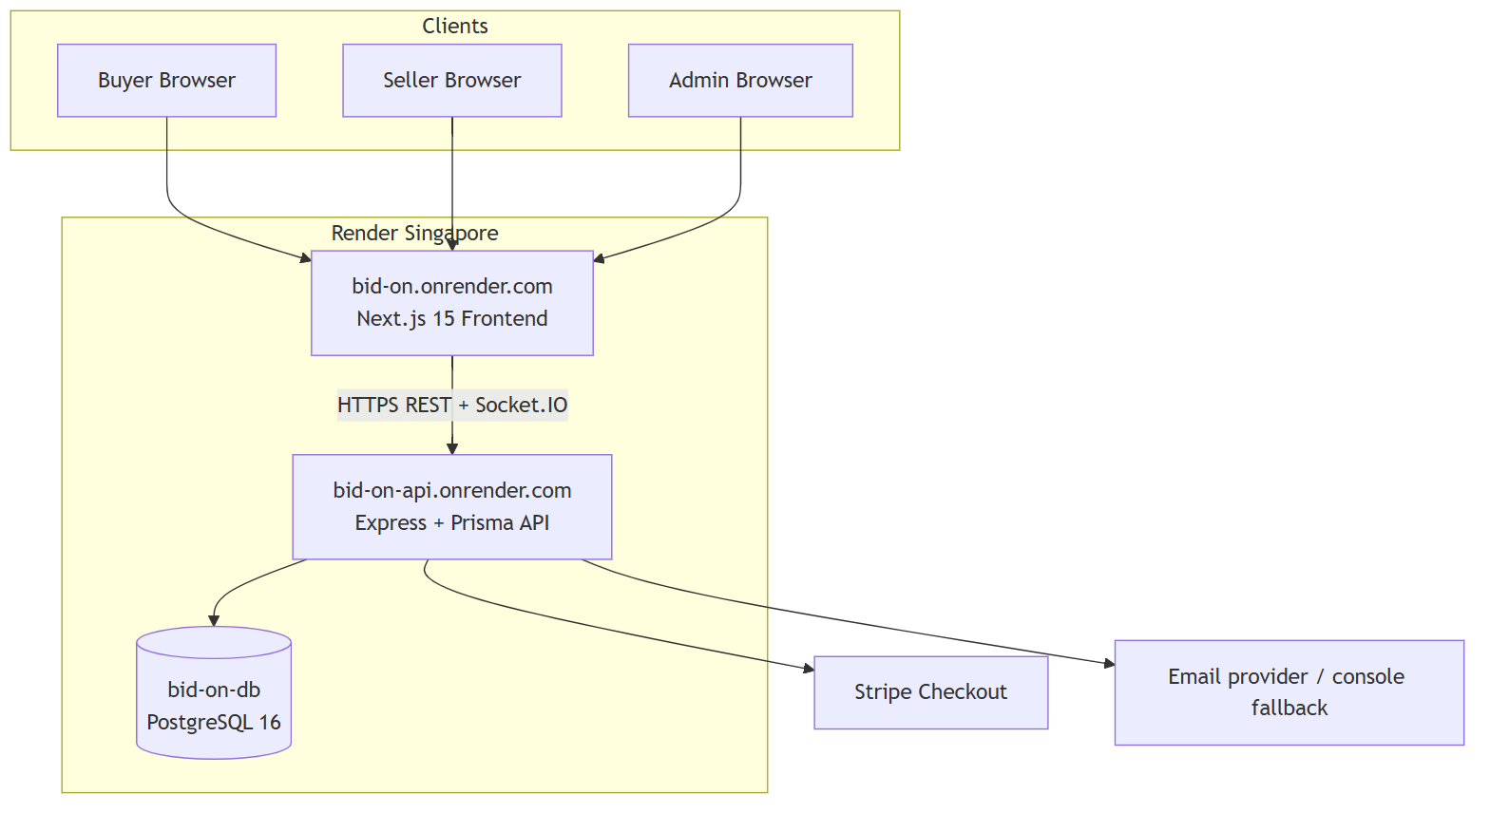
Figure 3.1 should be read left to right: the browser hosts the Next.js progressive interface; HTTPS REST calls and a Socket.IO channel reach the Express application tier; Prisma translates domain operations into PostgreSQL SQL; Stripe is contacted only for checkout session creation and payment-status confirmation. This separation keeps card data off the Bid On servers under ordinary Checkout usage.
Figure 3.2: Deployment view on Render (docs/diagrams/source/deployment/deployment.mmd).
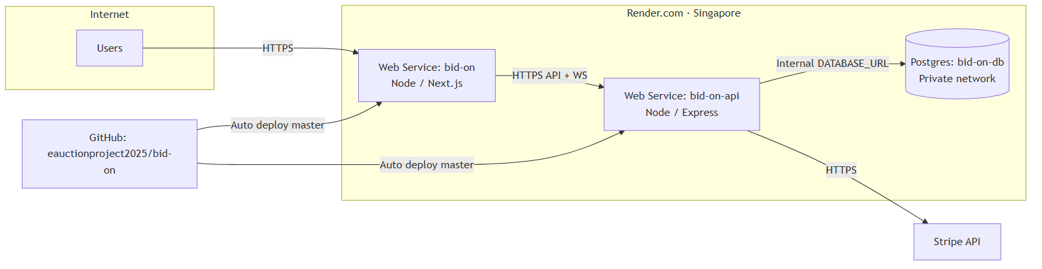
Figure 3.2 emphasizes regional co-location in Singapore and the GitHub-to-Render deployment path. Examiners verifying the live system should expect free-tier cold starts on the web and API services after idle periods; the database service remains the durable store for auctions and bids across process sleeps.
Table 3.3: Technology stack used in Bid On
Layer | Technologies
Frontend | Next.js 15, React 19, TypeScript, Tailwind, TanStack Query, Zustand, Socket.IO client, Axios
Backend | Express 5, Prisma 5, Zod, JWT + httpOnly cookies, Multer, Socket.IO, Stripe SDK
Database | PostgreSQL 16 (Render bid-on-db, Singapore)
Hosting | Render services bid-on (web) and bid-on-api (API)
Tooling | GitHub, Vitest, OpenAPI/Swagger UI at /api/docs

3.4 Process and interaction models
Major workflows were modelled before coding and refined against the repository. Figure 3.3 shows a context-level data flow diagram in which buyers, sellers, admins, and Stripe exchange data with the Bid On system. Figure 3.3b expands to a Level-0 view with processes for authentication, listing management, moderation, bidding, settlement, and notification, together with stores for users, auctions, bids, transactions, and notifications.
Figure 3.5 presents the activity flow for placing a bid, including authentication and compliance checks, auction row locking, minimum-next-bid validation, persistence of the Bid row, update of Auction.currentBid, and emission of Socket.IO events. Figure 3.6 shows the sequence for winner checkout and escrow placement, emphasizing that payment confirmation depends on Stripe session completion state rather than on redirect alone. Figure 3.6b covers login and session hydration. Figure 3.7 summarizes component responsibilities across frontend stores, API routers, Prisma models, and external services.
A use-case view (Figure 3.8) groups capabilities by actor. Buyers register, verify, browse, watch, bid, and pay. Sellers create and edit pending listings subject to rules. Admins approve or reject listings, review KYC and bank submissions, manage users, and export reports. These use cases map directly onto Express route modules and Next.js pages rather than onto speculative future screens.
Domain class relationships (Figure 3.9) mirror the Prisma models: User, Category, Auction, Bid, Watchlist, Notification, Transaction, and Review, with enumerations for roles, auction status, transaction status, verification status, and notification type. The class view is intentionally close to the schema to avoid a parallel fantasy model that examiners cannot reconcile with migrations.
Figure 3.3: Context-level DFD (docs/diagrams/source/dfd-context.mmd).
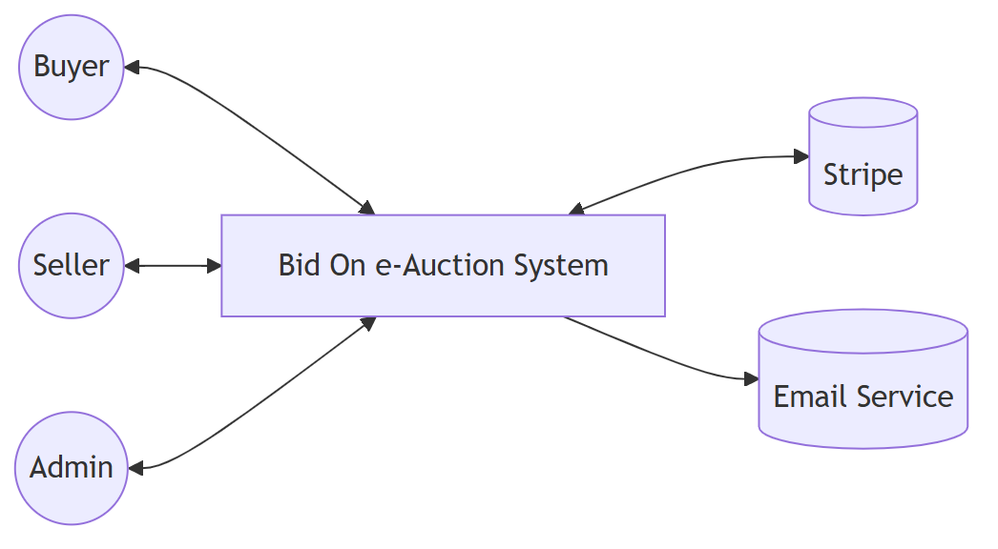
Figure 3.3b: Level-0 DFD (docs/diagrams/source/dfd-level0.mmd).
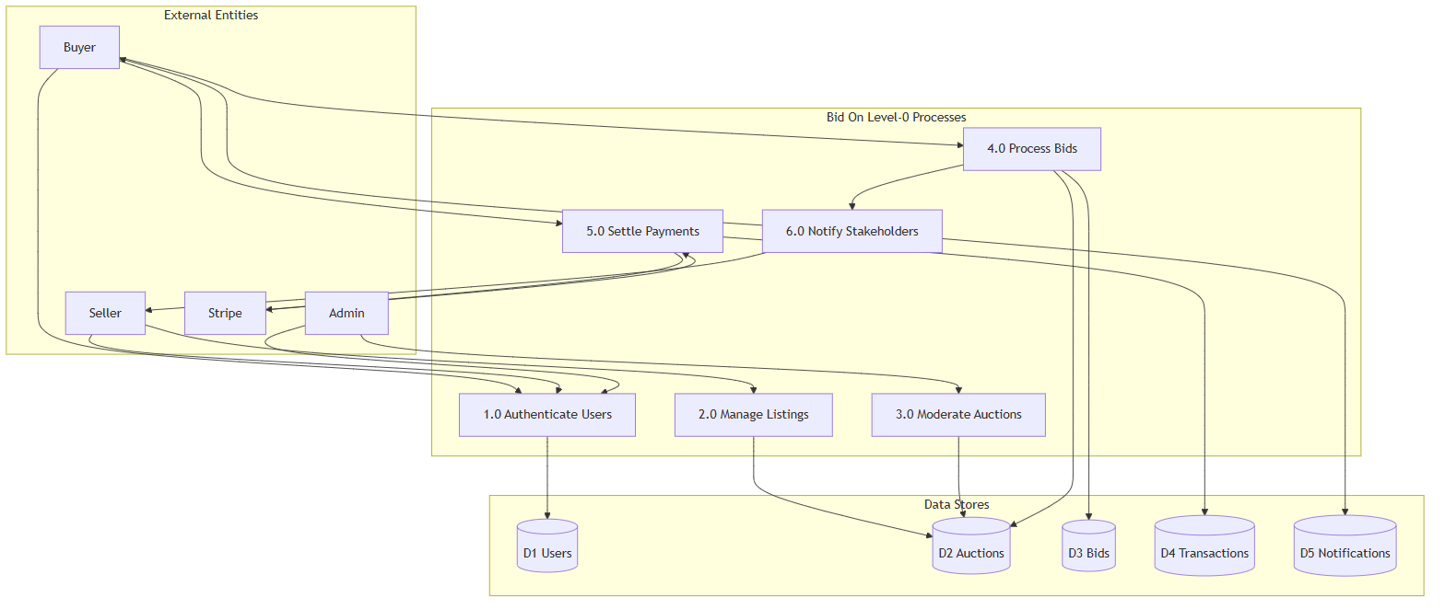
Figure 3.5: Activity — place bid (docs/diagrams/source/activity/place-bid.mmd).
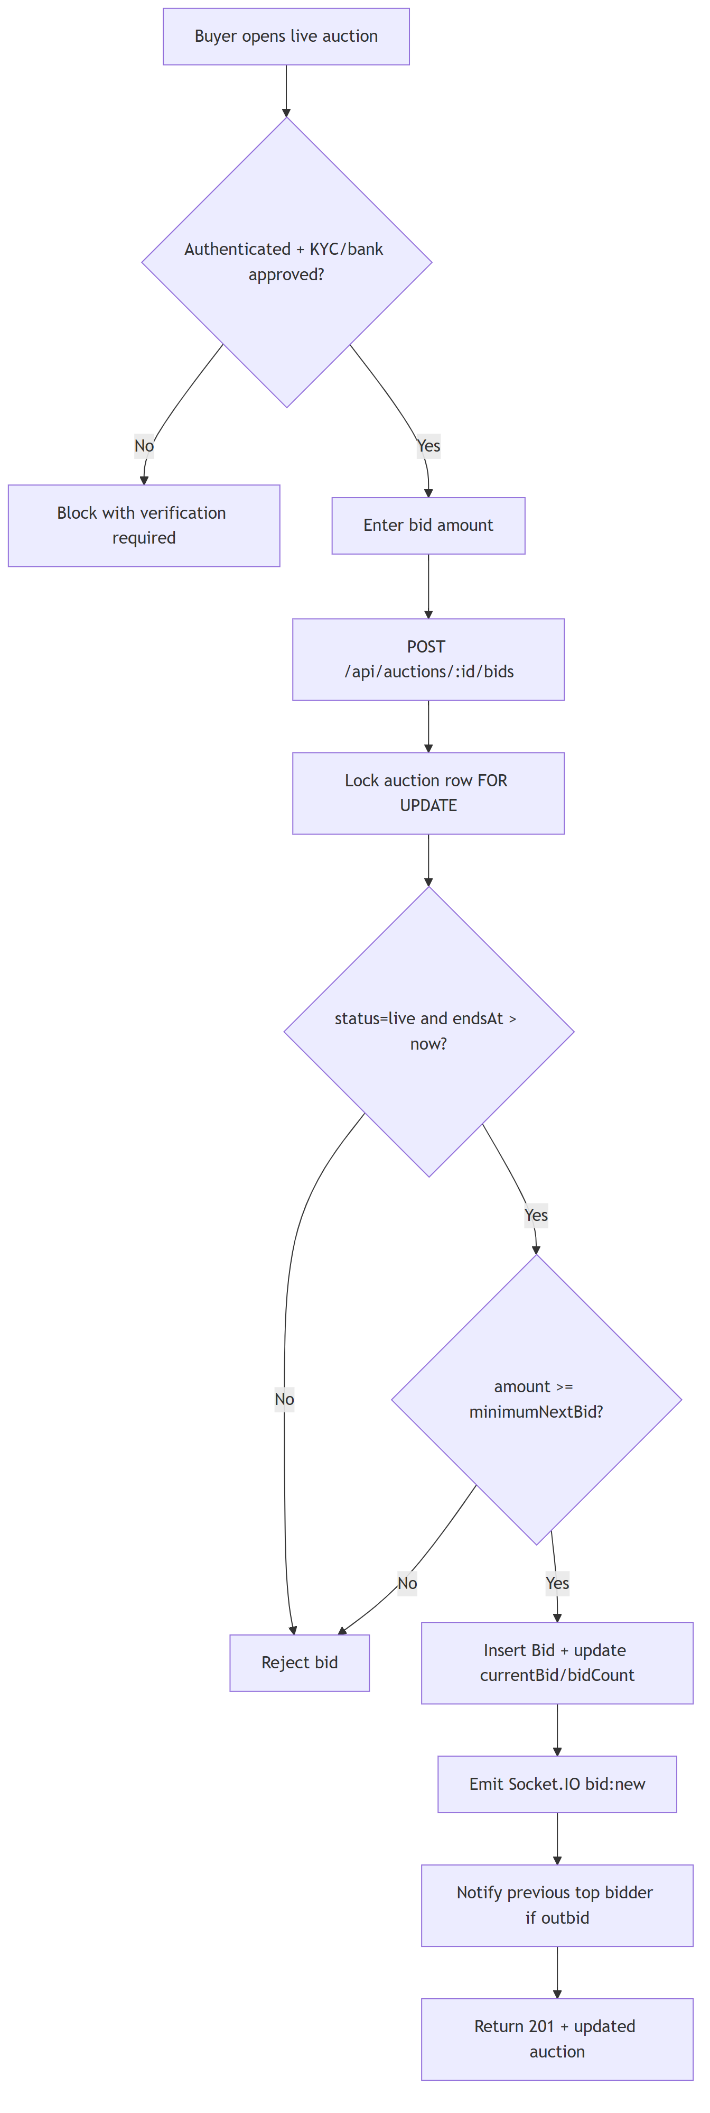
Figure 3.6: Sequence — checkout/escrow (docs/diagrams/source/sequence/checkout.mmd).
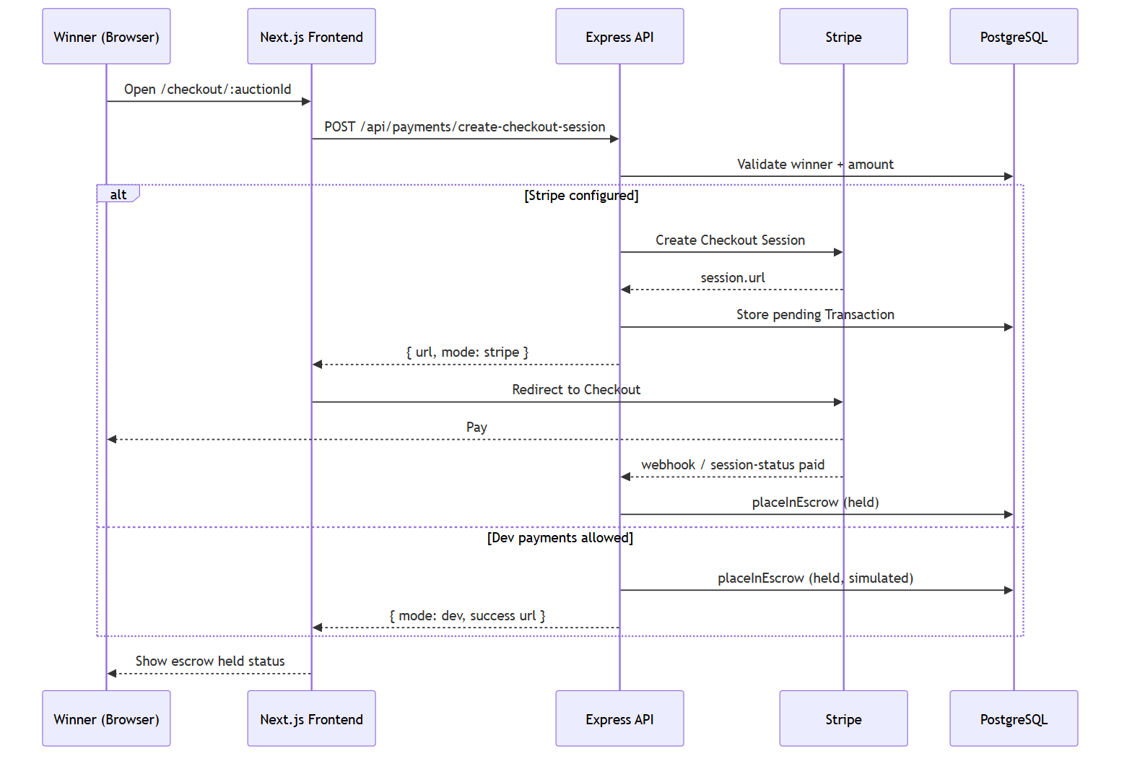
Figure 3.6b: Sequence — login (docs/diagrams/source/sequence/login.mmd).
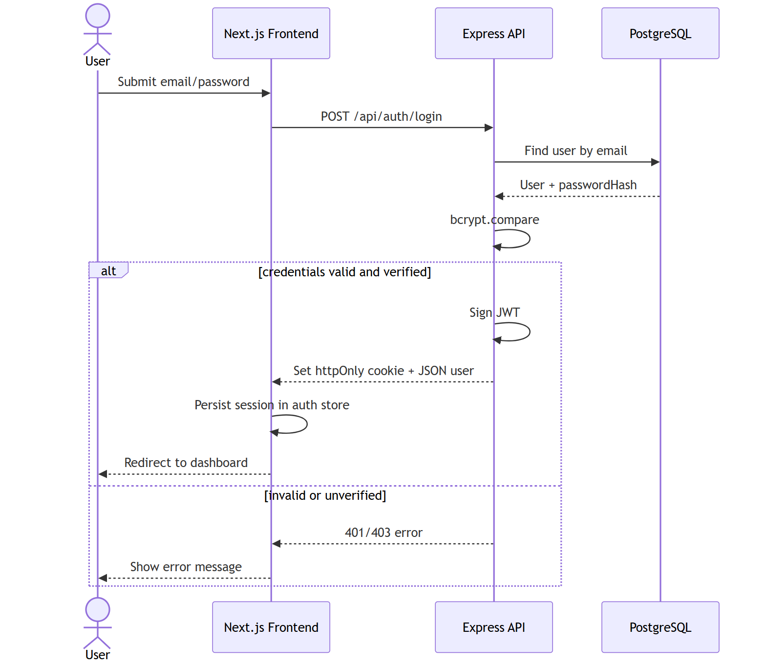
Figure 3.7: Components (docs/diagrams/source/component/components.mmd).
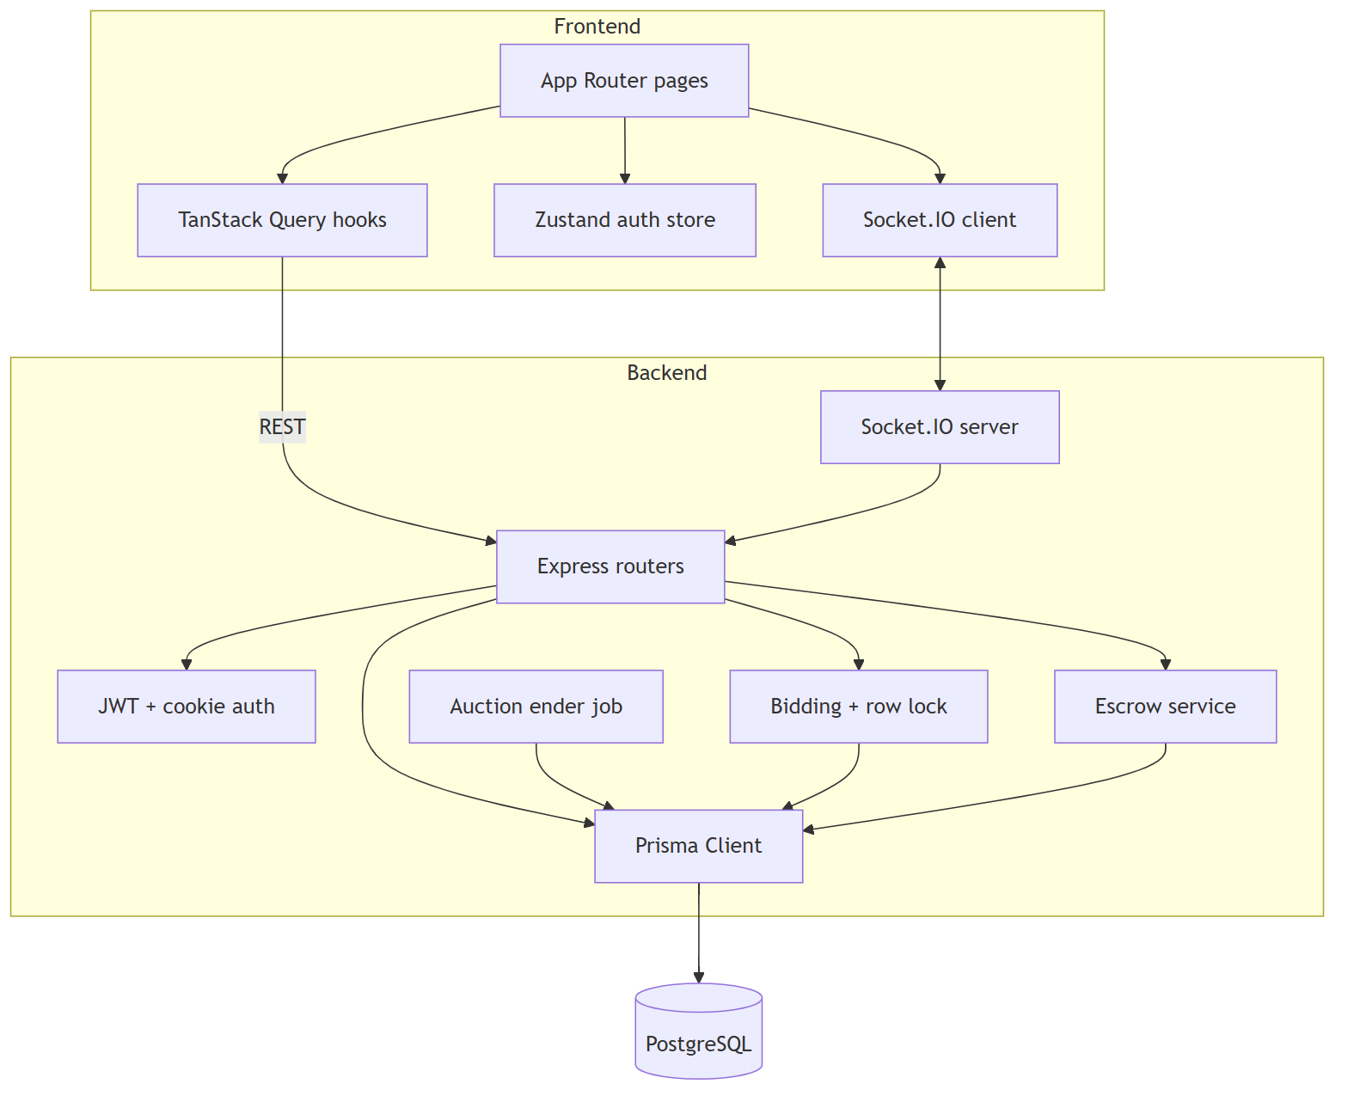
Figure 3.8: Use cases (docs/diagrams/source/use-case.puml).
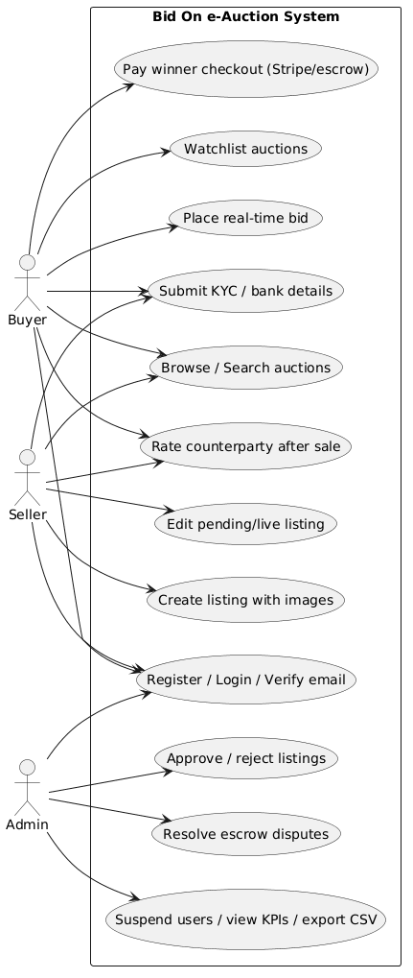
Figure 3.9: Domain classes (docs/diagrams/source/class-domain.puml).
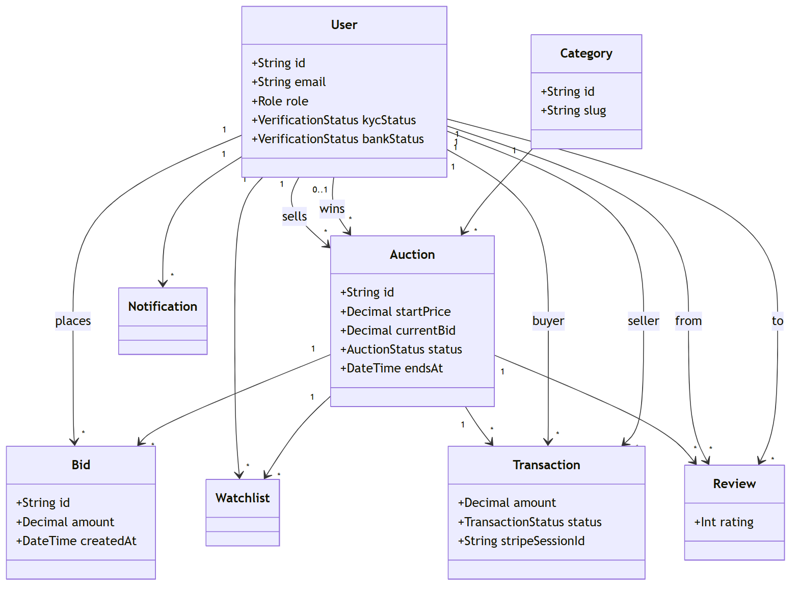
Reading Figure 3.5 in conjunction with the bids route clarifies why UI-only validation is insufficient. Even if the client computes minimum next bid correctly, two clients can still race; only the locked server transaction serializes acceptance. Socket emissions after commit ensure observers learn the authoritative amount without polling storms.
Reading Figure 3.6 with the payments routes clarifies why redirect landing pages are untrusted as sole payment proof. The sequence requires a server-side session-status check against Stripe before escrow held state is recorded. Retries are guarded by unique stripeSessionId constraints to reduce duplicate ledger rows.
Reading Figure 3.8 (use cases) against Role and VerificationStatus enumerations shows that authorization is not a single Boolean authenticated flag. Seller listing, buyer bidding, and admin moderation are distinct capabilities, further constrained by KYC/bank gates where the application enforces them.
Reading Figure 3.9 (domain classes) against migrations shows a one-to-one conceptual mapping rather than a separate UML fantasy model. Examiners can open backend/prisma/schema.prisma and recognize the same nouns. That mapping is deliberate academic hygiene.
3.5 Database design and implementation
The logical schema comprises eight primary entities: User, Category, Auction, Bid, Watchlist, Notification, Transaction, and Review. Table 3.2 lists responsibilities. Money fields use Decimal(12,2). Enumerations encode lifecycle states. Production persistence is PostgreSQL accessed through Prisma migrations stored under backend/prisma.
User stores identity, role, verification flags, aggregated rating fields, and embedded KYC and bank verification attributes with status enumerations. Category supports a parent–child taxonomy through an optional parentId. Auction stores listing content, pricing rules, timing, status, and optional winner linkage. Bid stores immutable accepted bids. Watchlist is a uniqueness-constrained junction between users and auctions. Notification stores typed messages with optional JSON metadata. Transaction stores escrow ledger rows linking buyer, seller, auction, amounts, Stripe identifiers, and lifecycle timestamps. Review stores ratings unique per (auction, fromUser).
Figure 3.4 presents the entity–relationship overview. Editable sources include docs/diagrams/source/erd/erd.mmd and docs/database/erd/database-erd.drawio. Independent MySQL-compatible DDL and DBML exports under docs/database/schema are logical equivalents of the implemented Prisma/PostgreSQL design; the runtime database on Render remains PostgreSQL. This separation satisfies the academic requirement for an independent database deliverable without inventing a second production schema.
Referential integrity is enforced with foreign keys. Indexes exist on auction status, endsAt, categoryId, bid auction/bidder foreign keys, notification user/read pairs, and transaction participant keys. Transaction.stripeSessionId is unique to reduce duplicate escrow rows for the same checkout session. Bid placement executes SELECT … FOR UPDATE on the auction row inside a transaction before validating amount and updating currentBid, which is the methodological answer to RQ2’s concurrency concern.
Normalization is intentionally pragmatic. KYC and bank fields remain on User rather than exploding into multiple one-to-one tables because each user has at most one active verification dossier of each type in the current product scope. Watchlist and the Review uniqueness constraints prevent duplicate association rows. Bid history is not overwritten; currentBid on Auction is a controlled redundancy maintained inside the same transaction that inserts a Bid, improving read performance for catalogue queries while preserving an auditable ledger of bids.
Table 3.2: Core database entities and responsibilities
Entity | Responsibility
User | Identity, RBAC, KYC/bank verification dossier, rating aggregates
Category | Taxonomy tree for listings
Auction | Listing content, pricing rules, clock, status, winner
Bid | Immutable accepted bid history
Watchlist | User–auction favourites (unique pair)
Notification | Typed in-app alerts
Transaction | Escrow ledger with Stripe identifiers and lifecycle timestamps
Review | Post-trade ratings unique per auction and reviewer

Figure 3.4: Entity–relationship overview (docs/diagrams/source/erd/erd.mmd; draw.io under docs/database/erd/).
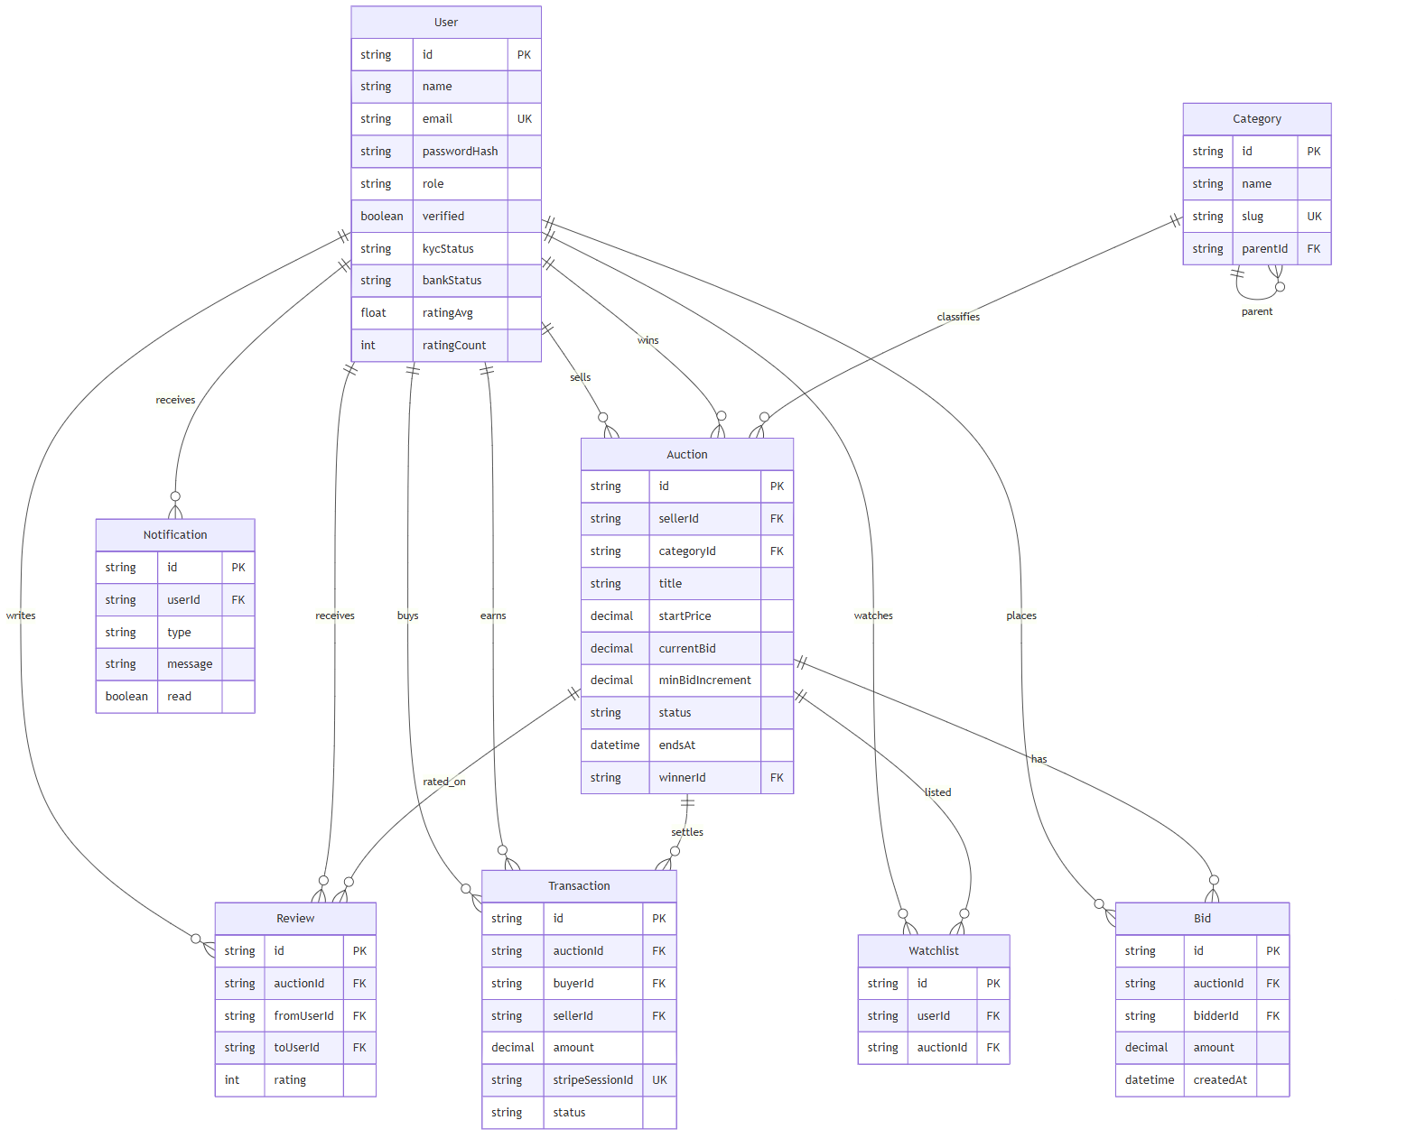
3.5.1 Bidding algorithm (implementation method)
Minimum next bid is computed from the auction’s currentBid and minBidIncrement. If currentBid is zero, the next acceptable amount equals startPrice; otherwise it equals currentBid plus increment, with monetary rounding applied in the bidding helper module. On POST /api/auctions/:id/bids, the API authenticates the buyer, enforces compliance gates, begins a database transaction, locks the auction row, re-reads auction state, validates live status and amount, inserts a Bid, updates currentBid and bidCount, commits, then emits Socket.IO events so connected clients observe a single consistent order of acceptance.
This algorithm is intentionally simple and auditable. It does not implement proxy bidding or second-price sealed mechanisms. Those alternatives remain outside the requirements chart and are noted only to clarify scope.
3.5.2 Escrow state method
When a winner initiates checkout, the API creates a Stripe Checkout session (or a guarded development substitute when explicitly enabled). On session-status confirmation, the API verifies that the processor reports a completed and paid session before creating or updating a Transaction in held state and associating stripeSessionId uniquely. Subsequent dispute, release, and completion transitions update timestamps and status enumerations so that administrators can inspect settlement progress without reconstructing browser history.
3.6 Security and compliance method
Passwords are stored as bcrypt hashes; plaintext passwords are never persisted. API authentication accepts a Bearer token or an httpOnly cookie named for the session token. The /api/auth/me endpoint supports session hydration after page reloads. In production, JWT_SECRET must be configured with sufficient length; weak defaults are rejected.
Authorization follows role-based access control. Seller routes require the seller role for listing creation. Admin routes require the admin role for approval, rejection, user management, and reporting. Buyer bidding routes require authentication plus KYC and bank approval gates where enforced by the application logic. Socket notification rooms are bound to authenticated user identifiers to prevent trivial cross-user subscription.
CORS origins are restricted to configured frontend URLs, including https://bid-on.onrender.com. Production payment creation requires Stripe unless an explicit development bypass flag is enabled. Payment confirmation endpoints verify Stripe session payment status before transitioning escrow Transaction rows into held state and updating auction commercial status.
These controls do not constitute a claim of formal penetration-test clearance. They are methodologically necessary minimums for a system that handles accounts and payment redirects. Residual risks—notably public accessibility of uploaded KYC files on free-tier disk—are recorded for Chapter 4 rather than silently omitted.
3.7 Implementation method
Development followed an iterative full-stack approach. Schema and migrations were established first so that API contracts could be typed against Prisma models. Express routers with Zod validation were implemented next for auth, auctions, bids, payments, admin, categories, and related domains. Next.js pages and TanStack Query hooks were then wired to those endpoints, followed by Zustand auth-store session management and Socket.IO client subscriptions.
Background auction-ending logic transitions live auctions past endsAt into ended/sold outcomes and supports notification generation for winners and participants according to route and job logic in the backend. Continuous checks during the project included TypeScript compilation, selected Vitest suites with Supertest, and live health/auction endpoint smoke tests after production deploys from GitHub master.
Hosting migration from earlier Railway experimentation to Render was driven by operational fit for a three-service Blueprint (web, API, Postgres). Environment variables separate database URLs, JWT secrets, Stripe keys, CORS origins, and frontend public API URLs. The methodological principle was that production configuration must be explicit; silent localhost defaults must not leak into public deployments.
Documentation was treated as part of implementation method rather than as an afterthought. DATABASE_ARCHITECTURE artefacts, DEPLOY runbooks, OpenAPI UI at /api/docs, and the thesis packs under docs/ were produced so that examiners and future maintainers can inspect design decisions without reverse-engineering every route.
Requirements validation was performed by walking each chart item against repository paths: authentication against backend auth routes and frontend auth store; listings against auction create/edit pages and image upload handlers; bidding against bids routes and Socket.IO emitters; payments against Stripe session creation and confirmation handlers; administration against approve/reject and reporting routes. Items that could not be traced to code were marked partial or out of scope rather than silently absorbed into marketing language.
Architectural quality attributes considered during design included deployability, inspectability, and evolvability. Deployability favored a managed multi-service host with PostgreSQL. Inspectability favored OpenAPI documentation, health endpoints, and a public GitHub repository. Evolvability favored clear module boundaries so that Stripe Connect payouts or private object storage could be added later without rewriting the entire auction domain.
The frontend architecture uses the Next.js App Router with client components where interactivity is required (bidding panels, countdown timers, checkout verification) and server-friendly layouts for navigation chrome. TanStack Query manages server-state caching for catalogues and detail views. Zustand holds authentication session state hydrated from /api/auth/me. Axios (or fetch wrappers in api.ts) centralizes the API base URL from NEXT_PUBLIC_API_URL so that production builds target https://bid-on-api.onrender.com.
The backend architecture mounts versioned logical route groups under /api for auth, auctions, bids (nested), payments, admin, categories, notifications, watchlist, reviews, and related utilities. Zod schemas validate inbound payloads. Prisma Client executes queries against PostgreSQL. A Socket.IO server shares the HTTP server instance to emit bid and notification events. Multer stores uploaded files on local disk for the current hosting tier—an acknowledged temporary choice.
Auction ending is handled by backend logic that identifies live auctions whose endsAt timestamp has passed and transitions them to ended or sold outcomes with winner assignment when bids exist and reserve conditions are considered according to implemented rules. This job-like behaviour is essential because browser countdown components alone cannot be trusted as the system of record for commercial state.
Error handling follows a pragmatic API style: validation failures return 4xx responses with messages suitable for UI display; authentication failures return 401/403; unexpected errors are logged server-side without leaking stack traces to clients in production configurations. The frontend surfaces these messages in forms and toast-style feedback where implemented.
Configuration management separates secrets from source control. Database URLs, JWT secrets, Stripe keys, and CORS allow-lists are injected through Render environment variables. Frontend public configuration is limited to values safe for browser exposure, principally the API base URL. DEPLOY.md documents the operational steps for examiners and maintainers.
3.7.1 Extended entity notes
Table User is the security and compliance anchor. Besides email uniqueness and passwordHash, it carries suspended flags, OTP fields for verification and password reset, and parallel KYC/bank attribute groups each governed by VerificationStatus. Rating aggregates (ratingAvg, ratingCount) denormalize review outcomes for quick profile display while Review rows remain the source of truth for individual scores.
Table Auction is the commercial center. Status progresses through pending, live, ended, cancelled, and sold. Pricing fields include startPrice, optional reservePrice and maxPriceCap, currentBid, and minBidIncrement. The images column stores an array of upload paths. Indexes on status, endsAt, and categoryId support catalogue filters and ending sweeps.
Table Bid is append-oriented. Bids are not updated in place when outbid; a new row is inserted. This design simplifies audit trails and dispute investigation. Cascading deletion from Auction removes bids if a listing is hard-deleted, which is acceptable for moderated draft cleanup but should be used cautiously for historically sold lots.
Table Transaction encodes marketplace settlement. It references auction, buyer, and seller, stores amount, optional Stripe session and payment identifiers, and timestamps for held, shipping, release, dispute, and resolution events. Unique stripeSessionId prevents duplicate held rows for the same Checkout session when clients retry confirmation.
Extensibility paths that preserve normalization include introducing a DocumentAsset table for private KYC storage keys, a Payout table for Connect transfer identifiers, and optional BidProxy settings if automatic bidding is later required. None of these extensions are claimed as present in the current schema.
3.7.2 Functional requirement implementation walkthrough
The following subsections walk through major functional requirements as implemented, so that examiners can correlate narrative claims with repository modules without relying on screenshots alone.
FR1 Authentication and registration. Users register with name, email, password, and role intent according to the auth route contract. Passwords are hashed with bcrypt before persistence. Email verification uses a one-time code with expiry; successful verification issues a JWT and sets an httpOnly cookie. Login repeats credential verification and session issuance. Password reset uses a parallel OTP channel. The frontend auth store hydrates from GET /api/auth/me after reload so that protected pages do not depend on in-memory tokens alone.
FR2 Listing creation. Authenticated sellers submit title, description, category, pricing fields, schedule, and images. New auctions enter pending status and remain invisible to the live catalogue until admin approval. Image uploads are accepted through Multer and stored as path references on the Auction.images array. Edit rules differ by status so that live commercial state cannot be silently rewritten in unsafe ways.
FR3 Real-time bidding. Authenticated buyers with required compliance gates post bids to /api/auctions/:id/bids. The server locks the auction row, validates liveness and minimum next bid, inserts a Bid, updates currentBid and bidCount, and emits Socket.IO events. The frontend countdown and bid panels consume both REST detail payloads and socket updates so that multiple browsers observing the same lot converge on the accepted price.
FR4 Notifications. The Notification model stores typed messages (outbid, ending soon, won, approved, rejected, general). In-app retrieval is implemented for authenticated users. Email is used for verification and recovery when configured. SMS delivery specified in early requirements is not implemented and is reported as partial coverage.
FR5 Payments. Auction winners create a Stripe Checkout session through the payments API. On return, session-status confirmation consults Stripe payment state before escrow Transaction rows are marked held and commercial auction state is updated. Development bypass exists only behind explicit configuration and must not be enabled in production examiner deployments.
FR6 Search and filter. GET /api/auctions accepts query parameters for text search, category, and status filters used by the catalogue UI. Indexes on status and categoryId support these access patterns at university scale.
FR7 Ratings. After eligible trades, Review rows capture integer ratings and optional comments with uniqueness per auction and reviewer. User rating aggregates are maintained for profile display.
FR8 Admin approval. Admins transition pending auctions to live or rejected with optional reject reasons. Rejecting non-pending auctions returns an error, preventing accidental cancellation of live commerce through the reject endpoint.
FR9 Countdown. The frontend Countdown component renders time remaining from endsAt. Server-side ending logic remains authoritative when the clock elapses.
FR10 Admin reporting. Administrative dashboards expose KPI summaries and CSV export paths for operational review. This satisfies medium-priority analytics needs without claiming a full warehouse-grade analytics platform.
3.7.3 Quality assurance method during construction
Quality assurance during implementation combined static typing, automated tests where available, and smoke tests against the deployed environment. TypeScript compilation on frontend and backend catches large classes of contract drift before runtime. Vitest with Supertest exercises selected API behaviours against a local database when developers provide DATABASE_URL and seed data.
Manual exploratory testing covered registration, verification, listing creation, approval, bidding on a live lot, watchlist interactions, and checkout initiation. Exploratory testing is acknowledged as non-exhaustive: it cannot replace a dedicated QA team or formal penetration test.
Configuration review checked that production CORS allow-lists include the Render frontend origin, that JWT secrets are not trivial, and that public frontend environment variables do not embed private Stripe keys. Secrets remain on the API service environment.
Documentation review checked that OpenAPI UI remains reachable at /api/docs, that DEPLOY.md matches the Render service names, and that database architecture documents reflect the Prisma models rather than an obsolete sketch.
3.7.4 Additional methodological notes
Use-case prioritization followed MoSCoW intuition even without a formal MoSCoW spreadsheet: must-have items were authentication, moderated listings, live bidding, countdown, and payment initiation; should-have items included watchlist, reviews, and admin CSV; could-have items included SMS and AI fraud; won’t-have for this release included multi-currency wallets and logistics tracking.
Interface contracts between frontend and backend were kept deliberately boring: JSON over HTTPS, cookie credentials for browser sessions, and Bearer tokens for API clients. Boring contracts reduce debugging time during deployment when CORS, cookies, and SameSite attributes interact with cross-subdomain hosting on Render.
Data migration discipline used Prisma migrate workflows so that schema changes remain replayable. Independent SQL/DBML exports were generated for academic reviewers who may not run Prisma, with an explicit note that production remains PostgreSQL. This dual representation is a documentation strategy, not a claim of dual production databases.
Logging and observability on the free tier are limited. The team relied on Render logs during incident response (for example CORS misconfiguration and cold-start timeouts) rather than a full APM stack. Future work may add structured request logging and metrics exporters once the service is on an always-on plan.
Accessibility and internationalization were not primary grading targets in the requirements chart, yet the UI uses readable typography and responsive layout as a baseline. Full WCAG audit and Bengali localization remain optional enhancements rather than asserted achievements.
Disaster recovery for a student deployment is necessarily lightweight: GitHub is the code recovery path; Render Postgres backups depend on plan features; uploaded files on ephemeral disk are not disaster-safe. The methodology therefore warns against storing irreplaceable KYC evidence solely on the free web filesystem.
3.8 Summary of the Chapter
This chapter presented the methodology for Bid On: requirements-to-module mapping, three-tier architecture and Render deployment, process and interaction models, normalized database design with concurrency and escrow controls, security and compliance method, and iterative implementation practice. These artefacts establish the technical basis for the results and discussion in Chapter 4 and answer, at the design level, research questions RQ1 and RQ2.

CHAPTER 4
RESULTS ANALYSIS AND DISCUSSION
4.1 Overview
This chapter reports the evaluation of the implemented Bid On system. For a software engineering thesis without a machine-learning experimental corpus, evaluation means functional verification against requirements, inspection of the deployed environment, critical discussion of security and payment behaviour, and transparent reporting of untested non-functional targets. The chapter deliberately avoids fabricating load-test numbers, latency percentiles, or user-study scores that were not collected.
4.2 Experimental setup
Table 4.1 summarizes the environment used for verification. The production stack is publicly reachable, which allows examiners to inspect the running system independently of the authors’ local machines. Local development used Node.js 22+, Git, and Vitest. The repository of record is github.com/eauctionproject2025/bid-on on branch master.
Demo and seed data on the live database support catalogue browsing without requiring every examiner to create listings from scratch. API health can be checked with GET /api/health. Interactive OpenAPI documentation is available at /api/docs on the API host. These affordances reduce ambiguity about which build is under discussion.
Table 4.1: Experimental / deployment environment
Component | Configuration
Frontend | Next.js 15 on Render service bid-on — https://bid-on.onrender.com
API | Express/Prisma on bid-on-api — https://bid-on-api.onrender.com
Database | PostgreSQL 16 bid-on-db (Singapore)
Repository | https://github.com/eauctionproject2025/bid-on
Local tooling | Node.js 22+, Git, Render CLI, Vitest

4.3 Functional verification results
Selected verification outcomes are shown in Table 4.2. Live smoke tests confirmed API health and auction catalogue retrieval from the Render deployment. The website at https://bid-on.onrender.com/auctions renders the catalogue experience when pointed at the production API. Code-level fixes validated during the hardening cycle include payment confirmation gating on Stripe session completion, auth session refresh via /api/auth/me, auction reject constraints limited to pending listings, and bid row locking with SELECT … FOR UPDATE.
Automated backend tests (Vitest + Supertest) exist in the repository and cover portions of auth and domain behaviour when a local Postgres instance and seed data are available. They are not claimed as a complete substitute for system testing on the production free tier, where cold starts and ephemeral disks introduce behaviours absent from a warm local environment.
Figure 4.1 corresponds to the live auctions page of the deployed frontend. The figure caption in the printed thesis should be accompanied by a screenshot captured by the authors at submission time; the URL itself remains the primary reproducible evidence. Supporting catalogues of endpoints and test identifiers are archived under docs/appendices so that Chapter 4 can remain analytical rather than encyclopedic.
Table 4.2: Selected functional verification outcomes
Check | Expected | Result
GET /api/health | {ok:true} | Pass (live)
GET /api/auctions | Live lots JSON | Pass (live)
Website /auctions | Catalogue UI renders | Pass (live)
Checkout confirm | Paid only if Stripe session complete+paid | Pass (logic verified)
Reject non-pending | HTTP 400 | Pass (logic verified)
Bid row lock path | Serialized accept under concurrency | Pass (code/path present)
Cold start < 3s | All pages after idle | Partial / Fail vs NFR4
5000 concurrent users | Sustained load | Not tested

Figure 4.1: Live auctions catalogue on the deployed frontend (https://bid-on.onrender.com/auctions).
[Figure 4.1 — insert screenshot of https://bid-on.onrender.com/auctions captured at submission time]
4.3.1 Expanded verification narrative
The evaluation narrative below expands Table 4.2 into examiner-readable prose. It distinguishes live observations on Render from logic verification performed through code review and targeted fixes during the hardening cycle.
Live API health. Repeated GET requests to https://bid-on-api.onrender.com/api/health returned a JSON body indicating service liveness. After idle periods, the first request sometimes incurred an elevated wake delay consistent with free-tier sleep; subsequent requests on a warm instance were materially faster. This observation is the primary empirical basis for marking NFR4 as partial rather than fully satisfied.
Live catalogue. GET /api/auctions returned auction objects including seeded demonstration lots. The Next.js page at /auctions rendered cards/list UI consuming that payload when NEXT_PUBLIC_API_URL pointed at the Render API. Visual confirmation of the catalogue is the basis for Figure 4.1’s caption; authors should attach a submission-time screenshot in the printed volume.
Authentication session refresh. Prior to hardening, reloading protected pages could leave the client without a hydrated user even when a cookie remained. Wiring /api/auth/me into the auth store corrected that class of defect. Verification combined code inspection with manual reload checks on authenticated flows.
Bidding integrity path. Inspection of backend/src/routes/bids.ts confirmed that bid acceptance performs a transactional lock on the auction row before re-validating amount and writing Bid plus Auction updates. Combined with backend/src/lib/bidding.ts minimum-next-bid rules, this constitutes the implemented answer to concurrent integrity concerns. A formal multi-client race harness at thousands of users was not executed.
Payment confirmation. Inspection and repair of payment session-status handling ensured that unpaid or incomplete Stripe sessions do not mark auctions or escrow rows as successfully paid. This closes a redirect-trust anti-pattern common in student payment demos.
Admin reject constraints. Reject handlers were verified to refuse non-pending auctions, returning a client error instead of mutating live or ended lots through the reject pathway.
Negative results are equally important. SMS was not delivered in any test because no SMS provider integration exists. Stripe Connect payouts were not executed because connected-account onboarding and transfer code are absent. A 5000-user load test was not performed; therefore no throughput, error-rate, or latency distribution is reported for that target.
4.4 Comparative discussion against requirements
Table 4.3 consolidates coverage against the requirements chart. High-priority functional requirements FR1–FR3 and FR5–FR9 are implemented in the deployed system. FR4 is partial because in-app notifications and email verification exist, but SMS delivery does not. FR10 is supported through admin KPI views and CSV export rather than through a separate business-intelligence warehouse.
Non-functional responsiveness of layout is qualitatively supported by a responsive UI. Quantitative page-load claims under free-tier cold start are not asserted as universally met; observed wake delays can exceed a three-second budget on first request after idle sleep. The five-thousand concurrent user target remains an unverified aspiration on the current hosting plan and is marked as not tested.
Dependencies mentioned in early planning documents—such as artificial-intelligence fraud detection—are not present in the codebase and are therefore classified as future work. This classification is a result, not a failure of honesty: the evaluation criterion is correspondence between claims and artefacts.
Table 4.3: Requirements coverage summary
Status | Items
Implemented | Auth, listings, live bidding, Stripe/escrow path, search/filter, ratings, admin approval, countdown, admin CSV/KPIs
Partial | Notifications without SMS; performance under sleep/wake
Not implemented / not tested | AI fraud detection; Connect payouts; formal 5000-user load test

4.5 Security and payment discussion
Relative to Gap 2 identified in Chapter 2, the system demonstrates concrete controls: production JWT secret enforcement, CORS tightening, authenticated socket rooms, unique Stripe session identifiers on escrow rows, and auction row locking during bid acceptance. Payment confirmation no longer trusts redirect alone.
Residual risks remain. KYC document files served from a public uploads directory on ephemeral free-tier disk create both privacy and durability limitations. Escrow completion does not yet execute a Stripe Connect transfer to sellers; the ledger can record held and completed states without automating disbursement. These points are treated as known constraints rather than as hidden defects, and they directly inform the future work list in Chapter 5.
From a research perspective, the results support affirmative answers to RQ1 and RQ2 at the level of a university-scale deployable system, while RQ3 receives a mixed but evidence-based answer: prioritized functional requirements are largely met; aggressive performance and payout automation goals are not yet met and are not pretended to be met.
4.5.1 Multi-lens discussion and threats to validity
Discussion of results is organized around three lenses: functional completeness, integrity of critical paths, and operational realism. Functional completeness asks whether a moderated auction can proceed from listing to payment. Integrity asks whether bidding and payment confirmation resist known race and redirect hazards. Operational realism asks whether free-tier hosting behaviour undermines non-functional promises.
Under the first lens, the live catalogue, authentication flows, admin approval path, countdown presentation, and Stripe checkout initiation demonstrate that the primary lifecycle exists as a connected whole. Seeded demonstration lots on the production database make this inspectable without private credentials beyond ordinary user registration where required.
Under the second lens, code review and targeted fixes provide evidence that previously weak points were addressed: session hydration after reload, reject-only-pending constraints, payment confirmation gated on processor state, and auction row locking during bid acceptance. These are engineering results with high relevance to RQ2 even without a formal concurrency stress battery.
Under the third lens, free-tier sleep, ephemeral disks, and the absence of Connect payouts dominate the negative findings. They do not erase functional success, but they bound the marketing language that can ethically accompany the project. The thesis therefore reports a qualified success: the academic and functional core is in place; industrial-scale operations are not.
Threats to validity include the limited set of formal UAT participants beyond the development team, the dependence on Stripe test/live configuration available at evaluation time, and the possibility that Render plan changes alter cold-start behaviour after submission. External validity to other auction mechanisms (Dutch, sealed bid) is not claimed.
Reproducibility guidance for examiners is as follows. Clone or browse the GitHub repository; open the live frontend and API URLs; call GET /api/health; browse /auctions; optionally register a new buyer account and explore read-only catalogue behaviour. Destructive admin actions should be avoided on the shared demonstration database unless examiners use a private fork.
Comparison with the proposal’s aspirational analytics language shows partial realization: administrative KPIs and CSV export provide operational visibility, but advanced data analytics, dashboards with predictive models, and fraud scoring are not present. Chapter 4 therefore interprets “data analytics” in the proposal title as a directional theme rather than as a completed ML work package.
User experience observations during team testing indicated that countdown timers and live price updates improve perceived fairness relative to static pages, while KYC gates increase onboarding friction. That friction is accepted as a trust trade-off. Quantitative SUS or NPS studies were not conducted and are not fabricated.
Security discussion in depth: bcrypt hashing mitigates offline password theft if the database is leaked; httpOnly cookies reduce some XSS token theft vectors but do not eliminate XSS itself; CORS restrictions reduce casual cross-origin API abuse from arbitrary websites; Stripe Checkout reduces PCI scope. Residual risks include XSS in any unsanitized rich content, public KYC file URLs, and account takeover via OTP channel weaknesses if email delivery is misconfigured.
Ethical considerations include informed handling of identity documents and avoidance of dark patterns in bidding. The system should not conceal fees or silently extend auctions without rules. Current ending logic follows configured endsAt rather than sniping-extension rules; if anti-sniping extensions are added later, they must be disclosed in the UI.
4.5.2 Research questions revisited
Answering RQ1 from results: the modular Next.js–Express–PostgreSQL deployment with admin moderation and Socket.IO bidding demonstrates that the architectural combination is workable in a live environment. The evidence is the running services and the traced modules, not a laboratory simulation.
Answering RQ2 from results: row locking, immutable Bid rows, Decimal monetary fields, and Transaction escrow statuses constitute a concrete data-and-transaction design for integrity. Remaining gaps (Connect payouts, private KYC storage) are extensions of the ledger and asset model, not contradictions of it.
Answering RQ3 from results: prioritized functional requirements are largely satisfied; SMS, AI fraud, Connect payouts, and 5000-user load remain unmet or untested. The honest scorecard is therefore mixed by design: strong on core lifecycle, incomplete on industrial NFRs.
The discussion closes by noting that academic software evaluation should reward measured humility. A thesis that admits free-tier cold starts and missing SMS is stronger under examiner scrutiny than one that asserts universal sub-three-second loads without instrumentation.
4.6 Summary of the Chapter
This chapter evaluated Bid On using deployment evidence, requirements-oriented verification, and critical security–payment discussion. The system meets the core moderated auction and bidding objectives articulated in Chapter 1, while performance-at-scale and automated seller payout remain future work. Chapter 5 concludes the study and maps outcomes to objectives.

CHAPTER 5
CONCLUSION AND FUTURE WORK
5.1 Research summary
This project designed, implemented, and deployed Bid On, a next-generation e-auction management system for secure, moderated, real-time online auctions. The work covered requirements analysis, architectural design, relational database modeling, full-stack implementation, cloud deployment, and supporting academic documentation aligned with MICE/BICE thesis guidance.
5.2 Major findings
A modular Next.js and Express architecture integrated with PostgreSQL and Socket.IO is sufficient to deliver a coherent auction lifecycle for a university-scale product. Concurrent bid integrity requires explicit database locking beyond optimistic user-interface updates. Payment confirmation must be bound to processor state, and escrow should be modeled as a first-class ledger entity. Free-tier hosting validates deployability but cannot alone substantiate large-scale performance claims.
5.3 Achievement of research objectives
Objective 1 is achieved through the deployed Bid On website and role-based workflows for buyers, sellers, and admins, including moderated listings and real-time bid updates.
Objective 2 is achieved through the Prisma/PostgreSQL schema, migrations, and independent SQL, DBML, and ERD artefacts under docs/database.
Objective 3 is achieved through requirements-mapped verification and an explicit limitations analysis; unverified non-functional requirements are not claimed as passed.
5.4 Contributions of the study
The study contributes (i) a working open repository and live deployment of a moderated real-time e-auction system, (ii) a documented relational schema with escrow semantics and concurrency controls, and (iii) an examiner-oriented documentation pack that separates thesis narrative from editable diagrams and independent database deliverables.
5.5 Limitations
Limitations include free-tier cold starts, ephemeral local upload storage, public accessibility of uploaded KYC files, absence of SMS notifications, absence of automated Stripe Connect seller payouts, and lack of a formal five-thousand-user load test. These limitations bound the external validity of performance-related claims.
5.6 Future recommendations
Future work should prioritize private object storage for KYC documents, Stripe Connect payouts, horizontal scaling with a paid always-on API tier, SMS or push notifications, and controlled load testing with published methodology. Optional analytics and anomaly detection may be added only after baseline operational metrics are collected and after privacy-preserving storage is in place.
In closing, Bid On demonstrates that a carefully scoped e-auction platform can embody moderation, real-time bidding, and escrow-aware settlement within a documented full-stack architecture suitable for postgraduate examination. The lasting value of the work lies equally in what was built and in what was refused: unverifiable performance theatre, silent AI features, and undocumented schemas.

REFERENCES
[1] I. Sommerville, Software Engineering, 10th ed. Boston, MA, USA: Pearson, 2016.
[2] E. Turban, J. Outland, D. King, J. K. Lee, T.-P. Liang, and D. C. Turban, Electronic Commerce 2018: A Managerial and Social Networks Perspective, 9th ed. Cham, Switzerland: Springer, 2018.
[3] Project team, “Online Auction System Requirement Chart,” internal requirements artefact, Bangladesh University of Professionals, Dhaka, Bangladesh, 2024.
[4] Vercel Inc., “Next.js Documentation.” [Online]. Available: https://nextjs.org/docs. [Accessed: 02-Nov-2026].
[5] OpenJS Foundation, “Express — Node.js web application framework.” [Online]. Available: https://expressjs.com. [Accessed: 02-Nov-2026].
[6] Socket.IO, “Socket.IO Documentation.” [Online]. Available: https://socket.io/docs. [Accessed: 02-Nov-2026].
[7] IEEE Std 830-1998, IEEE Recommended Practice for Software Requirements Specifications. New York, NY, USA: IEEE, 1998.
[8] Prisma Data Inc., “Prisma Documentation.” [Online]. Available: https://www.prisma.io/docs. [Accessed: 02-Nov-2026].
[9] Stripe Inc., “Checkout.” [Online]. Available: https://stripe.com/docs/payments/checkout. [Accessed: 02-Nov-2026].
[10] eauctionproject2025, bid-on. GitHub. [Online]. Available: https://github.com/eauctionproject2025/bid-on. [Accessed: 02-Nov-2026].
[11] Render, “Render Documentation.” [Online]. Available: https://render.com/docs. [Accessed: 02-Nov-2026].
[12] PostgreSQL Global Development Group, “PostgreSQL 16 Documentation.” [Online]. Available: https://www.postgresql.org/docs/16/. [Accessed: 02-Nov-2026].

APPENDICES
Appendix A — Repository documentation map
docs/final-report (this thesis DOCX/PDF and audit notes), docs/database (SQL/DBML/ERD/docs/seed), docs/diagrams (editable Mermaid/PlantUML sources and exports), docs/appendices (API and test catalogues), docs/DEPLOY.md (hosting runbook), backend/prisma/schema.prisma (runtime schema).
Appendix B — Representative API surface
Production API base: https://bid-on-api.onrender.com. Interactive OpenAPI UI: /api/docs. Authentication uses Authorization Bearer and/or httpOnly cookie with credentials included.
Method | Path | Auth | Notes
GET | /api/health | No | Service liveness
POST | /api/auth/register | No | Create unverified user
POST | /api/auth/verify | No | OTP verify; cookie + token
POST | /api/auth/login | No | Cookie + JWT
POST | /api/auth/logout | No | Clear cookie
GET | /api/auth/me | Yes | Session hydrate
POST | /api/auth/forgot-password | No | OTP reset start
POST | /api/auth/reset-password | No | OTP reset complete
GET | /api/auctions | Optional | Search/filter catalogue
GET | /api/auctions/:id | Optional | Detail + escrow snapshot
POST | /api/auctions | Seller | Create pending listing
PATCH | /api/auctions/:id | Seller/Admin | Edit by status rules
POST | /api/auctions/:id/approve | Admin | pending → live
POST | /api/auctions/:id/reject | Admin | pending only
POST | /api/auctions/:id/bids | Buyer | Row-locked bidding
GET | /api/categories | No | Tree + live counts
POST | /api/payments/create-checkout-session | Winner | Stripe or guarded dev
GET | /api/payments/session-status | Winner | Confirm paid → escrow
* | /api/admin/* | Admin | KPIs, users, CSV

Appendix C — Test case catalogue
Legend: V = verified in this project cycle; P = partial; N = not executed. Automated suites: backend Vitest/Supertest; frontend Vitest where present.
ID | Area | Expected | Status
TC-AUTH-01 | Register | 201 + unverified user | V
TC-AUTH-02 | Login | 200 + cookie/token | V
TC-AUC-01 | List live | JSON auctions array | V (live)
TC-AUC-02 | Health | ok true | V (live)
TC-BID-01 | Min bid | 4xx below minimum | P
TC-PAY-01 | Unpaid session | UI does not mark paid | V
TC-ADM-01 | Reject live | 400 | V
TC-UI-01 | Live site | Catalogue UI | V
TC-NFR-01 | 5000 users | Sustained load | N
TC-NFR-02 | Cold start <3s | All pages | P

Appendix D — Selected implementation excerpts
Bid placement locks the auction row before validation (backend/src/routes/bids.ts). Minimum next bid is computed in backend/src/lib/bidding.ts. Frontend API base URL is resolved from NEXT_PUBLIC_API_URL in frontend/src/lib/api.ts. Excerpts and commentary: docs/appendices/code-examples.md.
Appendix E — Independent database pack
MySQL-compatible DDL: docs/database/schema/database-schema.sql. DBML: docs/database/schema/database-schema.dbml. Editable ERD: docs/database/erd/database-erd.drawio. Narrative: docs/database/documentation/*.md. Seed: docs/database/seed/sample-data.sql. These artefacts describe the logical schema corresponding to the Prisma/PostgreSQL implementation; runtime production remains PostgreSQL.
Appendix F — Column summary for core tables
The following summary supports examiners who read the thesis without opening Prisma. It is not a substitute for the SQL/DBML pack.
Table | Key columns (selected)
User | id, name, email, passwordHash, role, verified, otp*, suspended, ratingAvg/Count, kyc*, bank*, timestamps
Category | id, name, slug, parentId
Auction | id, sellerId, categoryId, title, description, images[], prices, currentBid, minBidIncrement, bidCount, status, startsAt, endsAt, winnerId, rejectReason
Bid | id, auctionId, bidderId, amount, createdAt
Watchlist | id, userId, auctionId, createdAt (unique user+auction)
Notification | id, userId, type, message, read, meta, createdAt
Transaction | id, auctionId, buyerId, sellerId, amount, stripe*, status, held/ship/release/dispute timestamps
Review | id, auctionId, fromUserId, toUserId, rating, comment, createdAt

