|  |
| --- |
| Eau de Web |
| Meeting Registration Tool |
| User Guide |
| Georgiana Aspru  7-10-2017 |

Table of contents

1. Introduction 3

2. Meetings 3

2.1. Adding a new meeting 3

2.2. Managing an existing meeting 7

2.2.1. Participants 7

2.2.1.1. View the list of participants 7

2.2.1.2. Manage a participant 7

Edit participant 9

Print items 9

Acknowledge Email 12

Search for participants 13

Delete participant 13

2.2.1.3. Export participants to Excel 13

2.2.2. Manage media participants 15

2.2.3. Printouts 16

2.2.4. Bulk emails 18

2.2.5. Duplicates management 19

2.2.6. Logs 20

2.2.6.1. Database logs 20

2.2.6.2. Emails sent 20

2.3. Meeting settings 21

2.3.1. Categories 21

2.3.2. Roles 24

1.3.3. Subscribers 25

1.3.4. Phrases 25

1.3.5. Fields 26

1.3.6. Rules 28

1.3.7. Logos 29

1.3.8. Badge templates 29

1.3.9. Edit a meeting 30

1.3.10. Clone a meeting 31

1.3.11. Overview 31

3. Admin section 32

3.1. Default categories 32

3.2. Default Custom Fields 33

3.3. Default Phrases 33

3.4. Meeting Types 34

3.5. Staff 34

3.6. Roles 35

3.7. Users 35

3.8. Settings 35

# Introduction

This document describes the Meeting Registration Tool application developed by Eau de Web and its functionalities. This is intended to be used by the users of the application, meaning the organizers of the meetings or other roles.

*Acronyms*

MRT – Meeting Registration Tool

# Meetings

After a user is logged in into the application, he/she will be shown a list of the meetings they have access to and the possibility to add a new meeting or to see the different details about a certain meeting.

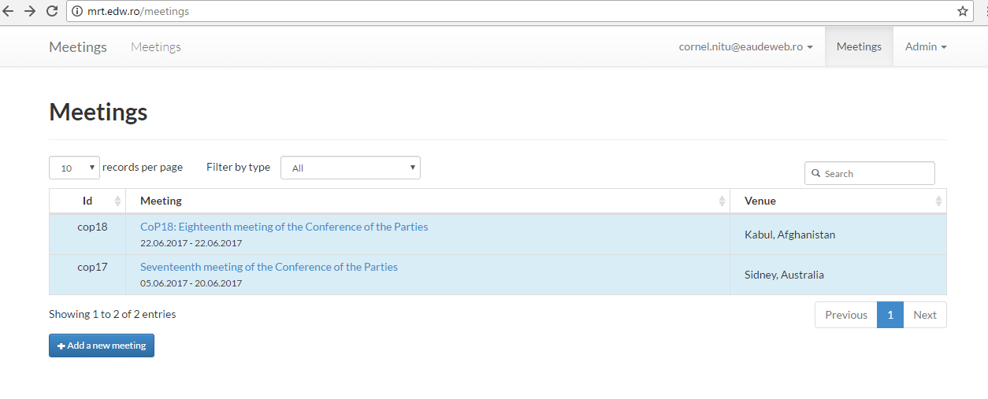

## Adding a new meeting

A new meeting can be added from the main page by clicking the “Add a new meeting” button placed below the meetings table. The user is shown the following screen where the mandatory fields are marked with the asterisk sign (*).

Some of the fields are accessible in 3 possible languages: English, French and Spanish. This will make the registration form to be available in the attendants’ corresponding language, with English being the default language.

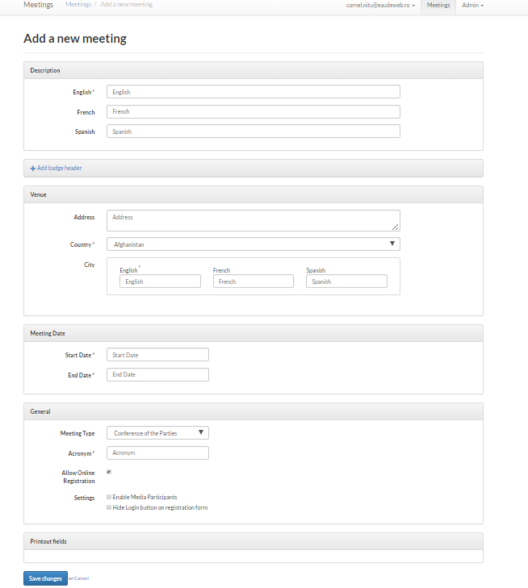

The attributes of the meeting that need to be filled in are the following:

**Description** – this field represents the title of the meeting and it is mandatory; it is recommended that it contains a short description of the event.

**Badge header** – you have the possibility to add a badge header; this is a text which will replace the full title of the meeting on the badges. It can be used for example when the Description field is a longer text and it does not fit on the badge.

**Venue** – this group of fields represent the location of the event takes place; this contains at least information about the Country and the City, but may also contain the address.

**Meeting date** – these fields contain a start date and an end date for the event and they are mandatory.

**Meeting type** – this is a choice field with choices defined by the Administrator of the application. The meeting types are useful for categorizing the meetings. They are also a way of defining a default behavior for a certain category of meetings - the default behaviour meaning default custom fields, default categories or default phrases. For example, we can set a field called Phone for all meetings of type “Conference of the Parties”. More details about this can be found in *Section 3: Admin* of the current guide.

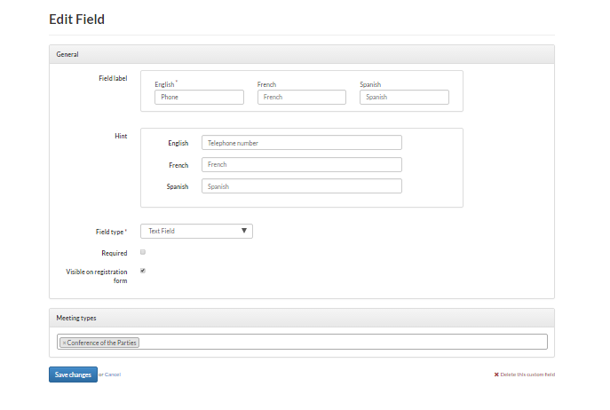

The registration form for the participants to the meeting will then look like this:

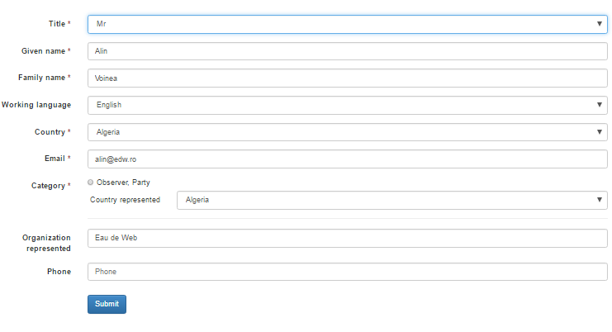

**Acronym** – This is an acronym of the name of the meeting, which will appear in the details of the meeting when viewing it

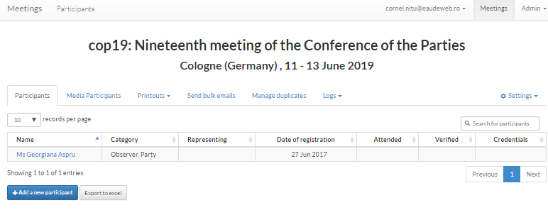

**Allow online registration** – this option will decide if the participants for the meeting will be added manually or by allowing online registration. Also, this option may be used to allow participants to register only during a certain period, after which the registration is closed by unchecking this option.

**Enable media participants** – this setting describes whether participants from media should be treated separately from the other participants, for example they could be viewed or approved by a different role.

**Hide login button on registration form** – this setting describes if at the end of the registration process the participant will be prompted to create a user account which will save the user details in order to be used for future registrations to other meetings.

## Managing an existing meeting

You may go to the meeting management page by clicking the meeting title in the meetings list.

### Participants

The Participants page for the meeting is the default page which is loaded:

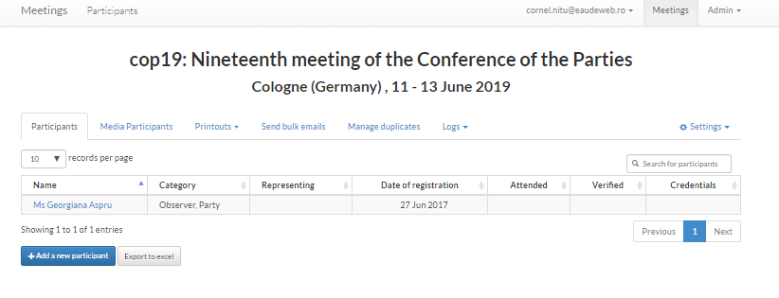

In the participants page you have the possibility to do one of the following actions:

#### View the list of participants

The columns for the participant list are:

**Name** – full name of the participant, including the title;

**Category** – category of the participant;

**Representing** – the organization/country/region/category (each category can define its own *representing* value) that the participant represents at the meeting;

**Date of registration** – the date when the participant registered;

**Attended** – a flag used by the Admin of the meeting to mark if the participant showed up at the meeting;

**Verified** – this is also a flag used by the Admin to mark if the participant was verified;

**Credentials** – also a flag used by the Admin.

#### Manage a participant

You may click on the name of the participant to view his/her details.

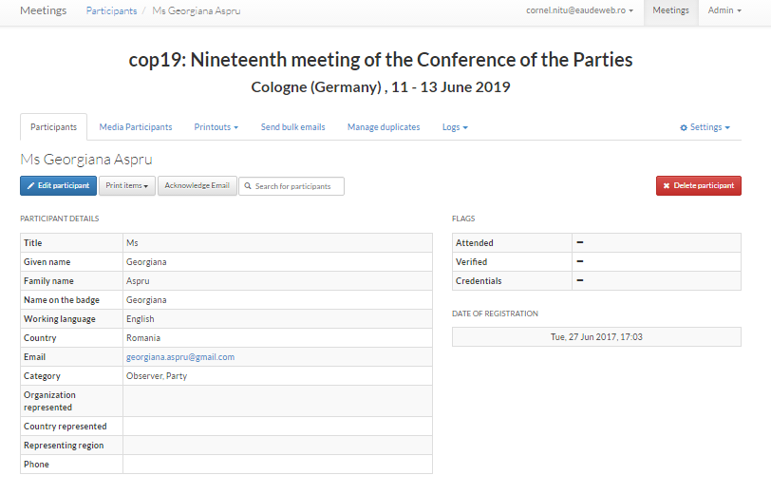

Here you have the possibility to Edit the participant (blue button), Print different items, Send acknowledge email to the participant, Search for other participants or Delete the participant (red button). Please note that delete is a soft operation, meaning that you can restore a participant deleted by mistake from the *Logs → Database activity* menu entry.

##### Edit participant

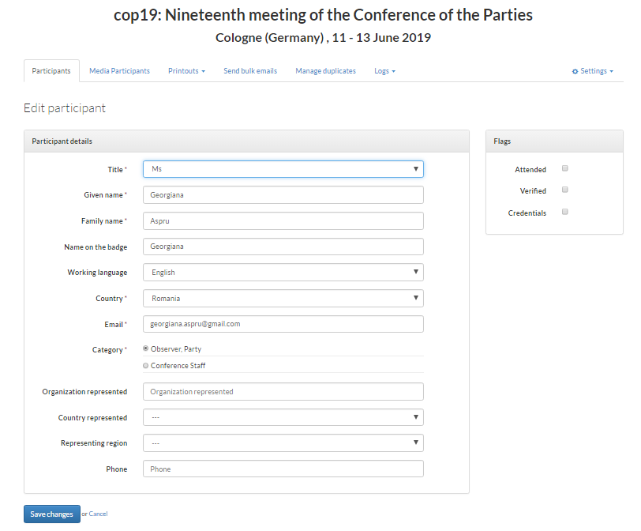

##### Print items

You have the possibility to print the following types of items:

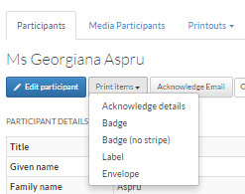

**Acknowledge Details** – this is the pdf file attached to the acknowledge email sent to the user.

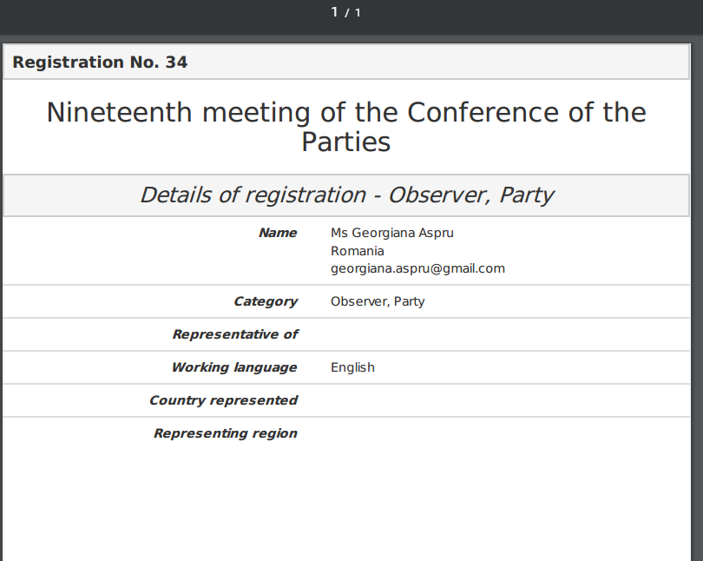

**Badge** – this is the user’s badge for the meeting.

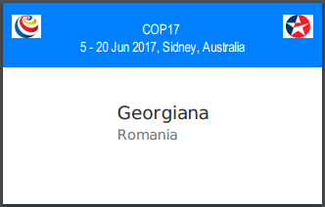

**Badge, no stripe** – this is the user’s badge for the meeting, without the colored stripe from above.

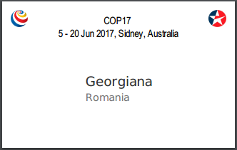

**Label** – this is a label for the participant in order to be used in the meeting.



**Envelope** – details can printed on an envelope.

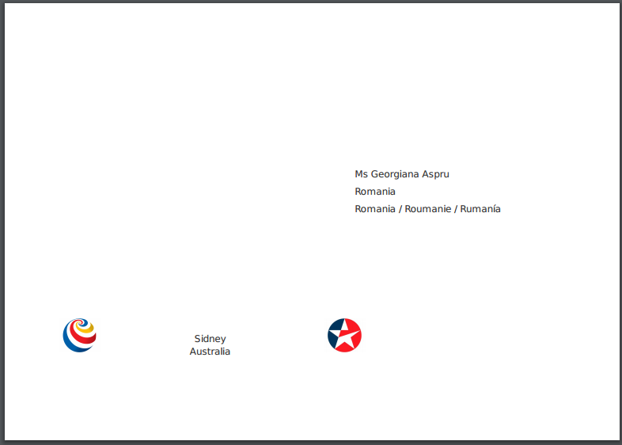

##### Acknowledge Email

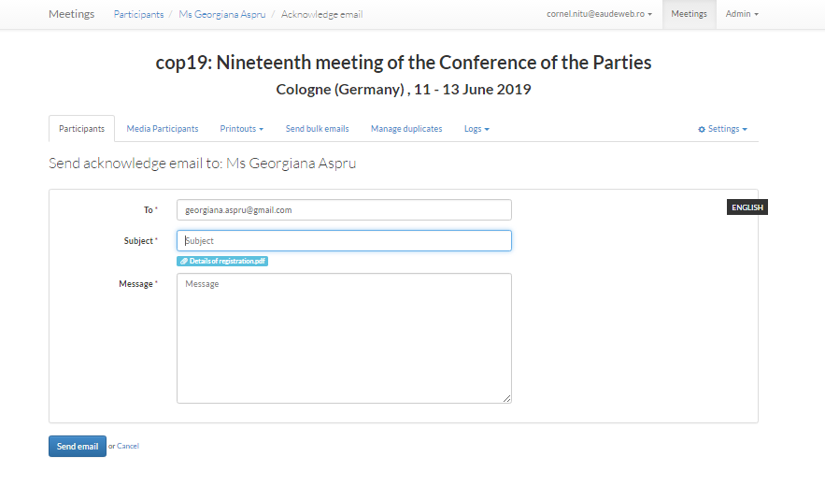

##### Search for participants

This feature provides you with the capability to search for participants and access the management page for that participant directly by clicking on the corresponding search result.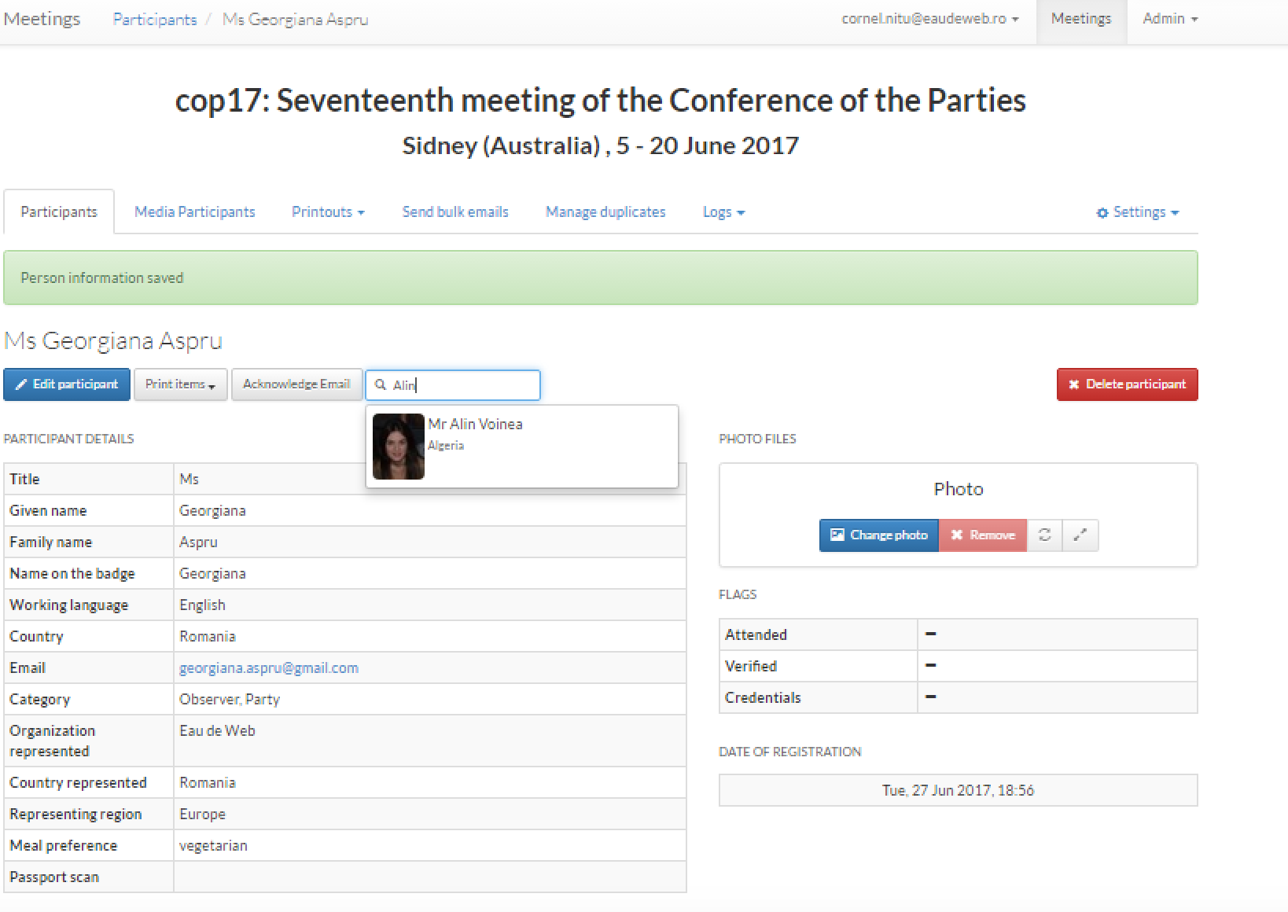

##### Delete participant

When trying to delete a participant, you will be prompted with a confirmation popup question, in order to avoid deletion errors.

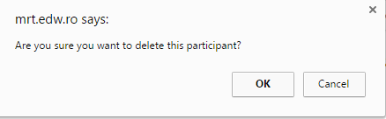

#### Export participants to Excel

By clicking on this button, an Excel export will start and you will be prompted with the following message:



The processing of the exports is done asynchronously. By clicking on the link you will be able to access the export jobs queue and their status.

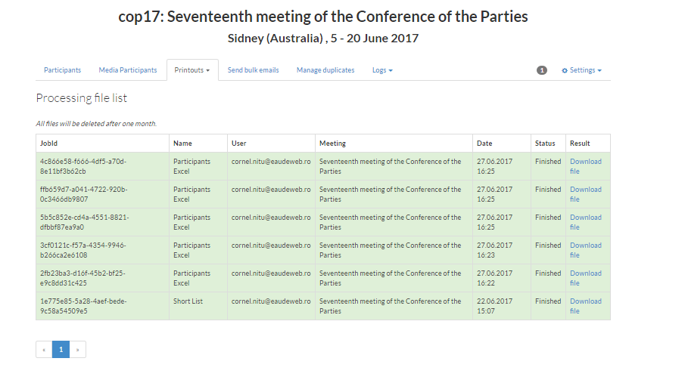

You will also be able to download the Excel file from this page.

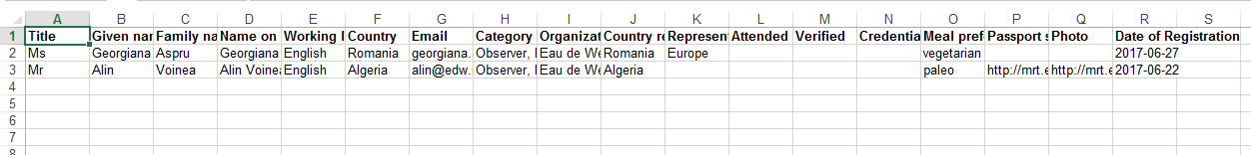

You may access the link with the export jobs queue at any time from **Processing file list** menu in the meeting management page:

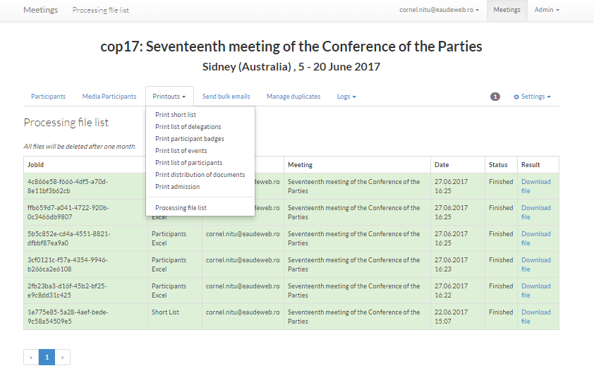

### Manage media participants

This section is similar to the management of the participants’ page, with the difference that media participants are more briefly described (fewer columns in the table and fewer attributes in the participant details page).

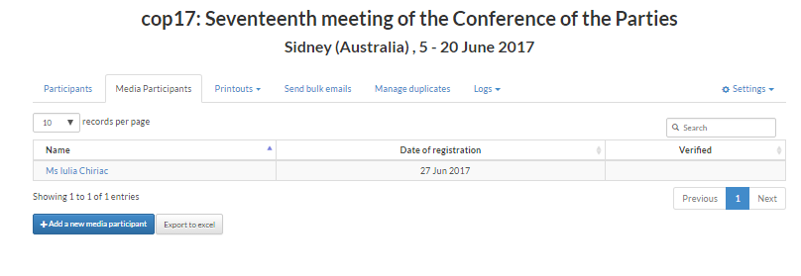

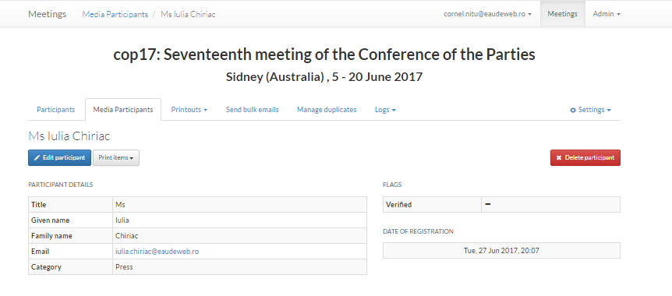

### Printouts

You may choose to export different types of printouts:

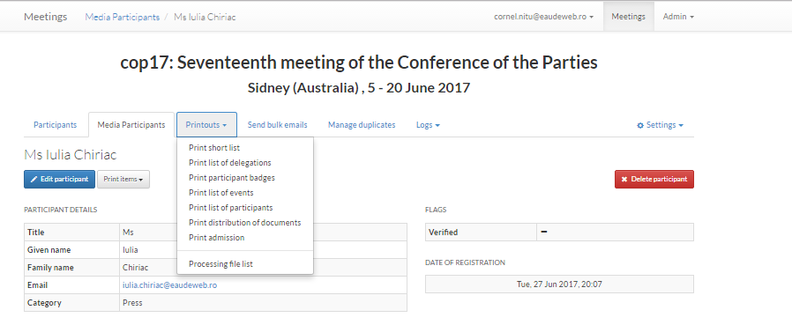

These printouts can will be added to the processing queue and can be downloaded in the Processing file list. Different filters can be used in the selection of the participants. For example, in the „Provisional list as entered by participant” printout, participants can be filtered by flag, meaning that the user can choose to view only participants that have attended the meeting, or only participants that are verified, or only participants with credentials.

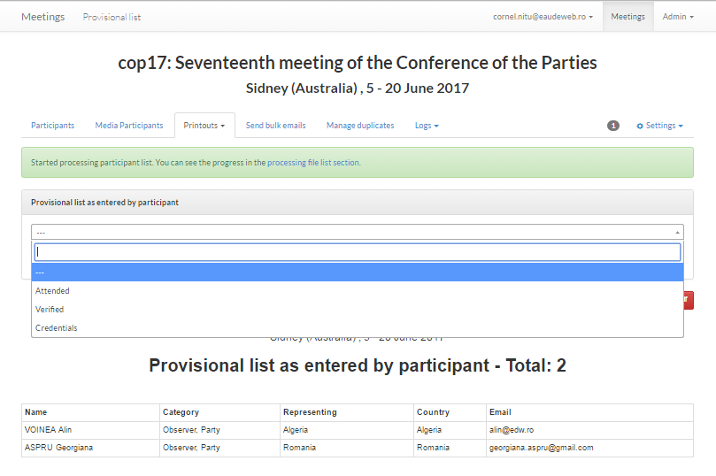

The number of jobs in the processing queue can be seen on the right of the menu options, right next to the „Settings” menu, for example in the following page it shows „1”:

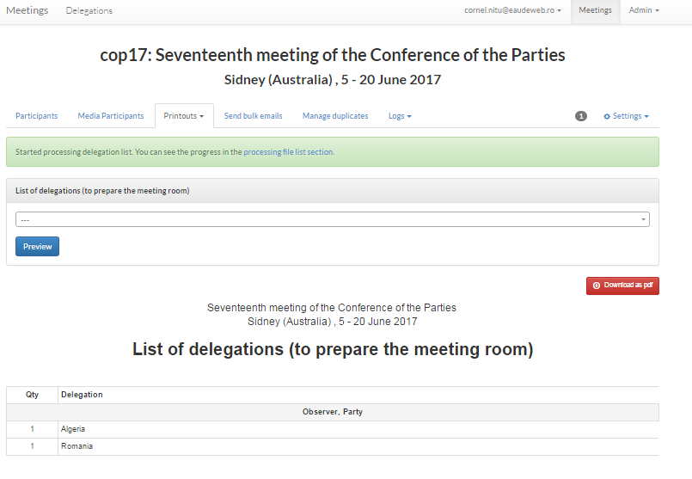

### Bulk emails

You can send bulk emails to the participants of the meeting. You will be able to select the categories of participants to whom the email is sent and their preferred language. You also have the option to preview the list of recipients:



### Duplicates management

It is possible that some users register more than once, for different reasons. In the *Manage duplicates* section you may view the duplicates and how frequent they are, in order to identify what is the actual reason of this multiple registration.

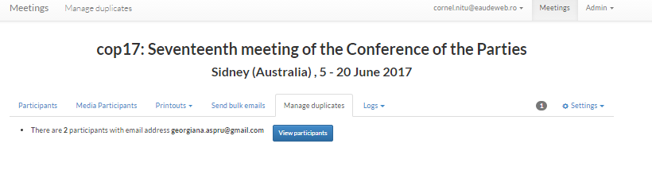

### Logs

There are two types of logs: the database logs and the email logs.

#### Database logs

This table displays entries in the participant management history. Every time a participant is added (by a meeting manager or by self-registration), edited or deleted, the action is logged. You have the possibility to filter the logs by staff member or by time span, to search the table, or to order by any of its columns.

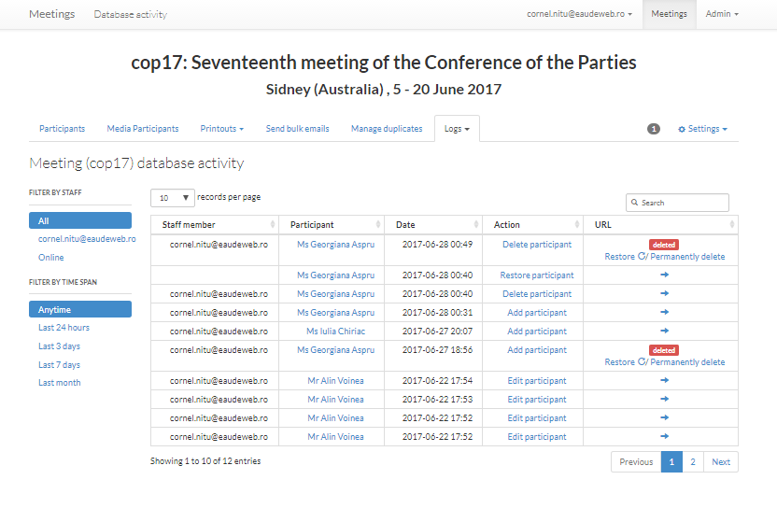

As you may see in the following table, the delete operations are soft deletes, meaning that the data is not actually erased from the database, but it is not visible in the application any more. You have the option to actually delete this data by selecting „Permanently delete” option from the URL column on the right. Also, you may choose the option „Restore”, which will undo the delete of the data. For the other types of operations, the URL column indicates an actual URL to the page the action is referring to.

#### Emails sent

This log shows a list of all the emails sent from the application for the current meeting:

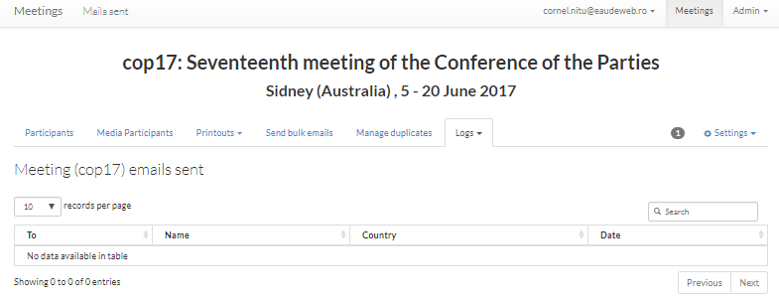

## Meeting settings

After creating a meeting, you will need to configure it, by accessing the Settings menu on the right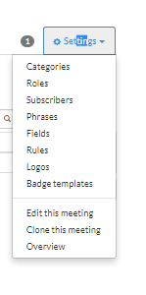

### Categories

You may configure different categories of participants to the meeting:

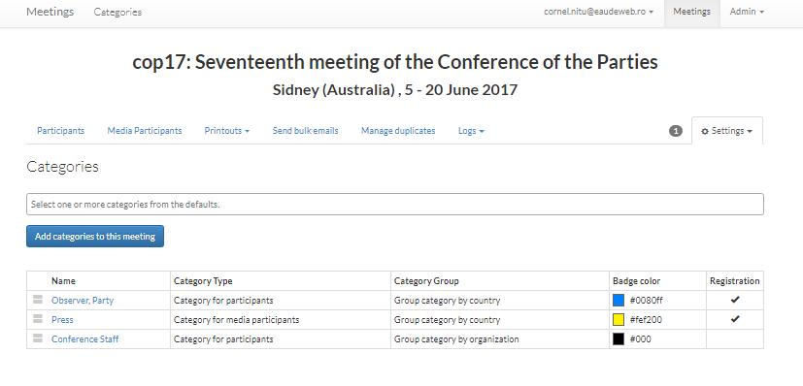

You can add a category by copying a default category, along with all its attributes. By clicking the Category name you can access the Edit category page, where you can customize it. The edit page is divided into four sections:

* *Category tags*: you can add/remove category tags that describe this category; category tags are used to filter participants in some of the printouts. A category tag can be used for more categories, and the same category can have multiple tags.
* *Title*: here you can edit the name of the category; this field is multilingual because it appears on the registration page which is translatable.
* *Badges*: the details that appear on the badge can be modified here; *Representing* is the text that appears right under the participant name on the badge.
* *Registration form*: options related to the registration page.

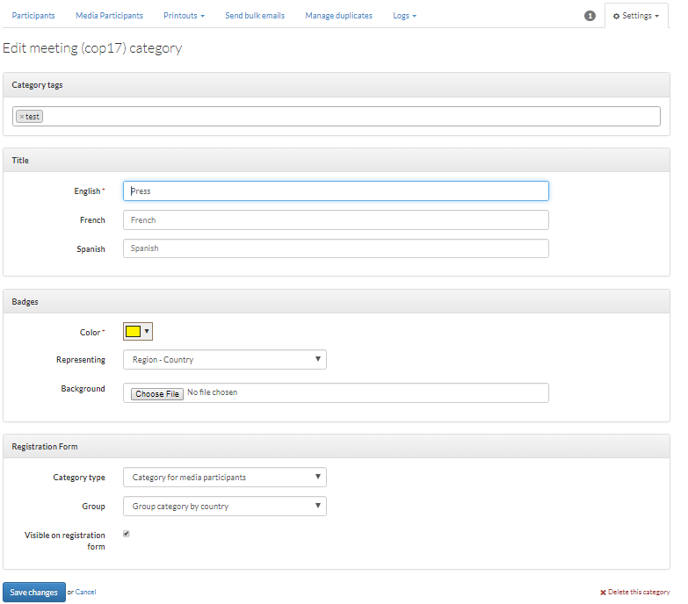

In case you select „Visible on the registration form, this category option will be shown. In case you do not select this option, you only have the possibility to add participants of this category manually. Here it is an example of a Group by country registration form.

You may set a category to be either for the general participants or for the media participants. Also, the categories may be grouped either by country or by organization.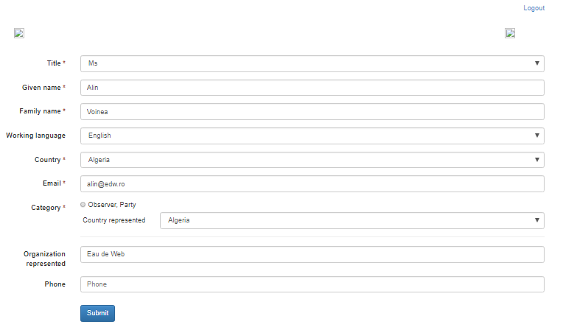

### Roles

You may assign different roles to different users. The roles are configured in the Admin section.

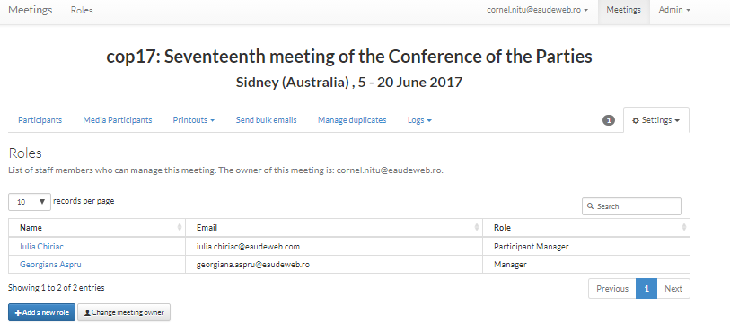

Also, as a meeting owner, you have the possibility to pass the meeting to another owner.

### 1.3.3. Subscribers

It is possible to configure some default notifications for specific users for either normal participant or media participant registration.

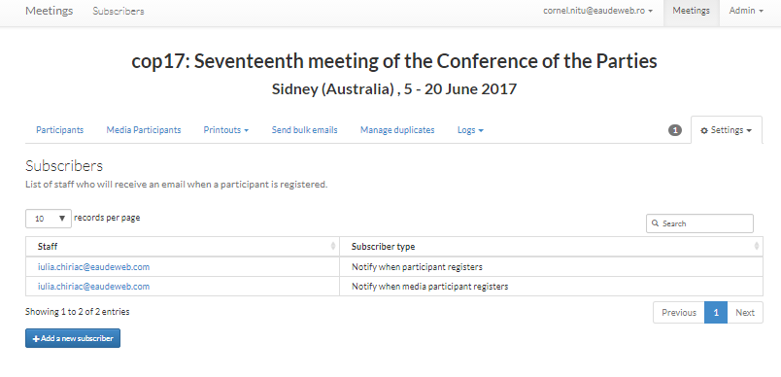

### Phrases

In this section, you have the possibility to configure the text that shows up in different steps of the registration process.

* Acknowledge email: this info is used to pre-fill the acknowledge email form accessible from the participant details page (described above under 2.2.1.2.).
* Email registration confirmation: the body of the registration confirmation email that is automatically sent on registration.
* Online registration: messages that appear on the registration form (header & footer), or immediately after submitting the form (confirmation) or when asked if he/she wants to create an account.

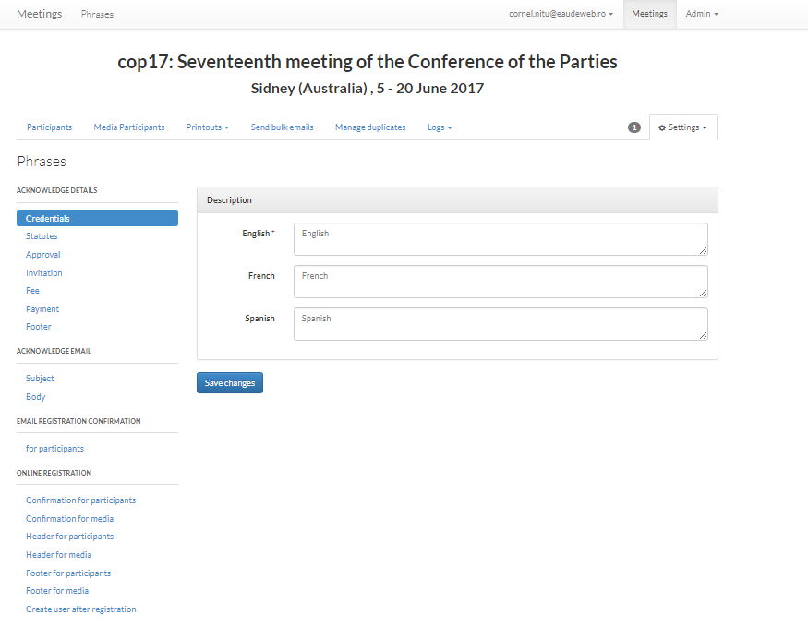

### Fields

You may also configure new fields to be added in the registration form, specific to the meeting.

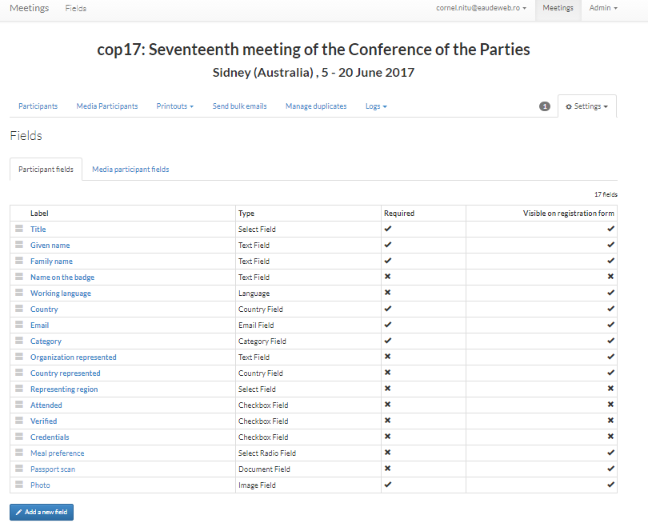

The fields which are added will have a label and a type. Optionally, they may also have a hint. In case that information is required at the participant registration, it will be marked as „Required” in this form. You may also choose to make the field visible on the registration form or not. A field that is not visible on the registration page is useful for the case when you, as a meeting manager, want to provide some extra info about the participant.

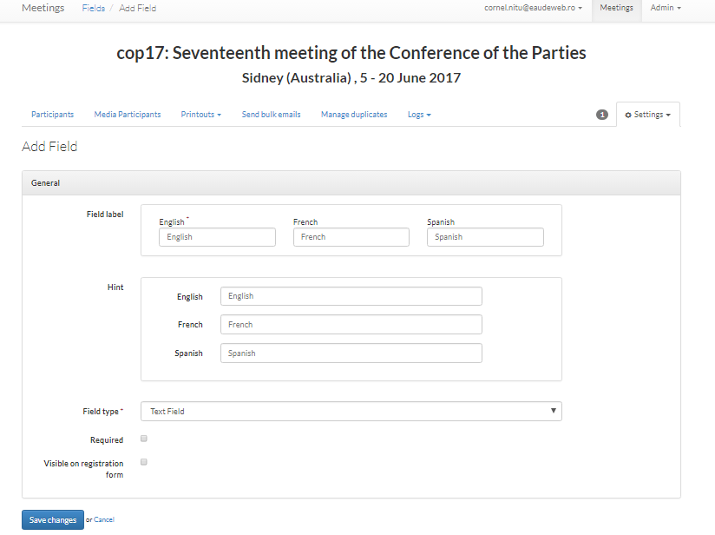

### Rules

The application offers the possibility to configure different rules.

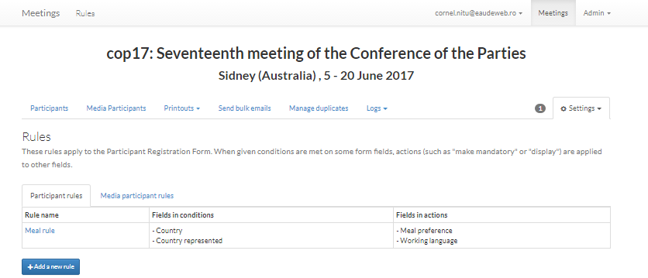

The rules are connected with AND logic operator and trigger certain actions on the final registration form, which you also configure.

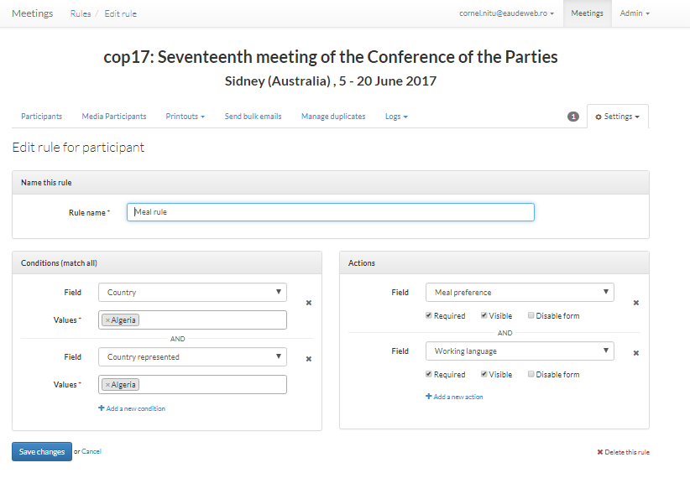

### Logos

You may configure the logos which will be used on the badges by accessing this section of the settings.

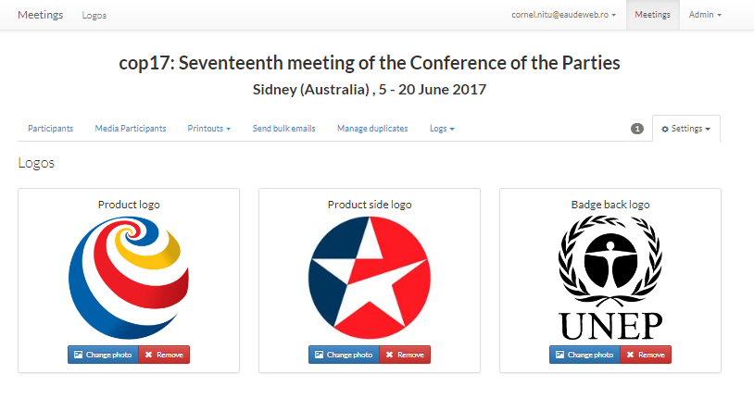

### Badge templates

You can choose from different badge templates, some of them only have the front part and some of them have front and back:

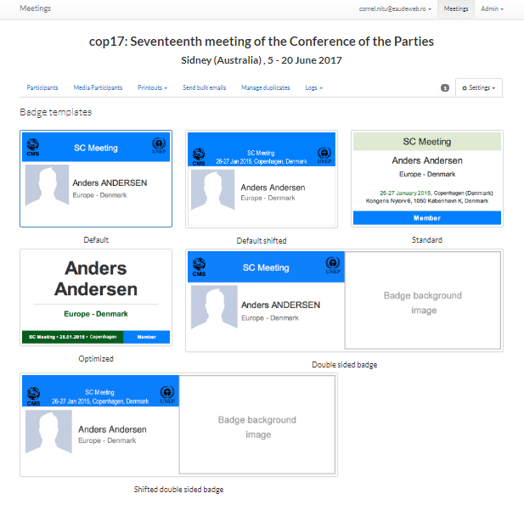

### Edit a meeting

A meeting can either be edited by accessing this menu option from the settings menu available in the meeting view, either by accessing the red edit button available when hovering over the meeting in the list of the meetings:

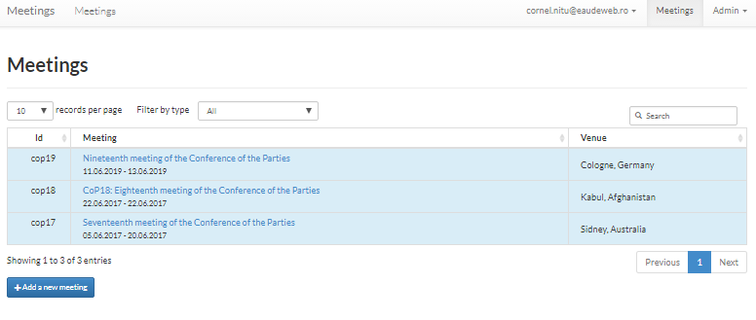

### Clone a meeting

It is possible to create a similar meeting by cloning another meeting. All configurations of the meeting are cloned, except for the participants. This will save a lot of time for the configurations.

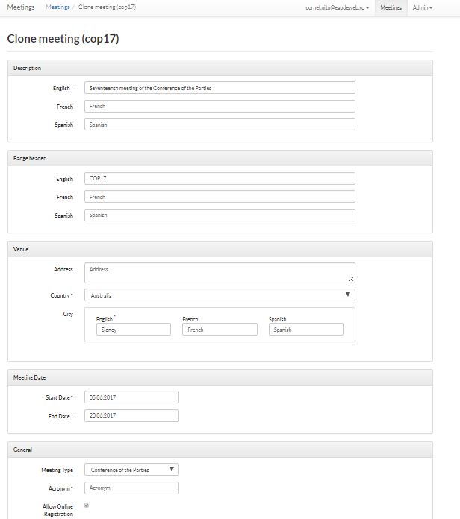

### Overview

The overview will show some details for the meeting, like the links for the registration and a count of participants per category and by country/delegates.

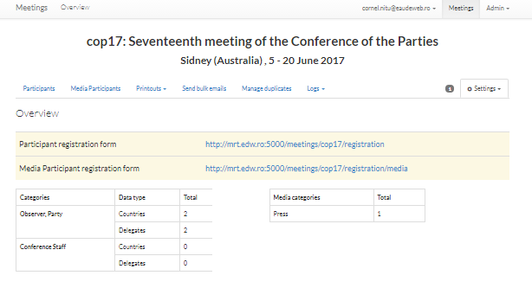

# Admin section

This section provides the possibility to configure some defaults, as well as users and roles.

## Default categories

Every meeting needs to have some categories for the participants. The default categories for the participants, which are used when adding categories to the meetings can be configured in this section.

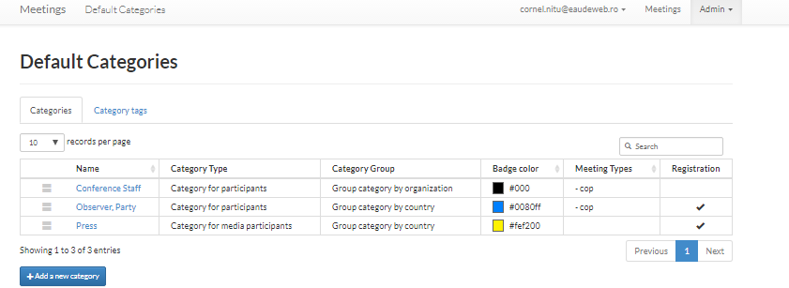

## Default Custom Fields

In case there are some default fields for the meetings which are not contained in the default form, you may add them here. They are connected to a meeting type, so all meetings with that meeting type will have these extra fields at creation.

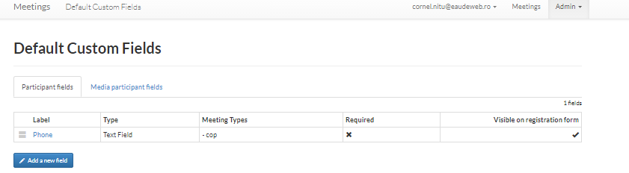

## Default Phrases

The default phrases which will be prefilled automatically in the default phrases of the meeting may be configured here:

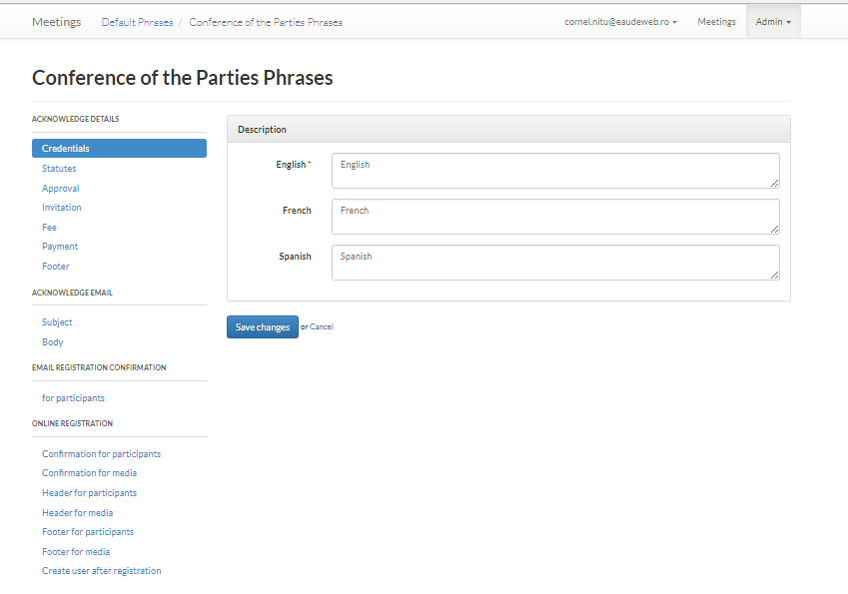

These default phrases may be configured for each meeting type:

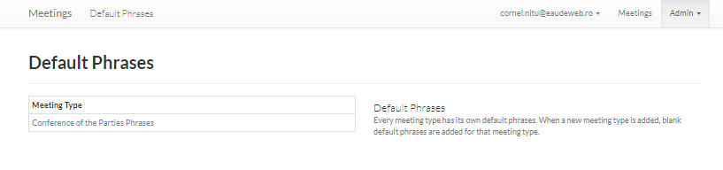

## Meeting Types

Meeting types can be created by accessing the Meeting Types menu:

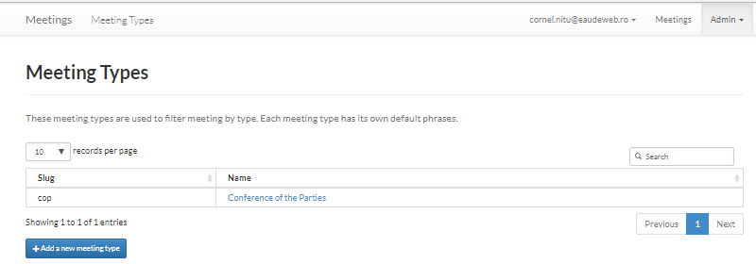

## Staff

The staff menu provides the possibility to add new staff members - people who manage the meetings and/or participants. After adding them in this list, they can be assigned roles on meetings, or can be subscribed for email notifications. Also, a staff member can be promoted to the super user role, thus being able to have full access to the application (administration area, all meetings).

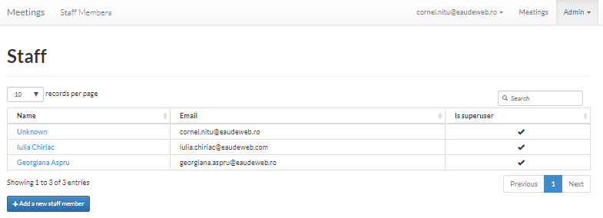

## Roles

The roles available in the application can be defined by creating a mapping between a role name and one or more permissions.

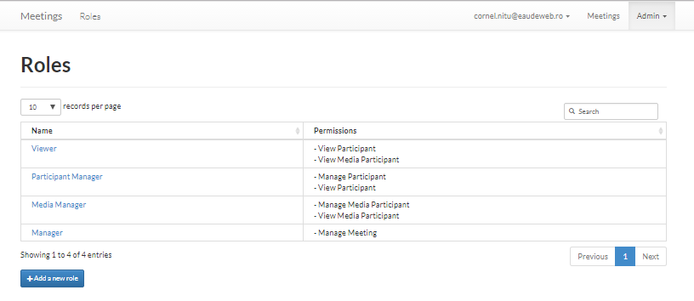

## Users

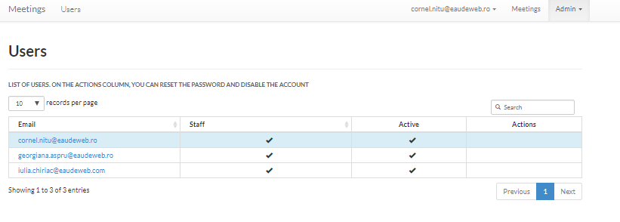

## Settings

This section provides some information on the default settings of the application. These are configured at the installation of the product and no modifications are necessary.

