 | EMWIS/SEMIDE Portal Toolkit
 | Administrator's manual
 | Manual version | 1.0
 | Author | Miruna Badescu

Table of contents

1 Introduction 4
1.1 Terms and abbreviations 4
2 Administration area 5
3 GUI – presentation and customisation 6
3.1 GUI overview 6
3.2 Customising the interface 7
3.2.1 Customising the header elements and the front page description 7
3.2.1.1 The site titles 7
3.2.1.2 The front page description 8
3.2.1.3 The logo 8
3.2.1.4 The header thumbnails 8
3.2.2 Customising the portal layout and colour scheme 8
3.2.2.1 Basic layout customisation 8
3.2.2.2 Advanced layout customisation 9
3.3 Managing and arranging the website portlets 10
3.4 Modern Web standards used in the SEMIDE portal toolkit 11
3.5 Separation among layers 12
4 USERS 12
4.1 Users and security 12
4.2 User profiles 12
5 CONTENT 12
5.1 Content types 12
5.2 Content Structure 14
5.2.1 Main sections 14
5.2.2 Folders with customized index 15
5.3 Understanding the workflow 15
5.4 Content management 16
5.4.1 Basic object operations 16
5.4.1.1 Adding content 16
5.4.1.2 Editing content 16
5.4.1.3 Other operations 17
5.4.1.4 Sorting objects 17
5.4.2 Administrative operations 17
5.4.2.1 Version control 17
5.4.2.2 Basket of approvals 17
5.4.2.3 Basket of validation 18
6 Multilinguality 18
6.1 Language negotiation process 18
6.2 Multilingual content 19
6.3 Multilingual interface 20
6.4 Multilingual searches 21
6.5 Multilingual syndication 21
7 Portal services 22
7.1 Search 22
7.2 Syndication 23
7.3 Thesaurus 23
7.4 Flash Tool 24
7.4.1 Monthly notifications 25
7.4.2 Instant notifications 25
7.5 SEMIDE Forum 26

Introduction
This manual describes the end user functionalities of the SEMIDE (version 2) website portal that is based on the product “Naaya” architecture. Naaya portal toolkit is a multilingual web content management system that allows users with all kind of backgrounds to administrate various aspects of a portal, with respect to their privileges and areas of expertise (content contributors, validators or managers, technical or non technical administrators, translators, etc.). It is a framework that works on top of the Zope (http://www.zope.org) open source web application server and development system.

Terms and abbreviations
In the descriptions contained by this manual, you may find the following terms and abbreviations.

Abbreviation | Meaning
CMS | Content Management System
PM | Portal Manager
ZPT | Zope Page Template
ZMI | Zope Management Interface
Zope Console | Refers also the ZMI
GUI | Graphic User's Interface
CSS | Cascading Style Sheet
WYSIWYG | What You See Is What You Get
CM | Content Manager
NFP | National Focal Point
Portlet | Reusable Web components that display relevant information to portal users
Table 1 - List of abbreviations and their meaning

Administration area
In general, the portal administration/customisation can be done through two major ways.
The first way refers to the changes that can be done by the portal administrator from the portal Administration. If you are logged in the system as an administrator (or as a portal manager) you can reach this portal area by selecting from the top services links list – the Administration option. All functionalities are listed in the right “Administration” portlet.
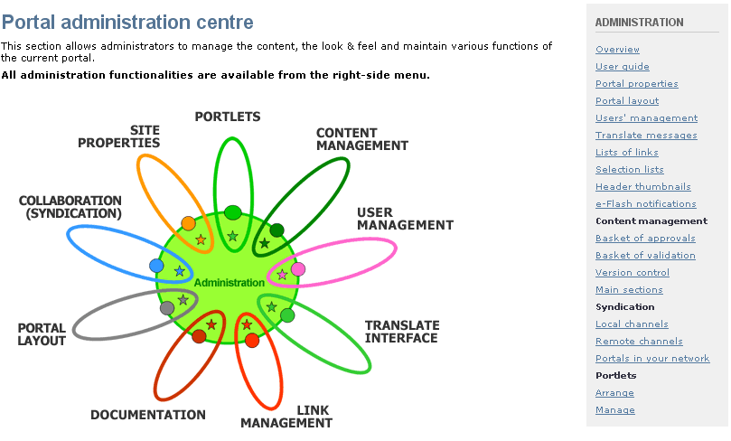
Figure 1 - Administration area
The second way, addressed only to site managers, supposes entering the Zope Console and operating different changes directly in the source files. If you are logged in the system as a portal manager you can reach the Zope Console by entering in your browser address the site URL followed by “/manage”:
http://semide_portal_url/manage

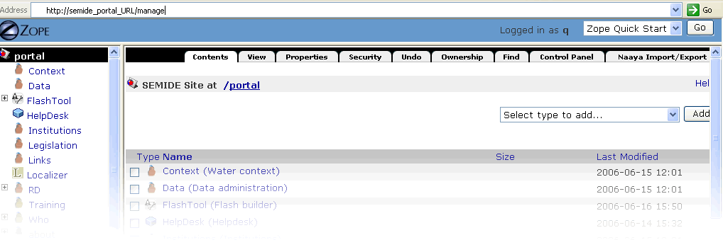
Figure 2 - The Zope console

GUI – presentation and customisation
The graphic user interface is structured into several well-defined areas. The following chapter will explain how the interface can be customised by the portal administrator and by the portal manager.
First of all let’s take a look at the interface elements that will be later referred in the customisation chapters.

GUI overview
All portal pages are constructed in a consistent manner, based on the same kind of templates for the header and footer areas, a dynamic left side menu, a set of right portlets and variable page content. This offers a consistent look and feel throughout the entire site and gives visitors a sense of place and easy navigation.
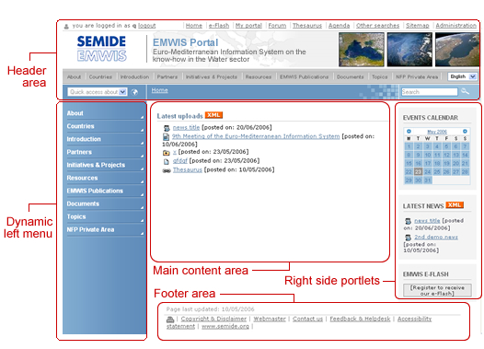
Figure 3 - The generic page elements

The header area is composed of:
- Authentication area - information and links for the users’ authentication status.
- Top service links list – contains links to specific portal services (detailed in section 4.2)
- Logo area, site titles and right thumbnails (a set of three images randomly selected to be displayed from a predefined list of images)
- On the top main navigation there can be found
    - the content links list - easy to access links from all pages that lead to area of great relevancy in the portal
    - the language select box - list of all available languages in the portal, which, upon selection, turns the portal interface and content in that language (if translation is available)
- Quick access links – allow quick access to relevant pages of the portal.
- Breadcrumb trail bar - helps users to determine where they are (in the portal hierarchy) and gives them the possibility to return up at any level between their current position and the site root.
- Search bar – free text search field that leads to a page that allows the refining of the results.

The Left side menu displays either the main sections of the portal or the listing of the current main section sub-folders.  There is a strong correspondence between the links list from the top bar and the left side menu. If a main topic is selected in the top bar, the left side column will display its sub-categories on 2 hierarchical levels.  Example:  If a user selects the main topic “Initiatives and Projects” (either from the top navigation bar, or from the initial left menu), the left column will display a sub-menu corresponding to that topic subcategories. Each of the listed items can be expanded as well, as shown in the Figure 2.  In the left menu, the selected items appear highlighted. | 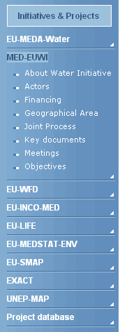  Figure 4 – Left  side column

The footer area remains the same in all pages and offer access to various user services.

Customising the interface

Customising the header elements and the front page description
This chapter will explain how the website administrator can customise these site elements from the portal Administration.

The site titles
In order to set the site title and the site subtitle the administrator must go to portal Administration (right portlet) – Portal properties – Metadata tag and fill in the fields corresponding to the “Site title” and “Site subtitle”.

The front page description
The administrator must follow the same procedure in order to set the front page description. If one goes to portal Administration (right portlet) – Portal properties – Metadata tag he will have to fill in the corresponding form the field entitled “Description (HTML)”. The administrators are given the possibility either to provide the description directly in HTML (if the “View HTML source” option is checked) or to edit and format the description in the incorporated WYSIWYG (What You See Is What You Get) editor.
The corresponding form offers support for the description of this elements (titles and description) in the default language and also for their translation in the other available languages.

The logo
In order to set the site logo the administrator must go to portal Administration (right portlet) – Portal properties –Logos tag and upload the corresponding image.

The header thumbnails
The three random thumbnails displayed in right side of the header are selected from a list that can be customised from the portal Administration (right portlet) – Header thumbnails. From this location one can always visualise the current list of thumbnails (“Images list” fieldset). The form offers support for adding new images to the thumbnails list (“Add a new image” fieldset) and for removing existing ones (by checking them directly from the image list and then by deleting the selected items).

Customising the portal layout and colour scheme
The SEMIDE graphic interface is based on layouts and colour schemes.
A layout defines the page elements positioning and graphical styles and has several choices for colour schemes. Each colour scheme has associated its own CSS files and images. The SEMIDE PTK comes with one default layout called SEMIDE and three different colour schemes (Blue, Green and Magenta).

Basic layout customisation
A quick change of the portal appearance in matter of layout/colour scheme can be easily made by the administrator from: Administration – Portal layout – Portal layout tab. The form has two combo boxes corresponding to the available “Layout” and “Colour scheme” versions and an area dedicated to the selections result preview. If satisfied with the new look and feel, the administrator can make the adjustments permanent by saving changes.
Some further changes regarding the website appearance can be made from: Administration – Portal layout – Charter colour tab.
This page offers support for changing some style properties for certain page elements, with no need of previous CSS knowledge. Therefore the administrator can modify from this page the default values for: fonts, font colours, font sizes, background images, border styles, background colours, etc. The changes that you make in the “Charter colour” form will overwrite the corresponding images and style attributes in the CSS files corresponding to the current colour scheme.

Advanced layout customisation
For more advanced changes of the portal skin some CSS knowledge and even some scripting skills are required (The scripting language for the Naaya Templates is TAL/METAL).
The portal toolkit offers the possibility to create and add new layout versions and colour schemes. The changes of the existing skin or the creation of completely new layouts can be operated only by the portal manager, from the Zope Console.
In order to do that, the portal manager must enter the portal_layout object from the corresponding SEMIDE object. The easiest way to create a new layout is to copy the SEMIDE one and to start modifying the ‘Naaya Template’ inside:
- portlet_center_macro – the template for the central portlets that appear on the front page
- portlet_left_macro – the template for the left-side portlets
- portlet_right_macro – the template for the right-side portlets
- site_footer – the dynamic page footer. Since Naaya Templates are XML documents, all opened tags must close and vice versa. That’s why this page also contains a dummy header area which only opens the tags that are closed in the actual footer. The two parts are separated by the string
<!--SITE_HEADERFOOTER_MARKER-->
- site_header – the dynamic page header. For the reason described below, this template also contains a dummy footer area which only closes the tags opened in the header; the tow areas are separated by the string
<!--SITE_HEADERFOOTER_MARKER-->
All pages are constructed following the schema presented below, where the site_header contains the “Header area” and the site_footer contains the “Left-side portlets” together with the “Footer area” shown in the figure below:

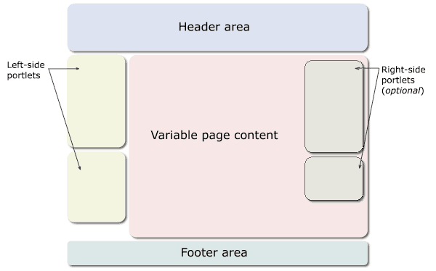
Figure 5 - Page template structure

Managing and arranging the website portlets
The main structure of one portal page is based on portlets. Portlets are reusable webpage components that display relevant information to portal users; they are displayed differently according to their destination place in the page.
The left dynamic menu is based on left-portlets; the variable central area is composed of several centre-portlets and the right side column can group one or more right-portlets.

Arranging the portlets around the portal
The site administrator can arrange the left, centre and right-side portlets around the portal from Administration -> Portlets - Arrange.
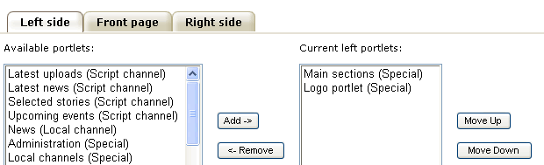
Figure 6 - Arrange portlets

The forms corresponding to each of the tabs (“Left side”, ”Front page”, ”Right side”) allow the establishment of the list of portlets to be displayed in the corresponding page area.
Given the “Available portlets” list, the administrator can select which portlets he wants to be displayed (using the “Add”/”Remove” buttons) and he can also set their display order (using the “Move Up”/”Move Down” buttons).
The default “Available portlets” list contains the following items:
  - Latest uploads (Script channel)
  - Latest news (Script channel)
  - Selected stories (Script channel)
  - Upcoming events (Script channel)
  - News (Local channel)
  - Administration (Special)
  - Main sections (Special)
  - Local channels (Special)
  - EMWIS eFlash (Special)
  - Events calendar (Special)
  - Initiatives News portlet (Special)
  - Initiatives Events portlet (Special)
  - Initiatives Projects portlet (Special)
  - Logo portlet (Special)
  - Harvested OAI records (Special)

Managing the portlets
Aside the default portlets described above, more portlets can be created (and automatically added to this “Available portlets” list) from:
Administration -> Portlets – Manage
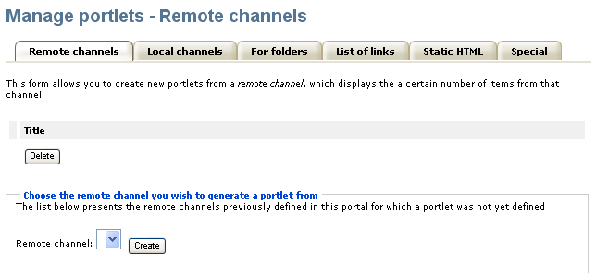
Figure 7 - Manage portlets
There are six general categories of portlets that can be created: Remote channels, Local channels, For folders, List of links, Static HTML and Special.
Each portlet type (except “Special”) is associated a form that offers support both for consulting the list of existing portlets of the corresponding category and for creating new portlets of that type. In order to reach this form the administrator must select the corresponding portlet category tab (see Figure above).
  - Remote channels and Local channels – are portlets associated with syndication channels that have been already defined in the portal (see the Syndication chapter for more details). The administrator is offered a combo box with all available remote / local channels – and he can create a new portlet simply by selecting the desired data channel name and then clicking the “Create” button.
  - For folders – are portlets associated with folders of high importance in the portal which need a special display and reference on some of the website pages / locations. The toolkit offers the possibility to create such portlets for each of the portal folders. The administrator only has to select from the given portal folder structure the item he wants to create a portlet for.
  - List of links – are portlets displaying lists of links that have been previously created. (for more details about lists of links, see the corresponding chapter). Such portlet can be created simply by selecting the name of the desired list from a combo box containing all available lists of links.
  - Static HTML – are portlets containing pieces of static HTML (the content of such portlets may include informative text, images and/or hyperlinks redirecting users to internal or external webpages). Such portlets can be created using the corresponding form where the content can be provided directly in HTML code or edited and formatted using the incorporated WYSIWYG editor.
  - Special – are exceptional portlets with specific functions in the portal, that cannot be modified or deleted from the portal administration. Examples of such special portlets are: Administration, Main sections, EMWIS e-Flash, Events calendar, etc.

Modern Web standards used in the SEMIDE portal toolkit
The SEMIDE website is fully compliant with the most important web standards:
- the website pages conform the Web Content Accessibility Guidelines 1.0 priority 2 (WAI-AA) for the End user interface
- the pages corresponding to the administrative area of the portal are compliant to the Web Content Accessibility Guidelines 1.0 priority 1 (WAI-A)
- all pages validate XHTML 1.0 Transitional
- all pages mark-up respects the semantic HTML rules
- the Cascading Style Sheets respect the CSS2 Specification
- the SEMIDE portal has a user-friendly interface build with respect of the most important usability principles
- The SEMIDE website is usable in any web browser.
The site information is accessible to all users (including users with disabilities), to all types of devices (different browsers, PDAs and mobile phones, TVs, speech synthesizers, Braille interpreters, TVs, printers, etc.) and to search engines.
The portal has different display versions for print (contains only useful content and ignores navigation elements) and for handheld browsers.

Separation among layers
******** Miruna ******

USERS
******** Miruna ******

Users and security
******** Miruna ******

User profiles
******** Miruna ******

CONTENT

Content types

The default content types provided by SEMIDE portals are generic. They are pluggable, in the sense that:
- managers can uninstall a subset of content types from a certain portal. In this case they will not be available for use inside that website
- programmers can create new content types. The programmer has to place the Python class along with the corresponding add, edit and index page templates in the specific folder.and then he has to place this folder in the NaayaContent folder. After restarting the Zope server the new content type will be available in the SEMIDE portal.

The content types provided by a default installation of SEMIDE portal:

- Document (HTML Document) – common HTML page, built by the content contributors using a WYSIWYG editor;
- Semide Document – object designed to contain documents.
- Semide News – announcement with a short period of relevancy;
- Semide Event – contains data about a meeting, conference, etc. such as the begin and end dates, location information, contact information; the events can be presented in a calendar form;
- URL – link to a web resource external to the portal; using a link checker, broken links can be individuated automatically and fixed by the content managers;
- Multimedia – special type of file which uses browser’s plug-ins to display short films, audio data or other similar content in a web page;
- ExFile – item able to store any type of file for each language of the portal and also able to keep old versions of it if necessary;
- Pointer – link to a web page from the very portal, therefore avoiding publishing and maintaining twice the same data;
- Semide Thematic Folder – special folder filtering information by keywords, dates and other criteria.
- Semide Project – item dedicated to publish information regarding a project, this also might contain the following types:
- Semide Organisation – defines a partner to the project and contains also contact information
- Semide Field Site – lists the geographical areas to which the project is targeted.
- Semide Funding – describes a funding source for the given project
- Semide Text of Laws – this item has specific properties designed to facilitate the publication of texts of law.

Note that the actual type names are Naaya Semide News for Semide News, Naaya URL for URL and so on. Attempting to keep the list simple the Naaya word was omitted before every type.

Important note!
There are actually two different news object types:
- Naaya News and
- Naaya Semide News
which must not be confounded.
This is because a new Naaya Semide News object was created instead of the existing one to best fit the needs of a Semide portal. In a newly created site the Naaya Semide News object type is installed while the Naaya News is uninstalled. This is also applicable to Events.

All types of content are based on:
- a common set of properties (metadata): e.g. title, description, keywords
- a set of custom relevant attributes: e.g. binary versions of data for files, start date/end date for events, images for news item
- a set of dynamic properties that can be added by managers for each type of data. These are immediately propagated on the existing object instances; when defining such properties, it is possible to specify their type, if they are searchable, a default value, etc.

Content Structure

Main sections

The portal content is structured into:
- specialized archives (folders) that group items of the same type (news, events, stories, photos)
- main sections which contain hierarchically arranged information of various types (files, HTML documents, news, events, links to remote sources of information, pointers to local data, etc.).

Direct access to these main sections and archives is ensured from each page of the website through the top navigation bar.

These can be managed through the Administration / Main sections form. Here new topics can be added, and the order of elements can be changed. The main section is purely a list of links to the key folders of the site. This means the following:
- Generally it should contain links to top level folders, but it may also contain links to other folders. To do so use the “Select existing folder - Assign existing folder as main section” form under Administration / Main topic.
- Deleting a main topic will merely remove the link to the folder itself. The folder and all its contents will persist on the server and will continue to be accessible through the sitemap and ZMI. If its complete removal is desired, this should be achieved separately using the ZMI console.
- When creating a new main topic, a first level folder is created in the portal with a random id (e.g. fol058845) and a link to it is added to the main sections. The random id is a drawback resulting from the simplicity of the Administration forms. If a human readable id is desired, first the folder should be created using the ZMI console and after that the link should be added to the main sections.

Folders with customized index

All folders in the SEMIDE portal have a default index page (portal_forms / folder_index ZPT).
The “predefined layout structure” for the index page usually contains the title as main heading, the description, a list of the sub-objects and the portlets on the right side (if defined). This can be overwritten from the ZMI checking the Use/create public interface property. A page template with the index id will be created within the folder containing the “predefined layout structure”. This page template can also be copied from one folder to another and after checking the Use/create public interface property in the other folder it will have the same behaviour.

An example of such folders is “News”. The index ZPT meant to overwrite the default one can be found at /portal_id/documents/news/index. The default Page Template was modified in order to include the ‘Search News’ form on this very page.

Understanding the workflow

Content management workflow is easily changeable and configurable when it comes to types of actors involved.

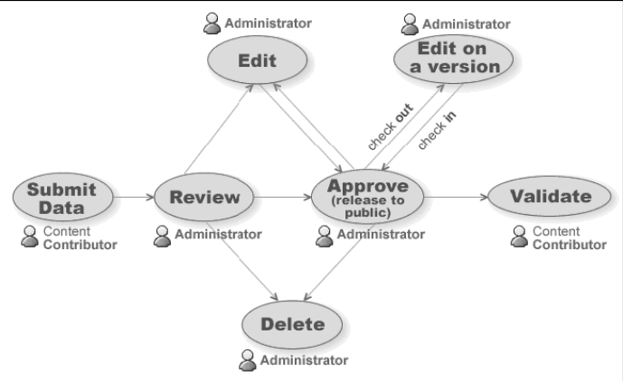
Figure 8 - Workflow

Contributors
By default the contributor may only submit content. He will not be able to edit or delete the submitted content. Once an object has been committed, it will appear on the portal only after an administrator has approved it.
Note! A contributor will not be able to see his own submission until it has been approved by an administrator.

Administrators
The unapproved objects will have a red exclamation point on the icons.
The administrators must review the unapproved objects and decide whether to:
- Approve the object
- Edit the object (and approve it eventually)
- Delete the object
- Check-out the object for editing.

The approval of objects happens at the folder level in the Basket of approvals page (see the Basket of approvals section under this chapter).
Once approved, the object will be released to the general public.
The administrator may edit, delete or even disapprove an object after it has been approved.

Content management

Basic object operations

Adding content
Both contributors and administrators can submit content. The difference is that the data sent by a contributor has to be approved by an administrator. When submitting a form the fields marked with a red star (*) are mandatory. The submitter has the possibility to select a posting language, however it is advised that all content is translated at least in the portal’s default language (see the Multilinguality section for further information).

Editing content
Once posted, an object can be edited. The translation of the object is made through a special form that can be reached using the translation bar situated at the bottom of each edit object page. In these translation forms some fields are multilingual while others are not.
Among the fields that are not translatable in Edit form:
- numerical values
- dates
- checkboxes – involve Boolean values (true or false)
- elements contained by select boxes – they are provided by the system and they must be translated from "Translate messages" (see the corresponding chapter)
- thesaurus terms – the translation is provided by the system taking into account the translations from the thesaurus.

In case of ample modification on an object this should be made through the check-in / check-out mechanism.
Checking out an object creates a temporary version of that object ensuring that the public will continue to see its original version and since the temporary version is saved on the server the user will be able to sign out and to return later to finish the changes he/she has begun. Checking out also locks the object preventing its modification (/overwriting) by other persons. The modifications will not apply to the object until the user checks in and commits the changes for public release. The user may also discard the changes thus cancelling all the modifications saved in the temporary version, thus removing the lock so that others could modify it.
On the editing form of a checked-out object the user must first save the changes and only after that he should commit the modifications.
Important Note! Simply pressing the Commit button will NOT result in the saving of all modifications. One should click explicitly the Save changes button (at the bottom of the page) before any Commit.

Other operations
Other operations may be performed on objects such as copy / cut / paste / delete. These processes are made at folder level since the items are copied or moved from one folders to others.

Sorting objects
The sub-objects inside a folder are sorted by the sort order property. Regardless of sort order the folders will always be listed on top. The sort order property can be edited individually for each object in its editing form, or in the sort order page of the corresponding folder (from here the sort order properties of all sub-objects can be edited at once).

Administrative operations
In the following chapters are described administrative operations such as “Version control”, “Basket of approvals”, ”Basket of validation”.

Version control
The version control under administration section provides a clear overview and a complete control over the locked objects through the check-in / check-out mechanism.

Basket of approvals
This page lists the folders from the entire portal (grouped by top-level containing folder) that contain pending (not yet approved) items. When clicking on a link you will be directed to the corresponding basket of approval form of that folder.

Basket of validation
The validation process was created in order to improve the quality of the portal content. This facility targets the URL, Pointer, HTML Document and ExFile content types.
The URL and the Pointer objects should refer valid addresses, a broken link decreasing the quality of the portal information. An HTML Document or the ExFile could contain obsolete information.
In order to validate objects within a folder, an administrator should follow the Validation link on the folder index page and mark the objects as OK or Not OK. In the second case a reason must be specified.
A centralized Basket of validation may be found at Administration / Basket of validation. This page provides statistics over the validations in the entire portal and a link to a tree view of the Validation report. This report provides a sitemap which highlights the folders containing unapproved, or checked as Not OK objects.

Multilinguality
SEMIDE-based portals are multilingual in terms of interface, content, search and syndication. After the installation, the languages available are English, French and Arabic.

Managers can easily define additional languages in which the portal can be translated by using the Zope Management Interface. Add/remove languages operations can be done by accessing the Languages tab of the portal_properties object for each SEMIDE portal;

Go to Zope Console,
SEMIDE portal root: potal_properties -> Language tab.

Also from here, the default language of the portal can be set. Once a language is added/deleted, this is immediately reflected around the portal interface and content.
All SEMIDE portal pages are encoded in UTF-8(Unicode) which means that all characters and signs from any language are supported.

Language negotiation process

The SEMIDE portal takes into consideration the following language settings:

- Navigation language (selected by the end user)
- Language preferences of the users’ browser
- Default portal language (set by a portal manager)

When an end user opens a page for the first time from this portal, a localization process takes place and the Navigation language is set. If any match is found between the list of available languages for the portal and the languages in the browsers preferences that language is set for the navigation language by default. If more language matches are found then the first one in the settings of the browser takes precedence.
The end user can manually select the navigation language at any time and from any portal page from the list of available languages. This will overwrite all other settings done automatically by the system:

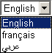
Figure 9 - Select language

Multilingual content
When a piece of content (news, file, folder, etc.) is not (fully) translated in the language selected by the end user, only its attributes which are translated in that language are visible.
All types of content from the portal can be translated in each available language. An item can be added in just one language, which is the content contributor's choice (Posting language field on each submission form):

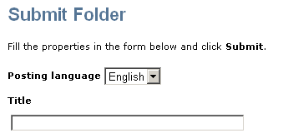
Figure 10 – Submit content sample

After that, the item can be edited in order to be translated.
Important note! : not all the properties need to be translated; some of them (e.g. dates, numbers, booleans, email addresses, URLs) are not multilingual and will be filled automatically for each language on the editing forms.

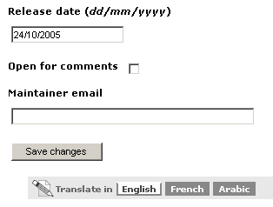
Figure 11 - Translating portal content

Multilingual interface
All labels, explanatory texts, lists of links and their descriptions, the portlets aside from the static ones and other texts that appear on the user interface can be translated by specialised people in any of the available languages using the Translate messages form available in the administration centre. By default, only Administrators and Managers have the right to access this interface.
Administration -> Translate message
The translation centre for the interface lists the messages marked for translation in the portal and users can translate them individually. To ease the translation process, when a message is translated in a language, an OK sign will appear next to it in the language column. A message search is available which will narrow down the list of messages to those that contain a certain text. Users can sort the list of messages, both ascending and descending: alphabetically or by translation status in a certain language.
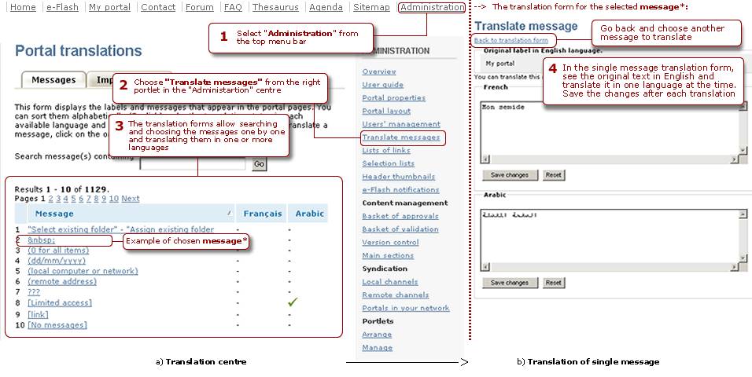
Figure 12 - Translating the portal interface

Important notice! Some of the messages contain HTML tags because splitting the texts around the tags would mean taking some phrases out of their context and therefore loose their meaning. All HTML tags MUST NOT be changed during the translation process.
When the SEMIDE portal has no translation for the navigation language it will attempt to find one in the languages from the settings of the browser. Ultimately the translation is shown in the default portal language.
Since the number of messages to translate is high, an export can be made in .PO or .XLIFF formats, the texts translated using external tools (e.g. text editors, specific translation tools) and imported back into the portal. Such operation can be made from the Import/Export tab of the Translate messages centre.
The PO file is a simple text file which will be downloaded with texts in English and the target language in which the messages have to be translated, while the XLIFF file is XML and it's very good when the translators use desktop programs that know to navigate among the messages, to suggest translations, search messages, escape HTML tags, etc.

Multilingual searches
The free text searches are performed in all available languages on the portal. For each result there are provided links to each available translation of the content.
When searching across multiple websites, the end user may select the languages in which the search will be performed.

Multilingual syndication
All local channels of information generated in RDF format can be downloaded by end users in the language selected in the browser. Only items which are translated in that language are included in the channel. An item is considered translated in a language if at least its title is translated.
When administrators define the relevant channels exposed by their website, they are able to choose the language in which each one of them is generated.

Portal services

Search
The portal offers several search mechanisms (these are described in detail in the End User Manual).
Free text search
This tool performs searches in the content published on the entire portal (inside titles, descriptive texts, etc. and also in the uploaded files: *.doc, *.pdf, *.xls etc.). By default, the search is carried out in the translations of the content in the selected language.

Advanced search
The advanced search gives the possibility to define more filters in order to further refine the results.

Search across multiple portals (Crawler)
The kit offers support for search across multiple portals , yet a default installation will not provide the link to this functionality.
In order to include this link (let’s say in the top services bar) the administrator must go to:
Administration -> List of links -> Menu navigation links .
And fill the “Add new link” form as shown below:
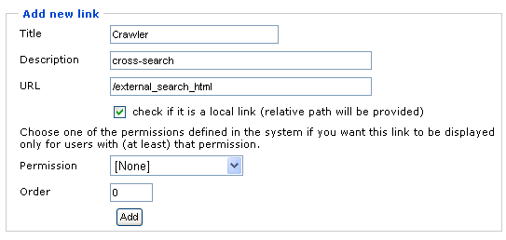
Figure 13 - Adding a link to Crawler

Note: It is important to fill in the URL field with exactly the “/external_search_html” reference and to check the option below it.

The top level link “Crawler” will lead now to the search across multiple portals form; This allows searching content published around the SEMIDE network (only portals using this portal kit allow this feature). End users are given the list of portals that will be searched and they can select the ones they prefer.
This list of portals is provided by the site administrator from Administration –> Portals in your network. The corresponding form requires for each new external portal added the “Title” and the “Portal URL”.

Custom search mechanisms
Aside from the search forms described above, customised search pages are available in certain portal folders: Project database, Agenda, News.

Syndication

Thesaurus

Right after the installation the portal contains a thesaurus of concepts.
The end users may access it through the Thesaurus link always available in the top services bar. Here the terms may be grouped by themes or alphabetically. Also a search interface is implemented. Under the RDF export tab a visitor may get information from within the thesaurus.
- The objects with icon are data storage modules and will be explained in detail below, as they represent the core of the application.
- The objects with icon are customizable Python Scripts for SKOS/RDF export. For example if you want the exports to be shown in a specific way just edit those objects and write the desired code. The necessary functions (getters) are found in the code, just write your own code. (This will reflect on exported files on RDF export tab found on end user interface)
- The object with icon is the thesaurus catalogue, here are indexed all data added into thesaurus.
- The object with icon is the customizable end user CSS file. Just edit it to make any changes on the end user display.

Data modules (marked with icon)

The data inside thesaurus is linked with complex relations, thus an order is required on adding it in order to maintain its consistency because of the constraints found on adding. (e.g. you cant insert an theme translation for a given theme id if that theme id does not exist). After adding data, more constraints are found (explained below) on edit and delete any record.

On any data module you can find the Properties tab from where you can set the title of the data module (this property is reflected only on ZMI), the Management tab from which you can handle the data stored inside (add/edit/delete), the Statistics tab where you can see information related to its data and the Undo tab from where you can undo any action you made on the current object. More, on some relevant modules a Import tab can be found from where a bulk, XML (SKOS/RDF) based, import can be done.
For further information please refer to the documentation of NaayaThesaurus product.

Flash Tool

This component of the Semide portal allows registered users to sign up for monthly e-Flash or instant notifications. The Flash builder tab on the end user’s profile page will allow him/her to subscribe / unsubscribe to this service.
The target of this chapter is to guide the administrators through e-Flash and Instant Notifications procedures.
First the administrator must go to: Administration -> e-Flash notifications

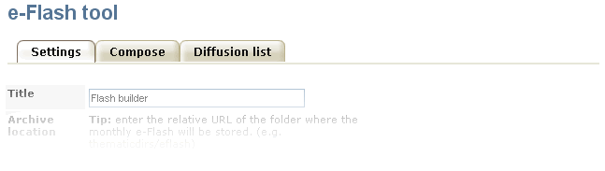
Figure 14 - e-Flash

Monthly notifications
The SEMIDE website sends a monthly newsletter to all subscribers, called e-Flash. It is a revised compilation of news, events and documents published during the previous month.

The monthly e-Flash is scheduled to be sent at the Notification date. Since this process isn’t completely automated it has to be assisted by the portal’s administrator. He will receive an reminder email a few days before (this number of days is specified in the Admin notification field) the scheduled Notification date regarding this matter.
On the Administration / e-Flash notifications page the administrator has to fill the Settings of the Flash builder:
- the title of the e-Flash
- the time intervals for the objects (once the e-Flash has been sent these increment automatically)
- the location of the objects (usually the entire portal)
- the portal location where the archive should be saved
- the languages for which the monthly notifications are to be generated.

After the settings are done the administrator should switch to the Compose tab and generate the e-Flash notification text. An HTML and a TEXT version of the e-Flash are created for each language. After all these texts are edited the administrator must go back to the Settings tab and press the Trigger notification button in order to send the notifications to the subscribers. A copy will be saved in the portal’s archive.
The notifications are created applying an XSLT transformation - XML generated by the e-Flash. These XSLT templates are accessible from ZMI in FlashTool. Here should be performed the translation of the email templates.

Instant notifications

On the Administration -> e-Flash notifications page are set the Instant notifications meta types. Whenever one of these types has been submitted, all subscribers who signed for this service will receive instant notifications.

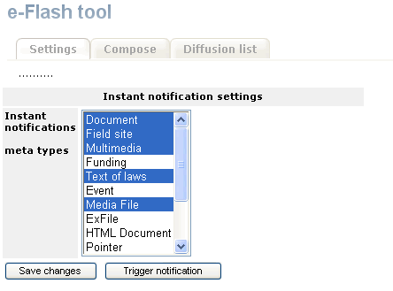
Figure 15 - Instant notification settings

For both e-Flash and Instant notification, the administrator can access the Diffusion list tab to consult the full list of the subscribers. Also this page allows emailing all the subscribers.

SEMIDE Forum
The forum functionality is a standard one: for each topic the users can post new massages, reply to old ones, thus creating threads. Each message has three options: edit, delete and reply.
The topics are grouped into categories which can be created only by the portal manager from the ZMI. There is only one “General” topic category created by default.
Any user that has topic permission can add a new topic. Any authenticated user can post a new message. The security options regarding the forum can be customized by the site manager.

