IS301 – Structured Programming

Screenshots of working code
First batch of digits: 21412
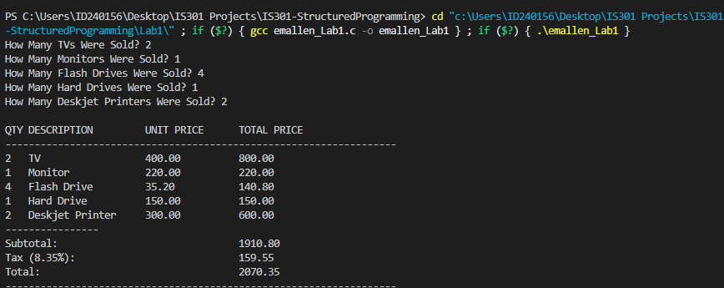

Second batch of digits: 302021
