ARTIFICIAL INTELLIGENCE

Assignment: Logical Reasoning,
Semantic Networks and NLP
TOTAL: 10 MARKS
Student name | Eavan Tan
Student ID | 24006152
Submission date | 11/11/2026

Instructions
- Answer all questions in your own words.
- Show your reasoning, not just the final answer.
- Draw the semantic network neatly by hand or using a digital tool.
- Complete the small Python coding activities.
- Include the code and its output in your submission.
- You may use VS Code or any other platform to execute Python code.

Part A — Logical reasoning (3 marks)
Q1. Reasoning about airline messages (3 marks)
An airline uses these rules:
- If a tweet reports a cancelled or delayed flight, it is a service complaint.
- If a tweet is a service complaint, it should be prioritised for support.
- If a tweet only asks for general flight information, it is an information request.
Classify the following messages:
A. “My flight has been cancelled and nobody has contacted me.”
B. “What time does flight AB123 depart?”
a) State the category of Tweet A and Tweet B. (1 mark)
Tweet A is a Service Complaint, because it reports a cancelled flight.
Tweet B is an Information Request, because it only asks for general flight information.

b) Which tweet should be prioritised? Explain the rule-based reasoning step by step. Can you conclude that Tweet B is positive or negative? Explain why. (1 mark)
Tweet A should be prioritised.

Reasoning (forward chaining):
- Fact: Tweet A reports a cancelled flight.
- Rule 1: cancelled or delayed flight causes a service complaint. Therefore, Tweet A is a service complaint.
- Rule 2: service complaint is prioritised for support. Therefore, Tweet A is prioritised.

Tweet B satisfies only Rule 3 (information request). No rule links information requests to priority, so it is not prioritised. We cannot conclude whether Tweet B is positive or negative. The rules classify message type, not sentiment, and no rule infers sentiment.

c) Complete the following Python code to implement the decision rules. (1 mark)
def classify_message(tweet):
tweet = tweet.lower()

if "cancelled" in tweet or "delayed" in tweet:
return "Service Complaint"

elif "what time" in tweet or "departure" in tweet:
return "Information Request"

else:
return "Other"

tweet_a = "My flight has been cancelled"
tweet_b = "What time does flight AB123 depart?"

print(classify_message(tweet_a))
print(classify_message(tweet_b))

Explain the output produced by the code.
Service Complaint
Information Request

- The text is first converted to lowercase, so keyword matching is case-insensitive.
- Tweet A contains “cancelled”, so the first condition is true and the function returns “Service Complaint”.
- Tweet B contains neither “cancelled” nor “delayed”, so the else if is checked. It contains “what time”, so the function returns “Information Request”.

Part B — Semantic network (3 marks)
Q2. Representing airline knowledge (3 marks)
Create a semantic network using the following facts:
- An Airline operates Flights.
- A Flight has a Departure Time and a Destination.
- A Passenger books a Flight.
- A Flight can be Delayed or Cancelled.
- A Delay may cause a Passenger Complaint.
- Draw a semantic network containing the concepts and labelled relationships above. (2 marks)

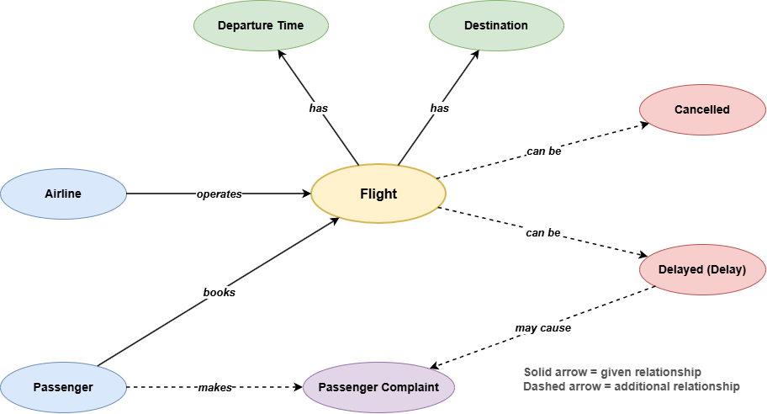

b) Represent at least four relationships from your semantic network using Python. (1 mark)
Use the following example as a starting point:
semantic_network = [
("Airline", "operates", "Flight"),
("Passenger", "books", "Flight"),
("Flight", "has", "Destination"),
("Flight", "has", "Departure Time")
]

for relationship in semantic_network:
print(relationship)

Expected output:
('Airline', 'operates', 'Flight')
('Passenger', 'books', 'Flight')
('Flight', 'has', 'Destination')
('Flight', 'has', 'Departure Time')
Add at least one more relationship of your own.

semantic_network = [
("Airline", "operates", "Flight"),
("Passenger", "books", "Flight"),
("Flight", "has", "Destination"),
("Flight", "has", "Departure Time"),
("Flight", "can be", "Delayed"),
("Flight", "can be", "Cancelled"),
("Delay", "may cause", "Passenger Complaint"),
("Passenger", "makes", "Passenger Complaint") # additional relationship
]

for relationship in semantic_network:
print(relationship)

Output:
('Airline', 'operates', 'Flight')
('Passenger', 'books', 'Flight')
('Flight', 'has', 'Destination')
('Flight', 'has', 'Departure Time')
('Flight', 'can be', 'Delayed')
('Flight', 'can be', 'Cancelled')
('Delay', 'may cause', 'Passenger Complaint')
('Passenger', 'makes', 'Passenger Complaint')

Part C — Natural Language Processing (4 marks)
Q3. Text preprocessing and sentiment (2 marks)
Consider this tweet:
@SkyAir My flight is NOT good! It was delayed again. https://airline.example
- Replace the username with USER and the URL with URL, convert the text to lowercase, and remove extra whitespace. Write the resulting text. (1 mark)

- Replace the username: USER My flight is NOT good! It was delayed again. https://airline.example
- Replace the URL: USER My flight is NOT good! It was delayed again. URL
- Lowercase: user my flight is not good! it was delayed again. url
- Remove extra whitespace: no change.

Result: user my flight is not good! it was delayed again. url

b) Complete the following Python code to perform basic text preprocessing. (1 mark)

import re

def preprocess_text(text):

# Replace usernames with USER
text = re.sub(r"@\w+", "USER", text)

# Replace URLs with URL
text = re.sub(r"https?://\S+", "URL", text)

# Convert text to lowercase
text = text.lower()

# Remove extra whitespace
text = re.sub(r"\s+", " ", text).strip()

return text

tweet = "@SkyAir My flight is NOT good! It was delayed again. https://airline.example"

clean_tweet = preprocess_text(tweet)

print(clean_tweet)

Write the output and explain why the word "not" should not be removed during preprocessing.
Output: user my flight is not good! it was delayed again. url
“not” is a negation word that reverses the meaning of the words after it. “my flight is not good” expresses negative sentiment. Although “not” appears in many stop-word lists, it carries essential sentiment information and must be kept.

Q4. Evaluating a sentiment classifier (2 marks)
A classifier correctly predicts 80 out of 100 tweets, but it fails to identify most neutral tweets.
a) Is 80% accuracy alone enough to conclude that the classifier performs well? Explain. (1 mark)
No. Accuracy measures only the overall proportion of correct predictions and does not show performance per class. If the dataset is imbalanced, the classifier can reach 80% by correctly predicting the majority classes (negative and positive) while failing on the neutral class.

b) Name one metric that gives a more balanced view across negative, neutral and positive classes. Explain why it is useful. (1 mark)
Macro-averaged F1-score.
F1 = 2 × (Precision × Recall) / (Precision + Recall)
Macro-averaging computes F1 separately for each class (negative, neutral, positive) and takes their unweighted mean, so every class contributes equally regardless of size. This gives a more balanced evaluation than accuracy.

Mark allocation
Part | Topic | Marks
A | Logical reasoning | 3
B | Semantic network | 3
C | Natural Language Processing | 4
 | TOTAL | 10

Submission - AI Lab Git repository
IMPORTANT: Submit your completed assignment to the Git repository you created for the AI Lab.
- Create a folder named Assignment_Reasoning_Semantic_NLP.
- Save your answers as AI_Assignment_YourName.pdf (or .docx).
- Include your semantic network diagram in this folder.
- Commit and push your changes to your existing AI Lab Git repository.
- Open the repository online and confirm that the files are visible.
Suggested folder structure
AI-Lab-Repository/
└── Assignment_Reasoning_Semantic_NLP/
├── AI_Assignment_YourName.pdf
└── semantic_network.png

Reminder
Your work will be assessed on correct reasoning, clear relationships in the semantic network, understanding of NLP preprocessing and evaluation, and clarity of explanation.

