# This is an implementation of predictive and predictive-deviance oriented segmentation and is intended to be executed in RStudio  
  
# Data Preparation  
set.seed(3498348)  
insurance <- read.csv("data/insurance.csv")  
insurance <- insurance[sample(nrow(insurance)),]  
insurance <- insurance[sample(nrow(insurance)),]  
insurance$sex <- as.factor(insurance$sex)  
insurance$smoker <- as.factor(insurance$smoker)  
insurance$region <- as.factor(insurance$region)  
  
# Find predictive deviants using LOOCV  
pd_fold <- function(i, nfold, model, outcome, dataset, fitted_scores){  
 folds <- cut(1:nrow(dataset), breaks=nfold, labels = FALSE)  
 test_indices <- which(folds == i, arr.ind = TRUE)  
 test <- dataset[test_indices, ]  
 train <- dataset[-test_indices, ]  
 trained <- lm(model, data = train)  
 predictions <- predict(trained, test)  
  
 fitted_scores[test_indices] - predictions # PD  
}  
  
  
kfold_pd <- function(model, outcome, dataset, nfold=NULL) {  
 if (is.null(nfold)) {  
 nfold <- nrow(dataset)}  
  
 fitted_model <- lm(model, data = dataset)  
 hetero<-lmtest::bptest(fitted_model)  
 fitted_scores <- predict(fitted_model, dataset)  
 unlist(sapply(1:nfold, pd_fold, nfold=nfold,   
 model = model, outcome=outcome, dataset = dataset,   
 fitted_scores = fitted_scores))  
}  
  
pd_loocv <- kfold_pd(charges ~ ., outcome='charges', dataset = insurance)  
  
# PD Plot  
sorted_pd <- sort(pd_loocv)  
pd_95 <- quantile(sorted_pd, probs = c(0.025, 0.975))  
plot(sorted_pd,col=rgb(0.7, 0.7, 0.7, 0.5), pch=19,xlab = "Cases", ylab = "Predictive Deviance",main = "Sorted Predictive Deviance")  
abline(h=pd_95)

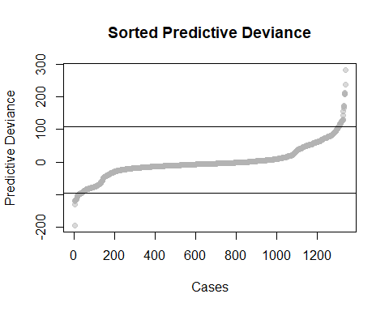

# Deviance Tree  
library(rpart)  
library(rattle)

## Loading required package: tibble

## Loading required package: bitops

## Rattle: A free graphical interface for data science with R.  
## Version 5.5.1 Copyright (c) 2006-2021 Togaware Pty Ltd.  
## Type 'rattle()' to shake, rattle, and roll your data.

library(rpart.plot)  
library(data.tree)  
  
# Find deviant nodes  
insurance_rpart <- rpart(pd_loocv~., data = insurance, minsplit = 2, minbucket = 1, cp = 0)  
  
frame_deviants <- (insurance_rpart$frame$yval <= pd_95["2.5%"]) | (insurance_rpart$frame$yval >= pd_95["97.5%"])  
all_deviants <- insurance_rpart$frame[frame_deviants, ]  
deviant_nodes <- all_deviants[all_deviants$var != "<leaf>", ]  
head(deviant_nodes)  
  
# Use semcoa package to find deviant groups  
library(semcoa)  
library(purrr)  
insurance_pd <- cbind(insurance, PD = pd_loocv)  
predictions <- list(pd_data = insurance_pd, PD = pd_loocv)  
  
dtree <- deviance_tree(predictions)  
grouped_deviants <- unname(unlist(dtree$deviant_groups))  
unique_deviants <- dtree$unique_deviants  
all_deviants <- c(grouped_deviants, unique_deviants)  
  
# Find total number of cases for a set of groups  
no_deviant_group_cases <- function(groups,original_rpart_dataset,deviance_tree_object){  
  
 groups<-toupper(groups)  
 no_by_group<-sapply(groups, function(x){group_nodes_index<-deviance_tree_object$deviant_groups[x]  
 group_cases<-sapply(group_nodes_index,function(i) original_rpart_dataset$frame[i, ]$n)  
 reduce(group_cases, sum)})   
   
 print(no_by_group)  
 cat("Total number of cases for this set of groups is:", reduce(no_by_group,sum))  
}  
  
no_deviant_group_cases(c("A", "B", "C", "D", "E"),insurance_rpart, dtree)  
  
  
# Model less deviants  
new_insurance <- insurance[-all_deviants, ]  
new_pd_loocv <- kfold_pd(charges ~ ., outcome = 'charges', dataset = new_insurance)  
  
new_sorted_pd <- sort(new_pd_loocv)  
new_pd_95 <- quantile(new_sorted_pd, probs = c(0.025, 0.975))  
plot(new_sorted_pd, col = rgb(0.7, 0.7, 0.7, 0.5), pch = 19,main = "Sorted Model without Deviants")  
abline(h = new_pd_95)

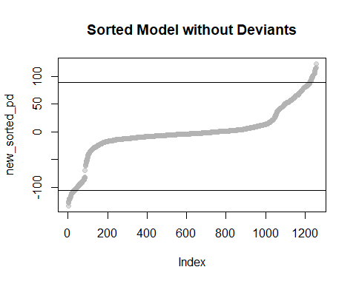

library(rpart)  
new_insurance_rpart <- rpart(new_pd_loocv~., data = new_insurance, minsplit = 2, minbucket = 1,cp = 0)  
node_leaves <- semcoa:::tree_node_cases(new_insurance_rpart) # WARNING: long-running  
  
# Get average PD of all cases under a node  
node_pd <- function(node_name, node_leaves, cases_pd){  
 mean(na.omit(new_pd_loocv[as.character(na.omit(node_leaves[[node_name]]))]))  
}  
  
# Find the number of cases that belong to a node  
cases_per_node<-function(x){  
 z<-c()  
 number_of_cases<-sapply(1:length(x),function(y){  
 z[[y]]<<-data.frame("NodeIndex" = match(x[y], node_leaves), "NodeName" = names(x[y]), "TotalNodeCases" = length(x[[y]]))} )  
 return(z)  
}  
  
cases_per_node(c(node_leaves[900], node_leaves[1000]))  
  
# Run regression on cases(subset) of a node  
library(broom)  
subsets_models <- sapply(1:length(node_leaves), function(x){  
 if(length(node_leaves[[x]]) > 6){  
 node_subset_elements <- insurance[node_leaves[[x]],]  
 node_subset_elements_number <- sapply(lapply(node_subset_elements, unique), length)  
 node_model <- lm(charges~., data = node_subset_elements[, node_subset_elements_number>1])  
 model_results <- data.frame(names(node_leaves[x]), t(node_model$coefficients), summary(node_model)$r.squared)  
 print(model_results)  
}})  
  
node_lm_results <- data.table::rbindlist(subsets_models, fill = TRUE)  
colnames(node_lm_results)[1] <- "nodename"  
colnames(node_lm_results)[2] <- "intercept"  
colnames(node_lm_results)[11]<- "r-squared"  
write.csv(node_lm_results,"node_lm_results.csv", row.names = FALSE)  
  
# Pruned insurance tree with PD  
simple_new_insurance_rpart <- rpart(new_pd_loocv~., data = new_insurance)  
fancyRpartPlot(simple_new_insurance_rpart, caption= NULL)

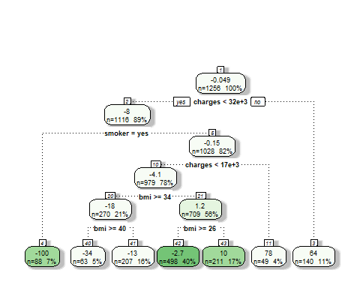

simple_node_leaves <- semcoa:::tree_node_cases(simple_new_insurance_rpart)  
  
library(data.tree)  
simple_new_datatree <- as.Node(simple_new_insurance_rpart)  
  
# Find the nodes that belong to a level  
library(dplyr)

##   
## Attaching package: 'dplyr'

## The following objects are masked from 'package:stats':  
##   
## filter, lag

## The following objects are masked from 'package:base':  
##   
## intersect, setdiff, setequal, union

level_combinations <- function(data_tree_object){   
 library(stringr)  
 return_level<-c()  
   
 # Convert the data.tree object into a dataframe and sort the dataframe  
 to_dataframe <- ToDataFrameTree(data_tree_object,'name', 'level', 'rpart.id', 'isLeaf', children = function(x){sapply(x$children, function(child)child$rpart.id)})  
 sorted_levels <- to_dataframe[order(to_dataframe$level), ]  
   
 total_level_children <- list()  
 leaves <- NULL  
   
 # Loop through levels of a tree  
 for(i in 1:(max(sorted_levels$level) - 1)){  
   
 # Current level's children  
 level_children <- na.omit(sorted_levels[sorted_levels$level == i, ]$children)  
 level_children <- str_trim(unlist(strsplit(level_children,split = ",")))  
   
 # Array of all children in a tree  
 total_level_children <- append(total_level_children,list(level_children))  
   
   
 # Ensure that there is a previous level  
 if(length(total_level_children) >= 1)  
 {  
 # Loop through previous level  
 sapply(total_level_children[i-1],function(x){  
   
 # Loop through children in previous level  
 sapply(x, function(y){  
   
 # Loop through sorted levels to get rpart.id of leaves  
 for (j in 1:nrow(sorted_levels)){  
 if(sorted_levels[j, ]$rpart.id == y && sorted_levels[j, ]$isLeaf == TRUE){  
 leaves <<- c(leaves, sorted_levels[j, ]$rpart.id)}  
 }  
 })})}   
   
 return_level[[i+1]] <- noquote(c(level_children, leaves))  
 return_level[[1]] <- sorted_levels[1, ]$rpart.id  
 }  
   
 return(return_level)  
}  
  
all_levels <- level_combinations(simple_new_datatree)  
  
# Find average r-squared per level  
levels_rsquared <- sapply(all_levels, function(x){ sapply(x, function(y){node_lm_results[node_lm_results$nodename == y, ]$`r-squared`})} )  
average_levels_rsquared <- sapply(levels_rsquared, function(z)(reduce(z, sum))/length(z))  
plot(average_levels_rsquared, type = "o", xlab = "Level", ylab = "Average R-squared", col = "blue", main = "Average R-squared per Level")

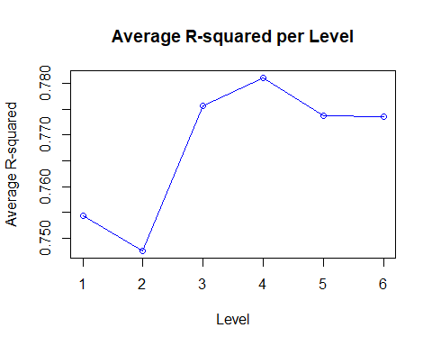

# Find average PD per level  
levels_pd <- sapply(all_levels, function(x){ sapply(x, function(y) {node_pd(y, node_leaves, new_pd_loocv)})} )  
average_levels_pd <- sapply(levels_pd, mean)  
plot(average_levels_pd, type = "o", xlab = "Level", ylab = "Average PD", col = "green",main = "Average PD per Level")  
abline(h = 0)

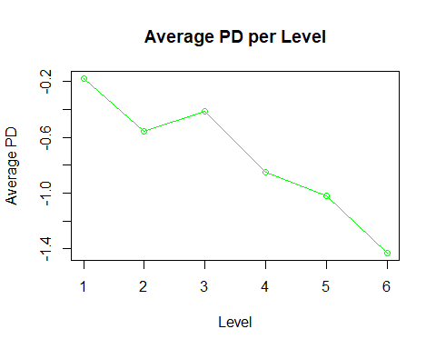

# Find out-of-sample predictive error per node  
node_pe <- function(node_name, node_leaves, cases_pe){  
 mean(na.omit(new_pe_loocv[as.character(na.omit(node_leaves[[node_name]]))]))  
}  
  
# Find predictive error using LOOCV  
pe_fold <- function(i, nfold, model, outcome, dataset){  
 folds <- cut(1:nrow(dataset), breaks=nfold, labels = FALSE)  
 test_indices <- which(folds == i, arr.ind = TRUE)  
 test <- dataset[test_indices, ]  
 train <- dataset[-test_indices, ]  
 trained <- lm(model, data = train)  
 predicted_outcome <- predict(trained, test)  
  
 pe <- test[, outcome] - predicted_outcome  
}  
  
kfold_pe <- function(model, outcome, dataset, nfold = NULL) {  
 if (is.null(nfold)) {  
 nfold <- nrow(dataset)  
 }  
 unlist(sapply(1:nfold, pe_fold, nfold = nfold,   
 model = model, outcome =outcome, dataset = dataset))  
}  
  
new_pe_loocv <- kfold_pe(charges ~ ., outcome = 'charges', dataset = new_insurance)  
  
levels_pe <- sapply(all_levels, function(x){ sapply(x, function(y) {node_pe(y, node_leaves, new_pe_loocv)})} )  
average_levels_pe <- sapply(levels_pe, function (x) mean(x*x))  
  
plot(average_levels_pe, type = "o", xlab = "Level", ylab = "Average PE", col = "green", main="Average PE per Level")

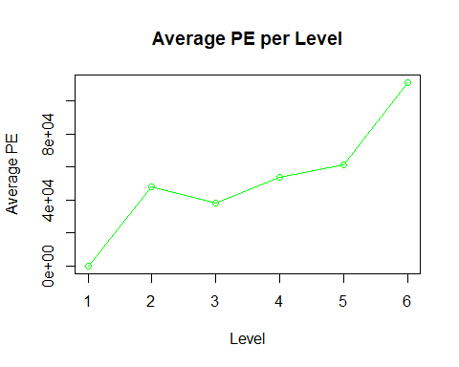

# Run the model on predictive segments  
PD_segments_model <- function(node_names,dataset,model){  
 node_cases <- sapply(node_names, function (element)lm(model, data = dataset[node_leaves[[element]], ]))  
 node_cases  
}  
  
PD_segments_model(c("3", "4", "5"), dataset = insurance, model = charges~.)  
  
lm(charges~.,data = insurance)  
lm(charges~.,data = insurance[node_leaves[["3"]], ])  
lm(charges~.,data = insurance[node_leaves[["4"]], ])  
lm(charges~.,data = insurance[node_leaves[["5"]], ])