A Planeterrella Experiment of the Stellar Ring Currents

Tom Keaton, Xu Wang and Mihály Horányi
Laboratory for Atmospheric and Space Physics, University of Colorado Boulder, Colorado 80303; and
NASA SSERVI’s Institute for Modeling Plasma, Atmospheres and Cosmic Dust, University of Colorado Boulder, Colorado 80303

Key words: Aurora, plasma glow, Planeterrella, Terrella, ring current, electron-neutral atom collisions, magnetic field

Abstract

The Terrella was the first laboratory experiment to study space plasmas such as the Aurora Borealis. An advanced version, dubbed the “Planeterrella”, has been used to demonstrate more space plasma phenomena. Here we present the new results of the Stellar Ring Current experiment. A star with a magnetic dipole field is simulated with a hollow sphere 5 cm in diameter in which a 0.5 Tesla permanent magnet is embedded. The sphere is biased up to -2kV to accelerate electrons outwards from the surface to a high energy to collide with and ionize neutral particles in the air at a pressure range of 500-750 mTorr. Two discrete glowing rings are observed at the equator of the sphere: a bright primary ring and a faint secondary ring with a distinct gap in between them. A test-particle simulation is performed to explain the formation of such ring system.

- Introduction

For many decades, our understanding of space plasmas and their interactions with the Earth’s magnetic field was sparse. In 1901 Kristian Brikeland built a device, dubbed “Terrella” to back up his theories regarding the auroras [7]. The Terrella is a magnetized sphere representing the Earth. When electrons precipitate to the sphere, a glow in the polar regions of the sphere is created due to collisions of the electrons with neutral particles, causing their ionization. The ionization is intensified in the polar regions where the electrons are focused by the magnetic cusp field due to the Lorentz force. The Terrella was the first laboratory experiment to study space physics. Since its creation, the device has been reproduced and improved. Recently, an advanced version, called the “Planeterrella”, has been developed by a French research team at the Laboratoire de Planetologie de Grenbole [1], Lilensten]. The Planeterrella consists of two magnetized spheres with one representing the Sun or a star and another one representing a planet. Several phenomena have been simulated in the Planeterrela, including aurora ovals, coronas, coronal holes, Van Allen belts as well as the Stellar Ring Currents which will be elaborated upon in this paper.
The Stellar Ring Currents has been reproduced in many Planterrella devices by a number of research groups around the world for mainly an educational purpose. Recently at the NASA SSERVI’s Institute for Modeling Plasma, Atmospheres and Cosmic Dust (IMPACT) at the University of Colorado – Boulder, we built a Planeterrella device based on the Grenbole team’s design. We discovered via both imaging data and computer simulations that this experiment produces two discrete “currents” within a specific pressure and voltage potential range. The results are very similar to the Van Allen Belts, although the initial conditions for the experiment are reversed. The experiment shows that Van Allen Belt like radiation regions may be possible around other astronomical bodies such as neutron stars. Moreover, given the simple initial conditions of the electrons, it may also become more feasible to derive an equation that can describe the geometry and collision frequencies of these radiation belts. The paper is outlined as follows. Section 2 describes the experimental apparatus and setup. The simulation method and configuration are described in section 3. Section 4 shows the imaging results compared with the simulation results. Our findings are concluded in section 5.

- Experimental Setup

In a typical Planeterrella device [Lilensten], there are two magnetized spheres as described above. For simulating the Stellar Ring Currents, only one of them is required. The experimental setup is shown in Fig. 1. The vacuum chamber is a 41 cm diameter and 63.5 cm tall bell jar resting on an aluminum base and sealed with a Viton o-ring. The base pressure was within a range of 500-750 mTorr achieved by a mechanical pump. The pressure of the chamber for the experiment was obtained by bleeding the air through a leak valve. An aluminum hollow sphere consisted of two hemispheres 2.5 cm in radius threaded together. A strong permanent magnet 0.5 Tesla at the surface was installed vertically inside the center of the hollow sphere, creating a magnetic dipole field representing the magnetic field of a star. The sphere stood on an insulating tube. A wire coming through the tube was connected to the sphere. The sphere was biased to between xxx and -2kV through a resistor of ~700k Ohms that limits the current to prevent arcing at the surface of the sphere. An electric field was therefore created around the sphere, which accelerates electrons outwards from the surface to ionize the air.
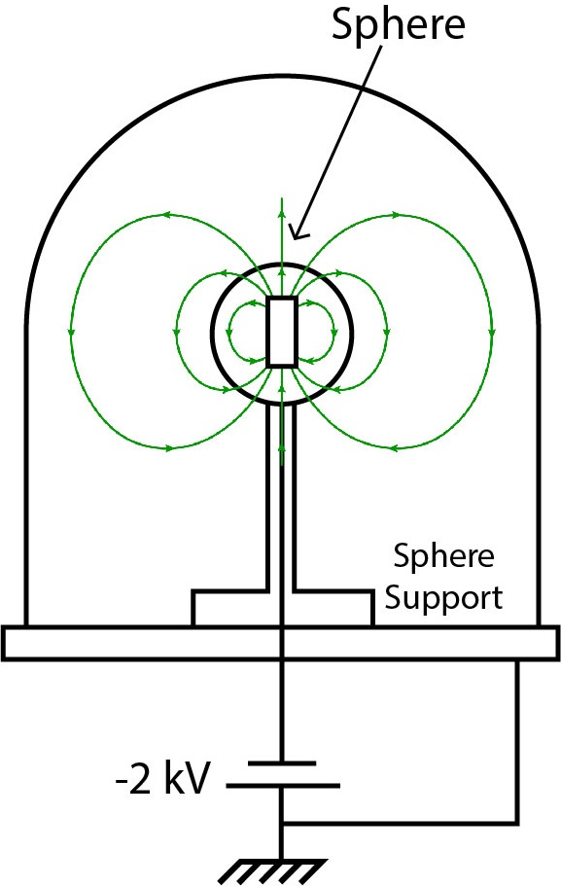

Figure 1 – Schematic of the experimental setup.

- Simulation Method
We used an ODE solver termed “ode15s” in Matlab to resolve the trajectories of the electrons emitted from the surface of the sphere. The solver computed the motion of the electrons due to the Lorentz force for each time step. We opted to for static time steps for saving computing time. The accuracy of the trajectories of the electrons was not affected by the time step size because the ODE solver in Matlab automatically chooses the amount of points sufficient to generate an “accurate” solution. The time step only determines the amount of data points generated for plotting.
The probability that an electron collides with a neutral particle within a given time step is calculated by the following equation

PCts=1-enAvts (1)
where $n$ is the number density of the neutral particles, $A$ is the collision cross-section, $\left|v\right|$ is the magnitude of velocity of an electron and $t_{s}$ is the time step size. The collision cross-section was approximated based on the data from xxx[2] for the electron energy of xx eV.

A plasma sheath was formed around the surface of the sphere. Due to the large plasma density, the sheath was so thin that its thickness (~0.4mm) was much smaller than the simulation radius of interest. Therefore, no sheath electric field was included in the simulation.
0.404 mm

λD=ε0kBTeneqe2

The sheath electric field is normal to the surface of the sphere , electrons accelerated by this large electric field are therefore approximately normal to the sphere surface. For gas at temperature T=1000 K we generated initial particle energies with weighted probability based on the energy dependent, Maxwellian distribution function. The B-field was approximated with a point dipole field.

PCts=1-enAvts

- Results and Discussion

  - Overview

An example of the image of the Stellar Ring Currents is shown in Fig. 2 in which the pressure was $750 mTorr$, the bias voltage was $-2 kV$. It shows two glowing rings around the sphere at its equator. A bright, purple-colored and thin primary ring is located in proximity to the surface of the sphere. A dark red-colored and wider secondary ring is located further from the sphere. The two rings are separated by a distinct dark gap.
Figure 3 shows the electron-neutral collision density above a threshold of $2∙{10}^{10} {collisions∙m}^{-3}$in a 3D profile. It clearly shows that the collisions are concentrated at the equator, forming a ring-shaped profile that is similar to the image of the glowing primary ring shown in Fig. 2. The secondary ring is too faint to be distinguishable in Fig. 3 from a diffused collision density profile outside the primary ring. It will be shown later in section 4.3 in a 2D profile of the collisions. The detailed features and simulation results are shown in the following sections to explain the formation of the Stellar Ring Currents.

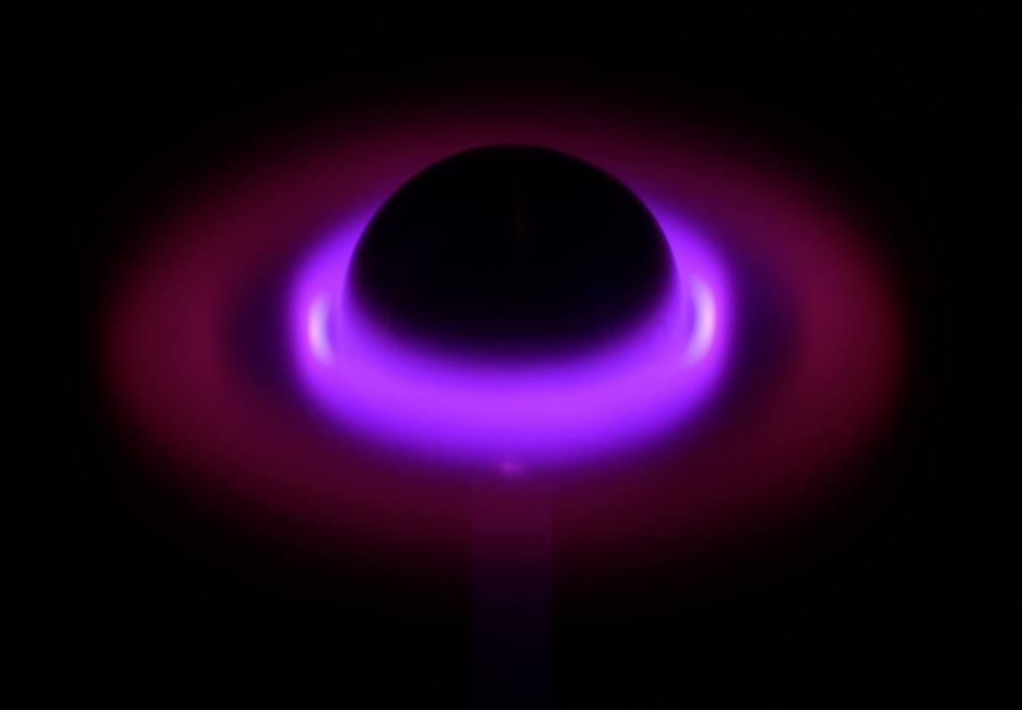

Figure 2 – Image of the Stellar Ring Currents at $750 mTorr$ in the experiment to show visual similarity to the simulation in figure 3. [Camera: SONY/ILCE-7R. Shutter Speed: 8 s, F-stop: F3.5, ISO: 50, Focal Length: 35 mm, Exposure Value: 0]

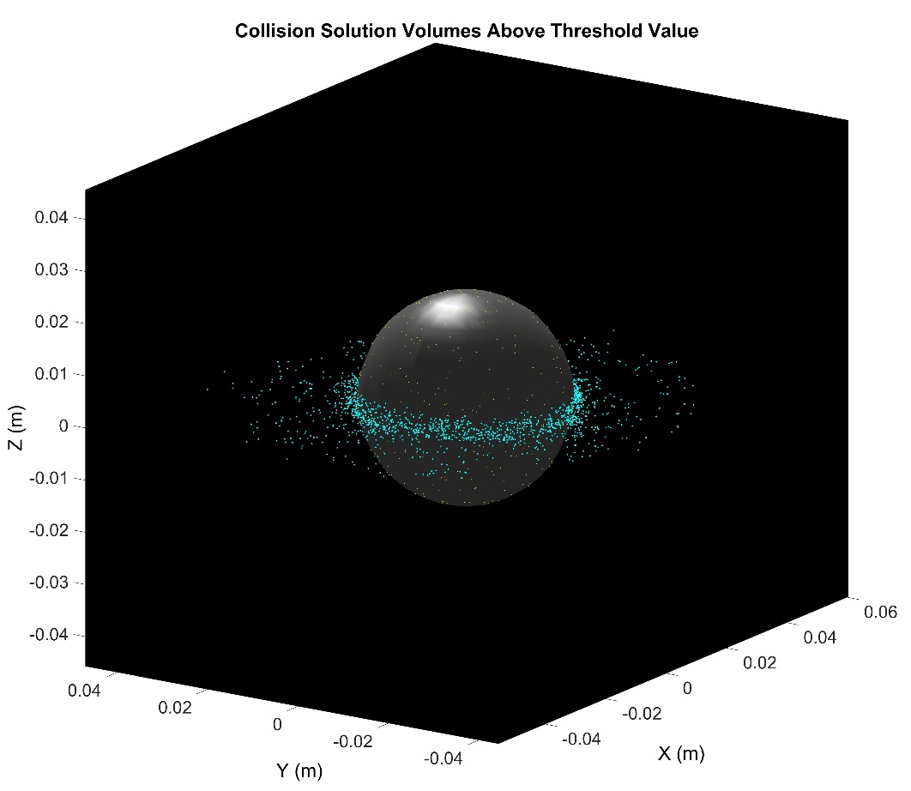

Figure 3 – The data analysis tool we created discretized the space around the sphere into spherical shell pieces and only kept collisions in these volumes that were equal or greater to the cut off collisional density value of $2∙{10}^{10} {collisions∙m}^{-3}$. The additional points surrounding the sphere in its equatorial plane are due to random noise. The yellow dots on the sphere show the locations where all the electrons initially started.

  - Primary Ring

To understand the formation of the primary ring, the examples of trajectories of the electrons launched from three different latitudes are shown in Fig. 4. The electrons that are released from higher latitudes (white and red colors on the top and bottom) start to follow their local magnetic field lines and then become a random walk away from the sphere relatively rapidly. This is because the magnetic field decreases more rapidly at higher latitudes and the motions of the electrons are more influenced by the electron-neutral collisions than the Lorentz force. This causes their random walks to be driven further out from the sphere and therefore a relatively low collision density. The electrons that are released from a lower latitude (cyan color in the middle) gyrate the field lines, bounce up and down around the equator within a small region due to the magnetic mirror effect and drift around the sphere due to xxx gradient B x B ?? effect. These electrons spend significant time at the equator and near the surface of the sphere to collide with neutral particles, causing intense ionization and consequently forming the primary ring.
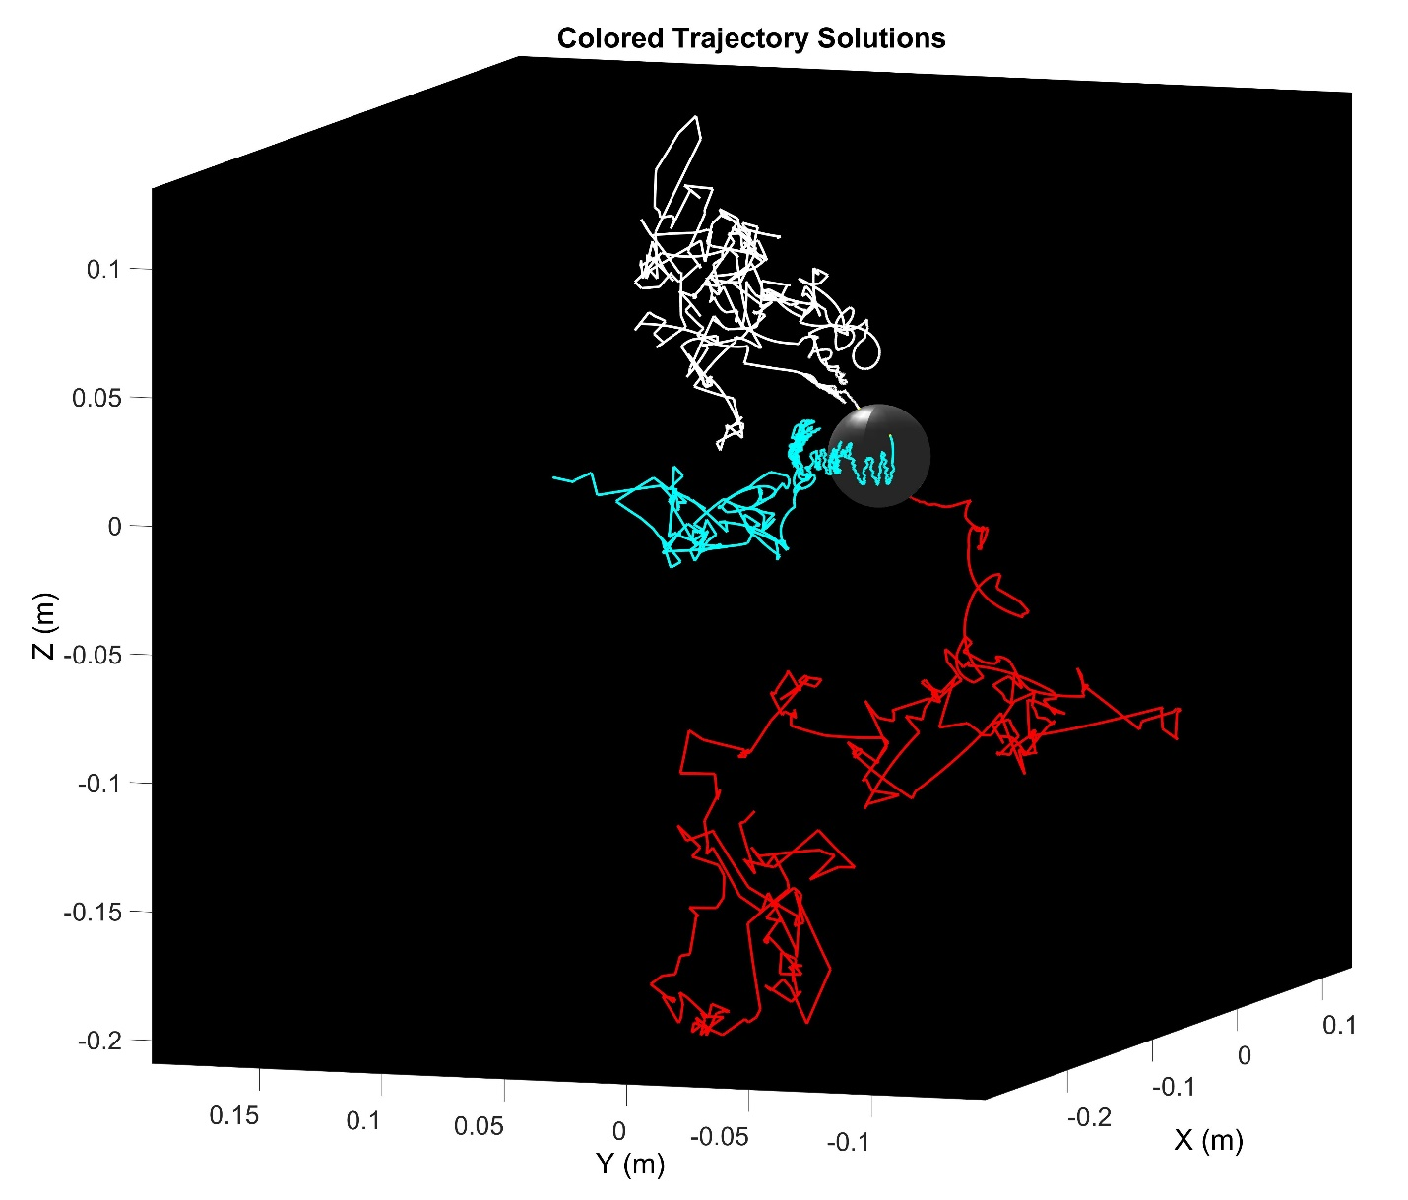
Figure 4 – Each electron here starts tangent to the sphere surface with the same initial energy of $1∙{10}^{-19}$ Joules and therefore the probability of collision was also the same. The white trajectory’s initial theta position (From the equatorial, X-Y plane) was $66.9505°$, the cyan line being $29.111°$and the red line being $-52.8145°$. Although the electron with the cyan path eventually does escape the mirroring oscillations close to the sphere, it is evident that in this time span, it has spent most of its life near the equatorial plane.

  - Secondary Ring

A new discovery in our experiment is the discrete secondary ring, as shown in Fig. 2. Figure 6 shows a top-down view of both primary and secondary rings. It clearly shows that the secondary ring is maroon in color and wider than the primary ring. A distinct dark region separates the primary and secondary rings. The secondary ring reaches its highest intensity at a pressure range of $500-750 mTorr$, where the ring is visible to the human eye.

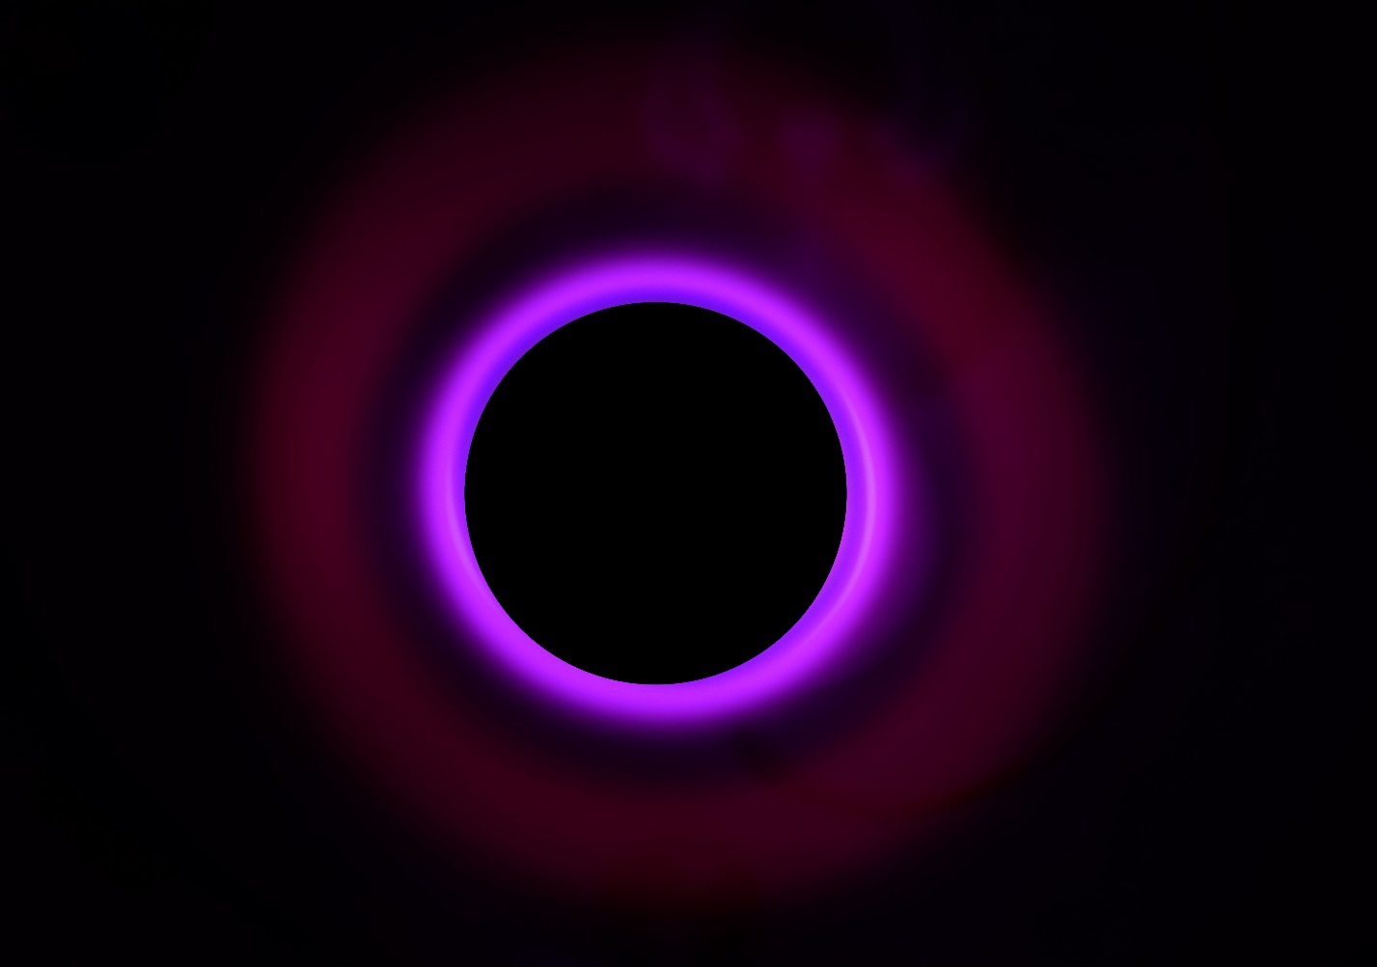

Figure 6 – Stellar Ring Currents experiment image, looking down at sphere along the Z-axis. The line in the photo is the pixel trace used for data analysis. The black circle in the primary ring is where the sphere surface begins. The subtle light underneath the rings on the right-hand side of the picture is due to a combination of a reflection by the base plate and some additional plasma being generated on the stand. [Camera: SONY/ILCE-7R. Shutter Speed: 5 s, F-stop: F3.2, ISO: 50, Focal Length: 35 mm, Exposure Value: 0]

The radial luminosity across the rings is shown in Fig. 7, which was sampled from the top-down image shown in Fig. 6, as indicated by a dashed green line. The radial collision density was plotted over in Fig. 7. It shows that both the luminosity and the collision density follow similar trends as a function of the radial distance from the surface of the sphere though the secondary ring and the gap between the two rings indicated from the collision density profile are not as significant as shown in the image data.

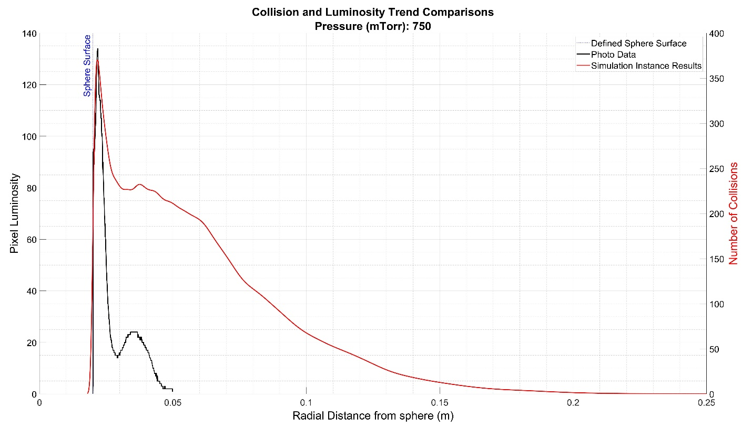

Figure 7 – The red line shows the collision density vs radial distance (m) plotted along with the pixel luminosity data (black) acquired from the top-down photo. Each pixel’s RGB values were converted to a single luminosity value that was then plotted against the distance each pixel was from the sphere’s surface. Simulation has shown that collision density usually peaks a second time to describe the secondary Stellar Ring Current after the primary peak which describes the primary Stellar Ring Current. At the very least in all simulation instances, the curve does not purely, exponentially decay after the primary peak and may plateau in the same region before decaying again.

5. Conclusion

The Stellar Ring Currents were created in a “Planeterrella” device at the IMPACT laboratory at the University of Colorado – Boulder. A hollow sphere in which a strong permanent magnet was installed vertically, simulating a star with a magnetic dipole field. The sphere was biased up to -2 kV to accelerate electrons outwards from the surface to a high energy. These energetic electrons collide with neutral particles in the air at the pressure of 500-750 mTorr, causing their ionization. A primary and a secondary glowing ring with a distinctive gap in-between were observed at the equator of the sphere. A test-particle simulation was performed to explain the formation of the two rings. It was shown from the electron-neutral collision density profiles that the primary ring is created because the electrons launched from lower latitudes are bounded within a small region around the equator due to the magnetic mirror effects, causing higher collision densities and intense ionization. The secondary ring is likely created because the electrons launched from higher latitudes are loosely bounded by the magnetic field whose magnitude decays as a function of the radial distance.

Acknowledgments

This work was supported by the Institute for Modeling Plasma and Cosmic Dust, a NASA SERRVI research group. The authors thank Chris Panella for simulation troubleshooting and assisting in the creation of the data analysis tools. The authors acknowledge the helpful comments made by anonymous sources over the course of this project.

References

[3] – Brudtland T. and Rypdal K., The Birkeland Terrella Experiments and their Importance for the Modern Synergy of Laboratory and Space Plasma Physics. Journal de Physique IV (Proceedings), 01(C4), pp, C4-113 – C4-132. (Oct. 1197) DOI: 10.1051/jp4:1997408
[6] - Chen, Francis F. Introduction to Plasma Physics and Controlled Fusion. 3rd ed., Springer, 2016. DOI: 10.1007/978-3-319-22309-4

[2] – Itikawa, Yukikazu, Cross Sections for Electron Collisions with Nitrogen Molecules. Journal of Physical and Chemical Reference Data, 35, pp. 31 - 52. (2006) DOI: 10.1063/1.1937426

[1] – Lilensten, Jean, The Planeterrella, a Pedagogic Experiment in Planetology and Plasma Physics. Acta Geophysica, vol. 67, no. 1, pp. 220 - 235. (2018) DOI: 10.2478/s11600-008-0079-x

[5] – Lilensten, Jean, Provan, Gabrielle, Grimald, Sandrine, Brekke, Asgeir, Fluckiger, Erwin, Vanlommel, Petra, Wedlund Simon, Cyril, Barthelemy, Mathieu, and Garnier, Pierre, The Planeterrella Experiment: From Individual Initiative to Networking. Journal of Space Weather and Space Climate, vol. 3, no. A07, pp. 2 – 9. (2013) DOI: 10.1051/swsc/2013029

[4] – Olbert, Stanislaw and Rossi, Bruno. Introduction to the Physics of Space. City: McGraw-Hill Book Company, 1970. Print.
[7] – Egeland, Alv, and William J. Burke. Kristian Birkeland, the First Space Scientist. Vol. 325. Springer. (2005) DOI: 10.1007/1-4020-3294-3

