Programming Fundamentals Lab 04 | Instructor: Mr. Muhammad Hamza
Program: AI/SE- Fall 2025 | Date: 30th October, 2025
Marks: 10 | Lab Engineer: Qandil Fatima
Student Name: Eshal Ayub | Reg. No: B25F1061AI100
Instructions:

- Submit the file with your names following your registration numbers like AI001_Name.
- Copy Paste work will be given no marks.


Lab Task

- Write a program to print positive numbers entered by the user. If the user enters negative number, print number entered is positive otherwise print number is negative

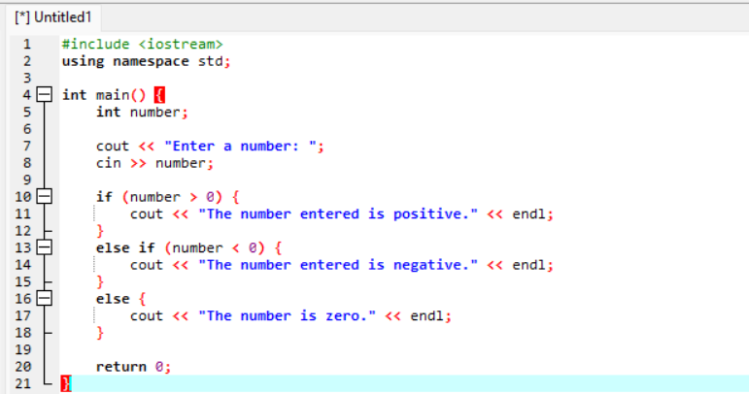
Output:
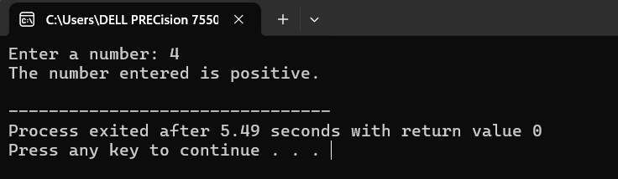

- Program to check whether an integer is positive, negative or zero.
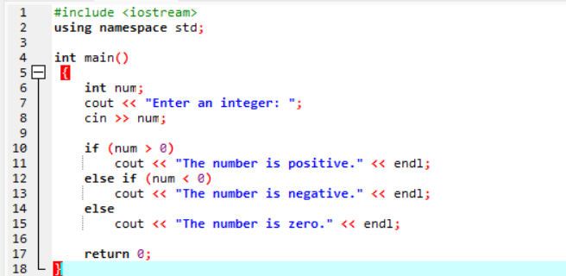
Output:
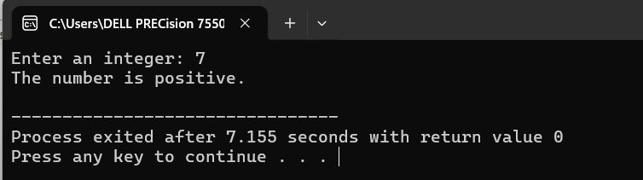

- Input: Mark
Process: If mark greater than and equal to 75, score will be A
If marks less than 75 and greater than and equal to 60, score will be B
If mark less than 60 and greater than and equal to 45, score will be C
If mark less than 30, score will be D
Output: Print the grade of your score.
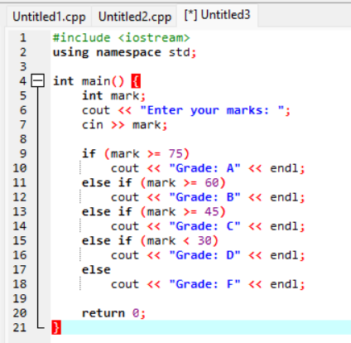
Output:

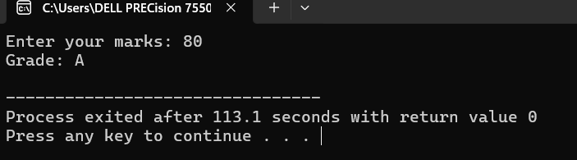

- Find Largest Number Using Nested if...else statement.
Check whether the number entered by the user is positive or not. If it is positive then calcuate how many digits the number has.
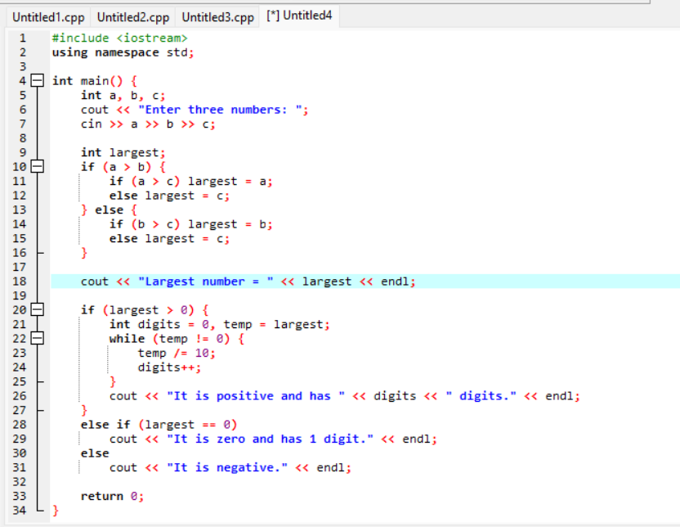
Output:
