**Class Work: Web Technology Projects Date: 2/august/2022**

**Project Owner:KALINDA Fabrice(221007633)**

**Project Name: IZACU MUSIC**

**Project github link**

**1.Introduction**

**What is your project about?**

My project is for rwandan music artist only for supporting them for ranking there music promotion and others, giving the right information about the artist projects to their fans

**State the problem your want to adress**

Many Rwandan don’t have any platform which rank their music and give the international promotion to their projects

**State your project objectives**

My project objective is to give more information about artist projects

Best ranking rwandan music platform

**Importance of your project solution(beneficiaries)**

It will help artist to achieve his goals and promote Rwanda music internationally

**2.Methodologies and Methods**

**How did you know the problem? by observation? Did you make a site visit?**

I knew the problem when there aren’t enough platforms to go and find the local trending music .

**What are your required hardware tools for your project? list them**

-I need a personal computer to develop my project

-i need a fast internet connection

**What are required software tools? list them**

-i need apps such as nodejs,apache,mysql dbms,visual studio code

**3.System Analysis and Design**

**3.System Analysis and Design**

3.1.1 Requirement specifications

* Login authentication,
* User Registration,
* Ranking Charts
* Trending music
* Popular songs
* Brand New

3.1.2. Data requirements

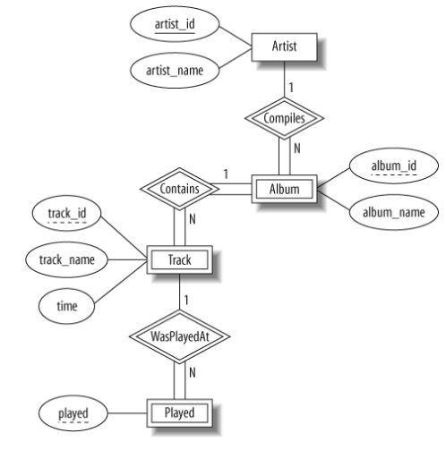

3.1.3 User requirements

main actors of my system :Admin ,Artists,Fans

3.1.4 Security requirements

security measures of my system

* Password encryption
* Routes Protection
* session timeout

3.1.5 Non-functional requirements

What is the system performance?

The performance of the system is should be excellent the server will have to serve the site 24/7

And the database has to be always in good condition in order to store data

What is the system's reliability?

The system is very reliable and will keep your information safely and you can access them whenever you feel the need to

Songs and Albums will be stored in the database safely and artist information.

What is the system's accessibility ?

The system is accessible to anyone who is registered in the university of Rwanda and will be accessed 24/7.

**system design**

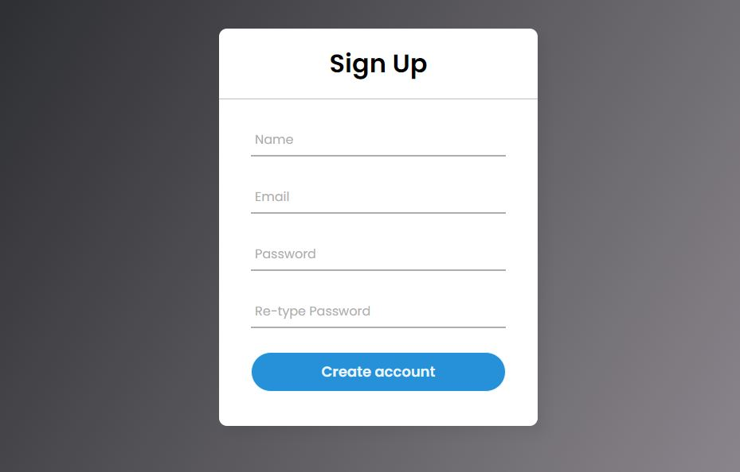

**4.System Implementation**

**Landing page**

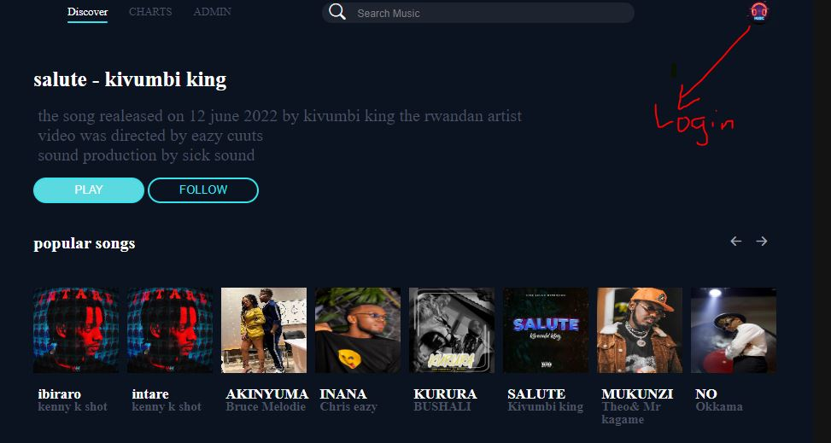

**SignUp page**



**Login Page**

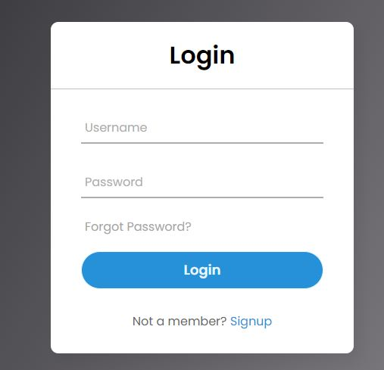

**Trending songs page**

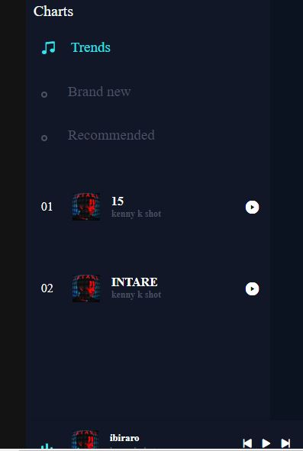

**5. Conclusion**

I managed to complete 40% of my project because of shortage of time and I am planning to to keep working on the next 60% and I think by the end of level 2 I will have completed it and I will keep thinking about new features to add. Giving the time will increase my knowledge and skills about web development

**6.Recommendation**

I have learned that website development is a step by step process and that it requires patience to complete .

I have also learned that there are many ideas to be digitized in order to make people’s life easier by using the skills I have learned throughout this project development

Something I can recommend other students is to used the resources like notes and internet in order to get more understanding of the web development project

Another advice is to stop being lazy and work on the web development skill because it’s market is growing but also as it grows the more it’s demanding strong skills

**7.Appendix**