**Class Work: Web Technology Projects Date: 2/august/2022**

**Project Owner: Habimana Didier Sharif(221015279)**

**Project Name: YOURDATE**

**Project Github Link:**[**YOURDATE**](https://github.com/habimanasharif/yourdate-frontend)

**1.Introduction**

**What is your project about?**

My project is a dating site that will be used by University of Rwanda students to connect and start a relationship between them with the help of the site

**State the problem your want to adress**

Many students are single not because they want to but because they fail to find someone to get in the relationship with who is ready. Some people feel intimidated to reach out to some because they think he/she might not be ready for a relationship

**State your project objectives**

My project objective is to match every one who wants to be in a relationship in the university of Rwanda and see people who connected throughout the program getting married

**Importance of your project solution(beneficiaries)**

It make people become happy by connecting them with partners who will be helping in their daily life

**2.Methodologies and Methods**

**How did you know the problem? by observation? Did you make a site visit?**

I knew the problem by observing people in the University of rwanda some are not happy at all and they are always lonely and some always get dumped because they didn't find the perfect date

**What are your required hardware tools for your project? list them**

-I need a personal computer to develop my project

-i need a fast internet connection

**What are required software tools?list them**

-i need apps such as nodejs,apache,mysql dbms,visual studio code

**3.System Analysis and Design**

**3.System Analysis and Design**

3.1.1 Requirement specifications

* Login authentication,
* User Registration,
* Matching Users
* Messaging
* Reporting Users
* Dashboard

3.1.2. Data requirements

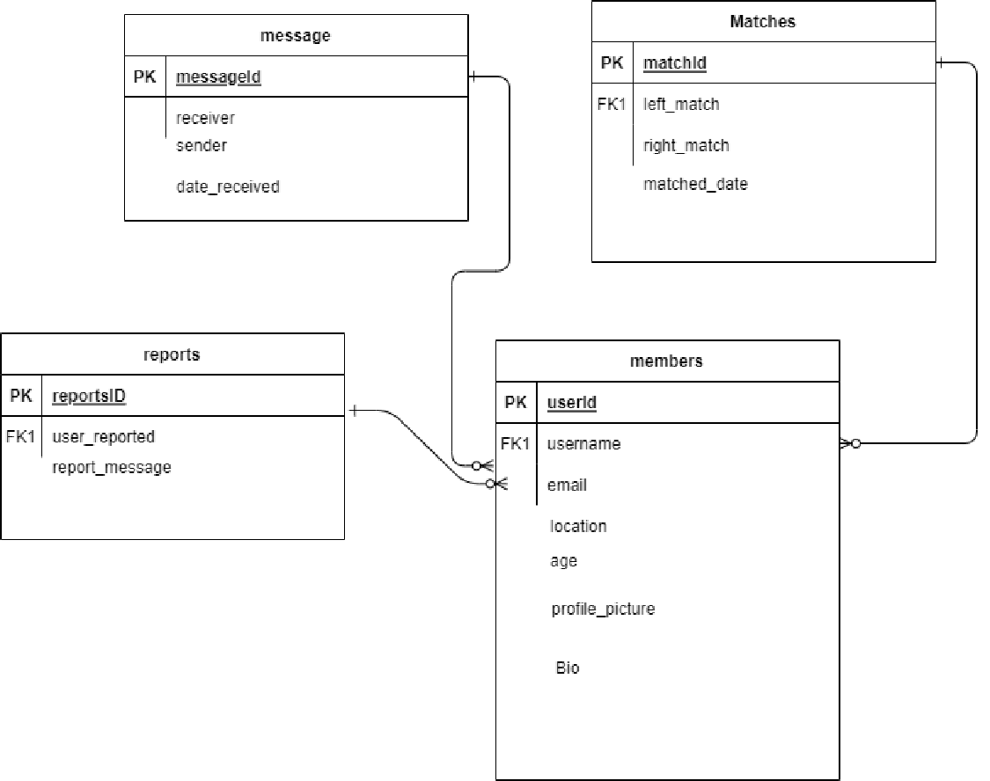

3.1.3 User requirements

main actors of my system:Admin,Client

3.1.4 Security requirements

security measures of my system

* Password encryption
* Routes Protection
* session timeout

3.1.5 Non-functional requirements

What is the system performance?

The performance of the system is should be excellent the server will have to serve the site 24/7

And the database has to be always in good condition in order to store data

What is the system's reliability?

The system is very reliable and will keep your information safely and you can access them whenever you feel the need to

What is the system's accessibility ?

The system is accessible to anyone who is registered in the university of Rwanda and will be accessed 24/7.

**system design**

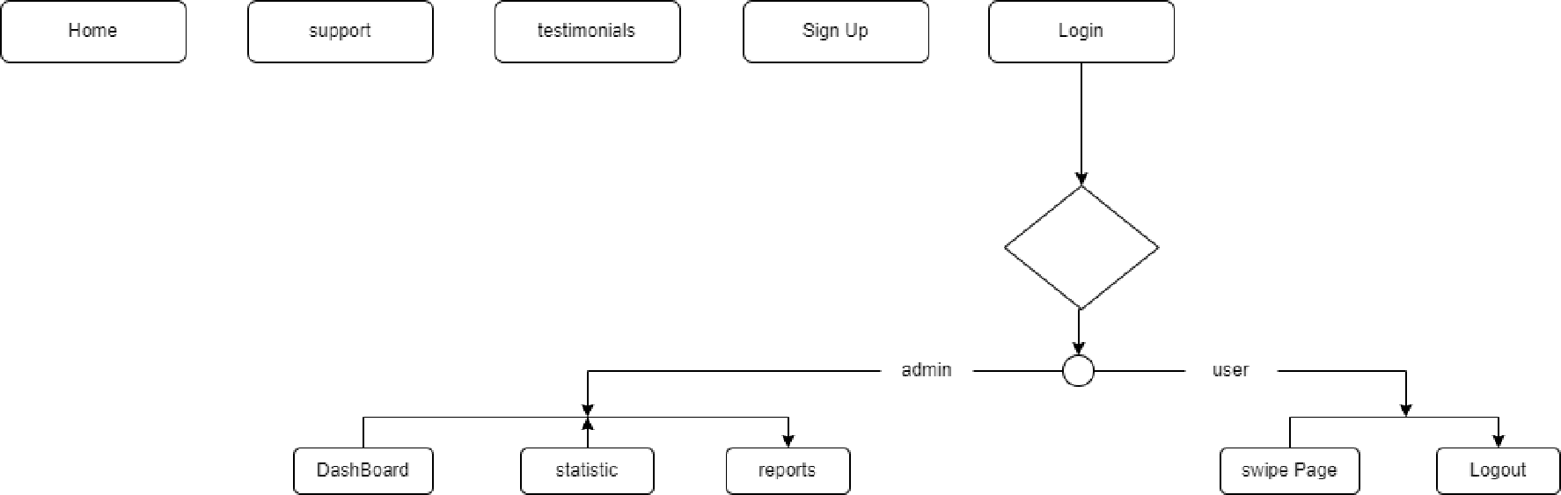

**4.System Implementation**

**Landing page**

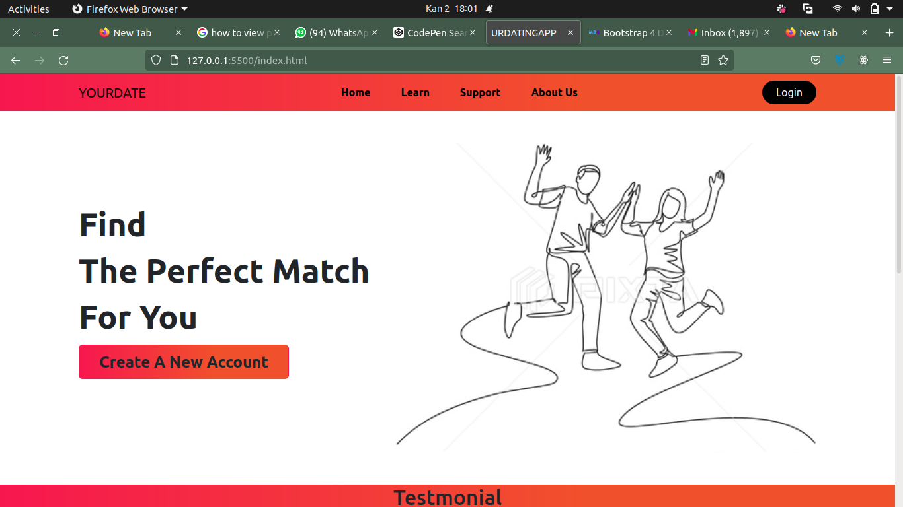

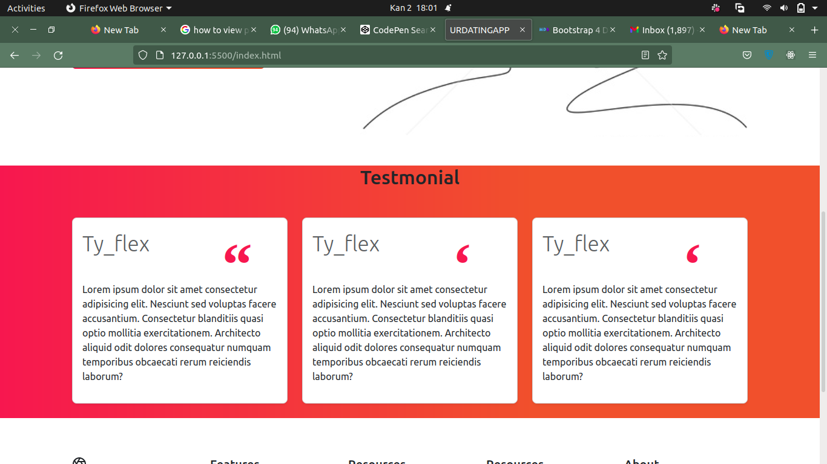

**SignUp page**

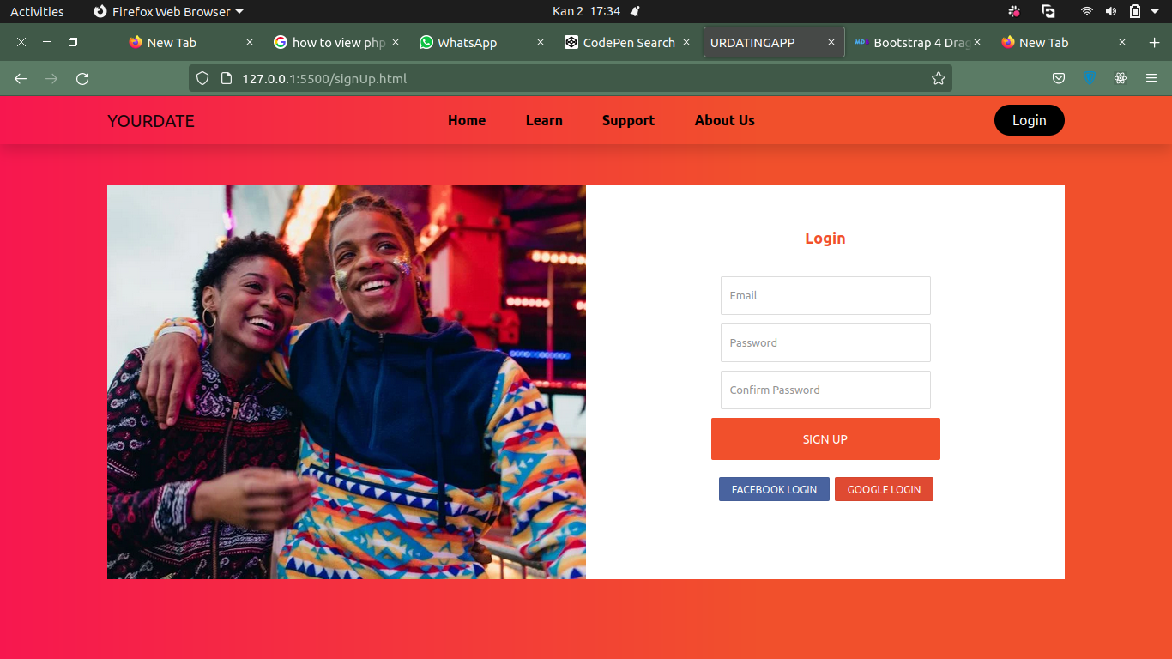

**Login Page**

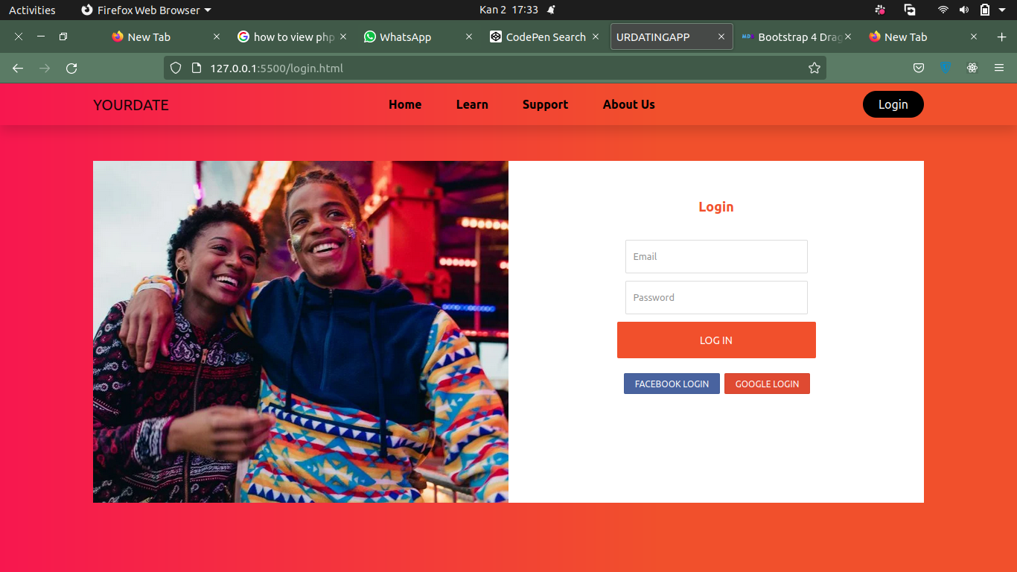

**Find match page**

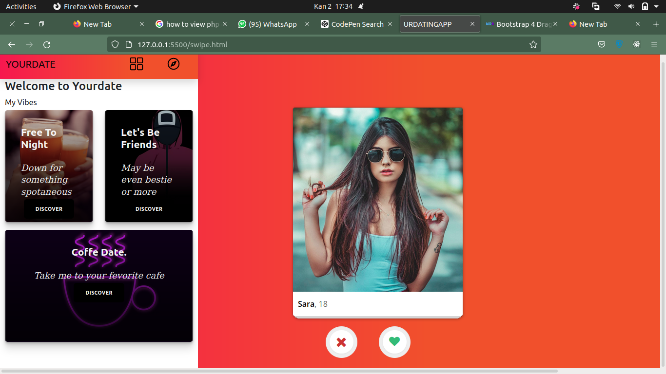

**Update Profile**

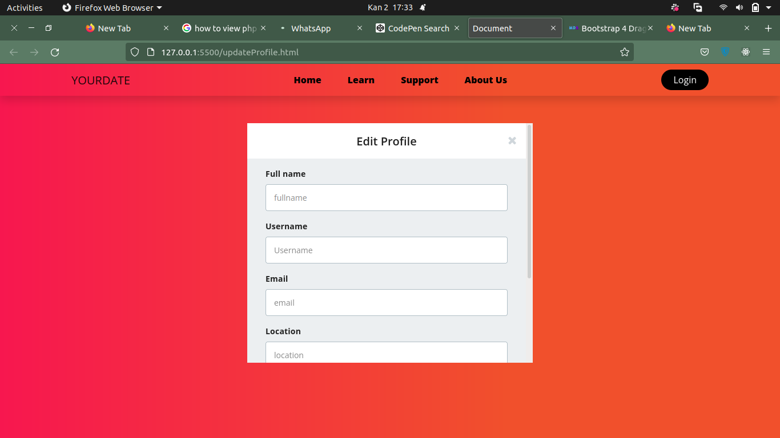

**5. Conclusion**

I managed to complete 50% of my project and I am planning to to keep working on the next 50% and I think by the end of level 2 I will have completed it and I will keep thinking about new features to add

**6.Recommendation**

I have learned that website development is a step by step process and that it requires patience to complete .

I have also learned that there are many ideas to be digitized in order to make people’s life easier by using the skills I have learned throughout this project development

Something I can recommend other students is to used the resources like notes and internet in order to get more understanding of the web development project

Another advice is to stop being lazy and work on the web development skill because it’s market is growing but also as it grows the more it’s demanding strong skills

**7.Appendix**

**GitHubLink:**[**YOURDATE**](https://github.com/habimanasharif/yourdate-frontend)