# Environment

**Software:** Virtual Box

**Operating System:** Linux (Unbuntu)

**Installation:** MySQL server on Linux, Python, CouchDb on Linux

Author: Yu Zhang, [zyu.1106@gmail.com](mailto:zyu.1106@gmail.com), [www.yu-zhang.net](http://www.yu-zhang.net)

# How to run

1. Login to MySQL server.
2. Check the table elements.

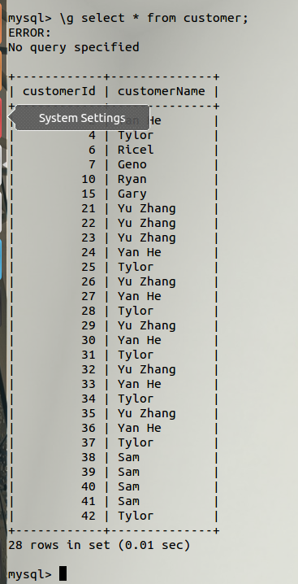

1. The last one is Tylor.
2. Run the python program.

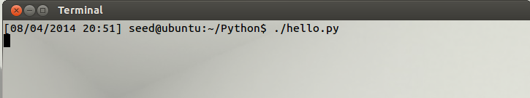

The program is now waiting for CouchDb changes.

1. Open CouchDb

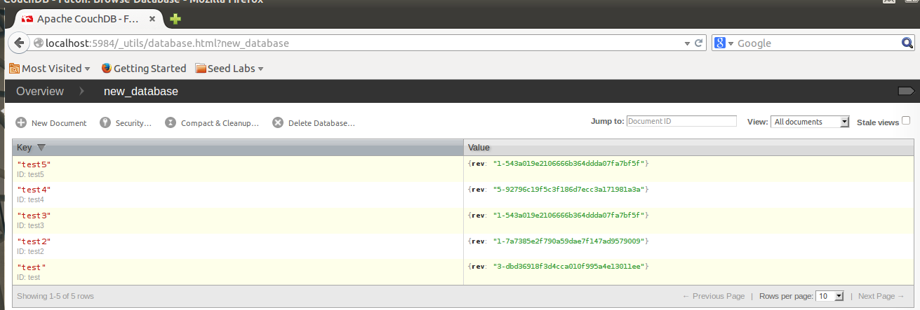

1. Create a new document.

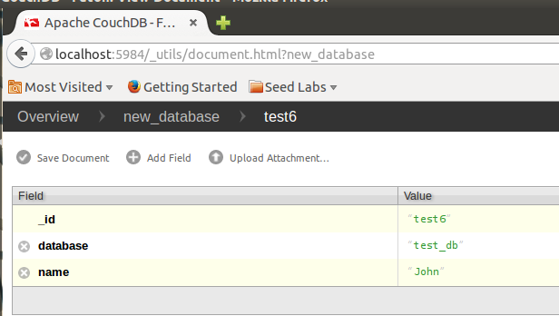

1. Save this document

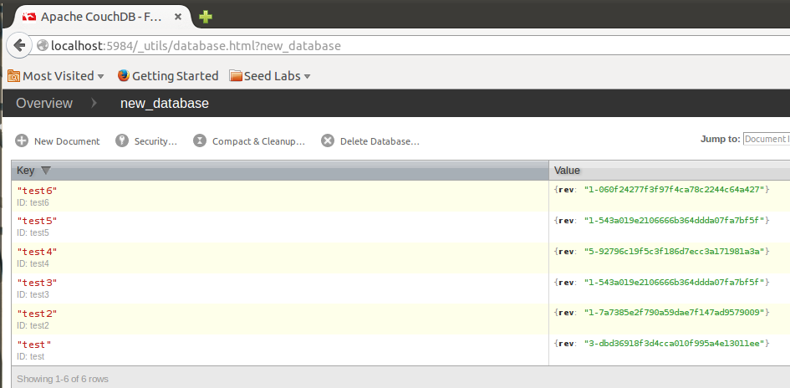

1. Look at the program.

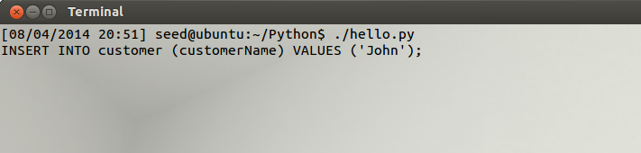

It create a new “Insert query” to the database.

1. Check MySQL Server.

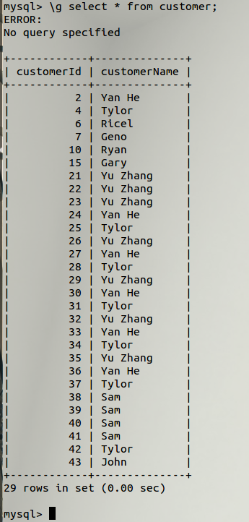

No. 43 is the new data added into the database.

# Description

For now, the program is only a very simple demo. If want to implement whole functionalities, I need to add more logic to parse the JSON object. As a result, the program will be able to handle “DELETE”, “UPDATE” and more queries.