List
Abs 6
Array 6
Access by index 6
Array to string 6
Group records in an array 6
length – cardinality 6
order array 6
Split array to individual records – unnest 6
split string to array – then to individual records 6
unnset 6
from 6
between 6
dates 6
numbers 6
Case 6
Count 7
Select 7
when in (array) 7
Cast 7
Datetime to Date 7
int to float 7
null to another column 7
String to int 7
ceil 7
Charindex 7
coalesce – if null then 7
count 7
case 7
Distinct 7
Filter 8
Create 8
Create new column 8
CTE – short lived tables 8
Date 8
Date manipulation – date trunc 8
date subtract - age 8
date subtract 8
day from date 8
day of week 8
day of week – mon tue wed… 8
days difference 8
deduct a period of time 8
deduct month 8
format date 8
month from date – date_part vs extract 9
time from day time 9
time – difference in hours 9
Year from date 9
Delete 9
Columns 9
Rows 9
Distinct – unique values only 9
distinct multiple columns 9
having 9
factorial 9
fetch 9
fetch first row with ties 9
floor 9
Format text 9
Trailing numbers 9
function – own 10
1 – variables declaration 10
2 – if else 10
3 – while loop 10
recursive 10
generate series – n col nr table 11
dates 11
With select 11
Greatest -> math max 11
group by 11
group by – distinct 11
group check – bool_or 11
group strings 11
mode – pick one value from group by 12
grouping sets – check rollup 12
having 12
count 12
count distinct 13
Filter 13
having every 13
max 13
if null then – coalesce 13
is not 13
Join 13
Cross join 13
Full join 14
Inner join 14
Lateral 14
Self cross join 15
Self join 15
using 15
with tables that are not connected by key with main table 15
json 15
individual array columns 15
individual value 15
Json array length 15
string json to columns 15
json array 15
where combination 16
least – math.min 16
left – substring from left side 16
in – grouped check 16
Length – len 16
Like 16
Array check 16
Limit rows – offset / fetch 16
Fetch 16
offset 16
mediana 16
percentile_disc 16
min math -> least 17
mod – modulo 17
Not in – different - <> 17
Order by 17
Case 17
Computation on columns 17
nulls last 17
Partition by 17
over 17
no particular column 17
Parametrized Postgresql 17
Partition By 17
Partition by multiple tables 18
Total aggregation 18
Individual aggregation (rolling calculation) 18
Order by – as its part 18
Rollup 18
Rollup with missing ‘grouped’ column 18
Pow 19
Rank 19
row number for grouped column 19
Regex 19
Regexp_replace (Postgresql) 19
Repeat string 19
rollup 19
date difference – LAG 20
Round 20
Two digits 20
Row number – show number of rows 20
Rolling 20
sqrt 20
sting concatenation 20
string contains – includes 20
string to array 21
Substring 21
Parsename – based on ‘.’ Delimiter 21
Substring 21
sum 21
count 21
distinct 21
Temporary table 21
Postgresql 21
Trim 21
Types 22
Date 22
Datetime 22
Float 22
Nvarchar 22
Union all – union with duplicates 22
union all – adding extra columns 22
Update 22
Update type 22
Update value 22
Update with ‘join’ 22
variables ( types of data) 22
bigint 22
int 23
View 23
Where 23
In – in other group of records 23
Not in 23
With aggregate function 23
With CTE 23
Multi cte 23
Xml 24
Multi rectords manipulation 24
Xmltable 24
Xpath 24

https://www.codewars.com/users/leaderboard/ranks?language=sql
https://www.codewars.com/kata/search/sql?q=&r%5B%5D=-6&xids=completed&order_by=total_completed%20desc

Abs
abs(s1.total_streams - s2.total_streams)

Array

Access by index
with cte as(
select distinct(username), array_agg(role) as roles

case
when roles[1] = 'internal' then true
1 is the first element (not index 0)

Array to string
array_to_string(array_agg(applicant_id order by applicant_id), ', ')

Group records in an array
select manager_id, ARRAY_AGG(name||' ('||id||')' order by id) as employee_names
from employees
where manager_id is not null
group by manager_id
order by 1

length – cardinality
with cte as(
select distinct(username), array_agg(role) as roles

from cte
where cardinality(roles) = 1

order array
array_to_string(array_agg(applicant_id order by applicant_id), ', ')

Split array to individual records – unnest
with list as (
select unnest(genres) as genre, title from books)

select genre, count(genre) as count, array_agg(title order by title) as books
from list
group by genre
order by 2 desc, 1

split string to array – then to individual records
unnest(string_to_array(user_access, ','))

unnset

from
from (select unnest(fm.special_features) as sf from film as fm) as fm2

between

dates
where rn.rental_date::date between '2005-05-24' and '2005-06-02'

numbers
levenshtein(emp2.name, crt2.cert_name) between 1 and 3

Case
Select distinct(
case
when SoldAsVacant = 'N' then 'No'
when SoldAsVacant = 'Y' then 'Yes'
else SoldAsVacant
end) as NewSoldAsVacant
from PortfolioProject..NashvilleHousing

Count
To apply count – apply one of the aggregate function
CASE
WHEN COUNT(DISTINCT supplier) > 1 THEN 'Several'
ELSE MIN(supplier)
END AS supplier
Simple ‘else supplier’ does not work – this is why the ‘min’ aggregate has been attached

Select
select
case
when (select * from cte2) = 0 then null
when (select * from cte1) = 0 then null
else round((select * from cte2) * 100.0 /
(select * from cte1), 2)
end as error_percentage

when in (array)
SELECT
n,
CASE
WHEN (n - 1) % 88 % 12 IN (0,2,3,5,7,8,10) THEN 'white'
ELSE 'black'
END as res
FROM pianokeys

Cast

Datetime to Date
convert(date, SaleDate)

int to float
cast(count(*) as float)

null to another column
isnull(pa2.PropertyAddress, pa1.PropertyAddress)

String to int
cast(vac.new_vaccinations as int)

ceil
(3 * ceil(n / 3.0))::int

Charindex
charindex(',', PropertyAddress)

coalesce – if null then
coalesce(ad.jd, ex.ed)::varchar as date,
coalesce(ad.jc, 0) as joins,
coalesce(ex.ec, 0) as exits,
coalesce(ad.jc, 0) - coalesce(ex.ec, 0) as net

count

case
'Product 1: ' || count(case when ord.product_name = 'Product 1' then 1 end) || ' times' ||
' || Product 2: ' || count(case when ord.product_name = 'Product 2' then 1 end) || ' times' as product_summary

Distinct
HAVING
SUM(CASE WHEN o.product_name = 'Product 3' THEN 1 ELSE 0 END) = 0
AND COUNT(DISTINCT o.product_name) = 2

Filter
Select coalesce(sex, 'Total') as "Sex/Handedness",
count(*) filter (where handedness = 'Right-handed') as "Right-handed",
count(*) filter (where handedness = 'Left-handed') as "Left-handed",
count(*) as "Total"
from survey_data
group by rollup(sex)
order by substring(sex from 2) nulls last

Create

Create new column
alter table PortfolioProject..NashvilleHousing
add SaleDateConverted date;

CTE – short lived tables
The tables stays in the memory for execution time only (short lived)
The number of returned columns must be exact of the subquery ones
Order by is prohibited
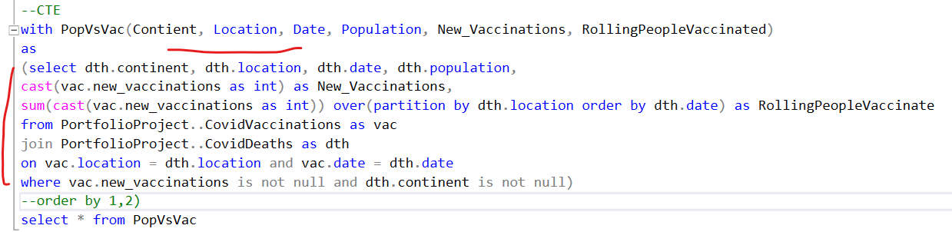

Date

Date manipulation – date trunc
To start from last week Monday:
s.sale_date >= DATE_TRUNC('week', CURRENT_DATE) - INTERVAL '1 week'
To end on last week Sunday
s.sale_date < DATE_TRUNC('week', CURRENT_DATE)

date subtract - age
age(current_date::date, (age::varchar)::date)

date subtract
date_one – date_two

day from date
date_part('day', date)

day of week
0 - 6
extract(dow from rental_date::date)

day of week – mon tue wed…
TO_CHAR(r.rental_date, 'DY') AS most_popular_day_of_week

days difference
(select(current_date::date - dlf.occurred_at::date) as days)

deduct a period of time
select host from host_software as hs
where hs.install_date >= current_date - interval '1 year'

deduct month
max(r1.rental_date)::date < (current_date - interval '1 month')::date

format date
month dd, yyyy
to_char(max(r1.rental_date)::date, 'FMMonth DD, YYYY')
September 09, 1999

month from date – date_part vs extract
date_part('month', date)
extract('year' from age(current_date::date, (age::varchar)::date))

time from day time
cast(rental_date as time) >= '18:00:00'::time

time – difference in hours
(select(extract (epoch from (current_timestamp - dlf.occurred_at::timestamp )))::integer/3600)

Year from date
date_part('year', date)

Delete

Columns
alter table PortfolioProject..NashvilleHousing
drop column OwnerAddress, TaxDistrict, PropertyAddress

Rows
delete
from RowNumCTE
where row_num > 1

Distinct – unique values only
select distinct(SoldAsVacant)
from PortfolioProject..NashvilleHousing

distinct multiple columns
attach group by
select n, heopsik(n) as res from pyramidheight
group by res, n
order by 1

having
HAVING
SUM(CASE WHEN o.product_name = 'Product 3' THEN 1 ELSE 0 END) = 0
AND COUNT(DISTINCT o.product_name) = 2

factorial
fact bigint := factorial(f_nr);

fetch

fetch first row with ties
limit 5 will return first 5 rows
fetch first 5 rows with ties will return distinct values based on order by
order by 3 desc, last_name
fetch first 5 rows with ties
limit 5: 23,21,19,19,19
fetch with ties: 23,21,19,19,19,18,18,14,14,14 (5 distinct values

floor
SELECT n, FLOOR(SQRT(n))::int as res
FROM doors;

Format text

Trailing numbers
to_char(population_increase, 'fm999.00')
34.0 -> 34.00
134 -> 124.00
23.2 -> 23.20
to_char(mod(total, 60), 'fm00')
78 -> 78
5 -> 05

function – own

1 – variables declaration
create or replace function sum_fct (f_max real, f_sum real, f_nr int)
returns real as $$
declare
temp_max real := f_max;
begin
return temp_max;
end;
$$ language plpgsql;

2 – if else
create or replace function sum_fct (f_max bigint, f_sum bigint, f_nr bigint)
returns bigint as $$
declare
temp_sum bigint := f_sum;
fact bigint := factorial(f_nr);
begin
if mod(fact, 2) = 0 then
temp_sum = temp_sum + fact;
end if;
if f_nr < f_max then
return sum_fct(f_max, temp_sum, f_nr + 1);
end if;
return f_sum;
end;
$$ language plpgsql;

3 – while loop
create or replace function sum_fct (f_max bigint)
returns bigint as $$
declare
a bigint := 0;
b bigint := 1;
res bigint := 0;
begin
while b < f_max loop
a = a + b;
if a < f_max and mod(a, 2) = 0 then res = res + a;
end if;
b = b + a;
if b < f_max and mod(b, 2) = 0 then res = res + b;
end if;
end loop;
return res;
end;
$$ language plpgsql;

recursive
Factorial
create or replace function recursive_function (ct int, f int, mk int)
returns table (n int, result int)
language plpgsql
as $$
begin
return query select ct, f;
if ct < mk then
return query select * from recursive_function(ct + 1, f * (ct + 1), mk);
end if;
end $$;

prepare generate_factorial(int) as
select * from recursive_function(1, 1, $1)

generate series – n col nr table

prepare draw_pattern(int) as
select repeat('*', gs) as star_pattern from generate_series(1, $1) as gs
order by 1 desc

dates
generate_series( date '2005-05-24',date '2005-06-02',INTERVAL '1' DAY)

With select
with cte as(
select *,
(select count(*) from sessions where length_seconds >= test and length_seconds < test + 5) as count
from generate_series(0, (select max(length_seconds) from sessions), 5) as test)

Greatest -> math max
select a, b,
(a * b * (a + b - 2) + (2 * least(a, b) * (least(a, b) - 1) * (3 * greatest(a, b) - least(a, b) - 1)) / 3) as res
from chessboard
select product_id, product_name,
greatest(generate_series(1,quantity_in_stock), quantity_in_stock) as quantity_in_stock
from products
order by product_id desc

group by
in complex cases – test grouping with multiple columns

group by – distinct
utilise distinct as group by if there are multiple columns
select distinct on (actor_id) actor_id, first_name || ' ' || last_name as full_name, title as film_title from actor
join film_actor using (actor_id)
join film using (film_id)
where first_name like 'J%'
order by actor_id, film_id desc;

group check – bool_or
The BOOL_OR() function returns true if at least one value in the group is true. If all values are false, the function returns false.
Please note that the BOOL_OR function ignores NULLs within the group.

select username, bool_or(role = 'internal') as internal, bool_or(role = 'admin') as admin
from user_roles
where role in ('internal', 'admin')
group by username
having count(role) = 1
order by username

group strings
select id, user_name, string_agg(pet_name, ', ') as pet_names from cte

mode – pick one value from group by
SELECT film.film_id, film.title AS film_title,MODE() WITHIN GROUP (ORDER BY to_char(rental_date, 'DY')) AS most_popular_day_of_week FROM film
JOIN film_category USING(film_id)
JOIN category USING(category_id)
JOIN inventory USING(film_id)
JOIN rental USING(inventory_id)
WHERE category.name ='Action'
GROUP BY film_id,film.title
ORDER BY film.title,film.film_id
Order by sets the result by mon 23 tue 19 wed 17 …
Mode picks the highest value

grouping sets – check rollup
adds extra rows
https://www.codewars.com/kata/5dac87a0abe9f1001f39e36d/train/sql
SELECT name product_name,
DATE_PART('year', date)::int as year,
DATE_PART('month', date)::int as month,
DATE_PART('day', date)::int as day,
sum(price * count) total
FROM sales_details d JOIN sales s ON d.sale_id = s.id
JOIN products p ON d.product_id = p.id
GROUP BY GROUPING SETS ((1,2,3,4),(1,2,3),(1,2),(1)) order by 1,2,3,4
in this case we will have four different groups but related to the same stack of data
if some data is not related to the stack then null value will be attached
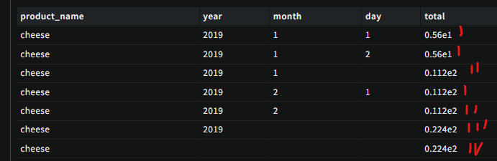
First group groups by day and sums total
Second group groups by month and sums total
Third group groups by year and sums total
Fourth group groups by product and sums total
select date_part('year', pm.payment_date::date)::int as Year,
date_part('month', pm.payment_date::date)::int as month,
ct.name as category, floor(sum(pm.amount))::int as revenue
from payment as pm
join rental as rn using(rental_id)
join inventory as iv on rn.inventory_id = iv.inventory_id
join film_category fc on iv.film_id = fc.film_id
join category ct on fc.category_id = ct.category_id
where date_part('year', pm.payment_date::date) = '2007'
group by grouping sets (
(date_part('year', pm.payment_date::date), date_part('month', pm.payment_date::date), ct.name),
(date_part('year', pm.payment_date::date), date_part('month', pm.payment_date::date)),
(date_part('year', pm.payment_date::date)))
order by 2, 4 desc, 3

having
remember – having operates after group by – it operates of the group so you can count, distinct etc

count
select username, bool_or(role = 'internal') as internal, bool_or(role = 'admin') as admin
from user_roles
where role in ('internal', 'admin')
group by username
having count(role) = 1
order by username

count distinct
HAVING COUNT(DISTINCT DATE_TRUNC('month', r.rental_date)) = 3

Filter
having count(rn.rental_date) filter(where rn.rental_date::date between '2005-05-01' and '2005-05-31') > 0

having every
SELECT host FROM host_software GROUP BY host
HAVING EVERY(software_title <> 'Title2') AND MAX(install_date) >= CURRENT_DATE - INTERVAL '1 year'
ORDER BY host;

with max_rate as (
select subject_id, max(mark_rate) from marks group by subject_id
)
: mat: 98, bio: 100, pol: 97
This are the max values
Marks consist records like:
John mat 96, bio 45
Bolo mat 98 pol 97
The task is to select only those students with top marks for all their subject results
Having every compares all subjects for individual student and checks if every has got max value based on the ‘with cte’ max values table
select student_id, student_name
from students
join marks using (student_id)
join max_rate using (subject_id)
group by student_id
having every(mark_rate = max)
order by 1 desc

max
SELECT host FROM host_software GROUP BY host
HAVING EVERY(software_title <> 'Title2') AND MAX(install_date) >= CURRENT_DATE - INTERVAL '1 year'
ORDER BY host;

if null then – coalesce
if table record is null then provide value
coalesce(tablerecord, value)

is not
<>
If there are null values try
distinct

Join
select distinct on (actor_id) actor_id, first_name || ' ' || last_name as full_name, title as film_title from actor
join film_actor using (actor_id)
join film using (film_id)
where first_name like 'J%'
order by actor_id, film_id desc;

Cross join
Cartesian join

Full join
with cte as(
select
coalesce(ad.jd, ex.ed)::varchar as date,
coalesce(ad.jc, 0) as joins,
coalesce(ex.ec, 0) as exits,
coalesce(ad.jc, 0) - coalesce(ex.ec, 0) as net
from(select distinct(ad.join_date::date) as jd,
count(*) over (partition by ad.join_date::date) as jc from admissions as ad) as ad
full join (select distinct(ex.exit_date::date) as ed,
count(*) over (partition by ex.exit_date::date) as ec from exits as ex) as ex
on ad.jd::date = ex.ed::date
order by 1)

select *, sum(net::int) over (order by date) as cumulative_net
from cte

Inner join

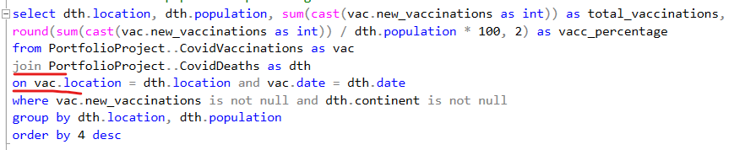

Lateral
Simple join will add all possible records based on ‘on’ clausule
Lateral expands the filter (clausule)
SELECT d.department_name, emp_details.name, emp_details.total_employees
FROM departments d
JOIN LATERAL (
SELECT e.name, COUNT(*) OVER() AS total_employees
FROM employees e
WHERE e.department_id = d.id
) emp_details ON true;
The important thing is that we need two loops. First, we need to iterate through the list of wishes and then we take a look at the sorted list of products, pick 3 and move on to the next wishlist.
Let’s see how this can be done using a LATERAL-join:
PgSQL
SELECT *
FROM t_wishlist AS w,
LATERAL (SELECT *
FROM t_product AS p
WHERE p.price < w.desired_price
ORDER BY p.price DESC
LIMIT 3
) AS x
ORDER BY wishlist_id, price DESC;
We’ll go through it step by step. The first thing you see in the FROM clause is the t_wishlist table. What LATERAL can do now is to use entries from the wishlist to do its magic. So for each entry in the wishlist, we pick three products. To figure out which products we need, we can make use of w.desired_price. In other words: It is like a “join with parameters”. The FROM-clause is the “outer loop” in our pseudo code and the LATERAL can be seen as the “inner loop”.

Self cross join
select s1.state as state_a, s2.state as state_b, abs(s1.total_streams - s2.total_streams) as difference
from state_streams as s1
cross join state_streams as s2
where s1.state < s2.state and abs(s1.total_streams - s2.total_streams) < 1000

Self join
In case of comparing columns for the same table
select pa1.UniqueID, pa1.ParcelID, pa1.PropertyAddress, pa2.PropertyAddress,
isnull(pa2.PropertyAddress, pa1.PropertyAddress) as updatedAddress
from PortfolioProject..NashvilleHousing as pa1
join PortfolioProject..NashvilleHousing as pa2
on pa1.ParcelID = pa2.ParcelID
--and pa1.PropertyAddress <> pa2.PropertyAddress
where pa1.PropertyAddress is not null and pa2.PropertyAddress is null

using
select student_id, student_name
from students
join marks using (student_id)

with tables that are not connected by key with main table
select rnt.customer_id, first_name ||' '|| last_name as full_name,
count(*) as total_rentals
from rental as rnt
join customer as ctm using (customer_id)
join inventory as inv using (inventory_id)
join film as flm
on flm.film_id = inv.film_id
group by rnt.customer_id, first_name, last_name
having every (rating <> 'NC-17')
order by 3 desc, last_name
limit 5
rental table does not have a connection with film table. It can have the connection via inventory table. Inventory table as connection with rental and film table.

json

individual array columns
pets[{name,type},{name,type}]
cast(jsonb_array_elements(info->'pets') ->> 'name' as text) as pet_name,
cast(jsonb_array_elements(info->'pets') ->> 'type' as text) as pet_type

individual value
cast(info ->> 'name' as text) as user_name,

Json array length
jsonb_array_length(json_column_name -> 'pets') as pets

string json to columns
cast(json_data ->> 'name' as text) as user_name,

json array
json_data#>>'{pets}' as dogs

SELECT replace(jsonb_pretty(data::jsonb -> 'first_name'), '"', '') as first_name,
replace(jsonb_pretty(data::jsonb -> 'last_name'), '"', '') as last_name,
extract(year from age(current_date::date, cast(replace(jsonb_pretty(data::jsonb -> 'date_of_birth'), '"', '') as date))) as age,
replace(jsonb_pretty(data::jsonb -> 'email_addresses' -> 0), '"', '') as email_address,
jsonb_pretty(data::jsonb -> 'private')::bool as access
from users

where combination
pets->[{name,type},{name,type}]
select id, info->>'name' as user_name, string_agg(pet->>'name', ', ') as pet_names
from users, jsonb_array_elements(info->'pets') as pet
where pet->>'name' like 'M%'
group by id
order by id

least – math.min
select a, b,
(a * b * (a + b - 2) + (2 * least(a, b) * (least(a, b) - 1) * (3 * greatest(a, b) - least(a, b) - 1)) / 3) as res
from chessboard

left – substring from left side

in – grouped check
WHERE LEFT(city_name, 1) in ('A','E','I','O','U')

Length – len
len(trim(PropertyAddress))

Like
select distinct on (actor_id) actor_id, first_name || ' ' || last_name as full_name, title as film_title from actor
join film_actor using (actor_id)
join film using (film_id)
where first_name like 'J%'
order by actor_id, film_id desc;

Array check
WHERE city_name LIKE ANY(ARRAY['A%','E%','I%','O%','U%'])

where (select sf from cte) like any (special_features)

Limit rows – offset / fetch

Fetch
Always combine with ‘order by’ and ‘offset’
select * from PortfolioProject..CovidDeaths
order by 1
offset 85 rows
fetch first 10 rows only

offset
Always with ‘order by’
select * from PortfolioProject..CovidDeaths
order by 1
offset 85170 rows

mediana

percentile_disc
select film_id, title, length
from film
where length < (select min(length) from film where rating = 'R')
or length > (select percentile_disc(0.5) within group(order by length) from film where rating = 'PG-13')
order by 3, 2, film_id
mediana of length film where rating = pg-13

min math -> least
least(s / 3 + 1, (t + 1) / 2);

mod – modulo
mod(a, 2)

Not in – different - <>
select host from host_software as hs
where 'Title2' not in (select software_title from host_software where host = hs.host) and
hs.install_date >= current_date - interval '1 year'
group by host
order by 1

SELECT host FROM host_software GROUP BY host
HAVING EVERY(software_title <> 'Title2') AND MAX(install_date) >= CURRENT_DATE - INTERVAL '1 year'
ORDER BY host;

Order by

Case
order by case
when "Sex/Handedness" = 'Male' then 1
when "Sex/Handedness" = 'Female' then 2
else 3
end

Computation on columns
select p2.country, to_char((p2.population - p1.population)::numeric / 1000000, 'FM9999999999.00') || ' M' as population_increase from world_population p2
join world_population p1 using (country)
where p1.year = 2000 and p2.year = 2020
order by p2.population - p1.population desc
limit 5

nulls last
ORDER BY sex DESC NULLS LAST

Partition by
SELECT *
FROM orders
ORDER BY
COUNT(*) OVER (PARTITION BY product_id) < 2,
MIN(order_id) OVER (PARTITION BY product_id),
order_id

over

no particular column
(count(*) * 100.0) / sum(count(*)) over ()

Parametrized Postgresql
prepare find_sections(int) as
select s_a.id, s_a.section_name
from section_access as s_a
join (select id, unnest(string_to_array(user_access, ',')) as kk from section_access) as u_a
on s_a.id = u_a.id
where cast(u_a.kk as int) = $1
order by id

Partition By
Let to aggregate and then attach result to individual columns without ‘group by’
select distinct(supplier_id) as supplier_id,
count(*) over (partition by supplier_id) as total_products
from products
order by supplier_id desc

Partition by multiple tables
select ParcelID, PropertyAddress, SalePrice, SaleDate, LegalReference,
ROW_NUMBER() over (
partition by ParcelID, trim(PropertyAddress), SalePrice, SaleDate, LegalReference
order by UniqueID
) row_num
from PortfolioProject..NashvilleHousing

Total aggregation
This aggregation sums all and adds end result for every individual column
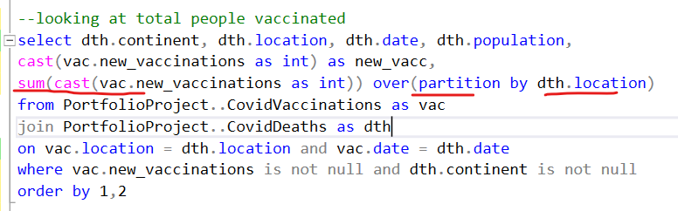
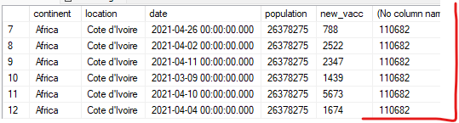
Aggregated result has been attached for every individual column.

Individual aggregation (rolling calculation)
Aggregates individual result and rolls it to another row (calculates it)
The ‘order by’ is the key operation
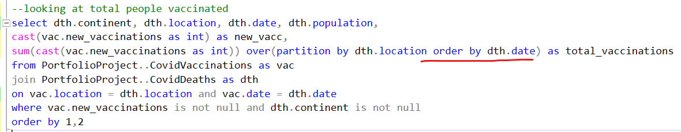
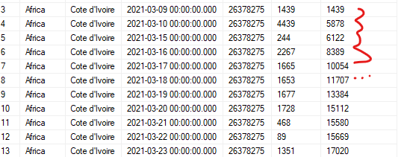

Order by – as its part
SELECT *
FROM recipe_priority
ORDER BY group_id, MAX(priority) OVER (PARTITION BY group_id, recipe) desc, recipe, priority desc, id desc
It’s not required to declare the partition by result column

Rollup

Rollup with missing ‘grouped’ column
Task: sum balance – day after day
Rollup does not require common column -> over (order by date)
with cte as (
select distinct(date::date) as date,'test' as id, sum(amount) over (partition by date::date) as balance
from operations)

select date, sum(balance) over (order by date) as balance from cte

Pow
select n, floor(pow(n,0.5))::int as res from doors

Rank
select count(*) over (order by sum(cs.score) desc, cs.student_id) as rank,
cs.student_id, st.name, sum(cs.score) as total_score
from courses as cs
join students as st on cs.student_id = st.id
where cs.course_name in ('Math', 'Science')
group by cs.student_id, st.name

row number for grouped column
select rnt.rental_id, cst.customer_id, rnt.rental_date,
row_number() over(partition by cst.customer_id order by rnt.rental_date) as rank
from customer as cst
join rental as rnt using (customer_id)
where cst.customer_id between 1 and 2

Regex
There is no regex support for sql server 2019

Regexp_replace (Postgresql)
select id,
regexp_replace(ip, '(^|\.)(0+)(\d)', '\1\3', 'g') as cleaned_ip
from ip_addresses
removal of trailing zeros from
00.01.02.003
If beginning of string or dot (^|\.) (\1)
Right after it one or more zeros (0+) (\2)
Right after it if there are digits (\d) (\3)

Pick sequence \1 and \3 as greedy ‘g’

regexp_replace(
xpath('email_addresses/address/text()', unnest(xpath('data/user/email_addresses', data)))::varchar,
'(\{|}|,.*)', '', 'g') as email_address,
Conditions: { or } or ,abcd…

Repeat string
prepare draw_pattern(int) as
select repeat('*', gs) as star_pattern from generate_series(1, $1) as gs
order by 1 desc

rollup
https://www.codewars.com/kata/5dac87a0abe9f1001f39e36d/train/sql
adding extra rows
select
name as product_name,
extract(year from date)::int as year,
extract(month from date)::int as month,
extract(day from date)::int as day,
sum(price * count) as total
from sales_details sd
join sales s on sd.sale_id = s.id
join products p on sd.product_id = p.id
group by name, rollup(year, month, day)
order by product_name, year, month, day
it is an equivalent of:
rollup(year, month, day)
group by year month day
union
group by year month
union
group by year
union
group by () => all

date difference – LAG
SELECT
rental_id,
customer_id,
TO_CHAR(rental_date, 'YYYY-MM-DD HH24:MI:SS') AS rental_date,
rental_date - LAG(rental_date) OVER (PARTITION BY customer_id ORDER BY rental_date) AS time_since_previous_rental
FROM rental
WHERE customer_id IN (1, 2)
ORDER BY 2, 3;
This will deduct dates between records (first record null )

Round
round((select * from cte2) * 100.0 /
(select * from cte1), 2)

Two digits
round((count(*) * 100.0) / sum(count(*)) over (), 2)

Row number – show number of rows
It shows number of rows that fulfil specific condition
select ParcelID, PropertyAddress, SalePrice, SaleDate, LegalReference,
ROW_NUMBER() over (
partition by ParcelID, trim(PropertyAddress), SalePrice, SaleDate, LegalReference
order by UniqueID
) row_num
from PortfolioProject..NashvilleHousing
In this case it is suspected there are duplicate records. Records are considered as duplicate if all provided parameters are the same. If so – then number of rows will be > 1.
UniqueID is unique for all records in this case.

Rolling
select *, row_number() over (order by employee_id) as counter

sqrt
SELECT n, FLOOR(SQRT(n))::int as res
FROM doors;

sting concatenation
select distinct on (actor_id) actor_id, first_name || ' ' || last_name as full_name, title as film_title from actor
join film_actor using (actor_id)
join film using (film_id)
where first_name like 'J%'
order by actor_id, film_id desc;

concat(test, '-', (test + 4))

string contains – includes
when position('D' in grp) < 1 then 'D'
when position('F' in grp) < 1 then 'F'
when position('I' in grp) < 1 then 'I'

string to array
string_to_array(user_access, ',')

Substring

Parsename – based on ‘.’ Delimiter
It splits string to substrings based on ‘.’
3605 HOODS HILL RD, NASHVILLE, TN
parsename(replace(trim(OwnerAddress), ',', '.'), 1) as OwnerState,
parsename(replace(trim(OwnerAddress), ',', '.'), 2) as OwnerCity,
parsename(replace(trim(OwnerAddress), ',', '.'), 3) as OwnerAddress

Substring
substring(trim(PropertyAddress), charindex(',', PropertyAddress) + 1, len(trim(PropertyAddress)))

sum

count
sum(count(*)) gives the sum of records for entire table – not a sum for current record!!!
select
name category_name,
rating film_rating,
round(count(*) * 100.0 / (sum(count(*)) over(partition by category_id)), 3) percentage
from category
join film_category using(category_id)
join film using(film_id)
group by category_id, rating

distinct
sum(distinct ‘column name’)
sum column name based on main grouped column

Temporary table
Stays in memory – not erased after execution – long lived memory allocation
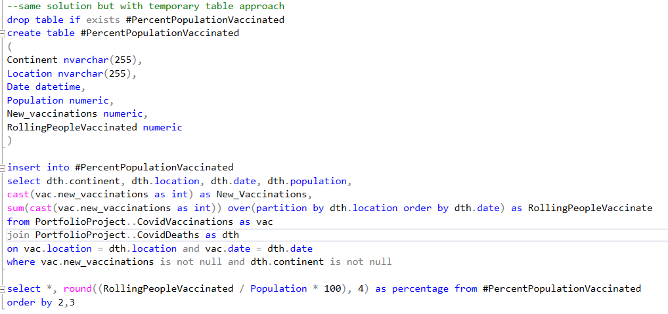

Postgresql
drop table if exists tt;
create temporary table tt(
id int,
c int,
d varchar(10)
);

insert into tt values (1, 0, '-'),(2, 0, '-'),(3, 0, '-'),(4, 0, '-'),(5, 0, '-'),(6, 0, '-'),
(7, 0, '-'),(8, 0, '-'),(9, 0, '-'),(10, 0, '-');

Trim
trim(PropertyAddress)

Types

Date
Just date – no time
‘date’

Datetime
Date and time
‘datetime’

Float
‘float’

Nvarchar
‘nvarchar’

Union all – union with duplicates
select a,b from (select * from sample_table order by a) t
union all
select 0, '-' from generate_series(1,10)

union all – adding extra columns
with cte as(
SELECT pr.name as product_name, date_part('year', date) as year,
date_part('month', date) as month,
date_part('day', date) as day, (pr.price * sd.count) as total FROM sales_details as sd
join sales as sl
on sd.sale_id = sl.id
join products as pr
on sd.product_id = pr.id)

select * from cte
union all
select product_name, year, month, null, sum(total) as total from cte
group by month, year, product_name
union all
select product_name, year, null, null, sum(total) as total from cte
group by year, product_name
union all
select product_name, null, null, null, sum(total) as total from cte
group by product_name
order by 1,2,3,4

Update

Update type
update PortfolioProject..NashvilleHousing
set SaleDate = convert(Date, SaleDate)

Update value
update PortfolioProject..NashvilleHousing
set PropertySplitAddress = substring(trim(PropertyAddress), 1, charindex(',', PropertyAddress) - 1)

Update with ‘join’
update pa2
set PropertyAddress = isnull(pa2.PropertyAddress, pa1.PropertyAddress)
from PortfolioProject..NashvilleHousing as pa1
join PortfolioProject..NashvilleHousing as pa2
on pa1.ParcelID = pa2.ParcelID
where pa1.PropertyAddress is not null and pa2.PropertyAddress is null

variables ( types of data)

bigint
select n, (cast(round(sqrt(n)) as bigint) - 1) * cast(round(sqrt(n)) as bigint) as res
from pronic

int
if result is in scientific notation – it is advisable to cast it to int
select *, sum(net::int) over (order by date) as cumulative_net
from cte

View
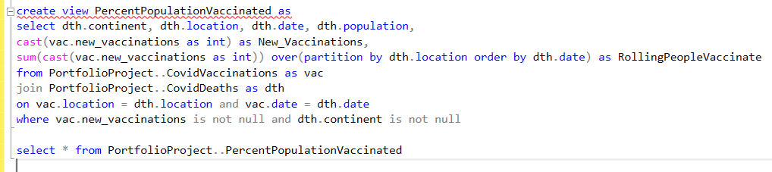

Where

In – in other group of records
where rn.customer_id in (select * from cte)

Not in
SELECT name, ce.ssn, cert_num, cert_start, cert_finish
FROM certs ce JOIN customers c ON ce.ssn = c.ssn
WHERE cert_finish - current_date <= 14 AND cert_finish > current_date AND
ce.ssn NOT IN (SELECT ssn FROM certs WHERE cert_finish - current_date > 14)
ORDER BY name, ce.ssn, cert_num ASC

With aggregate function
It is forbidden to apply aggregate functions
Select * from table
Where birth_date > min(birth_date)
The subquery is the solution
select min(birth_date)
from employees
where team = 'backend' and birth_date > (
select min(birth_date)
from employees
where team = 'backend')

With CTE
with dupa as(
select loans.book_id, count(loans.book_id) as sumka, books.title
from loans
join books
on loans.book_id = books.book_id
where return_date is not null
group by loans.book_id, books.title)

select loans.book_id, dupa.title
from dupa
join loans
on loans.book_id = dupa.book_id
group by loans.book_id, dupa.title, dupa.sumka
having dupa.sumka = count(loans.book_id)
order by book_id desc

Multi cte
with cte as (
select student_id, count(*) over (partition by student_id) as s_count from marks as mk
join (select distinct subject_id, max(mark_rate) as m_score
from marks
group by subject_id) as ts
on mk.subject_id = ts.subject_id and mk.mark_rate = ts.m_score
),
cte2 as (
select mk.student_id, st.student_name, count(mk.student_id) as s2_count from marks as mk
join students as st
on mk.student_id = st.student_id
group by mk.student_id, st.student_name
)

Xml

Multi rectords manipulation
Data:
<user><email_addresses><address><address>…
We can have more than one address:
WHEN array_length(xpath('/user/email_addresses/*[1]/text()', data2), 1) is null THEN 'None'
else unnest(xpath('/user/email_addresses/*[1]/text()', data2))::text

WHEN not xpath_exists('/user/email_addresses/address', data) THEN 'None'
ELSE (xpath('/user/email_addresses/address/text()', data))[1]

Xmltable
<data><user><>first_name<> and so on
select first_name,last_name,extract(year from age(date_of_birth))::int as age,
case when private then 'Hidden' else coalesce(email,'None') end email_address
from users,xmltable('/data/user' passing data columns
first_name text,last_name text,date_of_birth date,private boolean,email text path 'email_addresses/address[1]') x
order by first_name,last_name;

SELECT
first_name,
last_name,
DATE_PART('year', AGE(date_of_birth))::integer as age,
CASE
WHEN private = true THEN 'Hidden'
WHEN email IS NULL THEN 'None'
ELSE email
END as email_address
FROM users x,
XMLTABLE('/data/user'
PASSING x.data
COLUMNS
first_name VARCHAR(50) PATH 'first_name',
last_name VARCHAR(50) PATH 'last_name',
date_of_birth DATE PATH 'date_of_birth',
private BOOLEAN PATH 'private',
email TEXT PATH 'email_addresses/address[1]'
) xt
order by first_name, last_name;

Xpath
--structure—
<data><user><>first_name<> and so on
with cte as(
select unnest(xpath('data/user/first_name/text()', data))::varchar as first_name,
unnest(xpath('data/user/last_name/text()', data))::varchar as last_name,
unnest(xpath('data/user/date_of_birth/text()', data)) as age,
regexp_replace(
xpath('email_addresses/address/text()', unnest(xpath('data/user/email_addresses', data)))::varchar,
'(\{|}|,.*)', '', 'g') as email_address,
(unnest(xpath('data/user/private/text()', data))::varchar)::boolean as access
FROM users)

select first_name, last_name,
extract('year' from age(current_date::date, (age::varchar)::date)) as age,
case
when access is true then 'Hidden'
when email_address = '' then 'None'
else email_address
end as email_address
from cte
order by 1,2

