Git install

1.Go to <https://gitforwindows.org/>

2.Click download



3.Install git – make sure to pick proper branch name

4.Open 3rd part access

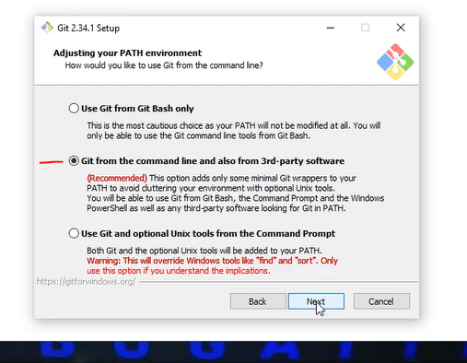

5.Create git remote account and token in git remote account

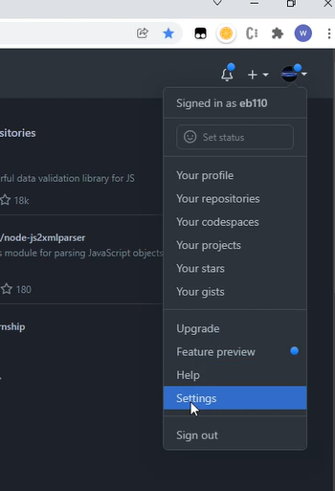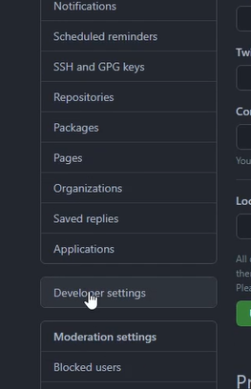

6.Store git user name, user email, user token.

7.Establish proper path in the IntelliJ terminal

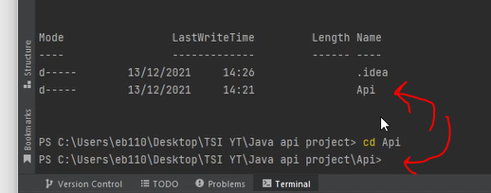

Type command ls to make sure the pom file will be displayed

8.Initialize the git version control within the project

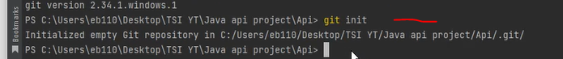

9.Execute security credentials git commands





