1.Pom update

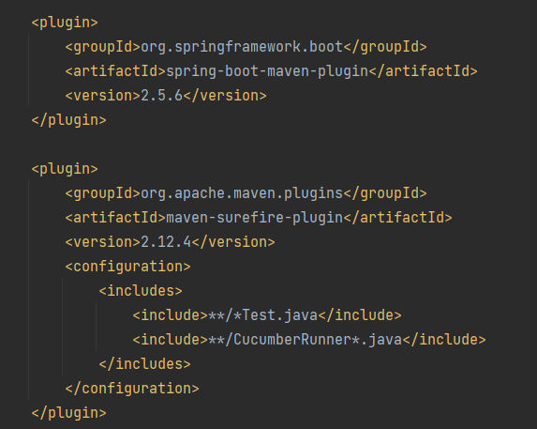

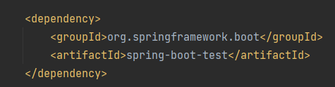

2.Create car class

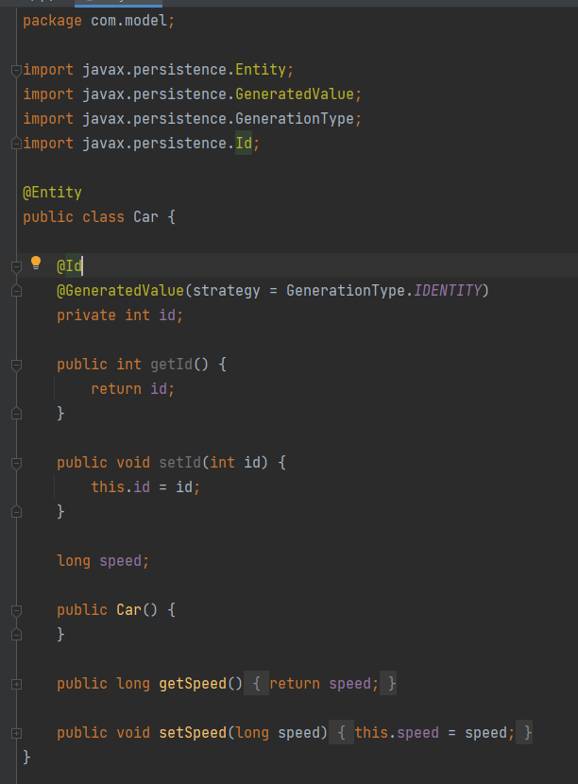

3.Create packages and folders as follow:

4.Context class

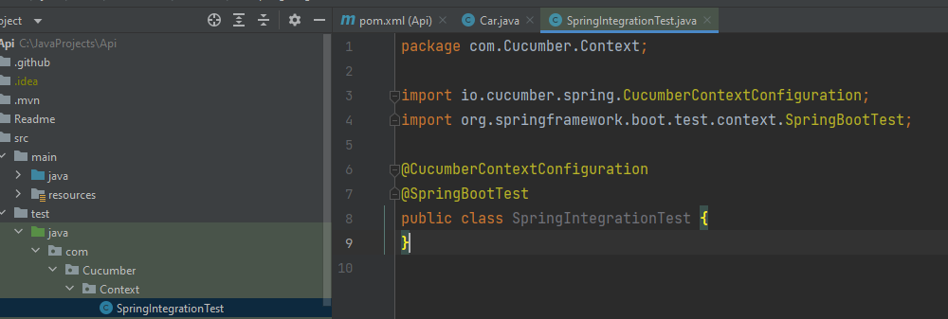

5.Features

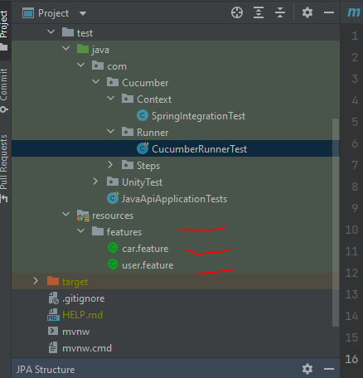

6.Runner class

7.Plugins

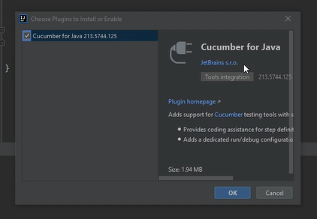

8.Run test and copy paste missing methods – attach them to the proper steps classes

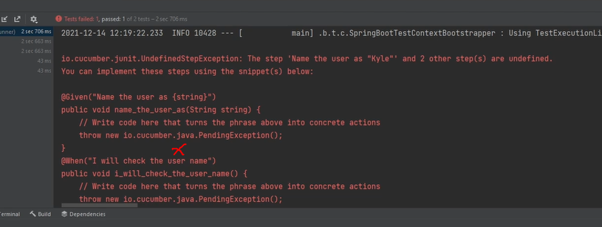

9.Type mvn clean test

10.Push changes and check coverage at sonar cloud

