Sequential model

In keras we can build model in two ways, one is Sequential API and other is Functional API. Here we will try understand Sequential API.

In Sequential API we can build a model by adding layers to it one by one. By adding layers we can make a stack of layers which will be interconnected and can be used.

We can make a sequential model by using the sequential module from the keras library. In which we can pass two arguments(args).

* layers : In this we can pass the optional list of layers that we want in the model
* name : In this we can give a name to the sequential model

Dropout can be implemented by randomly selecting any nodes to be dropped with a given probability (50% or 0.5) each weight update cycle.

**Splitting the data**

The train-test split is a technique for evaluating the performance of a machine learning algorithm.

It can be used for classification or regression problems and can be used for any supervised learning algorithm.

The procedure involves taking a dataset and dividing it into two subsets. The first subset is used to fit the model and is referred to as the training dataset. The second subset is not used to train the model; instead, the input element of the dataset is provided to the model, then predictions are made and compared to the expected values. This second dataset is referred to as the test dataset.

There is no general rule regarding the choice of the size of test and train size.so we tried using different test and train size.

Using 80 for train and 20 for test we got the following confusion matrix

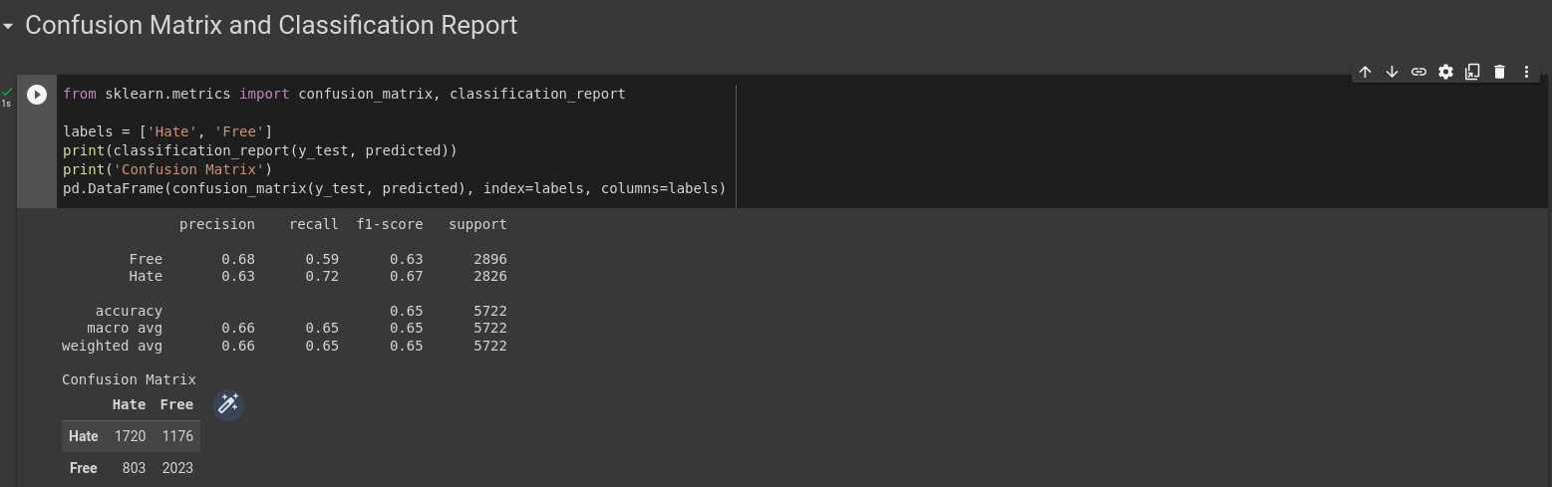Using 90 %for train and 10% for test we got the following confusion matrix result

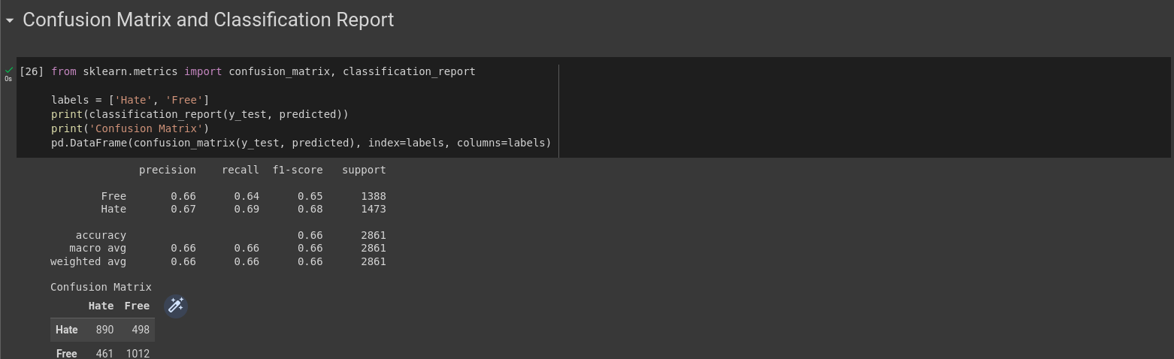 Which clearly shows the 90% for train and 10% for test has higher f1 value