Project Khermit

A music quiz game on Facebook

Development timeframe

Competitors

Ideas

Music data APIs, besides Decibel

Wireframes

Facebook promotion page

Play now

Login

Create your own quiz - Step 1

Create your own quiz - Step 2a: Mix tape, search

Create your own quiz - Step 3a: Mix tape, info

Create your own quiz - Step 4a: Mix tape, sharing

## Development timeframe

* 120 hours
* Used so far: **10 hours**
* Expected first release: 15th October 2014.

## Competitors

* <http://quizified.com>

## Ideas

Rewards: when solving a quiz question, get a link to the relevant youtube video or spotify music.

Monetization:

1. Affiliate link to iTunes to let gamers purchase music and/or video.
2. In-game currency to reveal a quiz answer. The in-game currency can be either earned by various activities or by paying with real cash. Ways to earn in-game currency for free:
   1. Sign up
   2. Login
   3. Answer a quiz question correctly
   4. Complete a whole quiz (correct or not)
   5. Answer all questions in a quiz correctly
   6. Share a quiz score
   7. Share the game
   8. Invite a Facebook friend else to play
   9. Invite a friend to play by entering his/her e-mail
3. That in-game currency can also be lost or spent:
   1. Answering a quiz question incorrectly
   2. Give up and reveal a quiz question answer

Marketing: Benefits of making a quiz for the gamer

1. Share your musical taste with friends to initiate a chat about your favourite music.
2. Create a “best of genre” quiz to challenge your friends..
3. Make a mix tape quiz to send to someone special.
4. Let fan clubs easily publish a quiz on their facebook page to foster interest from their members.

Integration with Spotify: <https://developer.spotify.com/web-api/authorization-guide/>

## Music data APIs, besides Decibel

Echonest

<http://developer.echonest.com/docs/v4>

Musix Match (lyrics)

<https://developer.musixmatch.com/>

Music brainz (not sure it’s a RESTful API I can use with Ajax)

<http://musicbrainz.org/>

## 

## 

## Wireframes

### Facebook promotion page

The Facebook promotion page is generated via the settings of the app and Facebook itself.

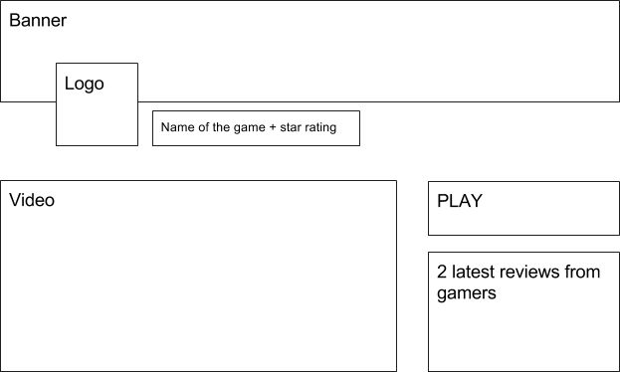

Play lists the permissions required by the game.

The logo is the graphical continuation of the banner. They merge into each other.

The video is a fun tutorial on how to answer a quiz, then how to make a quiz. Highlight the benefits of making a quiz (see marketing: benefits).

### 

### 

### Play now

This is the default homepage. If the gamer is not logged in via Facebook, redirect him to the login page.

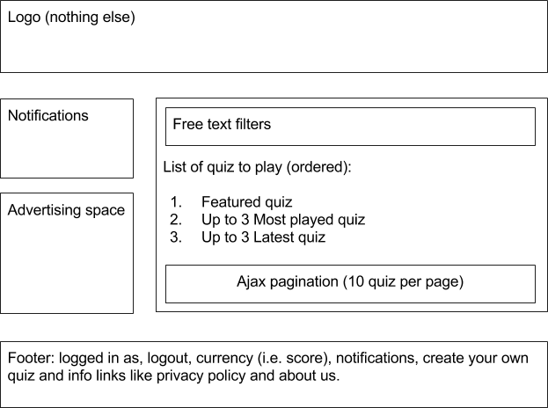

### Login

The login screen only lets Facebook account holders in. Logging in for the first time is the equivalent of creating an account. No password is ever asked.

Should the gamer start from inside the Facebook promotion page, the login / signup will be done automatically. The default page is never the login page, it’s the “Play now” page instead.

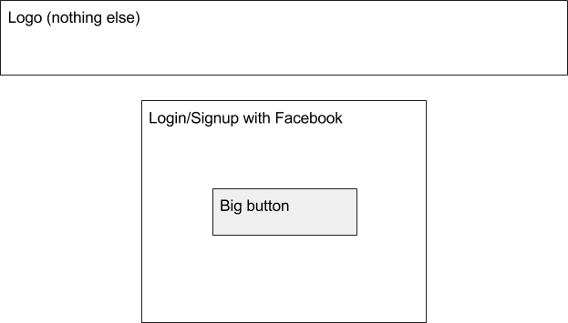

There is no footer on the login page.

### 

### 

### Create your own quiz - Step 1

Every time a quiz is completed, the gamer is asked if he wants to create his own quiz and challenge his friends. This is the screen where the gamer starts creating a quiz by first selecting the quiz type.

It’s also possible to reach this screen from a small link in the footer.

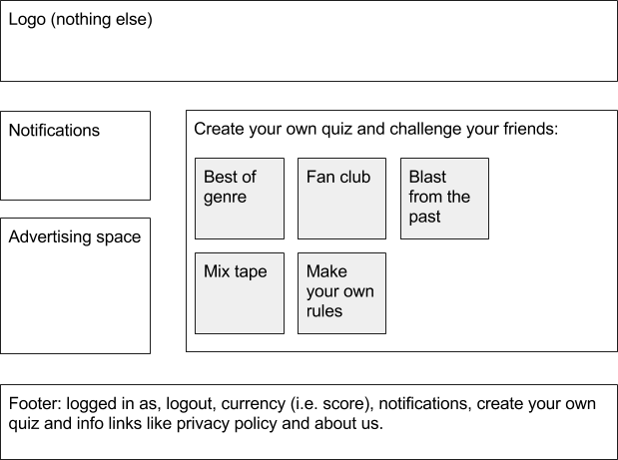

### 

### 

### Create your own quiz - Step 2a: Mix tape, search

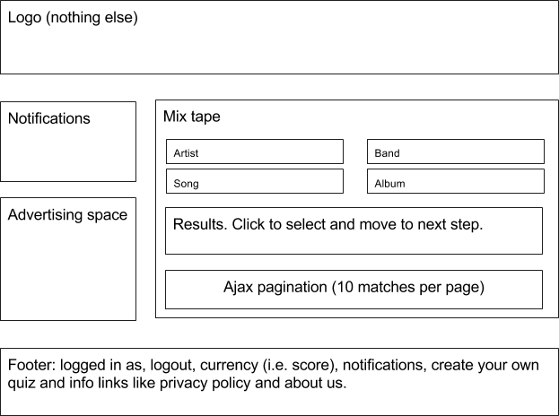

### 

### 

### Create your own quiz - Step 3a: Mix tape, info

This screen should give the gamer enough information to write a question and a list of answers, of which at least one is correct.

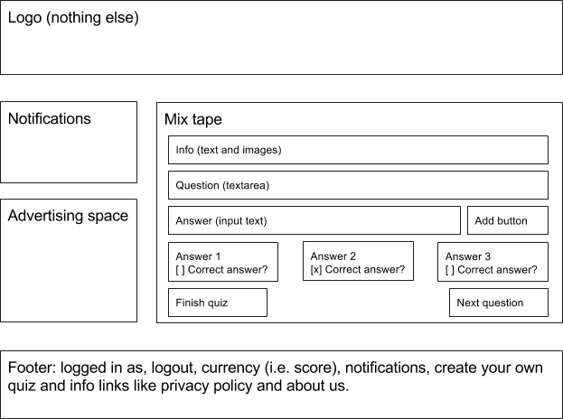

### 

### 

### Create your own quiz - Step 4a: Mix tape, sharing

On this final step, the gamer who just clicked on Finish quiz can share it with Facebook friends or send it by e-mail.

Sharing with friends on Facebook will probably cause a permission popup to ask if the app can access the full list of friends of that gamer, and not just the friends that also play the game from the authorization step.

