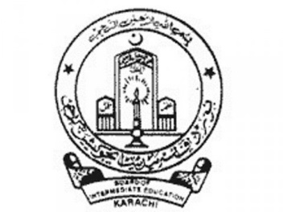

**Board of intermediate education Karachi**