**Cyber-Physical Systems architecture**

**1. Introduction to Cyber-Physical Systems**

**Definition and Concept**

Cyber-Physical Systems (CPS) integrate physical processes with computational algorithms and networks. They enable real-time monitoring, control, and automation of physical systems through connected sensors and actuators.

**Importance and Relevance**

CPS revolutionizes industries by enhancing efficiency, safety, and decision-making through interconnected systems. It bridges the gap between digital technologies and physical infrastructures, transforming traditional systems into smart and adaptive environments.

**2. Components of CPS Architecture**

**Physical Components**

* **Sensors and Actuators**: Devices that monitor physical parameters and initiate actions based on data received.
* **Embedded Systems**: Hardware components that integrate with physical devices to collect and transmit data.

**Cyber Components**

* **IoT Devices**: Networked devices that connect physical objects to the internet, enabling data exchange and remote control.
* **Cloud Computing**: Provides storage, processing power, and scalability for CPS applications.
* **Edge Computing**: Distributes computational capabilities closer to the data source, reducing latency and enhancing real-time processing.

**Interface and Integration**

CPS architecture facilitates seamless interaction between physical and cyber components through standardized interfaces and protocols. This ensures efficient data exchange and synchronization across distributed systems.

**3. Key Technologies and Protocols**

**IoT Devices and Sensors**

* **Types of Sensors**: Motion sensors, temperature sensors, pressure sensors, etc., tailored to specific monitoring needs.
* **Wireless Connectivity**: Utilizes protocols like Zigbee, Bluetooth, and Wi-Fi for data transmission between devices and networks.

**Communication Protocols**

* **MQTT (Message Queuing Telemetry Transport)**: Lightweight protocol for IoT applications, ensuring efficient and reliable data exchange.
* **CoAP (Constrained Application Protocol)**: Designed for resource-constrained devices in low-power and lossy networks.

**Edge Computing and Cloud Integration**

* **Edge Devices**: Local processing units that analyze data near the data source, reducing latency and bandwidth usage.
* **Cloud Services**: Centralized storage and computing resources for data aggregation, analytics, and long-term storage.

**4. Design Principles and Framework**

**Layered Architecture**

* **Physical Layer**: Includes sensors and actuators interacting with the physical environment.
* **Communication Layer**: Facilitates data exchange between devices, networks, and cloud services.
* **Application Layer**: Implements control algorithms, decision-making processes, and user interfaces.

**Real-Time Processing**

* CPS requires real-time data processing to respond promptly to dynamic changes in the physical environment, ensuring timely control actions and system stability.

**Security and Privacy Considerations**

* **Data Encryption**: Ensures secure transmission and storage of sensitive information.
* **Access Control**: Restricts unauthorized access to devices and data, mitigating cyber threats and privacy breaches.

**5. Applications and Use Cases**

**Smart Grids and Energy Management**

* Optimizes energy distribution, consumption, and renewable integration through smart metering and predictive analytics.

**Healthcare Monitoring Systems**

* Enhances patient care with remote monitoring devices, real-time health data analysis, and automated alert systems.

**Autonomous Vehicles**

* Enables autonomous navigation, collision avoidance, and vehicle-to-infrastructure communication for safer and efficient transportation.

**Industrial Automation**

* Streamlines manufacturing processes with predictive maintenance, robotic control, and supply chain optimization.

**6. Challenges and Future Directions**

**Scalability and Interoperability**

* Addressing the complexity of integrating diverse devices, protocols, and systems to support scalable CPS deployments.

**Security Concerns**

* Mitigating risks associated with cyber-attacks, data breaches, and unauthorized access in interconnected CPS environments.

**Emerging Trends**

* Integration of Artificial Intelligence (AI) for advanced analytics, autonomous decision-making, and adaptive control in CPS applications.

**7. Conclusion**

**Summary of CPS Benefits**

* CPS architecture revolutionizes industries by enhancing operational efficiency, safety, and sustainability through intelligent automation and real-time data insights.

**Future Outlook**

* As CPS continues to evolve, advancements in technology and adoption will drive innovations in smart cities, healthcare, transportation, and beyond.

**Components of CPS Architecture in the Smart Home Example:**

**1. Sensors and Actuators**

* **Example**:
  + **Motion Sensor (MotionSensor)**: Simulates detecting movement within the home environment.
  + **Thermostat (Thermostat)**: Adjusts room temperature based on predefined settings.
  + **Security Camera (SecurityCamera)**: Monitors specific areas for visual surveillance.
  + **Smart Lighting (SmartLighting)**: Controls illumination based on detected motion or user commands.
  + **Voice Assistant (VoiceAssistant)**: Activates or deactivates based on voice commands.

**2. IoT Devices and Communication Protocols**

* **Example**:
  + **Usage**: Sensors and actuators communicate their data and receive commands using simulated protocols or direct method calls (turn_on, turn_off).
  + **Integration**: Demonstrates how these devices can be interconnected and controlled via centralized logic (SmartHomeSimulation).

**3. Edge Computing and Cloud Integration**

* **Example**:
  + **Local Processing**: Each device (MotionSensor, Thermostat) processes data locally to simulate real-time responses.
  + **Cloud Interaction**: Interaction patterns mimic cloud-based analytics or storage for long-term data logging (plot_device_states function for visualization).

**4. Security and Privacy Considerations**

* **Example**:
  + **Data Handling**: Simulates secure communication (get_status methods) and discrete actions (turn_on, turn_off) to ensure privacy and prevent unauthorized access.

**5. Applications and Use Cases**

* **Example**:
  + **Smart Home Functionality**: Showcases how CPS principles optimize daily routines (security monitoring, energy efficiency with the Thermostat, and enhanced convenience with the VoiceAssistant).

**Integration of CPS Concepts in the Smart Home Example:**

* **Real-Time Monitoring**: The simulation (simulate method) illustrates how sensors (MotionSensor) detect events (detect_motion) and trigger corresponding actions (turn_on Security Camera, turn_on Smart Lighting).
* **Automation and Control**: The SmartHomeSimulation class serves as the central control unit, orchestrating interactions between simulated devices (SecurityCamera, MotionSensor) and responding to events based on predefined logic.
* **Data Visualization**: Utilizes matplotlib to visualize the state of devices (plot_device_states), akin to how CPS applications might display real-time data for monitoring and decision-making.

**Conclusion:**

The coded example of a smart home simulation effectively demonstrates key aspects of CPS architecture:

* Integration of physical and cyber components (MotionSensor, SecurityCamera).
* Real-time data processing and control (Thermostat, SmartLighting).
* Secure communication and interaction patterns (VoiceAssistant).

This alignment showcases how CPS principles can be applied practically in a smart home context, enhancing efficiency, security, and user experience through interconnected and automated systems.

**CODESOURCE PUSH**

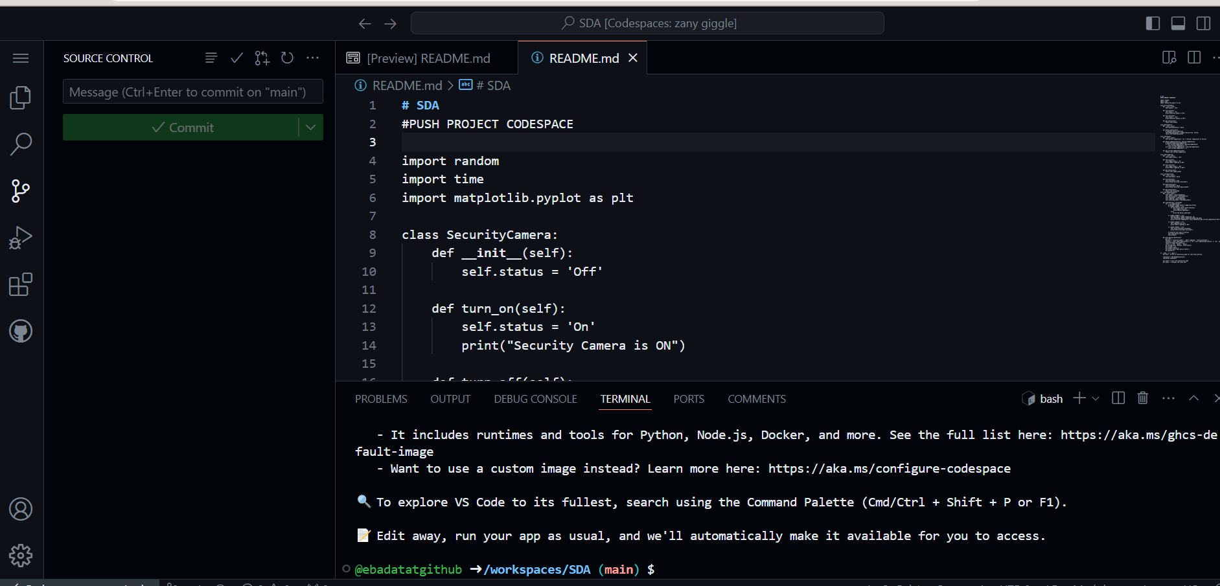

**PUSH AND COMMIT**

