CarShare

Module: GUI Development

Date: 4/10/2015

Students: Jahan Zeb Khan [20056714] & Ebadullah Gul [20058639]

Contents

Introduction 1

Data Model 1

User Interface 2

Login 2

Signup 2

MainActivity 3

• Set Destination 3

• Settings 3

• Saved Destination 3

4

Available Lifts (RdieList) 4

User Details 5

Design Pattern 5

Extra Features 5

Technologies used 5

Conclusion 5

# Introduction

CarShare mobile application allows its users to share their car with other people who are travelling to the same destination and are located nearby. There are two types of users one who is driving a car and the other who is looking for a lift. Once the application is installed in a device, the application allows the user to register by providing their basic details. At the registration stage user is required to provide their name and contact number and create a username and password. Once registered and signed in the application detects user’s current location through devices location services and user is allowed to choose their desired destination by touching on a map which leaves a marker on that location being touched. The marker can be dragged if the location being touched is not precise. A destination can be saved for later use. Once the user’s current location and destination has been determined they can search for other users. A list of user’s is displayed which is compiled based on the user’s current location, their chosen destination and whether they are driving or not. User can call or send an SMS directly from the app to any other user who is displayed in the list.

# Data Model

The application stores user’s basic information on a remote server. This information includes user’s full name, a unique username, password, contact number, current location, destination, a true/false value for car status, a profile picture and a value for search radius. All this data is stored as one user object in a cloud service (parse.com). Following is the user table description as stored in Parse.com.

|  |  |
| --- | --- |
| Field name | Data type |
| ObjectId | String (unique) |
| username | String (unique) |
| password | String |
| name | String |
| location | GeoPoint |
| destination | GeoPoint |
| hasCar | boolean |
| phone | String |
| photo | File |
| radius | String |

Figure 1 below shows a class diagram of some significant classes used in the app.

Figure Class diagram

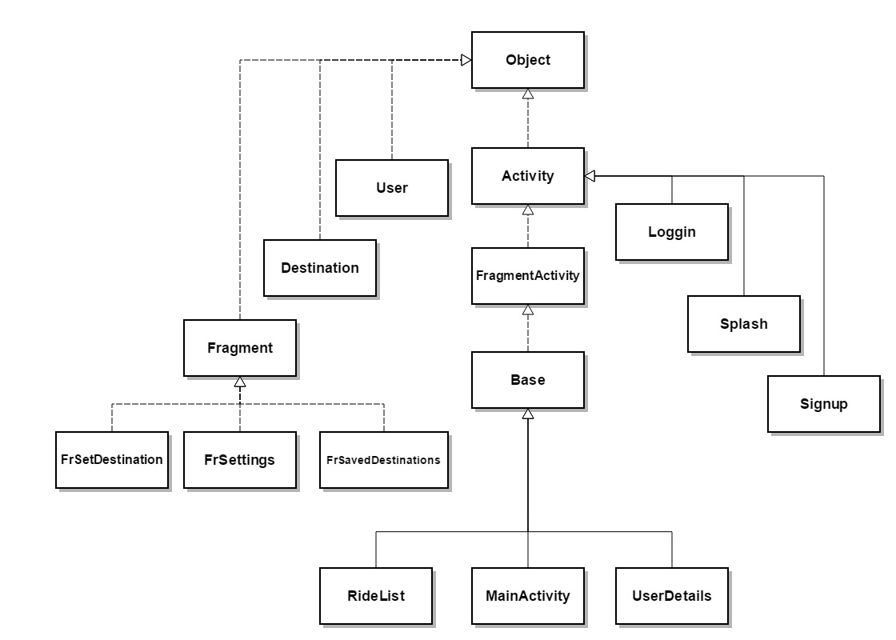

# User Interface

User Interface of the application consists of a number of activities and fragments. The following is a brief description of each screen/activity.

## Login

When the app is launched, login screen is presented to the user following the splash screen, if the user is not already registered and logged in. From this screen user has the option to login using their username and password or they can go to the Signup screen by clicking the “Signup” button shown on this screen to register. Figure 2.1 shows a screenshot of the login screen.

## Signup

Signup screen [figure 2.2] includes a registration form which allows the user to create a username and password and requires them to enter their name and contact number which are necessary fields. When ‘signup’ button is clicked username field is checked against the database to verify its uniqueness. If the username is not unique, the sign up process is aborted and user is prompted with appropriate message. Otherwise details entered by the user are instantly stored on the remote server and user is directed to the main screen [Figure 2.3].

Figure .1 Login screen

## MainActivity

MainActivity consists of three fragments which are presented in the form of tabs for easy use. User can navigate between these tabs by swiping across the screen or clicking on the tab heading. These tabs are listed below.

### Set Destination

Set destination tab [figure 2.3] is the first screen presented to the user after logging in. This screen allows the user to choose a destination by clicking on the map. User’s current location is automatically detected when this activity starts. In case the device’s location services are turned off user is prompted with a message [figure 2.4] which allows the user to go to device’s settings and turn on the location services. Once the location services are turned on and user’s current location is detected and the destination has been sit up by the user, the user can click the ‘GO’ button which will display a list of other users who are currently located nearby and their destination is close to the current user’s destination. Alternatively user can save the selected destination for future use by clicking the “Save Destination” button.

Figure 2.2 Signup screen

### Settings

Settings is the second tab [figure 2.5] in the MainActivity. This tab gives users options to:

* + - Choose and upload a profile picture from their device gallery.
    - Edit their name.
    - Edit their contact number.
    - Set search radius.

Figure 2.3 Set Destination tab

* + - Turn on or off if they are driving or not.

### Saved Destination

This tab displays a list of saved destinations [figure 2.6] each list item is clickable and when clicked, it shows list of users who are going to the same destination based of this destination. User also has the option to delete these destinations.

### 

Figure 2.4 GPS message

Figure 2.6 Saved destinations tab

Figure 2.5 Settings tab

## Available Lifts (RdieList)

This screen [figure 2.7] displays a list of users which match the current user’s destination, location and their driving status (if current user is driving all non-driving users are displayed and vice versa). User has an option to call or send an SMS to any of the users displayed in the list by just one click. Or more details of any of these users can be viewed by clicking on the appropriate row/user which redirects the user to the clicked to the **User Details**.

Figure 2.8

Figure 2.7 Available Lifts

## User Details

User Details screen [figure 2.8] shows extra details of any user displayed in the list of available lifts. This screen includes:

* A map showing a marker on the user’s current location.
* The available lift’s destinations.
* Address of user’s destination (reverse geo coding).
* User’s contact number and a button to call directly.
* And distance from current user in meters.

# Design Pattern

Modal View Controller Design pattern is used in the app development. The following diagram show the MVC. The MVC represents how the classes are lay out. The Modal is the data where the data is stored, retrieved and updated. Controller controls how the view operates and how data is added, changed and removed from the database. The View the screen which what the user interacts with.

# Extra Features

Following is a list of extra features which are included in the second version.

1. Login and signup
2. Remote database (Parse.com)
3. Tabbed layout (Fragments)
4. Settings screen allowing users to edit their details and add a profile picture.
5. Option to change search radius.
6. Make call to other users directly from the app.
7. Send SMS directly from the app.
8. GPS check on app launch, if location services are turned off a message window is displayed which allows user to go to device’s location setting by clicking a button.

# Technologies used

Java, Android xml, Google Maps API, Parse API, Photoshop, eclipse IDE

# Conclusion

This was a great learning experience working in a group.