TAOS Configuration File Generation Tool

Gambro BCT, Inc.

Revision: 1.0 (28-Jun-2004)

This document is the sole property of Gambro BCT, Inc. and is considered proprietary and confidential.

Copyright © 2004 by Gambro BCT, Inc. All rights reserved.
Change History
Date | Author | Description
28-Jun-2004 | J. Lindner | Original version

Table of Contents

1. Overview 4
2. Configuration File Format 5
2.1 Header Section 6
2.2 Data Section 6
3. Usage 7
3.1 Command Line 7
3.2 Data Structures 8
3.3 Support Classes 9

Overview

The TAOS system uses a common format for all files containing run-time configuration information. Each data file is related to a particular aspect of the system (e.g. hardware configuration). Within each file are one or more sections, each containing one or more parameter settings. Sections are specified using the format “[section-name]”. Parameters are specified using the format “parameter=value”.

The TAOS configuration file generation tool provides a method for automatically generating data structures and access classes for reading and writing these files, as well as accessing the parameter data within the files. The tool also generates default data files for installation on a TAOS system. Using this tool eliminates the need for the developer to update multiple source and data files when modifying a configuration. Instead, only a single “.cfg” file is modified, and the tool is used to automatically generate all of the related files. Figure 1 shows how the tool is used during the build process. Table 1 describes the files referenced in this figure.

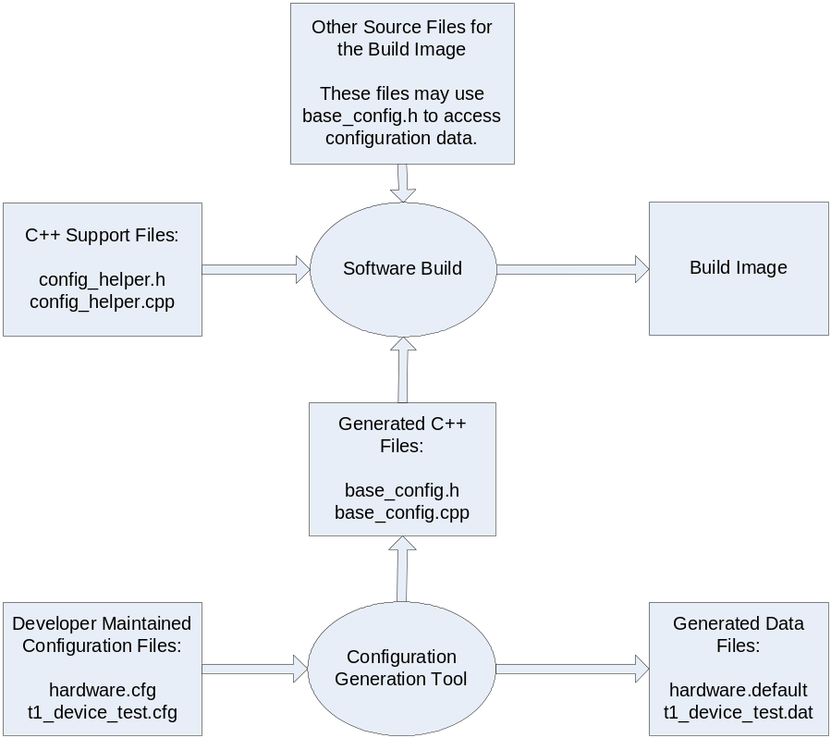
Figure 1 - Flow Path of Build Process

Table 1 - Description of Files Used During Configuration Generation
Element | Description
Developer maintained configuration files | Theses files describe the contents of each of the configuration data files, including the sections and parameters present in the files, the type of each parameter (e.g. string, double), installed file location on the TAOS system (e.g. “/config/base/hardware.dat”), and overall properties of the file (e.g. read-only, read-write). The generation tool requires one or more “.cfg” files as input, and combines the information from the files into a single access class.
C++ support files | These files contain support routines required by the generated C++ files which are not dependent on the “.cfg” file contents.
Generated C++ files | These files define and implement (along with the C++ support files) an interface to the configuration data. This interface is defined within a single access class, which combines the interface for all of the “.cfg” files specified as input to the configuration generation tool. The name of this class (and the names of the associated files) is specified as a command line option to the tool.
Generated data files | These files contain the default parameter values, as specified in the corresponding “.cfg” files. For files which may not be changed after initial installation, “.dat” files are generated. These files are installed with the TAOS software. For files which support update after installation (for example files which may be used to customize a particular machine), “.default” files are generated with default values, to be used at initial install or to return a machine to the default configuration.

Configuration File Format

Each configuration (“.cfg”) file is a list of option settings, section names, parameters, and comments. Option settings are enclosed within the strings “@{” and “@}”, and are used to specify settings required by the configuration generation tool. Section names are enclosed in square brackets “[“ and “]”. Parameters are specified as “parameter_name=value”. Comments start with the ‘#’ character, and continue to the end of the current line. Comments may appear anywhere within the “.cfg” file except within a string constant or within an option setting.

A configuration file comprises two sections: a header section describing the file, and a data section listing each of the parameters.

Header Section
The header section consists of a group of option settings, and is used to specify options applying to the file as a whole rather than a particular parameter within the file. Table 2 lists the options available. The “class-name” and “file-name” options must be specified for each configuration file.

Table 2 - Description of Header Options
Option | Description
@{class-name name@} | Set the class name to be used for this file in the generated code. name must be a valid C++ identifier.
@{default-file-name “name”@} | Set the file name to be used for the default data on the TAOS platform. This option is only useful for files on the “/config” partition, and specifies the location for a “.default” file on TAOS to be used in the primary and backup file in “/config” are not available. If this option is not specified for files on the “/config” partition, no associated data file is generated by the tool when the data_file_dir option is specified.
@{enum parameter-name enum-list@} | Defines an enumeration type for the specified parameter.
@{file-name “name”@} | Set the file name to be used for this data on the TAOS platform. name must specify the absolute path for the file, and must be on the “/taos” or “/config” partition. Files on the “/taos” partition are assumed to be included in the CRC for the installed software. Files on the “/config” partition are assumed to have individual CRC protection, and code will be generated to handle the CRC and backup files associated with them.
@{include include-reference@} | Causes an include file to be specified in the generated header file as “#include include-reference”.
@{read-write@} | Causes the code generator to define “set” functions for each parameter in the file, allowing the parameters to be changed at run-time.

Data Section
The data section consists of a group of section names and parameter specifications. It is an error to have specify an empty section (a section with no parameters), or to have parameters before the first section name.

Parameters can be one of five types: string, integer, floating point, boolean, or enumerated. String values are specified as “string”, where string can include any character other than a newline. To include the ‘”’ character in a string, precede it with a backslash. String values are internally represented as the type “const char *”.

Integer values are specified as a sequence of the digits. By default, they are assumed to be in decimal. If the value starts with “0x” or “0b”, they are assumed to be hexadecimal or binary respectively. Integer values are internally represented as the type “long”.

Floating point values are specified as in C++. Floating point values must include either a decimal point or an exponent specification (otherwise they are treated as integer values). Floating point values are internally represented as the type “double”.

Boolean values are specified as either true or false, and are not case sensitive. Boolean values are internally represented as the type “bool”.

Enumerated types are specified as described in Section 2.1. If a parameter name matches a specified enumeration type, the value for the parameter must be one of those specified in the associated enumeration list. Enumerated types are internally represented as the type “enum Tname” (i.e. the type name for the enum is the parameter name with the letter ‘T’ inserted at the beginning).

Each parameter can be followed by a group of option settings. Table 3 lists the available options.

Table 3 - Description of Parameter Options
Option | Description
@{range min max@} | Cause the code generator to define a parameter range function of the form bool range(type & min, type & max). The function sets min and max as specified and returns true. The “range” option is supported only for integer and floating point types.
@{range-func function@} | Causes the code generator to define a parameter range function of the form bool range(type & min, type & max), with function included literally in the body, and type determined by the parameter type. The function must set min and max, and return true if the range is specified, or false to indicate range checking is disabled and that min and max have not been set. The “range-func” option is supported only for integer and floating point types. This option is normally used only where the valid range for a parameter is dependent on other machine settings or conditions. For constant ranges, the “range” option should be used instead.
@{validate function@} | Causes the code generator to define a parameter validation function of the form bool validate(type value), with function included literally in the body, and type determined by the parameter type. The function should return true if the value is valid for the associated parameter, and false otherwise.

If specified, the range and validate functions are automatically used any time a value is assigned to the parameter (including when initially reading settings from a data file). The assignment will not be performed if the validate function returns false, or if the value is not within the allowed range.

Usage

Command Line
The configuration tool command line for code generation is of the form:

config_parse –output output_name [–output_dir output_dir_name]
[[-input_dir input_dir_name] file_list] ...

The configuration tool command line for data file generation is of the form:

config_parse –output name
[–data_file_dir data_file_dir_name]
[–output_dir output_dir_name]
[[-input_dir input_dir_name] file_list] ...

The “-output” option specifies both the output file name and the associated class name. For example, “-output BaseConfig” would cause the tool to generate code defining the class “BaseConfig” in the files “base_config.h” and “base_config.cpp”. The “-output” option must be specified

The “-data_file_dir” option is optional. If present, it specifies the directory for the generated data files. Otherwise, data files are not generated.

The “-output_dir” option is optional. If present, it specifies the directory for the generated source files. Otherwise, source files are generated in the current directory.

The “-input_dir” option is optional, and may be specified multiple times. If used, it specifies the directory to be used for accessing the files listed following the option on the command line. By default, the current directory is used.

The “.cfg” files to be processed are listed on the command line (without the “.cfg” extension). At least one file must be specified.

Data Structures
The configuration tool generates a data structure for each “.cfg” file within the output class. This structure is declared within the single class output_name (as specified on the command line) and is of the form:

class output_name
{
public:
struct class_name_Data
{
struct section_1_name
{
parameter_1_type parameter_1_name;
parameter_2_type parameter_2_name;
...
};
...
}
};

The configuration tool also generates a single static instance of each structure within the class output_name. This structure is accessed for read operations through a static member function class_name.

class output_name
{
private:
class_name_Data _class_name_Data;

public:
const class_name_Data & class_name(void) { return _class_name_Data; }
};

Enumeration types, if needed for any of the parameters, are also declared as public within the class output_name (note that this implies that all enumeration types defined for the set of “.cfg” files must be unique).

While software can declare separate instances of the data structures, the static instance of the data structure should be used for the current configuration settings on the machine.

Support Classes
The configuration tool also generates a support class for each “.cfg” file. This support class includes methods for reading data files and accessing information about the parameters. For files on the “/config” partition, this support class also supports writing data files. For “.cfg” files with the “read-write” option, a “set” method is also defined for each parameter to change the parameter value. The general format for the support classes is shown in the following.

class output_name
{
private:
class _C_class_name : public ConfigFile
{
class _C_section_1_name
{
class _C_parameter_1_name
{
public:
static const char * name(void);
static bool getRange(parameter_1_type & min, parameter_1_type & max);
static bool validate(void * valuePtr);
bool set(parameter_1_type & value);
};
...

public:
static const char * name(void);
_C_parameter_1_name parameter_1_name;
...
};

public:
_C_class_name(class_name_Data & data);
const char * name(void);

bool getParamValueByName(const char *sectionName,
const char * paramName, ParamValue & value);

const char * getParamNameByRef(void *value);
const char * getSectionNameByRef(void *value);

ReadStatus readFile(DataLog_Level *logLevel, DataLog_Level *errorLevel);
WriteStatus writeFile(DataLog_Level *logLevel,
DataLog_Level *errorLevel);
}
};

Table 4 - Description of Support Functions
Function | Description
const char * name(void) | Returns the ASCII name of the associated object (the class name for a file, the section name for a section, or the parameter name for a parameter).
bool getRange(type & min, type & max) | Generated for parameters with either the range or range-func option specified to allow access to the associated range values. See Section 2.2 for details.
bool validate(void * valuePtr) | Generated for parameters with the validate option specified. See Section 2.2 for details.
bool getParamValueByName | Allows retrieving the parameter value by specifying the parameter name and section name. The code generator does not produce particularly efficient code for this function, so this function should not be used as a substitute for access through the associated data structure as described in Section 3.2.
const char * getParamNameByRef | Allows retrieving a parameter name by specifying a pointer to the associated data member. This is primarily intended for error message logging.
const char * getSectionNameByRef | Allows retrieving the section name of a parameter by specifying a pointer to the associated data member. This is primarily intended for error message logging.
ReadStatus readFile | Read configuration data from the associated data file.
WriteStatus writeFile | Write configuration data to the associated data file. This method is generated only for files on the “/config” partition.

