SOFTWARE DESIGN SPECIFICATION (SDS)
for

Message System

Prepared For
Gambro BCT R&D

Date May 30, 2002
Software Rev 1.0

Gambro BCT, Inc.
Blood Component Technology

This document is the sole property of Gambro BCT, Inc. and is considered proprietary and confidential.
Copyright © 1996-2002 by Gambro BCT, Inc. All rights reserved.

Change History
Date | Description of Change | Reason for Change
May 30, 2002 | Initial Revision
Table of Contents

1. Scope 5
1.1 Identification 5
1.2 System Overview 5
1.3 Document Overview 5
1.4 Requirements Traceability 5
2. Referenced Documents 6
2.1 Message System Requirements Specification, rev 3.0. 6
3. Definitions 7
3.1 Acronyms and Abbreviations 7
4. Design Overview 8
4.1 MessageFlow 8
4.2 Task Requirements 9
4.3 System Requirements 9
5. External Interface 10
5.1 System overrides 10
5.1.1 Network nodes 10
5.1.2 Non-recoverable Errors 10
5.2 Initialization/Creation 10
5.2.1 Router 11
5.2.2 Gateway 11
5.2.3 MessageSystem 12
5.2.3.1 VxWorks specific initialization 13
5.2.3.2 Dispatcher initialization 13
5.2.3.3 Examples 13
5.2.4 Messages 14
5.2.4.1 Message< Type > 14
5.2.4.2 TimerMessage 14
5.3 Usage Rules 15
5.3.1 Messages with the same data type 15
5.3.2 Message scoping 15
5.4 Message Loop 16
5.4.1 Blocking example 16
5.4.2 Non-blocking example 16
5.5 Callback Functions 17
6. System Classes 18
6.1 Callback< Type > and CallbackBase 18
6.2 Dispatcher 19
6.2.1 Dispatcher data 19
6.2.2 Dispatcher functions 20
6.3 Gateway 21
6.4 Message< Type > 21
6.5 MessageBase 22
6.6 MessagePacket 25
6.6.1 MessageData 26
6.6.1.1 OsCode 26
6.6.1.2 msgId Error! Bookmark not defined.
6.7 MessageSystem 26
6.7.1 Completion 26
6.8 Router 27
6.9 TimerMessage 27

Scope

Identification
This document applies to the software release of the Message System for the VxWorks Operating System.

System Overview
The Message System provides for generic communication facilities through messages using a project-independent method. The Message System will provide for both inter-processor and intra-processor communication.

Document Overview
This document details the design of the Message System.

Requirements Traceability
The design detailed in this document is traceable to Message System Requirements Specification referred to in section 2.0 In the following design descriptions, the controlling requirement is listed in italicized print in each section.

Referenced Documents

Message System Requirements Specification, rev 3.0.

Definitions

Acronyms and Abbreviations
CRC | Cyclical redundancy code
GUI | Graphical User Interface
IPC | Inter-Processor Communication
msgID | Message ID
MSReq | Message System Requirement Specification
NID | Node ID
osCode | A field in the message header which directs the router’s actions
PID | Processor ID
POSIX | Portable Operating System Interface standard
TCP | Transport Control Protocol

Design Overview

MessageFlow
The Message System’s overall purpose is to reliably distribute messages to the tasks. Figure 1 below illustrates message flow in a system. The shaded objects represent the elements of the Message System.

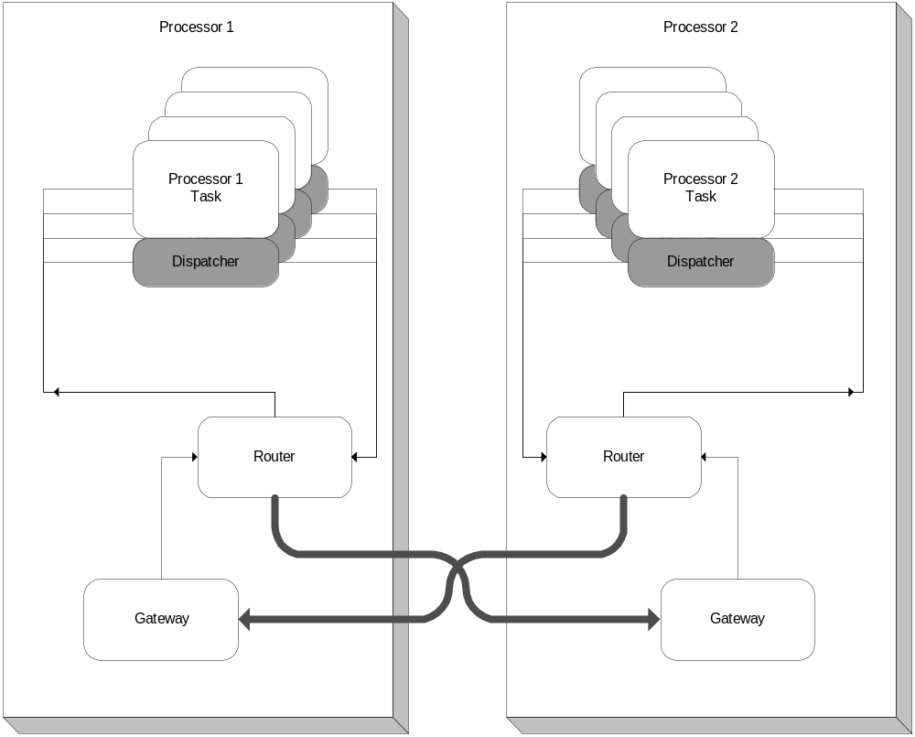
Figure 1: Message Flow
The message system passes Message objects between the different messaging components. The connections between components are created using POSIX message queues for messages to the Router and Dispatchers. The message sent from the Router to the Gateway tasks are transported using TCP socket connections.
The Message object can handle any type of data structure from integers to strings, and arrays. The Message object handles all the data copying, storing, and integrity checking. Message objects, to be sent or received, must be registered with the task’s Dispatcher object.
Therefore, every task must have a Dispatcher object to interface with the message system. The Dispatcher sends and receives messages for the task while isolating the task from the details of the messaging system.
The Dispatcher objects are connected using a Router task. The Router task distributes the messages to intra-computer tasks. The Router also maintains links to other computers/processors and forwards messages through these links to provide an inter-processor layer of communication.
The Gateway task completes the inter-processor layer of messaging. The messages are sent from computer to computer via TCP sockets. The Router task will send messages to other computers’ Gateway tasks. The Gateway tasks forward these messages to their Router task. The Router task then completes the distribution to interested tasks on that computer.
All messages sent by tasks are sent to the Router and are not addressed to a specific receiver. As the router receives messages from a task’s Dispatcher object, the Router task looks in its lists of tasks to see who has expressed an interest in the message. The Router forwards a copy of the message to each interested task. The Router automatically sends all messages specified as global to the other processors’ Gateway task.
Messages, sent through the message system, are uniquely identified by C++ class names. The class name gets CRC’d and turned into a 32bit integer which will uniquely identify one message, as verified by the Router task. In this manner, all messages can be type checked to ensure message system integrity at compile time.

Task Requirements
To use the message system, every task must create a MessageSystem object. The MessageSystem object acts as the global interface for the task. The MessageSystem object provides a common initialization method for all tasks in the system. The MessageSystem object must be created and initialized before any Message object can be used. The Dispatcher is created automatically when the MessageSystem object instantiates. The Dispatcher object registers the task with the Router task. The Message objects register with the Dispatcher object using the interface created through the MessageSystem object.

System Requirements
Each computer/processor must have one and only one Router task. The Router task must be started before any other task related to the messaging system. The Router provides the hooks for which all other tasks will connect.
Each computer will have one and only one Gateway task to receive the messages from other computers. Computers which do not need to communicate with other computers do not need to create a Gateway task. The Gateway tasks will connect with the Router tasks on the other processors. The Gateway tasks must be running and connected before any IPC can be completed.

External Interface
This section describes the external interfaces of the messaging system. The first section describes system functionality which must be provided before the message system can be used. The remaining interfaces are broken down into three areas. The areas correspond to the different phases where the message system is used:
- Creating messages and components
- Receiving messages
- Sending messages
( MSReq 2.1.1 - 2.1.3 )

System overrides

Network nodes
The message system has been designed in such a way as to provide a generic scheme for message handling for both intra-processor and inter-processor communication. The design should handle as many nodes which the system contains. To enable the message system to initialize and connect to all of the nodes, the target system must pass in the nodes for which the message system needs to connect.
This design chose to use a function, implemented by the target system, to pass on the network addresses.
void getNetworkedNodes( set< unsigned long > &nodes );
The target system must accept an STL set object and fill in the set with the 32bit network address for all system nodes, other than the local node’s address. The Router task will use the set data to establish the TCP socket connections between the Router and the Gateway tasks between the different nodes.

Non-recoverable Errors
The message system provides and requires the target system a facility to define a method to handle non-recoverable errors. These errors arise when the operating system calls fail, or the message validation fails. In these cases, the message system is left in an unusable state. When this happens, the message system will call the following function:
_FATAL_ERROR( char* file, int line, char* eString);
The target system must define appropriate behavior for this function. If the target system allows a return from this function, the message system will continue on without giving further notice of the previous error. The message system might or might not be in a indeterminant state.
( MSReq 2.2.4 )

Initialization/Creation
The Router and Gateway components are tasks in the system. Since the components are tasks, the only phase that will be described in this section is their creation. The initialization of the tasks happen automatically. The MessageSystem and Message components are objects and must be initialized after their creation, inside the task which uses them.

Router
The Router task should be created after all operating system components have been initialized, but before any other message system components are created. The Router task acts as the central information center for the message system. All other tasks must connect and/or register with the Router task. All messages must be registered with the Router task before they can be sent through the system.
The Router task only needs to be created to be used. The Router task will determine all initialization information for itself upon creation. There are two different methods from which the Router may be started.
- From command shell prompt:
Lookup the address of the Router’s main fuction
->lkup “Router_main”
Router::Router_main(void) 0x049a1ecc text (router.out)
value = 0 = 0x0
Take the address in the second column of the output and use it in the argument to the spawn command
->tid = sp ( 0x049a1ecc )
task spawned: id = 4af8a40, name = s1u0
new symbol "tid" added to symbol table.
tid = 0x49970c0: value = 78613056 = 0x4af8a40
- From inside a program startup or initialization process:
if ( taskSpawn ("tRouter", 4, 0, 20000,
(FUNCPTR) Router::Router_main,
0,0,0,0,0,0,0,0,0,0) == ERROR )
{
cout << "Could not spawn task" << endl;
return ERROR;
}
In the examples, the priority of the Router task has been set to 4. This was arbitrarily chosen for the example. The only real restriction on the priority is that it should be a higher priority (a lower number) than the tasks which connect to it. The Router needs to be able to preempt all of its connected tasks. The higher priority is needed to ensure that Router can pass off all the messages before the tasks can handle them, so that the Router’s queue will not fill.

Gateway
The Gateway task only needs to be created if inter-processor message need to be sent. If connection between processors is needed, the Gateway should be created after the Router task gets created, but still before any other message system components are created. The Router task will start trying to connect to the Gateways after the Router gets created.
The Gateway task, like the Router, only needs to be created to be used. The Router task will determine all initialization information for itself upon creation. There are two different methods from which the Gateway may be started.
- From command shell prompt:
Lookup the address of the Gateway’s main fuction
->lkup “Gateway_main”
Gateway::Gateway_main(void) 0x049a1ecc text (gateway.out)
value = 0 = 0x0

Take the address in the second column of the output and use it in the argument to the spawn command
->tid = sp ( 0x049a1ecc )
task spawned: id = 4af8a40, name = s1u0
new symbol "tid" added to symbol table.
tid = 0x49970c0: value = 78613056 = 0x4af8a40
- From inside a program startup or initialization process:
if ( taskSpawn ("tGateway", 4, 0, 20000,
(FUNCPTR) Gateway::Gateway_main,
0,0,0,0,0,0,0,0,0,0) == ERROR )
{
cout << "Could not spawn task" << endl;
return ERROR;
}
In the examples, the priority of the Gateway task has been set to 4. This was arbitrarily chosen for the example. In practice, the priority of the Gateway task should be equal to the priority of the Router task.

MessageSystem
The MessageSystem object provides a wrapper for using the message system. The MessageSystem object hides the initialization sequence, hides the interface with the Dispatcher object, provides a common interface of the message objects and hides the cleanup required when the task completes.
When the MessageSystem object is initialized, it can be passed the arguments which will specify the name of the message queue, and size of the message queue. The message queue name will default to the name of the task if none is specified. The Queue length defaults to 30 if not provided.
The MessageSystem object can be initialized as either message blocking or non-blocking. By initializing the MessageSystem object as blocking, the task must wait for a message to arrive to receive any processing time. If the message system is initialized as non-blocking, the task must check the message queue periodically to receive messages off of the message queue.
The MessageSystem object performs necessary initialization steps to ensure each task gets initialized properly. The MessageSystem object will set up the operating system specifics to ensure multiple tasks can use the MessageSystem object in VxWorks. The MessageSystem object also creates the Dispatcher object as the interface to the Router task.

VxWorks specific initialization
The MessageSystem object encapsulates the necessary initialization steps to enable the message system to work on any operating system. In the case of VxWorks, the MessageSystem object registers itself as a task specific variable. This call guarantees that no other task within the VxWorks operating system can reference any other task’s MessageSystem object.

Dispatcher initialization
The Dispatcher object initialization creates the input queue and sets up communication with the Router task’s queue. When the Dispatcher object is instantiated, it is passed the arguments which will specify the router and size of the queue. Queue lengths range from 1 to 400.

Examples

Blocking example

#include “messagesystem.h”
…

MessageSystem ms;

void blockingExample( void )
{
ms.initBlocking( “blockingExample”, 30 );

…
ms.dispatchMessages();
}

Non-blocking example

#include “messagesystem.h”
…

MessageSystem ms;
Message< int > msg;
int count=0;

void nonBlockingExample( void )
{
ms.initNonblock( “nonblockingExample”, 30 );

…

for (int I=0;I<5;I++ )
ms.dispatchMessages();

cout << “finished” << endl;
}

Messages
Message objects are the main interface point between the application and the message system. Message objects may be created at any time, but must only be initialized after the Dispatcher object has been created by the MessageSystem object. The initialization step happens when the ‘init’ function is called, or when the message is constructed with any other constructor other than the default.
The only messages defined to work in the message system are the data message (Message< Type > class) and the timer message (TimerMessage class).

Message< Type >
Message objects can be created as one of 5 different types. The different types describe how the message can be used. The type are:
- SEND_LOCAL – creates a message which can only send data on the local computer.
- SEND_GLOBAL – creates a message which can only send data on the local and networked computers.
- SNDRCV_SEND_LOCAL – creates a message which can receive and send data on the local computer.
- SNDRCV_SEND_GLOBAL – creates a message which can receive and send data on the local and networked computers.
- SNDRCV_RECEIVE_ONLY – creates a message which can only receive data.
To create send-only messages, the message constructor or ‘init’ function must only specify a scope of local or global for the message.
Message< int > msg;
msg.init( SEND_LOCAL );
…
Message< int > msg( SEND_LOCAL );
To create a send-and-receive message, the message must be given a function through a ‘Callback’ object. The scope of local or global must be specified if the message is intended to be sent. If the message is not intended to be sent, it can be created as a receive only message.
Message< int > msg;
msg.init( Callback< Class >( classPtr, &Class::cb1 ),
SNDRCV_RECEIVE_ONLY );
…
Message< int > msg( Callback< Class >( classPtr, &Class::cb1 ),
SNDRCV_RECEIVE_ONLY );

TimerMessage
Timer messages set up a mechanism to receive a message notification after a specified time interval has elapsed. The TimerMessage class must be constructed with a time interval, a callback function, and whether or not it should be active upon creation. The time interval argument takes integer values in units of milliseconds. The callback function must be specified with an argument of Callback object type. The last argument is of Boolean type to specify whether the timer should be active. In the following call, the timer is created as active, which is the default.
TimerMessage tm( 500, Callback< Class >( classPtr, &Class::cb1 ) );
The timer can be created as active with an argument of ‘true’ as the last parameter.
TimerMessage tm( 500,
Callback< Class >( classPtr, &Class::cb1 ),
true );

Usage Rules

Messages with the same data type
Messages can be created and used as specialized classes. To create several different messages which send the same data, the Message class must be derived upon. Since messages get their system wide Id from their type, messages sending the same type must create a new type name for themselves. The new type name is created using the C++ inheritance scheme.
To create multiple messages which send an integer type around, derive a new class off of the Message< int > class.
class IntMessage1 : public Message< int >
{
IntMessage1( MessageBase::SendType t ) : Message( )
{ init( t ); }
IntMessage1( CallbackBase &cb,
MessageBase::SendReceiveType t ) : Message( )
{ init( cb, t ); }
virtual ~IntMessage1() { };
};
This class will create a unique message to send integer data around the message system. Creating two objects of type Message< int > will be identified as the same message, even if the objects themselves are uniquely identified. Therefore if a system requires multiple messages of a given data type, each message will need to be instantiated as a derived class.

Message scoping
Messages must be created with a scope in mind. A variety of different messages may be created with this message system. Thought should be given to creating objects in the manner with which they will be used. Messages which never get sent out and are only received should be created as a receive only type. When a message gets created as any of the send-only, or send-receive types, the dispatcher must register the message. This registration creates extra overhead in the message system and therefore the process using the message system.
Messages which send data only needed by the local node should be created as local type. Creating a message with global type causes the message to be sent across the network. Having all messages go across the network could possibly cause performance problems. To prevent performance problems only create global messages to send data know to be needed by the other networked computers. All other messages should be local.

Message Loop
To receive messages, the task must enter the MessageSystem object’s message loop. The loop is actually in the Dispatcher object, but the MessageSystem object hides the Dispatcher’s call. The Dispatcher’s message loop receives messages off of the message queue and notifies the task of the reception of the message. The message loop can be set to deliver one message and return, or wait for messages delivering them as they arrive. The message loop can be exited at any time by calling the MessageSystem’s stopLoop function.
The MessageSystem loop will receive messages indefinitely when created in blocking mode. When the MessageSystem object is created as non-blocking, the message loop just receives one message and returns. This allows for applications that must block on other inputs to still receive messages. A GUI application would be a good example of this kind of use.
The message loop should be entered after all initialization steps are finished. The message loop will take control of the main thread of the process. The application code will only be called when messages are received when in blocking mode. If the message loop is entered in non-blocking mode, the message loop will exit after all messages are received.

Blocking example

#include “messagesystem.h”
#include “message.h”

void cb1( void );

MessageSystem ms;
Message< int > msg;
int count=0;

void blockingExample( void )
{
ms.initBlocking( “blockingExample”, 30 );

msg.init( CallbackBase( &cb1 ), SNDRCV_SEND_LOCAL );
msg.send( 0 );

ms.dispatchMessages();
}

void cb1 ( void )
{
cout << “received message” << endl;

int count = msg.get();
if ( count<5 )
++count;
else
ms.stopLoop();

msg.send( count );
}

Non-blocking example

#include “messagesystem.h”
#include “message.h”

void cb1( void );

MessageSystem ms;
Message< int > msg;
int count=0;

void nonBlockingExample( void )
{
ms.initNonblock( “nonblockingExample”, 30 );

msg.init( CallbackBase( &cb1 ), SNDRCV_SEND_LOCAL );
msg.send( 0 );

for (int I=0;I<5;I++ )
ms.dispatchMessages();

cout << “finished” << endl;
}

void cb1 ( void )
{
cout << “received message” << endl;
msg.send( count );
}

Callback Functions
As seen in the previous examples, messages can be set up to call any user function within functional scope when the message is received. This allows for easier design and implementation of code.
To set up a callback function of a ‘C’ style function, the CallbackBase object can be used.
msg.init( CallbackBase( &cb1 ), SNDRCV_SEND_LOCAL );
The ‘cb1’ function should have access to the ‘msg’ object when called to use the data supplied in the Message object.
To set up a callback function for a ‘C++’ member function, the Callback object must be used. The Callback object is a template class which accepts the type of the class from which the function is a member.
msg.init( Callback( classPtr, &Class::cb1 ), SNDRCV_SEND_LOCAL );
The ‘Class::cb1’ function must be a public member function, and the ‘classPtr’ pointer must be a valid type of ‘Class *’.

System Classes

Callback< Type > and CallbackBase
The Callback class encapsulates function addresses for ‘C’ style and ‘C++’ style functions. The functions can then be called by using the objects overloaded operator(). Messages use the callback classes to perform message notification in the task.
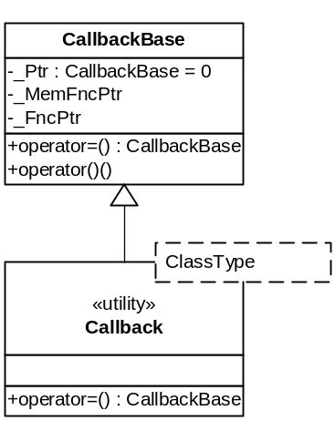
When the Callback object gets created, the constructor can be called in three different ways.
- CallbackBase() – This creates an object with no function supplied. The object will not do anything when created this way.
- CallbackBase( &functionToCall ) – This creates an object that can call ‘C’ style functions.
- Callback< ClassType >( classTypePtr, &ClassType::functionToCall ) – Creating an object this way allows the use of ‘C++’ member functions to be used as ‘callback’ functions.

Dispatcher
The Dispatcher class hides the functionality for connecting a task with the Router task. The Dispatcher object performs the queue creation and connections. The Dispatcher object performs the necessary registration for tasks and messages. The Dispatcher object reads and writes the MessagePacket objects to and from the queues. The Dispatcher object performs error checking on the MessagePacket data to ensure its integrity. At task completion, or Dispatcher destruction, the Dispatcher object will perform the necessary closures of the open queues, deregister all messages with the Router task, deregister the task with the Router task, and cleanup all its data.
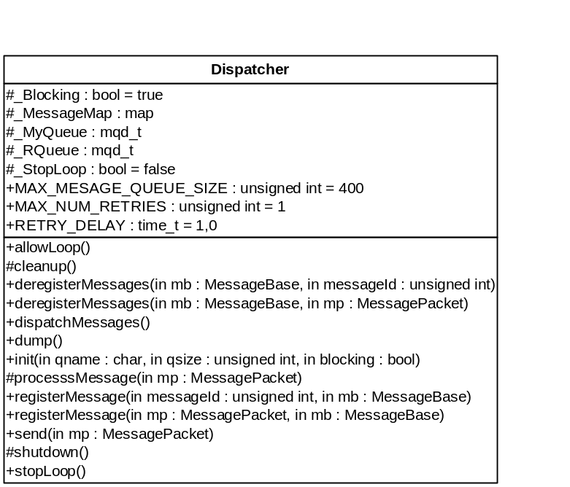
The Dispatcher object is hidden from the user through the MessageSystem class. No function or data needs to be called directly from the Dispatcher by the user.

Dispatcher data
The Dispatcher contains both public and protected data. The public data is static and constant.
- MAX_MESSAGE_QUEUE_SIZE – This constant defines the maximum size that the Dispatcher will allow for a message queue
- MAX_NUM_RETRIES – This constant defines the number of retries the dispatcher will attempt for POSIX message queue calls. (MSReq 2.2.2, 2.2.3)
- RETRY_DELAY – This constant specifies the time to wait between retries for the POSIX message queue calls.
The protected data follows.
- _Blocking – This Boolean flag specifies whether or not the message queue was created in a blocking state, or a non-blocking state.
- _MessageMap – This STL map structure contains all know messages registered by the task. The map holds the data in a container which is indexed by the message’s Id. Each message Id will have a container of objects. An STL set container holds all created and registered messages of the given Id. The messages are uniquely identified by their memory location.
- _MyQueue – This is the task’s POSIX message queue.
- _Rqueue – This is the Router task’s POSIX message queue
- _StopLoop – This Boolean flag specifies whether the message loop should loop continuously or just check the queue one time and return.

Dispatcher functions
- allowLoop – This function sets the _StopLoop flag to true.
- cleanup – This function cleans up the memory allocated by the _MessageMap. This function is called automatically when the Dispatcher object is destructed.
- deregisterMessages – This function deregisters the message with the Router task and removes the message from the _MessageMap.
- dispatchMessages – This function loops around the message queue receive call waiting for messages. When a message packet is received, the MessagePacket object is sent to the processMessages function to distribute appropriately.
- dump – This function prints out the contents of the Dispatcher data structure.
- init – This function creates the task’s message queue, opens the Router task’s message queue, and registers the task with the Router.
- processMessages – This function first validates the contents of the MessagePacket object (MSReq 2.2.1). When the contents are to be valid, the function determines to which Message object the MessagePacket belongs. The MessagePacket is then passed to the Message object thereby notifying the Message object.
- registerMessages – This function registers the message with the Router task and adds the message to the _MessageMap.
- send – This function sends a MessagePacket object over the message queue to the Router task.
- shutdown – This function closes the message queues after it deregisters the task from the Router. This function is called automatically when the Dispatcher object is destructed.
- stopLoop – This function sets the Boolean _StopLoop flag to false, which stops the dispatchMessage function from looping on the message queue receive call.

Gateway
The Gateway task will connect with other networked computers to allow for IPC. The connections are made with TCP sockets. The Gateway task will connect with the other computers’ Router tasks to accomplish the communications. The Gateway task must also connect with its own computer’s Router task’s message queue. When a Gateway task receives a message over the socket connection, the message is immediately sent to the Router task’s message queue. The Router will then distribute the message as all other messages.
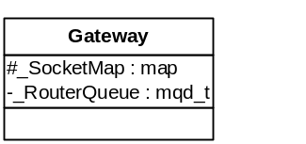

Message< Type >
The Message class will be the basis for all messages sent through the system. The class is a templated class, so it will accept any ‘C++’ type. The Message class places a restriction on the types though. The types must be able to be copied correctly using the operator= and the copy constructor.
The Message class inherits functionality and data from the MessageBase class. The only original data is the template data member, _MsgData. The functions provided in the Message class override methods in MessageBase to deal with the special feature of the template data.
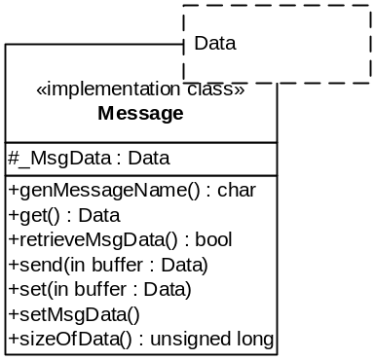
- genMessageName – This function generates the unique character representation of the Message object. In the case of the Message class, the unique character representation is generated by the compiler. The typeid operator, in ‘C++’, returns the compiler generated name for the specific type of class.
- get – This function returns the template data, _MsgData, stored in the Message class.
- retrieveMsgData – This function takes the base class’s list of MessagePacket objects and combines them into the template data type.
- send – This function takes a template data object and copies the data into the _MsgData data member. After the copy is finished, the send function from the MessageBase class is called to start sending the data through the system.
- set – This function takes a template data object and copies the data into the _MsgData data member.
- setMsgData – This function takes the template data object, _MsgData, and converts it into the MessagePacket objects in the MessageBase class list.
- sizeOfData – This function returns the size of the template data member.

MessageBase
The MessageBase class provides the infrastructure for the message objects. This class knows how to break data into packets, assemble and disassemble the packets to accomplish the propagation through the message system. This class handles the notification of the application when all the MessagePacket objects have arrived for a new message. This class generates the message Id from the unique message names. This class also supplies the tracking data in the MessagePacket objects such as task and node Ids, send times, and the generated integer message Id.
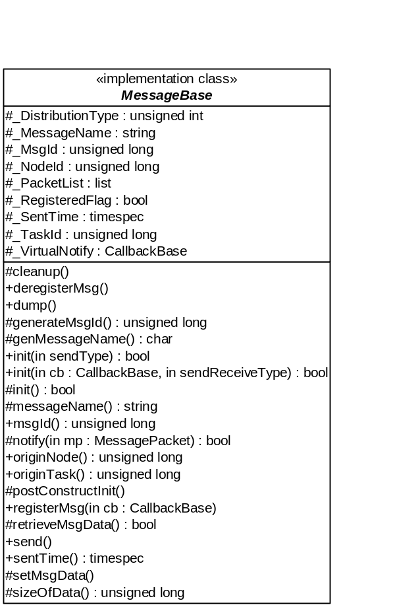

MessageBase data
- _DistributionType – The distribution type of the message is an enumeration of three possible values:
  - SNDRCV_LOCAL – This value tells the Router task to only distribute the message over the local computer.
  - SNDRCV_GLOBAL – This value tells the Router task to distribute the message over the local and networked computers.
  - SNDRCV_RECEIVE_ONLY – This value tells the Message object to register this message with the Dispatcher object. Messages created with this setting cannot be sent out, but only received.
The value of this flag is propagated with all of the Message object’s message packets. A Message object can be created with two other enumerations:
  - SEND_LOCAL – This value tells the Router task to only distribute the message over the local computer.
  - SEND_GLOBAL – This value tells the Router task to distribute the message over the local and networked computers.
These enumerations create the message in a send only phase. Messages created with these flags can be sent, but the messages will not be registered with the Dispatcher object. As a result, when the messages are received, these object will not be notified.
- _MessageName – This STL string object will contain the unique character representation of the message. This string will be used to create the integer Id for the message as it is propagated through the message system.
- _MsgId – This is the integer Id of the message that will identify the message while it is propagated through the message system.
- _NodeId – This will contain the network address of the sender of the message. If the number is 0, the message originated for the local node.
- _PacketList – This STL list object owns the MessagePacket objects needed to contain the data of the Message class.
- _RegisteredFlag – This Boolean flag contains the knowledge of whether or not this message is registered for receiving.
- _SentTime – This timespec structure contain the time the message was sent from the originating task.
- _TaskId – This integer contains the task Id of the originating task of the message.
- _VirtualNotify – This CallbackBase object contains the function to be called when this message is received.

MessageBase functions
- cleanup – This function cleans up the memory allocated for the MessagePacket object list.
- deregisterMsg – This function removes the message from the Dispatcher object to stop further reception of this message type.
- dump – This function will print the contents of the Message object to standard output.
- generateMsgId – This function generates the unique message Id based on the _MessageName member data. The _MessageName string is passed into the system CRC generation function. This function generated an integer based on the specified characters’ order. This Id may not be unique. Through the registration process of the message, the generated Id will be guaranteed to be unique or an error will be presented.
- genMessageName – This is only the declaration of the function which must be provided by inheriting classes.
- init – These functions set up the message for the message system. The function will register, or deregister the message with the Dispatcher object. The protected version of the function creates the MessagePacket object list based on the sizeOfData function.
- messageName – This function gets the _MessageName data member.
- msgId – This function gets the _MsgId data member.
- notify – This function gets called by the Dispatcher object when one of this message’s MessagePacket objects get received. When all MessagePackets come in over the message system, the notify function will call the function held in the _VirtualNotify data member.
- originNode – This function gets the _NodeId data member.
- originTask – This function gets the _TaskId data member.
- postConstructInit – This function performs initialization which must happen regardless of which init function is called. This function sets up the message name and id.
- registerMsg – This function registers this Message object with the Dispatcher object.
- retrieveMsgData – This is only a declaration of the function which must be provided by inheriting classes.
- send – This function sends the MessagePacket objects to the Dispatcher for sending over the message system.
- sentTime – This function gets the _SentTime data member.
- setMsgData – This function is only a declaration of the function which must be provided by inheriting classes.
- sizeOfData – This function is only a declaration of the function which must be provided my inheriting classes.

MessagePacket
The messages on the message queue are actually MessagePacket objects. The MessagePacket objects can contain the whole Message object, or the Message object may need several MessagePacket objects to be sent on the message queue. When all MessagePacket objects for a Message object have been received, the Message object notifies the calling task’s notification function. The size of the MessagePacket objects can be tuned at compile time by setting the MessageData::MAX_MESSAGE_SIZE constant. When Message objects are initialized, the Message object will create the appropriate number of MessagePacket objects to contain the data.
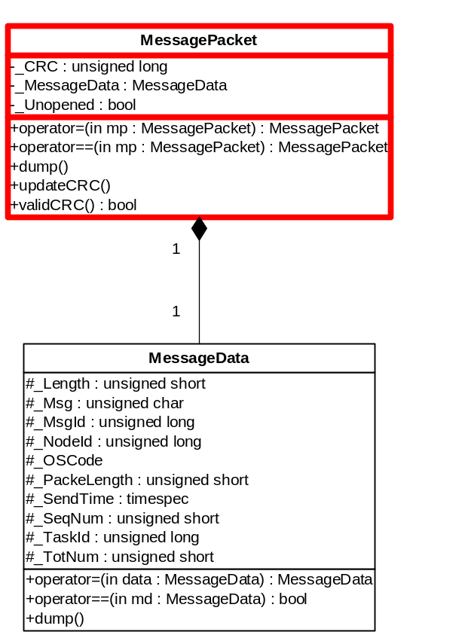

MessagePacket data
- _CRC – This data gets generated before the packet is sent. The CRC generation functions generate the integer data from the _MessageData data member.
- _Unopened – This Boolean data member gets set to true when the packet arrives from the Router. When all packets in a message have the flag set to true, the message notifies the application.

MessagePacket functions
- operator= - This function copies the MessagePacket object exactly.
- operator== - This function compares the _MessageData data member to determine if the message packet matches. This function is used to set the local copy of the data with the incoming message data.
- dump – This function prints the contents of the MessageData object to standard output.
- updateCRC – This function update the _CRC data member. The _MessageData data member is passed to the CRC generation function.
- validCRC – This function returns true if the CRC in the MessagePacket object matched the CRC generated by the CRC function over the _MessageData data member. This function is called when the message packet is received in the Dispatcher.

MessageData class
The MessageData class is purely a container to encapsulate all message data that will be included in the CRC. The MessageData class provides a convenient mechanism to determine the size and pass around pertinent message data.
- _Length – This data member contains the length of all data in the Message object, not the MessagePacket object. This could be equal to the _PacketLength data member, or bigger.
- _Msg – This is the actual packet of data to be sent out from the Message object. All other data members are used for identification and verification. This member contains the user data.
- _MsgId – This is the integer Id generated from the MessageBase object.
- _NodeId – This is the sending tasks network address. The integer will be 0 if the message came from the local computer.
- _OSCode – This data member specifies the action the Router task needs to take on the MessagePacket object. The 12 possible values are:
  - TASK_REGISTER - This deregisters the sending task with the Router task.
  - TASK_DEREGISTER – This deregisters the sending task with the Router task.
  - MESSAGE_NAME_REGISTER – This designates that the message Id found in this packet should be verified and added to the list of known message Ids.
  - MESSAGE_REGISTER - This designates the calling task wants to receive the message Id found in the message packet.
  - MESSAGE_DEREGISTER – This designates that the calling task wants to deregister the message Id found in this packet. By deregistering, the message does not get sent to the task again.
  - GATEWAY_CONNECT– This code registers the calling task as a Gateway task with the Router task.
  - GATEWAY_DISCONNECT – This code unregisters the calling task as a Gateway task.
  - SPOOFER_REGISTER - This code registers the sending task with the Router task as a Spoofer.
  - SPOOFER_DEREGISTER – This code unregister the sending task with the Router task as a Spoofer.
  - MESSAGE_MULTICAST – This designates the message should be sent out across the network and on the local node.
  - MESSAGE_MULTICAST_LOCAL – This designates the message should only be sent out on the local computer.
  - SPOOFED_MESSAGE – This designates the message as having been generated by the Spoofer task.
- _PacketLength – This data member specifies the length of the actual data in the MessagePacket object. This integer will be equal to the _Length data member, if the length is less than the size of the _Msg data member, or will be the size of the _Msg data member or will a remainder packet.
- _SendTime – This data is set when the message is sent by the originating task.
- _SeqNum – This is the sequence number of this packet in the packet list. All messages will arrive in proper sequence order.
- _TaskId – This is the task Id of the originator of the message.
- _TotNum – This data member contains the total number of packets in the packet list.

MessageSystem
The MessageSystem class encapsulates operating system specific setup, and the Dispatcher object connection. This class becomes the application’s only interface with the Dispatcher component of the message system. The Message objects also require the MessageSystem object to be created. The Message objects use this class to interface with the Dispatcher object.
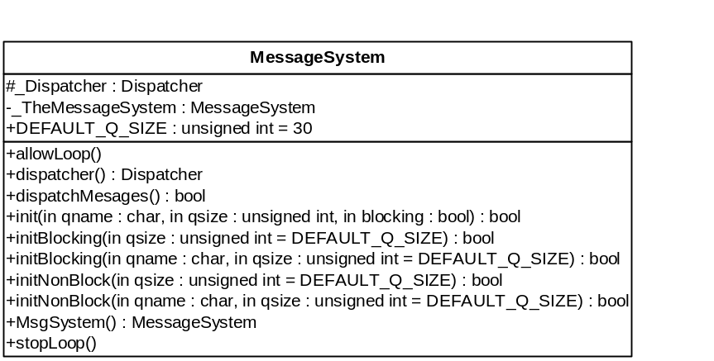

MessageSystem data
- _Dispatcher – This is the task’s Dispatcher object. This object is accessible only through the MessageSystem object.
- _TheMessageSystem – This is a static pointer to the task’s MessageSystem object, if it has been created. This pointer gets assigned to the VxWork’s Task Variable List. The Task Variable List is a list which get context switched in and out when the task gains or loses control of the processor. This allows the MessageSystem to be specific per task on one computer.
- DEFAULT_Q_SIZE – This constant will be used for the task’s message queue size if the task fails to specify a size when the MessageSystem object is initialized.

Message System functions
- allowLoop – This function calls the Dispatcher’s corresponding function.
- dispatcher – This function returns the Dispatcher object pointer for the application.
- dispatchMessages – This function starts the message loop, or rather wraps the Dispatcher object’s dispatchMessages function
- init – This function creates the task variable for the MessageSystem object.
- initBlocking – This function creates a Dispatcher object which blocks on the message queue waiting for messages forever. The only way the application has to get out of the message loop is to call the stopLoop function.
- initNonBlock – This function creates the Dispatcher in a non-blocking mode. This means the Dispatcher object will not wait for a message to be received. The Dispatcher object will attempt to receive a message, if none are on the message queue, the dispatchMessages function will return.
- MsgSystem – This static function allows the MessageSystem object to be accessible throughout the entire task.
- stopLoop – This function calls the Dispatcher’s corresponding function.

Destruction
Upon completion of the MessageSystem object, the object will remove the MessageSystem from the list of task specific variables need by VxWorks. The object will also destruct the Dispatcher. The Dispatcher object will deregister the task and all of the task’s message from the router. After all of the task has been deregistered, the Dispatcher object will close the Router’s and the task’s message queue.

Router
The Router class encapsulates the routing portion of the message system. All message sent through the system go through the Router object. The Router determines the validity of the message, who wants the message, and where to send the message. The Router establishes the network connections to the Gateway tasks, if any.
The message Id check for uniqueness occurs in the Router object. When a Message object is created, the Dispatcher notifies the Router. The notification message packet contains the perspective Id and the message name of the new Message object. The Id and name are matched to existing Ids and names to ensure their uniqueness throughout the message system.
The Router object also maintains a list of tasks which are registered in the system. When a task registers with the Router, the Router adds the task to the list. At this point, the entry can be removed two ways. The task can deregister itself, or if the task terminates, the operating system will notify the Router object and the task will be removed at that point.
The Router object keeps track of all Gateway tasks to which the Router object connects. This list associates the Gateway with its socket connection. When global messages get sent through the system, any message originating on the local node will be propagated to the Gateway tasks in this list. The Gateway task must deregister to be removed from the list.
The last list the Router object maintains is the message Id to task Id mapping list. This list maintains a list of all messages for which a task registers. The task can register multiple times for the same message. Every time a message is registered, a counter, associated with the task, is incremented. This ensures that the list will not lose its integrity if a task registers multiple times. When a task deregisters, the counter is decremented. If the counter is 0, the task is removed.
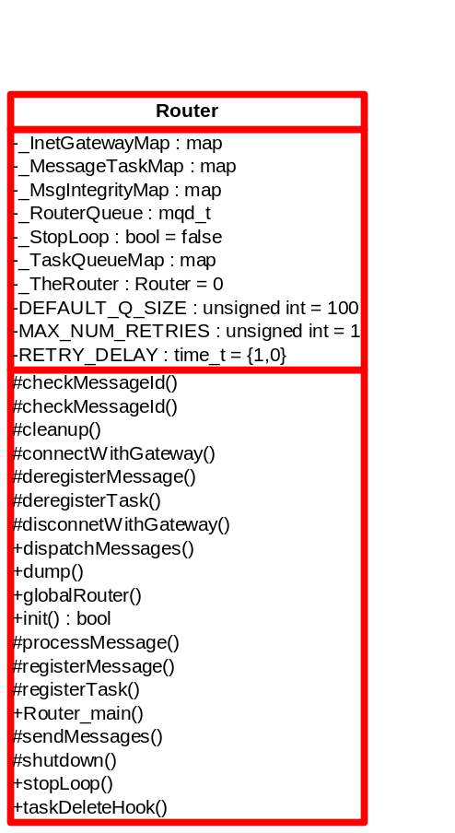

Router data
- _InetGatewayMap – This STL map object contains a list of Gateway network addresses associated with the socket connection to that address.
- _MessageTaskMap – This STL map object contains a list of registered messages associated with the task Ids of the task who wants to receive them. The task Ids are in another map which associates taskIds with the number of registrations per that task Id.
- _MsgIntegrityMap – This STL map object contains a list of messages which can be sent through the message system. The msg Ids are associated with the character representation of the message name that was created by the Message object.
- _RouterQueue – This is the Router task’s POSIX message queue.
- _StopLoop – This Boolean flag determines whether the message loop will continue receiving message or will exit.
- _TaskQueueMap – This STL map object associates a task with its POSIX message queue.
- _TheRouter – This static variable contains a pointer to the created Router object.
- DEFAULT_Q_SIZE – This constant holds the queue size of the Router’s message queue if the creator doesn’t specify a size.
- MAX_NUM_RETRIES - This constant defines the number of retries the router will attempt for POSIX message queue calls. (MSReq 2.2.2, 2.2.3)
- RETRY_DELAY – This constant specifies the time to wait between retries for the POSIX message queue calls.

Router functions
- checkMessageId – These functions verify that each integer matches up with one and only one character name. If the message Id is not found, the Id and name will be added to the _MsgIntegrityMap.
- cleanup – This function gets called when the Router object gets destructed. This function cleans the memory allocated in the map structures. This function also removes the hook to the function which gets called every time a task exits.
- connectWithGateway – This function will attempt to establish a connection to the Gateway task at the specified network address. If a connection is established, the address and socket connection are added to the _InetGatewayMap.
- deregisterMessage – This function will decrement the task Id’s registration count in the _MessageTaskMap. When a task Id’s registration count reaches 0, the task Id is removed from the map as the task Id no longer has anyone listening for the specified message Id.
- deregisterTask – This function removes the task Id from the _MessageTaskMap, and removes the task Id from the _TaskQueueMap, and closed the task’s queue.
- disconnectWithGateway – This function closes the socket connection and removes the address of the Gateway task from the _InetGatewayMap.
- dispatchMessages – This function has a loop which continually blocks receiving messages on the _RouterQueue message queue. The loop can be stopped by calling the stopLoop function.
- dump – This function prints the contents of the Router’s data structures to standard out.
- globalRouter – This static function provides access to the processor’s Router object.
- init – This function opens the Router object’s message queue. This function also creates the task delete hook into the VxWorks operating system. The task delete hook will call the taskDeleteHook function whenever a task exits.
- processMessage – This function is executed whenever any message is received on the message queue. This function validates the message contents. This function performs the instructions specified by the MessagePacket’s _OSCode data member. A function exists in the Router class to handle every enumeration that can be specified in the _OSCode member.
- registerMessage – This function will add an entry to the _MessageTaskMap for the specified message and task Ids.
- registerTask – This function will add an entry in the _TaskQueueMap for the specified task Id. This function also opens the task’s message queue for writing.
- Router_main – This function will create and initialize one and only one instance of the Router object. After the object is created, the function will enter the dispatchMessages function.
- sendMessage – This function sends a MessagePacket object to the specified task Id. The task Ids are found in the _MessageTaskMap. If the message has been marked as a global message, this function will send the MessagePacket object to all registered Gateway tasks on the other networked computers, if any. Before the message is sent to the Gateway, the Router will set the MessagePacket’s _NodeId data member to be the local network address. This will allow the other networked computer to know where the message originated. (MSReq 2.1.4)
- shutdown – This function closes all open message queues.
- stopLoop – This function set the Boolean _StopLoop flag.
- taskDeleteHook – This function is called every time a task exits.

TimerTask
TBD

TimerMessage
The TimerMessage class allows the using application to create a timer and receive notification through the message system. The TimerMessage class inherits from the Message<unsigned long> class. This allows the TimerMessage to behave as a regular message. The Timer task receives timer requests and stores the associated message. When the timer expires, the message gets sent back to the originator as notification.
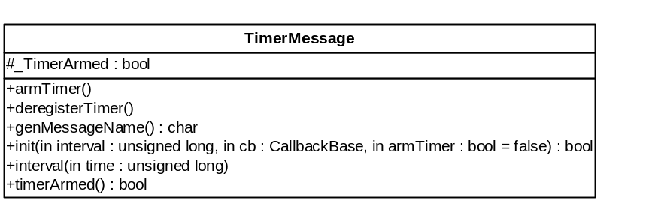

TimerMessage data
_TimerArmed – This Boolean flag specifies whether the timer has been turned on or not.

TimerMessage functions
armTimer – This function turns the timer on.
deregisterTimer – This function deregisters the timer with the message system.
genMessageName – This function generates a character name for the timer.
init – This function registers the timer with the Dispatcher object.
interval – This function sets the interval of the timer.
timerArmed – This function return true if the timer is turned on

