Date | Author | Change Description
07/16/08 | Aditya Dalvi | Initial revision

This table lists the working of the new character based token split algorithm used in cgui_text.cpp. Various test strings have been used as shown below. The Bounding box for each of the text strings is marked.

Sr. no | Text String | Properties | Screen-shot
1 | A mixture of Japanese and English text with new lines | BoxHeight=250  BoxWidth=195 | 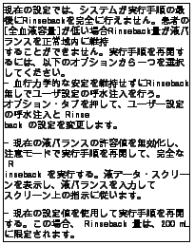
2 | "Have a nice day" | BoxHeight=40  BoxWidth=40 | 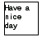
3 | "Liquid (mL)" | BoxHeight=40  BoxWidth=40 | 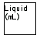
4 | "num 542,438" | BoxHeight=40  BoxWidth=40 | 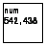
5 | "num 544.358" | BoxHeight=40  BoxWidth=40 | 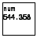
6 | "This is an apple" | BoxHeight=45  BoxWidth=45 | 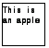
7 | "My test. Thank you" | BoxHeight=40  BoxWidth=40 | 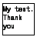
8 | "num (((250))" | BoxHeight=40  BoxWidth=40 | 