 | STANDARD OPERATING PROCEDURE (SOP)  Data analysis  -CNV analysis- | SOP # | SOP 22
 |  | Implementation Date | NA
 |  | Revision #
Author Lukasz Truszkowski |  | Last Update | 10.09.26
Reviewer Elisa Balmas |  | Approval

PURPOSE Introduction and background information
- SOP for the analysis of Illumina-microarray based low resolution karyotyping, primarily for detection of copy number variations (CNVs)

SCOPE Relevant audience
- Bertero lab members

RESPONSIBILITIES Contact information of relevant people
- Alessandro Bertero (alessandro.bertero@unito.it)

REFERENCES Related manuals, papers, other SOPs, etc.

DEFINITIONS Explanation of acronyms, etc

EQUIPMENT Required machines, centrifuges, etc

 | Notes | Location
WindowsOS computer |  | e.g. workstation
GenomeStudio 2.0.5 with the cnv 3.2.1 plugin installed | WindowsOS only, requires and account (free) at Illumina | https://emea.support.illumina.com/array/array_software/genomestudio/downloads.html
Rstudio with dplyr 1.1.4 and xml2 1.3.8 packages installed | any OS is fine - I analysed on MacOS | https://posit.co/download/rstudio-desktop/

PROCEDURE Action; quantity, time and conditions; notes/comments

- When the SNP karyotyping is done, you’ll get an email from the company with a link to the side where you can download the data. The password for it will come in a separate email.
- Enter the folder and the following subfolders leading to GSP_YEAR-XXXXXX folder.
- Create a folder for the experiment.
- Inside this folder place start-genomestudio.sh (if using windows or linux) or start-genomestudio.bat (if using windows) inside the experiment folder. This script will be used to start the genomestudio docker image.
- Inside this folder, place 2 folders:
Output
scratch/input_files
scratch/input_files_genomestudio
- Place in Scratch/input_files_genomestudio:
- The samplesheet.csv
- the files obtained by life and brain including the .bsc file
- the manifest (file: .egt and .bpm) if it is different from the default one (the default manifest is already inside the docker, file: GSAMD_24v3-0_A1-LAB-2235HiQ-Samples.egt and GSAMD-24v3-0-EA_20034606_A1.bpm)

- Place in Scratch/input_files:
- The samplesheet.csv
- the files you will save from genomestudio

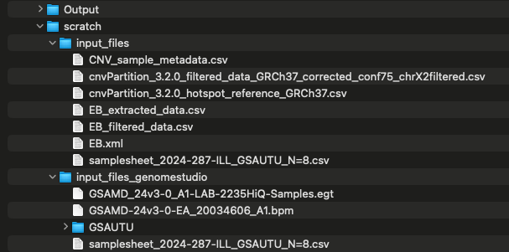

- Open the terminal
- Run docker in the terminal

CNV_ROOT=/Users/elisabalmaselisabalmas/Library/CloudStorage/GoogleDrive-elisa.balmas@unito.it/Shared drives/MBC-HEDGe_EB/001_vario/softwares/CNV_analysis_docker

cd "$CNV_ROOT"

sh start-genomestudio.sh --port 8890

docker run -d --rm \
--platform linux/amd64 \
--name cnv-rstudio-test \
-p 127.0.0.1:8080:8787 \
-e PASSWORD='test-password' \
-v "$CNV_ROOT/Output:/home/rstudio/project/Output" \
-v "$CNV_ROOT/scratch:/home/rstudio/project/scratch" \
hedgelab/cnv-rstudio:2.0

NB. "$CNV_ROOT" is your experiment folder

- Open the RStudio Server interface and Genome studio in your web browser. You can access it by navigating to the URL provided by your server administrator. Once you are logged in, you can start analyzing copy number variations (CNVs) using R and various bioinformatics packages.

http://localhost:8080 for RStudio Server and http://localhost:8890/lab for Genome Studio.

Rstudio password is either rstudio rstudio unless you set it up when running the docker.
If you follow the example above

username: rstudio
password: test-password (if you use the password of the docker run code)

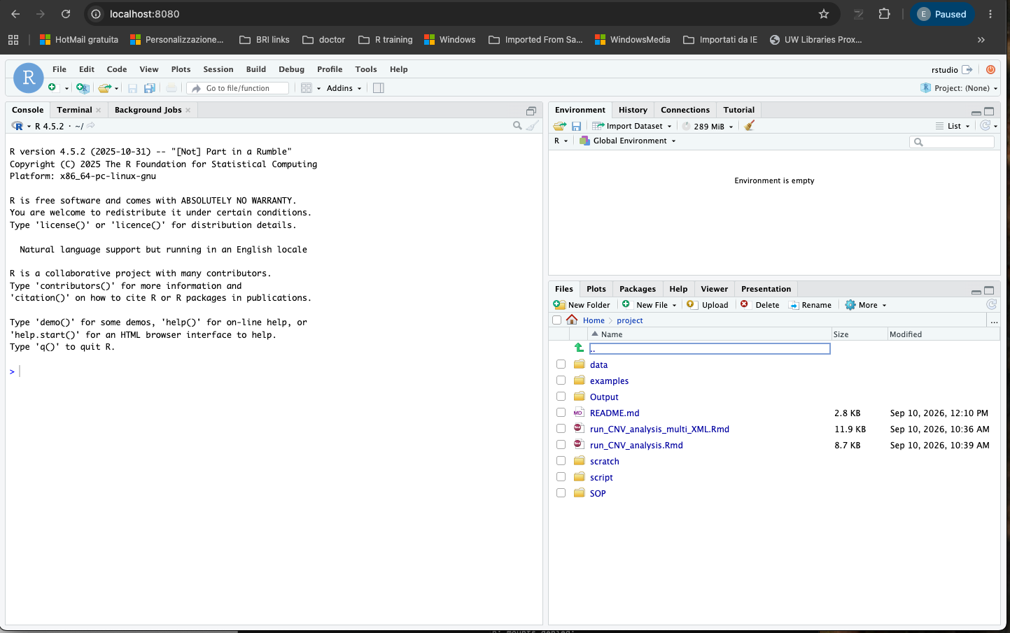

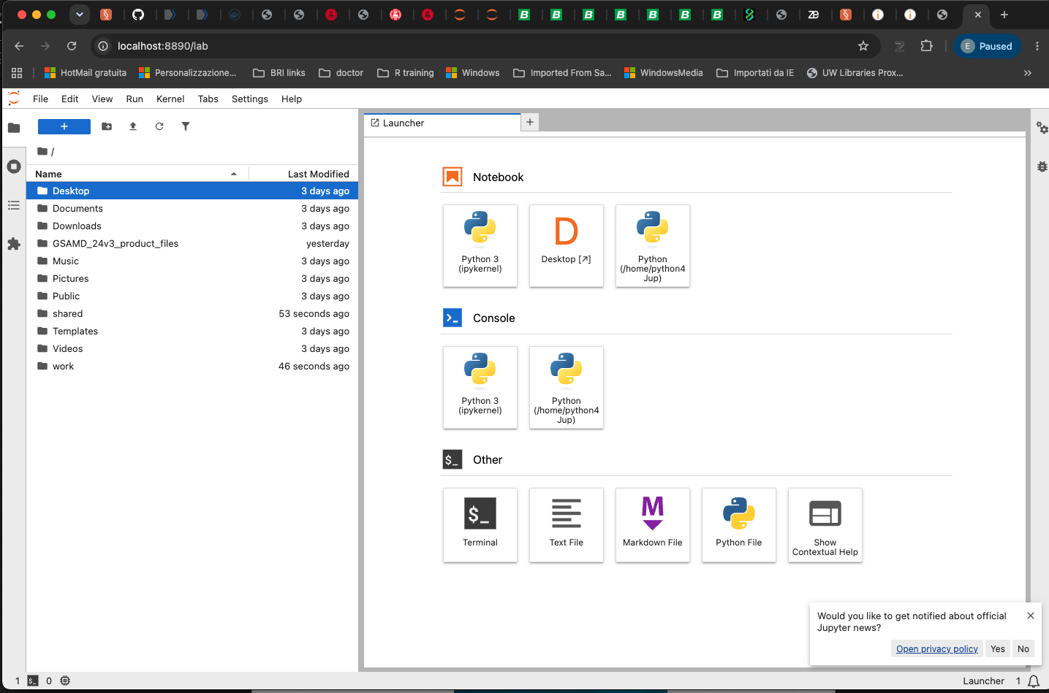

- Open the “Desktop” icon and it will open windows. Go on genomestudio from the applications and run Genotyping:
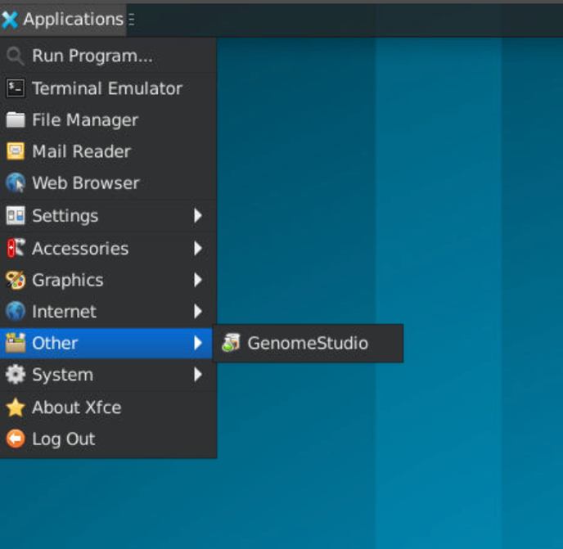
In the file system you can see the manifest folder with the files already inside the Docker and the shared folder contains the shared folder with the “Output” and “scratch” folder in your computer.
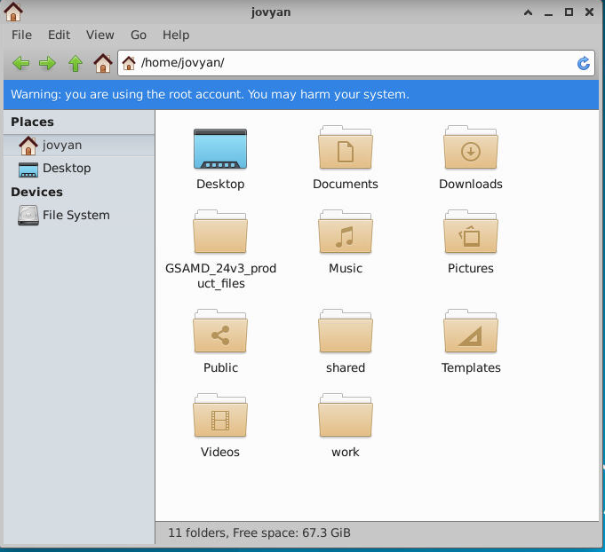
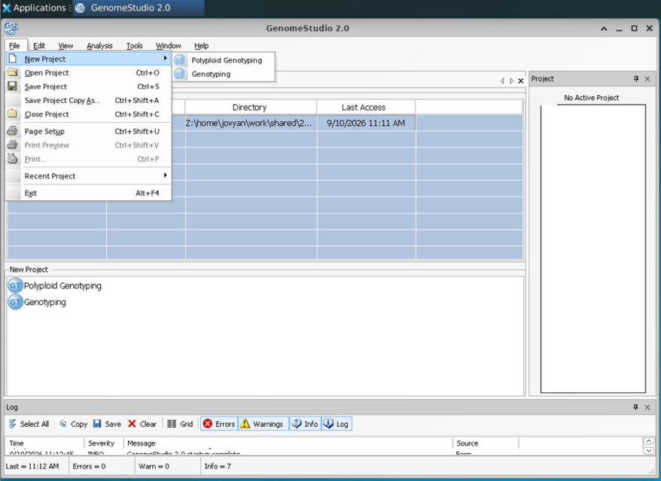
- Place as project Repository the Output folder
- Set up the “Genotyping Project”
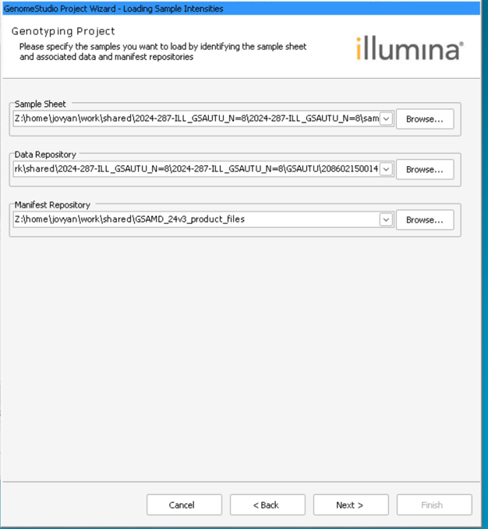
These should be all inside the Scratch/input_files_genomestudio folder:
- Sample sheet: The samplesheet.csv
- Tata repository is the Data obtained by life and brain, place here the path to the folder with the intensities.
- the manifest (file: .egt and .bpm) if it is different from the default one (the default manifest is already inside the docker and described in step 9 , file: GSAMD_24v3-0_A1-LAB-2235HiQ-Samples.egt and GSAMD-24v3-0-EA_20034606_A1.bpm)
- Click Next and insert the cluster file. This is the .egt file that you find in the docker with the manifest files. Click “import cluster positions from a cluster file” and “calculate sample and SNP statistics”

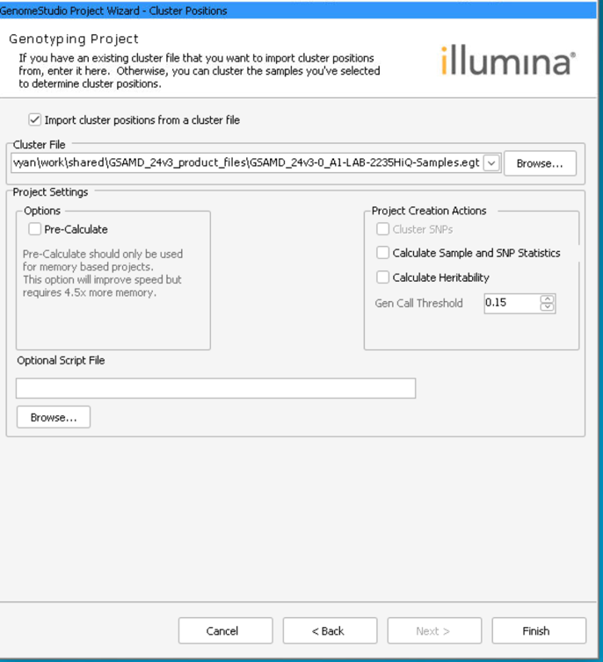
- On the left-hand side, you’ll see Samples table. The important info for now is Index, Sample ID and Sample Name (the one you gave) - these will help you identify your sample, as later only index and sample ID are displayed.
- Select the samples you want to be analysed (keep Control pressed to select multiple) - skip if you are analysing all the samples.
NB. You can analyze them all and just filter the final graphs.
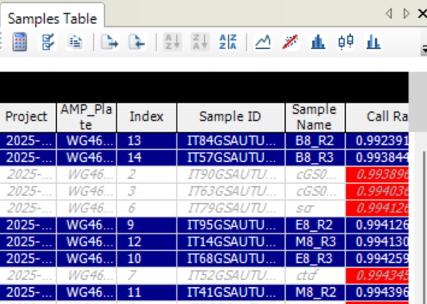
- From the menu, select Analysis/CNV Analysis…
- Select cnvPartition 3.2.0 algorithm (the only option) in the dropdown menu (A)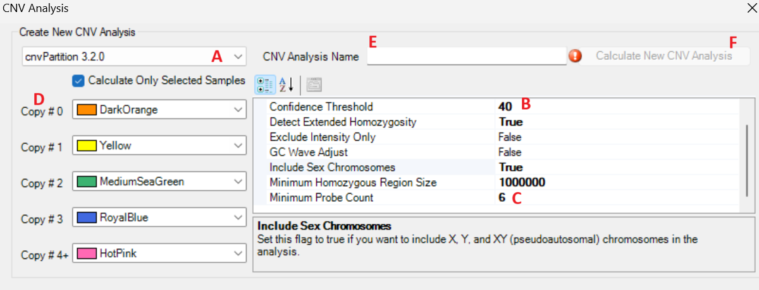
- Change the parameters - set the Confidence Threshold (default recommendation - 70 - B) and Minimum probe count (recommended 6 - C)
- Change the colors for visualization - the colors in the example show a colorblind-friendly palette - D
- Name your analysis - if you don’t use the default parameters, include it in the name or write it somewhere else, as the parameters are not recoverable/reusable.
- Check the ‘Calculate Only Selected Samples’ box if you only want to analyse some of the samples.
- Once the analysis is complete, a visualisation of the results will pop up. You can right click and save the image as TIFF if you want to keep it.
- Go back to the main window and select Tools/Show Genome Viewer…
- The ‘Add Favorite Data Plots Form’ will pop up.
Select one of the data you analyzed from the Sample menu (check the box) and CNV Value in the Subcolumns menu. Press ‘Add to favorite’ button! (red box)
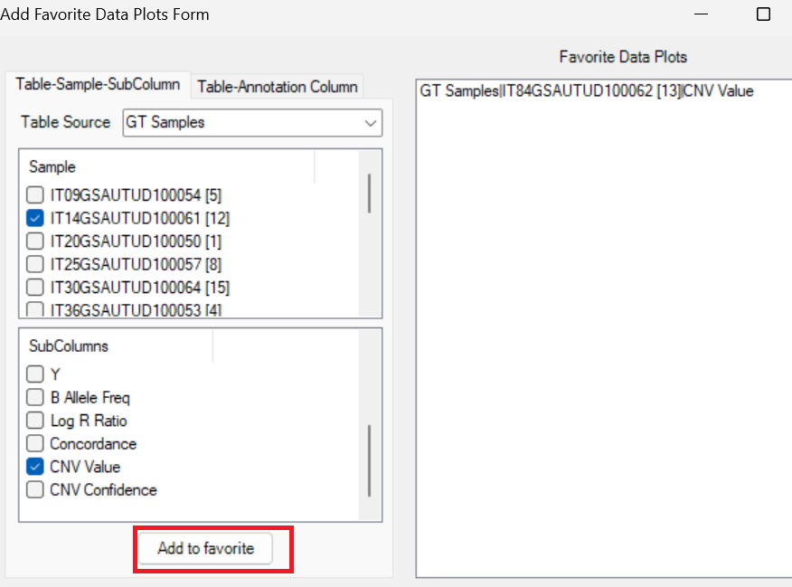
- Select the sample that has now appeared in the Data plots menu. Press ‘Update’ above the area (highlighted)
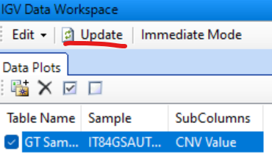
- Select from the menu View/CNV Analysis as Bookmarks.
- Select your analysis, press OK.
- You can now browse the CNVs highlighted with chosen colors on the chromosomes, with all kinds of zoom in/out scales in the Genome Viewer Window.
- To export the data, go to View/Bookmark Viewer menu. Select your analysis and press ‘Save Selected Bookmark Analysis’ (red box). This will save an XML file containing all the info.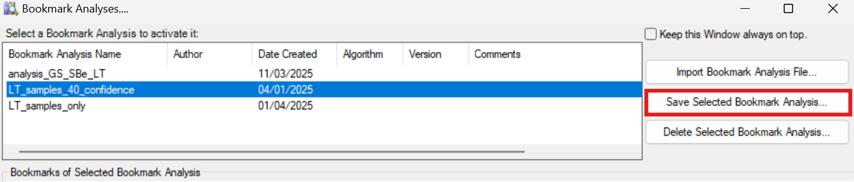
- Save the file in the folder scratch/input_files so that you can use for the next analysis
- Open Rstudio server localhost:8787
- Set up the working directory to the folder with the R markdown “run_CNV_analysis.Rmd”. You should be able to see also the folder “Output” and “scratch” too.
You can search the file system in the tab “file” and when you are in the right folder you can right-click on the blue will to set up the working folder.
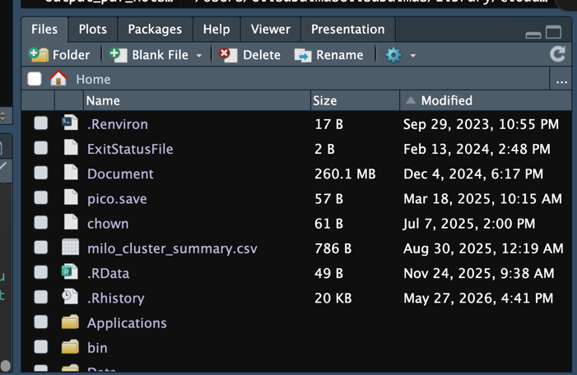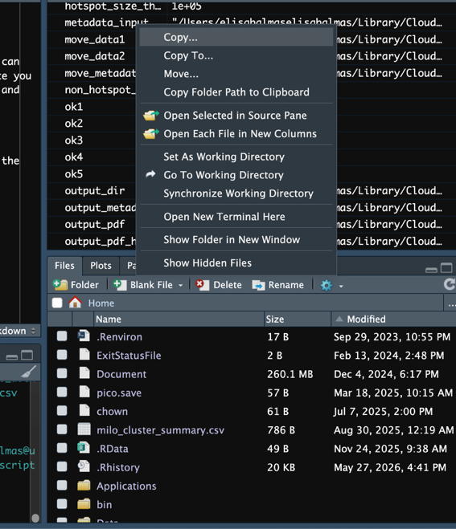
- Open run_CNV_analysis.Rmd and run the analysis by clicking on the green arrows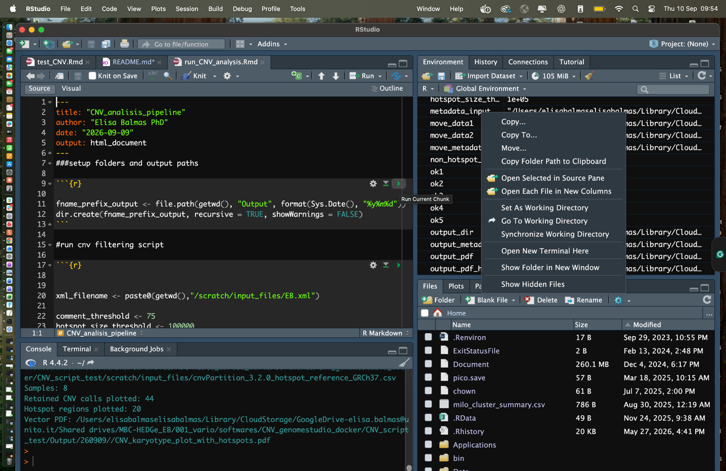
- Make sure you place the correct name of the .xml file afterward _extracred and _filtered files will have the same prefix, make sure to change it.
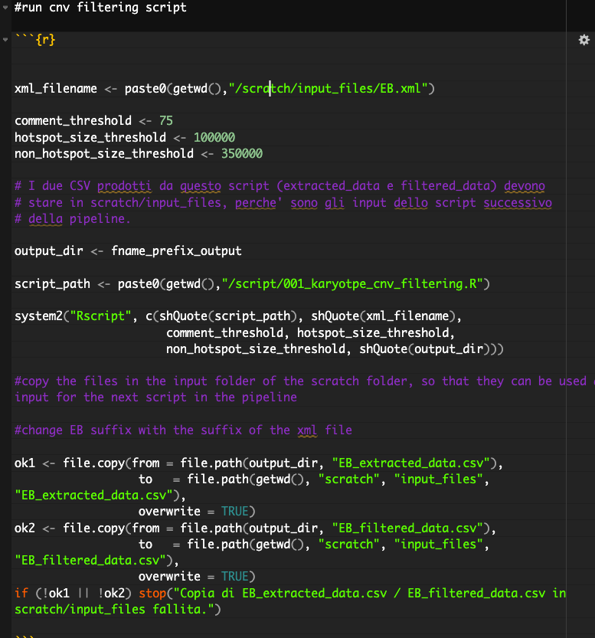
- The final graphs can also be produced by selecting the correct set samples to visualize. Make sure you specify as described in the comments.
