**Help and Instructions**

To Add Birthdays to the Calendar

1. Make sure to select the appropriate calendar from the dropdown that you would like to add the birthday to.

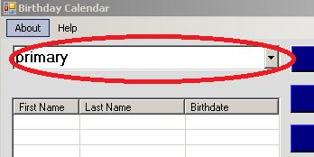

1. Click Add Birthday

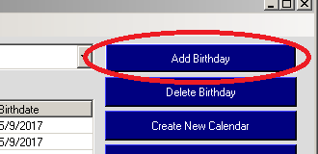

1. Fill in birthday Details and click “Add Record”

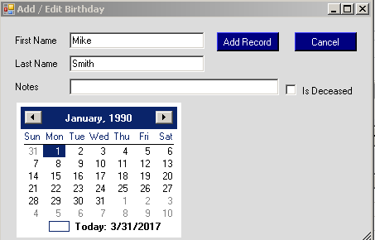

To Add a new Calendar to the Dropdown

1. Click “Create New List”

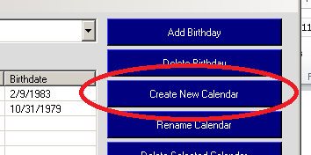

1. Fill In the new calendar name and click “Add Calendar”.

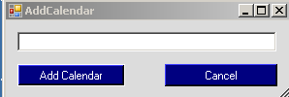

To Update an Existing Birthday

1. Find the birthday from the list and **Double-Click** 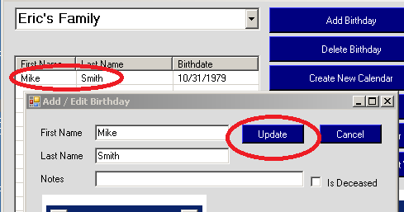
2. Update the information and click “Update”.

To Delete an Existing Birthday

1. Select the birthday by **Single-Clicking** on it.
2. Press the “Delete Birthday” button.
3. It will confirm that you are sure. Click Ok if you are sure.

To Delete an Existing Calendar (This will delete the calendar and all Birthdays associtated with it)

1. Select the Calendar from the dropdown.
2. Press the “Delete Selected Calendar” button.
3. It will confirm that you are sure. Click Ok if you are sure.

To Rename a calendar

1. Select the Calendar from the dropdown.
2. Press the “Rename Selected Calendar” button.
3. Update the calendar name and click “Update”.

To Export your calendar so that you can send it to another user

1. Select the file menu.
2. Select Export from the menu option

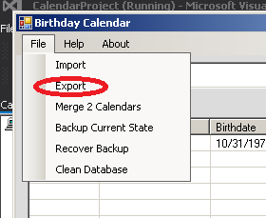

1. For each calendar that you would like exported, select the calendar and click “Add To Export”. The item will then appear in the listbox below.
2. Once all the calendars are added to the listbox, select “Create File” to produce the export file.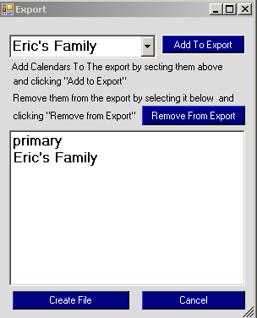

To Import a Calendar from another user

1. You can only import a calendar that was produced with this program. The calendar file should have the file extension .cal
2. Select the file menu
3. Select “Import” from the menu option.

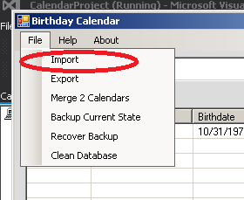

1. Select the file to import from the open file dialog. All the calendars will be imported into your program named exactly as they were when they were exported. If you need you can merge or rename calendars as needed.

To merge 2 Calendars

1. Select the file menu.
2. Select “merge 2 calendars” from the menu option.

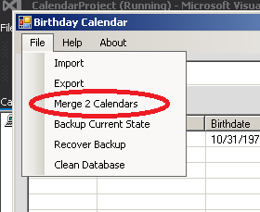

1. There are 2 dropdows. One for each of the 2 calendars you want to merge. Note that all the entries will be merged into the bottom calendar (see image). The below example will result in 1 calendar named “Eric’s Family”.

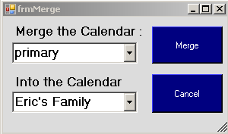

To Backup Database

1. This is different than exporting. These are backups that are made and stored in your system. You can then later go back to a previous state of the calendar if you make any mistakes. It is a good practice to take a backup of your database before “cleaning” it.
2. Hit the File menu.
3. Hit the “Backup Current State” menu option.

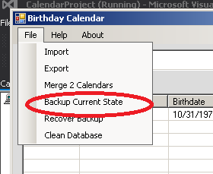

1. This will give you a message that the backup has been created.

To Recover Database backup from a previous state

1. Hit the file menu.
2. Select “Recover Backup” from the menu option.

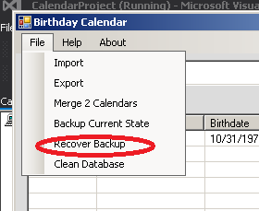

1. This will open up a list of all previously created backups.

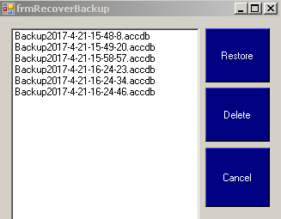

1. The backups are all dated. If you want you can restore a backup from any date. Note. When you restore a backup from a previous date, a new backup is created for your working copy. If you restore many backups, you may end up with an abundance of backups to choose from and it can become confusing. You can always delete any auxiliary backups that are no longer needed.

To clean the Database

1. In this program, nothing is actually deleted. When you delete a birthday, or a calendar, you are just removing it from view. This is a measure taken so that your history can be recovered. However, every once in a while, you may want to go through and actually permanently delete those previously “deleted” records. This should not be necessary, but if your database becomes slow, you can clean the database. Before cleaning the database, you may want to take a backup.
2. Hit the file menu.
3. Hit the “Clean Database” menu option.

To Print a Calendar

1. Confirm that you have the correct calendar list selected that you would like to print.
2. If you want to print this year’s calendar, press the “Print this year” button.
3. If you want to print next year’s calendar, press the “Print next year” button.
4. This will automatically print all 12 months to a printer of your choosing (Paper must be 8.5x11). If you want to print only a specific month, use the print dialog to select to print only specific pages. For example, if you want to print April, select pages 4-4.

