

**Republic of the Philippines**

**Cavite State University – Rosario Campus**

**Rosario, Cavite**

**DEVELOPMENT OF PET SIMULATOR: AN ANDROID GAME APPLICATION**

**FOR CARING DOMESTICATED ANIMALS**

**A Project**

**Submitted to the Faculty of**

**Computer Science Department**

**In Partial Fulfillment**

**Of the Requirement**

**In DCIT 60**

**Joshua L. Austria**

**Earl Christian M. Bantay**

**BSCS 302**

**Chapter 1**

**INTRODUCTION**

In this generation of information age, most of the people needs a lot of information to in order to communicate in the society. This information that the people seeks in these days are very useful also it helps for the solution for their specific questions that to be answer on their selves. These information provided in these generation have bigger and bigger percent of reliability and consistency.

In the help of the internet, people can know a lot of information around the world without travelling in many countries that provides information for the readers. Also with the help of electronic hardware like computers and mobile phones, the society will always connected to this useful information in daily living. With this technology, people could message their relatives in other countries in a seconds, always updated in their environment on what are happened and also instant possible answers provided by the internet when they ask questions.

The information is greatly powerful to the society but our obsession for the information, people do not notice other things in the environment or even on their home the presence of their pets or domesticated animals that also important to society. These animals need attention in order to feel the presence of their owner and to be able to build their companionship in each other. Nowadays, many in our society adopt domesticated animals in their home to treat like a part of their family but many children in this present time that are willing to take care domesticated animals cannot afford to adopt because of some conditions like insufficient money for providing foods for their pets, they cannot control the behavior of the pet that will be adopt and most of all, their parents are strict and they do not want to adopt a pet.

In the help of technology, the researchers maintain the balance between the man and the animals to provide such as information about caring domesticated animals. This application that will be develop by the researchers is a big benefits for those children that who do not own a pet and want to care a domesticated animals. The application will show the simulation of specific pets to help the user to know the proper and easy way caring for this domesticated animals.

**Objectives of the Study**

The general objective of the study is to develop a Pet Simulation Game: An android application for pet lovers.

Specifically, the study aims to:

1. design the logical and user interface of a simulation game of domesticated animal, especially dogs
2. test and evaluate the android application
3. install the free beta version of the mobile application to mobile phones, tablets and similar gadgets.

**Importance of the Study**

The development of android simulation game will be useful to an individual who lacks the knowledge in taking care of some domesticated animals. It will provide a proper information about the animals that you want to take care of.

Furthermore, this android simulation game can also be an entertainment for an individual and for the kids who loves animals. It can be used even without internet or Wi-Fi connection to save time, effort and money in playing this simulation game.

**Scope and Limitation of the Study**

The android simulation game will have the capability of giving possible and necessary solutions needed by the user. It will give an idea on how to take care of your pets. This android simulation game will include proper tips, feeding, cleaning, taking care of your pet. The main user target of this game is kids age 8-12.

The Limitation of the development of Pet Simulator android application is that it will only have one model choice which is a dog. This android simulation game is offline. The animation of the game will be limited or will sometimes have a looping of movements of the animals.

**Time and Place of the Study**

The study will be conducted in Cavite State Rosario from December 2015 to March 2016.

**Conceptual Frameworks**

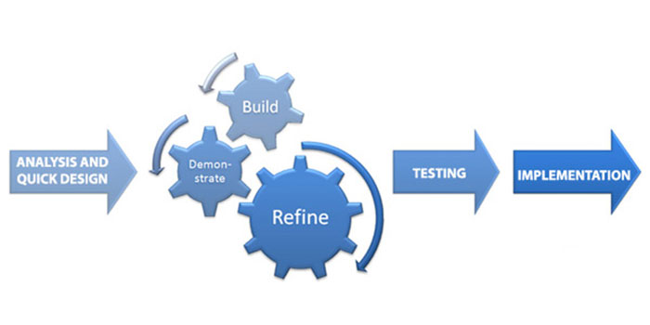

The developers will use Rapid Application Development in the system development. The analysis and quick design will having the implementation of design for the requirements needed in the system. When it is complete, it will undergo building state in order to demonstrate the flow of the system. After building the system, it will be refine to sort small or bigger bugs and errors and test the system if the refinement is complete. When the system is tested, it will be implemented and the software is ready to use.

**Definition of Terms**

The terms used in the study were defined operationally.

**Animation**. A way of making a movie by using a series of drawings, computer graphics, or photographs of objects(such as puppets or models) that are slightly different from one another and that when viewed quickly one after another create the appearance of movements.

**Mobile Application**. A mobile application, most commonly referred to as an app, is a type of application software designed to run on a mobile devices, such as a smartphone or tablet computer.

**Simulation**. The act of process of simulating. The imitative representation of the functioning of one system or process by means of functioning another (a computer simulation of an industrial process).

**Simulator**. A device that enables the operator to reproduce or represent under test conditions phenomena likely to occur in actual performance.

**REVIEW OF RELATED LITERATURE**

This chapter contains the review of related literature and related system that contains relevant and useful information related in conducting and conceptualizing this study.

**New study reveals impact of technology for children in the developing world**

The report, entitled 'Children, ICTs and Development: Capturing the potential, meeting the challenges' found that the use of technology, including mobile phones and social media, has spread rapidly across the globe, leading to an increase in efforts to use the power of communication and speedy access to information in order to aid development.  
But while ICT can be extremely effective in addressing children's issues, the study also identifies certain challenges, such as when ICT development projects are planned in a top-down way, not paying sufficient attention to local context and results are not properly monitored. Summarizing the evidence from 133 articles and 35 expert interviews, the report calls for an approach that is sensitive to factors such as gender and which works in participatory ways, often with children as co-designers of the projects. (Holloway, 2014)

The article used by the developers will affect for the application will be created for children. It interacts more on mobile phones that is daily used by the society and helping the user to know it easier. Mobile phones helps the child to develop their communication to the society.

**Assistive technology for kids with Learning Disabilities**

Assistive technology (AT) is available to help individuals with many types of disabilities — from cognitive problems to physical impairment. This article will focus specifically on AT for individuals with learning disabilities (LD). The use of technology to enhance learning is an effective approach for many children. Additionally, students with LD often experience greater success when they are allowed to use their abilities(strengths) to work around their disabilities (challenges). AT tools combine the best of both of these practices. (Higgins & Raskind, February 2010)

The article used by the developers will know how to handle some user or the child with learning disabilities when the developing software will used by these children. The user interface and the user experience will develop by the developers have a big effect to the child that will use this application.

**Learning Empathy Through Simulation**

Summary Statement: Simulation is increasingly used as an educational methodology for teaching empathy to preservice health professional students. This systematic review aimed to determine if and how simulation, including games, simulated patients, and role-play, might develop empathy and empathetic behaviors in learners. Eleven databases or clearing houses including MEDLINE, EMBASE, CINAHL, PsychInfo, and ERIC were searched for all articles published from any date until May 2014, using terms relating to (i) preservice health professional students, (ii) simulation, and (iii) empathy. Twenty-seven studies met the inclusion criteria, including 9 randomized controlled trials. A narrative synthesis suggests that simulation may be an appropriate method to teach empathy to preservice health professional students and identifies the value of the learner taking the role of the patient. (Bearman, Margaret PhD, October 2015)

The article used by the developers will provide the educational learning by simulating it. The use of simulation for the developing software “Pet Simulator” will help the user to visualize the real world experience for the related behavior of pets.

**Outcomes of game-based learning**

One approach to digital learning is to harness the broad appeal of video games for educational purposes. While research on the cognitive and behavioral impacts of violent video games have shown mixed outcomes, some nonviolent games have shown promise. Certain video games have been shown to improve brain functions, while others have the potential of reversing cognitive loss associated with aging. These “serious games” require players to make decisions to drive its progress, and they can range from the simple to the sophisticated. (Weigel, May 20, 2013)

The developers used this article to maintain the developing application will provide only the positive effects for this behavior and help the child that will use this application to know the right procedure of taking care domesticated animals.

**Game-Based Learning in Science Education**

“The purpose of this study is to review empirical research articles regarding game-based science learning (GBSL) published from 2000 to 2011…. The results indicate that cognitivism and constructivism were the major theoretical foundations employed by the GBSL researchers and that the socio-cultural perspective and enactivism are two emerging theoretical paradigms that have started to draw attention from GBSL researchers in recent years. The analysis of the learning showed that most of the digital games were utilized to promote scientific knowledge/concept learning, while less than one-third were implemented to facilitate the students’ problem-solving skills. Only a few studies explored the GBSL outcomes from the aspects of scientific processes, affect, engagement, and socio-contextual learning. Suggestions are made to extend the current GBSL research to address the affective and socio-contextual aspects of science learning. The roles of digital games as tutor, tool, and tutee for science education are discussed, while the potentials of digital games to bridge science learning between real and virtual worlds, to promote collaborative problem-solving, to provide affective learning environments, and to facilitate science learning for younger students are also addressed.” (Li & Tsai, February 2013)

The developers used this article gives a specific task that must be done in the application will use by the child. While the child interact to the task, the application will help to develop their critical thinking skills in order to work with the task must be done.

**Digital Game-Based Learning**

“Although many studies have investigated the effects of digital game-based learning (DGBL) on learning and motivation, its benefits have never been systematically demonstrated. In our first experiment, we sought to identify the conditions under which DGBL is most effective, by analyzing the effects of two different types of instructions (*learning* instruction vs. *entertainment* instruction). Results showed that the learning instruction elicited deeper learning than the entertainment one, without impacting negatively on motivation. In our second experiment, we showed that if learners are given regular feedback about their performance, the entertainment instruction results in deep learning. These two experiments demonstrate that a serious game environment can promote learning and motivation, providing it includes features that prompt learners to actively process the educational content.” (Erhel & Jamet, September 2013)

The article used by the developers can gives a lot of ideas in how to manage and to know what are the behaviors that will carrying on the developing software. It is more effective that real world experience game application have many instruction and quick guides to provide information for the child that will use in order that user can easily understand it.

**Dynamical Model for Gamification**

“This paper proposes a dynamical model for the gamification of learning. The main idea of this model is based on the correlations of four primary factors (curiosity, challenge, fantasy and control) originating from digital games which are built on the foundations of separate theories: (1) Game Design Features, (2) Key Characteristics of a Learning Game, (3) ARCS Model, and (4) MDA framework. Through this dynamical model, we will show that the effectiveness of the gamification of learning is educationally superior to traditional ways of learning in a specific setting, after an elapsed adaptive time period with a reasonable relationship of the four primary factors. The model presents the meaningful positions of four primary factors on the equation for educational effectiveness of gamification. We posit that this dynamical model for the gamification can strengthen the ‘theoretical foundation’ of gamification as well as spread the idea of ‘the pure and right function of game.’” (Kim & Lee, 2012)

The developers used this application to improve their character modeling and the creation of environment that will be the interface of the game. In this improvements that will be implement in the application, it will affect the user to know more on the gameplay of the application and to learn about how the game teaches the user.

**Learning in Serious Virtual Worlds**

“The objective of this study is to present and to evaluate the E-Junior application: a serious virtual world (SVW) for teaching children natural science and ecology. E-Junior was designed according to pedagogical theories and curricular objectives to help children learn about the Mediterranean Sea and its environmental issues while playing. In this study, we present data about the E-Junior evaluation. A class in a serious virtual world (virtual group) was compared with a traditional type of class (traditional group) that contained identical learning objectives and contents but lacked a gaming aspect. The results showed that the serious virtual world does not present statistically significant differences with the traditional type of class. However, students from the virtual group reported enjoying the class more, being more engaged, and having greater intentions to participate than students from the traditional group. The plausible explanation for this can be found in the qualitative data. The implications of these results and improvement proposals are also discussed in this work.” (Wrzesien & Alcaniz-Raa, August 2010)

The developers used this article to know how the application will be effective for the children will using it. The developers choose the simulation for the game to give ideas to the user experiencing what specific domesticated looks like.

**Gamifying Learning Experiences**

“Gamification is the use of game design elements and game mechanics in non-game contexts. This idea has been used successfully in many web-based businesses to increase user engagement. Some researchers suggest that it could also be used in web-based education as a tool to increase student motivation and engagement. In an attempt to verify those theories, we have designed and built a gamification plugin for a well-known e-learning platform. We have made an experiment using this plugin in a university course, collecting quantitative and qualitative data in the process. Our findings suggest that some common beliefs about the benefits obtained when using games in education can be challenged. Students who completed the gamified experience got better scores in practical assignments and in overall score, but our findings also suggest that these students performed poorly on written assignments and participated less on class activities, although their initial motivation was higher.” (Dominquez, Saenz, Marcos, Fernandoes, Pages & Martinez, April 2013)

The article used by the developers will help the children did not experience or not having a chance taking care a domesticated animal or pet. The application “Pet simulator” will give the chance to experience a child what they want to carry of.

**Using Mobile Phones to Improve Educational Outcomes**

Despite improvements in educational indicators, such as enrolment, significant challenges remain with regard to the delivery of quality education in developing countries, particularly in rural and remote regions. In the attempt to find viable solutions to these challenges, much hope has been placed in new information and communication technologies (ICTs), mobile phones being one example. This article reviews the evidence of the role of mobile phone-facilitated mLearning in contributing to improved educational outcomes in the developing countries of Asia by exploring the results of six mLearning pilot projects that took place in the Philippines, Mongolia, Thailand, India, and Bangladesh. In particular, this article examines the extent to which the use of mobile phones helped to improve educational outcomes in two specific ways: 1) in improving access to education, and 2) in promoting new learning. Analysis of the projects indicates that while there is important evidence of mobile phones facilitating increased access, much less evidence exists as to how mobiles promote new learning. (Valk, Rashid, and Elder, March 2010)

The article used by the developers gives information how the mobile phones affects the world today. Mobile phones today is much comprehensive than later mobile phones and it provides fast connection of communication with other people also it develops the user their educational learning in this information age.

**Optimizing Mobile Deployments**

Mobile devices are increasingly powerful and flexible tools for grassroots work. This document offers guidelines for thinking about your deployment, drawing attention to the latent project features that can influence the use of a device you issue for community level or frontline social service work.(Schwartz, Bhavsar, Cutrell, Donner & Densmore, April 1, 2014)

The article used by the developers will help them know the guidelines on how to upgrade their system features.

**Usability of mobile applications**

The usefulness of mobile devices has increased greatly in recent years allowing users to perform more tasks in a mobile context. This increase in usefulness has come at the expense of the usability of these devices in some contexts. We conducted a small review of mobile usability models and found that usability is usually measured in terms of three attributes; effectiveness, efficiency and satisfaction. Other attributes, such as cognitive load, tend to be overlooked in the usability models that are most prominent despite their likely impact on the success or failure of an application. To remedy this we introduces the PACMAD (People At the Centre of Mobile Application Development) usability model which was designed to address the limitations of existing usability models when applied to mobile devices. PACMAD brings together significant attributes from different usability models in order to create a more comprehensive model. None of the attributes that it includes are new, but the existing prominent usability models ignore one or more of them. This could lead to an incomplete usability evaluation. We performed a literature search to compile a collection of studies that evaluate mobile applications and then evaluated the studies using our model. **(Harrison, Flood & Duce, May 7, 2013).**

The article used by the developers will help them gather information about mobile application that is very useful to their system.

**A Guideline for Game Development-Based Learning**

This study aims at reviewing the published scientific literature on the topics of a game development-based learning (GDBL) method using game development frameworks (GDFs) with the perspective of (a) summarizing a guideline for using GDBL in a curriculum, (b) identifying relevant features of GDFs, and (c) presenting a synthesis of impact factors with empirical evidence on the educational effectiveness of the GDBL method. After systematically going through the available literature on the topic, 34 relevant articles were selected for the final study. We analyzed the articles from three perspectives: (1) pedagogical context and teaching process, (2) selection of GDFs, and (3) evaluation of the GDBL method. The findings from the 34 articles suggest that GDFs have many potential benefits as an aid to teach computer science, software engineering, art design, and other fields and that such GDFs combined with the motivation from games can improve the students’ knowledge, skills, attitudes, and behaviors in contrast to the traditional classroom teaching. Furthermore, based on the results of the literature review, we extract a guideline of how to apply the GDBL method in education. The empirical evidence of current findings gives a positive overall picture and can provide a useful reference to educators, practitioners, and researchers in the area of game-based learning. [(Wu](http://www.hindawi.com/32435956/) & Wang, November 24, 2012).

The article used by the developers will help them review the analization of their game development to further improve their systems feature.

**The animal as fourth educator**

This literature review presents the case for acknowledging the animal in early childhood settings as the fourth educator. This idea builds on the work of Malaguzzi (1998), who proposed the environment as third teacher. Drawing on a range of research as well as changing perspectives about the animal and child relationship, the literature presented here argues for the animal to be considered respectfully as a pedagogical support and motivator for learning. The review covers interdisciplinary aspects of the field of human and animal relationships and also draws on new work about animals in mechanical/robot form. These animal and machine intersections come together in posthuman theory. The review highlights opportunities for research in this increasingly important area. (Jane, June 2013).

The article used by the developers will help them know the relationship of animals and humans for a better information used by the system.

.**Games, simulations, and learning in emergency preparedness**

Between 2007 and 2011, a comprehensive review of the literature was conducted to identify the usefulness of educational games and simulations in developing and evaluating the competency of public health professionals to prepare for, respond to, and recover from emergencies. This article presents an overview of the literature related to the use of games and simulations in education and training, summarizes key findings, identifies key features of gaming simulation design for educational effectiveness, and suggests that use of these emerging teaching and learning strategies be considered in the development of a comprehensive approach for creating and evaluating competency. (Am J Disaster, 2012).

The article used by the developers will help them have a background information about the simulations and on how to develop a simulator that is accurate to their ideal simulation.

**The ‘pet effect’: Health related aspects of companion**

People keep pets for companionship, recreation and protection,[1](http://www.racgp.org.au/afp/2012/june/the-pet-effect/#1) rather than for the specific purpose of enhancing their health. However, a considerable body of literature supports the idea that companion animals can improve overall quality of life, including physical, social and psychological health.[2](http://www.racgp.org.au/afp/2012/june/the-pet-effect/#2)–[5](http://www.racgp.org.au/afp/2012/june/the-pet-effect/#5) This phenomenon has been described as the ‘pet effect’.[6](http://www.racgp.org.au/afp/2012/june/the-pet-effect/#6)

Pet ownership may have implications for the healthcare system and public expenditure, as improved health and wellbeing associated with pet ownership has been found to reduce the use of healthcare services.[7](http://www.racgp.org.au/afp/2012/june/the-pet-effect/#7) To date, there has been little discussion of the role that companion animals can play in primary healthcare and health promotion. (Canberra, June 2012)

The article used by the developers will help them and the user to know how can a pet improves or change your health and wellbeing.

**Friends with Benefits: Pets Make Us Happier, Healthier**

In three different studies, we found consistent evidence that pets represent important social relationships, conferring significant benefits to their owners ([McConnell et al., in press(link is external)](http://psycnet.apa.org/psycinfo/2011-13783-001/)). In one study involving 217 community members, pet owners exhibited greater[self-esteem](https://www.psychologytoday.com/basics/self-esteem), were more physically fit, were less lonely, were more [conscientious](https://www.psychologytoday.com/basics/conscientiousness), were more socially [outgoing](https://www.psychologytoday.com/basics/extroversion), and had healthier relationship styles (i.e., they were less [fearful](https://www.psychologytoday.com/basics/fear)and less preoccupied) than nonowners. Another interesting finding was that pet owners reported receiving as much support from their pets as they did from their family members (e.g., siblings, [parents](https://www.psychologytoday.com/basics/parenting)), and that people reported being closer to their pets as they were also closer to other people. Thus, people did not turn to pets because their human social support was poor -- instead, owners seem to extend their general human social competencies to their pets as well.( McConnell, July 11, 2011).

The article used by the developers will help them and the user to know how can a pet affects your emotion and your health.

**LOCAL LITERATURE**

According to **Matthew O’mara (February 14, 2013)**For those who spent countless hours caring for their virtual pets, Namco Bandai Games Inc. Is bringing backthe Tamagotchi as a downloadable smartphone application for Google Inc.‖s Androidplatform and Apple Inc’siOS: Tamagotchi L.I.F.E. The pocket pet was released in North America in 1997. Tamagotchi itself is a hybrid of the Japanese word ―Tamago‖ meaningegg, and the word ―Watch.‖ According to the tamagotchi L.I.F.E website, more than 78million Tamagotchi devices have been sold, not to mention the various releases onhand held systems.TamagotchiL.I.F.E.,released on the 16th birtday of the electronic pet, featuresmore characters and higher resolution graphics, so the game looks the part on mobiledevices. The game allows players to interact with the virtual pet in either game mode orapp mode. Game mode looks like the traditional handheld device with the three buttonsallowing you to feed, interact, and clean up after your pet. App mode is morestreamlined allowing users on the go- though there are garish banners- to take care oftheir little pet. The Tamagochi game is a type of pet game, which allows theprogrammers/ proponent used to conceptualize the extend of caring to pets, such asfeeding them, providing them food, and care to be able to perform well in the interactionof the game.

The article used by the developers will help the children did not experience or not having a chance taking care a domesticated animal or pet. The application “Pet simulator” will give the chance to experience a child what they want to carry of.

According to **Chad Ata (August 12, 2012)**Furdiburb has been in development fornearly 3 years. Early on, the developers planned for a community-influenced project, sothey released a minimally functional version in order to get immediate feedback. Theearliest builds began with a focus on purely virtual pet aspects, resulting in aTamagotchi-like experience. Users enjoyed these features but wanted more to do withthe simple pet. Given this feedback the team (aka Team Furdi) decided to focus on thestoryline of Furdiburb returning to his home planet via action and adventure gameplay.In summer of 2011 Team Furdi made the switch to working full-time on Furdiburb inorder to pursue this goal.Furdiburb is a virtual pet, puzzle, and adventure game mashed into one. Playerscare for their newly adopted pet by feeding and cleaning him. They may also customizehis looks, furniture, and house with fun-themed designs. The main goal of the game isto explore gorgeous lands, play mini-games (fishing, star jumping, bug dodging, andmusic writing), and solve puzzles in order to collect parts to fix up a broken spaceshipso that Furdiburb may return home one day.

The article used by the developers will help the user to get some information about the game and its contents.

**LOCAL STUDIES**

According To **ANPT.GlosoftPEHM-Development Company( Augsut 23, 2013)** the immersed in the LITTLEST PET SHOP world and collect your favorite pets HelpBLYTHE and her friends, Minka, Penny, Pepper, Russell, Sunil, Vinnie and Zoe toadopt, take care of and entertain cute little pets!The features are 150 pets to collect! Dogs, cats, bears and more,Wash them, feed themand play with them in fun mini-games, Build houses and play areas to welcome andentertain even more pets, Visit your friends and find the hidden objects in theirtowns.Littlest Pet Shop is free to play, but if you wish you can enrich your experience bypurchasing game items with real money. You can disable in-app purchases by adjusting your device’s settings. The Proponent used the Little Pet Shop as the medium of instruction in creatingthe system as the guide in order to possibly do the system. The system is evaluate tobe able to address requirement of the proposed system in dealing with the movement ofthe data, the movement of the characters /sprite (Potchi). This serve as a guide in thedevelopment of the characters in the game, the scores obtain by the gamer, goals arefully adapted by the proponents

The article used by the developers will help the them upgrade their system through the use of the information gathered from the article.

**Chapter 2**

**METHODOLOGY**

This chapter describes the description of the system, system analysis and design procedures, principles of operation, technical evaluation and data gathered.

**Description of the system**

The application “Pet Simulator” has main page which includes start, how to use and about button. For the start button it includes the choices of pets that you want to play. For the how to use button, it shows the user how to use the application. And lastly, the about button, it show what is the application all about and its developers.

The laptops that the developers will be using for developing mobile application has the following specification, 4 Gigabytes of Random Access Memory (RAM), a Genuine Intel® CPU, with a speed of 1.7 GHz, 300 Gigabytes hard disk with Windows 10 for the Operating System (OS). The proposed application was expected to run in a mobile phone with the Android OS version 2.3 (Gingerbread) and above and has 3 inches screen size.

The other laptop that the developers will be using for designing the mobile application has the following specification, 8 gigabytes of Random Access Memory (RAM), an Intel Core i7 CPU, with a speed of 2.6 GHz, 1 Terabyte hard disk with Windows 8.1 for Operating System.

In terms of software specification, the developers will be using Unity 3D and C# as their programming language in developing their mobile application

“Pet Simulator”. In designing, the developers used Adobe Photoshop Cs6 for the mobile application’s buttons and interface, Autodesk Maya for the character design of the game. And for the documentation, the developers will be using Microsoft Word 2010 and Visio Professional 2013.

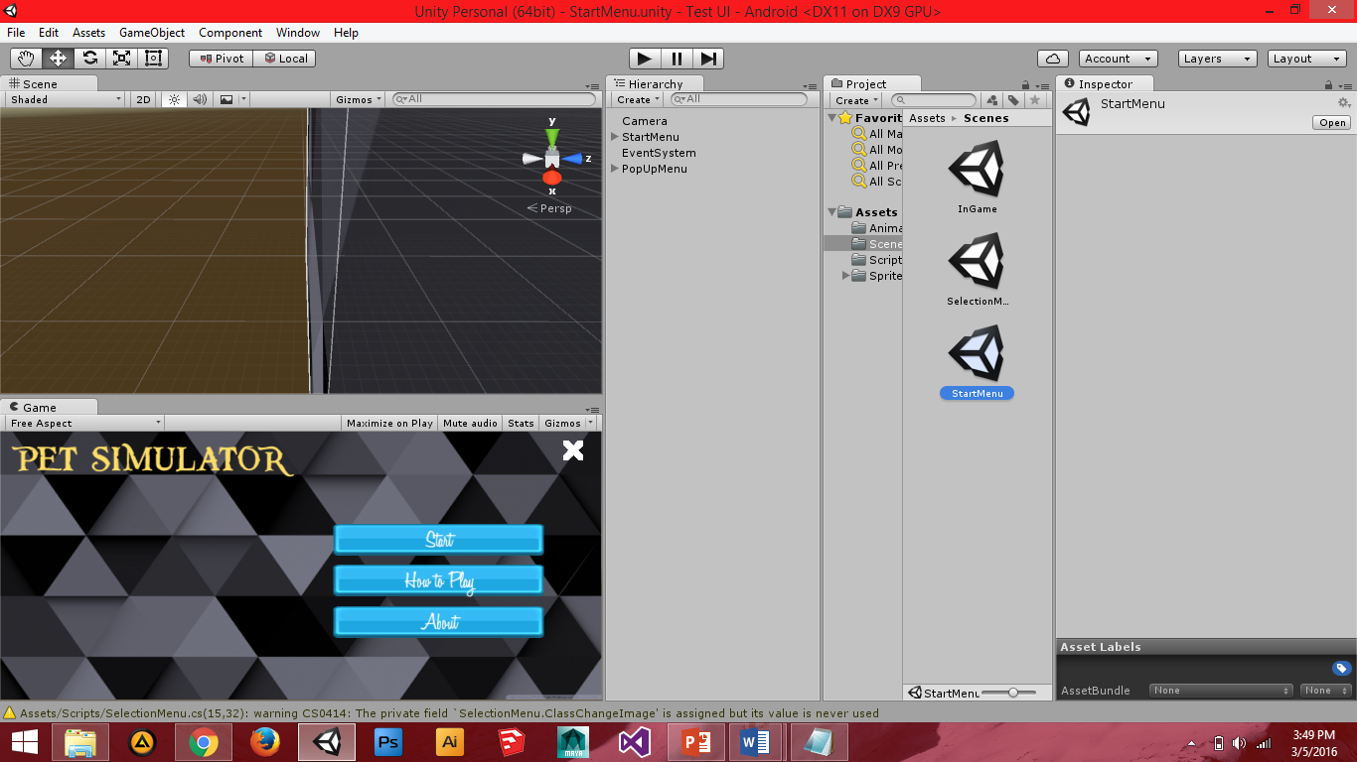

**Figure 1. Start Page**

The main page of Pet Simulator mobile application has three buttons. The start

button is where you can choose what pet you want to play. Instructions and guidelines

are located in the how to use the button, and you can browse all about the Pet Simulator

application and developers in about button.

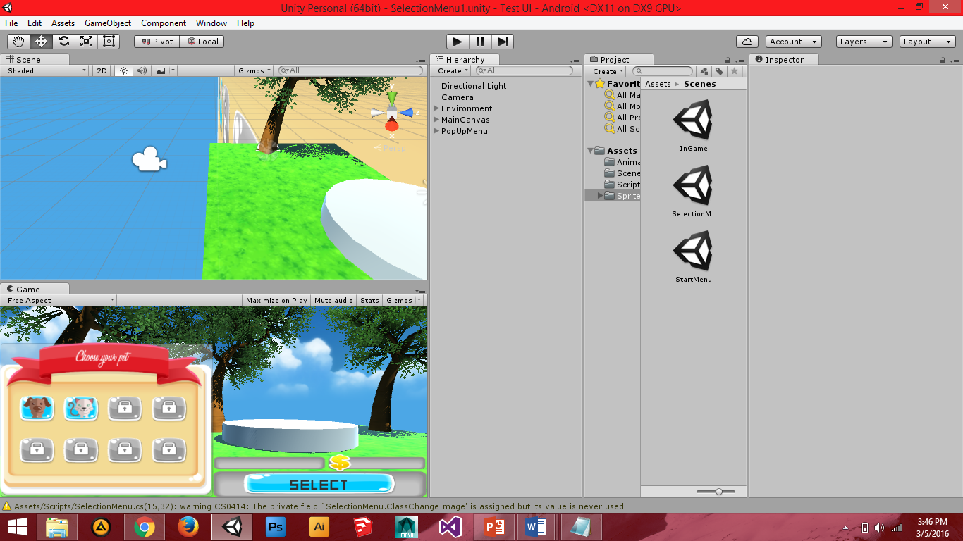**Figure 2. Selection Page**

The selection page shows the user can choose any available pets he/she want to

create and play. The user can input the desire name of his/her pet when he/she select

the pet.

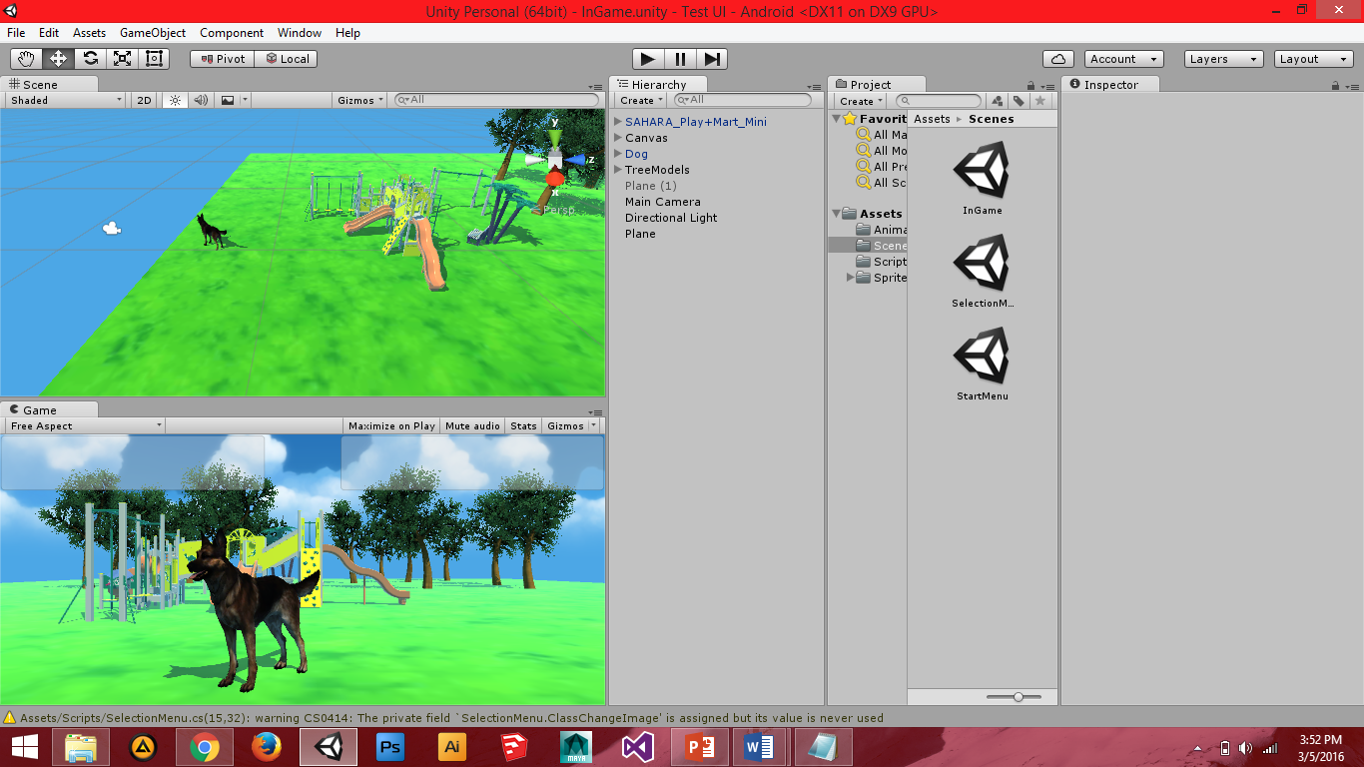

**Figure 3. Gameplace Page**

In this page, the selected pet of the user can see his/her pet moving and interact with

the user.

**System Analysis and Design Procedures**

The developers used a system development method called rapid application development or RAD where, planning, analysis and design task interact continuously to produce the Pet Simulator: Mobile Application Simulation that could be tested, evaluated, and implemented through Android Operating System.

In the requirement planning stage, the developers will identify the project scope, constraints and system requirements. During the user design stage, the researchers will develop models and prototypes that will represent all system processes, outputs and inputs. In the construction stage, researchers will perform the coding and accept suggestions, comments and improvements from the users based on modules being developed. Lastly, during the cutover stage, the Pet Simulator android application will be tested and evaluated before it will be installed in mobile phones and similar gadgets with android operating systems.

The developers will use Rapid Application Development (RAD) for faster delivery time, for better quality of the application, for lower cost, lower maintenance, greater customer satisfaction, for better project management and to reduce the risk of errors or risk of the application.

**Principles of Operation**

The application “Pet Simulator” allows the user to experience on how to take care of some domesticated animals in the game. After the user finished choosing what pet he/she like, the user will be required to name his/her pet. And lastly the user can see his/her attendance in a calendar, so the user can see if their pet improved or not.

The user can download the Pet Simulator application through our website page. It will be installed automatically after downloading the application.

**Technical Evaluation**

The software will be evaluated by the IT experts and end-users using the following criteria shown in Table 1.

**Table 1. Program/Software Evaluation Criteria**

|  |  |  |
| --- | --- | --- |
| **CRITERIA** | **POINTS**  **POSSIBLE** | **POINTS EARNED** |
| 1. Does the software support the needs and objectives of the curriculum?  * Are the objectives of the software documented? * Do the objectives match curriculum goals and mandated standards? * Are activities and evaluations matched the objectives? * Does the software fill a need not addressed by existing software? | 10 |  |
| 1. Does the target audience match the intended learner audience?  * Does the software match the learner audience in age, reading, and skill level? * Is the software accessible to students with disabilities? * Is the rate of display of information appropriate to the learner audience? | 10 |  |
| 1. Is the return on investment justifiable to the stakeholders?  * Is the software cost efficient? * Is the necessary hardware available and affordable? | 10 |  |
| 1. Is the software easy to use?  * Are directions easily understood? * Can the user navigate through the software easily? * Are records stored and easily retrieved? * Is there a site map? * Are the button located properly? | 15 |  |
| 1. Is the software well supported?  * Is there a print or online manual? * Does the software include all necessary guides or workbooks? * Is technical support provided online or by phone? | 10 |  |
| 1. Is the content accurate?  * Is the program free of gender and racial stereotypes? * Is the language free of errors in spelling, grammar, and pronunciation? * Does the program provide immediate feedback? * Is the feedback credible and context-based? * Is IPR properly observed? | 10 |  |
| 1. Is the software an appropriate medium for learning the targeted skills?  * Is text displayed consistently and easy to read? * Is the quality of visual and auditory elements acceptable? * Are graphics and animations appropriate to the target audience? * Do the graphics and animations support the program’s intentions? * Does the program promote higher levels of cognitive activity? * Does the program incorporate active participation?   Interactive? | 15 |  |
| 1. Is the design of the pages and output formats appropriate? | 10 |  |
| TOTAL | 100 |  |

**Data Gathered**

The developers will conduct a visit to Cavite State University Rosario to ask the students for their pet that will be needed in the application. They will gather the information needed in the development of the system from the internet, from the people who has a pet, and from pet lovers. Also, the developers will visit the school’s library to have detailed research and also read different materials that are relevant to the study being conducted. To support the needed information in the developing system, the developers will research for the behavior of specific domesticated animals for the developing system in order to simulate the real world actions of modern day animals in how they will interact in other animals, how they build companionship together with their owner, and how can they adopt in depends on their environment.

**Data Analysis**

The gathered information from the respondents in Cavite State University Rosario

Campus will be categorize based on their year levels, course, and gender in order to obtain more specific details needed in the development. All answers gather by the developers will consolidate to make better changes in the system. The information gather will be classified to know the specific problems and difficulties of the system. Answers and opinions of respondents can give newer information such as upgrades, additional and bug fixes in the system. The repondents feedback in the developing system will be proiritize if is low or high depends if the specific response have the same feedback of other respondents on the system.

**Cost Analysis**

**Hardware Requirements**

Personal Computer/ Laptop (Available)

\ Intel Core i7, 2.6 GHz (Available)

1 Terabyte HDD (Available)

8 Gigabytes RAM (Available)

1Terabyte External HDD 3,500.00

Android Smartphone:

Version Gingerbread and up 9,000.00

**Software Requirements**

Windows 8 & 10 Operating System (Available)

MS Office 2013(Available)

Adobe Photoshop CS5 (Available)

Autodesk Maya (Available)

Unity (Available)

Internet Connection (Available)

**Operational Expenses**

Transportation (Campus Travel Order)

Office Supplies 1,000.00

**Estimated Total Amount** PhP 13,500.00

**Requirements Analysis**

The android game “Pet Simulator” is a 3 dimentional simulation game where you can experience how it feels like to play with a domesticated animal. The animals in this software has many type of animation or movements like walking, idle, and etc. Each animation was created with the use of Autodesk Maya and Unity where the models that will be used in this game should be rigged in order to have a movement. The models of animals are all presentable and looks realistic.

Rigging is the process of creating a skeleton for a 3D model so it can move. Most commonly, characters are **rigged** before they are **animated** because if a character model doesn't have a **rig**, they can't be deformed and moved around.

**Software Design**

Motion of the subject during an MRI scan can cause the image to contain distortions or artifacts. The MMDS application seeks to develop a way to easily inform the MRI operator and subject in real time when non-trivial motion has occurred. The MMDS application will do this by interfacing with the MMDS Hardware to Software Interface.

The Pet Simulation will act on a synchronized schedule or time with the mobile phone in order to provide accurate information regarding the status of your pet.

**System Requirements**

**Hardware**

The Android game Pet Simulator requires a mobile phone with atleast Ginger Bread android version until the last version and has atleast 500 mb ram to play it smoothly.

**Software**

Pet Simulator can be created in any version of Autodesk Maya but the most recommend version is the Autodesk Maya 2015 where there are more tutorials that you can see on the internet than the other versions. The lowest or the minimum Android version for the Pet Simulator is Ginger Bread but the recommended version for it is Lollipop 5.0 and 5.1.

**Human Resource**

Programmers who are knowledgable in:

* C#
* Visual Studio
* Unity
* Autodesk Maya

**Software Testing**

**Testing Activities**

The Pet Simulator has many test to undergo. The buttons on the main menu should be test one by one after coding or even after updating some line of codes. The animation requires a lot of testing. Frame by frame, you have to test the motion of the rigged model every time you save a frame.

**Test Case**

The compatibility of android version of the game and the android version of mobile phones are the frequent problem when testing to install the Pet Simulator. Some functions might not function when the game is installed in an unsupported android version.

**Installation Process**

1. Copy the unity file “.apk” in your android phone.
2. Install the apk file in your mobile phone.
3. Wait until the installation to complete.
4. After the installation you will notify that the installer has benn successfully installed in your android phone and ready to launch.

**Software Maintenance Plan**

The game Pet Simulator will not just be maintained, but it will also be upgraded. This game should be upgraded every time the android version change in order to maintain its accurate function. Some elements and functions on this game should be upgrade. The model or the animal that used in this game should have a minor animation like the movements of ears, tail, and etc. The choices of breed or type of animal should also be upgraded.