Figures

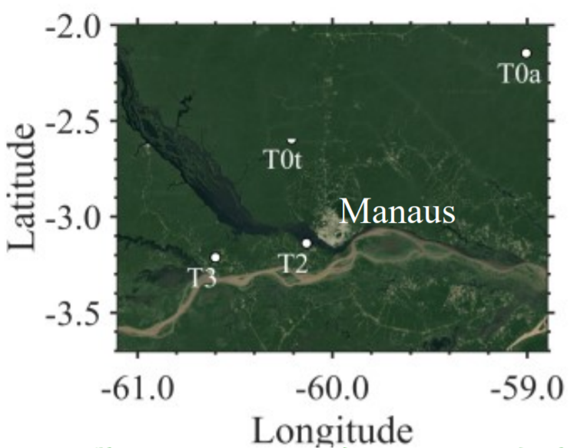

Figure 1. GoAmazon field site location with respect to the city of Manaus. Figure courtesy of de Sa 2019, ACP.

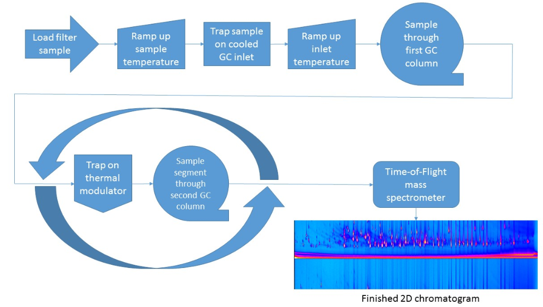

Figure 2: TD-GCxGC-EI-HR-ToF Mass Spec Diagram. Simplified representation of the Thermal Desorption-2D Gas Chromatography-Electron Ionization-High Resolution-Time of Flight-Mass Spectrometer used to analyze both the Amazonian filter samples and the external standard mixture.

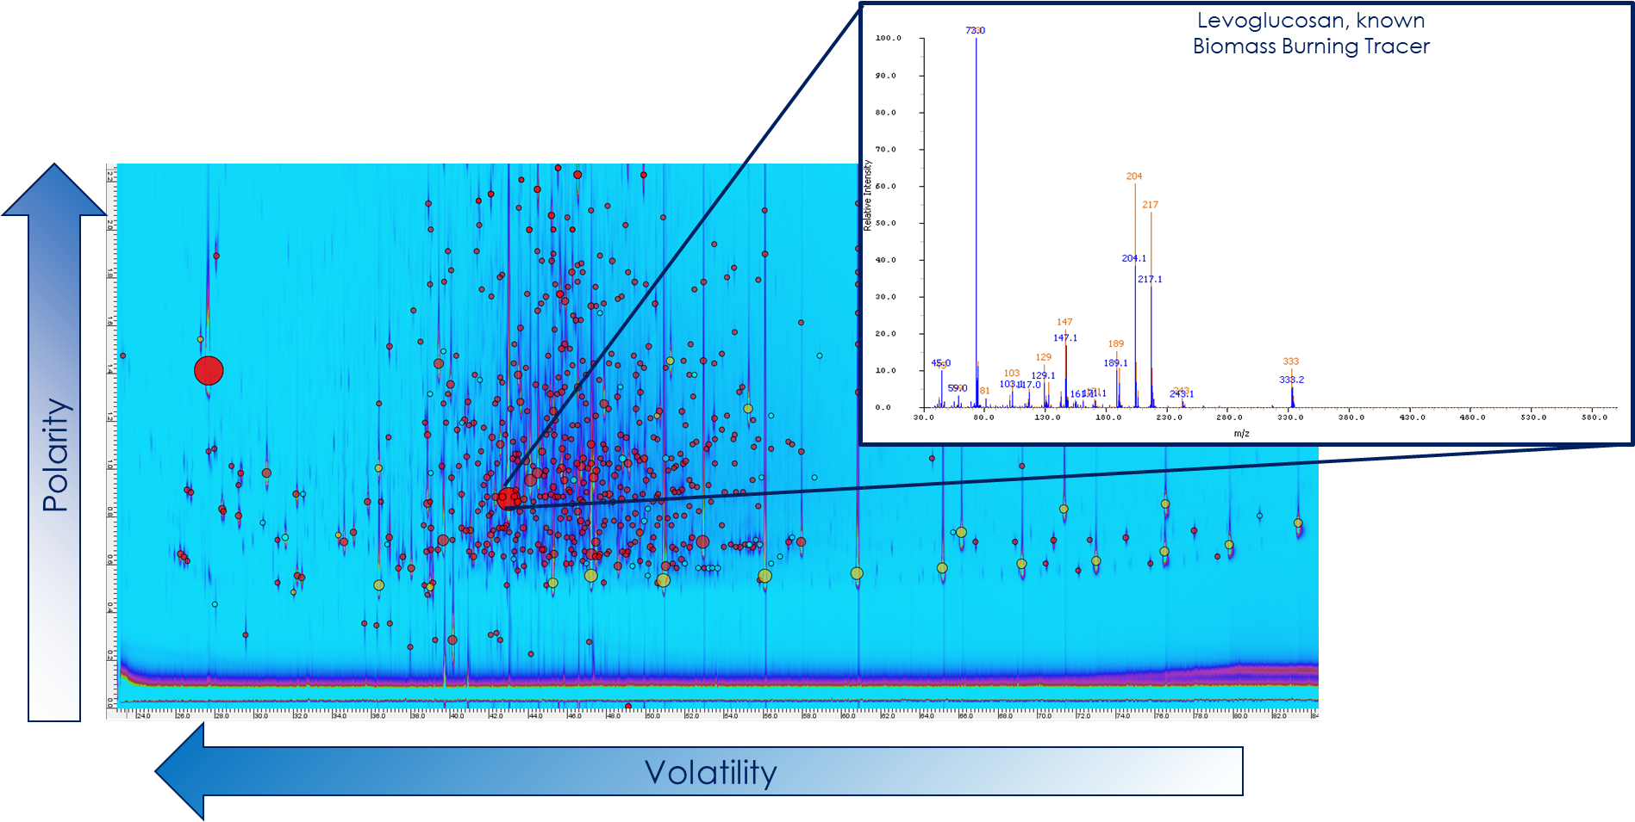

Figure 3: GC-image 2D chromatogram with mass spectra example. Volatility increases right to left, polarity increases vertically, and each circle indicates a compound for which a mass spectrum has been generated. Red circles indicate sample analytes while yellow circles are internal standard compounds.

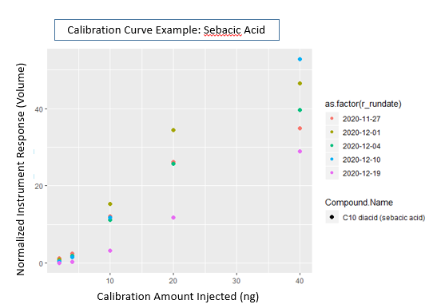

Figure 4: Calibration curve example for sebacic acid

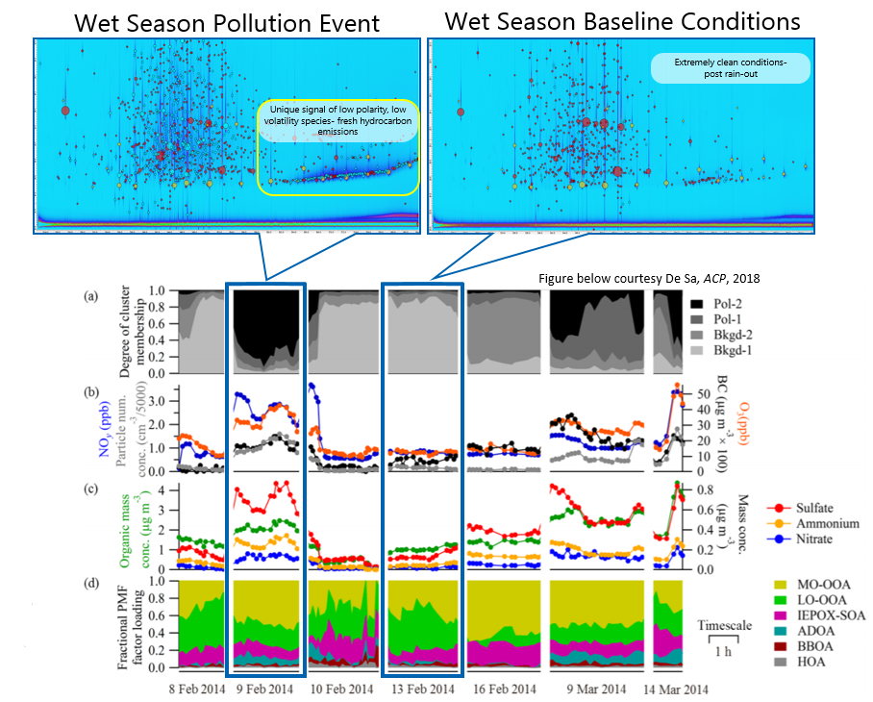

Figure 5. AMS Positive Matrix Factorization example as published in de Sa 2019, coupled with the GCxGC template images selected from the indicated days. PMF factors from AMS illustrated in bottom panel. MO-OOA indicates ‘more oxidized oxidized organic aerosol’, LO-OOA indicates ‘less oxidized oxidized organic aerosol’, IEPOS-SOA indicates isoprene derived secondary organic aerosol, BBOA indicates biomass burning organic aerosol.

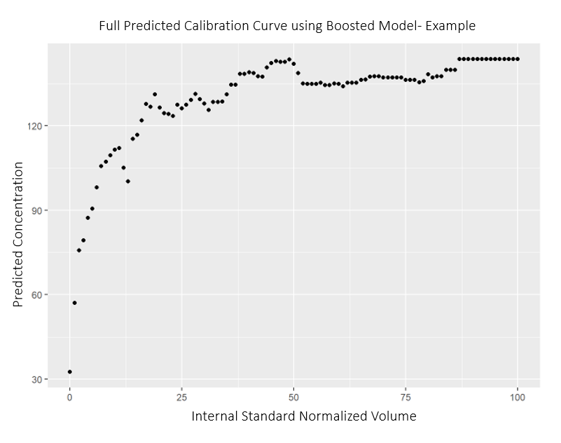

Figure 6. Full predicted calibration curve example using boosted model.