Evidence for Limited Organic Contamination Due to Transport at SeaScape 2019

*Compiled by Emily Barnes, UC Berkeley*

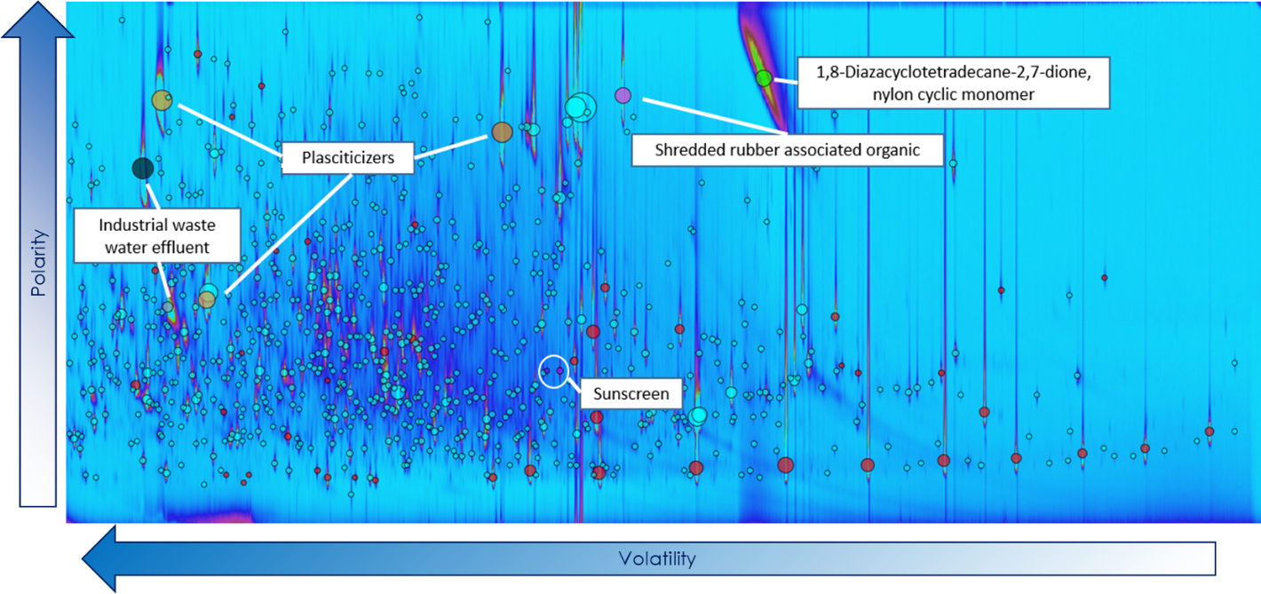

Figure 1. GCxGC spectrum of Scripps Pier mDOM prior to transport. Significant contributions of anthropogenic plasticizers, wastewater effluent products, and personal care products (identified by confident mass spectral match to NIST library complemented by literature review) highlighted.

*Takeaways:* Coastal water utilized in 2019 SeaScape campaign was significantly impacted by anthropogenic influence at the source due to contamination from a variety of sources, some directly attributable to runoff and human activity directly on the adjacent beach.

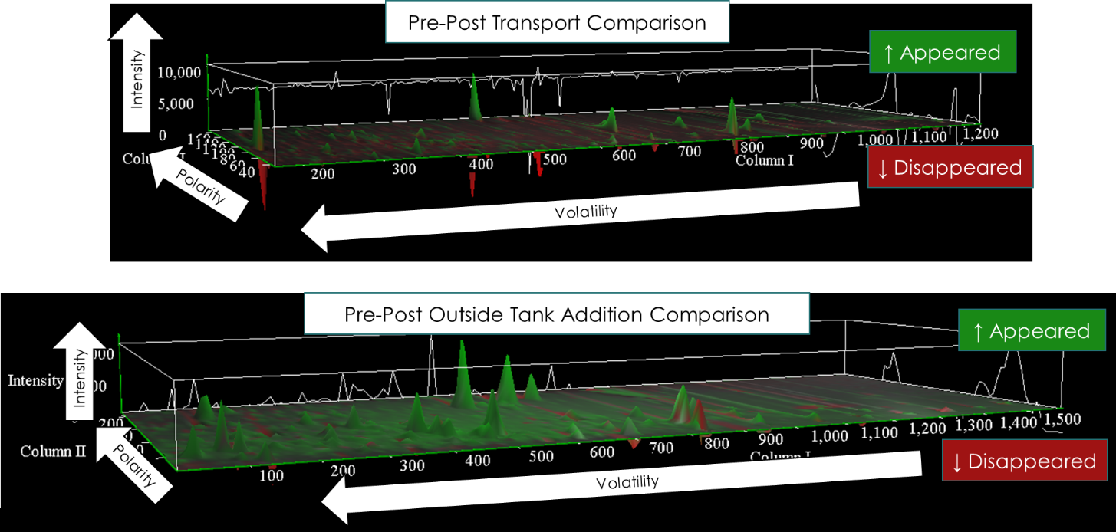

Figure 2. Three dimensional mDOM GCxGC comparison spectra: a) Comparison of organic signature pre and post water transport from pier b) Comparison of organic signature pre and post concentrated bloom addition.

*Takeaways*: Limited evidence for introduction or significant enhancement of anthropogenic contaminants due to transport. Total change in organic signature due to transport insignificant compared to changes driven by accelerating biological activity observed after concentrated bloom addition. *Bonus:* Sunscreen signature entirely consistent across transport

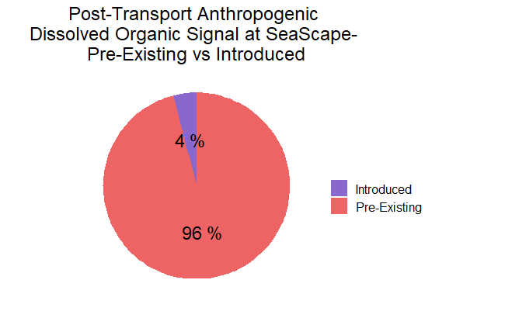

Figure 3: Maximum contributions of introduced organics to total anthropogenic organic signature post water transport observed by GCxGC.

*Assumptions:* All introduced organics (newly appeared) assumed to be anthropogenic-introduced and only organics confidently identified as coastal anthropogenic contaminants by mass spectral match and documentation in literature assumed to be anthropogenic-preexisting, therefore 4% is a **ceiling** on potential contribution of introduced anthropogenic organics to total anthropogenic mDOM signature within GCxGC detection limits.

*Takeaways:* Transport-introduced anthropogenic organics insignificant relative to pre-existing anthropogenic organics in coastal Scripps water utilized in SeaScape 2019 mesocosm experiment

Note: Sensitivity of GCxGC methods to entire distribution of organics in mDOM unknown- however, logical tracers of transport-induced alterations to organic composition (personal care products from handling by operators and common plasticizers potentially attributable to hoses and containment vessels) within sensitivity window and not significantly altered by transport.

*Note to jon: if you want a figure documenting this I can work on it, just lmk