**Team Members**

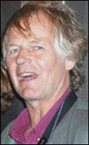Professor Pieter Sjipkes has been experimenting with the idea of ice architecture for years in his courses with various projects. Various courses taught by Professor Sjipkes have involved a form of ice architecture in lectures and projects, particularly his courses in structures. He has created elegant structures by creating thin shell ice curves by means of freezing water onto stretched nylon sheets, constructed a large catenary arch from 2000 ice blocks cast from two-liter milk cartons, and built a scale models in ice and snow of both the Pantheon on the McGill campus, and the Berlin Wall along Parc Avenue.

Professor Jorge Angeles

Eric Barnett, PhD

Robert Pontarelli